1. What is blockstack?

A full stack for building decentralized applications.

Blockstack is a full-stack decentralized computing network that enables a new generation of applications where developers and users can interact fairly and securely. Blockstack uses blockchain technology to build protocols and developer tools designed to enable a fair and open Internet that returns digital rights to developers and consumers.

2. Blockstack storage architecture. 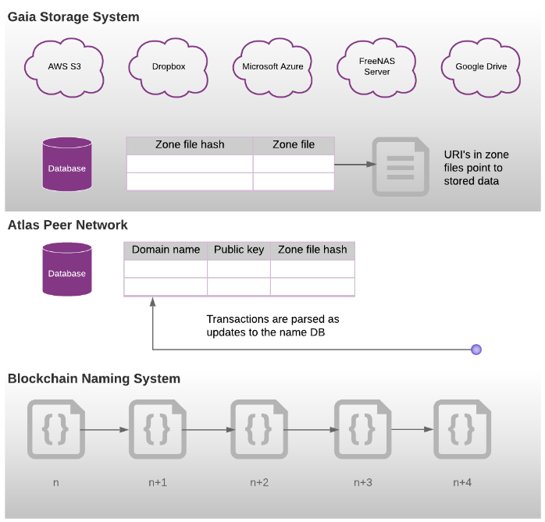

Blockchains require consensus among large numbers of people, so they can be slow. Additionally, a blockchain is not designed to hold a lot of data. This means using a blockchain for every bit of data a user might write and store is expensive. For example, imagine if an application were storing every tweet in the chain.

Blockstack addresses blockchain performance problems using a layered approach. At the base of the system is a blockchain and the Blockstack Naming System (BNS). The blockchain governs ownership of names (identities) in the system, names such as domain names, usernames, and application names.

Names in Blockstack correspond to routing data in the OSI stack. The routing data is stored in the Atlas Peer Network, the second layer. Every core node that joins the Blockstack Network is able to obtain an entire copy of this routing data. Blockstack uses the routing data to associate names (usernames, domains, and application names) with a particular storage location.

The final layer is the Gaia Storage System. A Gaia system consists of a hub service and storage resource on a cloud software provider such as Azure, DigitalOcean, Amazon EC2, and so forth. Typically the compute resource and the storage resource belong to same cloud vendor. Gaia currently has driver support for S3 and Azure Blob Storage, but the driver model allows for other backend support as well.

Because Gaia stores application and user data off the blockchain, a Blockstack DApp is typically more performant than DApps created on other blockchains. Moreover, users choose where their data lives, and Gaia enables applications to access that user data via a uniform API. When the user logs in, the authentication process gives the application the URL of a Gaia hub, which then writes to storage on behalf of that user.

3. Blockstack authentication diagram.

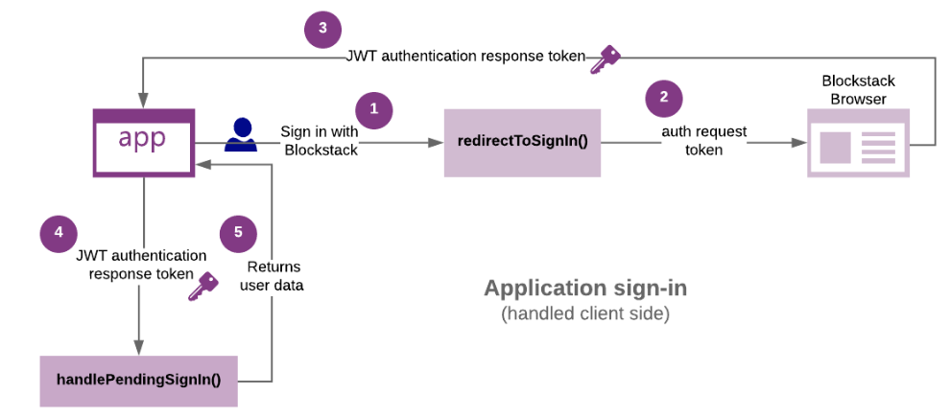

A decentralized application (DApp) and the Blockstack Browser communicate during the authentication flow by passing back and forth two tokens. The requesting application sends the Blockstack Browser an authRequest token. Once a user approves a sign-in, the Blockstack Browser responds to the application with an authResponse token. These tokens are [JSON Web Tokens](https://jwt.io/), and they are passed via URL query strings.

When a user chooses to “Sign in with Blockstack” on your DApp, the redirectToSignIn()method sends the user to the Blockstack Browser. The browser responds with an authentication token and an app private key.

The app private key is application-specific. It is generated from the user’s identity address private key using the appDomain as input. This key is deterministic, meaning that for a given Blockstack ID and domain name, the same private key is generated each time. The app private key is securely shared with the app on each authentication and encrypted by the Blockstack Browser. The key serves three functions, it:

* is used to create the credentials that give an app access to the Gaia hub storage bucket for that specific app
* is used in the end-to-end encryption of files stored for the app on the user’s Gaia hub
* serves as a cryptographic secret that apps can use to perform other cryptographic functions

4. Storing data in gaia storage.

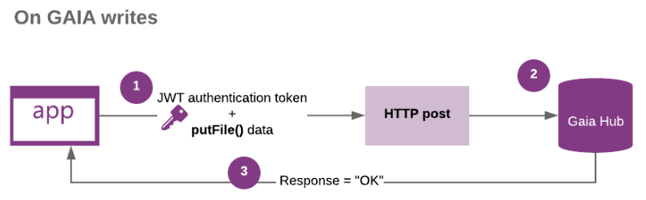

When an application writes to a Gaia hub, the authentication token, key, and the data are passed to the Gaia hub. The token ensures the DApp has the authorization to write to the hub on the user’s behalf.

5. Reference links.

<https://docs.blockstack.org/org/overview.html>

<https://docs.blockstack.org/browser/hello-blockstack.html> - Hello Blockstack tutorial.

<https://docs.blockstack.org/core/smart/overview.html> - Clarity.

<https://docs.blockstack.org/storage/overview.html> - Gaia Storage.

<https://blockstack.github.io/blockstack.js/> - blockstack.js library.

<https://blockstack.org/whitepaper.pdf> - blockstack whitepaper.

<https://docs.blockstack.org/faqs/allfaqs> - blockstack FAQ.

<https://docs.blockstack.org/develop/zero_to_dapp_1.html> - Zero to DApp.

<https://docs.blockstack.org/develop/add_auth.html> - Auth implementation link.

<https://docs.blockstack.org/develop/storage.html> - Storage implementation link.

<https://docs.blockstack.org/core/naming/introduction.html> - blockstack core.

<https://community.blockstack.org/slack> - blockstack slack link.

<https://github.com/BlockSurvey/blockstack-angular> - blocksurvey github link.

Videos:

<https://www.youtube.com/watch?v=7SmC7AuZNWY> - Blockstack - A New Internet for Decentralized Apps

# <https://www.youtube.com/watch?v=g84M_5KruZ4> - What are some specific apps you could build on Blockstack?

# <https://www.youtube.com/watch?v=uhsr9HtwmxU> - How was Blockstack built for scalability?

# <https://www.youtube.com/watch?v=cXNhwFXwmR8> - What are general misconceptions about blockchain use cases?