Daniel Wong

BMI203 HW#1

The following figures have the x-axis as the list length, and the y-axis as the average value of either number of conditionals (figure 1) or number of assignments (figure 2). Each average is derived from 100 iterations of the sorting method with 100 randomly generated lists. Reference lines of N^2 and 15Nln(N) are shown as well, with N being the x value.

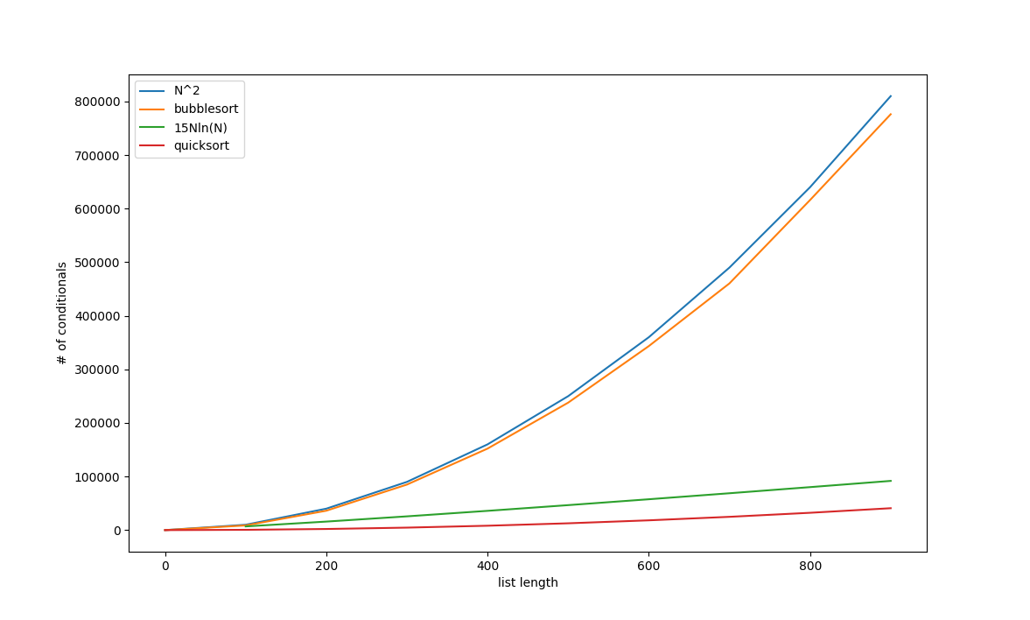

figure 1: Number of Assignments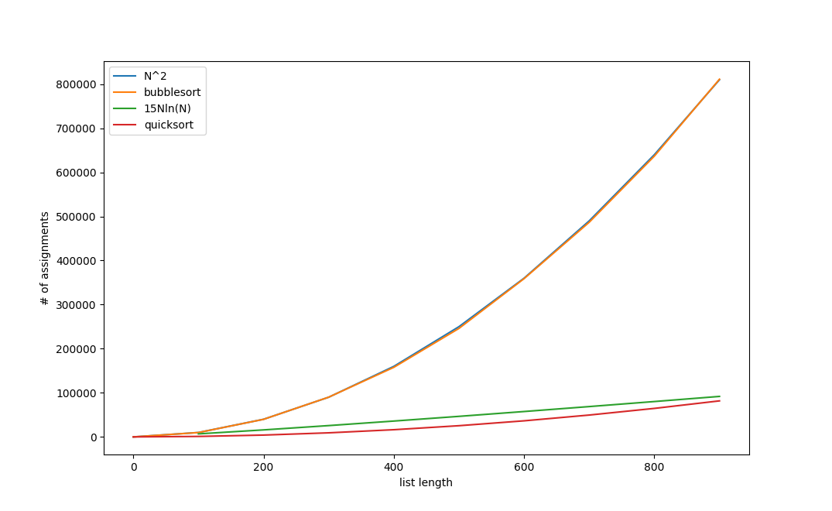

figure 2: Number of Conditionals

Definition: O(f) is the set of all functions g from N to R such that there exists a real number c > 0, and there exists an n_0 in N, such that g(n) <= c*f(n) whenever n >= n_0.

Suppose f(n) = n^2, g(n) = # of conditionals as a function of list length n when performing bubblesort

x(n) = nln(n), y(n) = # of conditionals as a function of list length n when performing quicksort

Bubblesort:

The average complexity of O(n^2) is as expected. This is clearly shown by figure 1 above. By the definition of big O, bubblesort is in O(N^2) because each bubblesort value is always less than or equal to the N^2 curve value. i.e. g(n) <= c*f(n) for c = 1. Note that we need to only find a single c value that will allow for the inequality to hold for the definition of big O. c = 1 is sufficient. In figure 2, which displays conditionals instead, we see that the two curves are about equal. Equality also satisfies the big O inequality. Choose n_0 to be 0 since this is within the range of possible values that we are evaluating. n >= n_0 will always hold since all of the list lengths are either positive or 0.

Quicksort:

Same argument follows as the bubblesort argument. y(n) <= c* x(n) for c = 15. Since we only need any real number c for the inequality to hold, and c = 15 works, we know that quicksort is in O(nln(n)).

Gitrepo:

<https://github.com/wongdaniel8/example>