**Intel® Intelligent Systems Centers of Excellence (CoE), HPC Artificial Intelligence and Edge Computing**

**School of Computing Science and Engineering**

**Galgotias University**

**Intel College Excellence Program   
Project Synopsis**

**Phase -2**

**“OWL AI-Business ESG Data Analyst”**

|  |  |  |  |
| --- | --- | --- | --- |
| **Team member’s detail** | | | |
| **S.No.** | **Participant Name** | **Mobile No.** | **Email ID** |
| 1 | Pritish Sinha | 9315740160 | p[ritish.20scse1010033@galgotiasuniversity.edu.in](mailto:Pritish.20scse1010033@galgotiasuniversity.edu.in) |
| 2 | Khushi | 7439707958 | k[hushi.20scse1010286@glagotiasuniversity.edu.in](mailto:Khushi.20scse1010286@glagotiasuniversity.edu.in) |
| 3 | Siddhant Jain | 8802854517 | siddhant.20scse1010186@galgotiasuniversity.edu.in |
| **Faculty(college) mentor detail** | | | |
| **S.No.** | **Mentor Name** | **Mobile No.** | **Email ID** |
| 1 | Ms. Vijaya Choudhary | 8377898095 | vijaya.choudhary@galotiasuniversity.edu.in |
| **College/University Name** | | | |
| Galgotias University, Gr.Noida | | | |

**BACKGROUND**

The world of finance has gained popularity through investing in Environmental, Social and Governance (ESG).[3]

We need to invest more in companies that are sustainable particularly in the 3 ESG categories

Environmental – Problems such as climate change and pollution

Social- Problems around worksites and human capital

Governance – Issues such as executive pay, accounting and ethics

**PROBLEM IDENTIFICATION**

Sustainable investment is investing in companies with more ESG scores and have good fiscal records according to rules and regulation amends by government and united nation sustainable development guidelines. Current approach for this analysis is setting up a network of 200+ business researchers and data analysts that source up whole data manually and setting scores according to Harvard Law School forum.

[4]This process involves 3 human interaction with data and complete process is manual. [2]Analyst company takes contracts from investing party, a researcher deals with fiscal data that target company has already documented on it’s official site according to guidelines. Then this researcher has to fill factset data after evaluating records. A factset is sheet with info to be filled about company regarding it’s environmental, social and governance protocols which is in le mans term data of electricity, water consumption, pollution created , rights and regulation etc. Then QC gives feedback of this factset and sent for final evaluation by master QC, i.e total estimated time for completion is 30+ on each setup.

**PROPOSED SOLUTION**

Our approach is to automate this whole process There are many sources like GDelt news air that reports business data into 3 ESG categories that we talked about before, moreover Twitter and other digital publications can be leveraged for this. Deep learning algorithm like Node2vec, Naïve Bays can be used for sentiment analysis of these data to do ESG scoring. We have used basic python applications to provide best service in data visualization as manual data visualization can always turn down to a understandable level for investor. Additionally Urllib3 data scrapper from site targets Annual reports and Sustainability reports. This data is ready to filled in expected template for analysis via Google Smart Auto Add-on. Current aim is to implement this model and create an user friendly UI where investor can select any companies they want to invest in and get there requirements fulfilled with just few clicks.

**LITERATURE SURVEY**

**Background Survey**

ESG score is just a numerical measure of performance of an entity on basis of environmental, social and governance (ESG) topics.Nowadays there’s been rapid rise in ESG investing with investors demanding portfolios with sustainable assets. ESG scores are now identity of these companies now and good ratings means healthy profit.An ESG scoring system evaluates millions of public data such as news, articles, blogs, prints and social media content on real time basis. Scope is also extended to National reporting system and NGO communications. SASB is accounting standards for metrics and fiscal policy modelers.

[8]Fiscal policy are government issued tax rates and regulation that moderates nation’s economy. Mainly capital share data handled by central bank, these policies are of two types that combine to direct country’s economy goals.

Fiscalisation refers to fiscal law[7], which aims to prevent retailer fraud. It ensures that VAT transactions are reported and paid correctly to the authorities. Fiscal law can vary greatly between countries that have adopted fiscalisation, so for retailers operating internationally, it can be extremely challenging, expensive and time consuming to ensure compliance.

**Research Survey**

We have done following surveys on existing models and research materials for ESG Sentiment Analysis through Google Scholarly and cited below in references.

# Socially Responsible Investing: Combining ESG Ratings with News Sentiment Generates Alpha[9]

ESG ratings as a downside screener for equities can be significantly improved when combined with sentiment indicators from news and social media. The performance and downside protection of ESG-screened portfolios can be enhanced by adding a sentiment overlay. Price response to negative ESG-related events results ina fast impulse signal followed by a slow reversal signal. Double overlays of broad emotions and ESG reversal signals improve alpha generation by up to 300 basis points and reduce maximum drawdown by half compared to random market portfolios.

**The role of AI (Artificial Intelligence) and ML (Machine learning) in ESG rating of Private and Commercial Sectors[10]**

Artificial intelligence is growing day by day and it is taking root in our daily life. The growth has been started and growing even faster in the last decades of evolution and improvement. The improvement in last decades in the emergence of AI has a major impact on numerous sectors that affect achieving the SDG goals. . The paper emphasizes that AI needs support from many organizations and regulators for AI-based technologies,Otherwise there may be gaps in transparency, ethical standards and security. Building-related AI applications include energy-efficient building designs and strategies to mitigate environmental and climate impacts. In addition, new computer code and algorithms for data mining and analysis are being developed daily. This paper begins with the history and techniques of AI and machine learning, and the role of AI and machine learning in ESG Rating.

# Artificial Intelligence and FinTech Technologies for ESG Data and Analysis[11]

ESG screening and analysis solutions that leverage artificial intelligence (AI) and FinTech can address ESG information bias and potentially ESG rating differences resulting from corporate self-reporting and annualized retrospective results. It became a "strategic enabler" report result information.

Gathering alternative data using machine learning and NLP technology is the key to getting real-time ESG information for "black box" companies and can provide a meaningful approach to managing ESG complexity. increase. This paper discusses the impact of regulations and industry expectations related to managing ESG data and frameworks, as well as AI-powered solutions to better manage and coordinate ESG information sources for publisher and dispute screening.

**PROJECT PLAN**

This project is broken down into 3 phases

**Planning + Project Building + Research**

**Phase I**

This projects aims for making an user friendly web application for investor for ESG scoring and automated fiscal data extraction of various available companies.

Along with data collection for ESG categorization model and ESG scoring model we need various sandbox API keys for real time news and data extraction from sources. Sandbox environment plays an important role in data availability and data latency so a good research on various available environment is needed.

**Phase II**

Working project is divided into 5 levels

* ESG miner
* Data download application
* Data plot and visualizer
* Fiscal auto-fill
* Web application

Data download application: that gets the most recent news articles about a company.

ESG miner: categorize data into ‘E’ , ‘S’ and ‘G’ categories and applies sentiment analysis to mine for an ESG score when given a ticker.

Data plot and visualizer: plots all data on selected type of visualization

Fiscal auto-fill: Fiscal data extracted by downloader is filled in offered factset template.

Web application: This is final build with all above apps integrated and allows user to use our innovation at full scale smoothly.

**Phase III**

Secondary objective of our project is a successful publication of research on our ESG miner algorithm. An automated ESG categorization model uses machine learning and NLP technology data harness data of companies and categorizes each data into ‘E’ , ‘S’ and ‘G’ categories and applies sentiment analysis it. According to various case studies not many such algorithm exists and our ML approach not yet implemented.

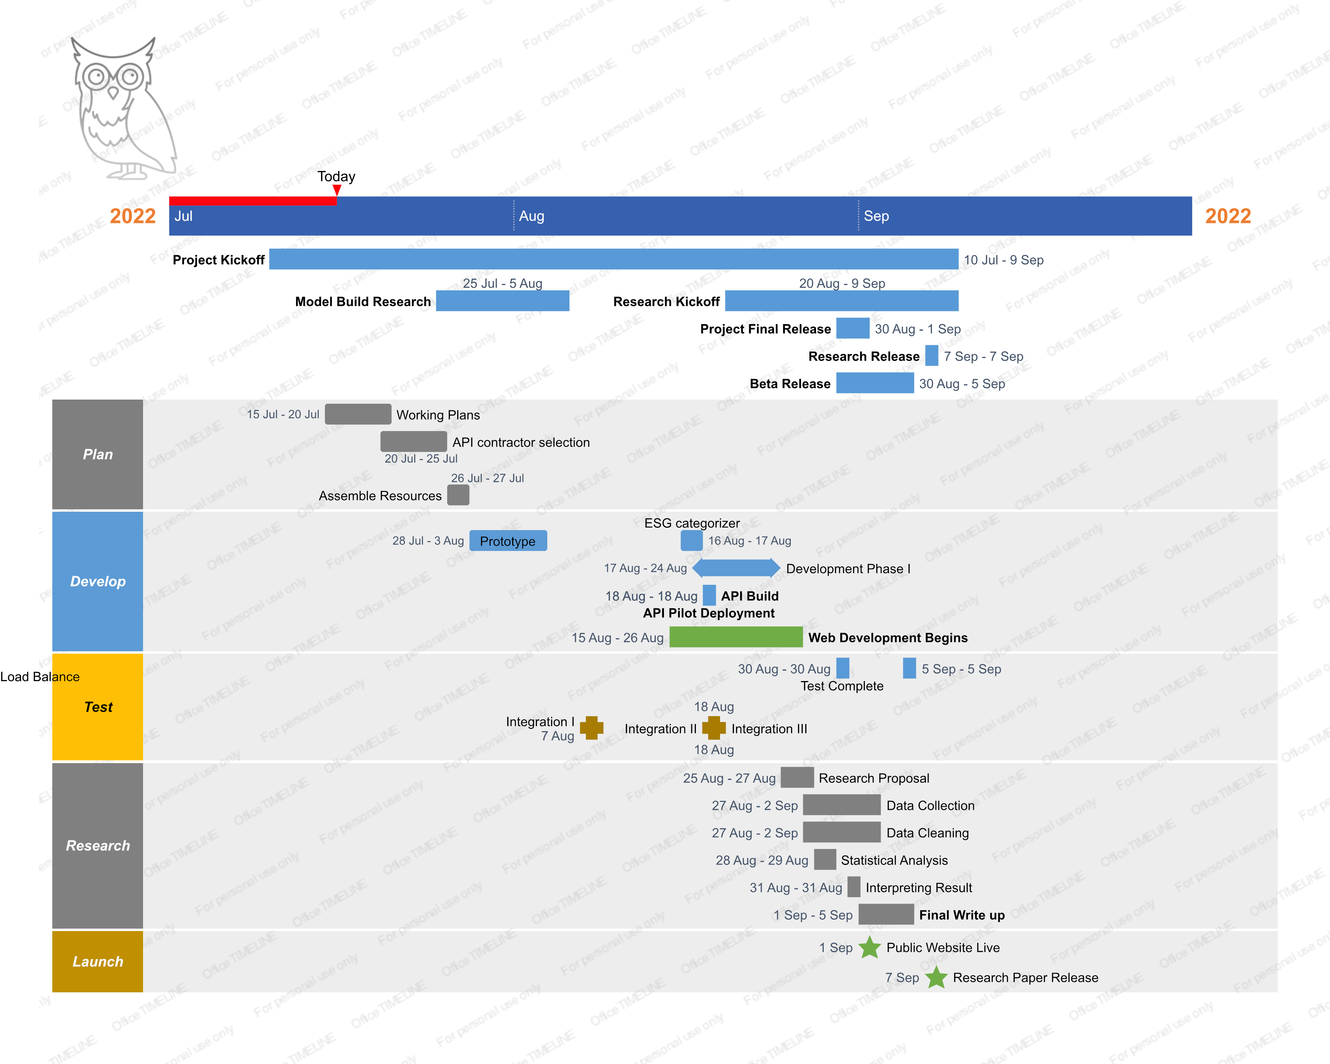

**NOVELTY**

According to above literature survey as ESG categorization and it’s sentiment analysis is still an unexplored area this project not only helps in feedback information of a setup but cutting 30+ hr workload to only few minutes or two.

Many sentimental analysis models exists even regarding ESG categorization but a complete automated ESG feedback option is new in market along with which we are supporting multiple option for data visualization according to investor needs in robust manner and auto feeder implementation for factset is complete new innovation.

**HARDWARE & SOFTWARE REQUIREMENTS**

**Hardware**

* Memory (RAM): 4 GB or more
* Size/Storage: ~Arguable

**Libraries/Models**

* Streamlit
* Python
* Pyspark
* DataBricks
* NetworkX
* Pytorch
* URllib3
* Google Smart Auto Add-on

**Dataset**

* https://github.com/Pritish-Sinha/Owl_AI/tree/main/dataset/data

**Model Training**

* Naïve Bayes
* OneR
* Node2vec[word2vec]

**REFERENCES**

**Github Publication**

https://github.com/Pritish-Sinha/Owl_AI

**Biblography**

1. Coskun, Y. (2022). The role of AI (Artificial Intelligence) and ML (Machine learning) in ESG rating of Private and Commercial Sectors.
2. Artificial intelligence bridges the gap between big data and sustainable investing. (2021). Vlerick Business School.
3. United Nations Economic and Social Council. Sustainable Development (United Nations Economic and Social Council, 2019).
4. Türegün, N. 2019. ―Impact of Technology in Financial Reporting: The Case of Amazon Go.‖ Journal of Corporate Accounting & Finance 30 (3): 90–95.
5. Nishant, R., M. Kennedy, and J. Corbett. 2020. ―Artificial Intelligence for Sustainability: Challenges, Opportunities, and a Research Agenda.‖ International Journal of Information Management 53: 102104.
6. Armando Marozzi and Filippo Lanza 2020. Modelling ESG with Twitter Data Knowsis: From Text to Signal
7. Eurostop- What is Fiscalisation & How Can it Affect Your Business
8. LESLIE KRAMER:Updated April 26, 2021- What Is Fiscal Policy
9. Hafez, P., & Gomez, F. (2019). Socially Responsible Investing: Combining ESG Ratings with News Sentiment Generates Alpha.
10. Coskun, Y. (2022). The role of AI (Artificial Intelligence) and ML (Machine learning) in ESG rating of Private and Commercial Sectors.
11. Macpherson, M., Gasperini, A., & Bosco, M. (2021). Artificial Intelligence and FinTech Technologies for ESG Data and Analysis. *Available at SSRN 3790774*.