Report, Data Quality Control

ContDataQC

Erik.Leppo

2021-04-08 14:34:21

Table of Contents

# DATA FILE INFORMATION

**Report Date:** 2021-04-08

**Generated By:** Erik.Leppo

**Filename:** QC_ECO66E09_AW_20160720_20160920.csv

**SiteID:** ECO66E09

**Period of Record, Requested:** NA

**Period of Record, Actual:**2016-07-20 to 2016-09-20

**Recording Interval:** 10 minutes

**Data Type:** NA

**Parameters Included:** Water.Temp.C, Air.Temp.C, Air.BP.psi, Water.P.psi, Sensor.Depth.ft,

# DATA SUMMARY, OVERALL

Estimated number of records per day is 144.

Number of records by year and month (with totals).

|  |  |  |  |  |
| --- | --- | --- | --- | --- |
|  | 7 | 8 | 9 | Sum |
| 2016 | 1115 | 2976 | 1859 | 5950 |
| Sum | 1115 | 2976 | 1859 | 5950 |

Number of records by day and month (with totals).

|  |  |  |  |  |
| --- | --- | --- | --- | --- |
|  | 7 | 8 | 9 | Sum |
| 1 | 0 | 96 | 96 | 192 |
| 2 | 0 | 96 | 96 | 192 |
| 3 | 0 | 96 | 96 | 192 |
| 4 | 0 | 96 | 96 | 192 |
| 5 | 0 | 96 | 96 | 192 |
| 6 | 0 | 96 | 96 | 192 |
| 7 | 0 | 96 | 96 | 192 |
| 8 | 0 | 96 | 97 | 193 |
| 9 | 0 | 96 | 96 | 192 |
| 10 | 0 | 96 | 96 | 192 |
| 11 | 0 | 96 | 96 | 192 |
| 12 | 0 | 96 | 96 | 192 |
| 13 | 0 | 96 | 96 | 192 |
| 14 | 0 | 96 | 96 | 192 |
| 15 | 0 | 96 | 96 | 192 |
| 16 | 0 | 96 | 96 | 192 |
| 17 | 0 | 96 | 96 | 192 |
| 18 | 0 | 96 | 96 | 192 |
| 19 | 0 | 96 | 96 | 192 |
| 20 | 59 | 96 | 34 | 189 |
| 21 | 96 | 96 | 0 | 192 |
| 22 | 96 | 96 | 0 | 192 |
| 23 | 96 | 96 | 0 | 192 |
| 24 | 96 | 96 | 0 | 192 |
| 25 | 96 | 96 | 0 | 192 |
| 26 | 96 | 96 | 0 | 192 |
| 27 | 96 | 96 | 0 | 192 |
| 28 | 96 | 96 | 0 | 192 |
| 29 | 96 | 96 | 0 | 192 |
| 30 | 96 | 96 | 0 | 192 |
| 31 | 96 | 96 | 0 | 192 |
| Sum | 1115 | 2976 | 1859 | 5950 |

Below are the dates with missing data between the min (2016-07-20) and max(2016-09-20 for the provided data. There are 0 records.

[1] ""

# FLAGS

Each data point is checked by each of the four QC tests below.

* **Gross Range Test (Gross):** Test if data point exceeds sensor or user defined min/max. The values are user defined based on parameter being measured and measuring instrument.
* **Spike Test (Spike):** Test if data point exceeds a user defined threshold relative to the previous data point. The user defined values are based on the parameter being measured.
* **Rate of Change Test (RoC):** Test if a data point exceeds a number of standard deviations from the previous data points over a user defined time period. Default is a 25 hour time period and 3 standard deviations.
* **Flat Line Test (Flat):** Test if a data point is within a user defined threshold from previous data points over a user defined range. Default is 3 previous points for suspect and 5 points for failure. The threshold is user defined and based on the measured parameter and sensitivity of the measuring instrument.

Flags are assigned to each data point (a single measured parameter at a unique point in time) first by each of the QC tests below. Flags are assigned numerical values;

* **P** = Pass,
* **S** = Suspect,
* **F** = Fail,
* **X** = No Data or Not Applicable (NA).

Overall flags are assigned by examining the results of the four tests below.

* **P** = no Fail or Suspect and at least one Pass,
* **S** = no Fail and at least one Suspect,
* **F** = at least one Fail,
* **X** = all tests were Missing Data.

The thresholds used in the tests are defined in the config file and are listed below.

Thresholds, Quick Reference

|  |  |  |  |  |  |
| --- | --- | --- | --- | --- | --- |
| Analyte | Flag | Gross | Spike | Rate of Change | Flat Line |
| Temperature, Water (deg C) | Fail | > 30 deg C or < -2 deg C | >= 1.5 deg C (+/-) | NA | > 30 consecutive measurements within 0.01 units of one another |
| Temperature, Water (deg C) | Suspect | > 25 deg C or < -0.1 deg C | >= 1 deg C (+/-) | >= 3 standard deviations within 25 hours | > 20 consecutive measurements within 0.01 units of one another |
| Temperature, Air (deg C) | Fail | > 38 deg C or < -25 deg C | >= 10 deg C (+/-) | NA | > 20 consecutive measurements within 0.01 units of one another |
| Temperature, Air (deg C) | Suspect | > 35 deg C or < -23 deg C | >= 8 deg C (+/-) | >= 3 standard deviations within 25 hours | > 15 consecutive measurements within 0.01 units of one another |
| Pressure, Water (psi) | Fail | > 17 psi or < 13 psi | >= 0.7 psi (+/-) | NA | > 15 consecutive measurements within 0.001 units of one another |
| Pressure, Water (psi) | Suspect | > 16.8 psi or < 13.5 psi | >= 0.5 psi (+/-) | >= 3 standard deviations within 25 hours | > 10 consecutive measurements within 0.001 units of one another |
| Barometric Pressure, Air (psi) | Fail | > 15 psi or < 13 psi | >= 0.25 psi (+/-) | NA | > 15 consecutive measurements within 0.001 units of one another |
| Barometric Pressure, Air (psi) | Suspect | > 14.8 psi or < 13 psi | >= 0.15 psi (+/-) | >= 3 standard deviations within 25 hours | > 10 consecutive measurements within 0.001 units of one another |
| Sensor Depth (ft) | Fail | > 1e+05 ft or < -1 ft | >= 10000 ft (+/-) | NA | > 60 consecutive measurements within 0 units of one another |
| Sensor Depth (ft) | Suspect | > 1000 ft or < 0 ft | >= 1000 ft (+/-) | >= 3 standard deviations within 25 hours | > 20 consecutive measurements within 0 units of one another |

Overall flags by parameter

## Water.Temp.C

|  |  |  |  |
| --- | --- | --- | --- |
| F | P | S | Sum |
| 3 | 2961 | 11 | 2975 |

## Air.Temp.C

|  |  |
| --- | --- |
| P | Sum |
| 2395 | 2395 |

## Air.BP.psi

|  |  |
| --- | --- |
| P | Sum |
| 2395 | 2395 |

## Water.P.psi

|  |  |  |
| --- | --- | --- |
| P | S | Sum |
| 2967 | 8 | 2975 |

## Sensor.Depth.ft

|  |  |  |
| --- | --- | --- |
| P | S | Sum |
| 2958 | 15 | 2973 |

# QC TESTS, BY PARAMETER

## QC TESTS, Water.Temp.C

### Flags

#### Flag summary, overall number of records.

|  |  |  |  |
| --- | --- | --- | --- |
| F | P | S | Sum |
| 3 | 2961 | 11 | 2975 |

Estimated number of records per day is 144.

Number of records by year and month (with totals)

|  |  |  |  |  |
| --- | --- | --- | --- | --- |
|  | 7 | 8 | 9 | Sum |
| 2016 | 1115 | 2976 | 1859 | 5950 |
| Sum | 1115 | 2976 | 1859 | 5950 |

Number of records by day and month (with totals)

|  |  |  |  |  |
| --- | --- | --- | --- | --- |
|  | 7 | 8 | 9 | Sum |
| 1 | 0 | 96 | 96 | 192 |
| 2 | 0 | 96 | 96 | 192 |
| 3 | 0 | 96 | 96 | 192 |
| 4 | 0 | 96 | 96 | 192 |
| 5 | 0 | 96 | 96 | 192 |
| 6 | 0 | 96 | 96 | 192 |
| 7 | 0 | 96 | 96 | 192 |
| 8 | 0 | 96 | 97 | 193 |
| 9 | 0 | 96 | 96 | 192 |
| 10 | 0 | 96 | 96 | 192 |
| 11 | 0 | 96 | 96 | 192 |
| 12 | 0 | 96 | 96 | 192 |
| 13 | 0 | 96 | 96 | 192 |
| 14 | 0 | 96 | 96 | 192 |
| 15 | 0 | 96 | 96 | 192 |
| 16 | 0 | 96 | 96 | 192 |
| 17 | 0 | 96 | 96 | 192 |
| 18 | 0 | 96 | 96 | 192 |
| 19 | 0 | 96 | 96 | 192 |
| 20 | 59 | 96 | 34 | 189 |
| 21 | 96 | 96 | 0 | 192 |
| 22 | 96 | 96 | 0 | 192 |
| 23 | 96 | 96 | 0 | 192 |
| 24 | 96 | 96 | 0 | 192 |
| 25 | 96 | 96 | 0 | 192 |
| 26 | 96 | 96 | 0 | 192 |
| 27 | 96 | 96 | 0 | 192 |
| 28 | 96 | 96 | 0 | 192 |
| 29 | 96 | 96 | 0 | 192 |
| 30 | 96 | 96 | 0 | 192 |
| 31 | 96 | 96 | 0 | 192 |
| Sum | 1115 | 2976 | 1859 | 5950 |

#### Flags by QC Test

##### Flags, Gross

|  |  |  |
| --- | --- | --- |
| P | S | Sum |
| 2964 | 11 | 2975 |

##### Flags, Spike

|  |  |  |  |
| --- | --- | --- | --- |
| F | P | X | Sum |
| 3 | 2971 | 1 | 2975 |

##### Flags, RoC

|  |  |  |
| --- | --- | --- |
| P | X | Sum |
| 2974 | 1 | 2975 |

##### Flags, Flat

|  |  |
| --- | --- |
| P | Sum |
| 2975 | 2975 |

QC Test Flag fields are saved in the data file so the user can identify data points that have been flagged as suspect or fail.

Test results marked as X (No/Missing Data) if unable to calculate the end point needed for the test. For example, the first record does not have a previous record for comparison for the Gross QC Test. QC Test flags are saved in the data file.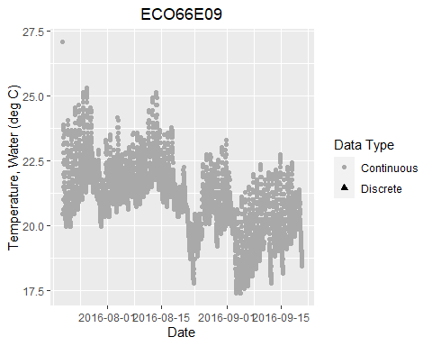

## QC TESTS, Air.Temp.C

### Flags

#### Flag summary, overall number of records.

|  |  |
| --- | --- |
| P | Sum |
| 2395 | 2395 |

Estimated number of records per day is 144.

Number of records by year and month (with totals)

|  |  |  |  |  |
| --- | --- | --- | --- | --- |
|  | 7 | 8 | 9 | Sum |
| 2016 | 1115 | 2976 | 1859 | 5950 |
| Sum | 1115 | 2976 | 1859 | 5950 |

Number of records by day and month (with totals)

|  |  |  |  |  |
| --- | --- | --- | --- | --- |
|  | 7 | 8 | 9 | Sum |
| 1 | 0 | 96 | 96 | 192 |
| 2 | 0 | 96 | 96 | 192 |
| 3 | 0 | 96 | 96 | 192 |
| 4 | 0 | 96 | 96 | 192 |
| 5 | 0 | 96 | 96 | 192 |
| 6 | 0 | 96 | 96 | 192 |
| 7 | 0 | 96 | 96 | 192 |
| 8 | 0 | 96 | 97 | 193 |
| 9 | 0 | 96 | 96 | 192 |
| 10 | 0 | 96 | 96 | 192 |
| 11 | 0 | 96 | 96 | 192 |
| 12 | 0 | 96 | 96 | 192 |
| 13 | 0 | 96 | 96 | 192 |
| 14 | 0 | 96 | 96 | 192 |
| 15 | 0 | 96 | 96 | 192 |
| 16 | 0 | 96 | 96 | 192 |
| 17 | 0 | 96 | 96 | 192 |
| 18 | 0 | 96 | 96 | 192 |
| 19 | 0 | 96 | 96 | 192 |
| 20 | 59 | 96 | 34 | 189 |
| 21 | 96 | 96 | 0 | 192 |
| 22 | 96 | 96 | 0 | 192 |
| 23 | 96 | 96 | 0 | 192 |
| 24 | 96 | 96 | 0 | 192 |
| 25 | 96 | 96 | 0 | 192 |
| 26 | 96 | 96 | 0 | 192 |
| 27 | 96 | 96 | 0 | 192 |
| 28 | 96 | 96 | 0 | 192 |
| 29 | 96 | 96 | 0 | 192 |
| 30 | 96 | 96 | 0 | 192 |
| 31 | 96 | 96 | 0 | 192 |
| Sum | 1115 | 2976 | 1859 | 5950 |

#### Flags by QC Test

##### Flags, Gross

|  |  |
| --- | --- |
| P | Sum |
| 2395 | 2395 |

##### Flags, Spike

|  |  |  |
| --- | --- | --- |
| P | X | Sum |
| 2394 | 1 | 2395 |

##### Flags, RoC

|  |  |  |
| --- | --- | --- |
| P | X | Sum |
| 2394 | 1 | 2395 |

##### Flags, Flat

|  |  |
| --- | --- |
| P | Sum |
| 2395 | 2395 |

QC Test Flag fields are saved in the data file so the user can identify data points that have been flagged as suspect or fail.

Test results marked as X (No/Missing Data) if unable to calculate the end point needed for the test. For example, the first record does not have a previous record for comparison for the Gross QC Test. QC Test flags are saved in the data file.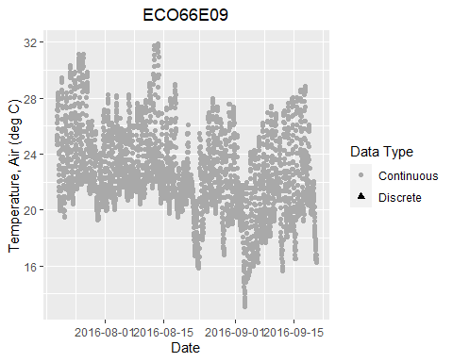

## QC TESTS, Air.BP.psi

### Flags

#### Flag summary, overall number of records.

|  |  |
| --- | --- |
| P | Sum |
| 2395 | 2395 |

Estimated number of records per day is 144.

Number of records by year and month (with totals)

|  |  |  |  |  |
| --- | --- | --- | --- | --- |
|  | 7 | 8 | 9 | Sum |
| 2016 | 1115 | 2976 | 1859 | 5950 |
| Sum | 1115 | 2976 | 1859 | 5950 |

Number of records by day and month (with totals)

|  |  |  |  |  |
| --- | --- | --- | --- | --- |
|  | 7 | 8 | 9 | Sum |
| 1 | 0 | 96 | 96 | 192 |
| 2 | 0 | 96 | 96 | 192 |
| 3 | 0 | 96 | 96 | 192 |
| 4 | 0 | 96 | 96 | 192 |
| 5 | 0 | 96 | 96 | 192 |
| 6 | 0 | 96 | 96 | 192 |
| 7 | 0 | 96 | 96 | 192 |
| 8 | 0 | 96 | 97 | 193 |
| 9 | 0 | 96 | 96 | 192 |
| 10 | 0 | 96 | 96 | 192 |
| 11 | 0 | 96 | 96 | 192 |
| 12 | 0 | 96 | 96 | 192 |
| 13 | 0 | 96 | 96 | 192 |
| 14 | 0 | 96 | 96 | 192 |
| 15 | 0 | 96 | 96 | 192 |
| 16 | 0 | 96 | 96 | 192 |
| 17 | 0 | 96 | 96 | 192 |
| 18 | 0 | 96 | 96 | 192 |
| 19 | 0 | 96 | 96 | 192 |
| 20 | 59 | 96 | 34 | 189 |
| 21 | 96 | 96 | 0 | 192 |
| 22 | 96 | 96 | 0 | 192 |
| 23 | 96 | 96 | 0 | 192 |
| 24 | 96 | 96 | 0 | 192 |
| 25 | 96 | 96 | 0 | 192 |
| 26 | 96 | 96 | 0 | 192 |
| 27 | 96 | 96 | 0 | 192 |
| 28 | 96 | 96 | 0 | 192 |
| 29 | 96 | 96 | 0 | 192 |
| 30 | 96 | 96 | 0 | 192 |
| 31 | 96 | 96 | 0 | 192 |
| Sum | 1115 | 2976 | 1859 | 5950 |

#### Flags by QC Test

##### Flags, Gross

|  |  |
| --- | --- |
| P | Sum |
| 2395 | 2395 |

##### Flags, Spike

|  |  |  |
| --- | --- | --- |
| P | X | Sum |
| 2394 | 1 | 2395 |

##### Flags, RoC

|  |  |  |
| --- | --- | --- |
| P | X | Sum |
| 2394 | 1 | 2395 |

##### Flags, Flat

|  |  |
| --- | --- |
| P | Sum |
| 2395 | 2395 |

QC Test Flag fields are saved in the data file so the user can identify data points that have been flagged as suspect or fail.

Test results marked as X (No/Missing Data) if unable to calculate the end point needed for the test. For example, the first record does not have a previous record for comparison for the Gross QC Test. QC Test flags are saved in the data file.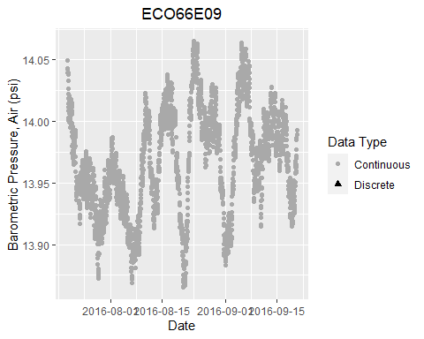

## QC TESTS, Water.P.psi

### Flags

#### Flag summary, overall number of records.

|  |  |  |
| --- | --- | --- |
| P | S | Sum |
| 2967 | 8 | 2975 |

Estimated number of records per day is 144.

Number of records by year and month (with totals)

|  |  |  |  |  |
| --- | --- | --- | --- | --- |
|  | 7 | 8 | 9 | Sum |
| 2016 | 1115 | 2976 | 1859 | 5950 |
| Sum | 1115 | 2976 | 1859 | 5950 |

Number of records by day and month (with totals)

|  |  |  |  |  |
| --- | --- | --- | --- | --- |
|  | 7 | 8 | 9 | Sum |
| 1 | 0 | 96 | 96 | 192 |
| 2 | 0 | 96 | 96 | 192 |
| 3 | 0 | 96 | 96 | 192 |
| 4 | 0 | 96 | 96 | 192 |
| 5 | 0 | 96 | 96 | 192 |
| 6 | 0 | 96 | 96 | 192 |
| 7 | 0 | 96 | 96 | 192 |
| 8 | 0 | 96 | 97 | 193 |
| 9 | 0 | 96 | 96 | 192 |
| 10 | 0 | 96 | 96 | 192 |
| 11 | 0 | 96 | 96 | 192 |
| 12 | 0 | 96 | 96 | 192 |
| 13 | 0 | 96 | 96 | 192 |
| 14 | 0 | 96 | 96 | 192 |
| 15 | 0 | 96 | 96 | 192 |
| 16 | 0 | 96 | 96 | 192 |
| 17 | 0 | 96 | 96 | 192 |
| 18 | 0 | 96 | 96 | 192 |
| 19 | 0 | 96 | 96 | 192 |
| 20 | 59 | 96 | 34 | 189 |
| 21 | 96 | 96 | 0 | 192 |
| 22 | 96 | 96 | 0 | 192 |
| 23 | 96 | 96 | 0 | 192 |
| 24 | 96 | 96 | 0 | 192 |
| 25 | 96 | 96 | 0 | 192 |
| 26 | 96 | 96 | 0 | 192 |
| 27 | 96 | 96 | 0 | 192 |
| 28 | 96 | 96 | 0 | 192 |
| 29 | 96 | 96 | 0 | 192 |
| 30 | 96 | 96 | 0 | 192 |
| 31 | 96 | 96 | 0 | 192 |
| Sum | 1115 | 2976 | 1859 | 5950 |

#### Flags by QC Test

##### Flags, Gross

|  |  |
| --- | --- |
| P | Sum |
| 2975 | 2975 |

##### Flags, Spike

|  |  |  |
| --- | --- | --- |
| P | X | Sum |
| 2974 | 1 | 2975 |

##### Flags, RoC

|  |  |  |  |
| --- | --- | --- | --- |
| P | S | X | Sum |
| 2966 | 8 | 1 | 2975 |

##### Flags, Flat

|  |  |
| --- | --- |
| P | Sum |
| 2975 | 2975 |

QC Test Flag fields are saved in the data file so the user can identify data points that have been flagged as suspect or fail.

Test results marked as X (No/Missing Data) if unable to calculate the end point needed for the test. For example, the first record does not have a previous record for comparison for the Gross QC Test. QC Test flags are saved in the data file.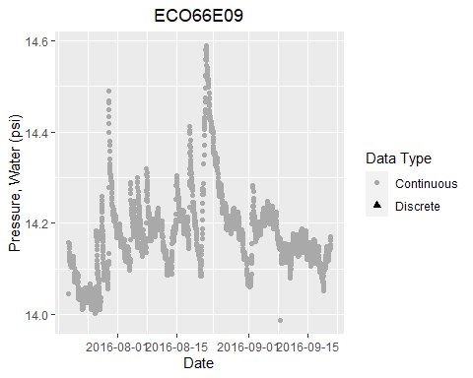

## QC TESTS, Sensor.Depth.ft

### Flags

#### Flag summary, overall number of records.

|  |  |  |
| --- | --- | --- |
| P | S | Sum |
| 2958 | 15 | 2973 |

Estimated number of records per day is 144.

Number of records by year and month (with totals)

|  |  |  |  |  |
| --- | --- | --- | --- | --- |
|  | 7 | 8 | 9 | Sum |
| 2016 | 1115 | 2976 | 1859 | 5950 |
| Sum | 1115 | 2976 | 1859 | 5950 |

Number of records by day and month (with totals)

|  |  |  |  |  |
| --- | --- | --- | --- | --- |
|  | 7 | 8 | 9 | Sum |
| 1 | 0 | 96 | 96 | 192 |
| 2 | 0 | 96 | 96 | 192 |
| 3 | 0 | 96 | 96 | 192 |
| 4 | 0 | 96 | 96 | 192 |
| 5 | 0 | 96 | 96 | 192 |
| 6 | 0 | 96 | 96 | 192 |
| 7 | 0 | 96 | 96 | 192 |
| 8 | 0 | 96 | 97 | 193 |
| 9 | 0 | 96 | 96 | 192 |
| 10 | 0 | 96 | 96 | 192 |
| 11 | 0 | 96 | 96 | 192 |
| 12 | 0 | 96 | 96 | 192 |
| 13 | 0 | 96 | 96 | 192 |
| 14 | 0 | 96 | 96 | 192 |
| 15 | 0 | 96 | 96 | 192 |
| 16 | 0 | 96 | 96 | 192 |
| 17 | 0 | 96 | 96 | 192 |
| 18 | 0 | 96 | 96 | 192 |
| 19 | 0 | 96 | 96 | 192 |
| 20 | 59 | 96 | 34 | 189 |
| 21 | 96 | 96 | 0 | 192 |
| 22 | 96 | 96 | 0 | 192 |
| 23 | 96 | 96 | 0 | 192 |
| 24 | 96 | 96 | 0 | 192 |
| 25 | 96 | 96 | 0 | 192 |
| 26 | 96 | 96 | 0 | 192 |
| 27 | 96 | 96 | 0 | 192 |
| 28 | 96 | 96 | 0 | 192 |
| 29 | 96 | 96 | 0 | 192 |
| 30 | 96 | 96 | 0 | 192 |
| 31 | 96 | 96 | 0 | 192 |
| Sum | 1115 | 2976 | 1859 | 5950 |

#### Flags by QC Test

##### Flags, Gross

|  |  |  |
| --- | --- | --- |
| P | S | Sum |
| 2972 | 1 | 2973 |

##### Flags, Spike

|  |  |  |
| --- | --- | --- |
| P | X | Sum |
| 2972 | 1 | 2973 |

##### Flags, RoC

|  |  |  |  |
| --- | --- | --- | --- |
| P | S | X | Sum |
| 2957 | 15 | 1 | 2973 |

##### Flags, Flat

|  |  |
| --- | --- |
| P | Sum |
| 2973 | 2973 |

QC Test Flag fields are saved in the data file so the user can identify data points that have been flagged as suspect or fail.

Test results marked as X (No/Missing Data) if unable to calculate the end point needed for the test. For example, the first record does not have a previous record for comparison for the Gross QC Test. QC Test flags are saved in the data file.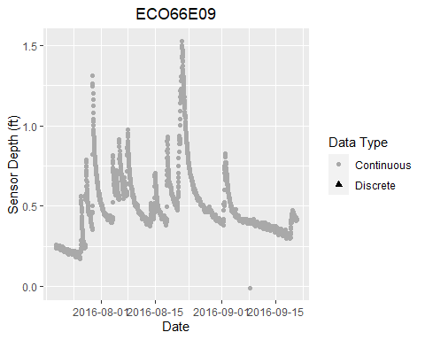

# PLOTS, MULTIPARAMETER

Multiparameter plots if exist in the data.

## PLOT, Temperature (Air vs. Water)

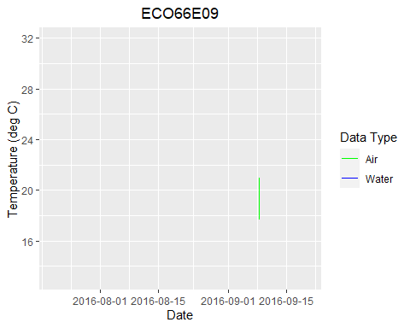

## PLOT, Sensor Depth vs. Water Temperature

