Report, Period Statistics

ContDataQC

2021-01-20 14:00:23

Table of Contents

# DATA FILE INFORMATION

**Report Date:** 2021-01-20

**Generated By:**

**Benchmark Date:** 2013-09-30

**Period (N, Units):** 30d, 60d, 90d, 120d, 1y

**Period Start Date:** 2013-09-01, 2013-08-02, 2013-07-03, 2013-06-03, 2012-10-01

**Minimum Date in File:** 2013-04-26

**Difference (Benchmark-Minimum Date):** 157

**Parameter(s):** Water.Temp.C, Sensor.Depth.ft

**Threshold:** 20

**QC Flag Failures Exclude:** FALSE

**Filename, Input:** DATA_period_test2_Aw_20130101_20141231.csv

# PLOTS

Mean daily values for requested date ranges with line for threshold (if provided).

## Water.Temp.C

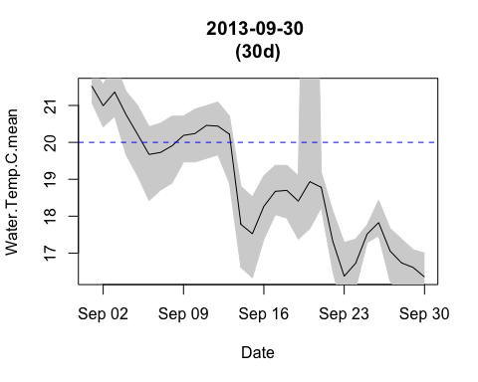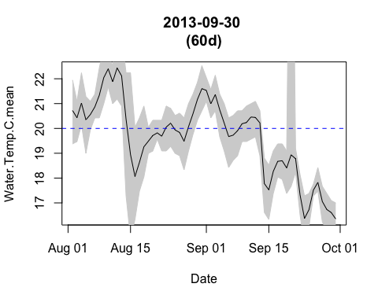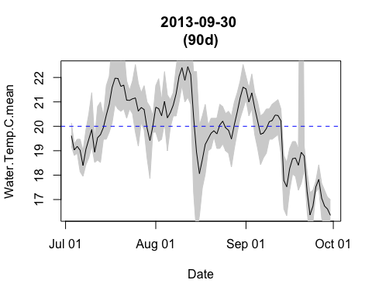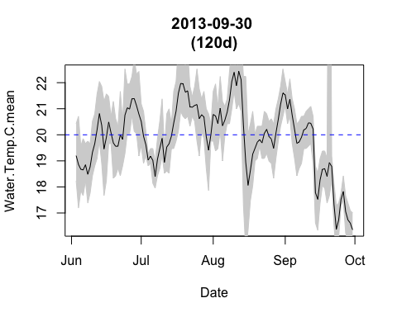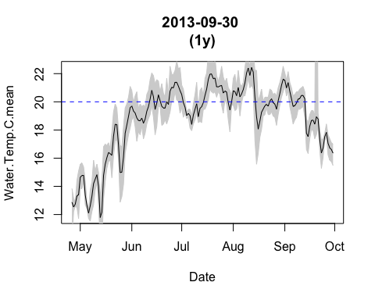

## Sensor.Depth.ft

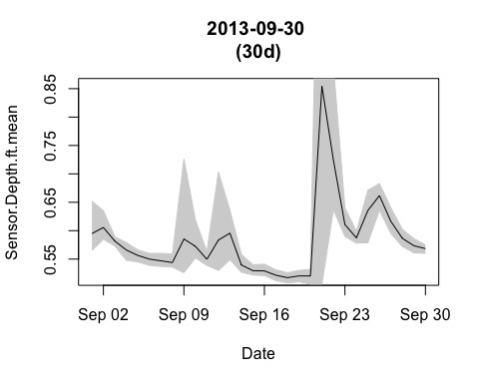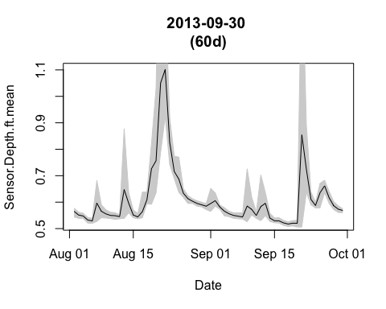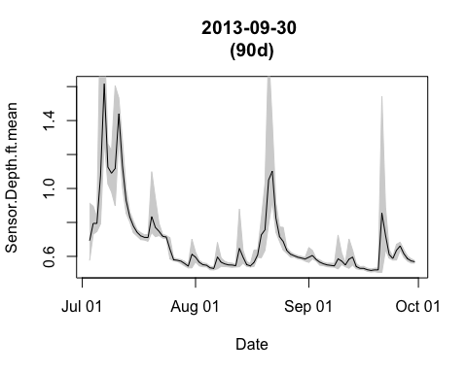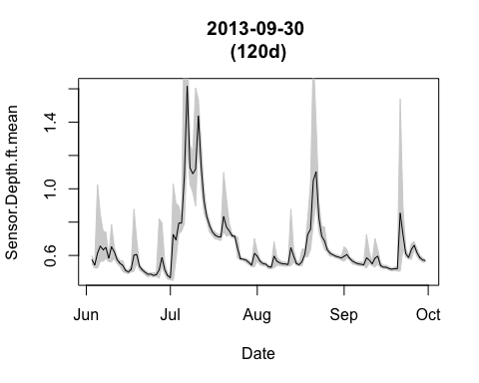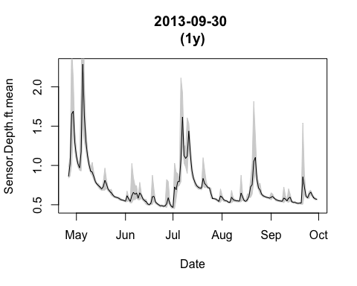

# PLOTS, MULTIPARAMETER

Multiparameter plots if exist in the data.

## Water.Temp.C and Sensor.Depth.ft

