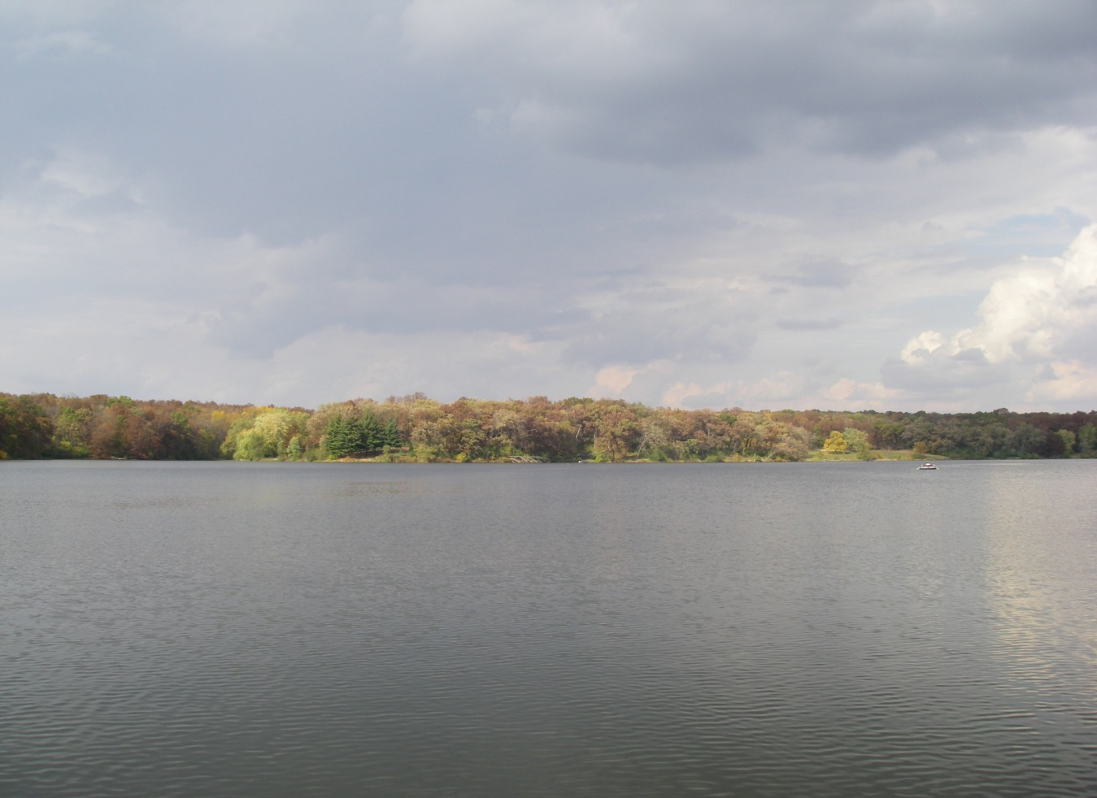

**Development of a**

**Multimetric Macroinvertebrate Index for Lakes in Illinois**

***Prepared for***

**U.S. Environmental Protection Agency**

**Region 5, Chicago, IL**

***and***

**Illinois Environmental Protection Agency**

**Bureau of Water, Springfield, IL**

***Prepared by***

**Ben Jessup, Jen Stamp, and Jeroen Gerritsen**

**Tetra Tech, Inc.**

**E:\CurrentData\Documents\TtOffice\Graphics\Ttlogo-blue-horizontal.tifOwings Mills, MD**

**December 17, 2015**

# Abstract:

In an effort to develop assessment tools for benthic macroinvertebrate conditions in lakes, the Illinois Environmental Protection Agency collected landscape information, physical habitat data and biological samples for 102 lakes throughout the state. A multimetric index was developed by defining a disturbance gradient among the lakes, identifying natural differences in lakes across the state, and combining metric scores for metrics that were responsive to disturbance after accounting for natural variation. Landscape information from a GIS analysis in lake catchments was the basis for defining reference sites, where intensive and proximate land uses indicated potential stress on the lake ecology. Habitat information was considered also, but because the habitat information was not available for all lakes, it was only used in secondary reference site criteria. Benthic macroinvertebrates were collected from 3 sites within each of five habitat types in each lake, providing composite samples for littoral fine substrates, littoral hard substrates, littoral macrophytes, sub-littoral zones and profundal zones. Sample metrics were calculated for a grand composite of all habitat types, all littoral types, and all non-littoral types. Metric sensitivity to stress was greatest when metrics were calculated from the littoral habitats. Three site classes were identified, based on multivariate differences in metrics among reference lakes. The classes corresponded to lake monitoring regions; Northern, Central, and Southern. A lake macroinvertebrate multimetric index was developed using five metrics covering sample richness, composition, feeding groups, habit, and pollution tolerance. The index correctly discriminated stressed sites in 79% of Northern lakes, 91% of Central lakes, and 86% of Southern lakes. The index was validated against Trophic State Index variables (phosphorus, Secchi depth, and chlorophyll a).

The cover photo of Pierce Lake was provided by Diane Tancl, IEPA.

Table of Contents

Abstract: i

List of Tables iv

List of Figures v

1 Introduction 1

Reference Conditions 1

Reference Identification Approach 3

2 Methods 5

Study area, design, and sites 5

Sampling and Processing 7

Habitat assessments 9

Lake Reference Designations 11

Site Classification 14

Metric Testing 14

Discrimination Efficiency (DE) and Z-score 16

Metric Scoring 17

Index Composition 18

3 Results 20

Reference Designations 20

Site Classification 20

Metric Sensitivity 24

Richness metrics 25

Composition Metrics 25

Feeding Group Metrics 25

Habit Metrics 25

Pollution tolerance 25

Index Synthesis 25

Index Validation 28

4 Discussion 32

Impairment thresholds for assessment 32

Index Application Guidelines 34

Data Preparation 35

Literature Cited 37

Appendix A. Generation of geospatial data for Illinois streams and lakes 1

Appendix B. Lake Reference Designations. 1

Appendix C. Metric Sensitivity. 1

Appendix D. Taxa attributes for calculating the lake macroinvertebrate index. 1

## List of Tables

Table 1. GIS variables analyzed within the lakes, catchments, and buffers. 6

Table 2. Water quality variables measured in each lake. 9

Table 3. Reference site criteria descriptions. 12

Table 4. Reference lake criteria. 13

Table 5. Codes and brief descriptions of the metrics calculated and tested during index development. 15

Table 6. Reference and stressed designations by monitoring unit. 20

Table 7. Correlation of variables with PCA Axes 1, 2, and 3. 22

Table 8. Spearman rank correlation coefficients for metrics with strong and consistent responses to stress. Absolute values greater than 0.75 are in bold type. 30

Table 9. The ten best-performing index alternatives, showing the metrics included in each alternative and performance statistics within the site classes. 31

Table 10. Index 1 error rates (% of lakes incorrectly assessed) associated with alternative assessment thresholds (10th, 25th, and 50th percentiles of reference data) in data sets defined by site class and reference designation. 34

Table 11. Potential index impairment thresholds based on distribution statistics of the reference sites. 34

Table 12. Metric scoring formulae. 36

## List of Figures

Figure 1. Locations of sampled lakes in Illinois, showing level 3 ecoregions. 5

Figure 2. Lake catchment and buffer configurations. 7

Figure 3. Thresholds used for identifying 5 reference categories across 6 ecoregions. 13

Figure 4. Box and whisker plot illustrating a metric that decreases with increasing stress and that has a DE slightly greater than 75%. 17

Figure 5. PCA diagram of reference and near reference lakes on first and second axis, showing vectors of metrics associated with the axes. 21

Figure 6. PCA diagram based on metrics in reference lakes in three monitoring units, showing latitude. 23

Figure 7. Distributions of selected metrics in reference (R) sites in the Northern (N), Central (C), and Southern (S) monitoring units. 24

Figure 8. Index 1 values by site class and reference status. Site classes are Northern (N), Central (C), and Southern (S). Reference status includes reference (R), other (O), and stressed (S). 27

Figure 9. Index 1 values in relation to nutrient indicators of the Trophic State Index. Phosphorus, Secchi depth, and chlorophyll a were rescaled to distributions within the data set. 29

# Introduction

A biological assessment is an evaluation of the biological condition of a water body using information on the structure and function of resident biological assemblages (USEPA 1998). The information is used to answer water quality management questions about condition, protection, and restoration (USEPA 2013). Over the past 40 years, states have independently developed technical approaches and indexes such as the Index of Biotic Integrity (IBI; Karr et al 1986) to assess biological condition and set designated aquatic life uses for their waters.

The Illinois Environmental Protection Agency (IEPA) has collected data from lakes statewide. Through the analysis described in this report, they have initiated development of a lake macroinvertebrate index for use in assessment programs. The Clean Water Act goal (Section 101) requires states to “restore and maintain the chemical, physical, and biological integrity of the Nation’s waters.” Currently, IEPA uses water chemistry and physical parameters for lake assessments. A biological index will provide a measure for determining biological integrity that can be used as a tool for assessing, managing, and protecting aquatic life uses in lakes.

A Multimetric Index, or MMI, is a numeric representation of biological or habitat conditions based on combined signals of many assemblage or physical measurements (Gerritsen 1995, Barbour et al. 1999). The process for index development included definition of site reference criteria, establishment of lake classes, calibration of multiple macroinvertebrate metrics to lake disturbance categories, and combination of the most responsive metrics in an index. Each measurement, or metric, is selected to be included in the index if it shows a consistent response along a known disturbance gradient. The combined index gives a reliable indication of biological integrity. In these analyses, the disturbance gradient is represented by reference and non-reference site designations. Responsiveness of metrics is evaluated within site classes.

## Reference Conditions

The basis for biological criteria in the United States is biological integrity, defined as “the capability of supporting and maintaining a balanced, integrated, adaptive community of organisms having a species composition, diversity, and functional organization comparable to that of natural habitats of the region” (Karr and Dudley 1981 after Frey 1977), and has been widely adopted by USEPA to be consistent with the purpose of the US Clean Water Act. The definition clearly relies on natural condition, and bioassessment is based on comparison of waterbodies to relatively natural reference conditions. Reference conditions are regional, based on populations of waterbodies, and take into account geographic classifications (e.g., ecoregions) and natural physical and chemical characteristics of waterbodies.

In order to develop a reference condition from a population of reference sites, it is necessary to specify criteria for the reference sites. Recognizing that many pristine sites no longer exist in some regions, Stoddard et al. (2006) proposed definitions for minimally disturbed condition (MDC = pristine), historic condition (HC), reference condition for biological integrity (RC(BI)), least disturbed condition (LDC = best available), and best attainable condition (BAC). Minimally disturbed (MDC) sites also qualify as RC(BI). In many regions, reference is based on Least Disturbed (LDC), which requires setting criteria for the LDC in terms of disturbance or measured stressors. An issue that is not often answered is whether LDC sites in heavily altered regions, which are used as the de facto reference, would qualify as having biological integrity as defined above. Historic condition (HC) may be based on observed biota rather than stressors (e.g., early naturalist/explorer descriptions, museum collections), and can be used to modify reference derived from LDC sites.

Most states currently have reference criteria based on land use/land cover, activities in the watershed, and some measured water quality (e.g., Pond et al. 2013). Single indexes of land use have been developed. For example, Florida currently uses the Landscape Development Index, a weighted average of land uses based on anthropogenic energy inputs (Fore et al. 2007; Brown and Vivas 2005). The land use/land cover criteria (whether single index or multiple measures) may be based on buffers around a stream or lake, or for the entire catchment of a sample point. Common categories of land uses that are summarized and used as criteria include forests, all natural cover, agriculture, and urban (including residential, commercial, industrial, and transportation).

In regions where nearly all natural waterbodies have been substantially altered, empirical reference criteria can only describe least disturbed (or the best available) sites, which may be substantially disturbed. If the reference site criteria are too stringent, there may be insufficient sites for a meaningful sample or for meaningful bioassessments. Relaxation of the reference criteria and use of the best available reference condition allows calibration of an index to a disturbance gradient.

In multimetric IBI development, there is an inherent assumption that all metrics are monotonic, i.e., the highest and lowest values are at the ends of the stressor gradient, and there is no modal response with a maximum value of the metric in the middle of the gradient. However, intermediate disturbance theory predicts an increase in species richness and abundances at low to intermediate levels of disturbance (whether natural or human disturbance), and observations of slight-to-moderate enrichment of extreme oligotrophic environments confirms the hypothesis.

Metric scoring for multimetric indexes most often is based on a database-wide “best” value; originally drawn by eye (Karr et al 1986) but now typically the 95th percentile value corresponding to the undisturbed end of the stressor gradient (Whittier et al. 2007, Blocksom 2003). Some developments have used the 95th percentile value in reference sites as the “best” value (Stoddard et al. 2008). If metrics are scored on the reference site values, then all higher values are compressed to the maximum reference site score: it is then not possible to identify sites that score higher than reference. Our preference is to derive best values from the entire metric distribution, not from reference sites. Higher scores than reference could be due to several reasons:

* random noise in metric values;
* classification is incomplete (higher scoring sites should be a separate waterbody class)
* reference sites have stress/disturbance; higher scoring sites may be better reference
* metrics are not monotonic and the high-scoring sites have intermediate stress that enriches the site

The principal use of reference sites in developing an IBI index is for classification of waterbodies, both categorical classes (e.g., ecoregions, drainage basins, sampling methods), and to determine and calibrate for effects of natural gradients such as stream slope and watershed size. In classification, we use the distribution and abundance of biota or the distribution of metric values in least disturbed sites to identify classes and responses to natural gradients. If reference sites are determined by existing IBI score instead of least-stressed environmental conditions, and then samples from the sites are used for classification, the natural gradients could be irretrievably confounded with anthropogenic stressors, and the classification may not be meaningful. For this reason, biological measures are not used to define reference sites.

Reference sites are also used to identify metric trends with impairment. When a set of stressed sites are identified using the opposite end of the disturbance scale, the response of metrics along the resulting stressor gradient can be detected. The direction and strength of response can be used for selecting candidate metrics for inclusion in an assessment index and properly scoring them.

The other use of reference sites is in setting thresholds of impairment: How much deviation from reference is a state willing to tolerate under the Clean Water Act? How many species is the state willing to lose? Application of thresholds based on the reference distribution of index values must account for the expectations of reference relative to the reference criteria and whether they were relaxed or stringent for defining reference sites.

### Reference Identification Approach

Illinois EPA (IEPA) and Illinois DNR (IDNR) identified disturbance gradients and least-disturbed conditions for other projects. The least-stressed sites were identified using distributions of land cover, habitat quality, sediment quality, and water quality. Tt agrees that these are the important considerations. The U.S. EPA (2013) advocates using only watershed measures of human influence (primarily land cover) but not habitat and water quality to avoid confounding natural gradients in habitat and water quality. Other arguments for avoiding habitat and water quality as reference criteria stem from unpredictable measurement variability over time, maintaining reference site designations for multiple endpoints, and maintaining independence of the biological responses from the direct stressors, many of which do not have established physical or chemical criteria. If we maintain the independence from physical and chemical criteria, we are not assuming that the immediate stressors (e.g., conductivity, nutrients, and substrates) are caused by human disturbance and in turn cause biological degradation.

Variables of marginal value for reference criteria are those that also vary with natural setting or over time. If the variation can be minimized through a defined sampling program, then the variables may be used. For example, dissolved oxygen (DO) is a stressor that could be a valuable criterion for reference sites/samples. However, DO varies throughout the day and season with temperature, photosynthesis, and respiration. If DO was standardized as an early morning reading within a limited sampling season, then some of the variability would be reduced, giving more dependable indications of relative stressor conditions.

Selecting reference sites or samples is a screening process: we wish to eliminate lakes where anthropogenic stressors are present, and also where the stressors *might* be present. For this, we can simply define screening levels for acceptance/rejection as candidate reference sites.

In defining reference conditions for streams, Smogor (2000) based disturbance ratings on seven measures: proportion of undisturbed and disturbed land, proportion of strip-mined land, maximum-storage volume of impounded water, maximum-storage volume of impounded industrial-, mining-, or sewage-waste water, number of hazardous point sources and number of sewage point sources. Sass et al. 2010 used similar measures (proportion of undisturbed and disturbed land, maximum volume of impounded water, proportion of strip-mined land), but made use of finer resolution data (approximately 57,000 watersheds were delineated vs. 800 in Smogor 2000) and added in a new measure, density of road crossings.

Disturbances in the immediate vicinity of a lake presumably have more impact than disturbances in the whole catchment of the lake. We considered such cumulative disturbances and relative impacts through definition of multiple zones around each lake, from whole catchment to buffer zones from the lake shore. We examined two land use measures in particular: agriculture and urban. In addition, we used other measures of development, including % imperviousness, road density, and road crossing density (number of bridges per unit area).  We also had information on specific disturbances in the vicinity of each lake. Habitat conditions were considered as reference criteria. IEPA collected habitat data for about half of the lakes. Because the habitat information was incomplete, the habitat data were used to screen out potential reference sites, but were not required for designation of a reference site.

IEPA agreed that the primary site criteria are valid measures of human impact, but that the measures were not giving a complete picture of reference and stressed conditions. IEPA staff are knowledgeable about specific conditions that affect the lakes but that are not detected by the reference criteria. Therefore, the designation of reference status for each lake was reviewed by IEPA and the designations were revised as needed.

# Methods

## Study area, design, and sites

Lakes occur throughout the state of Illinois, including glacially formed lakes in the north and reservoirs throughout the state. The IEPA lake monitoring program targeted 102 lakes in three monitoring units: north, central, and south. Lakes were sampled for benthic macroinvertebrates, field water quality, analytical chemistry, physical habitat, and macrophytes during July, August, and September of 2008 - 2012. Lakes are less common and were not thoroughly targeted in an area of north-central Illinois, north of Peoria and south of Peru (Figure 1). Lakes in the study had surface areas ranging from 0.03 to 76.5 square kilometers.

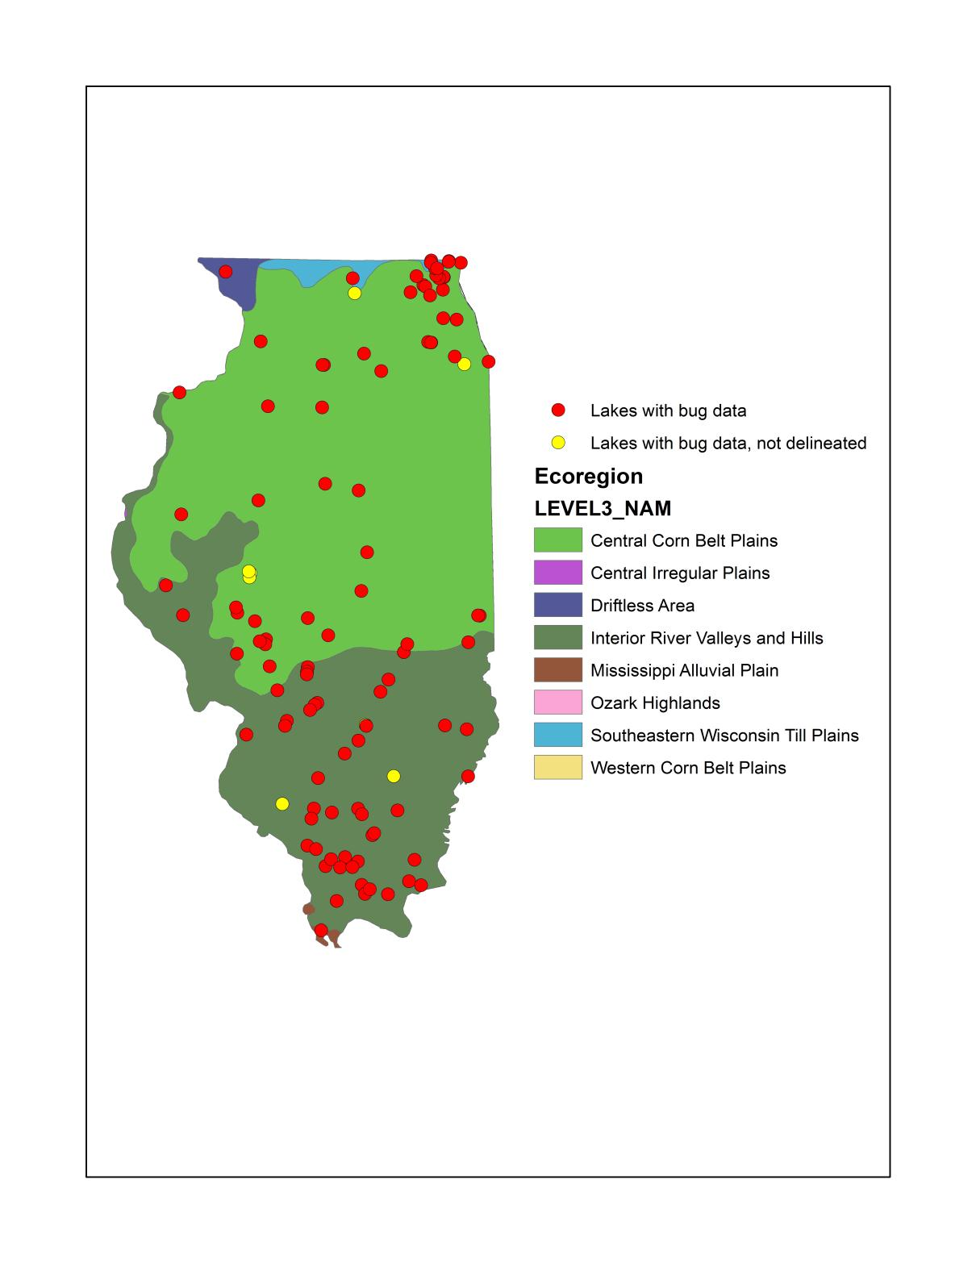

Illinois Lake Site

Figure . Locations of sampled lakes in Illinois, showing level 3 ecoregions.

Spatial analyses were conducted to characterize landscape features of the lakes, their drainage areas, and their immediate surroundings. The surrounding landscape features were summarized for the whole lake catchment (total contributing area based on NHD flow lines and elevation models) and for buffers of 100m, 500m, and 1km surrounding the lakes in all directions (Figure 2). We included uniform buffers around the lake in any direction even when elevations suggested that some areas were below the outlet. This was done to capture general development patterns in the lake vicinity and to simplify the delineations around lakes with poorly defined topography. The parameters analyzed using GIS are as shown in Table 1. Additional details are in Appendix A.

Table . GIS variables analyzed within the lakes, catchments, and buffers.

|  |  |
| --- | --- |
| Variable | Description |
| Lake Surface Area | Area of the water surface of the lake |
| Watershed Area | Area of the landscape contributing to runoff to the lake |
| US L3 Eco | EPA ecoregion level 3 at the site |
| US L4 Eco | EPA ecoregion level 4 at the site |
| US L3 Eco % | Proportion of total watershed in each Level 3 ecoregion |
| % Impervious | Percent impervious surface in the catchment |
| % NLCD | Land cover types, including urban and agricultural uses |
| # Mines | Number of gravel mines |
| # Coal Mines | Number of active surface and auger coal mines |
| # NPDES | Number of permitted discharges |
| # CERCLIS | Number of Superfund sites |
| # TRI | Number of Toxic Release Inventory sites |
| # Dams | Number of Dams in the catchment |
| # Road Crossings | Number of roads crossing streams |
| Road Miles | Length of roads in the catchment in miles |

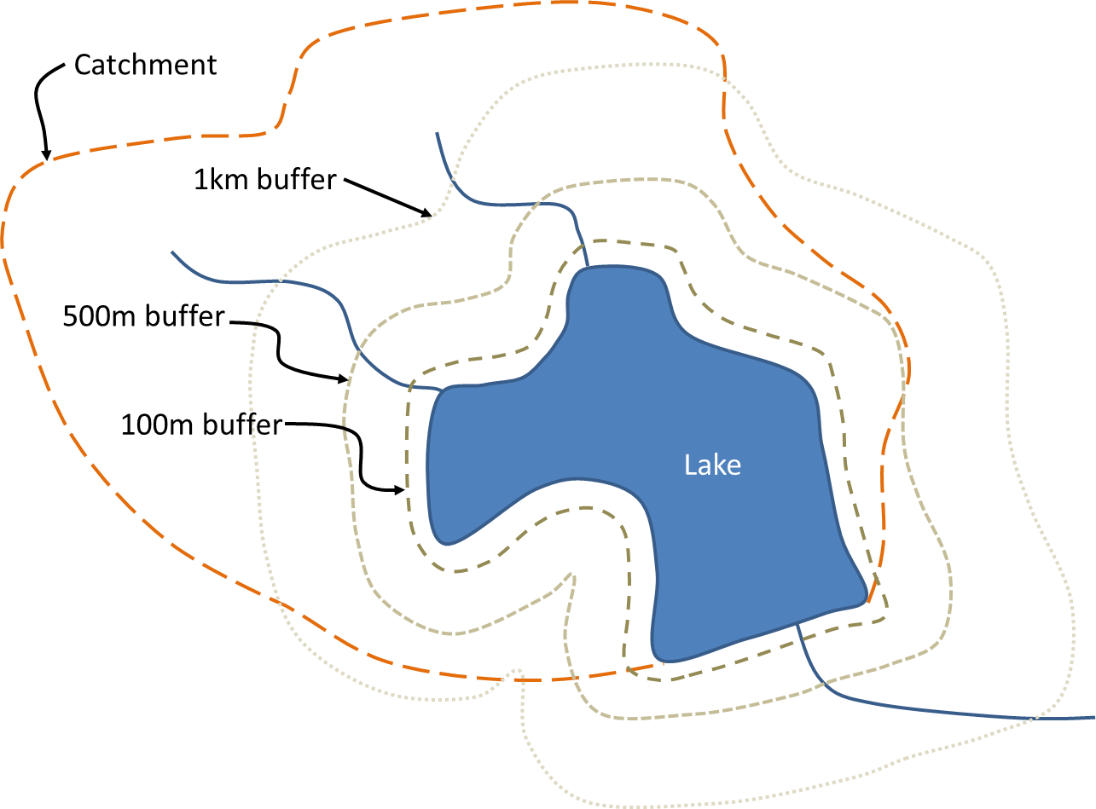

Figure . Lake catchment and buffer configurations.

## Sampling and Processing

Illinois lake and reservoir benthic samples were collected from five different habitats. Three samples were taken from each habitat. When possible, the samples were equally spread throughout the lake or reservoir representing the different zones. The three samples were composited in the field into one sample per habitat. The five habitats are:

* the **littoral fines** (≤ 2 mm diameter) - 3 Ponar/Ekman grabs
* **littoral plants** - 3 net jabs from macrophytes
* **littoral cobble/woody debris** - 3 net jabs from cobble or other hard substrate (woody debris)
* **sub-littoral** - 3 Ponar/Ekman grabs
* **profundal** - 3 Ponar/Eckman grabs

The zones were defined as follows. The maximum depth of the littoral zone is defined as twice the average Secchi depth. The sub-littoral zone extends one foot deeper than the maximum depth of the littoral zone. The profundal zone is any depth deeper than the sub-littoral. The morphology and clarity of some lakes and reservoirs restricted definition of all three zones. In these cases, the samples from non-existent habitat types were either not collected or were re-allocated to another habitat type.

Sample processing in the laboratory included a random subsample to a target of 500 organisms for each habitat. Taxonomic resolution was to a variable level. There was a mix of species, genus and family-level identifications that were standardized to levels that were most common across samples and over time. The standardized level was mostly genus, though species information was retained for the midges *Ablabesmyia, Dicrotendipes*, and *Polypedilum* because predominant identifications were made at the species level. Metrics were calculated using the standardized level of taxonomy.

For metric calculation, subsampled enumerations were multiplied up to whole sample densities based on the subsampling fraction in each habitat type. For example, if 15 of 30 possible grids were picked to arrive at the 500 organism subsample, then the organism counts were multiplied by a factor of 2. This does not affect taxa richness or proportional composition within a single habitat sample. The density calculation is used when virtually compositing multiple habitat types for a lake.

Water quality and analytic chemistry were collected in all lakes. Field water quality was complete for Secchi depth. Turbidity was complete for 58 lakes. Other fields, pH and conductivity, were incomplete (results for 17 lakes). Analytical chemistry in water was complete for 14 analytes in categories of physical properties, ions, plant pigments, nutrients, and solids (Table 2). Another 69 analytes were collected in water in 26 – 49 lakes, including metals and organic compounds. Sediment chemistry was analyzed in more than 96 lakes for 37 analytes, mostly organic compounds and metals. An additional 6 metals were analyzed in sediments of 80 – 87 lakes.

Table . Water quality variables measured in each lake.

|  |  |  |  |
| --- | --- | --- | --- |
| Physical properties and ions | Plant pigments | Nutrients | Solids |
| Temperature, sample | Chlorophyll a, corrected for pheophytin | Nitrogen, ammonia as N | Solids, suspended, volatile |
| Alkalinity, total | Chlorophyll a, uncorrected for pheophytin | Nitrogen, Kjeldahl | Solids, Total Suspended (TSS) |
| Chloride | Chlorophyll-b | Nitrogen, Nitrite (NO2) + Nitrate (NO3) as N |  |
|  | Chlorophyll-c | Phosphorus as P |  |
|  | Pheophytin-a |  |  |

## Habitat assessments

At 10 stations at each of 51 lakes, observations were made in and around 10 evenly-spaced 15 x 15 m plots adjacent to the lake shore. As was done in the NLA (U.S. EPA 2010), IEPA summarized the shoreline and littoral physical habitat information with four integrative measures of lake condition: *RDis_IX*, incorporating measures of the extent and intensity of human land use activities; *RVegQ_7,* incorporating the structure and cover in layers of riparian vegetation, including inundated vegetation; *LitCvr*, a combined biotic cover complexity measure including large woody snags, brush, overhanging vegetation, aquatic macrophytes, boulders, and rock ledges; and *LitRipCvr*, which combines *RipVeg* and *LitCvr* in an index of the cover and complexity of the land-water interface of lakes.

The **Lakeshore Disturbance Index** *RDis_IX* was based on field observations tallying the presence and proximity of 12 types of human activities or disturbances in and around the riparian plots. The extent was expressed simply as the proportion of the shoreline stations that have at least one type of human activity recorded within their 15 x 15 m shore plot and adjacent 10 x 15 m littoral plot (*hifpAnyCirca*). The intensity of human disturbances was expressed by the mean proximity-weighted tally of the number of types of human land-use activities per observation station, both agricultural (*hiiAg*) and non-agricultural (*hiiNonAg*), where disturbances observed outside of the plots were given half the weight of those within the shoreline-littoral plots.

Nine designated non-agricultural human disturbances were tallied: buildings, commercial developments, parks/man-made beaches, docks/boats, walls/dikes/revetments, trash/landfill, road/railroad, power lines, and lawns. Similarly three designated types of agricultural disturbances were tallied: row crops, pasture/range/hayfield, and orchard. To avoid over-representing non-agricultural disturbances and underrepresenting agricultural disturbances in *RDis_IX*, the disturbance intensity tallys for agricultural land use were weighted by 5x. This weighting effectively scales agricultural land-uses equal in disturbance potential to those for non-agricultural land use. The index is scaled from 0 to 1, where 0 indicates absence of any human disturbances and 1 indicates extremely high disturbance.

For the NLA, uniform condition criteria were applied:

Low Disturbance *RDis_IX* <0.20

Medium Disturbance *RDis_IX* >0.20 but < 0.75

High Disturbance *RDis_IX* >0.75

Field data used to calculate indices of riparian cover and complexity included cover-class estimates of woody and non-woody vegetation in the mid-layer (0.5 to 5 m), and woody, non-woody, inundated, and barren classes in the ground cover layer (<0.5 m) of the 10 lakeshore plots. The **lakeshore habitat index**, *RVegQ_7,* accommodates lack of tree canopy in ref sites by summing two lower layers of woody vegetation, where *Low Cover Wood = Woody ground cover + Woody understory* (midpoint averages for each lake were re-scaled 0-1 based on dataset maximum). It also includes inundated vegetation (rescaled 0-1) as a positive characteristic. This index is appropriate for plains ecoregions where presence of tree canopy or enhanced tree canopy cover around lakes may be associated with human activities (like the Temperate Plains [TPL]). All lakes in Illinois are in the TPL except for one lake in northwest Illinois for which we have no habitat record.

Field data related to littoral cover included estimates of woody snags >0.3m diameter, wood and brush <0.3m diameter, inundated live trees >0.3m diameter, inundated aquatic and herbaceous vegetation, overhanging vegetation <1m above water surface, rock ledges, boulders, and human structures, plus a separate estimation of floating and emergent aquatic macrophytes. As with the riparian measures, the estimates were midpoint averages for each lake, re-scaled to 0-1 based on dataset maximum. The **shallow water habitat index**,*LitCvr_D*, was chosen for use in the Temperate Plains Region for the National Lake Assessment Survey calculations. This region includes land from Minnesota to Indiana and is the appropriate littoral cover-complexity index formulation for the lake types in Illinois. It excludes submerged aquatic macrophytes, but increases the weighting of floating and emergent macrophytes in addition to snags.

Where: SomeNatCvr = BouldCov+Brush+Ledges+LiveTrees+Overhanging)

The **physical habitat complexity index,** L*itRipCvQ*, is simply the arithmetic mean of the respective values for the riparian and littoral indices RVegQ_7 and LitCvr_D. Higher scores in this index indicate greater habitat complexity.

## Lake Reference Designations

Lakes were associated with a conceptual disturbance gradient that was based mostly on GIS-derived information on land uses, road density, habitat conditions, and specific activities. The land use variables were considered primary reference criteria and were used in identifying reference and stressed sites. Habitat and specific use variables were secondary criteria, used to screen sites out of the reference categories, but not required for reference site identification. Habitat conditions were measured in half of the lake sites and were therefore inappropriate as required indicators of reference. The activities included mines (gravel and coal), NPDES discharges, and Superfund sites. These activities were rare and were effectively absent in close proximity to reference lakes.

An analysis to designate site reference status to was conducted on a statewide basis. The criteria were established based on distributions for land use and point source variables in the 102 lakes. Uniform application of reference criteria allowed for conceptualization of five reference condition categories: Reference, Near Reference, Other, Stressed, and Extremely Stressed. We expected that some parts of the state would be lacking in the best reference sites or the worst stressed sites based on predominant development patterns. Having multiple reference categories allowed flexibility in using the available disturbance gradient for regional index calibration.

The reference criteria included nine variables: five land use, two activity categories, and two habitat (Table 3). Imperviousness, road density, and road crossing density were measured in the whole catchment of the lake. Indices of urban and agricultural land uses were weighted by proximity to the lake. Percentages of each land use coverage were doubled if they were within 500m of the lake shoreline and tripled if within 100m. We weighted the occurrence of point source pollutants by their proximity to the sampling site. Those within the 1 km buffer were counted without any weighting. If a source was within 100 m of the lake shore, it was triple-weighted (count * 3). We devised these weighting schemes to account for our understanding that uses and activities closer to the lakes have stronger and more direct impacts than those that are further away. Habitat variables were considered secondary because they were only used to screen sites with poor habitat from the reference designations. With half of the lakes missing habitat information, good habitat conditions were not a requirement for reference designations and poor habitat did not automatically result in a stressed designation.

Table 3. Reference site criteria descriptions.

|  |  |  |  |
| --- | --- | --- | --- |
| Variable | | Description | |
| Primary Variables | | | |
| ImprvPct | | | % imperviousness in the whole catchment |
| UrbIndWgt | | | % low, med, and high development land uses;  weighted by distance: (catchment stat + 2* 500m stat + 3 * 100 stat)/6 |
| AgIndWgt | | | % crops and pasture uses;  weighted by distance: (catchment stat + 2* 500m stat + 3 * 100 stat)/6 |
| RdDens | | | Count of road/stream crossings per 100 acres |
| RdXDens | | | Length of roads in miles per 100 acres |
| Mine | | | Gravel & coal mines, weighted by distance: # in 1km + 3*# in 100m buffer |
| PtSrc | | | NPDES & CERCLIS sites, weighted by distance: # in 1km + 3*# in 100m buffer |
| Secondary Variables | | | |
| RDist | Riparian Disturbance Habitat Index (as calculated by National Lakes Assessment) | | |
| LitRip | Littoral and Riparian Complexity Habitat Index (as calculated by NLA) | | |

The thresholds for identifying degrees of disturbance for each reference criterion were based on distributions of values among ecoregions (Figure 3). The figure illustrates an example for the weighted agricultural index. Values above the upper (red, dashed) line indicate extreme stress. Between the red and brown upper lines, values indicate stress, but not extreme stress. Below the lower (blue, dashed) line, values indicate reference conditions. Between the blue and green lower lines, values indicate nearly reference conditions. After estimating thresholds by eye, the resulting numbers of reference and stressed sites were determined and thresholds were adjusted to capture several candidate reference sites and few candidate stressed sites. The ecoregions were used so that spatial distributions of reference sites could be considered. We did not expect that uses would be uniform across the landscape, but used this framework to help set thresholds that would not exclude whole areas from the extremes of the disturbance gradient.

Each reference variable was scored on a scale of +2 (reference) to -2 (extremely stressed) (Table 4). The scores were combined to arrive at a reference designation for a lake. Reference lakes met all the primary criteria for reference or met all but one and the last was near reference. If a secondary criterion indicated stress, a site could not be designated as reference or near reference. Stressed sites were designated if two or more primary criteria were in the stressed range. Extremely stressed designations were for lakes with two or more criteria in the extremely stressed range.

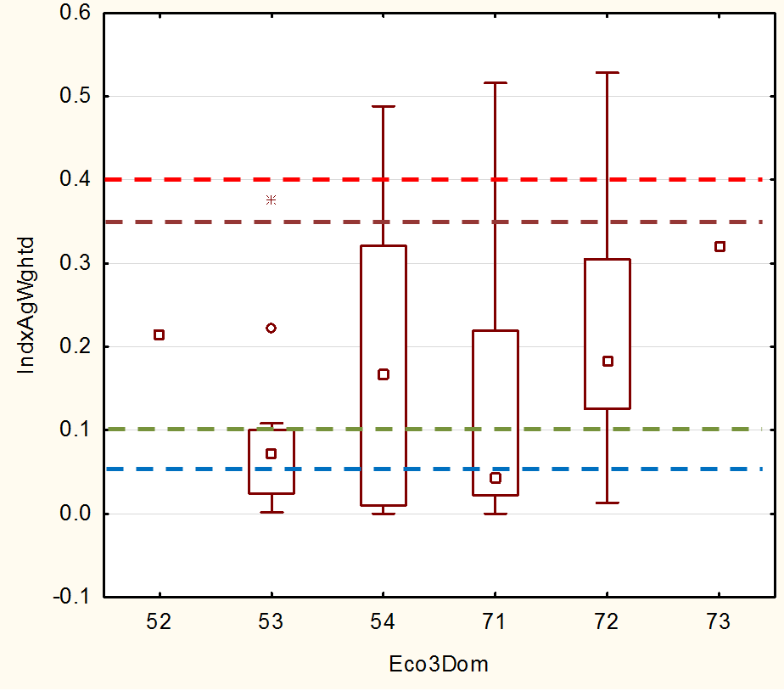

Figure . Thresholds used for identifying 5 reference categories across 6 ecoregions.

Table 4. Reference lake criteria.

|  |  |  |  |  |
| --- | --- | --- | --- | --- |
| Criteria | Reference  (+2) | Near Reference (+1) | Stressed  (-1) | Extremely Stressed  (-2) |
| Primary |  |  |  |  |
| ImprvPct | 2 | 5 | 10 | 15 |
| UrbIndWgt | 0.02 | 0.05 | 0.35 | 0.45 |
| AgIndWgt | 0.05 | 0.15 | 0.35 | 0.4 |
| RdXDens | 0.05 | 0.1 | 0.15 | 0.2 |
| RdDens | 0.4 | 0.5 | 0.9 | 1.2 |
| Mine | 0 | 0 | 1 | 2 |
| PtSrc | 0 | 0 | 1 | 2 |
| Secondary |  |  |  |  |
| Rdist |  |  | 0.85 | 0.9 |
| LitRip |  |  | 0.15 | 0.1 |

The site designations were reviewed by IEPA for consistency with their knowledge of specific conditions at the sites. Most of the specific conditions only affected a small number of lakes, so the lakes and their criteria-based designations were reviewed and individually screened for the following specific conditions.

Thermal impacts from nuclear power plants

Atmospheric deposition

Heavy siltation due to eroded shorelines from human disturbances

Lake management (fertilization, macrophyte treatments, etc.)

Repeated fish kills from known and unknown pollutants

Proximity to coal power plants/coal ash ponds

Best professional judgment of shoreline development

## Site Classification

Site classification is the process by which natural gradients among sites are examined to identify sites with similar biological expectations in the absence of human disturbance. In Illinois, we lack sites with an absence of human disturbance, so we use the least disturbed reference sites for this exercise. The purpose of classification is to minimize within-class variability of indicators so that anthropogenic disturbance can be recognized with less background noise (Barbour et al. 1999, Hughes et al. 1995). Potential site classification variables and biological metrics were analyzed simultaneously to identify patterns of covariance that could suggest how biological communities could be classified according to environmental characteristics.

The community structure of benthic macroinvertebrate samples was explored using an ordination of assemblage metrics using Principal Components Analysis (PCA). The PCA simplifies the taxa list for each sample to a location in the ordination diagram relative to other samples with similar community structure. Sites were arranged on the PCA axes such that sites with similar metric values were plotted in close proximity and those with less similarity were plotted at a distance. Interpretation of the ordination diagram with respect to taxa within the samples and characteristics of the sites takes place through visual inspection of variable overlays and correlation along the ordination axes. We used metrics calculated from the 3 littoral habitats, assuming that they were the most productive habitats. Most metrics met the assumption of normality of residuals (Kolmogorov–Smirnov test) in an untransformed state and were therefore not modified. One percentage metric was transformed using an arcsin-square root transformation. The metrics were relativized to the mean of each metric based on the standard deviations. The PCA analysis was performed using PC-Ord software (McCune and Mefford 2006).

## Metric Testing

Sixty-eight (68) metrics 5 metric categories were calculated and tested for responsiveness to the disturbance gradient in each site class (Table 5). The metric categories included richness, composition, feeding groups, habit, and pollution tolerance. The testing proceeded using three habitat compilation schemes: compositing all 5 habitats, compositing only 3 littoral habitats, and compositing only the profundal and sublittoral habitats.

Table . Codes and brief descriptions of the metrics calculated and tested during index development.

| Metric Code | Description |
| --- | --- |
| ni_total | Total Individuals |
| nt_total | Total Taxa |
| nt_Coleo | Coleoptera Taxa |
| nt_Ephem | Ephemeroptera Taxa |
| nt_Pleco | Plecoptera Taxa |
| nt_Trich | Trichoptera Taxa |
| nt_EPT | EPT Taxa |
| nt_ECT | Ephemeroptera, Coleoptera, Trichoptera Taxa |
| nt_Dipt | Diptera Taxa |
| nt_Chiro | Chironomidae Taxa |
| nt_Tanyt | Tanytarsini Taxa |
| nt_NonIns | Non-insect Taxa |
| nt_Bival | Bivalve Taxa |
| nt_CruMol | Crustacea & Mollusca Taxa |
| nt_Decap | Decapod Taxa |
| pt_EPT | EPT % of Taxa |
| pt_Dipt | Diptera % of Taxa |
| pt_NonIns | Non-insect % of Taxa |
| pi_EPT | % EPT individuals |
| pi_OCT | % Odonate, Coleoptera, Trichoptera individuals |
| pi_Ephem | % Ephemeroptera individuals |
| pi_Trich | % Trichoptera individuals |
| pi_Baet2Ephem | % Baetidae of Ephemeroptera individuals |
| pi_Hydro2Trich | % Hydropsychidae of Trichoptera individuals |
| pi_Dom01 | % Dominant Taxon individuals |
| pi_Coleo | % Coleoptera individuals |
| pi_Odon | % Odonata individuals |
| pi_Dipt | % Diptera individuals |
| pi_Chiro | % Chironomidae individuals |
| pi_Tanyt | % Tanytarsini individuals |
| pi_NonIns | % Non-Insect individuals |
| nt_scrap | Scraper Taxa |
| pi_scrap | % Scraper |
| nt_shred | Shredder Taxa |
| pi_shred | % Shredder |
| nt_cllct | Collector Taxa |
| pi_cllct | % Collector |
| nt_filtr | Filterer Taxa |
| pi_filtr | % Filterer |
| nt_pred | Predator Taxa |
| pi_pred | % Predator |
| pi_clngr | % Clinger |
| nt_clngr | Clinger Taxa |
| pi_brrwr | % Burrower |
| nt_brrwr | Burrower Taxa |
| nt_clmbr | Climber Taxa |
| nt_sprwlr | Sprawler Taxa |
| nt_swmmr | Swimmer Taxa |
| pi_clmbr | % Climber |
| pi_sprwl | % Sprawler |
| pi_swmmr | % Swimmer |
| nt_intol | Intolerant Taxa |
| nt_toler | Tolerant Taxa |
| pt_intol | Intolerant % of Taxa |
| pt_toler | Tolerant % of Taxa |
| pi_intol | % Intolerant |
| pi_EPT123 | % sensitive EPT (BCG attrib 1, 2, 3) |
| nt_EPT123 | Sensitive EPT Taxa (BCG attrib 1, 2, 3) |
| nt_BCG12 | Sensitive Taxa (BCG attrib 1, 2) |
| nt_BCG123 | Sensitive Taxa (BCG attrib 1, 2, 3) |
| nt_BCG56 | Tolerant Taxa (BCG attrib 5, 6) |
| pi_BCG12 | % sensitive (BCG attrib 1, 2) |
| pi_BCG123 | % sensitive (BCG attrib 1, 2, 3) |
| pi_BCG56 | % tolerant (BCG attrib 5, 6) |
| pi_toler | % Tolerant |
| x_Beck | Beck's Index |
| x_HBI | Hilsenhoff's Index |
| x_Shan_2 | Shannon-Weiner Index (base 2) |

## Discrimination Efficiency (DE) and Z-score

The ability of each metric to distinguish between reference and stressed sites within a site class was measured as discrimination efficiency (DE) (Flotemersch et al. 2006). For metrics with a pattern of decreasing value with increasing environmental stress, DE is the percentage of stressed values below the 25th percentile of reference site values. For metrics that increase with increasing stress, DE is the percentage of stressed sites that have values higher than the 75th percentile of reference values. DE can be visualized on box plots of reference and stressed metric or index values with the inter-quartile range plotted as the box (Figure 4). Higher DE denotes more frequent correct association of metric values with site conditions. DE values ≤25% show no discriminatory ability in one direction. DE values ≥50% are generally adequate for consideration in an index. However, in a site class, adequacy was usually dependent on relative DE values within a metric category. A second measure of metric discrimination was the *Z*-score, which was calculated as the difference between reference and stressed metric or index values divided by the standard deviation of reference values. This is similar to Cohen’s d (Cohen 1988), except that the standard deviation in our *Z*-score is only from the reference distribution, which we would prefer to be small, regardless of variability in the stressed sites. There is no absolute *Z*-score value that indicates adequate metric performance, but among metrics or indices, higher *Z*-scores suggest better separation of reference and stressed values and lower variability in reference sites.



Figure . Box and whisker plot illustrating a metric that decreases with increasing stress and that has a DE slightly greater than 75%.

## Metric Scoring

Initial developments of the IBI (Karr et al. 1986) used a maximum species richness line, such that the maximum species richness found for a given waterbody type was taken as a best value, and metrics were scored according to the best value. This approach simply uses the best available as reference. Current IBI developments continue to use a best value for scoring each metric, regardless of whether the best value occurs in identified reference sites (Blocksom 2003). The critical assumption for using best value is that all metrics respond monotonically across the stress gradients; violations of the assumption would be modal responses to stress.

Metrics were scored on a common scale prior to combination (as an average of scores) in an index. For metrics that decrease with increasing stress, the 95th and 5th quantiles of all data across all site classes were used to bound the scoring scale to lessen the influence of outliers (Barbour et al. 1999). Decreasing metrics were scored as follows:

**

Metrics that increase with increasing stress (reverse metrics) were scored using the 5th percentile of all data as the optimal, receiving a score of 100. Decreasing scores were calculated as metric values increased to the 95th percentile using the equation:

**

The metric scoring range was from 0 to 100. Scores outside of this range were re-set to the nearest extreme before the index was calculated.

## Index Composition

A multimetric index is a combination of metric scores that indicates a degree of biological stress in the aquatic community (Barbour et al. 1999). Individual metrics were candidates for inclusion in the index if they:

- discriminated well between least and most disturbed sites;

- were ecologically meaningful (mechanisms of responses were plausible);

- represented diverse types of information (multiple metric categories); and

- were not redundant with other metrics in the index.

Several index alternatives were calculated using an iterative process of adding and removing metrics, calculating the index as an average of the metric scores, and evaluating index responsiveness. The first index alternatives included those metrics that had the highest DEs within each metric category. Subsequent index alternatives were formulated by adding, removing, or replacing one metric at a time from the initial index alternatives that performed well. When we found index alternatives that performed particularly well in one or another site class, we considered them as valid alternatives while we also sought index alternatives that performed reasonably well across all site classes.

Each alternative index was evaluated based on DE and *Z*-scores in calibration data, and inclusion of representative and non-redundant metrics. In addition, the IEPA workgroup reviewed indices with similar performance characteristics to select a final index that included metrics that were meaningful to their programs. As many metric categories as practical were represented in the index alternatives so that signals of various stressor-response relationships would be integrated into the index. While several metrics should be included to represent biological integrity, redundant metrics can bias an index to show responses specific to certain stressors or taxonomic responses. Redundancy was evaluated using a Spearman rank order correlation analysis. In this index development effort, we excluded metrics that were redundant at the 0.85 level or higher.

# 3 Results

## Reference Designations

IEPA agreed with analytical designations (Reference, Other, Stressed) for 58 lakes and changed designations for 44 lakes based on familiarity with lake characteristics. The lake designations are listed in Appendix B. Only 4 sites were designated as reference (Table 6). The southern Shawnee National Forest area contained 3 of the reference sites. The 25 near-reference sites were evenly distributed between the monitoring units. More extremely stressed sites were recognized in the more urban northern monitoring unit compared to the central and southern units. Stressed sites were evenly distributed among the monitoring units. Given the paucity of reference and extremely stressed sites in some regions of Illinois, we continued analyses using combined categories for site classification and metric sensitivity testing. Reference and near reference sites were used in classification and to characterize reference conditions. Stressed and extremely stressed sites were used to detect metric in index responses to stress.

Table . Reference and stressed designations by monitoring unit.

|  |  |  |  |  |  |  |
| --- | --- | --- | --- | --- | --- | --- |
| Monitoring Unit | Ref | NearRef | Other | Strs | XStrs | Totals |
| Northern | 1 | 10 | 8 | 7 | 8 | 33 |
| Central | 0 | 7 | 11 | 7 | 4 | 29 |
| Southern | 3 | 8 | 21 | 6 | 1 | 39 |
| Totals | 4 | 25 | 39 | 20 | 13 | 102 |

## Site Classification

The PCA ordination included 28 common metrics in all metric categories. There were 28 reference and near reference lakes after removing one outlier in the preliminary ordinations. The outlier was Waverly Lake, which was hypereutrophic on the TSI scale and had only 21 taxa. The first axis indicated that the percentages of chironomids and of non-insects were distinguishing characteristics of the samples, explaining 25% of the variance in the metrics. Other metrics that were associated with percent chironomids were percent tolerant individuals, Hilsenhoff’s Biotic Index, and the number of Diptera taxa (Figure 5). Three other axes were significant, explaining an additional 36% of variance, combined.



Figure . PCA diagram of reference and near reference lakes on first and second axis, showing vectors of metrics associated with the axes. The vectors represent the direction and magnitude of the relationship of the metric with the sites (shown as triangles). Metric labels are as described in Table 5.

Classification variables were not strongly correlated with any of the significant axes (r2 < 0.10), with the exception of latitude (Table 7). Latitude was higher (northern) in those sites with higher percentages of non-insects (Figure 6). Classification based on latitude was not considered feasible because of the relatively weak correlation coefficient. However, the categorical monitoring units were related to latitude and provided a rational site classification scheme. Other categorical variables (ecoregion, lake origin/type, reference status [reference or near reference], trophic state [mesotrophic or eutrophic], and stratification) did not show distinctive groupings in the PCA diagram. Based on these results, approval from the IEPA, and confirmation with phytoplankton classification schemes (Rasmussen 2007; Allen 2008), the sites were classified by the three monitoring units. Metric distributions for selected metrics suggest that the central and southern monitoring units were more similar to each other than either was to the northern monitoring unit (Figure 7). Although there was overlap in the sites from each monitoring unit (Figures 6 and 7), the classification scheme was the strongest of those observed in PCA diagrams or metric distributions.

Table . Correlation of variables with PCA Axes 1, 2, and 3.

|  |  |  |  |  |  |  |
| --- | --- | --- | --- | --- | --- | --- |
| Axis: | 1 | | 2 | | 3 | |
|  | r | r-sq | r | r-sq | r | r-sq |
| Average Latitude | 0.521 | 0.271 | -0.191 | 0.037 | -0.102 | 0.01 |
| Average Longitude | 0.09 | 0.008 | -0.133 | 0.018 | 0.155 | 0.024 |
| Lake surface area | 0 | 0 | -0.074 | 0.005 | -0.18 | 0.032 |
| Watershed area | 0.037 | 0.001 | -0.104 | 0.011 | -0.173 | 0.03 |
| Shoreline length | -0.025 | 0.001 | -0.057 | 0.003 | -0.213 | 0.045 |
| Maximum depth | 0.13 | 0.017 | -0.112 | 0.013 | -0.152 | 0.023 |
| Mean depth | 0.011 | 0 | -0.101 | 0.01 | -0.131 | 0.017 |
| Relative depth | -0.212 | 0.045 | 0.291 | 0.085 | 0.053 | 0.003 |



Figure . PCA diagram based on metrics in reference lakes in three monitoring units, showing latitude. Larger symbols represent larger (northern) latitudes. Side graphs show linear regressions of latitude on each axis (red line) and a 95% envelope (blue line).

  

Figure . Distributions of selected metrics in reference (R) sites in the Northern (N), Central (C), and Southern (S) monitoring units.

## Metric Sensitivity

Fifty-five (55) metrics showed some level of discrimination of reference and stressed sites in the site classes (Appendix C). Metrics that responded strongly (DE > 40%) and had consistent trends among site classes were more common when calculated from the three littoral habitats, including 12 metrics in five metric categories. In contrast, none of the profundal metrics were strong and consistent in more than 2 site classes. When all habitats were composited, eight metrics were strong and consistent among site classes. Several profundal metrics had trends that were opposite to the littoral metric trends and that had less plausible mechanisms (see Discussion). Inclusion of profundal samples with the littoral samples (as in the all habitats metrics) would dilute the signal of littoral samples. Therefore, we emphasized metrics calculated from the three littoral habitats in the discussion below and in index development.

In the following metric response discussions, we refer to increasing and decreasing metric values relative to increasing stress, where increasing stress is considered to be characteristic of the stressed sites relative to the reference sites.

### Richness metrics

The numbers of taxa and percentages of taxa within taxa groups generally declined with increasing stress in all site classes. Only percent Diptera taxa increased with some consistency across site classes. The number of Ephemeroptera, Plecoptera, and Trichoptera (nt_EPT) had the strongest response in the Southern lakes. It was not responsive in Northern lakes. By substituting Coleoptera for Plecoptera, the number of ECT taxa became the most consistently responsive metric across site classes. Percent of EPT taxa and number of crustacean and mollusca taxa were also responsive across site classes.

### Composition Metrics

Percent Diptera individuals and percent Chironomidae individuals increased with increasing stress in all three site classes. In contrast, percent non-insects decreased consistently with increasing stress. The percent of Odonata, Coleoptera, and Trichoptera individuals (pi_OCT) decreased in all site classes, though the DE was weak in the Northern site class. In other taxa groups, metric responses were variable among site classes.

### Feeding Group Metrics

In the feeding group metrics, the percent of filterer and shredder individuals increased consistently with increasing stress. The DE of the percent filterers was the highest, especially in the Central lakes. Scrapers decreased in taxa richness and percent of individuals across all site classes. Other feeding group metrics responded variably across site classes. Common filterer taxa included *Glyptotendipes*, *Tanytarsus*, Tanytarsini (Chironomidae), *Cyrnellus* (Trichoptera), Pisidiidae, and *Pisidium* (Bivalvia)

### Habit Metrics

Percent of burrower individuals increased with increasing stress and number of climber taxa decreased consistently across site classes. Many burrowers were Diptera and the metrics of percent Diptera and percent burrowers were correlated (Spearman r = 0.85). Other habit metrics responded variably across site classes. Common climbers are *Enallagma* and *Ischnura* (Odonata), *Physella* (Gastropoda), *Cladotanytarsus* (Chironomidae), and several *Polypedilum* species (Chironomidae).

### Pollution tolerance

The consistently responsive tolerance metrics included percent tolerant individuals, the Hilsenhoff Biotic Index (HBI), and the percent of tolerant individuals as defined by biological condition attributes 5 and 6 (pi_BCG56). All of the tolerance attributes were assigned to taxa in the context of stream organisms and their tolerances. However, the tolerant taxa appear to be appropriate for lakes also. Other tolerance metrics responded variably across site classes.

## Index Synthesis

The responsive metrics were commonly correlated with other metrics in the same metric category. In a few cases, higher correlations (|r| >0.80) were seen for metrics from different metric categories (Table 8). Correlated metric pairs included:

richness of scrapers and Crustacean/Mollusca

percent individuals of filterers and burrowers

percent individuals of (filterers or burrowers) and (Diptera or Chironomidae individuals) percent individuals of (filterers or burrowers) and (tolerant individuals or the HBI)

These correlations suggest that the Crustacea and Mollusca were mostly gastropod scrapers. Filterer taxa were often also burrowers. Filterers and burrowers were often tolerant or chironomids.

Thirty-three (33) different combinations of metrics were tested as possible indices. Performance statistics of the alternatives ranged from 42-100 for DE and 0.56 – 2.06 for Z-scores. The best alternatives (Table 9) were reviewed by IEPA for metric response plausibility and application feasibility (whether the metrics could be calculated and communicated without difficulty). One set of metrics that included the best performing metrics in each metric category had excellent performance in discriminating reference and stressed sites in all three site classes (Figure 8). The five metric categories, the index metrics, and their trends with increasing stress included:

* + Richness: Count of ECT taxa decreaser
  + Composition: % Diptera individuals increaser
  + Feeding group: % filterer individuals increaser
  + Habit: Count of climber taxa decreaser
  + Pollution tolerance: % tolerant individuals increaser

This index (Index 1) had DE of 79, 91, and 86 and Z-scores of 1.27, 1.31, and 2.01 in the Northern, Central, and Southern site classes, respectively. Index 1 includes metrics from each metric category. Two sets of metrics are correlated at high, but acceptable levels. These include % Diptera individuals and % filterer individuals (r = 0.81) and % filterer individuals and % tolerant individuals (r = 0.80). It is the preferred index for uniform application across all site classes. A uniform index suggests that the metric responses are robust in lakes across Illinois.

In the Northern site class, DE of Index 24 was higher than other alternatives (DE = 86). This index also includes metrics from all five metric categories. The tolerance metric in Index 24 uses attributes from the stream BCG exercise instead of stream tolerance values on the Hilsenhoff scale. The low Index 1 reference score was from Lake George (RML). Lake George is one of the few reservoirs in the Northern region. According to IEPA biologists, it is characteristically more similar to the lakes in the central region.

In the Central site class, the Z-score of Index 6 is higher than other alternatives. This index includes one metric in addition to those in Index 1; percent non-insect individuals. The low Index 1 reference score was from Waverly Lake (SDC). Waverly Lake was recognized as an outlier in the site classification exercise also.

In the Southern site class, Index 2 has a higher DE than other alternatives. Index 2 includes sets of metrics that are correlated at levels close to our cut-off value (r = 0.85).



Figure . Index 1 and component metric values by site class and reference status. Site classes are Northern (N), Central (C), and Southern (S). Reference status includes reference (R), other (O), and stressed (S).

## Index Validation

We had few sites to use in calibrating the index, so none were reserved for independent application of the index and comparison to reference designations. Therefore, index values were compared to stressors that were not used in defining the index calibration stressor gradient. These included three variables, phosphorus, Secchi depth, and chlorophyll a, which were components of the Trophic Stress Index (TSI, Carlson 1977). There is an apparent drop in Index 1 values at TSI scores near 60 for each variable (Figure 9). This suggests that the benthic macroinvertebrate index responds to factors also affecting these nutrient indicators. This index response to the independent stressors validates the index. The response is similar within each site class, though the decline in Index 1 values in the Northern lakes may be more gradual over the TSI scales than it is in the other classes. A TSI value of 60 corresponds to 0.05 mg/L Total Phosphorus, which is the state water quality standard for lakes.

The TSI score of 60 corresponds with the IEPA water quality standard for phosphorus (0.05 mg/L of total phosphorus). Chlorophyll a is the best/closest measure of algal biomass using the TSI. TSIs for phosphorus and secchi can be influenced by non-volatile suspended solids especially in reservoirs. The factors influencing the index may be closer related to solids, which would explain why it has “less” of an impact on the northern lakes, which are represented by a lot of glacial lakes where solids have less of an influence on TSI.

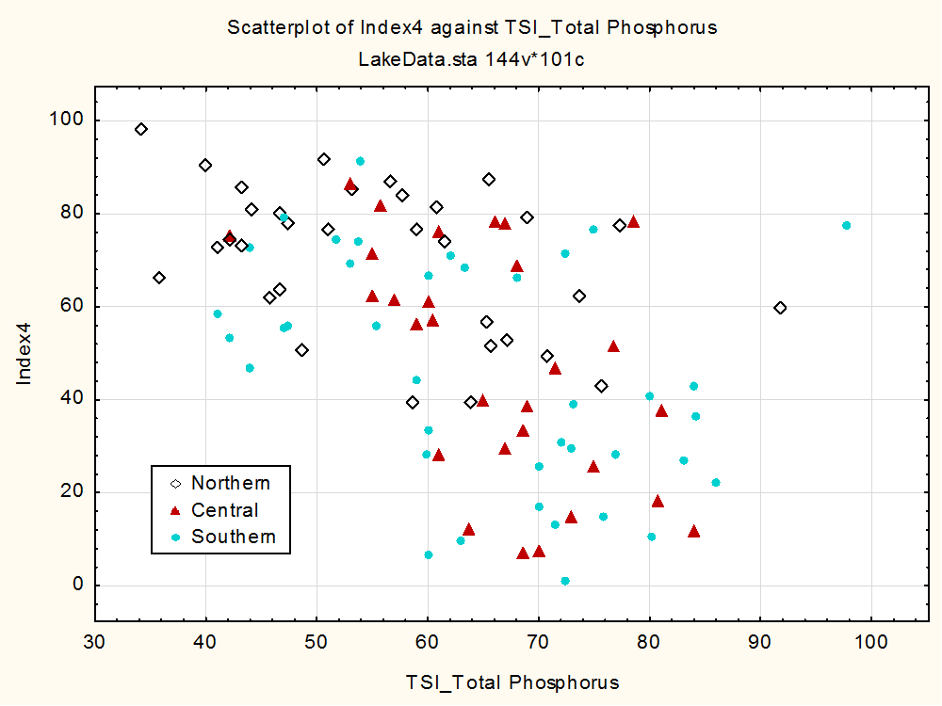

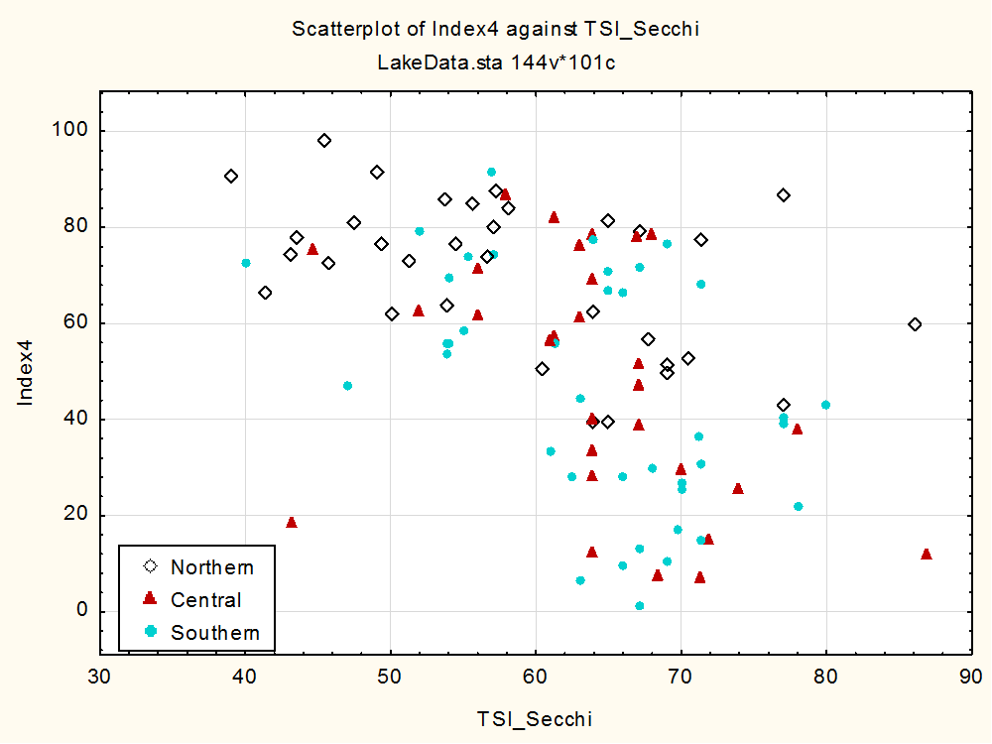

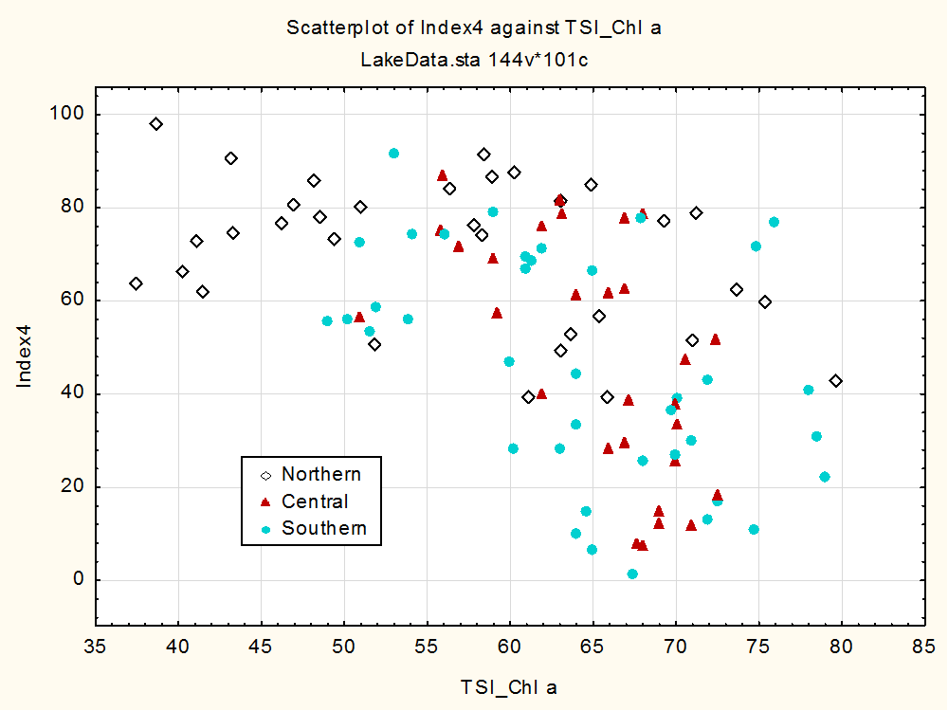

Figure . Index 1 values in relation to nutrient indicators of the Trophic State Index. Phosphorus, Secchi depth, and chlorophyll a were rescaled to distributions within the data set.

Table . Spearman rank correlation coefficients for metrics with strong and consistent responses to stress. Absolute values greater than 0.75 are in bold type.

|  |  |  |  |  |  |  |  |  |  |  |  |  |  |  |  |  |  |
| --- | --- | --- | --- | --- | --- | --- | --- | --- | --- | --- | --- | --- | --- | --- | --- | --- | --- |
|  | nt_EPT | nt_ECT | nt_CruMol | pt_EPT | pt_Dipt | pi_OCT | pi_Dipt | pi_Chiro | pi_NonIns | nt_scrap | pi_scrap | pi_shred | pi_filtr | pi_brrwr | nt_clmbr | pi_toler | x_HBI |
| nt_ECT | **0.85** |  |  |  |  |  |  |  |  |  |  |  |  |  |  |  |  |
| nt_CruMol | 0.46 | 0.46 |  |  |  |  |  |  |  |  |  |  |  |  |  |  |  |
| pt_EPT | 0.72 | 0.48 | 0.06 |  |  |  |  |  |  |  |  |  |  |  |  |  |  |
| pt_Dipt | -0.42 | -0.57 | -0.64 | -0.17 |  |  |  |  |  |  |  |  |  |  |  |  |  |
| pi_OCT | 0.41 | 0.54 | 0.29 | 0.13 | -0.32 |  |  |  |  |  |  |  |  |  |  |  |  |
| pi_Dipt | -0.39 | -0.40 | -0.54 | -0.09 | 0.59 | -0.42 |  |  |  |  |  |  |  |  |  |  |  |
| pi_Chiro | -0.40 | -0.42 | -0.55 | -0.09 | 0.60 | -0.43 | **0.99** |  |  |  |  |  |  |  |  |  |  |
| pi_NonIns | 0.34 | 0.28 | 0.55 | 0.13 | -0.38 | 0.17 | **-0.80** | **-0.79** |  |  |  |  |  |  |  |  |  |
| nt_scrap | 0.63 | 0.65 | **0.83** | 0.27 | -0.63 | 0.34 | -0.49 | -0.50 | 0.46 |  |  |  |  |  |  |  |  |
| pi_scrap | 0.44 | 0.45 | 0.74 | 0.17 | -0.49 | 0.33 | -0.48 | -0.49 | 0.49 | **0.79** |  |  |  |  |  |  |  |
| pi_shred | 0.17 | 0.16 | -0.09 | 0.17 | 0.22 | 0.15 | 0.23 | 0.25 | -0.22 | 0.01 | -0.04 |  |  |  |  |  |  |
| pi_filtr | -0.33 | -0.30 | -0.32 | -0.16 | 0.35 | -0.33 | **0.81** | **0.82** | -0.63 | -0.30 | -0.28 | 0.14 |  |  |  |  |  |
| pi_brrwr | -0.41 | -0.36 | -0.53 | -0.11 | 0.48 | -0.41 | **0.85** | **0.84** | -0.62 | -0.47 | -0.45 | 0.04 | **0.80** |  |  |  |  |
| nt_clmbr | 0.54 | 0.65 | 0.70 | 0.01 | -0.53 | 0.57 | -0.59 | -0.59 | 0.45 | 0.72 | 0.66 | 0.09 | -0.37 | -0.57 |  |  |  |
| pi_toler | -0.33 | -0.27 | -0.35 | -0.13 | 0.35 | -0.34 | 0.72 | 0.72 | -0.47 | -0.31 | -0.23 | 0.02 | **0.80** | **0.78** | -0.42 |  |  |
| x_HBI | -0.36 | -0.29 | -0.41 | -0.14 | 0.36 | -0.34 | **0.75** | **0.75** | -0.57 | -0.37 | -0.32 | 0.04 | **0.81** | **0.84** | -0.45 | **0.93** |  |
| pi_BCG56 | -0.34 | -0.28 | -0.26 | -0.14 | 0.23 | -0.37 | 0.55 | 0.55 | -0.28 | -0.27 | -0.20 | -0.04 | 0.70 | 0.75 | -0.36 | **0.85** | **0.88** |

Table . The ten best-performing index alternatives, showing the metrics included in each alternative and performance statistics within the site classes.

|  |  |  |  |  |  |  |  |  |  |  |  |
| --- | --- | --- | --- | --- | --- | --- | --- | --- | --- | --- | --- |
| Site Class | Statistic | Index1 | Index2 | Index6 | Index11 | Index21 | Index24 | Index27 | Index28 | Index32 | Index33 |
|  |  | nt_ECT | nt_CruMol | nt_ECT | nt_ECT | nt_EPT | nt_ECT | nt_ECT | nt_ECT | nt_ECT | nt_ECT |
|  |  | pi_Dipt | pi_NonIns | pt_Dipt | pi_Chiro | pi_Chiro | pi_Chiro | pi_Chiro | pi_Coleo | pi_Dipt | pi_Dipt |
|  |  | pi_filtr | nt_scrap | pi_NonIns | pi_filtr | pi_filtr | pi_filtr | pi_filtr | pi_filtr | pi_Scrap | pi_Scrap |
|  |  | nt_clmbr | pi_brrwr | pi_filtr | nt_clmbr | nt_clmbr | pi_brrwr | nt_clmbr | nt_clmbr | pi_filtr | pi_filtr |
|  |  | pi_toler | x_HBI | nt_clmbr | pi_toler | pt_toler | pi_BCG56 | pi_BCG56 | pi_toler | nt_clmbr | nt_clmbr |
|  |  |  |  | pi_toler |  |  |  |  |  | pi_toler | x_HBI |
| Northern | DE | 79 | 43 | 64 | 79 | 57 | 86 | 79 | 71 | 57 | 57 |
|  | Z-score | 1.27 | 0.72 | 1.41 | 1.23 | 0.77 | 1.13 | 1.30 | 1.24 | 1.15 | 1.09 |
| Central | DE | 91 | 82 | 91 | 91 | 91 | 82 | 91 | 82 | 91 | 91 |
|  | Z-score | 1.31 | 1.20 | 1.55 | 1.33 | 1.51 | 1.11 | 1.25 | 1.31 | 1.29 | 1.25 |
| Southern | DE | 86 | 100 | 71 | 86 | 86 | 86 | 86 | 86 | 86 | 86 |
|  | Z-score | 2.01 | 1.73 | 1.74 | 1.97 | 1.79 | 1.73 | 1.96 | 2.02 | 2.06 | 1.97 |

# 4 Discussion

The proposed benthic macroinvertebrate multimetric index for Illinois lakes is a practical tool for assessing biological conditions throughout the state. The index is proven to be responsive to the calibration stressor gradient based on landscape disturbances and activities as well as to the independently defined TSI gradients. The index can be used to identify lake conditions relative to the available reference lakes. If IEPA has confidence that these reference lakes are representative of acceptable conditions and the index thresholds account for responsiveness of the index and variability and error in index calibration, then the index can be used for ranking lakes on a scale of acceptable to unacceptable conditions. Unacceptable conditions could be associated with biological impairment, if IEPA decides to make that determination. If not, the relative condition rankings can be used to set lake restoration and protection priorities in monitoring and assessment programs that do not require definition of an impairment threshold.

One issue the IEPA questioned was the value of sampling multiple lake habitats. Future sampling could be more efficient and give adequate assessment signals if sublittoral and profundal samples were excluded. Littoral samples were more productive in both richness and density compared to sublittoral and profundal samples. In addition, the littoral metrics were more responsive and were consistent in their response among site classes. Of 28 littoral metrics that responded consistently among the 3 site classes, only 4 profundal metrics showed similar responses. These profundal metrics included % Diptera taxa, % shredders, % filterers, and the HBI, all increasing with increased stress. Eighteen (18) profundal metrics responded contrary to the littoral metric responses. Richness metrics increase with stress in profundal samples, contrary to expectations. A possible mechanism for describing this richness response involves the relative lack of plants in reference lakes and subsequent decrease in detritus food resources on the lake bottom. One metric that had consistent response among site classes was % predators, which decreased with increasing stress.

The index we proposed used identical metrics in three site classes, including northern, central, and southern regions. A uniform index among site classes suggests that the metric responses are robust across the state and would be applicable in new assessments. In addition, manipulations and interpretations of the index across site classes will be easier with a uniform index. However, different index alternatives were presented and could be selected for optimizing index performance within each site classes.

## Impairment thresholds for assessment

Selection of an impairment threshold to assess biological integrity is the responsibility of IEPA and depends on the error rate in assessment results, confidence in the reference lake designations and conditions, and the level of protection to be enforced. The reference condition concept implies that biological integrity is represented by the biological characteristics observed in sites with less human disturbance. However, because we do not have pristine, undisturbed reference sites and we do not know to what degree the reference sites differ from the optimal potential condition, selection of a threshold is arbitrary.

IEPA can associate a threshold with a definitive use impairment, such as a BCG rating or a criterion violation. Index values below 60 are more often associated with TSI score above 60 than below 60 (Figure 9), though this varies by site class. If a TSI score of 60 represents a definitive impairment, then further analysis could be conducted to find risk of TSI impairment associated with potential index thresholds. Conditional probability analysis (Paul et al. 2008) could be used to quantify such risks, but the analysis is not within the scope of this project.

Impairment thresholds can be derived from the distributions of index values in reference sites of each site class. The site classes were established based on perceived differences in reference lake biota across the state. The lakes could be assessed on a common index scale regardless of site class because the index is calculated identically in each class. Reliance on the reference lake index distribution in each site class might be too specific for the small number of reference lakes. Application of an overall index threshold would imply that the biological differences among site classes and the index differences among reference lakes are less important.

The 25th quantile of reference site values can be used as a threshold and it is a common practice to do so. This quantile implies that 25% of reference sites are below the threshold because of natural variability or error in their reference designation. Other quantiles can be selected based on the subjective confidence in reference site quality or the level of protectiveness and error that is acceptable to IEPA. Selection of a high quantile as a threshold implies that there is greater error in the definition and designation of reference lakes. Selection of lower thresholds implies confidence in the integrity of reference lakes. Table 10 shows potential assessment errors associated with three thresholds. The index is least discriminating in the northern sites, where the 10th percentile threshold results in 57% of stressed sites identified as similar to reference. This might be valid if stressed sites in the north are somehow buffered from typical stressors or those stressors are not as intensive as in the central and south regions. Using the 25th percentile as a threshold results in lower stressed site error rates than the 10th in all regions except the south, where discrimination is equal for all three reference quantiles. Application of a common threshold in all site classes would result in greater error in detecting stressed sites at each of the percentiles when compared to application of different thresholds in each site class. Most of the errors would be in identification of stressed conditions in the Northern region.

In consideration of error rates for the calibration reference and stressed designations, IEPA could use thresholds based on the 10th or 25th percentiles to describe lake biological conditions that are similar to reference conditions (Table 11). In the north, the 25th percentile reference threshold has the lowest overall error rate of the three thresholds considered (25 + 21 = 46% error). In the central region, the 25th percentile threshold yields the lowest combined error rate (25 + 9 = 34% error), though this is similar to the error rate at the 10th percentile (10 + 27 = 37). In the south, the threshold based on the 10th percentile gives the lowest error rate (10 + 14 = 24).

Table . Index 1 error rates (% of lakes incorrectly assessed) associated with alternative assessment thresholds (10th, 25th, and 50th percentiles of reference data) in data sets defined by site class and reference designation.

|  |  |  |  |
| --- | --- | --- | --- |
| Reference Percentile | 10th | 25th | 50th |
| Reference Sites | 10 | 25 | 50 |
| Northern Stressed | 57 | 21 | 21 |
| Central Stressed | 27 | 9 | 9 |
| Southern Stressed | 14 | 14 | 14 |
| All Lakes | 37 | 31 | 28 |

Table . Potential index impairment thresholds based on distribution statistics of the reference sites.

|  |  |  |  |
| --- | --- | --- | --- |
| Reference Percentile | 10th | 25th | 50th |
| Northern | 66.3 | 79.1 | 81.5 |
| Central | 42.7 | 61.8 | 71.5 |
| Southern | 46.9 | 54.6 | 58.6 |
| All Lakes | 52.1 | 58.5 | 72.6 |

Most of the primary variables for reference designation are related to urban land uses. The Central and Southern regions have mostly agricultural-related human impact. The degree to which agricultural stressors affect macroinvertebrates might be a factor in the less robust index response in the more urban Northern class. Watershed management might differ among site classes if it is determined that the Northern lakes are buffered from impacts or that urban effects on habitat or other essential lake characteristics are not as severe as effects from agricultural land uses. Such determinations might not be possible until more samples are collected from high quality reference lakes and disturbed lakes.

## Index Application Guidelines

Use of the Illinois Lake Macroinvertebrate Index requires that field sampling, laboratory sample processing and taxonomic identification, and metric and index calculation and scoring be done following IEPA procedures. Data preparation includes all of those activities necessary for producing sample results suitable for the calculations.

**Data Preparation**

Field sampling should be completed in accordance with IEPA lake sampling protocols, as described in Section 2 – Methods – Sampling and Processing. The index is calculated on a virtual composite of samples from the three littoral habitats only, littoral fines, littoral plants, and littoral cobble/woody debris. Each sample is subsampled to 500 organisms and each organism is identified to species or the most practical level. Target levels for metric calculation are mostly genus, but species level information is retained for the following midges: *Ablabesmyia*, *Dicrotendipes*, *Polypedilum*, and *Tribelos*. Oligochaetes are identified to family level.

**Site Classification**

Sites are classified according to their locations within the IEPA Northern (N), Central (C), and Southern (S) monitoring units, which is aligned with latitude from north to south.

**Metric Calculation**

Metric calculations are based on uniform taxonomic levels with attributes as listed in Appendix D). Other than taxonomic hierarchies, attributes used in metric calculations relate to functional feeding groups, habit (methods of attachment or locomotion), and degrees of pollution or stressor tolerance. Tolerance values range from 0 (most sensitive) to 10 (most tolerant). Feeding group and tolerance attributes were primarily from IEPA. For taxa without a designation by IEPA, values were adopted from the USEPA Rapid Bioassessment Protocols (Barbour et al. 1999) and the USEPA Wadeable Streams Assessment.

Richness metrics (ECT taxa and climber taxa) are calculated such that only unique taxa are counted within each sample. Those taxa identified at higher taxonomic levels because of damage or under-developed features are not counted as unique taxa if other individuals in the sample are identified to a lower taxonomic level within the same sample. This exclusion happens in individual samples, not across samples, as it is dependent on relative levels of identification within samples. Also, the exclusion is not applied to percentage metrics, where counts of individuals are included for all taxa in the sample.

**Metric Scoring**

Metrics are scored on a common scale prior to combination (as an average of scores) in an index (Table 12). The scale ranges from 0-100 (Blocksom 2003, Barbour et al. 1999) with the optimal score is determined by the distribution of data. For metrics that decrease with increasing stress (decreasers), the 95th percentile of all data across all site classes is considered optimal (to lessen the influence of outliers [Barbour et al. 1999]), and scored as 100 points using the equation:

**

Metrics that increase with increasing stress (reverse metrics) were scored using the 5th percentile of data as the optimal, receiving a score of 100. Decreasing scores were calculated as metric values increased to the 95th percentile using the equation:

**

Table 12. Metric scoring formulae.

|  |  |
| --- | --- |
| Metric | Scoring formulaa |
| Count of ECT taxa | (X – 2) / 8 |
| % Diptera individuals | (92.2 – X) / 83.4 |
| % filterer individuals | (65.5 – X) / 65 |
| Count of climber taxa | (X – 3) / 11 |
| % tolerant individuals | (80.6 – X) / 70.7 |

a: “X” represents the metric value. In each formula, the result is multiplied by 100 to convert to a percentage scale. Scores that are above 100 are re-set to 100 and those below 0 are re-set to 0 before averaging in an index.

**Index Calculation**

Scores calculated from metrics and scoring formulae in Table 12 are averaged to arrive at an index score. Any metric score that is above 100 or below 0 should be re-set to 100 or 0 before averaging.

**Threshold Comparison**

Compare the index to the selected impairment threshold (Table 11). Make an assessment determination based on the selected threshold. When reporting the assessment, include the index value and performance statistics (site class, index error rates, reference percentile used for the threshold).

# Literature Cited

Allen, J.D., 2008. Correlating phytoplankton assemblages with water quality in Illinois lakes and reservoirs: validating models based on historical data. Masters Theses. Paper 30. <http://thekeep.eiu.edu/theses/30>

Barbour, M.T., J. Gerritsen, B.D. Snyder, and J.B. Stribling. 1999. Rapid Bioassessment Protocols for Use in Streams and Wadeable Rivers: Periphyton, Benthic Macroinvertebrates and Fish, Second Edition. EPA 841-B-99-002. U.S. Environmental Protection Agency; Office of Water; Washington, D.C.

Blocksom, K. A. 2003. A performance comparison of metric scoring methods for a multimetric index for Mid-Atlantic Highlands streams. Environmental Management, 31(5): 670-682.

Brown, M. T., and Vivas, M. B. 2005. Landscape development intensity index. Environmental Monitoring and Assessment, 101(1-3): 289-309.

Carlson, R.E. 1977. A trophic state index for lakes. Limnology and Oceanography 22(2):361-369.

Cohen, J. 1988. Statistical power analysis for the behavioral sciences (2nd ed.). Hillsdale, NJ: Erlbaum.

Flotemersch, Joseph Edward, James B. Stribling, and Michael J. Paul. Concepts and Approaches for the Bioassessment of Non-wadeable Streams and Rivers. US Environmental Protection Agency, Office of Research and Development, 2006.

Fore, L., R. Frydenborg, D. Miller, T. Frick, D. Whiting, J. Espy, and L. Wolfe. 2007. Development and testing of biomonitoring tools for macroinvertebrates in Florida streams (stream condition index and biorecon). Final Report. Prepared for the Florida Department of Environmental Protection, Tallahassee, FL.

Frey, D. G. 1977. Biological integrity of water - an historical approach. In: The integrity of water. Proceedings of a symposium. US Environmental Protection Agency. Washington, DC, USA (pp. 127-140).

Gerritsen, J. 1995. Additive biological indices for resource management. Journal of the North American Benthological Society, 14(3):451-457.

Hughes, R.M. 1995. Defining acceptable biological status by comparing with reference conditions. In: Biological assessment and criteria: tools for water resource planning and decision making (Davis,W.S. and T.P. Simons, eds.). Lewis Publishers. Boca Raton. Pp. 31-47.

Karr, J. R., Fausch, K. D., Angermeier, P. L., Yant, P. R., and Schlosser, I. J. 1986. Assessing biological integrity in running waters. A method and its rationale. Illinois Natural History Survey, Champaign, Special Publication, 5.

Karr, J. R., & Dudley, D. R. 1981. Ecological perspective on water quality goals. Environmental management, 5(1): 55-68.

McCune, B. and M. J. Mefford. 2006. PC-ORD. Multivariate Analysis of Ecological Data. Version 5.18. MjM Software, Gleneden Beach, Oregon, U.S.A.

Paul, J. F., Cormier, S. M., Berry, W. J., Kaufmann, P. R., Spehar, R. L., Norton, D. J., Cantilli, R. E., Stevens, R., Swietlik, W. F., and Jessup, B. K. 2008. Developing water quality criteria for suspended and bedded sediments. Water Practice, 2(1): 1-17.

Pond, G. J., Bailey, J. E., Lowman, B. M., and Whitman, M. J. 2013. Calibration and validation of a regionally and seasonally stratified macroinvertebrate index for West Virginia wadeable streams. Environ Monit Assess, 185: 1515-1540.

Rasmussen, J.A. 2007. Classification of Illinois lakes and reservoirs and evaluation of the potential use of phytoplankton as biocriteria. Masters Theses. Paper 23. <http://thekeep.eiu.edu/theses/23>

Sass, L., Hinz, L.C., Epifaniol, J. and A.M. Holtrop. 2010. Developing a Multimetric Habitat Index for Wadeable Streams in Illinois. Prepared for Illinois Natural History Survey, Project Number: (T-25-P-001).

Smogor, R. 2000. Draft manual for calculating Index of Biotic Integrity scores for streams in Illinois. Prepared for: Illinois Environmental Protection Agency and Illinois Department of Natural Resources. 23 pp.

Stoddard, J. L., Larsen, D. P., Hawkins, C. P., Johnson, R. K., and Norris, R. H. 2006. Setting expectations for the ecological condition of streams: the concept of reference condition. Ecological Applications, 16(4): 1267-1276.

Stoddard, J. L., Herlihy, A. T., Peck, D. V., Hughes, R. M., Whittier, T. R., and Tarquinio, E. 2008. A process for creating multimetric indices for large-scale aquatic surveys. Journal of the North American Benthological Society, 27(4): 878-891.

U.S. EPA. (US Environmental Protection Agency). 1998. Lake and Reservoir Bioassessment and Biocriteria: Technical Guidance Document. EPA 841-B-98-007. Office of Water. Washington, D.C.

U.S. EPA. (US Environmental Protection Agency). 2010. National Lakes Assessment: Technical Appendix. EPA 841-R-09-001a. Office of Water/Office of Research and Development. Washington, D.C.

U.S. EPA. (US Environmental Protection Agency). 2013. Biological Program Review: Assessing Level of Technical Rigor to Support Water Quality Management. EPA 820-R-13-001. USEPA. Office of Science and Technology. Washington, DC.

Whittier, T. R., Stoddard, J. L., Larsen, D. P., and Herlihy, A. T. 2007. Selecting reference sites for stream biological assessments: best professional judgment or objective criteria. Journal of the North American Benthological Society, 26(2): 349-360.

# Appendix A. Generation of geospatial data for Illinois streams and lakes

Geospatial data were generated at several different spatial scales for both streams and lakes. For streams, we used Geographic Information System software (ArcGIS 10.0) to spatially join the biological sampling sites with National Hydrography Dataset Plus Version 2 flowlines (NHDPlusV2) (http://www.horizon-systems.com/NHDPlus/NHDPlusV2_home.php). Next we used ArcHydro custom watershed delineation to delineate exact watersheds for all of the sites. Then we created 1-km and 5-km buffers, as shown in Figure 1. Data were generated for all 3 spatial scales (total watershed, 5-km buffer and 1-km buffer).

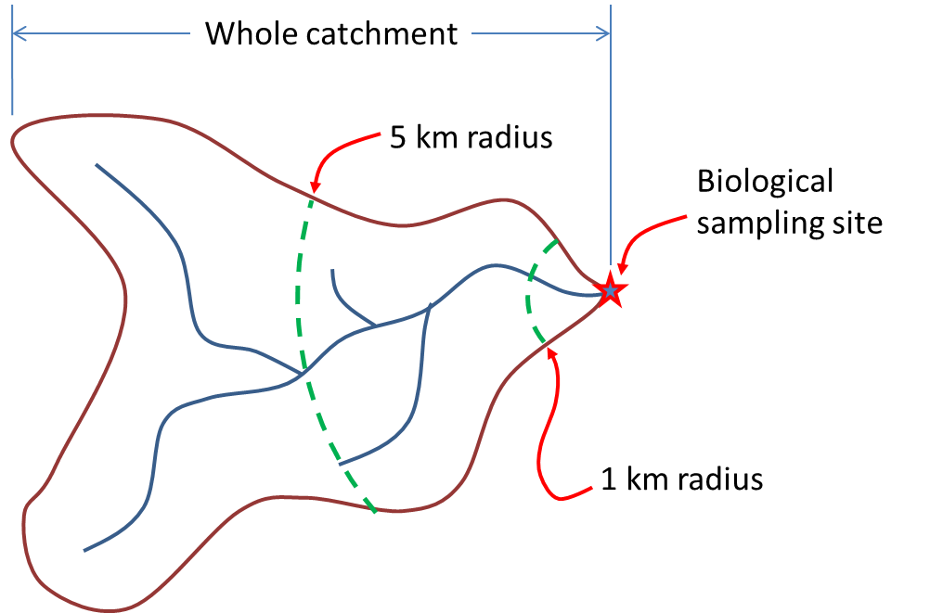

**Figure 1.** Geospatial data for streams were generated at 3 spatial scales: total watershed, 1-km and 5-km.

For lakes, we used GIS software to generate data for 4 spatial scales: total contributing watershed and 100-m, 500-m and 1-km buffers around the lakes, as shown in Figure 2. The most downstream portion of the lake was identified using the NHD plus flowline layer. From this resulting point the total contributing watershed area (catchment) was determine by calculating all surface water that drains to it. The process was completed using ArcHydro custom watershed delineation.

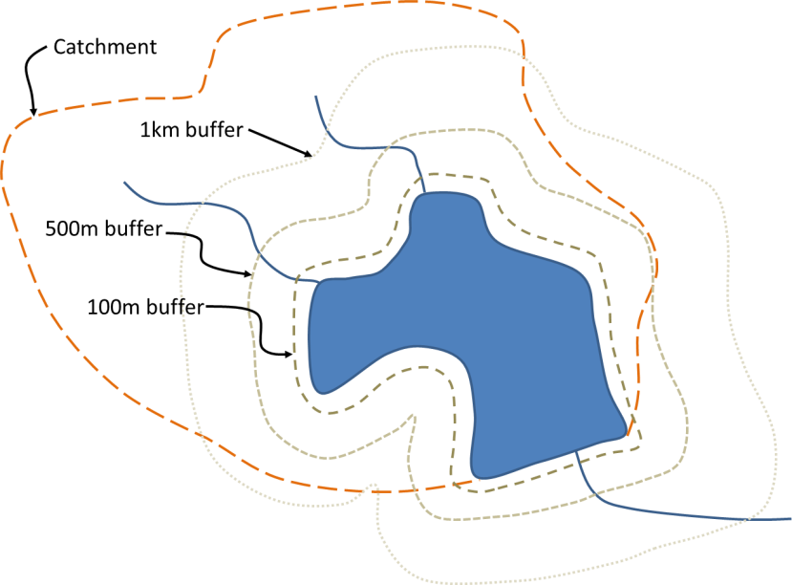

**Figure 2**. Geospatial data for lakes were generated at 4 spatial scales: total contributing watershed and 100-m, 500-m and 1-km buffer around the lake.

The geospatial data were used for the classification analyses and to screen sites for disturbance.

Tetra Tech used the following references when selecting parameters to generate for the disturbance screening process:

* Esselman, P.C., Infante, D.M., Wang, L., Wu, D., Cooper, A.R., Taylor, W.W., 2011. An index of cumulative disturbance to river fish habitats of the conterminous United States from landscape anthropogenic activities. Ecol. Restor. 29: 133–151.
* Sass, L., Hinz, L.C., Epifaniol, J. and A.M. Holtrop. 2010. Developing a Multimetric Habitat Index for Wadeable Streams in Illinois. Prepared for Illinois Natural History Survey, Project Number: (T-25-P-001).
* Smogor, R. 2000. Draft manual for calculating Index of Biotic Integrity scores for streams in Illinois. Prepared for: Illinois Environmental Protection Agency and Illinois Department of Natural Resources. 23 pp.

One of the sets of data that was used for disturbance screening was land use. Table 1 contains a list of the land use parameters that were generated for both streams and lakes (at each spatial scale). The source of these data was the 2006 National Land Cover Database (NLCD) dataset (<http://www.mrlc.gov/nlcd06_data.php>) (Fry et al. 2011). Some of these parameters were later combined to generate land use indexes. Examples include:

* % Agriculture = % Cultivated Crops (code 82) + % Pasture/Hay (code 81)
* % Urban = % Developed, Low Intensity (code 22) + % Developed, Medium Intensity

(code 23) + % Developed, High Intensity (code 24)

Table 2 contains a list of the other geospatial data that were generated by Tetra Tech for their analyses.

**Table 1**. Land use data that were generated for both streams and lakes. Source: 2006 National Land Cover Database (NLCD) dataset (<http://www.mrlc.gov/nlcd06_data.php>).

|  |  |
| --- | --- |
| **Code** | **Description** |
|  | % Impervious cover |
| PNLCD_11 | % Open Water |
| PNLCD_21 | % Developed, Open Space |
| PNLCD_22 | % Developed, Low Intensity |
| PNLCD_23 | % Developed, Medium Intensity |
| PNLCD_24 | % Developed, High Intensity |
| PNLCD_31 | % Barren |
| PNLCD_41 | % Deciduous Forest |
| PNLCD_42 | % Evergreen Forest |
| PNLCD_43 | % Mixed Forest |
| PNLCD_52 | % Shrub/Scrub |
| PNLCD_71 | % Grassland/Herbaceous |
| PNLCD_81 | % Pasture/Hay |
| PNLCD_82 | % Cultivated Crops |
| PNLCD_90 | % Woody Wetlands |
| PNLCD_95 | % Emergent Herbaceous Wetlands |

**Table 2.** List of non-land use geospatial data generated by Tetra Tech (at each spatial scale).

|  |  |  |
| --- | --- | --- |
| **Parameter** | **Metrics** | **Source** |
| Drainage area (streams only) | Drainage areas based on exact watershed delineations (km2, mi2, m2, acres) | Delineations generated by Tetra Tech using GIS software (ArcGIS 10.0) and National Hydrography Dataset Plus Version 2 (NHDPlusV2) |
| Strahler order | Strahler order | NHDPlusV2 |
| Elevation | Elevation of the site (m, ft) | NHDPlusV2 & National Elevation Dataset (NED) (http://ned.usgs.gov/) |
| Flowline slope (streams only) | Slope of flowline (meters/meters) based on smoothed elevations | NHDPlusV2: http://www.horizon-systems.com/NHDPlus/NHDPlusV2_home.php |
| Flowline feature type (FTYPE) (streams only) | Type of flowline that the site is located on (e.g., stream/river, canals/ditches, pipelines) |
| EPA ecoregion (Level 3 & 4) | EPA ecoregion that the site is located in | Ecoregions of Illinois: http://www.epa.gov/wed/pages/ecoregions/il_eco.htm |
| Proportion of total watershed in each Level 3 ecoregion (some catchments span multiple ecoregions) |
| Dams | # of dams | National Atlas of the United States. 2006. Major Dams of the United States: National Atlas of the United States, Reston, VA. Available online: http://nationalatlas.gov/atlasftp.html#dams00x |
| Maximum reservoir storage |
| Mines | # of mines | U.S. Geological Survey (USGS). 2005. Active mines and mineral processing plants in the United States in 2003. http://mrdata.usgs.gov/mineplant/ |
| # of sand & gravel mines |
| Roads | # of roads crossing streams | Illinois Department of Transportation: http://gis.dot.illinois.gov/gist2/  Indiana Department of Transportation, Business Information and Technology Systems, GIS mapping:  <http://igs.indiana.edu/arcims/statewide/download.html>  Statewide TIGER 2010 shapefiles for Wisconsin: <http://legis.wisconsin.gov/ltsb/wiselr/data.htm> |
| # of road miles |
| Coal mines | # of active surface and auger coal mines | Illinois Coal Resource Shapefiles: http://www.isgs.illinois.edu/research/coal/shapefiles |

**Table 2** continued…

|  |  |  |
| --- | --- | --- |
| **Parameter** | **Metrics** | **Source** |
| National Pollutant Discharge Elimination System (NPDES) Majors from the Permit Compliance System | Count of NPDES major permits | U.S. Environmental Protection Agency. Geospatial data download service - Geospatial information for all publicly available FRS facilities that have latitude/longitude data [file geodatabase]. Accessed August 27, 2013. Available online: http://www.epa.gov/enviro/geo_data.html |
| Superfund National Priorities List (SNPL) from the Compensation and Liability Information System | Count of SNPL sites |
| Toxics Release Inventory (TRI) Program | Count of TRI sites |

Tetra Tech performed quality assurance and quality control procedures to screen for errors in the geospatial data. Tt was unable to check all of the stream data due to the large number of sites (n=1234). Also, delineating watersheds in some parts of the state was difficult due to flow alteration (e.g., the Calumet River system south of Lake Michigan). Tetra Tech used the following procedures to screen for errors: desktop screening in Google Earth; plotting drainage area vs. stream width and looking for outliers (streams only); and communicating with IEPA staff and others with local knowledge to verify data that appeared questionable.

**Literature Cited**

Esselman, P.C., Infante, D.M., Wang, L., Wu, D., Cooper, A.R., Taylor, W.W., 2011. An index of cumulative disturbance to river fish habitats of the conterminous United States from landscape anthropogenic activities. Ecol. Restor. 29: 133–151.

Fry, J., Xian, G., Jin, S., Dewitz, J., Homer, C., Yang, L., Barnes, C., Herold, N., and Wickham, J., 2011. [Completion of the 2006 National Land Cover Database for the Conterminous United States](http://www.mrlc.gov/downloadfile2.php?file=September2011PERS.pdf), *PE&RS*, Vol. 77(9):858-864

Michigan State University (MSU) Department of Fisheries and Wildlife, Peter C. Esselman, Dana M. Infante, LizhuWang, WilliamW. Taylor, WesleyM. Daniel, Ralph Tingley, Jacqueline Fenner, Arthur Cooper, DanielWieferich, Darren Thornbrugh, and Jared Ross, 2011, National FishHabitat Action Plan (NFHAP) 2010 HCI Scores and Human Disturbance Data for Conterminous United States linked to NHDPLUSV1:National Fish Habitat Action Plan (NFHAP), Denver, CO.

Omernik, J.M. 1987. Ecoregions of the Conterminous United States. Annals of the Association of American Geographers 77(1): 118-125.

Sass, L., Hinz, L.C., Epifaniol, J. and A.M. Holtrop. 2010. Developing a Multimetric Habitat Index for Wadeable Streams in Illinois. Prepared for Illinois Natural History Survey, Project Number: (T-25-P-001).

Smogor, R. 2000. Draft manual for calculating Index of Biotic Integrity scores for streams in Illinois. Prepared for: Illinois Environmental Protection Agency and Illinois Department of Natural Resources. 23 pp.

# Appendix B. Lake Reference Designations.

| Station | Lake Name | Unit | Tt rating | IEPA rating | reason/human impact |
| --- | --- | --- | --- | --- | --- |
| QZV | Sand Pond | North | Other | NearRef | Northeastern lake, set within a IDNR managed park. Least disturbed condition for area. |
| RDU | Depue | North | Strss | Strss |  |
| RGB | Diamond | North | XStrs | XStrs |  |
| RGD | Silver | North | XStrs | Strss | NPDES permit and superfund, but lake water quality very high, good habitat, and lake is set inside a forest preserve |
| RGI | Gages | North | XStrs | Other | high quality glacial lake, although shoreline developed habitat is still high quality |
| RGK | Grays | North | XStrs | Other | Lake is highly developed, but high quality habitat exists in the lake, a lot of shoreline is natural |
| RGZA | Crooked | North | Other | Other |  |
| RGZQ | Axehead | North | XStrs | XStrs |  |
| RGZX | Busse Woods | North | XStrs | XStrs |  |
| RHA | Wolf | North | XStrs | XStrs |  |
| RHD | Maple | North | Other | NearRef | high quality lake in NE IL, set inside a preserve. Most of the shoreline is natural and undeveloped |
| RHZE | Arrowhead | North | XStrs | XStrs |  |
| RML | George | North | NearRef | NearRef | in lake human impacts due to draw downs, little to no plants |
| RMM | Galena | North | NearRef | Strss | Very developed shoreline, golf course impacts, frequent algal blooms |
| RPC | Pierce | North | Other | NearRef | in a large state park, some in lake management, but good natural shoreline, some high quality plants |
| RPD | Johnson Sauk Trail | North | Other | Strss | lake very impacted from ag and silt, frequent harmful algae blooms |
| RPE | Cherry Valley | North | Other | NearRef | good habitat some in lake management. In a park, little development for the area |
| RPF | Carlton | North | NearRef | NearRef |  |
| RPK | Black Oak | North | NearRef | Other | small shallow, silted lake. Ag impacted |
| RPM | Woodhaven | North | Other | Other |  |
| RTH | Round | North | XStrs | Strss | developed shoreline, but excellent habitat, some natural areas |
| RTI_RTD | Channel/Catherine | North | Strss | Strss |  |
| RTK | Cedar | North | Other | Ref | developed but little management interference, high quality glacial lake, T&E plant species, good least distrubed for NE IL |
| RTR | Marie | North | Other | Other |  |
| RTY | Griswold | North | Other | NearRef | developed but low in lake management, very high quality habitat present |
| RTZD | Mccullom | North | XStrs | XStrs |  |
| RTZI | Island | North | Other | XStrs | overly managed and developed lake, failing septics present on lake |
| VTD | Deep | North | Other | NearRef | very high quality glacial lake, good habitat a lot of natural shoreline, represents least disturbed in NE IL |
| VTI | Grassy | North | Strss | Strss |  |
| VTU | Shabbona | North | NearRef | NearRef |  |
| VTX | Holiday | North | Other | Other |  |
| VTZH | Crystal | North | XStrs | XStrs |  |
| WGM | Herrick | North | Other | Other |  |
| WGZJ | Sterling | North | Strss | NearRef | high quality habitat, in a forest preserve, represents least disturbed in NE IL |
| RBL | Paris Twin East | Cent | Other | Other |  |
| RBW | Mill Creek Pond | Cent | NearRef | NearRef |  |
| RBX | Paris Twin West | Cent | Other | Other |  |
| RCE | Sara | Cent | Other | Other |  |
| RCF | Mattoon | Cent | XStrs | Other | this lake does have some human impacts, however the in lake habitat is good. |
| RCG | Paradise | Cent | Other | Strss | heavy siltation, shoreline habitat poor |
| RCJ | Altamont New | Cent | Other | NearRef | little human impact, set back from disturbances, habitat good |
| RDB | Siloam Springs | Cent | NearRef | NearRef |  |
| RDD | Canton | Cent | Other | Strss | some mining impacts, shoreline overly developed, habitat suffers |
| RDE | Argyle | Cent | Other | Other |  |
| RDF | Otter | Cent | NearRef | Strss | bacteria problems, over managed for Public Water Supply, highly developed shoreline |
| RDG | Carlinville | Cent | Other | Other |  |
| RDI | Jacksonville | Cent | Strss | Other | in lake habitat ok, some development |
| RDO | Bloomington | Cent | Other | XStrs | in lake habitat very poor, developed, all steel retention walls |
| RDZF | Greenfield | Cent | Other | Strss | human impacts from lake management poor habitat |
| RDZP | Palmyra-Modesto | Cent | Other | XStrs | golf course impacts, suffers routine harmful algal blooms |
| REA | Decatur | Cent | Strss | XStrs | factory impacts, suffers fish kills |
| REB | Sangchris | Cent | XStrs | Other | high water quality and good habitat, but does have development around the lake |
| REC | Taylorville | Cent | NearRef | Strss | suffers from fish kills, historic coal ash contamination, high incidences in the area of cancer |
| REI | Clinton | Cent | NearRef | Strss | frequent recreational use boating and fishing, thermal impacts/power plant cooling lake |
| REZP | Prairie | Cent | NearRef | NearRef |  |
| REZQ | Gridley | Cent | Other | NearRef | In the same park as Prairie, similar good habiata |
| REZR | Drake | Cent | Other | NearRef | In the same park as Prairie, similar good habiata |
| RJA | Staunton | Cent | Other | Other |  |
| ROL | Glenn Shoals | Cent | NearRef | Other | developed poor shoreline habitat |
| ROT | Hillsboro Old | Cent | Other | Strss | heavy shoreline development, country club |
| SDC | Waverly | Cent | NearRef | NearRef |  |
| SDL | Mauvaise Terre Cr | Cent | Other | XStrs | silted and overly developed lake, poor habitat |
| SDS | Eureka | Cent | Other | Other |  |
| RAF | Glen O Jones | South | Ref | NearRef | in lake phosphorus fertilization, campground, marina/concession area, good water quality |
| RAM | Dutchman | South | NearRef | NearRef | water quality is fairly good, has less in lake disturbances than Herrin New and Pinckneyville (listed as Reference) |
| RAP | Glendale | South | Ref | NearRef | some in lake human impacts, beach and campground, very good water quality and habitat |
| RAQ | One Horse Gap | South | Ref | Ref |  |
| RAW | Vienna City | South | Other | Other |  |
| RAZA | Mcleansboro | South | Other | Other |  |
| RAZI | Bloomfield | South | Other | Other |  |
| RAZN | Tecumseh | South | Ref | Ref |  |
| RBB | Red Hills | South | NearRef | NearRef | shoreline partially developed - restaurant, campground |
| RBZH | Beall Woods | South | Other | NearRef | good in lake habitat, fair water quality, half of lake shoreline mowed picnic/play area |
| RCC | Olney East Fork | South | Other | Other |  |
| RCT | Wayne City | South | Other | Other |  |
| RIA | Horseshoe | South | Other | Other |  |
| RIE | Dongola City | South | Other | Other |  |
| RJC | Horseshoe | South | Strss | XStrs | near E. St. Louis, highly industrial area, refineries, fish advisories |
| RNA | Crab Orchard | South | NearRef | Other | upper end shallow from siltation, PCB problems fish contamination, beach, high boat traffic, campground |
| RNB | Rend | South | Other | Other |  |
| RNC | Kinkaid | South | Other | NearRef | some development - beach, marina, boat ramps, picnic areas, high boat traffic, a lot of shoreline rip rap, habitat & water quality is good |
| RND | Murphysboro | South | NearRef | Other | campground, concession area |
| RNE | Cedar | South | Ref | NearRef | human impacts from beach and boat ramp areas, high water quality, good habitat |
| RNG | Duquoin | South | Other | Other |  |
| RNH | Pinckneyville | South | Ref | Other | some developed shoreline, Public Water Supply, ag in watershed |
| RNI | Carbondale | South | Other | Other |  |
| RNK | Little Grassy | South | Ref | NearRef | human impacts from beaches and campgrounds, high water quality, good habitat |
| RNL | Marion | South | Other | Other |  |
| RNO | Benton | South | Other | Other |  |
| RNP | West Frankfort Old | South | Other | Other |  |
| RNQ | West Frankfort New | South | NearRef | Strss | suffers from frequent algal blooms, highest level of microcystin in IL in 2013, shoreline development - homes, beach, camps |
| RNZC | Herrin New | South | Ref | Other | frequent algal blooms, toxins |
| RNZK | Boulder South | South | Ref | Ref |  |
| ROK | Raccoon | South | NearRef | Strss | heavy siltation, development around shoreline, ag in watershed, fairly poor water quality |
| ROO | Nashville | South | Other | Other |  |
| ROP | Governor Bond | South | NearRef | Strss | heavy silt, aeration system in place, high boat traffic, shoreline erosion, ag in watershed |
| ROR | Salem | South | Other | Strss | heavy ag runoff, develped shoreline, hospital, water plant, possible bacteria problems related to large population of wintering Canada Geese |
| ROY | Patriot'S Park | South | Other | Strss | frequent harmful algal blooms, some shoreline development, park, home, picnic area |
| ROZA | Highland Silver | South | Other | Strss | frequent algae problems, public water supply, algae grows on filtration system, fish advisory |
| ROZY | Kinmundy Old | South | Other | Other |  |
| SOC | Sparta New | South | Other | Other |  |
| SOF | Kinmundy New | South | XStrs | Other | fairly new lake, decent water quality, some development in watershed |

# Appendix C. Metric Sensitivity.

Metric discrimination efficiency (DE), trend with increasing stress (-/+), and Z-scores in three site classes (Northern, Central, and Southern) and three habitat configurations (all habitats, littoral habitats, and profundal habitats). When DE were <30, the metric trend was deemed not responsive (nr). Z-scores with high (>0.8) and low (<0.5) absolute values were emphasized and de-emphasized by font boldness.

Table C-1.

|  | **All 5 Lake Habitats** | | | | | | **3 Littoral Habitats** | | | | | |
| --- | --- | --- | --- | --- | --- | --- | --- | --- | --- | --- | --- | --- |
|  | Northern | | Central | | Southern | | Northern | | Central | | Southern | |
| Metric | DE (-/+) | Z-score | DE (-/+) | Z-score | DE (-/+) | Z-score | DE (-/+) | Z-score | DE (-/+) | Z-score | DE (-/+) | Z-score |
| ni_total | 57 (+) | -0.49 | <30 (nr) | 0.41 | <30 (nr) | 0.47 | 50 (+) | -0.40 | 55 (-) | 0.45 | <30 (nr) | 0.46 |
| nt_total | 36 (-) | 0.27 | 36 (-) | 0.64 | 57 (-) | **1.13** | 36 (+) | -0.17 | 64 (-) | 0.71 | 71 (-) | **1.49** |
| nt_Coleo | 57 (-) | 0.71 | 36 (-) | -0.01 | <30 (nr) | -0.06 | 57 (-) | 0.76 | 36 (-) | -0.01 | <30 (nr) | -0.06 |
| nt_Trich | <30 (nr) | 0.27 | 73 (-) | **1.38** | <30 (nr) | **0.91** | <30 (nr) | 0.19 | 73 (-) | **1.38** | <30 (nr) | **0.99** |
| nt_EPT | <30 (nr) | 0.30 | 36 (-) | **1.09** | 71 (-) | **1.00** | <30 (nr) | 0.16 | 55 (-) | **1.18** | 86 (-) | **1.07** |
| nt_ECT | 36 (-) | 0.57 | 55 (-) | **0.92** | <30 (nr) | 0.77 | 43 (-) | 0.56 | 55 (-) | **1.00** | 43 (-) | 0.78 |
| nt_Dipt | <30 (nr) | -0.48 | <30 (nr) | -0.26 | 57 (-) | **1.08** | 71 (+) | **-1.08** | <30 (nr) | -0.07 | 57 (-) | **1.40** |
| nt_Chiro | 50 (+) | -0.52 | <30 (nr) | -0.39 | 57 (-) | **1.11** | 57 (+) | **-1.20** | <30 (nr) | -0.26 | 57 (-) | **1.30** |
| nt_NonIns | 43 (-) | 0.39 | <30 (nr) | 0.73 | <30 (nr) | 0.42 | 57 (-) | 0.45 | <30 (nr) | 0.77 | 57 (-) | **0.89** |
| nt_CruMol | 36 (-) | 0.38 | 36 (-) | **0.92** | 43 (-) | 0.77 | 43 (-) | 0.45 | 45 (-) | **0.97** | 57 (-) | **1.19** |
| pt_EPT | 36 (-) | 0.14 | 73 (-) | 0.69 | 71 (-) | 0.63 | 36 (-) | 0.26 | 64 (-) | 0.66 | 71 (-) | 0.42 |
| pt_Dipt | 57 (+) | **-1.00** | 55 (+) | **-1.04** | <30 (nr) | -0.39 | 64 (+) | **-1.34** | <30 (nr) | **-0.95** | 43 (+) | -0.42 |
| pt_NonIns | <30 (nr) | 0.31 | 45 (-) | 0.63 | 43 (+) | -0.43 | <30 (nr) | 0.51 | <30 (nr) | 0.55 | 57 (-) | 0.06 |
| pi_EPT | <30 (nr) | 0.43 | <30 (nr) | 0.10 | 86 (-) | 0.71 | <30 (nr) | 0.46 | <30 (nr) | 0.21 | 86 (-) | 0.22 |
| pi_OCT | 36 (-) | 0.61 | 73 (-) | 0.22 | 71 (-) | 0.80 | 36 (-) | 0.58 | 55 (-) | 0.39 | 71 (-) | **0.86** |
| pi_Ephem | <30 (nr) | 0.10 | 45 (+) | -0.33 | <30 (nr) | 0.16 | <30 (nr) | 0.15 | 36 (+) | -0.11 | <30 (nr) | -0.18 |
| pi_Trich | 64 (-) | 0.57 | <30 (nr) | 0.48 | 71 (-) | **0.97** | 64 (-) | 0.51 | <30 (nr) | 0.47 | 71 (-) | 0.69 |
| pi_Dom01 | 57 (+) | -0.21 | <30 (nr) | 0.29 | <30 (nr) | -0.26 | <30 (nr) | 0.05 | <30 (nr) | 0.08 | 43 (+) | -0.52 |
| pi_Coleo | 57 (-) | 0.45 | 36 (-) | 0.23 | <30 (nr) | 0.54 | 64 (-) | 0.50 | 36 (-) | 0.13 | <30 (nr) | 0.51 |
| pi_Odon | 36 (+) | 0.16 | 45 (-) | -0.09 | 57 (-) | 0.60 | 36 (+) | 0.13 | 36 (-) | 0.19 | 71 (-) | 0.64 |
| pi_Dipt | 57 (+) | -0.72 | 73 (+) | **-0.88** | <30 (nr) | -0.52 | 64 (+) | **-0.88** | 82 (+) | **-1.22** | 71 (+) | **-1.01** |
| pi_Chiro | 50 (+) | -0.75 | 82 (+) | **-1.17** | 86 (+) | **-0.93** | 64 (+) | **-0.81** | 82 (+) | **-1.26** | 71 (+) | **-1.01** |
| pi_Tanyt | <30 (nr) | -0.30 | 73 (+) | **-5.46** | <30 (nr) | 0.50 | <30 (nr) | -0.33 | 73 (+) | **-11.88** | 43 (-) | 0.49 |
| pi_NonIns | 36 (-) | 0.42 | 64 (-) | **0.99** | <30 (nr) | 0.25 | 43 (-) | 0.55 | 91 (-) | **1.39** | 57 (-) | 0.71 |
| nt_scrap | 43 (-) | 0.42 | 45 (-) | 0.67 | 71 (-) | **1.29** | 50 (-) | 0.48 | 55 (-) | 0.67 | 71 (-) | **1.31** |
| pi_scrap | 64 (-) | 0.36 | 36 (-) | 0.43 | 57 (-) | 0.70 | 64 (-) | 0.46 | 36 (-) | 0.44 | 57 (-) | **0.82** |
| nt_shred | <30 (nr) | -0.21 | 64 (+) | **-0.81** | 57 (-) | **1.04** | <30 (nr) | -0.38 | 55 (+) | **-0.88** | 57 (-) | **1.02** |
| pi_shred | 36 (+) | **-0.90** | 73 (+) | **-5.23** | 43 (-) | 0.29 | 36 (+) | **-0.90** | 73 (+) | **-5.73** | 43 (+) | 0.09 |
| nt_cllct | <30 (nr) | -0.51 | <30 (nr) | -0.02 | **71 (-)** | **1.47** | 57 (+) | **-1.12** | <30 (nr) | 0.07 | 71 (-) | **1.73** |
| pi_cllct | 50 (+) | 0.10 | 36 (-) | 0.34 | <30 (nr) | 0.20 | 50 (+) | 0.13 | 73 (-) | 0.64 | 43 (-) | **0.81** |
| pi_filtr | 50 (+) | -0.42 | 91 (+) | -0.52 | 71 (+) | **-1.55** | 57 (+) | -0.42 | 91 (+) | -0.68 | 71 (+) | **-1.82** |
| nt_pred | <30 (nr) | 0.15 | 36 (-) | 0.60 | 43 (-) | 0.65 | <30 (nr) | -0.11 | 55 (-) | 0.73 | 43 (-) | **1.00** |
| pi_pred | 36 (-) | 0.03 | <30 (nr) | 0.31 | 71 (-) | 0.64 | 36 (+) | -0.10 | <30 (nr) | 0.49 | 43 (-) | 0.56 |
| pi_clngr | 50 (+) | **-1.23** | 64 (+) | **-1.63** | 100 (-) | **0.99** | 50 (+) | **-1.26** | 73 (+) | **-1.29** | 57 (-) | **0.95** |
| nt_clngr | <30 (nr) | -0.03 | 64 (-) | **0.96** | 43 (-) | **0.91** | <30 (nr) | -0.09 | <30 (nr) | 0.57 | 57 (-) | **0.99** |
| pi_brrwr | 50 (+) | -0.44 | 64 (+) | **-0.80** | 86 (+) | **-1.23** | 57 (+) | -0.54 | 82 (+) | -0.79 | 100 (+) | **-1.17** |
| nt_brrwr | <30 (nr) | -0.06 | 36 (-) | 0.26 | 71 (-) | **0.91** | <30 (nr) | -0.33 | 36 (-) | 0.40 | 71 (-) | **1.18** |
| nt_clmbr | 43 (-) | **0.80** | 55 (-) | 0.75 | 57 (-) | **1.01** | 43 (-) | 0.74 | 64 (-) | **0.96** | 57 (-) | **1.08** |
| nt_sprwlr | <30 (nr) | 0.13 | 36 (-) | 0.75 | 43 (-) | **0.94** | <30 (nr) | -0.42 | 36 (-) | **0.83** | 57 (-) | **1.59** |
| pi_clmbr | 50 (-) | 0.25 | 55 (+) | -0.50 | 43 (-) | 0.31 | 43 (-) | 0.36 | 36 (+) | -0.10 | 43 (-) | 0.32 |
| pi_sprwl | 36 (-) | 0.34 | 91 (-) | **1.21** | 43 (-) | 0.70 | <30 (nr) | 0.31 | 82 (-) | **1.10** | 57 (-) | 0.63 |
| pi_EPT123 | 71 (-) | 0.33 | <30 (nr) | 0.45 | <30 (nr) | 0.33 | 64 (-) | 0.36 | <30 (nr) | 0.40 | <30 (nr) | 0.23 |
| nt_EPT123 | 57 (-) | 0.79 | <30 (nr) | **0.86** | <30 (nr) | 0.62 | 57 (-) | 0.79 | <30 (nr) | **0.86** | <30 (nr) | 0.62 |
| nt_BCG123 | <30 (nr) | 0.09 | <30 (nr) | 0.77 | 57 (-) | **0.85** | <30 (nr) | -0.06 | <30 (nr) | 0.62 | 57 (-) | **1.04** |
| pi_BCG123 | 36 (-) | 0.45 | 36 (+) | **-0.81** | 43 (+) | -0.22 | <30 (nr) | 0.46 | 45 (+) | **-1.03** | 57 (-) | 0.13 |
| pi_BCG56 | 50 (+) | **-1.33** | 64 (+) | -0.69 | 86 (+) | **-1.79** | 50 (+) | **-1.42** | 82 (+) | -0.63 | 71 (+) | **-1.67** |
| nt_intol | <30 (nr) | -0.35 | <30 (nr) | 0.36 | 43 (-) | **1.22** | <30 (nr) | -0.52 | <30 (nr) | 0.42 | 43 (-) | **1.33** |
| nt_toler | <30 (nr) | 0.19 | 36 (+) | -0.56 | <30 (nr) | 0.29 | 43 (+) | -0.24 | <30 (nr) | -0.29 | <30 (nr) | 0.56 |
| pi_intol | <30 (nr) | 0.46 | 36 (+) | -0.70 | <30 (nr) | 0.14 | <30 (nr) | 0.44 | 36 (+) | **-0.82** | <30 (nr) | -0.05 |
| pi_toler | 50 (+) | **-0.82** | 73 (+) | -0.71 | 71 (+) | **-1.13** | 57 (+) | **-1.27** | 82 (+) | **-0.84** | 71 (+) | **-1.26** |
| pt_intol | 50 (+) | -0.58 | <30 (nr) | -0.06 | 43 (-) | 0.58 | 50 (+) | -0.52 | <30 (nr) | -0.35 | 43 (-) | 0.46 |
| pt_toler | <30 (nr) | 0.00 | 82 (+) | **-1.27** | 71 (+) | **-1.93** | <30 (nr) | -0.30 | 64 (+) | **-1.62** | 43 (+) | **-1.82** |
| x_Beck | 36 (-) | 0.25 | 36 (-) | 0.57 | 57 (-) | **0.89** | 36 (+) | -0.03 | 55 (-) | 0.62 | 57 (-) | **1.28** |
| x_HBI | 50 (+) | -0.73 | 64 (+) | -0.67 | 86 (+) | **-1.58** | 57 (+) | **-0.87** | 82 (+) | -0.72 | 71 (+) | **-1.35** |
| x_Shan_2 | <30 (nr) | 0.23 | 36 (+) | -0.52 | 43 (-) | 0.54 | 36 (-) | -0.03 | <30 (nr) | -0.13 | 57 (-) | 0.71 |

Table C-2.

|  | **Profundal and Sublittoral Habitats** | | | | | |
| --- | --- | --- | --- | --- | --- | --- |
|  | Northern | | Central | | Southern | |
| Metric | DE (-/+) | Z-score | DE (-/+) | Z-score | DE (-/+) | Z-score |
| ni_total | <30 (nr) | **-1.06** | <30 (nr) | 0.20 | <30 (nr) | 0.23 |
| nt_total | <30 (nr) | 0.09 | 55 (+) | **-1.03** | <30 (nr) | -0.33 |
| nt_Coleo | <30 (nr) | -0.41 | <30 (nr) | -0.34 | <30 (nr) |  |
| nt_Trich | <30 (nr) | 0.46 | <30 (nr) | -0.58 | <30 (nr) | 0.06 |
| nt_EPT | <30 (nr) | 0.38 | 55 (+) | **-2.03** | <30 (nr) | -0.10 |
| nt_ECT | <30 (nr) | 0.20 | 64 (+) | **-1.19** | <30 (nr) | -0.10 |
| nt_Dipt | <30 (nr) | -0.21 | 64 (+) | **-1.16** | <30 (nr) | -0.30 |
| nt_Chiro | 36 (+) | -0.31 | 45 (+) | **-1.06** | <30 (nr) | -0.59 |
| nt_NonIns | <30 (nr) | 0.11 | <30 (nr) | 0.39 | 57 (+) | **-1.40** |
| nt_CruMol | <30 (nr) | 0.13 | <30 (nr) | 0.55 | <30 (nr) | **-0.87** |
| pt_EPT | <30 (nr) | 0.37 | 55 (+) | **-1.42** | <30 (nr) | -0.20 |
| pt_Dipt | <30 (nr) | -0.24 | 45 (+) | -0.52 | <30 (nr) | 0.25 |
| pt_NonIns | <30 (nr) | 0.04 | 82 (-) | **1.02** | 57 (+) | -0.66 |
| pt_intol | <30 (nr) | 0.39 | 36 (+) |  | 43 (+) | **-0.92** |
| pt_toler | <30 (nr) | -0.26 | 36 (-) | 0.62 | <30 (nr) | 0.17 |
| pi_EPT | <30 (nr) | **-1.22** | 55 (+) | **-2.33** | 43 (+) | -0.23 |
| pi_OCT | <30 (nr) | 0.24 | <30 (nr) | -0.38 | <30 (nr) | 0.37 |
| pi_Ephem | <30 (nr) | **-3.20** | 45 (+) |  | <30 (nr) | -0.18 |
| pi_Trich | <30 (nr) | 0.39 | <30 (nr) | -0.25 | <30 (nr) | **-0.88** |
| pi_Dom01 | 36 (+) | -0.71 | <30 (nr) | 0.78 | 57 (-) | **0.82** |
| pi_Coleo | <30 (nr) | -0.48 | <30 (nr) | 0.12 | <30 (nr) |  |
| pi_Odon | <30 (nr) | -0.11 | <30 (nr) | **-1.18** | <30 (nr) | 0.48 |
| pi_Dipt | 43 (+) | 0.26 | <30 (nr) | 0.01 | **57 (-)** | **1.93** |
| pi_Chiro | 50 (-) | 0.11 | 64 (+) | **-1.51** | **57 (+)** | **-1.80** |
| pi_Tanyt | <30 (nr) | -0.21 | 36 (+) | **-2.12** | 43 (+) | 0.18 |
| pi_NonIns | 43 (+) | -0.15 | <30 (nr) | 0.03 | 71 (+) | **-2.03** |
| pi_EPT123 | <30 (nr) |  | <30 (nr) |  | <30 (nr) |  |
| nt_EPT123 | <30 (nr) |  | <30 (nr) |  | <30 (nr) |  |
| nt_BCG123 | <30 (nr) | 0.36 | <30 (nr) | -0.66 | <30 (nr) | -0.60 |
| pi_BCG123 | <30 (nr) | 0.35 | <30 (nr) | 0.02 | 57 (+) | **-2.47** |
| pi_BCG56 | 43 (-) | -0.07 | 36 (+) | -0.22 | 86 (+) | **-1.57** |
| nt_scrap | <30 (nr) | -0.02 | <30 (nr) | -0.16 | <30 (nr) | 0.10 |
| pi_scrap | <30 (nr) | -0.15 | 36 (+) | -0.48 | <30 (nr) | 0.11 |
| nt_shred | 43 (+) | -0.24 | <30 (nr) | -0.14 | <30 (nr) | 0.13 |
| pi_shred | <30 (nr) | -0.01 | 36 (+) | **-4.57** | 43 (+) | -0.56 |
| nt_cllct | <30 (nr) | 0.24 | 45 (+) | **-1.80** | <30 (nr) | -0.51 |
| pi_cllct | 36 (+) | 0.05 | <30 (nr) | -0.25 | 71 (+) | **-1.39** |
| pi_filtr | <30 (nr) | -0.17 | 36 (+) | -0.60 | 71 (+) | -0.15 |
| nt_pred | 57 (-) | 0.44 | 36 (+) | **-1.20** | <30 (nr) | -0.05 |
| pi_pred | 36 (-) | 0.12 | 45 (-) | 0.44 | 71 (-) | **1.39** |
| pi_clngr | 36 (+) | -0.38 | 36 (+) | -0.55 | 43 (+) | 0.19 |
| nt_clngr | 50 (+) | -0.77 | <30 (nr) | -0.31 | <30 (nr) | 0.08 |
| pi_brrwr | 50 (-) | 0.34 | <30 (nr) | -0.21 | 71 (+) | **-1.58** |
| nt_brrwr | <30 (nr) | 0.16 | 73 (+) | **-2.09** | <30 (nr) | -0.15 |
| nt_clmbr | <30 (nr) | -0.10 | 64 (+) | -0.58 | <30 (nr) | 0.10 |
| nt_sprwlr | <30 (nr) | 0.40 | <30 (nr) | -0.63 | 71 (+) | -0.67 |
| pi_clmbr | 36 (-) | -0.54 | 73 (+) | **-6.14** | 43 (+) | -0.52 |
| pi_sprwl | 43 (+) | -0.12 | 55 (-) | 0.51 | 71 (-) | **1.51** |
| nt_intol | <30 (nr) | 0.51 | 36 (+) |  | 43 (+) | -0.17 |
| nt_toler | <30 (nr) | -0.02 | 36 (+) | **-0.94** | 43 (+) | **-0.93** |
| pi_intol | <30 (nr) | 0.36 | 36 (+) |  | 43 (+) | **-4.97** |
| pi_toler | 50 (+) | 0.17 | 55 (-) | 0.72 | 57 (-) | **1.13** |
| x_Beck | <30 (nr) | 0.59 | 45 (+) | **-0.97** | <30 (nr) | -0.12 |
| x_HBI | <30 (nr) | 0.04 | <30 (nr) | 0.25 | 57 (+) | **-0.93** |
| x_Shan_2 | 43 (-) | 0.60 | 36 (+) | **-0.97** | 57 (+) | **-1.03** |

# Appendix D. Taxa attributes for calculating the lake macroinvertebrate index.

| Final ID | Uniform Taxonomic Unita | Family | TolValb | TolVal Source | FFGc | FFG Source | Habitd | Habit Source |
| --- | --- | --- | --- | --- | --- | --- | --- | --- |
| **Nematomorpha** |  |  |  |  |  |  |  |  |
| Gordius | Gordius | Gordiidae |  |  |  | IEPA |  |  |
| **Platyhelminthes** |  |  |  |  |  |  |  |  |
| Turbellaria | Turbellaria |  | 6 | IEPA | PR | IEPA | SP | WSA |
| Dugesia | Dugesia | Planariidae | 6 | IEPA | CG,PR | WSA | SP | WSA |
| Dugesia tigrina | Dugesia | Planariidae | 6 | IEPA | PR | IEPA | SP | WSA |
| **Oligochaeta** |  |  |  |  |  |  |  |  |
| Oligochaeta | Oligochaeta |  | 10 | IEPA | CG | IEPA | BU | WSA |
| Lumbricidae | Lumbricidae | Lumbricidae |  |  |  |  |  |  |
| Ophidonais serpentina | Naididae | Naididae |  |  |  |  |  |  |
| Tubificidae | Tubificidae | Tubificidae |  |  |  |  |  |  |
| **Hirudinea** |  |  |  |  |  |  |  |  |
| Hirudinea | Hirudinea |  | 8 | IEPA | PR | IEPA | SP | WSA |
| Erpobdella | Erpobdella | Erpobdellidae | 8 | IEPA | PR | WSA | SP | WSA |
| Erpobdella punctata | Erpobdella | Erpobdellidae | 8 | IEPA | PR | IEPA |  |  |
| Erpobdellidae | Erpobdellidae | Erpobdellidae | 8 | IEPA | PR | IEPA | SP | WSA |
| Mooreobdella | Mooreobdella | Erpobdellidae | 8 | IEPA | PR | IEPA | SP | WSA |
| Mooreobdella microstoma | Mooreobdella | Erpobdellidae | 8 | IEPA | PR | IEPA |  |  |
| Hirudinidae | Hirudinidae | Hirudinidae | 8 | IEPA | PR | IEPA |  |  |
| Desserobdella phalera | Desserobdella | Glossiphoniidae |  |  |  |  |  |  |
| Glossiphoniidae | Glossiphoniidae | Glossiphoniidae | 8 | IEPA | PR | IEPA | SP | WSA |
| Helobdella | Helobdella | Glossiphoniidae | 8 | IEPA | PA | IEPA | SP | WSA |
| Helobdella stagnalis | Helobdella | Glossiphoniidae | 8 | IEPA | PR | IEPA | SP | WSA |
| Helobdella triserialis | Helobdella | Glossiphoniidae | 8 | IEPA | PA | IEPA |  |  |
| Placobdella | Placobdella | Glossiphoniidae | 8 | IEPA | PR | IEPA |  |  |
| Placobdella papillifera | Placobdella | Glossiphoniidae | 8 | IEPA | PA | IEPA |  |  |
| **Bivalvia** |  |  |  |  |  |  |  |  |
| Unionidae | Unionidae | Unionidae | 1.5 | IEPA | CF | IEPA | BU | WSA |
| Corbicula | Corbicula | Corbiculidae | 4 | IEPA | CF | IEPA | BU | WSA |
| Corbicula flumineum | Corbicula | Corbiculidae | 4 | IEPA |  | IEPA |  |  |
| Dreissena polymorpha | Dreissena | Dreissenidae |  |  |  | IEPA |  |  |
| Pisidiidae | Pisidiidae | Pisidiidae | 5 | IEPA | CF | RBP2 |  |  |
| Pisidium | Pisidium | Pisidiidae | 5 | IEPA | CF | IEPA | BU | WSA |
| Sphaerium | Sphaerium | Pisidiidae | 5 | IEPA | CG | IEPA | BU | WSA |
| Sphaeriidae | Sphaeriidae | Sphaeriidae | 5 | IEPA |  | IEPA |  |  |
| **Gastropoda** |  |  |  |  |  |  |  |  |
| Ancylidae | Ancylidae | Ancylidae | 7 | IEPA | SC | IEPA | CB | WSA |
| Ferrissia | Ferrissia | Ancylidae | 7 | IEPA | SC | IEPA | CB | WSA |
| Laevapex | Laevapex | Ancylidae | 6 | IEPA | SC | IEPA | CB | WSA |
| Fossaria | Fossaria | Lymnaeidae | 7 | IEPA | SC | IEPA | CB | WSA |
| Lymnaea | Lymnaea | Lymnaeidae | 7 | IEPA | SC | IEPA | CB | WSA |
| Lymnaeidae | Lymnaeidae | Lymnaeidae | 7 | IEPA | SC | IEPA | CB | WSA |
| Pseudosuccinea | Pseudosuccinea | Lymnaeidae | 7 | IEPA | SC | IEPA | CB | WSA |
| Physella | Physella | Physidae | 9 | IEPA | SC | IEPA | CB | WSA |
| Gyraulus | Gyraulus | Planorbidae | 6 | IEPA | SC | IEPA | CB | WSA |
| Helisoma | Helisoma | Planorbidae | 7 | IEPA | SC | IEPA | CB | WSA |
| Menetus | Menetus | Planorbidae | 6.5 | IEPA | SC | IEPA | CB | WSA |
| Planorbella | Planorbella | Planorbidae | 6.5 | IEPA | SC | IEPA | CB | WSA |
| Planorbidae | Planorbidae | Planorbidae | 6.5 | IEPA | SC | IEPA | CB | WSA |
| Planorbula | Planorbula | Planorbidae | 7 | IEPA | SC | IEPA |  |  |
| Promenetus | Promenetus | Planorbidae | 6.5 | IEPA | CG | IEPA | CB | WSA |
| Odostomia | Odostomia | Pyramidellidae | 10 | IEPA | CG | IEPA |  |  |
| Valvata | Valvata | Valvatidae | 2 | IEPA | SC | IEPA |  |  |
| Valvata tricarinata | Valvata | Valvatidae |  |  |  |  |  |  |
| Valvatidae | Valvatidae | Valvatidae |  |  | SC | RBP2 |  |  |
| Cipangopaludina chinensis | Cipangopaludina | Viviparidae |  |  |  |  |  |  |
| Viviparus | Viviparus | Viviparidae | 1 | IEPA | SC | IEPA | CB | WSA |
| Bithyniidae | Bithyniidae | Bithyniidae | 6 | IEPA |  | IEPA |  |  |
| Amnicola | Amnicola | Hydrobiidae | 4 | IEPA | SC | IEPA | CB | WSA |
| Hydrobiidae | Hydrobiidae | Hydrobiidae | 6 | IEPA | SC | IEPA | CB | WSA |
| Elimia | Elimia | Pleuroceridae | 6 | IEPA | SC | IEPA |  |  |
| Pleurocera | Pleurocera | Pleuroceridae | 7 | IEPA | SC | IEPA |  |  |
| **Amphipoda** |  |  |  |  |  |  |  |  |
| Crangonyx | Crangonyx | Crangonyctidae | 4 | IEPA | CG | IEPA | SP | WSA |
| Gammarus | Gammarus | Gammaridae | 3 | IEPA | CG,SH | WSA | SP | WSA |
| Gammarus fasciatus | Gammarus | Gammaridae | 3 | IEPA | CG | IEPA |  |  |
| Hyalella azteca | Hyalella | Hyalellidae | 5 | IEPA | CG | IEPA | SP | WSA |
| **Decapoda** |  |  |  |  |  |  |  |  |
| Cambaridae | Cambaridae | Cambaridae | 5 | IEPA | CG | IEPA | SP | WSA |
| Cambarus diogenes | Cambarus | Cambaridae | 5 | IEPA |  | IEPA |  |  |
| Orconectes | Orconectes | Cambaridae | 5 | IEPA | CG,SH | WSA | SP | WSA |
| Orconectes rusticus | Orconectes | Cambaridae | 5 | IEPA |  | IEPA |  |  |
| Orconectes virilis | Orconectes | Cambaridae | 5 | IEPA |  | IEPA |  |  |
| Palaemonetes kadiakensis | Palaemonetes | Palaemonidae | 4 | IEPA | OM | RBP2 |  |  |
| **Isopoda** |  |  |  |  |  |  |  |  |
| Caecidotea | Caecidotea | Asellidae | 6 | IEPA | CG | IEPA | SP | WSA |
| Lirceus | Lirceus | Asellidae | 4 | IEPA | CG | IEPA | SP | WSA |
| **Coleoptera** |  |  |  |  |  |  |  |  |
| Coleoptera | Coleoptera | Coleoptera | 4 | WSA | PR | IEPA |  |  |
| Curculionidae | Curculionidae | Curculionidae | 6 | WSA | SH | IEPA | CN | WSA |
| Helichus | Helichus | Dryopidae | 4 | IEPA | SH | IEPA | CN | WSA |
| Dytiscidae | Dytiscidae | Dytiscidae | 5 | WSA | PR | IEPA | CB, SW | WSA |
| Hydrovatus | Hydrovatus | Dytiscidae |  |  | PR | IEPA |  |  |
| Dubiraphia | Dubiraphia | Elmidae | 5 | IEPA | CG | IEPA | CN | WSA |
| Dubiraphia vittata | Dubiraphia | Elmidae | 7 | IEPA | OM | RBP2 | CN | RBP2 |
| Macronychus | Macronychus | Elmidae | 2 | IEPA | CG,SC | WSA | CN | WSA |
| Stenelmis | Stenelmis | Elmidae | 7 | IEPA | SC | IEPA | CN | WSA |
| Dineutus | Dineutus | Gyrinidae | 4 | IEPA | PR | IEPA | SW | WSA |
| Gyrinus | Gyrinus | Gyrinidae | 4 | IEPA | PR | IEPA | SW | WSA |
| Haliplus | Haliplus | Haliplidae | 6 | WSA | MH | IEPA | CB | WSA |
| Peltodytes | Peltodytes | Haliplidae | 5 | WSA | SH | IEPA | CB, CN | WSA |
| Berosus | Berosus | Hydrophilidae | 8 | WSA | PR | IEPA | SW | WSA |
| Enochrus | Enochrus | Hydrophilidae | 6 | WSA | CG | IEPA | BU | WSA |
| Hydrobius | Hydrobius | Hydrophilidae | 4 | WSA | PR | IEPA | CB, CN | WSA |
| Hydrophilidae | Hydrophilidae | Hydrophilidae | 5 | WSA | PR | IEPA | SW | WSA |
| Tropisternus | Tropisternus | Hydrophilidae | 6 | WSA | PR | IEPA | CB | WSA |
| Cyphon | Cyphon | Scirtidae | 7 | IEPA | SC | IEPA | CB | WSA |
| Scirtes | Scirtes | Scirtidae | 7 | IEPA | SH | IEPA | CB | WSA |
| Scirtidae | Scirtidae | Scirtidae | 7 | IEPA | SC | IEPA | CB | RBP2 |
| Staphylinidae | Staphylinidae | Staphylinidae |  |  |  |  |  |  |
| **Diptera: non-chironomidae** | |  |  |  |  |  |  |  |
| Diptera | Diptera |  | 10 | IEPA | CG | WSA | CB | WSA |
| Alluaudomyia paraspina | Alluaudomyia | Ceratopogonidae |  |  |  |  |  |  |
| Atrichopogon | Atrichopogon | Ceratopogonidae | 2 | IEPA | PR | IEPA | CN | WSA |
| Bezzia | Bezzia | Ceratopogonidae | 5 | IEPA | CG | IEPA | SP | WSA |
| Ceratopogon | Ceratopogon | Ceratopogonidae | 5 | IEPA | PR | IEPA | BU | WSA |
| Ceratopogonidae | Ceratopogonidae | Ceratopogonidae | 5 | IEPA | PR | IEPA | SP | WSA |
| Culicoides | Culicoides | Ceratopogonidae | 5 | IEPA | PR | IEPA | BU | WSA |
| Dasyhelea | Dasyhelea | Ceratopogonidae | 5 | IEPA | CG | IEPA | SP | WSA |
| Forcipomyia | Forcipomyia | Ceratopogonidae | 5 | IEPA | SC | IEPA | BU | WSA |
| Nilobezzia | Nilobezzia | Ceratopogonidae | 5 | IEPA | PR | IEPA | BU | WSA |
| Palpomyia | Palpomyia | Ceratopogonidae | 6 | IEPA | PR | IEPA | BU | WSA |
| Probezzia | Probezzia | Ceratopogonidae | 5 | IEPA | PR | IEPA | BU | WSA |
| Serromyia | Serromyia | Ceratopogonidae | 5 | IEPA | PR | WSA | BU | WSA |
| Sphaeromias | Sphaeromias | Ceratopogonidae | 5 | IEPA | PR | WSA | BU | WSA |
| Stilobezzia | Stilobezzia | Ceratopogonidae | 5 | IEPA | PR | WSA | SP | WSA |
| Chaoboridae | Chaoboridae | Chaoboridae | 8 | IEPA | PR | IEPA | SP | WSA |
| Chaoborus | Chaoborus | Chaoboridae | 8 | IEPA | PR | IEPA | SP | WSA |
| Aedes | Aedes | Culicidae | 8 | IEPA | CF | IEPA | SW | WSA |
| Anopheles | Anopheles | Culicidae | 6 | IEPA | CF | IEPA | SW | WSA |
| Culex | Culex | Culicidae | 8 | IEPA | CF | IEPA | SW | WSA |
| Culex erraticus | Culex | Culicidae | 8 | IEPA |  | IEPA |  |  |
| Culicidae | Culicidae | Culicidae | 8 | IEPA | CG | IEPA | SW | WSA |
| Dixa | Dixa | Dixidae | 10 | IEPA | CG | IEPA | CB | WSA |
| Dolichopodidae | Dolichopodidae | Dolichopodidae | 5 | IEPA | PR | IEPA | BU | WSA |
| Empididae | Empididae | Empididae | 6 | IEPA | PR | IEPA | SP | WSA |
| Ephydridae | Ephydridae | Ephydridae | 8 | IEPA | CG | IEPA | BU | WSA |
| Sciomyzidae | Sciomyzidae | Sciomyzidae | 10 | IEPA | PR | IEPA | BU | WSA |
| Stratiomyidae | Stratiomyidae | Stratiomyidae | 10 | IEPA | CG | IEPA | SP | WSA |
| Stratiomys | Stratiomys | Stratiomyidae | 10 | IEPA | CF | IEPA | SP | WSA |
| Chrysops | Chrysops | Tabanidae | 7 | IEPA | CG | IEPA | SP | WSA |
| Tabanidae | Tabanidae | Tabanidae | 7 | IEPA | PR | IEPA | SP | WSA |
| Tabanus | Tabanus | Tabanidae | 7 | IEPA | PR | IEPA | SP | WSA |
| Antocha | Antocha | Tipulidae | 5 | IEPA | CG | IEPA | CN | WSA |
| Dicranota | Dicranota | Tipulidae | 4 | IEPA | PR | IEPA | BU, SP | WSA |
| Tipula | Tipula | Tipulidae | 4 | IEPA | SH | IEPA | BU | WSA |
| Tipulidae | Tipulidae | Tipulidae | 4 | IEPA | SH | IEPA | BU | WSA |
| **Diptera: chironomidae** |  |  |  |  |  |  |  |  |
| Ablabesmyia | Ablabesmyia | Chironomidae | 6 | IEPA | CG | IEPA | SP | WSA |
| Ablabesmyia annulata | Ablabesmyia annulata | Chironomidae | 6 | IEPA | CG | WSA | SP | WSA |
| Ablabesmyia janta var ii | Ablabesmyia janta var ii | Chironomidae | 6 | IEPA |  | IEPA |  |  |
| Ablabesmyia mallochi | Ablabesmyia mallochi | Chironomidae | 6 | IEPA | CG | WSA | SP | WSA |
| Ablabesmyia peleensis | Ablabesmyia peleensis | Chironomidae | 6 | IEPA | OM | RBP2 | SP | RBP2 |
| Axarus | Axarus | Chironomidae | 6 | IEPA | CG | IEPA | SP | WSA |
| Chironomidae | Chironomidae | Chironomidae | 6 | IEPA | CG | IEPA | BU | WSA |
| Chironomini | Chironomini | Chironomidae | 6 | IEPA | CG | IEPA | BU | WSA |
| Chironomus | Chironomus | Chironomidae | 11 | IEPA | CG | IEPA | BU | WSA |
| Chironomus major | Chironomus | Chironomidae |  |  |  |  |  |  |
| Chironomus plumosus | Chironomus | Chironomidae |  |  |  |  |  |  |
| Cladopelma | Cladopelma | Chironomidae | 6 | IEPA | CG | IEPA | BU | WSA |
| Cladotanytarsus | Cladotanytarsus | Chironomidae | 7 | IEPA | CG | IEPA | CB | WSA |
| Cladotanytarsus species a | Cladotanytarsus | Chironomidae | 7 | IEPA |  | IEPA |  |  |
| Cladotanytarsus species b | Cladotanytarsus | Chironomidae | 7 | IEPA |  | IEPA |  |  |
| Cladotanytarsus species f | Cladotanytarsus | Chironomidae | 7 | IEPA |  | IEPA |  |  |
| Clinotanypus | Clinotanypus | Chironomidae | 6 | IEPA | PR | IEPA | BU | WSA |
| Clinotanypus pinguis | Clinotanypus | Chironomidae | 6 | IEPA | PR | IEPA | BU | WSA |
| Coelotanypus | Coelotanypus | Chironomidae | 4 | IEPA | PR | IEPA | BU | WSA |
| Coelotanypus concinnus | Coelotanypus | Chironomidae | 6 | IEPA | PR | IEPA |  |  |
| Corynoneura | Corynoneura | Chironomidae | 2 | IEPA | CG | IEPA | SP | WSA |
| Cricotopus | Cricotopus | Chironomidae | 8 | IEPA | SH | IEPA | CN | WSA |
| Cricotopus bicinctus | Cricotopus | Chironomidae | 10 | IEPA | CG | WSA | BU | WSA |
| Cricotopus intersectus | Cricotopus | Chironomidae | 8 | IEPA | SH | IEPA |  |  |
| Cricotopus sylvestris | Cricotopus | Chironomidae | 8 | IEPA | CG | WSA | BU | WSA |
| Cricotopus trifascia | Cricotopus | Chironomidae | 6 | IEPA | CG | WSA | BU, SP | WSA |
| Cryptochironomus | Cryptochironomus | Chironomidae | 8 | IEPA | PR | IEPA | SP | WSA |
| Cryptotendipes | Cryptotendipes | Chironomidae | 6 | IEPA | CG | IEPA | BU | WSA |
| Dicrotendipes | Dicrotendipes | Chironomidae | 6 | IEPA | CG | IEPA | BU | WSA |
| Dicrotendipes modestus | Dicrotendipes modestus | Chironomidae | 6 | IEPA | CG | IEPA |  |  |
| Dicrotendipes neomodestus | Dicrotendipes neomodestus | Chironomidae | 6 | IEPA | CG | IEPA | BU | WSA |
| Dicrotendipes nervosus | Dicrotendipes nervosus | Chironomidae | 6 | IEPA |  | IEPA |  |  |
| Dicrotendipes simpsoni | Dicrotendipes simpsoni | Chironomidae | 6 | IEPA |  | IEPA |  |  |
| Einfeldia | Einfeldia | Chironomidae | 10 | IEPA | CG | IEPA | BU | WSA |
| Endochironomus | Endochironomus | Chironomidae | 6 | IEPA | SH | IEPA | CN | WSA |
| Endochironomus nigricans | Endochironomus | Chironomidae | 6 | IEPA | SH | IEPA |  |  |
| Endochironomus subtendens | Endochironomus | Chironomidae | 6 | IEPA | SH | IEPA |  |  |
| Epoicocladius | Epoicocladius | Chironomidae | 6 | IEPA | CG | IEPA |  |  |
| Eukiefferiella | Eukiefferiella | Chironomidae | 4 | IEPA | CG | IEPA | SP | WSA |
| Glyptotendipes | Glyptotendipes | Chironomidae | 10 | IEPA | CF | IEPA | BU | WSA |
| Guttipelopia | Guttipelopia | Chironomidae | 6 | IEPA | PR | IEPA | SP | WSA |
| Harnischia | Harnischia | Chironomidae | 6 | IEPA | CG | IEPA | BU, CB | WSA |
| Hyporhygma quadripunctatum | Hyporhygma | Chironomidae |  |  |  |  |  |  |
| Kiefferulus | Kiefferulus | Chironomidae | 7 | IEPA | CG | IEPA | BU | WSA |
| Labrundinia | Labrundinia | Chironomidae | 4 | IEPA | PR | IEPA | SP | WSA |
| Labrundinia neopilosella | Labrundinia | Chironomidae | 4 | IEPA | PR | RBP2 |  |  |
| Larsia | Larsia | Chironomidae | 6 | IEPA | PR | IEPA | SP | WSA |
| Lauterborniella agrayloides | Lauterborniella | Chironomidae |  |  |  |  |  |  |
| Lopescladius | Lopescladius | Chironomidae | 4 | IEPA | CG | WSA | BU | WSA |
| Mesosmittia | Mesosmittia | Chironomidae |  |  |  |  |  |  |
| Metriocnemus | Metriocnemus | Chironomidae |  |  |  |  |  |  |
| Microchironomus | Microchironomus | Chironomidae | 6 | IEPA | CG | IEPA | BU | WSA |
| Micropsectra | Micropsectra | Chironomidae | 4 | IEPA | CG | IEPA | CB, CN, SP | WSA |
| Microtendipes | Microtendipes | Chironomidae | 6 | IEPA | CF | IEPA | CN | WSA |
| Microtendipes pedellus | Microtendipes | Chironomidae | 6 | IEPA | CF | IEPA | CN | WSA |
| Nanocladius | Nanocladius | Chironomidae | 3 | IEPA | CG | IEPA | SP | WSA |
| Nilothauma | Nilothauma | Chironomidae | 3 | IEPA |  | IEPA |  |  |
| Odontomesa | Odontomesa | Chironomidae | 6 | IEPA | CG | IEPA | SP | WSA |
| Orthocladiinae | Orthocladiinae | Chironomidae | 6 | IEPA | CG | IEPA | BU | WSA |
| Orthocladius | Orthocladius | Chironomidae | 4 | IEPA | CG | IEPA | SP | WSA |
| Orthocladius/cricotopus | Orthocladius/cricotopus | Chironomidae | 6 | IEPA |  | IEPA |  |  |
| Pagastiella | Pagastiella | Chironomidae | 6 | IEPA | CG | WSA | SP | WSA |
| Parachironomus | Parachironomus | Chironomidae | 8 | IEPA | PR | IEPA | SP | WSA |
| Parachironomus carinatus | Parachironomus | Chironomidae | 8 | IEPA | PR | IEPA |  |  |
| Parachironomus directus | Parachironomus | Chironomidae | 8 | IEPA |  | IEPA |  |  |
| Parachironomus frequens | Parachironomus | Chironomidae | 8 | IEPA |  | IEPA |  |  |
| Parachironomus monochromus | Parachironomus | Chironomidae |  |  |  |  |  |  |
| Parachironomus pectinatella | Parachironomus | Chironomidae | 4 | IEPA |  | IEPA |  |  |
| Parachironomus potamogeti | Parachironomus | Chironomidae |  |  |  |  |  |  |
| Parachironomus tenuicaudatus | Parachironomus | Chironomidae | 8 | IEPA |  | IEPA |  |  |
| Paracladopelma | Paracladopelma | Chironomidae | 4 | IEPA | CG | IEPA | SP | WSA |
| Parakiefferiella | Parakiefferiella | Chironomidae | 5 | IEPA | CG | WSA | SP | WSA |
| Paralauterborniella | Paralauterborniella | Chironomidae | 6 | IEPA | CG | IEPA | BU | WSA |
| Paralauterborniella nigrohalteralis | Paralauterborniella | Chironomidae | 6 | IEPA |  | IEPA |  |  |
| Paramerina | Paramerina | Chironomidae | 6 | IEPA | PR | IEPA | SP | WSA |
| Parametriocnemus | Parametriocnemus | Chironomidae | 4 | IEPA | CG | IEPA | SP | WSA |
| Paraphaenocladius | Paraphaenocladius | Chironomidae | 6 | IEPA | CG | IEPA | SP | WSA |
| Paratanytarsus | Paratanytarsus | Chironomidae | 6 | IEPA | CG | IEPA | CN | WSA |
| Paratendipes | Paratendipes | Chironomidae | 3 | IEPA | CG | IEPA | BU | WSA |
| Paratendipes albimanus | Paratendipes | Chironomidae | 3 | IEPA | CG | RBP2 | CN | RBP2 |
| Pentaneura | Pentaneura | Chironomidae | 3 | IEPA | PR | IEPA | SP | WSA |
| Phaenopsectra | Phaenopsectra | Chironomidae | 4 | IEPA | SC | IEPA | CN | WSA |
| Polypedilum | Polypedilum | Chironomidae | 6 | IEPA | SH | IEPA | CB, CN | WSA |
| Polypedilum aviceps | Polypedilum aviceps | Chironomidae | 6 | IEPA | SH | WSA | CB | WSA |
| Polypedilum convictum gr. | Polypedilum convictum gr. | Chironomidae | 6 | IEPA | SH | IEPA |  |  |
| Polypedilum fallax | Polypedilum fallax | Chironomidae | 6 | IEPA | SH | IEPA | CB | WSA |
| Polypedilum flavum | Polypedilum flavum | Chironomidae | 6 | IEPA | SH | WSA | CB | WSA |
| Polypedilum halterale | Polypedilum halterale | Chironomidae | 4 | IEPA | SH | IEPA | CB | WSA |
| Polypedilum illinoense | Polypedilum illinoense | Chironomidae | 5 | IEPA | SH | IEPA | CB | WSA |
| Polypedilum scalaenum | Polypedilum scalaenum | Chironomidae | 6 | IEPA | SH | IEPA | CB | WSA |
| Polypedilum species a | Polypedilum species a | Chironomidae | 6 | IEPA |  | IEPA |  |  |
| Procladius | Procladius | Chironomidae | 8 | IEPA | PR | IEPA | SP | WSA |
| Psectrocladius | Psectrocladius | Chironomidae | 5 | IEPA | CG | IEPA | SP | WSA |
| Pseudochironomus | Pseudochironomus | Chironomidae | 5 | IEPA | CG | IEPA | BU | WSA |
| Rheotanytarsus | Rheotanytarsus | Chironomidae | 6 | IEPA | CF | IEPA | CN | WSA |
| Stempellina | Stempellina | Chironomidae | 2 | IEPA | CG | IEPA | CB | WSA |
| Stempellinella | Stempellinella | Chironomidae | 2 | IEPA | CG | IEPA | CB, CN | WSA |
| Stenochironomus | Stenochironomus | Chironomidae | 3 | IEPA | SH | IEPA | BU | WSA |
| Stictochironomus devinctus | Stictochironomus | Chironomidae | 5 | IEPA | OM | RBP2 |  |  |
| Tanypodinae | Tanypodinae | Chironomidae | 6 | IEPA | PR | IEPA | BU | WSA |
| Tanypus | Tanypus | Chironomidae | 8 | IEPA | PR | IEPA | SP | WSA |
| Tanypus carinatus | Tanypus | Chironomidae | 8 | IEPA | OM | RBP2 |  |  |
| Tanypus neopunctipennis | Tanypus | Chironomidae | 8 | IEPA | OM | RBP2 |  |  |
| Tanypus punctipennis | Tanypus | Chironomidae | 8 | IEPA | OM | RBP2 | SP | RBP2 |
| Tanypus stellatus | Tanypus | Chironomidae | 8 | IEPA | OM | RBP2 |  |  |
| Tanytarsini | Tanytarsini | Chironomidae | 6 | IEPA | CF | IEPA | BU | WSA |
| Tanytarsus | Tanytarsus | Chironomidae | 7 | IEPA | CF | IEPA | CN | WSA |
| Thienemanniella | Thienemanniella | Chironomidae | 2 | IEPA | CG | IEPA | SP | WSA |
| Thienemannimyia | Thienemannimyia | Chironomidae | 6 | IEPA | PR | IEPA | SP | WSA |
| Tribelos | Tribelos | Chironomidae | 5 | IEPA | CG | IEPA | BU | WSA |
| Tribelos fuscicorne | Tribelos fuscicorne | Chironomidae | 4 | IEPA | CG | IEPA | BU | RBP2 |
| Tribelos jucundus | Tribelos jucundus | Chironomidae | 5 | IEPA | CG | RBP2 |  |  |
| Xenochironomus xenolabis | Xenochironomus | Chironomidae | 6 | IEPA | PR | WSA | BU | WSA |
| Zavreliella | Zavreliella | Chironomidae | 2 |  | CG | WSA | BU | RBP2 |
| Zavreliella marmorata | Zavreliella | Chironomidae | 2 | IEPA |  | IEPA |  |  |
| Zavrelimyia | Zavrelimyia | Chironomidae | 8 | IEPA | PR | IEPA | SP | WSA |
| **Ephemeroptera** |  |  |  |  |  |  |  |  |
| Acerpenna pygmaeus | Acerpenna | Baetidae | 4 | IEPA | OM | RBP2 |  |  |
| Baetidae | Baetidae | Baetidae | 4 | IEPA | CG | IEPA |  |  |
| Baetis | Baetis | Baetidae | 4 | IEPA | CG | IEPA | CN | WSA |
| Baetis brunneicolor | Baetis | Baetidae | 4 | IEPA | CG | IEPA | CN | WSA |
| Callibaetis | Callibaetis | Baetidae | 4 | IEPA | CG | IEPA | BU | WSA |
| Centroptilum | Centroptilum | Baetidae | 2 | IEPA | CG | IEPA | SW | WSA |
| Cloeon | Cloeon | Baetidae | 3 | IEPA | OM | RBP2 | SW | WSA |
| Paracloeodes | Paracloeodes | Baetidae | 4 | IEPA | SC | IEPA | SW | WSA |
| Procloeon | Procloeon | Baetidae | 4 | IEPA | CG | WSA | SW | WSA |
| Caenis | Caenis | Caenidae | 6 | IEPA | CG | IEPA | SP | WSA |
| Hexagenia limbata | Hexagenia | Ephemeridae | 5 | IEPA | CG | IEPA | BU | WSA |
| Heptageniidae | Heptageniidae | Heptageniidae | 3.5 | IEPA | SC | IEPA | CN | WSA |
| Maccaffertium | Maccaffertium | Heptageniidae | 4 | IEPA | SC | IEPA |  |  |
| Stenacron | Stenacron | Heptageniidae | 4 | IEPA | SC | IEPA | CN | WSA |
| Stenacron interpunctatum | Stenacron | Heptageniidae | 4 | IEPA | CG | WSA | CN | WSA |
| Stenonema | Stenonema | Heptageniidae | 4 | IEPA | SC | IEPA | CN | WSA |
| Stenonema femoratum | Stenonema | Heptageniidae | 7 | IEPA | SC | IEPA | CN | WSA |
| Tricorythodes | Tricorythodes | Leptohyphidae | 5 | IEPA | CG | IEPA | SP | WSA |
| **Hemiptera** |  |  |  |  |  |  |  |  |
| Hemiptera | Hemiptera |  |  |  | PR | IEPA | CB | WSA |
| Belostoma | Belostoma | Belostomatidae | 10 | WSA | PR | IEPA | CB | WSA |
| Corixidae | Corixidae | Corixidae | 8 | WSA | PR | IEPA | SW | WSA |
| Gerridae | Gerridae | Gerridae | 6 | WSA | PR | IEPA | SK | WSA |
| Gerris | Gerris | Gerridae |  |  | PR | IEPA |  |  |
| Metrobates | Metrobates | Gerridae | 6 | WSA | PR | IEPA | SK | WSA |
| Trepobates | Trepobates | Gerridae |  |  | PR | IEPA | CB, SK | WSA |
| Mesovelia | Mesovelia | Mesoveliidae |  |  | PR | IEPA | SK | WSA |
| Naucoridae | Naucoridae | Naucoridae | 5 | WSA | PR | IEPA | CB | WSA |
| Pelocoris | Pelocoris | Naucoridae | 7 | RBP2 | PR | IEPA | CB | WSA |
| Ranatra | Ranatra | Nepidae | 7 | WSA | PR | IEPA | CN | WSA |
| Ranatra fusca | Ranatra | Nepidae |  |  | PR | IEPA |  |  |
| Neoplea | Neoplea | Pleidae |  |  | PR | IEPA | SW | WSA |
| Pleidae | Pleidae | Pleidae |  |  | PR | IEPA |  |  |
| Microvelia | Microvelia | Veliidae | 6 | WSA | PR | IEPA | SK | WSA |
| **Lepidoptera** |  |  |  |  |  |  |  |  |
| Lepidoptera | Lepidoptera |  | 7 | WSA | SH | IEPA |  |  |
| Crambidae | Crambidae | Crambidae |  |  | SH | IEPA |  |  |
| Pyralidae | Pyralidae | Pyralidae | 4 | WSA | SH | IEPA | SP | WSA |
| **Megaloptera** |  |  |  |  |  |  |  |  |
| Chauliodes | Chauliodes | Corydalidae | 4 | IEPA | PR | IEPA | CN | WSA |
| Chauliodes rastricornis | Chauliodes | Corydalidae | 4 | IEPA | PR | IEPA | CN | WSA |
| Sialis | Sialis | Sialidae | 4 | IEPA | PR | IEPA | BU | WSA |
| **Odonata** |  |  |  |  |  |  |  |  |
| Aeshna | Aeshna | Aeshnidae | 4 | IEPA | PR | IEPA | CB | WSA |
| Anax | Anax | Aeshnidae | 5 | IEPA | PR | IEPA | CN | WSA |
| Anax junius | Anax | Aeshnidae | 5 | IEPA | PR | IEPA | CB | RBP2 |
| Boyeria vinosa | Boyeria | Aeshnidae | 3 | IEPA | PR | IEPA | CN | WSA |
| Nasiaeschna pentacantha | Nasiaeschna | Aeshnidae | 2 | IEPA | PR | IEPA | CB, BU | WSA |
| Argia | Argia | Coenagrionidae | 5 | IEPA | PR | IEPA | CB | WSA |
| Argia apicalis | Argia | Coenagrionidae | 5 | IEPA | PR | IEPA |  |  |
| Argia tibialis | Argia | Coenagrionidae | 5 | IEPA | PR | IEPA | CB | RBP2 |
| Coenagrion | Coenagrion | Coenagrionidae |  |  |  |  |  |  |
| Coenagrionidae | Coenagrionidae | Coenagrionidae | 5.5 | IEPA | PR | IEPA | CB | WSA |
| Enallagma | Enallagma | Coenagrionidae | 6 | IEPA | PR | IEPA | CB | WSA |
| Enallagma civile | Enallagma | Coenagrionidae | 6 | IEPA |  | IEPA |  |  |
| Enallagma divagans | Enallagma | Coenagrionidae | 6 | IEPA | PR | IEPA | CB | RBP2 |
| Enallagma exsulans | Enallagma | Coenagrionidae | 6 | IEPA |  | IEPA |  |  |
| Enallagma signatum | Enallagma | Coenagrionidae | 6 | IEPA | PR | IEPA | CB | RBP2 |
| Ischnura | Ischnura | Coenagrionidae | 6 | IEPA | PR | IEPA | CB | WSA |
| Corduliidae | Corduliidae | Corduliidae | 4.5 | IEPA | PR | IEPA | CB | WSA |
| Epicordulia | Epicordulia | Corduliidae | 4.5 | IEPA | PR | IEPA |  |  |
| Epicordulia princeps | Epicordulia | Corduliidae | 4.5 | IEPA | PR | IEPA | SP | RBP2 |
| Epitheca | Epitheca | Corduliidae | 4 | IEPA | PR | IEPA | CB | WSA |
| Macromia | Macromia | Corduliidae | 3 | IEPA | PR | IEPA | SP | WSA |
| Neurocordulia | Neurocordulia | Corduliidae | 3 | IEPA | PR | IEPA | CB | WSA |
| Neurocordulia molesta | Neurocordulia | Corduliidae | 3 | IEPA | PR | IEPA |  |  |
| Somatochlora | Somatochlora | Corduliidae | 1 | IEPA | PR | IEPA | CB | RBP2 |
| Odonata | Odonata | Corduliidae/Libellulidae | 5 | WSA | PR | IEPA | CB | WSA |
| Arigomphus | Arigomphus | Gomphidae | 7 | IEPA | PR | IEPA | BU | WSA |
| Dromogomphus | Dromogomphus | Gomphidae | 4 | IEPA | PR | IEPA | BU | WSA |
| Gomphidae | Gomphidae | Gomphidae | 4.5 | IEPA | PR | IEPA | BU | WSA |
| Gomphus | Gomphus | Gomphidae | 7 | IEPA | PR | IEPA | BU | WSA |
| Gomphus submedianus | Gomphus | Gomphidae | 7 | IEPA |  | IEPA |  |  |
| Stylurus | Stylurus | Gomphidae | 7 | IEPA | PR | IEPA | SP | WSA |
| Lestes inaequalis | Lestes | Lestidae | 6 | IEPA |  | IEPA |  |  |
| Celithemis | Celithemis | Libellulidae |  |  |  |  |  |  |
| Erythemis | Erythemis | Libellulidae | 5 | IEPA | PR | IEPA | CB, SP | WSA |
| Erythemis simplicicollis | Erythemis | Libellulidae | 5 | IEPA | PR | IEPA | CB | RBP2 |
| Erythrodiplax | Erythrodiplax | Libellulidae | 5 | IEPA | PR | IEPA | CB | RBP2 |
| Leucorrhinia | Leucorrhinia | Libellulidae |  |  |  |  |  |  |
| Libellula | Libellula | Libellulidae | 8 | IEPA | PR | IEPA | SP | WSA |
| Libellulidae | Libellulidae | Libellulidae | 4.5 | IEPA | PR | IEPA | SP | WSA |
| Pachydiplax | Pachydiplax | Libellulidae | 8 | IEPA | PR | IEPA | SP | WSA |
| Pachydiplax longipennis | Pachydiplax | Libellulidae | 8 | IEPA | PR | IEPA | SP | WSA |
| Perithemis | Perithemis | Libellulidae | 4 | IEPA | PR | IEPA | SP | WSA |
| Perithemis tenera | Perithemis | Libellulidae | 4 | IEPA | PR | IEPA | SP | RBP2 |
| Plathemis lydia | Plathemis | Libellulidae | 3 | IEPA | PR | IEPA |  |  |
| Sympetrum | Sympetrum | Libellulidae | 4 | RBP2 | PR | RBP2 | SP | RBP2 |
| Tramea | Tramea | Libellulidae | 4 | IEPA | PR | IEPA |  |  |
| Tramea carolina | Tramea | Libellulidae | 4 | IEPA | PR | IEPA |  |  |
| **Trichoptera** |  |  |  |  |  |  |  |  |
| Agabus | Agabus | Glossosomatidae | 6 | WSA | PR | IEPA | SW | WSA |
| Agapetus | Agapetus | Glossosomatidae | 2 | IEPA | SC | IEPA | CN | WSA |
| Helicopsyche borealis | Helicopsyche | Helicopsychidae | 2 | IEPA | SC | IEPA | CN | WSA |
| Cheumatopsyche | Cheumatopsyche | Hydropsychidae | 6 | IEPA | CF | IEPA | CN | WSA |
| Hydropsyche bidens | Hydropsyche | Hydropsychidae | 5 | IEPA |  | IEPA |  |  |
| Hydropsychidae | Hydropsychidae | Hydropsychidae | 5.5 | IEPA | CF | IEPA | CN | WSA |
| Hydroptila | Hydroptila | Hydroptilidae | 2 | IEPA | SC | IEPA | CN | WSA |
| Hydroptila waubesiana | Hydroptila | Hydroptilidae | 2 | IEPA |  | IEPA |  |  |
| Hydroptilidae | Hydroptilidae | Hydroptilidae | 3.5 | IEPA | PH | IEPA | CB | WSA |
| Ochrotrichia | Ochrotrichia | Hydroptilidae |  |  |  |  |  |  |
| Orthotrichia | Orthotrichia | Hydroptilidae | 1 | IEPA | SC | IEPA | CN | WSA |
| Oxyethira | Oxyethira | Hydroptilidae | 2 | IEPA | MH | IEPA | CB, CN | WSA |
| Leptoceridae | Leptoceridae | Leptoceridae | 3.5 | IEPA | CG | IEPA | CB | WSA |
| Leptocerus | Leptocerus | Leptoceridae |  |  |  |  |  |  |
| Leptocerus americanus | Leptocerus | Leptoceridae |  |  |  |  |  |  |
| Nectopsyche | Nectopsyche | Leptoceridae | 3 | IEPA | SH | IEPA | CB, SP | WSA |
| Nectopsyche albida | Nectopsyche | Leptoceridae |  |  |  |  |  |  |
| Oecetis | Oecetis | Leptoceridae | 5 | IEPA | PR | IEPA | CN, SP | WSA |
| Oecetis cinerascens | Oecetis | Leptoceridae | 5 | IEPA | PR | IEPA |  |  |
| Oecetis inconspicua | Oecetis | Leptoceridae | 5 | IEPA | PR | IEPA | CN, SP | WSA |
| Oecetis nocturna | Oecetis | Leptoceridae | 5 | IEPA | PI | WSA | SP | WSA |
| Setodes | Setodes | Leptoceridae | 3.5 | IEPA | CG,SH | WSA | SP | WSA |
| Triaenodes | Triaenodes | Leptoceridae | 3 | IEPA | MH | IEPA | SW | WSA |
| Cernotina | Cernotina | Polycentropodidae | 3 | IEPA | PR | WSA | CN | WSA |
| Cyrnellus | Cyrnellus | Polycentropodidae | 5 | IEPA | CF | IEPA | CN | WSA |
| Neureclipsis | Neureclipsis | Polycentropodidae | 3 | IEPA | CF | IEPA | CN | WSA |
| Nyctiophylax | Nyctiophylax | Polycentropodidae | 1 | IEPA | CF | IEPA | CN | WSA |
| Polycentropodidae | Polycentropodidae | Polycentropodidae | 3.5 | IEPA | CF | IEPA | CN | WSA |
| Polycentropus | Polycentropus | Polycentropodidae | 3 | IEPA | PR | IEPA | CN | WSA |

a: Uniform Taxonomic Units used in calculating metrics.

b: Tolerance values (TolVal) used in calculating the % tolerant individuals metric. All taxa with tolerance values > 7 are tolerant. Sources are the Illinois Environmental Protection Agency (IEPA), the USEPA Rapid Bioassessment Protocols (1999, RBP2), and the USEPA Wadeable Streams Assessment (WSA).

c: Functional feeding groups (FFG) used in calculating the % filterer individuals metric. Taxa designated with “CF” in any combination of designations are filterers.

d: Habit used in count of climber taxa metric. Taxa designated with “CB” in any combination of designations are climbers.