MassDEP Stream IBI Summary Report

Metric Scores and Values

ben.block

2020-10-06 16:31:45

Table of Contents

# INTRODUCTION

The following document is dynamic - it changes depending on the data input into the Mass DEP R Shiny Application.

Please refer to the “Data File Information” section for general properties of the input dataset used to genereate this report.

Histograms in the “Plots” section will change depending on the input dataset.

# DATA FILE INFORMATION

**Report Date:** 2020-10-06 16:31:45

**Generated By:** ben.block

**Number of Records:** 444

**Period of Record:** 7/10/2006 to 9/9/2008

# SUMMARY TABLES

## The tables below summarize the data that were input into the shiny app.

### Table 1. Number of sites by Index Narrative and Index Region.

|  |  |  |
| --- | --- | --- |
| Index Narrative | Central Hills | Western Highlands |
| Exceptional | 28 | 22 |
| Satisfactory | 87 | 62 |
| Moderately Degraded | 98 | 69 |
| Severely Degraded | 61 | 17 |

### Table 2. Index scores summary statistics by Index Region.

|  |  |  |  |  |  |  |
| --- | --- | --- | --- | --- | --- | --- |
| INDEX_REGION | N | Min | q25 | Med | q75 | Max |
| CENTRALHILLS | 274 | 7.7 | 36.3 | 49.9 | 64.8 | 90.6 |
| WESTHIGHLANDS | 170 | 12.7 | 44.9 | 54.7 | 65.9 | 92.9 |

### Table 3. Metrics in the Western Highlands IBI, with scoring formulas. Trend is the direction of metric response with increasing stress.

|  |  |  |  |
| --- | --- | --- | --- |
| Metric abbreviation | Metric | Trend | Scoring formula |
| nt_total | Number of taxa - total | Dec. | 100*(metric value)/ 38.8 |
| pi_Pleco | Percent individuals - Order Plecoptera | Dec. | 100*(metric value)/ 18.3 |
| pi_ffg_filt | Percent individuals - Functional Feeding Group (FFG) - collector-filterer (CF) | Inc. | 100*(50.5-metric value)/ 40.7 |
| pi_ffg_shred | Percent individuals - FFG - shredder (SH) | Dec. | 100*(metric value)/ 23 |
| pi_tv_intol | Percent individuals - tolerance value - intolerant = 3 | Dec. | 100*(metric value)/ 51.5 |
| x_Becks | Becks Biotic Index* | Dec. | 100*(metric value)/ 36.8 |

*Beck’s Biotic Index = 2 x [Class 1 Taxa]+[Class 2 Taxa] where Class 1 taxa have tolerance values of 0 or 1 and Class 2 taxa have tolerance values of 2, 3 or 4.

### Table 4. Metrics in the Central Hills IBI, with scoring formulas. Trend is the direction of metric response with increasing stress.

|  |  |  |  |
| --- | --- | --- | --- |
| Metric abbreviation | Metric | Trend | Scoring formula |
| nt_total | Number of taxa - total | Dec. | 100*(metric value)/ 34.9 |
| pt_EPT | Percent taxa - Orders Ephemeroptera, Plecoptera & Trichoptera (EPT) | Dec. | 100*(metric value)/ 54.5 |
| pi_Ephem NoCaeBae | Percent individuals - Order Ephemeroptera, excluding Families Caenidae and Baetidae | Dec. | 100*(metric value)/ 13.9 |
| pi_ffg_filt | Percent individuals - Functional Feeding Group (FFG) - collector-filterer (CF) | Inc. | 100*(79.9-metric value)/ 66.9 |
| pt_ffg_pred | Percent taxa - Functional Feeding Group (FFG) - predator (PR) | Dec. | 100*(metric value)/ 28.5 |
| pt_tv_intol | Percent taxa - tolerance value - intolerant = 3 | Dec. | 100*(metric value)/ 39.1 |

# PLOTS

## Map of Sites in Massachusetts

These are the sites that have been input into the R shiny application. 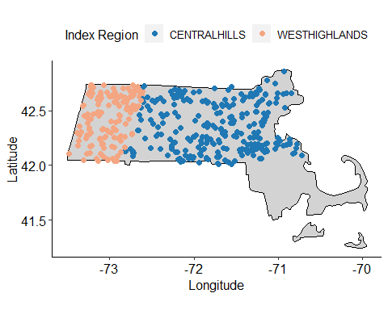

## Overall Index Scores by Index Region

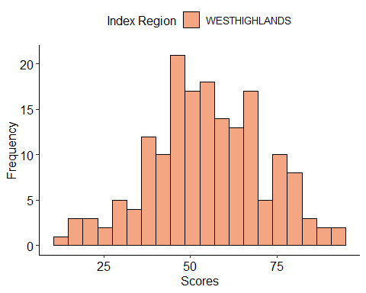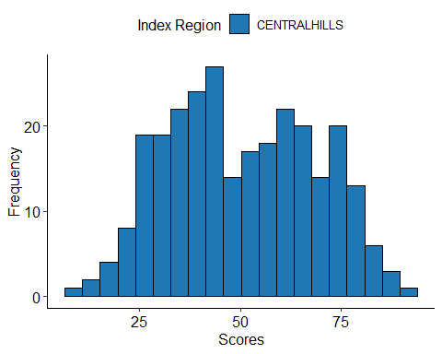

## Metric Values Distribution by Index Region.

Note, metrics are calculated, by BioMonTools package, for all Index Regions even if not applicable.

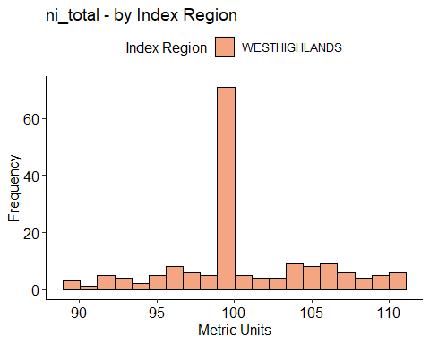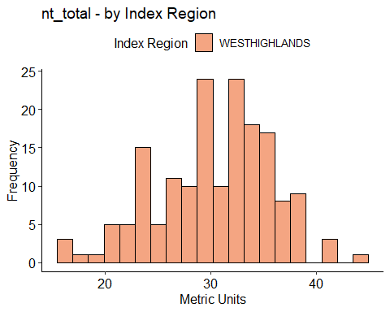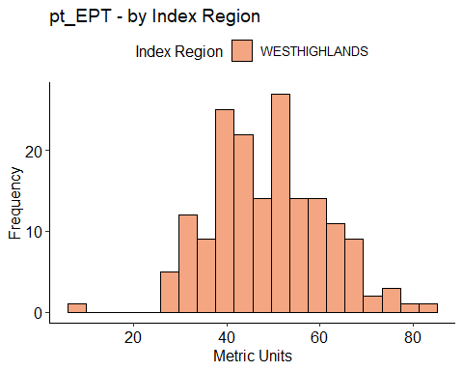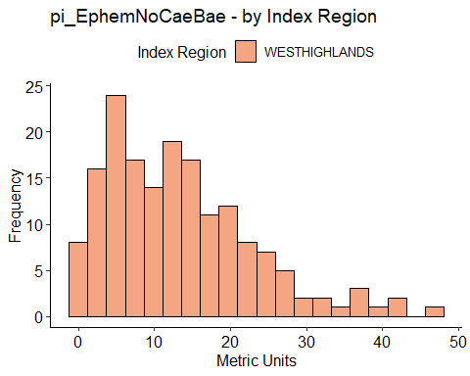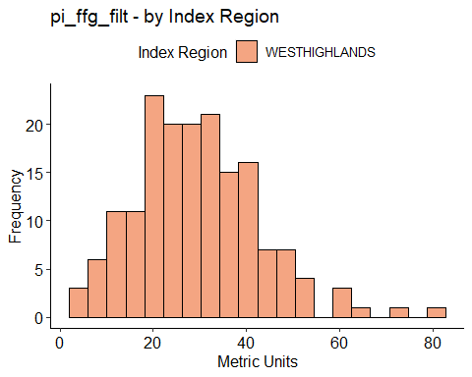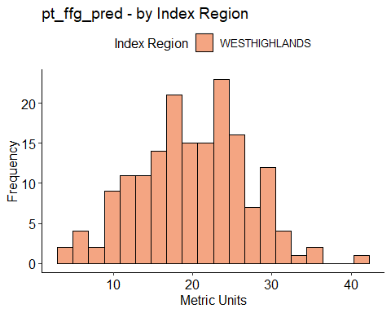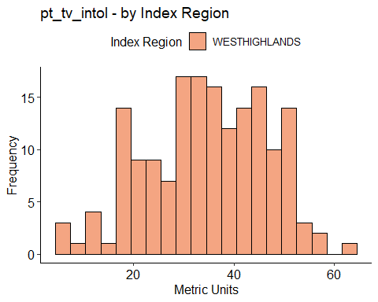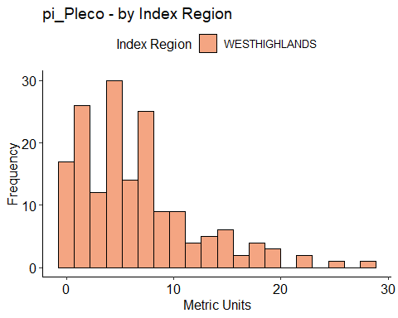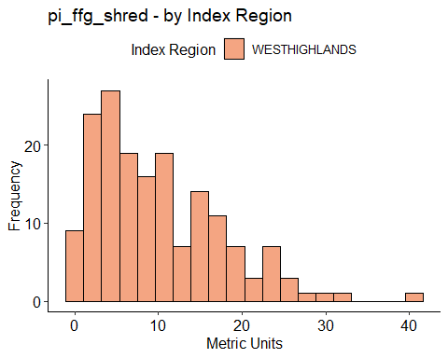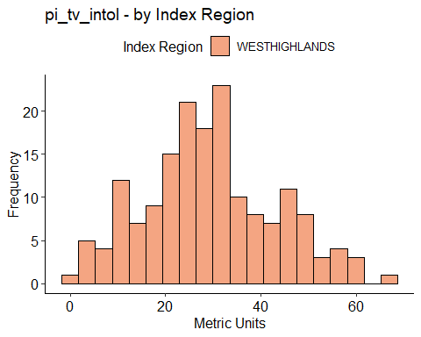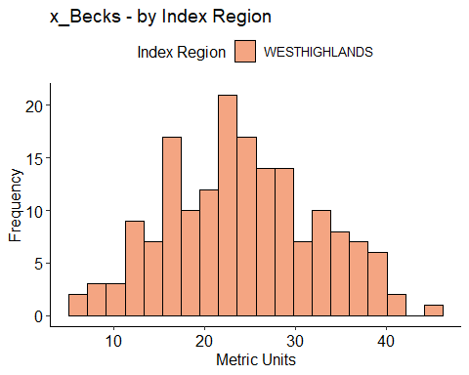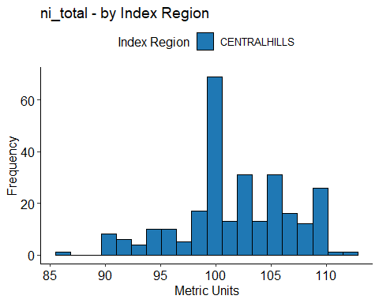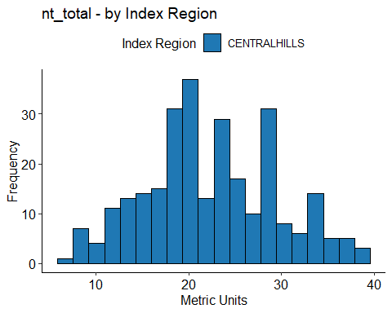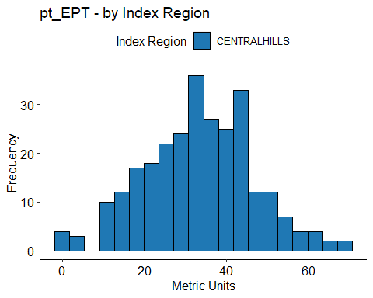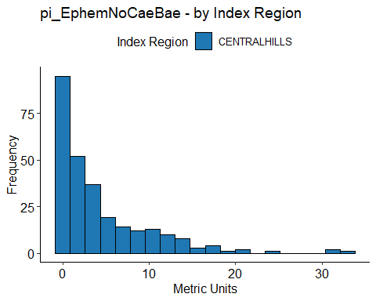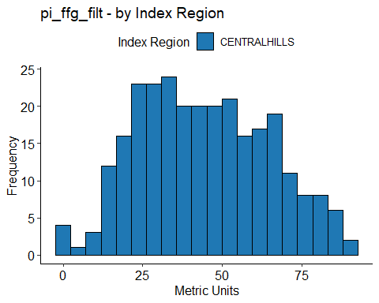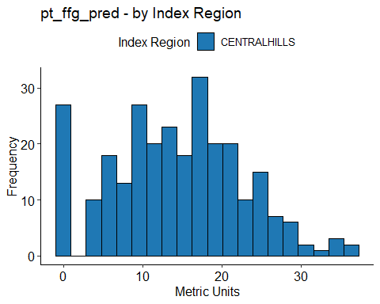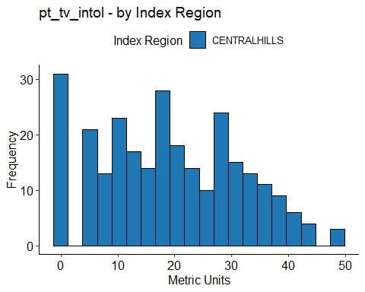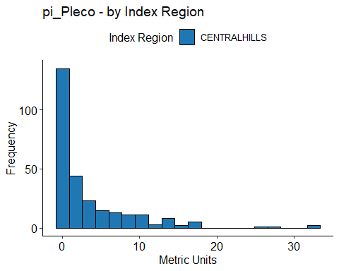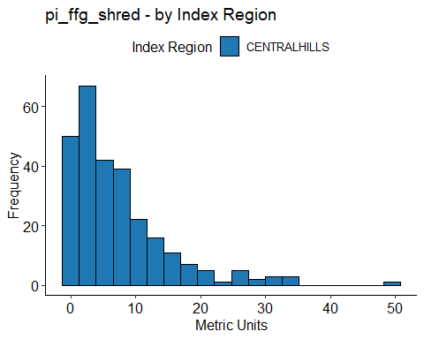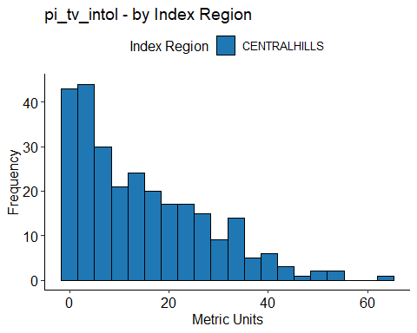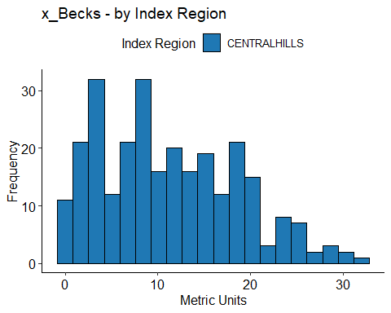

## Metric Scores Distribution by Index Region.

Only metrics applied within each region are plotted.

