Southeast New England Coastal Watershed Restoration Program (SNEP) Stream IBI Summary Report

Metric Scores and Values

ben.block

2020-11-02 17:16:42

Table of Contents

# INTRODUCTION

The following document is dynamic - it changes depending on the data input into the SNEP R Shiny Application.

Please refer to the “Data File Information” section for general properties of the input dataset used to generate this report.

Histograms in the “Plots” section will change depending on the input dataset.

# DATA FILE INFORMATION

**Report Date:** 2020-11-02 17:16:43

**Generated By:** ben.block

**Number of Records:** 225

**Period of Record:** 2013-07-01 to 2019-09-16

# SUMMARY TABLES

### The tables below summarize the data that were input into the R Shiny Application.

### Table 1. Number of sites by Index Narrative and Index Region.

| Index Narrative | Low Gradient IBI |
| --- | --- |
| No Narrative | 225 |

### Table 2. Index scores summary statistics by Index Region.

| Index Region | N | Min | q25 | Med | q75 | Max |
| --- | --- | --- | --- | --- | --- | --- |
| LowGradientIBI | 225 | 7.90 | 41.10 | 56.40 | 67.90 | 90.90 |
| SNEP IBI Stress Sites | 27 | 14.04 | 31.16 | 35.93 | 48.78 | 68.79 |
| SNEP IBI Reference Sites | 23 | 32.95 | 67.78 | 72.92 | 83.51 | 91.27 |

### Table 3. Metrics in the SNEP IBI, with scoring formulas. Trend is the direction of metric response with increasing stress.

| Metric (abbrev) | Response to stress | Scoring formula |
| --- | --- | --- |
| % POET taxa (Plecoptera, Odonata, Ephemeroptera, and Trichoptera) (pt_POET) | Decrease | 100*(metric)/40 |
| % Predator taxa (pt_ffg_pred) | Decrease | 100*(metric)/32 |
| % Non-insect taxa (pt_NonIns) | Increase | 100*(46-metric)/42 |
| % OET individuals (Odonata, Ephemeroptera, and Trichoptera) (pi_OET) | Decrease | 100*(metric)/49 |
| % Tolerant taxa (pt_tv_toler) | Increase | 100*(36-metric)/33 |
| % Semivoltine taxa (pt_volt_semi) | Decrease | 100*(metric)/12 |

# PLOTS

## Map of Sites in SNEP region

These are the sites that have been input into the R Shiny Application. 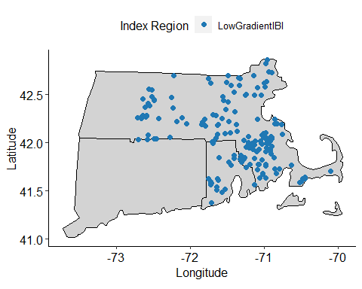

## Overall Index Scores by Index Region

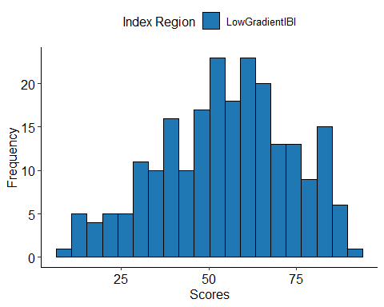

## Metric Values Distribution by Index Region.

Note, metrics are calculated, by BioMonTools package, for all Index Regions even if not applicable.

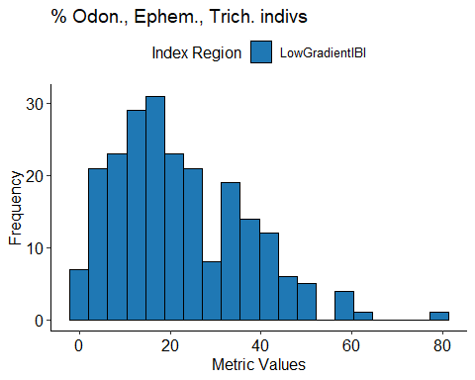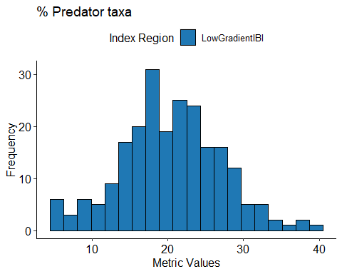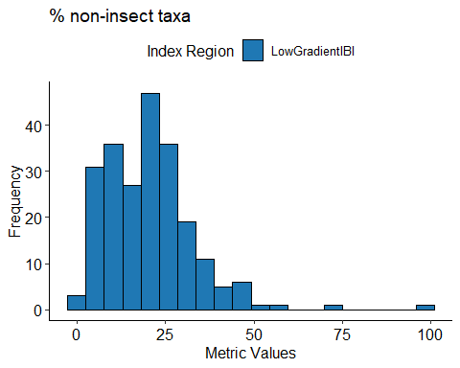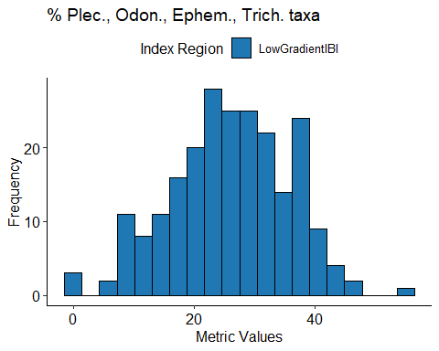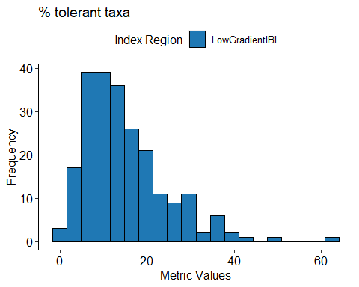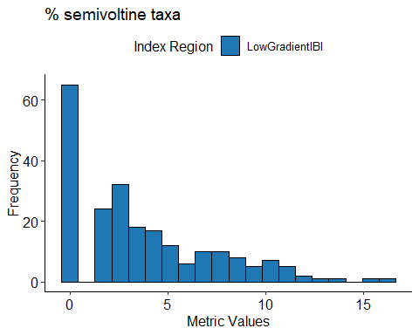

## Metric Scores Distribution by Index Region.

Only metrics applied within each region are plotted.

