Appendix A

Taxa tolerance analyses

**A1 Background**

Taxon tolerance analyses allow for visualization of the shape of the taxon-stressor relationship across a continuous numerical scale, and can be used to identify optima (the point at which the taxon has the highest probability of occurrence) as well as tolerance limits (the range of conditions in which the taxon can persist) (Yuan 2006). To help inform macroinvertebrate tolerance value assignments related to sensitivity to stressors in low gradient streams in Massachusetts (MA) and Rhode Island (RI), we ran taxa tolerance analyses on four variables that capture anthropogenic disturbance: the Indices of Watershed and Catchment Integrity (IWI & ICI, respectively) (Thornbrugh et al. 2018, Johnson et al. 2019), percent urban and percent agricultural land use. We also ran analyses to better understand the relationship between taxon occurrence and drainage area, flowline slope, elevation and modeled summer stream temperature. The tolerance analyses were run on a regional dataset that included low gradient data from Massachusetts (MA), Rhode Island (RI), Connecticut (CT), Vermont (VT), and New York (NY). The regional scale allowed for a larger sample size than just the MA/RI dataset alone, which improved the robustness of the analyses and allowed tolerance assignments to be generated for more taxa. Biologists from MassDEP reviewed results from the analyses and assigned taxa to three tolerance categories: intolerant, intermediate, and highly tolerant. In this document, we describe the dataset, methods and results and conclude with recommendations on potential future analyses that could further improve our understanding of taxon-stressor relationships in low gradient streams.

**A2 Data compilation**

**A2.1 Macroinvertebrates**

The regional dataset was comprised of macroinvertebrate samples from low gradient, freshwater, wadeable, perennial streams in MA, RI, CT, VT and NY that were collected with each state’s low gradient collection method (Table A1). Data from 541 sites that spanned nine Level 3 ecoregions were included in the analysis (Table A2, Figure A1).

Table A1. Summary of the regional macroinvertebrate collection methods being used in MA, RI, CT, VT and NY.

|  |  |  |  |  |  |  |  |
| --- | --- | --- | --- | --- | --- | --- | --- |
| Method | Habitat | Effort | Gear | Reach length | Index period | Target # organisms | Taxonomic resolution |
| MassDEP RBP multihabitat | Snags and root wads, leaf packs, aquatic macrophytes, undercut banks and overhanging vegetation, hard bottom (riffle/cobble/boulder) | Any combination of 10 kicks, sweeps, and/or jabs, which are then combined into a single composite sample. Sampling is proportional to the relative makeup of the reach by the major habitat types | Kick-net with 500-μm mesh, 46‑cm wide opening. Brushes are used on woody debris | 100-m | July 1 – September 30 | 300 | Lowest practical level |
| Southern New England Program (SNEP) multihabitat (used in RI and at some MA sites) | Submerged wood (including leaf packs wedged in the wood), submerged vegetation, undercut banks/overhanging vegetation, hard bottom/rocky substrates | Composite of 10 jabs, sweeps, or kicks; each jab/sweep/kick lasted for a minimum of 30 seconds and a maximum of 45 seconds. The goal is to dislodge and capture as many organisms as possible in that area. The habitats will be sampled in rough proportion to their occurrence within the reach* | Kick-net with 500-μm mesh and ~28-cm wide opening; brushes are *not* used on woody debris | 100-m | July 1 – September 30 | 300 | Lowest practical level |
| CT DEEP Standard Semi-Quantitative Low Gradient | Multiple habitat approach that focuses primarily on the most productive habitats (vegetation, woody debris, undercut banks/roots) but also includes, at minimized effort, the less productive fine sediment habitat (sand/silt) | 20 jabs/sweeps (1 meter in length, followed by 2-3 sweeps through the suspended material. fixed number of two jabs/sweeps from fine sediments; the other eighteen are based on the percentage of most productive habitats present in sampling reach | Long handled, 500-micron mesh, D-frame net | 100 meters |  | 200 | Lowest practical level |

Table A1. continued...

|  |  |  |  |  |  |  |  |
| --- | --- | --- | --- | --- | --- | --- | --- |
| Method | Habitat | Effort | Gear | Reach length | Index period | Target # organisms | Taxonomic resolution |
| NYSDEC Low gradient | Four habitats: bank, center channel substrate, woody debris/snags and macrophyte bed | Composite of two jab samples for each of the four habitats (8 samples in total). Consistent effort at each habitat for ~30 seconds (total of ~4 minutes for all samples and habitats). Alternating jabbing and sweeping is performed to catch dislodged macroinvertebrates. | Rectangular kick net (23 cm × 46 cm) with 800−900-μm mesh. | 20 times wetted width at sample site | June-September | 200 | Lowest practical level |
| VT DEC Low gradient (Sweep Bottom Kick Net Sampling) | Debris dams, vegetation, or root wads. Used in wadeable low gradient streams with substrates dominated by silt or sand and velocities, where velocity is less than 0.2 fps and the depth is less than 1 meter | Four-point composite sample. A jab is performed by jabbing the net into debris dams, vegetation, or root wads, pulling back rapidly to dislodge animals, then sweeping forward again into the same area to scoop up dislodged animals. This jabbing and sweeping motion should be repeated several times at the same point and considered one of four jabs. All four jabs (from different points in reach) are then combined into a single composite sample | Mesh size 500 microns, 18" wide x 9" high |  | September–mid-October | 300 | Lowest practical (species whenever possible) |

Figure A1. Locations of low gradient sites that were used in the regional tolerance analysis, against a Level 3 ecoregion backdrop.

Table A2. Number of sites in each Level 3 ecoregion.

|  |  |  |  |  |  |  |
| --- | --- | --- | --- | --- | --- | --- |
| US_L3NAME | CT | MA | NY | RI | VT | Total |
| Atlantic Coastal Pine Barrens |  | 7 | 17 |  |  | ***24*** |
| Eastern Great Lakes Lowlands |  |  | 66 |  | 53 | ***119*** |
| Erie Drift Plain |  |  | 3 |  |  | ***3*** |
| North Central Appalachians |  |  | 2 |  |  | ***2*** |
| Northeastern Coastal Zone | 57 | 152 | 15 | 23 | 1 | ***248*** |
| Northeastern Highlands | 5 | 2 | 24 |  | 84 | ***115*** |
| Northern Allegheny Plateau |  |  | 22 |  |  | ***22*** |
| Northern Piedmont |  |  | 2 |  |  | ***2*** |
| Ridge and Valley |  |  | 6 |  |  | ***6*** |
| ***Total*** | ***62*** | ***161*** | ***157*** | ***23*** | ***138*** | ***541*** |

**A2.2 Disturbance variables**

We performed the tolerance analysis on four anthropogenic disturbance variables: ICI, IWI, percent urban and percent agricultural land use (Table A3). The data came from the USEPA Stream-Catchment (StreamCat) dataset[1] (Hill et al. 2016), which is associated with the National Hydrography Dataset (NHD) Plus Version 2 (NHDPlusV2) geospatial layer (McKay et al. 2012) via the unique identifiers for the stream segments (COMID) and local catchments (FEATUREID). First we used Geographic Information System software (ArcGIS 10.7.1) to spatially join the biological sampling sites with the NHDPlusV2 dataset. Then we joined the sites with StreamCat data via the NHDPlusV2 identifiers. This was done in a MS Access relational database.

We did several cursory quality control (QC) checks to evaluate whether the biological sampling sites were associated with the correct NHDPlusV2 flowlines. If NHDPlusV2 stream segments had waterbody names (referred to as ‘GNIS_Names’), we checked those against the waterbody names of the sites and flagged mismatches for further evaluation. If exact drainage areas were available for the sites, we calculated differences between those and the estimated drainage areas from the StreamCat dataset[2] and flagged sites where differences seemed excessively large (based on our best professional judgment). Next we visually checked the flagged sites to try and determine whether they were associated with the incorrect flowline. One of the most common errors occurred when sites were located on small tributaries that were not captured in the 1:100K NHDPlusV2 dataset and the nearest flowline was a large mainstem. In the end, we excluded 46 sites from the analysis because they were clearly associated with the incorrect flowline.

StreamCat data are available at two spatial scales: local catchment (Cat) (which is defined as the landscape area draining to a single stream segment, excluding upstream contributions) and total watershed (Ws) (which includes the local catchment plus the accumulated area of all upstream catchments) (Figure A2). Three of the disturbance variables (ICI, percent urban and percent agricultural) were at the local catchment scale, while the IWI was at the watershed scale. Because the StreamCat data are not based on exact watershed delineations (except in instances where the site happens to be located at the downstream end of the NHDPlusV2 local catchment), there may be occasional inaccuracies in the attribute data. For example, if a site is located upstream of urban land cover, but the urban land cover is located within the local catchment, the urban land cover data will be (wrongly) associated with the site.

The dataset captured a wide range of disturbance. IWI and ICI scores, which are scaled from 0 (worst) to 1 (best), ranged from 0.16 to 0.92, with most sites falling in the middle of that range (0.4 to 0.7) (Table A4, Figure A3). Urban and agricultural land cover at most sites was < 10% (Figure A3), with median values of 4 and 6%, respectively (Table A4, Figure A3). Figure A4 shows the sites overlaid on the NLCD 2016 land cover geospatial layer.

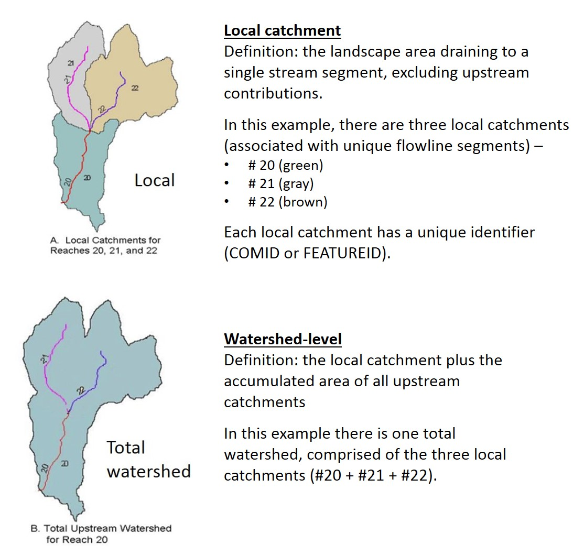

Figure A2. USEPA’s StreamCat metrics (Hill et al. 2016) cover two spatial scales: local catchment and total watershed.

Table A3. Disturbance variables that were included in the taxa tolerance analyses.

|  |  |  |  |
| --- | --- | --- | --- |
| **Metric (Abbrev)** | **Scoring scale** | **Description** | **Source** |
| Index of Watershed Integrity version 2.1 (IWI_21) | 0 (worst) to 1 (best) | Overall watershed condition at the total watershed scale. Scored based on six components: hydrologic regulation, regulation of water chemistry, sediment regulation, hydrologic connectivity, temperature regulation, and habitat provision | EPA StreamCat (Thornbrugh et al. 2018, Johnson et al. 2019) |
| Index of Catchment Integrity version 2.1 (ICI_21) | 0 (worst) to 1 (best) | Overall watershed condition at the local catchment scale. Scored based on the six components listed above | EPA StreamCat (Thornbrugh et al. 2018, Johnson et al. 2019) |
| % Urban land use - local catchment scale, based on NLCD 2016 (pcUrb_local) | 0 to 100% | % of catchment area classified as developed, low-intensity land use (NLCD 2011 class 22) + medium-intensity land use (NLCD 2011 class 23) + high-intensity land use (NLCD 2011 class 24) | EPA StreamCat (NLCD 2016 - Dewitz 2019) |
| % Agricultural land use - local catchment scale, based on NLCD 2016 (pcAg_local) | 0 to 100% | % of catchment area classified as hay land use (NLCD 2011 class 81) + crop land use (NLCD 2011 class 82) | EPA StreamCat (NLCD 2016 - NLCD 2016 - Dewitz 2019) |

Table A4. Summary statistics for the anthropogenic disturbance variables.

|  |  |  |  |  |  |  |  |  |  |  |
| --- | --- | --- | --- | --- | --- | --- | --- | --- | --- | --- |
| Variable | Valid N | Minimum | 10th percentile | 25th percentile | 50th percentile | Mean | 75th percentile | 90th percentile | Maximum | Std.Dev. |
| Index of Catchment Integrity version 2.1 (ICI_21) | 541 | 0.16 | 0.35 | 0.45 | 0.56 | 0.57 | 0.69 | 0.79 | 0.92 | 0.16 |
| Index of Watershed Integrity version 2.1 (IWI_21) | 541 | 0.16 | 0.36 | 0.46 | 0.57 | 0.57 | 0.69 | 0.79 | 0.92 | 0.16 |
| % Urban land use - local catchment scale, based on NLCD 2016 (pcUrb_local) | 541 | 0.00 | 0.35 | 1.25 | 4.44 | 15.69 | 19.65 | 51.35 | 98.91 | 22.71 |
| % Agricultural land use - local catchment scale, based on NLCD 2016 (pcAg_local) | 541 | 0.00 | 0.00 | 0.61 | 6.12 | 14.62 | 21.54 | 48.17 | 84.18 | 18.84 |

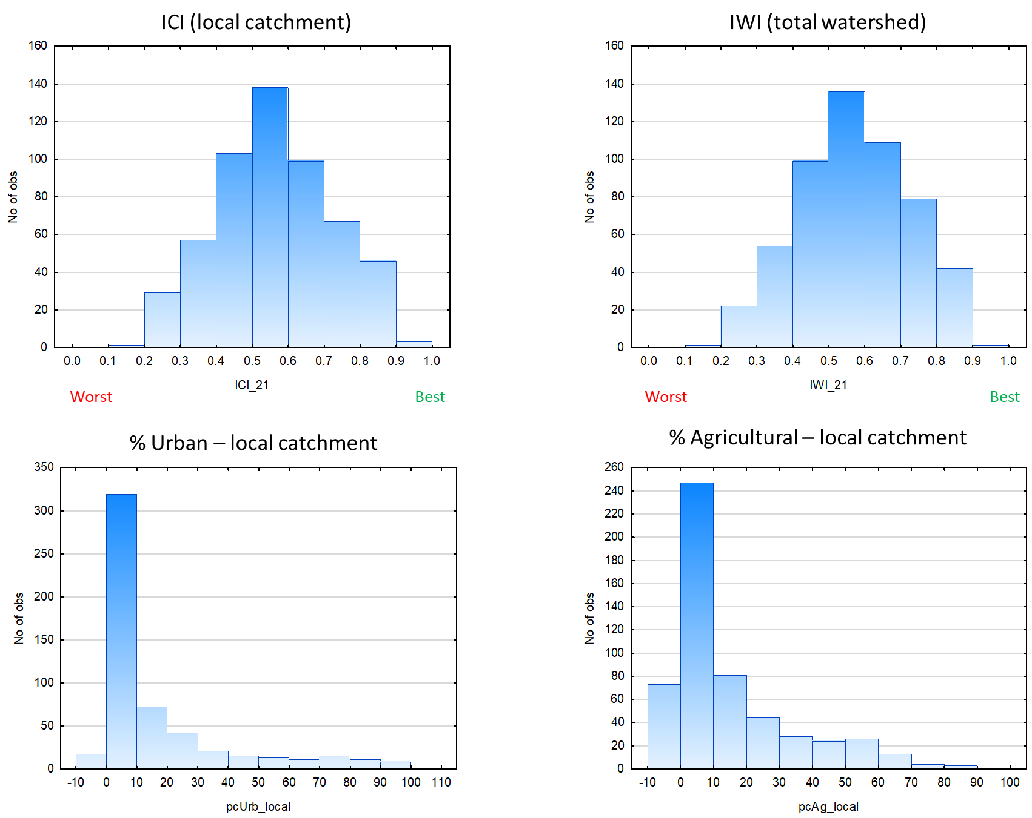

Figure A3. Histograms showing the distribution of sites across the disturbance gradient for each variable (broken into incremental ‘bins’).

*Figure A4. Sites overlaid on the NLCD 2016 land cover geospatial layer.*

**A2.3 Natural variables**

A secondary analysis was performed on four natural variables: drainage area, flowline slope, elevation and modeled summer stream temperature (Table A5). Flowline slope was derived from the NHDPlusV2 attribute data. The source of the other variables was the USEPA Stream-Catchment (StreamCat) dataset (Hill et al. 2016). All four variables are known to influence distributions of macroinvertebrates along a longitudinal gradient (from headwaters to mouth) (Vannote et al. 1980). Most sites had drainage areas less than 100 km2 (median = 21) and flowline slopes of less than 1% (median = 0.3) (Table A6, Figure A5). Elevation ranged from 7 to 609 meters (median = 111 meters). Most sites had summer stream temperatures in the transitional cool-warm range (18-21°C) (Table A6, Figure A5).

Table A5. Natural variables that were included in the taxa tolerance analyses.

|  |  |  |
| --- | --- | --- |
| **Metric, units (Abbrev)** | **Description** | **Source** |
| Drainage area, km2 (DrArea_km2) | Watershed area based on exact delineations where available; where not available, based on EPA StreamCat (estimate from NHDPlusV2 stream segment outlet, i.e., at the most downstream location of the vector line segment | exact delineation or EPA StreamCat estimate |
| Elevation - local catchment scale, meters (ElevCat) | Mean catchment elevation (m). Obtained from the NHDPlusV2 snapshot of the National Elevation Datasets (NED). Data are distributed through NHDPlusV2 website by HydroRegion. | EPA StreamCat |
| Flowline slope, % (pcSLOPE) | Slope of flowline (meters/meters) based on smoothed elevations; a value of -9998 means that no slope value is available. See NHDPlusV2 user guide for information about slope computation. Multiplied by 100 to convert to a percentage | NHDPlusV2 (McKay et al. 2012) \NHDPlusAttributes\ElevSlope |
| Summer stream temperature, °C (MSST_avg) | Modeled mean values for July-August; based on average of 2008, 2009, 2013 and 2014 values in the EPA StreamCat Dataset (which correspond with years of the National Rivers and Streams Assessment (NRSA)) | EPA StreamCat (Hill et al. 2013) |

Table A6. Summary statistics for the natural variables.

|  |  |  |  |  |  |  |  |  |  |  |
| --- | --- | --- | --- | --- | --- | --- | --- | --- | --- | --- |
| Variable | Valid N | Minimum | 10th percentile | 25th percentile | 50th percentile | Mean | 75th percentile | 90th percentile | Maximum | Std.Dev. |
| Drainage area (km2) (DrArea_km2) | 541 | 0.22 | 4.88 | 9.75 | 21.16 | 45.93 | 48.72 | 99.95 | 1235.12 | 91.97 |
| Percent Flowline slope (pcSLOPE) | 540 | 0.00 | 0.03 | 0.13 | 0.30 | 0.64 | 0.78 | 1.40 | 10.30 | 0.95 |
| Elevation - local catchment scale (m) (ElevCat) | 541 | 7.18 | 21.34 | 42.16 | 111.28 | 153.75 | 213.78 | 376.56 | 608.97 | 138.07 |
| Summer stream temperature, degree Celsius (MSST_avg) | 536 | 14.50 | 16.70 | 18.00 | 19.16 | 19.00 | 20.18 | 20.88 | 22.76 | 1.58 |

Figure A5. Histograms showing the distribution of sites across gradients for each variable (broken into incremental ‘bins’).

**A3 Methods**

**A3.1 Data preparation**

Data from 541 sites were included in the analysis. To prevent unequal weighting, only one sample per site (the one from the most recent sampling date) was included. To prepare the data, unique taxa names from each entity’s dataset were composited into a single ‘master’ taxa list. We assigned a ‘FinalID’ after reconciling differences across entites stemming from misspellings and naming schemes (for example, some entities use ‘grp’ and others use ‘group’ – e.g., “Eukiefferiella devonica grp” vs. “Eukiefferiella devonica group”; for the FinalID, we changed all to ‘group’). We did not delve into possible differences due to use of different taxonomic keys. For each taxon in each sample, we calculated relative abundance, which was used in the tolerance analysis (vs. straight abundance data).

We generated results for five levels of taxonomic resolution: species, genus, tribe, subfamily and family. Analyses were limited to taxa that occurred in at least 10 samples. Table A7 shows an example of how data for seven species of Polypedilum were collapsed to coarser levels of resolution for the genus, tribe, subfamily and family-level analyses. Because all seven species occurred at 10 or more sites, results were generated for each species. For the genus-level run (Polypedilum), the seven species were collapsed to genus-level (otherwise their counts would have been excluded from the coarser-level analyses). The species and genus-level identifications were further collapsed for the tribe, subfamily and family-level analyses (and combined with data for other Chironomini, Chironominae and Chironomidae taxa, as appropriate). Table A8 shows how many taxa within each major taxonomic group were assessed and at what level of taxonomic resolution.

Table A7. Example of how species-level data (in this case, for the midge Polypedilum) were collapsed to coarser levels of resolution for the genus, tribe, subfamily and family-level analyses.

|  |  |  |  |  |  |  |
| --- | --- | --- | --- | --- | --- | --- |
| TaxaID | Total # sites | Species | Genus | Tribe | Subfamily | Family |
| Polypedilum | 438 | Exclude | Polypedilum | Chironomini | Chironominae | Chironomidae |
| Polypedilum aviceps | 107 | Polypedilum aviceps | Polypedilum | Chironomini | Chironominae | Chironomidae |
| Polypedilum fallax group | 104 | Polypedilum fallax group | Polypedilum | Chironomini | Chironominae | Chironomidae |
| Polypedilum flavum | 124 | Polypedilum flavum | Polypedilum | Chironomini | Chironominae | Chironomidae |
| Polypedilum halterale group | 50 | Polypedilum halterale group | Polypedilum | Chironomini | Chironominae | Chironomidae |
| Polypedilum illinoense group | 284 | Polypedilum illinoense group | Polypedilum | Chironomini | Chironominae | Chironomidae |
| Polypedilum scalaenum group | 92 | Polypedilum scalaenum group | Polypedilum | Chironomini | Chironominae | Chironomidae |
| Polypedilum tritum | 67 | Polypedilum tritum | Polypedilum | Chironomini | Chironominae | Chironomidae |

Table A8. Number of taxa within each major taxonomic group that were assessed, along with the level of taxonomic resolution.

|  |  |  |  |  |  |  |
| --- | --- | --- | --- | --- | --- | --- |
| **Taxonomic Group** | **Family** | **Subfamily** | **Tribe** | **Genus** | **Species** | **Total** |
| Amphipods & Isopods | 4 |  |  | 5 | 5 | ***14*** |
| Bivalvia | 2 |  |  | 4 | 1 | ***7*** |
| Chironomidae | 1 | 5 | 10 | 73 | 37 | ***126*** |
| Coleoptera | 10 | 1 | 1 | 23 | 17 | ***52*** |
| Decapoda | 1 |  |  | 1 | 2 | ***4*** |
| Diptera without Chironomidae | 11 | 4 |  | 19 | 3 | ***37*** |
| Ephemeroptera | 10 |  |  | 24 | 15 | ***49*** |
| Gastropoda | 10 | 1 |  | 11 | 11 | ***33*** |
| Megaloptera | 2 |  |  | 3 | 1 | ***6*** |
| Odonata | 7 |  |  | 11 | 5 | ***23*** |
| Plecoptera | 9 |  |  | 9 | 2 | ***20*** |
| Trichoptera | 16 | 1 |  | 30 | 13 | ***60*** |
| Water mites (Trombidiformes) | 8 |  |  | 9 |  | ***17*** |
| Worms and Leeches | 6 | 2 |  | 11 | 9 | ***26*** |
| ***Total*** | ***97*** | ***14*** | ***11*** | ***233*** | ***121*** | ***476*** |

**A3.2 Outputs**

We used customized R code to generate weighted average optima (WAopt) and tolerance (WAtol) values for each taxon. The WAopt is a commonly used measure for estimating the central tendency of a taxon along an environmental gradient. The WA is calculated by multiplying taxon relative abundance (=the weighting factor) by the variable of interest (e.g., IWI) for each sample, summing the resulting numbers and dividing that by the sum of all the weights. The width of the bell shape is often called ‘tolerance’ which can also be used to characterize the environmental niche for species along the environmental gradient.

In addition to the WAopt and WAtol values, we generated histograms (Figure A6), relative abundance scatterplots (Figure A7) and cumulative distribution functions (CDFs) (Figure A8) to visualize the relationship between each taxon’s occurrence and the environmental variables. The results provide information on where the taxa occur along stressor gradients and whether they increase or decrease in relative abundance with increasing or decreasing stress. Each output also included taxon distribution maps, with data points sized by relative abundance (such that locations with higher relative abundances had larger dots). Separate sets of output files were generated for each taxonomic group, and disturbance and natural variables were analyzed separately.

The WA optima and tolerance values for each taxon/variable were compiled into a MS Excel worksheet. The worksheet also included sample size. Taxa that occurred in fewer than 30 samples were flagged for low abundance[3] and their outputs were interpreted with caution. In addition to the numeric WAopt values for each disturbance variable, the worksheet contained columns with categorical, relative rankings for each variable (five levels, ranging from worst to best, based on the criteria in Table A9).

Table A9. Five narrative rankings were assigned to each taxon for each disturbance variable, using the criteria below. Thresholds were based on statistics (the distributions of WAopt values in the dataset) and best professional judgment.

|  |  |  |  |  |
| --- | --- | --- | --- | --- |
| Category | ICI | IWI | PctUrb | PctAg |
| Worst | <0.50 | <0.50 | <5 | <5 |
| Worse | 0.50-0.54 | 0.50-0.54 | 5-9.9 | 5-9.9 |
| Intermediate | 0.55-0.65 | 0.55-0.65 | 10-19.9 | 10-19.9 |
| Better | 0.66-0.79 | 0.66-0.79 | 20-29.9 | 20-24.9 |
| Best | ≥0.80 | ≥0.80 | ≥30 | ≥25 |

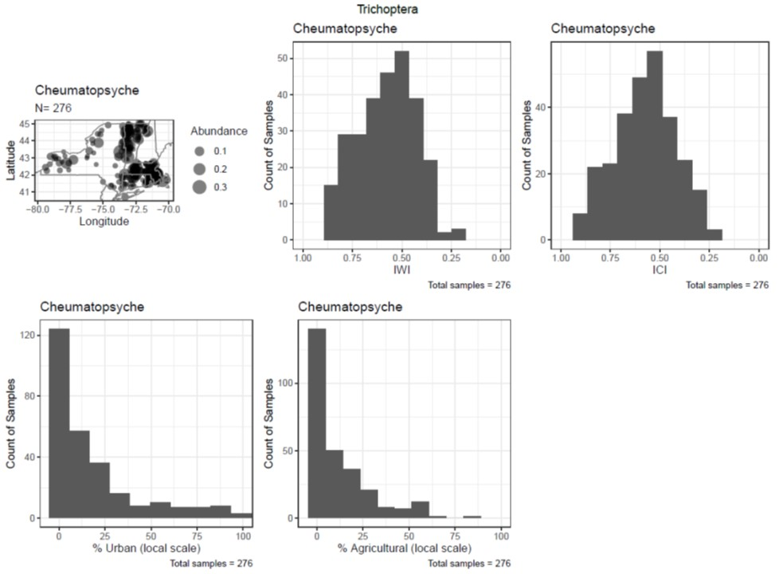

Figure A6. Example of a histogram plot.

Figure A7. Example of a relative abundance scatterplot. The blue vertical dashed line equals the weighted average optima value.

Figure A8. Example of a cumulative distribution function (CDF) plot. The blue vertical dashed line equals the weighted average optima value.

**A3.3 Intepretation of results**

Biologists from MassDEP who were experienced at assessing macroinvertebrate assemblages reviewed the Excel worksheet and assigned taxa to three tolerance categories: intolerant (numeric value = 2), intermediate (numeric value = 5) and tolerant (numeric value = 8). The worksheet was limited to taxa that occurred in the MA and RI dataset. The review process focused on the disturbance variables, not the natural variables.

The biologists considered multiple lines of evidence when making taxa tolerance assignments, including: 1) WAopt and WAtol values and rankings; 2) distribution across the stressor gradients as shown by the scatterplots, CDFs and histograms; 3) sample size (the more samples the taxon occurred in, the more confident we were in the results); and 4) personal experience and best professional judgment (BPJ). When assigning taxa to the three tolerance categories, the reviewers looked for patterns like those shown in Figure A9. Intolerant taxa occurred mostly (and in higher relative abundance) at sites with the lowest levels of disturbance. Intermediate taxa were generally ubiquitous and most prevalent in the middle of the disturbance gradient. Tolerant taxa tended to occur throughout the stressor gradient and generally increased in relative abundance as stress levels increased. Some taxa showed differing sensitivities to the four disturbance variables. In these situations, the reviewers generally made their assignments based on the ‘worst’ results (for example, if a taxon was found to be tolerant to stressors associated with urban land cover but not to agricultural land cover, the taxon was generally assigned to the ‘tolerant’ category).

When interpreting results, it was important for the reviewers to consider both the plots and the WAopt values since WAopt values were sometimes influenced by outliers (see example in Figure A10). The outliers could be either legitimate or incorrect. Potential reasons for erroneous outliers include: the disturbance variable was incorrect (perhaps because the StreamCat data were not based on exact watershed delineations), or the taxon was misidentified. Reasons for the outliers were not investigated.

When interpreting results, the reviewers took note of outliers but focused more on the dispersal of data points across the rest of the gradient.

Figure A9. Examples of taxon-response patterns for taxa that were categorized as intolerant, intermediate tolerant and tolerant. The IWI scoring scale ranges from 0 (worst) to 1 (best).

Figure A10. Example of a situation where a taxon’s WAopt value was influenced by an outlier.

**A4 Results**

Table A10 shows the number of taxa in each tolerance category, by taxonomic group. Most taxa were placed in the intermediate group (257 of the 331 taxa that were assessed). The worms/leeches and Chironomidae had the most taxa in the tolerant group, while Plecoptera had the most intolerant taxa, followed by Ephemeroptera and Chironomidae (Table A10). The full set of results (including the plots and worksheet that the reviewers used) are available upon request (contact [Jen.Stamp@tetratech.com](mailto:Jen.Stamp@tetratech.com)).

Table A10. Distribution of taxa across tolerance categories, broken into taxonomic groups.

|  |  |  |  |  |
| --- | --- | --- | --- | --- |
| **Taxonomic Group** | **# Intolerant** | **# Intermediate** | **# Tolerant** | ***Total #*** |
| Amphipods & Isopods | 0 | 2 | 5 | ***7*** |
| Bivalvia | 0 | 3 | 2 | ***5*** |
| Chironomidae | 6 | 80 | 15 | ***101*** |
| Coleoptera | 1 | 26 | 0 | ***27*** |
| Diptera without Chironomidae | 1 | 21 | 2 | ***24*** |
| Ephemeroptera | 6 | 25 | 1 | ***32*** |
| Gastropoda | 0 | 14 | 5 | ***19*** |
| Megaloptera | 0 | 5 | 0 | ***5*** |
| Odonata | 2 | 16 | 1 | ***19*** |
| Plecoptera | 7 | 8 | 0 | ***15*** |
| Trichoptera | 3 | 42 | 0 | ***45*** |
| Water mites (Trombidiformes) | 0 | 6 | 3 | ***9*** |
| Worms and Leeches | 0 | 9 | 14 | ***23*** |
| ***Total*** | ***26*** | ***257*** | ***48*** | ***331*** |

**A5 Conclusions**

We used low gradient stream macroinvertebrate data provided by regional partners and the StreamCat dataset to examine relationships between taxa occurrence and anthropogenic disturbance. Results helped inform macroinvertebrate tolerance value assignments related to sensitivity to stressors in low gradient streams. The tolerance values were then used to calculate tolerance-based metrics, one of which is included in MassDEP’s low gradient Index of Biological Integrity (IBI) (% Tolerant taxa).

While the taxa tolerance analysis described here was an important step forward, more work remains to be done. If resources permit, recommendations for possible future work include:

* Running a similar analysis on data collected from riffle habitats in higher gradient, rocky bottom streams, and then comparing results with the low gradient outputs. This will help biologists better understand differences in the structure and function of macroinvertebrate assemblages in low vs. higher gradient streams, which in turn will improve the ability of biomonitoring programs to identify degradation in biological integrity and water quality.
* Rerunning the low gradient analyses with:
  + New data that MA, RI, CT, NY and VT have collected since the time of the analysis
  + (Possibly) data from low gradient streams in Maine and New Hampshire (caveat: first we’d need to evaluate the suitability of rock basket data for this type of analysis)
  + Environmental data based on exact watershed delineations. Doing exact watershed delineations with the USGS StreatStats stream layer may allow for inclusion of the 46 sites that had to be excluded because they did not match with the NHDPlusV2 flowlines
  + Running an additional set of plots based on Generalized Additive Models (GAM) (see examples in Yuan 2006)
* Working with a group of regional biologists on reviewing results, and through that process, developing better guidance on how to interpret results.
* Developing a regional Biological Condition Gradient (BCG) model for low gradient streams, to go along with the existing New England high gradient streams BCG model (Stamp and Gerritsen 2009)

**A6 Literature Cited**

Dewitz, J., 2019, National Land Cover Database (NLCD) 2016 Products: U.S. Geological Survey data release, <https://doi.org/10.5066/P96HHBIE>.

Flotemersch, J.E., Leibowitz, S.G., Hill, R.A., Stoddard, J.L., Thomas, M.C., & Tharme, R.E.

2016. A watershed Integrity Definition and Assessment approach to Support Strategic

Management of Watersheds. River Research and Applications, 32, 1654–1671.

Hill, R.A., C.P. Hawkins, and D.M. Carlisle. 2013. Predicting thermal reference conditions for USA streams and rivers. Freshwater Science 32(1):39-55. doi:10.1899/12-009.1.

Hill, R.A., Weber, M.H., Leibowitz, S.G., Olsen, A.R., Thornbrugh, D.J., 2016. The Stream-

Catchment (StreamCat) dataset: a database of watershed metrics for the Conterminous

United States. J. Am. Water Res. Assoc. 52 (1), 120–128

Johnson, Zachary & G. Leibowitz, Scott & Hill, Ryan. (2018). Revising the index of watershed integrity national maps. Science of The Total Environment. 10.1016/j.scitotenv.2018.10.112.

McKay, L., Bondelid, T., Dewald, T., Johnston, J., Moore, R., Reah, A., 2012. NHDPlus Version 2: User Guide. U.S. Environmental Protection Agency

Stamp, J. and J. Gerritsen. 2009. Methods and Assessment Comparability Among State and Federal Biological Monitoring Protocols. Prepared for New England Interstate Water Pollution Control Commission. Prepared by Tetra Tech, Inc.

Thornbrugh, D. J., Leibowitz, S.G., Hill, R. A., Weber, M. H., Johnson, Z.C. Olsen, A. R.,

Flotemersch, J. E., Stoddard, J. L., & Peck, D. V. 2018. Mapping watershed integrity for

the conterminous United States. Ecological Indicators, 85, 1133-1148.

Vannote, R.L., Minshall, G., Cummins, K., Sedell, J., & Gushing, C.E. 1980. The River Continuum Concept. Canadian Journal of Fisheries and Aquatic Sciences, 37, 130-137.

Yuan, Lester. 2006. Estimation and Application of Macroinvertebrate Tolerance Values. Report No. EPA/600/P-04/116F. National Center for Environmental Assessment, Office of Research and Development, U.S. Environmental Protection Agency, Washington, D.C.

**Acknowledgments**

State partners provided low gradient data that were used in the regional taxa tolerance analyses. Contributors included Allyson Yarra, James Meek and Robert Nuzzo from Massachusetts Department of Environmental Protection (MassDEP), Katie DeGoosh and Jane Sawyers from Rhode Island Department of Environmental Management, Ansel Aarrestad and Chris Bellucci from the Connecticut Department of Energy & Environmental Protection, Aaron Moore from the Vermont Agency of Agriculture Food and Markets (AAFM), Steve Fiske (retired, formerly of the Vermont Department of Environmental Conservation), and Gavin Lemley, Brian Duffy and Zachary Smith from New York Department of Environmental Conservation. We are very grateful for your assistance.

1. https://www.epa.gov/national-aquatic-resource-surveys/streamcat-dataset-0
2. StreamCat data are not based on exact watershed delineations except in instances where the site happens to be located at the downstream end of the NHDPlusV2 local catchment; instead, a site is characterized based on the attributes that are associated with the catchment in which the site is located.
3. More specifically, those that occurred in 10 to 19 samples were flagged as ‘very low’ and those that occurred in 20-29 samples were flagged as ‘low’.