**Region 8**

**Stream Diatom Metrics and Indices**

Prepared for:

U.S. Environmental Protection Agency (EPA)

Tina Laidlaw, Region 8, Helena, MT

Sylvia Lee, Office of Research and Development, Washington, DC

and

Wyoming Department of Environmental Quality (DEQ)

Eric Hargett, Water Quality Division, Watershed Protection Program, Cheyenne, WY

Jeremy ZumBerge, Water Quality Division, Watershed Protection Program, Sheridan, WY

Prepared by:

Ben Jessup and Diane Allen

Tetra Tech, Montpelier, VT

Final Draft: June 1, 2022

Table of Contents

List of Tables iii

List of Figures iv

Acknowledgements v

Introduction 1

Approach 2

Data Set 3

GIS Analysis 5

Methods 6

Taxa Traits and Harmonization 6

GIS Analysis 7

Diatom Metrics 7

Site Classification 7

Metric Performance 8

Random Forest Metric Adjustment 9

Metric Scoring 10

Index Compilation 10

Precision Analysis 11

Index Interpretation and Application 11

Results 12

Diatom Taxa Harmonization 12

Site Classification 13

Metric Performance 13

Metric Adjustment 14

Index Compilation 18

Precision Analysis 22

Discussion 23

Index Calculation 23

Index Application 23

Index Metric Descriptions 25

References Cited 31

Appendix A. Metric Descriptions 37

Appendix B. Initial Site Classification 38

Appendix C. Random Forest Detailed Methods 39

Appendix D. Metric Discrimination 46

Appendix E. Metric Correlations 47

Appendix F. Wyoming Stream Diatom Index and Metric Scores 48

Attachment 1. Diatom Traits. File: Att1_Region8_TaxaTraits_20220624.xlsx

Attachment 2. Metric calculation database. File: WY_Diatom_MetricCalculation.mdb

# List of Tables

Table 1. Diatom harmonization match types when comparing WDEQ taxa identifications to the trait databases of the Diatoms of North America (DONA) or Tetra Tech. 12

Table 2. Site classes resulting from preliminary distinct site classification analysis. 13

Table 3. Numbers of metrics that were consistently responsive with relatively strong discrimination efficiencies (DE > 45%), within metric trait categories. 14

Table 4. Metrics that passed selection criteria for consistent responsiveness and were retained for index analysis. 15

Table 5. Predictor variables used in random forest (RF) analysis to account for natural gradient effects on diatom metrics. 16

Table 6. Random Forest results for the 17 candidate index metrics and eight predictor variables, showing the pseudo-R2 and variables in the model in order of importance. 17

Table 7. Spearman rho correlation coefficients between candidate index metrics. 19

Table 8. Metric composition of best performing index candidates without redundant metrics. 20

Table 9. Best performing candidate index Pearson correlation coefficients to log10 transformed grab sample chloride concentration (mg/L), specific conductivity (uS/cm), total nitrogen concentration (mg/L), total phosphorus concentration (mg/L), and low, medium and high urban land cover obtained from StreamCat (NLCD 2016). 20

Table 10. Precision statistics for metrics and the selected index derived from same-day replicate sample sets.. 23

Table 11. Distribution statistics for the Wyoming stream diatom index in reference and degraded sites. 24

# List of Figures

Figure 1. Diatom sites throughout Wyoming, marked by disturbance category and showing level 3 ecoregions (Chapman 2004). 5

Figure 2. Box and whisker plot illustrating the percent nitrogen tolerant taxa metric distributions among disturbance categories. 9

Figure 3. Wyoming stream diatom index scores in relation to total nitrogen (log TN, top) and total phosphorus (log TP, bottom). 21

Figure 4. Metric occurrence in the top nine seven-metric indices. 22

Figure 5. Box plots illustrating Wyoming stream diatom index score distributions among disturbance conditions and site types. 24

Figure 6. Box plots illustrating the national diatom index (Carlisle et al. 2022) score distributions among disturbance conditions and site types. 25

Figure 7. Box plots illustrating the proportional abundance of BC 1 and BC 2 taxa (BC_12.pa) distributions among disturbance conditions and site types. 26

Figure 8. Box plots illustrating the percent taxa of salinity tolerant taxa (pt_H_WDEQ_34, left) and the weighted average of salinity tolerance by abundance (WA_Salinity_USGS, right) distributions among disturbance conditions and site types. 27

Figure 9. Box plots illustrating the number of nitrogen sensitive taxa metric distributions among disturbance conditions and site types. 28

Figure 10. Number of nitrogen sensitive taxa adjusted to environmental predictors (nt_Diatas_TN_2_RFadj_std) in relation to total nitrogen (log TN). 28

Figure 11. Box plots illustrating the percent taxa of oligotrophic taxa (pt_T_WDEQ_12, left) and the percent taxa of eutrophic taxa (pt_T_WDEQ_56, right) distributions among disturbance conditions and site types. 29

Figure 12. Box plots illustrating the percent of taxa with affinity for relatively low oxygen (pt_O_WDEQ_4) distributions among disturbance conditions and site types. 30

# Acknowledgements

The participants in regular project meetings gave meaningful comments and guidance to improve the development of the diatom index as a useful tool for assessing biological conditions in Wyoming streams. Eric Hargett, Jeremy ZumBerge, and Ron Steg from the Wyoming Department of Environmental Quality (DEQ) provided the data and made critical decisions on the metric and index selection. Along with Tina Laidlaw and Sylvia Lee of the U.S. EPA, they gave direction to ensure that the analyses and outcomes were defensible, thorough, and applicable. Additional project participants from the U.S. EPA included Janice Alers-Garcia, Britta Bierwagon, and Tom Johnson. Ben Holcomb of the Utah Division of Water Quality was an observer throughout the project.

This project was funded through a contract between the U.S. EPA and Tetra Tech. Contract Number: 68HERC20D0016, Task Order: 68HERC21F0072.

Ben Jessup and Diane Allen of Tetra Tech were the primary authors of the report and analyses. They were assisted by Michael Paul, who provided review oversight and by Ben Block, who developed the index calculation and application tools.

Cover Photo: Coantag Creek (below Mistum). Panorama of reach from right valley side slope, looking south. Provided by WDEQ.

# Introduction

Indices of Biological Integrity (IBI) calculate measures of the aquatic community (metrics) that, when combined, indicate the similarity of a biological sample to expected conditions of a well-balanced community. Thefederal Clean Water Act (CWA) has an objectiveto restore and maintain the chemical, physical, and biological integrity of the Nation’s waters. In assessing samples relative to biological integrity, management activities to meet the CWA objective can be targeted, prioritized, and justified. The process by which the metrics are selected and combined in an IBI follows established and innovative analytical methods of the reference condition approach (Hughes et al. 1986, Bailey et al. 2004). In this approach, biological conditions from relatively undisturbed sites and that account for natural variability, are set as a standard (or reference) to which other samples are compared (Stoddard et al. 2006). Using metrics to establish the numeric index scale, IBI values that are comparable to those found in reference sites meet the expectations for a well-balanced aquatic community. IBI values that are unlike the reference values indicate departure from the expected biological conditions and are assumed the result of anthropogenic disturbance.

The algal assemblage, including diatoms, is an important indicator of biological integrity (McCormick et al. 1994, Pan et al. 1996, Hill et al. 2000, Wang et al. 2005, Cao et al. 2007, Stevenson et al. 2008a, Stevenson et al. 2010, Fetscher et al. 2013, 2014, Hausmann et al. 2016, Paul et al. 2020). Algae were part of the early saprobic indicator system for assessing the biological state of waters in relation to organic pollution (Kolkwitz and Marrson 1908). In the United States, algae were also one of the first assemblages used in biological assessment (Stevenson 2014; Stevenson et al. 2010; Stevenson and Smol 2003). Algae have been effective in these earlier and ongoing assessment systems because they exhibit a wide variety of sensitivity among taxa and algal physiologies, making the assemblage conducive to investigating biological responses across a range of stressors. The diatom assemblage, metrics, and indices can indicate relative condition among samples and in relation to stressors, such as nutrients (Porter et al. 2008, Potapova and Charles 2007). Diatom responses to disturbance differ from the responses of other aquatic groups (benthic macroinvertebrates, fish, and macrophytes) and might be differently suited for detecting certain types of disturbance (Johnson et al. 2006a, Hering et al. 2006, Justus et al. 2010) and over different time periods (Lavoie et al. 2008, Smucker and Vis 2011, Johnson et al. 2006b, McCormick and Scinto 1999). They are specifically sensitive to nutrients (Charles et al. 2019) and are the assemblage most directly affected by changes in nutrient concentrations in streams, and subsequent food web and water chemical impacts contribute to effects observed in invertebrate and vertebrate assemblages with eutrophication. As a result, algae are the aquatic life “first responders” to nutrient impacts and have been used effectively in developing nutrient targets (Stevenson and Smol 2003, Stevenson et al. 2010, Charles et al. 2019). In addition, algal measurements are readily interpreted and understood by scientists, policy makers, and the public (U.S. EPA 2000). Therefore, diatom samples and metrics of diatom community traits were used to explore biological responses to stressor conditions.

Several states within U.S. EPA Region 8 are interested in using diatom data to support development of biological criteria and numeric nutrient criteria for rivers and streams. To do so requires development of diatom stressor-response relationships by linking diatom taxa with autecological traits and to test available diatom metrics for responses to nutrients and other stressors.

The Wyoming Department of Environmental Quality (WDEQ) has diatom assemblage data from nearly 700 river and stream samples collected during 2007 to 2020. WDEQ’s data provide an opportunity to test diatom metrics with independently established disturbance gradients and classification based on natural variability within Wyoming. The diatom metric performance and development of a Wyoming-specific diatom index can be described alongside the national metrics and IBI developed by Carlisle and others (2022). The national-scale IBI is robust to taxonomic inconsistency, resistant to variation due to natural gradients, and informs sensitivity to specific stressors (e.g., nutrients, pesticides, salinity).

The objective of this project was to use diatom traits, metrics, and indices developed at the national-scale and apply similar analyses and explorations to state-level data from WDEQ. The project will contribute to WDEQ efforts to develop diatom-based tools that support the development of the state’s assessment methods for streams and rivers and inform numeric nutrient criteria development. The tasks undertaken to reach the project objective included description of natural influences on diatom sample composition through multiple site classification exercises, evaluation of metric sensitivity to disturbance gradients and individual stressors, development of a diatom IBI to integrate the signals of multiple metrics, establishment of a reliable IBI assessment tool for Wyoming, and comparison of the Wyoming IBI to the national IBI.

## Approach

There are many aspects to the characterization of the diatom assemblage as an indicator of natural environmental variables, biological conditions, and stressor intensity. A set of tasks was undertaken to achieve the project objective of developing a responsive and reliable diatom IBI. The primary tasks include:

1. Describing how the diatom samples change with natural variations in the sampled sites.
2. Selecting diatom traits and metrics that respond consistently to generalized and specific stressor gradients.
3. Calibration of a diatom IBI for assessment of streams throughout Wyoming.
4. Comparison of the Wyoming IBI and component metrics to the national IBI and metrics.

For Task 1, a site classification analysis following methods described in Jessup et al. (2021) was conducted to develop discrete bio-geographical site classes within which diatom assemblages and associated metric values were similar and associated with unique combinations of natural environmental variables. A second approach to account for natural variation follows Carlisle and others (2022), in which metric expectations for each site were predicted from multiple natural environmental variables at reference sites using a random forest model. In the random forest analysis, the classification is continuous, not in discrete site classes, and observed metric values are compared to the model-predicted values to evaluate whether each metric is as predicted or underperforming.

Task 2 was addressed by comparing distributions of metric values at reference sites with distributions of metric values from degraded sites. A distinction between reference and degraded values would show that the metric is reasonably sensitive to the influence of stressors. The WDEQ determined the site disturbance category (reference or degraded) based on water chemistry, habitat conditions, and anthropogenic influences (Hargett 2011). While the generalized disturbance gradient was used as the primary indication of metric sensitivity, metrics were also correlated to specific stressors.

For Task 3, metrics shown to be sensitive to the general disturbance gradient from Task 2 were used in combination to develop an IBI that met multiple criteria. An index was selected that was more sensitive and robust than any single metric and that incorporated multiple metrics and therefore multiple response mechanisms to multiple stressors. With multiple metrics, the index provides a comprehensive signal of biological condition that can be further interpreted by examining individual metrics within the IBI. Multiple metric combinations were evaluated by systematically including or excluding sensitive metrics from at least six metric categories in multiple index trials. Each unique combination was rated for index performance (efficiency in discriminating reference and degraded sites), representation of multiple trait categories, interpretability of metrics, and ecological importance. The index selected as the most effective and understandable indicator of diatom conditions was presented as a potential assessment tool, with thresholds along the index scale to indicate narrative levels of condition (Excellent, Good, Fair, and Poor) that might be adopted as indicators of aquatic life use attainment or of nutrient stressor intensities.

Task 4 was answered by comparison of the state-specific IBI and component metrics to the nationally-derived IBI and component metrics (Carlisle et al. 2022). This comparison could inform assessors and biological scientists on the importance of the indicators at the two calibration scales (national and state). The initial premise was that the smaller state-wide scale would allow index calibration that was more responsive to stressors and diatom conditions in Wyoming than the national scale, that necessarily included streams, stressors, and diatoms that might not occur in Wyoming.

## Data Set

The WDEQ data were provided as Excel spreadsheet files that included station metadata, diatom raw data, physical habitat data, diatom taxa traits, and chemistry data. The water chemistry data included total phosphorus, total nitrogen, and 20 additional analytes that were recorded in more than 500 samples. There were 708 periphyton (diatom) samples from 495 unique sites, all sampled in years 2007 - 2020. When multiple samples were available at a site, the sample used in index calibration analysis was identified as the primary of same-day duplicates (N = 79 duplicate sets) or the most complete or most recent sample of re-visited sites (N = 134 revisit samples). The reserved samples were used in metric and index precision analyses. The U.S. EPA provided files of diatom taxa traits for the taxonomic harmonization analysis (Attachment 1).

WDEQ identified 152 reference sites and 31 degraded sites throughout Wyoming (Figure 1). Disturbance designations were based on water chemistry, habitat conditions, and anthropogenic influences (Hargett 2011). Least-disturbed reference sites were identified based on whether water chemistry met numeric in-stream aquatic life criteria (WDEQ 2007), and sites met applicable criteria in the evaluation of bed, bank and stream habitat conditions in addition to anthropogenic influence. Degraded sites exceeded one or more numeric in-stream aquatic life criteria (WDEQ 2007), exceeded one or more maximum concentrations levels (MCLs) for nitrate-nitrogen (3.5 mg/L) or total phosphorus (1 mg/L) modified from Stoddard et al. (2005), were documented as possessing unstable bed and banks or habitat degradation, point-source discharges that exceed in-stream water quality criteria, appreciable flow augmentation or depletion, and/or appreciably affected by urbanization and stormwater discharges. Most degraded sites were located on reaches known to be partially or non-supportive of fisheries and/or other aquatic life uses (WDEQ 2007 and 2010).

Diatom field sampling protocols are as detailed in the WDEQ Manual of Standard Operating Procedures (WDEQ 2021). In brief, the field protocols include scrubbing periphyton from the targeted habitat representing the most common and stable habitat in the stream reach. For riffle habitats, 8 locations are randomly identified within the stream reach. At each location, cobbles representing approximately 10 cm2 are scrubbed, scrubbed periphyton is collected, and the scrubbed area is measured. All samples from the reach are composited and the composite sample is subsampled. Samples are preserved with Lugol’s solution and sent to the laboratory for analysis. Diatom samples were identified by Rhithron Associates. Identification subsample size was 600 valves, counted along transects of prepared microscope slides. There were 971 algae taxa listed in the raw tables. Of these, 864 were diatoms and 107 were soft algae (which were not used in the project analysis). 637 diatom taxa occurred at reference sites.

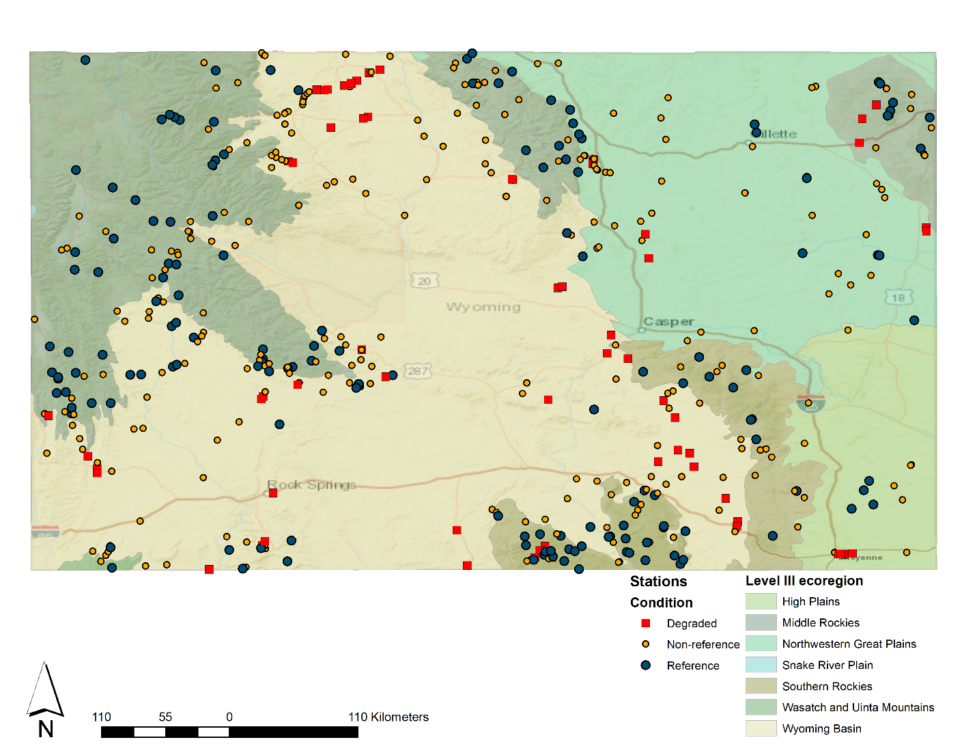

Figure 1. Diatom sites throughout Wyoming, marked by disturbance category and showing level 3 ecoregions (Chapman 2004).

## GIS Analysis

The sampled sites were analyzed in a Geographical Information System (GIS) to identify landscape features and characteristics that determine disturbance intensity or natural factors that could affect diatom responses. The analysis integrated information from the National Hydrography Dataset Plus version 2.1 (NHDPlusV2.1). Variables were associated with site watershed and local catchments using the StreamCat database (Hill et al. 2016)[1]. The landscape features derived from the GIS were used in classification and metric adjustment analyses as well as index correlations with stressors.

# Methods

## Taxa Traits and Harmonization

Diatom taxa are commonly renamed based on current and evolving knowledge of taxonomic characteristics and systematic associations. Taxa identified in earlier samples or using earlier identification resources might have an assigned name that no longer matches with current taxa lists because of name changes. The process of recognizing taxa synonyms and associating previous names with current names and traits is called harmonization. The harmonization of taxa identifications between disparate taxa lists allows assignment of current and authoritative taxa traits that can then be associated with taxa identifications and their synonyms found in the WDEQ dataset.

Diatom taxa were associated with traits based on three sources: 1) a binary trait database provided by the Diatoms of North America (DONA[2]) workgroup (Tyree et al. 2020), 2) a traits database compiled by Tetra Tech in 2015 from literature and regional studies (Potapova et al. 2004, Stevenson and Wang 2001, Stevenson et al. 2008a, Porter et al. 2008, Bahls 1993, Teply and Bahls 2005, Kelly and Whitton 1995, van Dam et al. 1994) and 3) traits from the WDEQ database, which were primarily based on van Dam et al. (1994).

The taxonomic identifications provided by WDEQ were used as the final identification throughout the analysis. The WDEQ taxa list was compared to the DONA taxa list and all exact matches were identified when the genus, species, and variety (if variety was identified) were equal between taxa lists. The matching process was documented in project taxa lists by listing the matched taxa names with the original taxa name and recording a “Match Type” identifier. The Match Type was “Exact” when no synonyms or name modifications were required to associate taxa between lists. However, to align WDEQ taxonomy with current nomenclature and diatom traits tables, taxa were harmonized using information on taxa synonyms found in multiple sources, as detailed below.

The DONA traits data table was considered to have current and authoritative taxa identifications. However, DONA is not comprehensive, and several taxa are not included. Additionally, although DONA continues to grow and improve over time, many older identifications did not use this resource. Previous efforts to harmonize identifications completed by disparate monitoring programs required the creation of numerous “slash groups” to define species concepts within the datasets. Harmonization of diatom taxa with slash groups has been shown to strengthen assemblage relationships with total phosphorus by reducing dataset analyst noise (Lee et al 2019). One strategy for matching taxa between the original and traits taxa lists included consideration of the slash groups identified by Lee and others (2019).

Taxa synonyms and misspellings were investigated for taxa that did not have exact or slash group matches between the WDEQ, DONA, and Tetra Tech traits lists. For some taxa, synonyms were provided by WDEQ in a field called “Synonym of” in their master taxa list. Other synonyms were derived from the USGS BioData database[3], the DONA website, and other web sources, all of which were documented in the “Match Type” field. If no matches were identified through the slash groups and synonyms, the unmatched taxa were referred to taxonomic experts at EPA and DONA (see WYDiatomList4Harmonization.xlsx). Finally, if no matches were identified at species-level, then the genus-level identifications were matched to the traits table.

## GIS Analysis

The sampled sites were analyzed in a Geographical Information System (GIS) to identify landscape features and characteristics that determine disturbance intensity or natural factors that could affect diatom sample results. The analysis integrated information from the National Hydrography Dataset Plus version 2.1 (NHDPlusV2.1). Variables were associated with site watershed and local catchments using the StreamCat database (Hill et al. 2016)[4]. The landscape features derived from the GIS were used in classification and metric adjustment analyses as well as index correlations with stressors.

In brief, sites were mapped by their provided coordinates in ArcGIS version 10.8 (ESRI 2019) and spatially joined to the nearest stream reach in the NHDPlus v2 medium resolution data set (Horizon Systems 2016). For sites where the description provided by the state did not match the GNIS name in the NHDPlus v2 dataset, direct inspection of the mapped location was used to determine the correct stream reach, uniquely identified in NHDPlus v2 by the COMID. To characterize land cover, variables derived from NLCD 2011 (Homer et al. 2015) were chosen to best represent the study time frame.

## Diatom Metrics

Diatom metrics were calculated using R statistical software and an Access database (Attachment 2). For each of the DONA traits, taxa richness, relative richness, relative abundance metrics were calculated for each sample using R code originally written by S. Spaulding of the USGS (2020). Additional metrics were calculated for the DONA and Tetra Tech traits such as the weighted averages of trait values (Appendix A). The traits included eight categories, including biological condition, ion sensitivity, nutrient sensitivity, saprobity, trophic status, moisture, oxygen sensitivity, and tolerance. All 394 metric calculations were based on unique harmonized taxa identifications within the samples. There was no exclusion of taxa or individuals due to lack of standardization or ambiguous redundancy.

## Site Classification

Site classification analyses for Wyoming diatom reference samples were performed to identify natural gradients in biological responses that introduce variability (noise) into IBIs that can confound the effect of human impacts on diatom responses (signal). Differences in diatom composition were compared to environmental variables, such as precipitation, geologic composition, elevation, and groundwater contribution for their effects on diatom composition among least degraded sites. The goal was to identify classes of sites that require development of unique sets of metrics, if more than one class was identified.

The classification analyses evolved starting with exploratory taxa ordination analyses, progressing to development of a categorical site classification, then changing to individual metric adjustment initially using classification and regression trees (CART) and resolving using random forest analysis. The initial analyses were informative, leading to refinement of the subsequent analyses, but ultimately only the random forest analysis was applied. The initial methods were exploratory and depended on a multiple lines of evidence and discussions with the WDEQto develop bio-geographically relevant naturally distinct stream types. Preliminary classification analyses are described in Appendix B.

Instead of categorical site classification, which assumed that the samples would have relatively homogenous composition within groups of environmentally similar sites, the random forest analysis identified metric variation attributable to multiple environmental variables. To explore metric adjustments for natural variation, random forest analysis was initially applied to a large set of environmental variables. After the initial iterations, the variable list was reduced to those variables that were consistently important in the models generated for several metrics and over several iterations. By reducing the variable list, the application process was simplified, and the precision of the models was not substantially reduced.

## Metric Performance

The ability of each metric to distinguish between reference and degraded sites was measured as discrimination efficiency (DE) (Flotemersch et al. 2006, Maxted et al. 2000). DE was calculated as the percentage of metric scores in degraded sites that were more extreme than each quartile of those in the reference sites. For metrics with a pattern of decreasing value with increasing environmental stress, DE is the percentage of degraded values below the 25th percentile of reference site values. For metrics that increase with increasing stress, DE is the percentage of degraded sites that have values higher than the 75th percentile of reference values. DE can be visualized on box plots (Barbour et al. 1999) of reference and degraded metric or index values with the inter-quartile range plotted as the box (Figure __). Higher DE denotes more frequent correct association of metric values with site disturbance conditions. DE values ≤25% show no discriminatory ability in one direction. Metrics with DE values ≥ 50% were generally considered for inclusion in the index. However, metric selection was usually dependent on relative DE values within a metric category.

The *Z*-score was a second measure of metric sensitivity to stress. It was calculated as the difference between mean reference and degraded metric or index values divided by the standard deviation of reference values. The *Z-*score is similar to Cohen’s D (Cohen 1992) and gives a combined measure of index sensitivity and precision. There is no absolute *Z*-score value that indicates adequate metric performance, but among metrics or indices, higher *Z*-scores suggest better separation of reference and degraded values. Cohen proposed that *Z* values ≥ 0.80 indicated a “large” and preferred effect.

The DE and *Z*-scores summarize the difference in distributions at critical potential threshold levels and incorporate the precision of the reference distribution. The DE is an estimate of the percentage of correct impaired assessments and can be interpreted for management applications.

Figure 2. Box and whisker plot illustrating the percent nitrogen tolerant taxa metric distributions among disturbance categories. The metric increases with increasing stress and has a DE slightly less than 75% (estimating from the upper quartile of reference values compared to the distribution of degraded values). Boxes show the intra-quartile ranges in each disturbance category.

## Random Forest Metric Adjustment

Modelling diatom metrics at reference sites to account for natural gradients increases metric precision (decreases variation) (Cao et al. 2017, Tang et al. 2016). Diatom communities are influenced by natural environmental variables including climate (e.g., air temperature, precipitation), location (e.g., latitude, longitude, elevation, watershed area), and geology (e.g., predicted rock hardness, predicted conductivity). Individual metric variability relative to natural conditions was evaluated using random forest analysis methods as described by Carlisle (2022). Random forest analysis is reported in this section and described in an illustrated example in Appendix C.

Analysis steps included random forest prediction of metric values using a broad suite of natural environmental variables, repetition of the analysis using a refined set of factors that were shown to be important in the first step, selection of metrics to be adjusted based on the amount of variability explained in the models, application of the random forest model to predict metric values under natural conditions, and calculation of the observed metric value in comparison to the predicted metric value. The advantages of the random forest analysis over categorical site classification or CART analysis is that the RF accounts for all important variables at one time and can interpret step, sigmoidal, bimodal, asymptotic, linear, or no response relationships. This results in specific metric predictions for each site based on natural environmental variables observed at reference sites.

Using site coordinates and associated environmental variables derived from StreamCat and other sources, random forest (RF) models were constructed to predict metric values at reference sites using the randomForest package (Liaw and Wiener 2002) in R (R Core Team 2020). When the RF model explained ≥ 20% of the metric variance, final RF models were built using a refined set of predictors that included only the most important environmental variables in each model. The 20% threshold was adopted from Carlisle et al. (2022), though Tang et al. (2016) used 10% as their threshold for diatom metric adjustment by RF. Adjusted metrics were then calculated as residual values by predicting site-specific values based on the RF model and using the residual value (the original value minus the model-predicted value) as the new, adjusted metric value.

## Metric Scoring

Both adjusted metric residuals and unadjusted metric values were standardized to a 100-point scale such that higher values represented better conditions. The metric standardization was an interpolation of metric values between the 5th and 95th percentiles of each metric distribution (Blocksom 2003). Values calculated as less than 0 or greater than 100 were truncated at 0 and 100. The standardization is the last step before combination in the index. It is applied to both raw metrics and adjusted metric residuals.

## Index Compilation

The index development process tested numerous index trials for overall responsiveness to generalized and specific stressor gradients. Each index trial included up to seven diverse (representing multiple trait categories), responsive, and ecologically meaningful metrics at a time. In successive trials, metrics were iteratively substituted or removed until all possible subsets of metrics were tested. Seven metrics were used in index trials so that most of the eight metric categories could be represented, including biological condition, ion sensitivity, nutrient sensitivity, saprobity, trophic status, moisture, oxygen sensitivity, and tolerance. Greater numbers of metrics do not necessarily improve index discrimination, can overburden hardware (RAM) limitations (Carlisle et al. 2022) and may increase the risk of model over-fitting.

The value for each index trial was calculated by averaging the standardized metric scores for the included metrics. Each index trial was tested for responsiveness using the DE and Z-score as described for the individual metrics. Index trials were considered diverse if they included several types of metrics, both by trait category and by metric calculation type. Ecologically meaningful metrics were those that could be readily communicated and that responded in ways that could be explained relative to environmental stressors and conditions. Redundant metrics were avoided within each index trial by including only one metric of metric pairs that were correlated at Spearman |rho|>0.80.

There were several metrics that were candidate for inclusion in the index based on responsiveness to the generalized stressor gradient. The metric selection process included calculation of the DE and Z-score for each metric in each of the preliminary site classes (plains, mid-elevation, and high elevation, see Appendix D). The metrics were organized by trait type and the most responsive metrics in each metric category and across the site classes were considered for index trials. If there were many strong and consistently responsive metrics, the metric selection was based on the relative strength of responses, metric format (e.g., the percent of taxa metrics were preferred over number of taxa), and metric transparency (rational response mechanisms and uncomplicated calculation).

To find metric combinations that resulted in responsive index options, an iterative code was run that combined and evaluated all possible sets of selected metrics limited to six or seven metrics per set. Metric combinations were randomly determined, and enough combinations were tested to ensure that every possible combination was included. For the randomization, all available data were used. For sites with more than one sample, the randomized datasets chose a sample at random from among those available at the site. This method accounts for the variation that occurred between samples taken at the sites at different times. The combinations were run on four randomized training data sets and the average DE of each index across the four data sets was calculated. The indices that performed best when evaluated with the DE were correlated with individual stressors.

## Precision Analysis

Precision of repeated measures for metrics and the index can indicate performance and inform application. Precision for the final metrics and index was analyzed as the coefficient of variation (CV) of sample sets that were collected at the same site on the same day. This characterizes the metric and index precision attributable to sampling protocol. A low CV (~ < 30) would indicate a precise metric. Metrics with CVs near and greater than 100 are imprecise and might contribute to variable index results.

From an ANOVA using a replicate set identifier as the grouping variable and metrics as dependent variables, the Root Mean Squared Error (RMSE) was derived as an estimate of the standard deviation of each metric or index. The RMSE was standardized to the replicate sample mean to give the coefficient of variability (CV), which is comparable among metrics. Low CVs (e.g., <30%) would indicate high precision for a metric and if included in an index might contribute to a precise index. Conversely, high CVs (e.g., >75%) could contribute to more variability in an index. The index 90% confidence interval was calculated as 1.645 * RMSE. Metric precision statistics were calculated for all replicate samples in the data set (not separately by site class). Index precision was calculated using the same methods.

## Index Interpretation and Application

The nationally calibrated multi-metric index (MMI) of Carlisle et al. (2022) was calculated as detailed in the paper and website[5]. This index has 4-5 metrics, depending on site location in the Plains or the West site class. The national MMI was compared among the disturbance categories and site types in the Wyoming data set. The nationally-calibrated MMI was expected to be less discriminating of disturbance compared to an index calibrated specifically for Wyoming streams.

# Results

## Diatom Taxa Harmonization

The WDEQ taxa list was derived from 708 diatom samples from 495 stream sites. The list included 864 diatom taxa and 107 soft algae taxa. Soft algae were not used in the current project and they were not considered in taxa harmonization. Of the 864 diatom taxa, 702 (81%) had exact matches to the DONA database and 723 (84%) had exact matches to the Tetra Tech database. Overall, there were more taxa matched to the DONA data set at the species level than matched to the Tetra Tech database (Table 1).

Table 1. Diatom harmonization match types when comparing WDEQ taxa identifications to the trait databases of the Diatoms of North America (DONA) or Tetra Tech.

|  |  |  |
| --- | --- | --- |
| Match type | DONA | Tetra Tech |
| Total taxa identifications | 864 | 864 |
| Exact matches | 702 | 723 |
| Match to synonyms | 82 | 23 |
| Match at genus-level | 68 | 86 |
| Taxa IDs at coarse levels (no traits) | 3 | 3 |
| No match (even at genus) | 7 | 27 |

Taxa that were not easily matched were relatively uncommon in the data set. Of the 68 taxa matched only at the genus level in the DONA database, five taxa occurred in 10 or more samples. These five taxa included *Encyonema fogedii* (the only common, unmatched taxon in reference sites), *Encyonema ventricosum* (synonymous with *Cymbella ventricosa*, but still unmatched), and three new taxa (*Fragilaria microvaucheriae*, *Gomphonema citera*, and *Gomphonema pala*). The seven diatom taxa with no match to the DONA database included *Rhoicosphenia* (most common with 19 sites), *Halamphora, Kolbesia ploenensis, Kolbesia suchlandtii, Parlibellus, Rossithidium,* and *Staurophora brantii*. These taxa were added in rows of the traits database assigning zeros (no trait information) for all traits. Ambiguous taxa (“undetermined pennate”, “unknown centric”, and “unknown genus”) were excluded in the analyses.

Of the 86 taxa matched only at the genus level in the Tetra Tech database, 14 taxa occurred in 10 or more samples. Another 27 taxa were unmatched even at the genus level, with four of those occurring in 10 or more samples. The Tetra Tech database was developed in 2015 based on current literature at that time. No taxonomic updates were made after that time, which might explain the lower rate of matching compared to the current DONA database.

There were 637 diatom taxa identified in reference sites. In the site classification step, the reference taxa list was consolidated to 199 operational taxonomic units (OTU). All but three of the 199 OTU were either associated with traits or occurred in less than 10 sites. The three more common reference taxa that were not associated with taxa traits included *Encyonema fogedii, Encyonema ventricosum*.

## Site Classification

Taxa OTUs from 152 reference samples were included in the exploratory site classification analyses using non-metric multidimensional scaling (NMS) ordination of taxa. The ordination diagrams with taxa similarities, metric similarities, and clusters resulted in plots of overlapping sites when plotted by multiple categorical variables, such as ecoregion and precipitation. Three site classes were derived from these analyses. The site classes were based on Level 3 ecoregions (Chapman et al. 2004) and site elevation: High-Elevation Mountains, Mid-Elevation Mountains and Basins, and Plains (Table 2). Details of the distinct site classification analysis are described in Appendix B.

The analyses were informative, but ultimately inappropriate because they did not result in categories of site types that could be reliably used in metric and index sensitivity analyses. This is because there were few sites identified as degraded in the High-Elevation Mountains and relatively few reference sites in the Plains. Though these three distinct site classes were not ultimately used for index calibration, they were used in interpretation of the index. Differences in reference metric distributions in these classes were recognized and resolved using individual metric adjustments to environmental factors in random forest analysis.

Table 2. Site classes resulting from preliminary distinct site classification analysis. BFI = Base Flow Index.

|  |  |
| --- | --- |
| Site Class | Description |
| High-Elevation Mountains | Sites in the Middle Rockies or Southern Rockies ecoregions that are generally above an elevation of 7,500’. Sites generally have smaller drainage basins (<50km2) and less contribution of groundwater (BFI <66). |
| Mid-Elevation Mountains and Basins | Sites in the mountain or basins ecoregions that are generally below 7,500’ elevation. Sites could be in large or small drainage basins and greater contribution of groundwater (BFI >66) |
| Plains | Sites in the plains ecoregions (High Plains or Northwestern Great Plains) and generally warmer temperature with higher specific conductance. |

## Metric Performance

Discrimination efficiency (DE) and Z-score were calculated for each metric in each of the three distinct site classes (Appendix D). DE and Z metric statistics were used to identify metrics that performed consistently in all site classes, and thus signaled that the metrics would be robust as indicators to be included in a multimetric index. Of the 397 metrics tested, 89 had similar positive or negative trends with increasing stress in all three site classes (Table 3, Appendix D). The metric trait categories with the most consistently responsive metrics were biological condition, nutrient tolerance, oxygen affinity, saprobity, pollution tolerance, and trophic status. Of these 89 metrics, we selected a subset to carry forward in the index development process. The selection criteria for ongoing analysis included relative strength of responses among metrics within each metric trait category, metric format, and metric transparency (e.g., rational response mechanism and uncomplicated calculation). Metrics with DE > 45% were considered to have a relatively strong response. Metrics with a relative richness format (percent of taxa relative to all taxa in the sample) were preferred over taxa richness metrics because the relative number of taxa also conferred dominance of a trait among all taxa. Metric correlations were calculated when metric pairs might represent identical measures and one of the highly correlated metrics was selected. The 43 metrics that were retained are listed in Table 4. This list was reduced to a final set of 17 metrics because subsequent analyses required <20 metrics to accommodate limited computer capacity to iteratively test all possible subsets of the metrics as index alternatives.

Table 3. Numbers of metrics that were consistently responsive with relatively strong discrimination efficiencies (DE > 45%), within metric trait categories.

|  |  |  |  |  |  |  |  |
| --- | --- | --- | --- | --- | --- | --- | --- |
| Acidity | 1 | Nutrients | 12 | Ions/Salinity | 7 | Tolerance | 10 |
| Condition | 11 | Oxygen | 10 | Moisture | 2 | Trophic | 15 |
| GenHab | 4 | Saprobity | 13 | Motility | 2 | Size | 2 |

## Metric Adjustment

Metrics were adjusted to environmental factors on a statewide basis. The metric value variability in reference sites was explained using environmental factors in a random forest (RF) analysis. The 17 metrics that were selected for ongoing index analyses (Table 4 above) were included in RF analyses in which the statewide reference metric values were parsed based on multiple iterative classification trees. The environmental factors entered into early models included geologic, hydrologic, soils and climate variables as predictors (Table 5). These were selected using exploratory bi-plots[6] and correlation analysis (Appendix E). The environmental factors were reduced to eight variables that consistently explained >20% of the variability in the selected responsive metrics. The RF analysis using eight predictor variables and 17 candidate index metrics resulted in 10 metrics that were adjusted based on a pseudo-Rsq value > 0.20 (Table 6). The pseudo-Rsq is a relative estimate of model performance, with higher values indicating that the model predictors have greater influence on metric values.

Table 4. Metrics that passed selection criteria for consistent responsiveness and were retained for index analysis. Metrics marked (*) were retained for index trials in the all-subsets analysis. Refer to Appendix A for metric code descriptions.

|  |  |  |  |  |
| --- | --- | --- | --- | --- |
| **Metric Category** | **Metric Code** |  | **Metric Category** | **Metric Code** |
| Biological Condition | WA_BC_USGS |  | Ions | *nt_Diat_Cl_2 |
| BC_12.r |  | *pt_Diat_Cond_2 |
| BC_5.pt |  | pt_Diat_CL_2 |
| *BC_45.pt |  | Salinity | SALINITY_1.r |
| *BC_12.pa |  | *pt_H_WDEQ_34 |
| BC_5.pa |  | *WA_Salinity_USGS |
| Nutrients | *nt_Diatas_TN_2 |  | Saprobity | nt_S_WDEQ_1 |
| pt_Diatas_TP_1 |  | pt_S_WDEQ_345 |
| *pt_Diatas_TN_1 |  | *WA_SAP_USGS |
| wa_N_WDEQ |  | SAP_45.pt |
| nt_N_WDEQ_1 |  | Pollution Tolerance | Bahls_3.r |
| *LOW_P.r |  | PT_12.pt |
| LOW_N.r |  | *Bahls_12.pt |
| LOW_P.pt |  | Trophic | pi_T_WDEQ_123 |
| HIGH_P.pt |  | nt_T_WDEQ_12 |
| HIGH_N.pt |  | *pt_T_WDEQ_12 |
| Oxygen | nt_O_WDEQ_1 |  | *pt_T_WDEQ_56 |
| *pt_O_WDEQ_34 |  | TROPHIC_56.pt |
| O_1.r |  | TROPHIC_123.pa |
| O_1.pt |  | General Habit | *pi_TubeDwellers |
| *O_45.pt |  | Moisture | *nt_M_WDEQ_12 |
| O_4.pa |  |  |  |

Table 5. Predictor variables used in random forest (RF) analysis to account for natural gradient effects on diatom metrics. Variables included in the final RF models are noted in the “Final” column. Variables marked with an * were provided by WDEQ. All other variables were derived from StreamCat based on coordinates. Continued on the following page.

| Name | Definition | Final |
| --- | --- | --- |
| Longitude* | Decimal degree site location |  |
| Latititude* | Decimal degree site location |  |
| Elevation* | Elevation above mean sea level (feet) | X |
| US_L3Code* | Omernik Level III ecoregion |  |
| WsAreaSqKm | Area of local NHDPlus catchment (square km) |  |
| BFIWs | Base flow is the component of streamflow that can be attributed to ground-water discharge into streams. The BFI is the ratio of base flow to total flow, expressed as a percentage, within watershed | X |
| Al2O3Ws | Mean % of lithological aluminum oxide (Al2O3) content in surface or near surface geology within catchment |  |
| CaOWs | Mean % of lithological calcium oxide (CaO) content in surface or near surface geology within watershed |  |
| Fe2O3Ws | Mean % of lithological ferric oxide (Fe2O3) content in surface or near surface geology within watershed |  |
| K2OWs | Mean % of lithological potassium oxide (K2O) content in surface or near surface geology within watershed |  |
| MgOWs | Mean % of lithological magnesium oxide (MgO) content in surface or near surface geology within watershed |  |
| Na2OWs | Mean % of lithological sodium oxide (Na2O) content in surface or near surface geology within watershed |  |
| P2O5Ws | Mean % of lithological phosphorous oxide (P2O5) content in surface or near surface geology within watershed |  |
| SWs | Mean % of lithological sulfur (S) content in surface or near surface geology within watershed | X |
| SiO2Ws | Mean % of lithological silicon dioxide (SiO2) content in surface or near surface geology within watershed |  |
| NWs | Mean % of lithological nitrogen (N) content in surface or near surface geology within watershed |  |
| HydrlCondWs | Mean lithological hydraulic conductivity (micrometers per second) content in surface or near surface geology within watershed |  |
| CompStrgthWs | Mean lithological uniaxial compressive strength (megaPascals) content in surface or near surface geology within watershed |  |
| KffactWs | Mean soil erodibility (Kf) factor (unitless) of soils within watershed. The Kffactor is used in the Universal Soil Loss Equation (USLE) and represents a relative index of susceptibility of bare, cultivated soil to particle detachment and transport by rainfall. | X |
| PctOw2016Ws | Percent of watershed area classified as open water land cover (NLCD 2016) |  |
| PrecipWs | 30-year (1981-2010) normal mean precipitation (mm) within the watershed (PRISM climate data) | X |
| TmaxWs | 30-year (1981-2010) normal maximum temperature (°C) within the watershed (PRISM climate data) | X |
| TmeanWs | 30-year (1981-2010) normal mean temperature (°C) within the watershed (PRISM climate data) | X |
| TminWs | 30-year (1981-2010) normal minimum temperature (°C) within the watershed (PRISM climate data) |  |
| MSST_4yrAvg | Predicted mean summer stream temperature (July-Aug) for year 2008 – 2009, 2013 - 2014 |  |
| RckDepWs | Mean depth (cm) to bedrock of soils (STATSGO) within watershed | X |

Table 6. Random Forest results for the 17 candidate index metrics and eight predictor variables, showing the pseudo-R2 and variables in the model in order of importance. Refer to Appendix A for metric code descriptions and Table 5 for predictor variable descriptions.

|  |  |  |  |  |  |  |  |  |
| --- | --- | --- | --- | --- | --- | --- | --- | --- |
| Metric | Pseudo-  Rsq | Adjust | pred1 | pred2 | pred3 | pred4 | pred5 | pred6 |
| pt_H_WDEQ_34 | 59.17 | Y | PrecipWs | BFIWs | TmaxWs | Elevation | KffactWs | TmeanWs |
| pt_T_WDEQ_56 | 57.63 | Y | KffactWs | Elevation | BFIWs | TmaxWs | PrecipWs | SWs |
| BC_45.pt | 53.36 | Y | TmaxWs | TmeanWs | KffactWs | BFIWs | RckDepWs | PrecipWs |
| pt_Diatas_TN_1 | 41.11 | Y | TmaxWs | TmeanWs | KffactWs | BFIWs | PrecipWs | Elevation |
| pt_T_WDEQ_12 | 39.52 | Y | PrecipWs | Elevation | SWs | BFIWs | TmaxWs | KffactWs |
| Bahls_12.pt | 37.02 | Y | TmaxWs | TmeanWs | KffactWs | RckDepWs | PrecipWs | BFIWs |
| pt_Diat_Cond_2 | 25.07 | Y | TmeanWs | TmaxWs | PrecipWs | KffactWs | SWs | RckDepWs |
| LOW_P.r | 22.23 | Y | TmeanWs | BFIWs | TmaxWs | KffactWs | SWs | RckDepWs |
| nt_Diatas_TN_2 | 20.43 | Y | TmaxWs | TmeanWs | SWs | BFIWs | KffactWs | PrecipWs |
| nt_M_WDEQ_12 | 20.1 | Y | BFIWs | PrecipWs | TmaxWs | TmeanWs | Elevation | SWs |
| nt_Diat_Cl_2 | 17.65 | N | PrecipWs | TmaxWs | BFIWs | SWs | KffactWs | TmeanWs |
| pt_O_WDEQ_4 | 11.56 | N | TmaxWs | KffactWs | TmeanWs | BFIWs | PrecipWs | RckDepWs |
| O_45.pt | 2.03 | N | TmeanWs | TmaxWs | KffactWs | PrecipWs | RckDepWs | Elevation |
| pi_TubeDwellers | -1.28 | N | KffactWs | TmaxWs | TmeanWs | SWs | Elevation | PrecipWs |
| BC_12.pa | -2.91 | N | TmaxWs | TmeanWs | KffactWs | SWs | PrecipWs | BFIWs |
| WA_SAP_USGS | -4.87 | N | TmaxWs | TmeanWs | KffactWs | BFIWs | RckDepWs | Elevation |
| WA_Salinity_USGS | -7.99 | N | TmaxWs | TmeanWs | KffactWs | BFIWs | PrecipWs | RckDepWs |

## Index Compilation

The 10 adjusted metric residuals and seven unadjusted metric values were scored to standardize on a 100-point scale. Indices were calculated as the average of metric scores for those metrics included in each index alternative. The all-subsets routine evaluated index performance for all possible 6-7 metric combinations. With 6-7 metrics, multiple trait categories could be included (biological condition, ion sensitivity, nutrient sensitivity, saprobity, trophic status, moisture, oxygen sensitivity, and tolerance). Including more than seven metrics in the index was not likely to improve index performance (Carlisle et al. 2022).

All-subsets of 17 metrics in seven-metric index combinations include 19,448 possibilities. To ensure that all combinations were tested, 30,000 random seven-metric index combinations were tested. The maximum DE of the seven-metric trials was 95.8%. The 95th quantile DE of all trials was 91.7%. There were 2,937 index combinations with DE >= 91.7%. To ensure that the final index was robust to the entire dataset, the top 5% of the metric combinations, in terms of DE, were further evaluated by building 4 randomized training datasets. The average DE of each of the 2,937 metric combinations was calculated for the 4 training data sets. Indices with high DE were considered as candidates for selection as the final index. Nine unique 7-metric combinations had the highest average DE of 96.8%. The only correlated pair of metrics included the two oxygen affinity metrics (r = 0.88) (Table 7). Of these nine candidate indices, five did not include both highly correlated oxygen affinity metrics and were considered the best performing index trials (Table 8). Six-metric index combinations were also evaluated but were not ultimately selected.

Final seven-metric index selection from among the five top performers was decided in part by index correlations with individual stressors (grab sample chloride concentration, specific conductivity, total nitrogen and total phosphorus concentrations, and urban land cover) (Table 9, Figure 3). Index #6 had relatively high correlations with all the stressors. This index was among the three that had the highest DE in the Mid-elevation Mountains and Basins site class (91.7%). DE in the other two site classes was invariable (100%) among index combinations. Through consensus of WDEQ staff, index #6 was selected as the final index. Index #6 included the following metrics from five metric categories:

* BC_12.pa % abundance of sensitive biological condition taxa
* pt_H_WDEQ_34_RFadj % taxa of salinity tolerant taxa
* WA_Salinity_USGS Weighted average of salinity tolerance by abundance
* nt_Diatas_TN_2_RFadj # taxa of nitrogen sensitive taxa
* pt_T_WDEQ_12_RFadj % taxa of oligotrophic taxa
* pt_T_WDEQ_56_RFadj % taxa of eutrophic taxa
* pt_O_WDEQ_4 % taxa with affinity for relatively low oxygen

Metrics in the selected index were common to several of the indices considered (Figure 4).

Index scores for primary samples in each site are shown in Appendix F.

Table 7. Spearman rho correlation coefficients between candidate index metrics. Refer to Appendix A for metric code descriptions.

|  |  |  |  |  |  |  |  |  |  |  |  |  |  |  |  |  |  |
| --- | --- | --- | --- | --- | --- | --- | --- | --- | --- | --- | --- | --- | --- | --- | --- | --- | --- |
|  | Metric | 1 | 2 | 3 | 4 | 5 | 6 | 7 | 8 | 9 | 10 | 11 | 12 | 13 | 14 | 15 | 16 |
| 1 | BC_45.pt_RFadj | . |  |  |  |  |  |  |  |  |  |  |  |  |  |  |  |
| 2 | pt_Diat_Cond_2_RFadj | 0.46 | . |  |  |  |  |  |  |  |  |  |  |  |  |  |  |
| 3 | pt_H_WDEQ_34_RFadj | 0.45 | 0.47 | . |  |  |  |  |  |  |  |  |  |  |  |  |  |
| 4 | nt_M_WDEQ_12_RFadj | 0.02 | -0.06 | -0.12 | . |  |  |  |  |  |  |  |  |  |  |  |  |
| 5 | nt_Diatas_TN_2_RFadj | 0.44 | 0.31 | 0.22 | 0.41 | . |  |  |  |  |  |  |  |  |  |  |  |
| 6 | pt_Diatas_TN_1_RFadj | 0.59 | 0.41 | 0.61 | 0.03 | 0.31 | . |  |  |  |  |  |  |  |  |  |  |
| 7 | LOW_P.r_RFadj | 0.42 | 0.28 | 0.29 | 0.51 | 0.70 | 0.38 | . |  |  |  |  |  |  |  |  |  |
| 8 | Bahls_12.pt_RFadj | 0.55 | 0.22 | 0.51 | 0.03 | 0.25 | 0.60 | 0.27 | . |  |  |  |  |  |  |  |  |
| 9 | pt_T_WDEQ_12_RFadj | 0.27 | 0.17 | 0.27 | -0.05 | 0.12 | 0.18 | 0.24 | 0.17 | . |  |  |  |  |  |  |  |
| 10 | pt_T_WDEQ_56_RFadj | 0.67 | 0.32 | 0.56 | -0.03 | 0.33 | 0.62 | 0.35 | 0.58 | 0.33 | . |  |  |  |  |  |  |
| 11 | BC_12.pa | 0.43 | 0.36 | 0.27 | 0.15 | 0.33 | 0.36 | 0.34 | 0.22 | 0.11 | 0.32 | . |  |  |  |  |  |
| 12 | pi_TubeDwellers | 0.18 | 0.17 | 0.26 | 0.13 | 0.25 | 0.23 | 0.36 | 0.12 | 0.12 | 0.28 | 0.38 | . |  |  |  |  |
| 13 | nt_Diat_Cl_2 | 0.23 | 0.34 | 0.27 | 0.59 | 0.53 | 0.27 | 0.53 | 0.15 | 0.12 | 0.32 | 0.31 | 0.28 | . |  |  |  |
| 14 | WA_Salinity_USGS | 0.25 | 0.12 | 0.30 | 0.06 | 0.16 | 0.27 | 0.21 | 0.31 | 0.13 | 0.25 | 0.50 | 0.23 | 0.17 | . |  |  |
| 15 | pt_O_WDEQ_4 | 0.58 | 0.31 | 0.53 | 0.02 | 0.31 | 0.61 | 0.33 | 0.58 | 0.23 | 0.56 | 0.37 | 0.30 | 0.31 | 0.29 | . |  |
| 16 | O_45.pt | 0.61 | 0.37 | 0.50 | -0.02 | 0.30 | 0.62 | 0.33 | 0.52 | 0.20 | 0.55 | 0.38 | 0.30 | 0.27 | 0.28 | **0.88** | . |
| 17 | WA_SAP_USGS | 0.41 | 0.21 | 0.33 | 0.09 | 0.30 | 0.43 | 0.31 | 0.45 | 0.11 | 0.36 | 0.61 | 0.20 | 0.19 | 0.74 | 0.47 | 0.46 |

Table 8. Metric composition of best performing index candidates without redundant metrics. Refer to Appendix A for metric code descriptions.

|  |  |  |  |  |  |
| --- | --- | --- | --- | --- | --- |
| Metric | #1 | #4 | #5 | #6 | #7 |
| **Biological Condition** |  |  |  |  |  |
| BC_45.pt_RFadj |  |  | 5 |  |  |
| BC_12.pa | 1 | 4 |  | 6 | 7 |
| **Ions** |  |  |  |  |  |
| pt_H_WDEQ_34_RFadj | 1 | 4 | 5 | 6 | 7 |
| WA_Salinity_USGS |  |  |  | 6 |  |
| pt_Diat_Cond_2_RFadj | 1 |  |  |  | 7 |
| **Nutrients** |  |  |  |  |  |
| nt_Diatas_TN_2_RFadj | 1 | 4 | 5 | 6 | 7 |
| **Trophic** |  |  |  |  |  |
| pt_T_WDEQ_12_RFadj | 1 | 4 | 5 | 6 | 7 |
| pt_T_WDEQ_56_RFadj |  | 4 | 5 | 6 |  |
| **Saprobian** |  |  |  |  |  |
| WA_SAP_USGS |  | 4 | 5 |  |  |
| **Oxygen** |  |  |  |  |  |
| pt_O_WDEQ_4 | 1 |  | 5 | 6 |  |
| O_45.pt |  | 4 |  |  | 7 |
| **Tolerance** |  |  |  |  |  |
| Bahls_12.pt_RFadj | 1 |  |  |  | 7 |

Table 9. Best performing candidate index Pearson correlation coefficients to log10 transformed grab sample chloride concentration (mg/L), specific conductivity (uS/cm), total nitrogen concentration (mg/L), total phosphorus concentration (mg/L), and low, medium and high urban land cover obtained from StreamCat (NLCD 2016).

|  |  |  |  |  |  |
| --- | --- | --- | --- | --- | --- |
| Stressor | #1 | #4 | #5 | #6 | #7 |
| logChlorides | -0.52 | -0.5 | -0.44 | -0.52 | -0.53 |
| logcond | -0.59 | -0.57 | -0.56 | -0.59 | -0.59 |
| logTN | -0.37 | -0.42 | -0.40 | -0.42 | -0.38 |
| logTP | -0.52 | -0.57 | -0.56 | -0.55 | -0.52 |
| logUrb | -0.44 | -0.46 | -0.46 | -0.45 | -0.45 |
| DE | 0.97 | 0.97 | 0.97 | 0.97 | 0.97 |
| Z score | 3.02 | 2.67 | 2.97 | 2.60 | 3.08 |

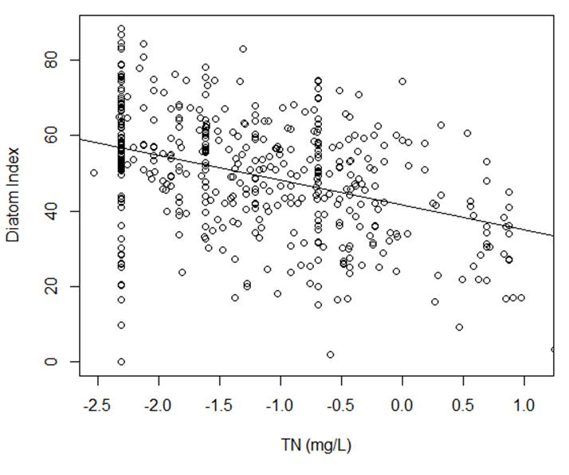

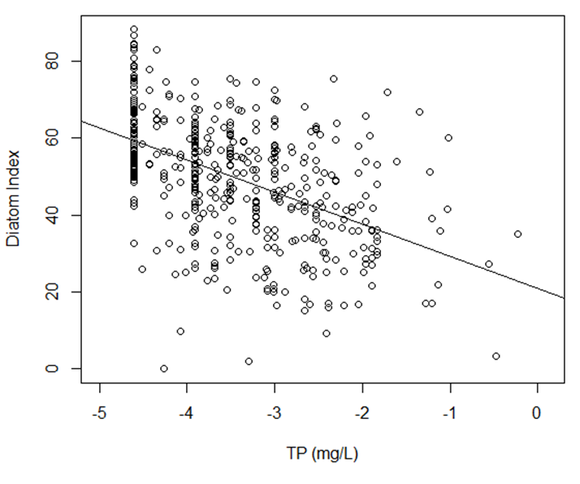

Figure 3. Wyoming stream diatom index scores in relation to total nitrogen (log TN, top) and total phosphorus (log TP, bottom). Adjusted Rsq values are 0.19 for TN and 0.30 for TP.

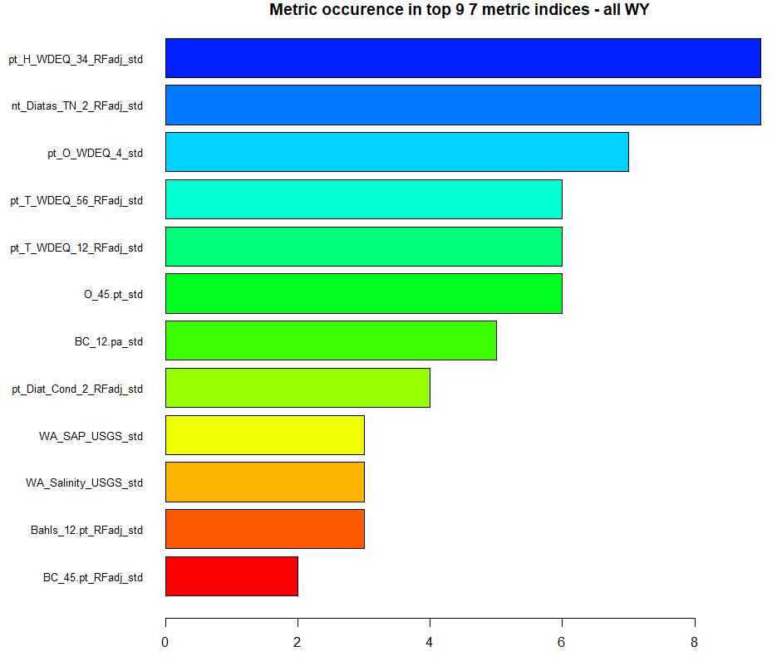

Figure 4. Metric occurrence in the top nine seven-metric indices.

## Precision Analysis

Precision statistics were derived from an ANOVA of 76 same-day replicate sample sets using the site identifier as the grouping variable. The CV was the lower (more precise) for the selected index in comparison to the component metrics of that index (Table 10). Metrics with relatively high precision included the weighted average of the salinity trait and the percent of salinity tolerant taxa. Metrics with relatively low precision were the number of nitrogen sensitive taxa and the percent of oligotrophic taxa. The CI90 for the index was 11.0 index points. This suggests that a true index score for a sample might be 11.0 points greater or lesser than the observed index score in 90% of cases. Therefore, index scores that differ by less than 11.0 points indicate similar diatom conditions for two samples. The precision was derived from same-day replicate sample sets, implying that variability could be attributed to sampling protocol variability. The CI90 should not be used in comparison to assessment thresholds because the error associated with the threshold is already incorporated in the index distribution statistics. There is some evidence that least disturbed index values are more precise than scores for non-reference sites (Smucker and Vis 2011).

Table 10. Precision statistics for metrics and the selected index derived from same-day replicate sample sets. MSE = mean square error; RMSE = root mean square error; mean = average value for the analyzed replicate sets; CI90 = 90% confidence interval; CV = coefficient of variation.

|  |  |  |  |  |  |
| --- | --- | --- | --- | --- | --- |
| Metric | MSE | RMSE | Mean | CI90 | CV |
| WA_Salinity_USGS_std | 82.3 | 9.1 | 43.0 | 14.9 | 21.1 |
| pt_O_WDEQ_4_std | 240.0 | 15.5 | 49.9 | 25.5 | 31.1 |
| pt_H_WDEQ_34_RFadj_std | 222.3 | 14.9 | 65.2 | 24.5 | 22.9 |
| pt_T_WDEQ_56_RFadj_std | 214.8 | 14.7 | 52.5 | 24.1 | 27.9 |
| BC_12.pa_std | 68.2 | 8.3 | 33.3 | 13.6 | 24.8 |
| nt_Diatas_TN_2_RFadj_std | 335.9 | 18.3 | 52.0 | 30.1 | 35.2 |
| pt_T_WDEQ_12_RFadj_std | 318.4 | 17.8 | 50.7 | 29.4 | 35.2 |
| Index #6 | 44.5 | 6.7 | 50.3 | 11.0 | 13.3 |

# Discussion

## Index Calculation

Enter Shiny-app address and instructions here

## Index Application

The Wyoming stream diatom index was shown to distinguish between reference and degraded sites in all site classes (Figure 5). In the Mountain site class, sites with intermediate disturbance had index scores that were similar to the reference sites. In the other classes, sites with intermediate disturbance had index scores that were generally intermediate to the reference and degraded scores.

The distribution of index values in the reference condition can be used in setting thresholds of impairment. Application of thresholds based on the reference distribution of index values can account for the expectations of reference conditions relative to the reference criteria and whether the reference sites represent a minimally disturbed condition or the least disturbed, or best observed, condition. The 10th – 25th percentiles of reference site values are commonly selected as assessment thresholds. Selecting the 25th quantile of reference sites as an assessment threshold would show that 25% of the reference sites would be below the threshold – suggesting stressed biological conditions. If there is greater confidence that the reference sites are undisturbed, then a lower quantile could be selected as an assessment threshold. For the index development dataset, distribution statistics for all sites (regardless of site type) show that 15% of reference sites are lower than 50 points and 15% of degraded sites are above 50 points (Table 11). At this potential assessment threshold, the error rate in reference and degraded assessments would be balanced. An index threshold that balances error would imply equal confidence in designations of reference and degraded sites.

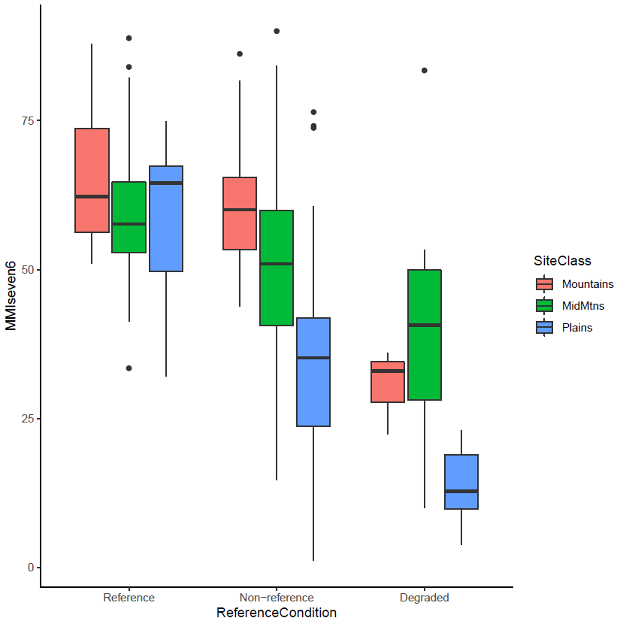

Figure 5. Box plots illustrating Wyoming stream diatom index score distributions among disturbance conditions and site types. Boxes show the intraquartile range (25th – 75 percentiles), whiskers are the non-outlier minimum and maximum, and central bars are medians.

Table 11. Distribution statistics for the Wyoming stream diatom index in reference and degraded sites.

|  |  |  |
| --- | --- | --- |
| Distribution Statistic | Reference | Degraded |
| Minimum | 32.1 | 3.8 |
| 5th quantile | 44.2 | 9.3 |
| 10th quantile | 46.0 | 10.8 |
| 15th quantile | 49.8 | 14.2 |
| 20th quantile | 52.8 | 19.7 |
| 25th quantile | 53.8 | 21.3 |
| Median | 58.9 | 33.4 |
| 75th quantile | 67.8 | 44.6 |
| 80th quantile | 69.2 | 47.0 |
| 85th quantile | 71.8 | 50.5 |
| 90th quantile | 74.9 | 51.9 |
| 95th quantile | 77.6 | 52.8 |
| Maximum | 88.8 | 83.4 |

The national diatom MMI (Carlisle 2022) distinguished reference and degraded in Plains sites (Figure 6). The national MMI did not distinguish disturbance conditions in the Mountains or the Mid-elevation Mountains and Basins. It should be expected that a statewide calibrated index would distinguish disturbance conditions better than an index calibrated to a larger national region.

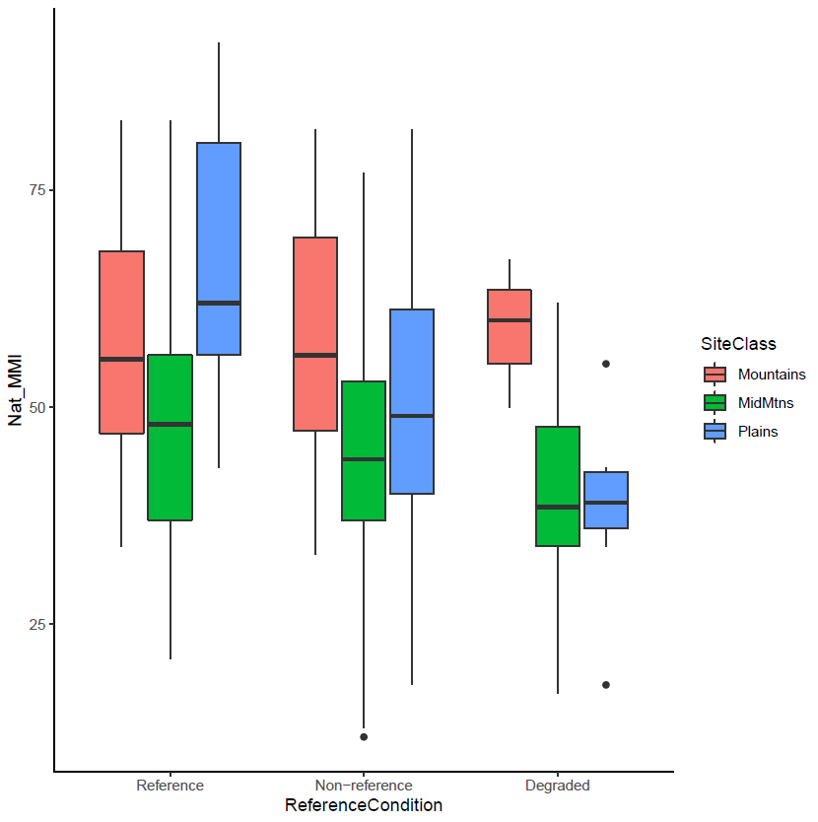

Figure 6. Box plots illustrating the national diatom index (Carlisle et al. 2022) score distributions among disturbance conditions and site types. Boxes show the intraquartile range (25th – 75 percentiles), whiskers are the non-outlier minimum and maximum, and central bars are medians.

## Index Metric Descriptions

The metrics considered and included in the Wyoming diatom index represented five metric categories: biological condition, nutrients, oxygen, salinity, and trophic status. Metrics from other categories were also responsive along the stressor gradient. The response mechanisms of the metrics and the stressors that they might indicate are described below.

***Biological Condition Attributes***

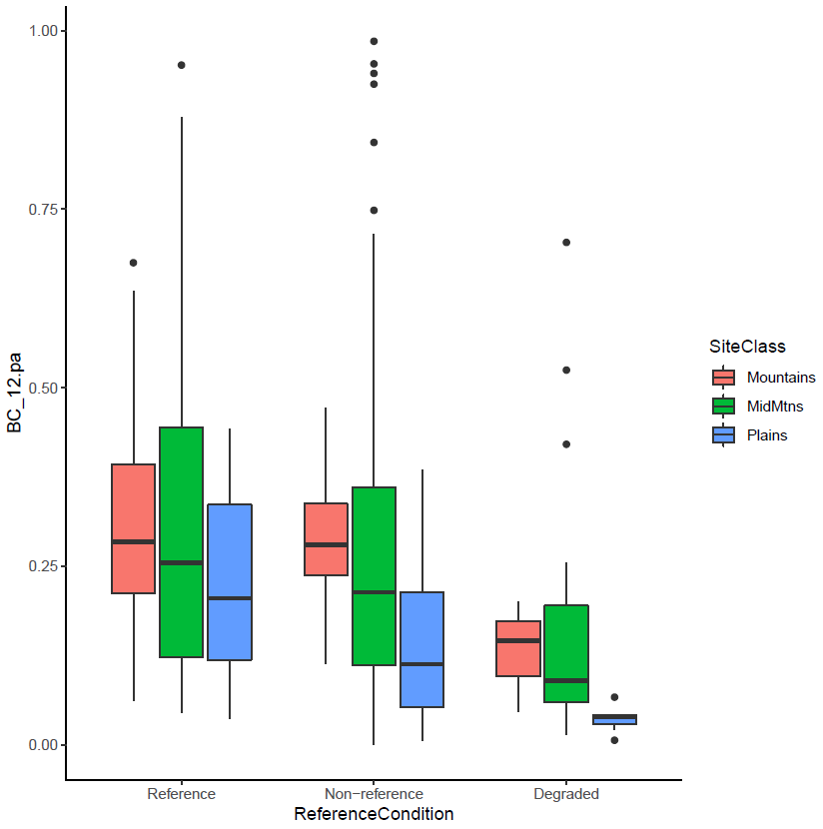The Biological Condition rating (diatoms.org) takes many factors into account (alkalinity, salinity, organic nutrients, etc.) based on a number of reports (Lange-Bertalot 1979, Van Dam et al. 1994, Bahls 1993, Porter et al. 2008) merged with professional experience following the Biological Condition Gradient (BCG) approach (Davies and Jackson 2006, Paul et al. 2020). The BC traits were established by staff at the EPA and USGS working with diatom taxa traits for the Diatoms of North America website (diatoms.org).

The proportional abundance of BC 1 and BC 2 taxa (BC_12.pa) was responsive along the stressor gradient (Figure 7) and was included in the index. The BC metric was not adjusted to environmental factors across the state. BC_1 represents the most sensitive diatoms and BC_2 represents moderately sensitive taxa. The scale is up to BC_5, the most tolerant taxa. In the BCG framework, the most sensitive and moderately sensitive taxa are proportionally diverse when environmental conditions are as naturally occurs. As stressors increase, the sensitive diatom taxa perish or emigrate, resulting in proportionally fewer BC 1 and BC 2 individuals (Hausmann et al. 2016, Paul et al. 2020, Charles et al. 2019).

Figure 7. Box plots illustrating the proportional abundance of BC 1 and BC 2 taxa (BC_12.pa) distributions among disturbance conditions and site types.

***Salinity Indicators***

Two salinity tolerance metrics were included in the index: e (pt_H_WDEQ_34) and the weighted average of salinity tolerance by abundance (WA_Salinity_USGS). The percent taxa metric was adjusted to environmental predictors. These metrics were not highly correlated with each other (Spearman rho = 0.30).

The salinity tolerance trait scales for both metrics range from 1 (most sensitive) to 4 (most tolerant) based on van Dam and others (1994). The metrics had higher values in degraded sites in all site types (Figure 8). For both metrics, responses were most evident in the Plains site types. Diatom community changes have been noted in association with increases in ions due to urbanization and road salting (Porter-Goff et al. 2013, Newall and Walsh 2005). Salt tolerant diatoms have been found to increase in catchments influenced by land use, including agriculture and urbanization (Leland & Porter, 2000, Rott et al., 1998; Munn et al., 2002, Sonneman et al. 2001, Potapova and Charles 2003).

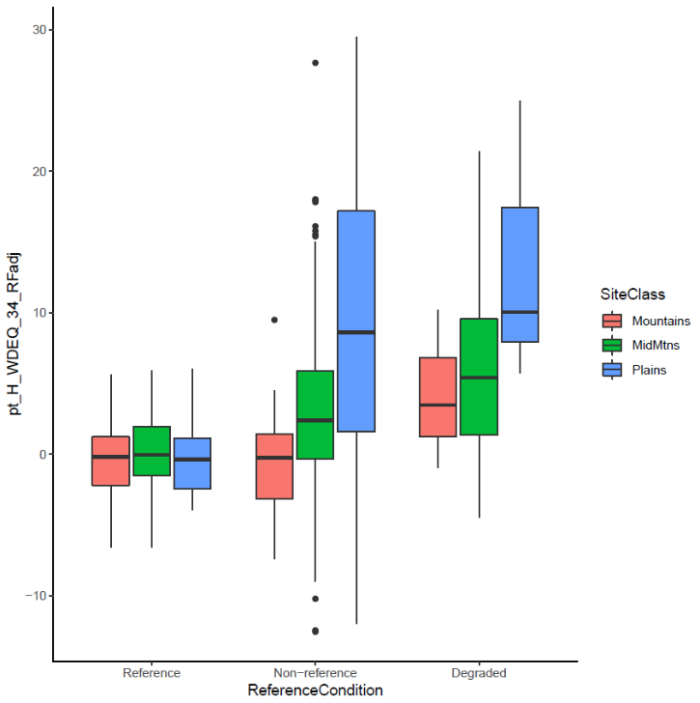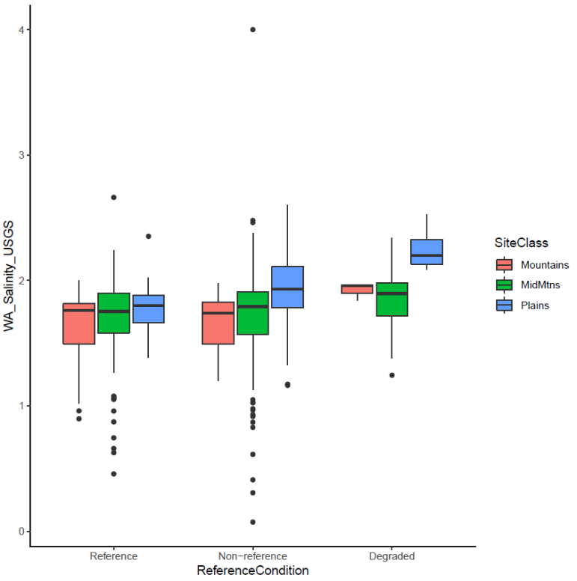

eept_H_WDEQ_34, left) and the weighted average of salinity tolerance by abundance (WA_Salinity_USGS, right) distributions among disturbance conditions and site types.

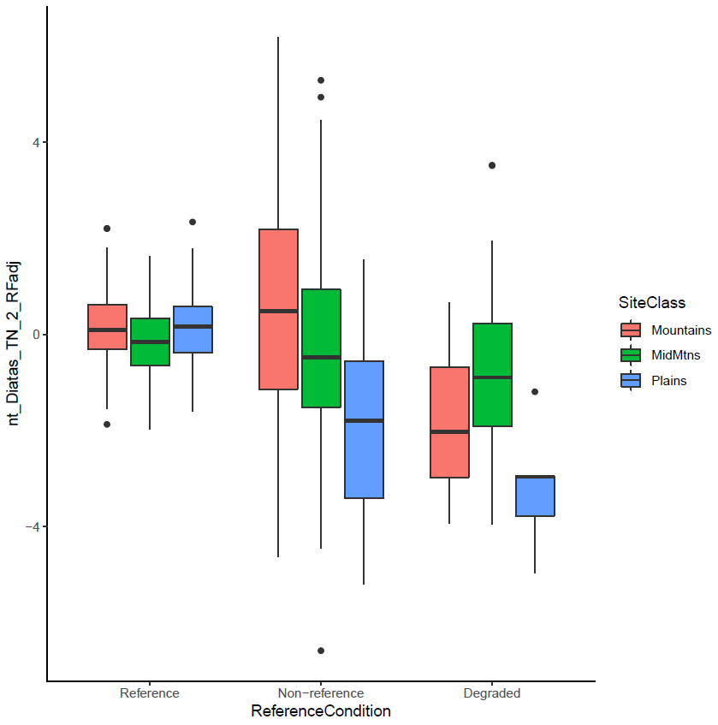***Nutrient/Nitrogen Indicator***

Several metrics based on nutrient traits were responsive to the general disturbance gradient. The one used in the Wyoming stream diatom index was the number of nitrogen sensitive taxa adjusted to environmental predictors (nt_Diatas_TN_2_RFadj). The metric values are distinguishable among disturbance categories in all site types (Figure 9). The adjusted and scored metric is less sensitive to measured nutrients than the index (compare Figure 10 and Figure 3).

Diatoms are commonly associated with nutrient availability (Charles et al. 2019, Haussman et al. 2016, Justus 2010, Ponader et al. 2007, Porter et al. 2008, Stevenson et al. 2008b). As nutrient concentrations in streams increase, those taxa that are sensitive to nutrient enrichment are displaced by more tolerant taxa.

Figure 8. Box plots illustrating the number of nitrogen sensitive taxa metric distributions among disturbance conditions and site types.

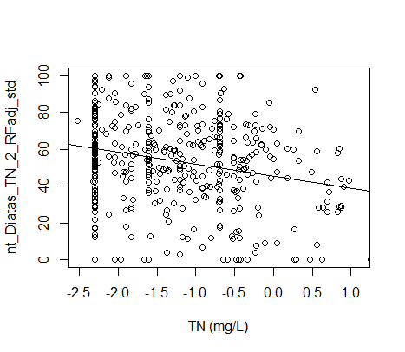

Figure 9. Number of nitrogen sensitive taxa adjusted to environmental predictors (nt_Diatas_TN_2_RFadj_std) in relation to total nitrogen (log TN). Adjusted Rsq value is 0.07.

***Trophic State Indicators***

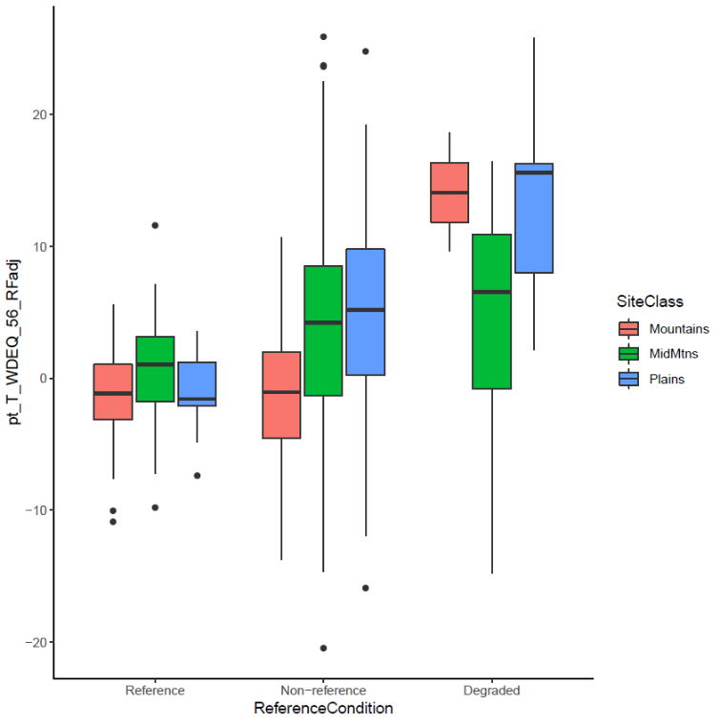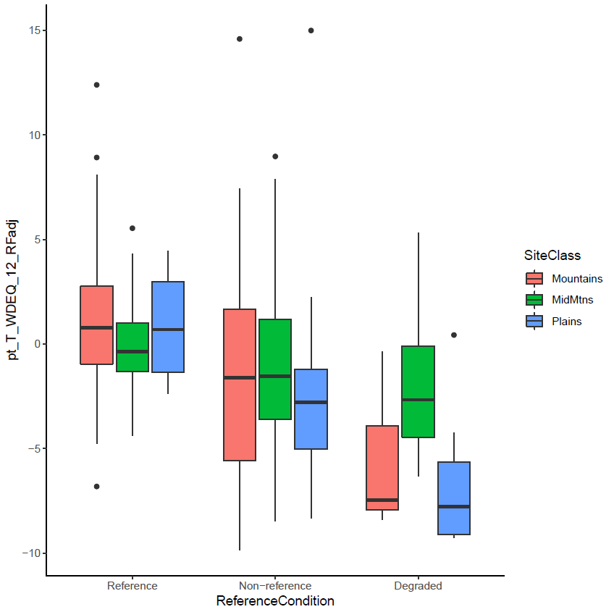Two trophic metrics were included in the index: percent taxa of oligotrophic taxa (pt_T_WDEQ_12) and the percent taxa of eutrophic taxa (pt_T_WDEQ_56). Both metrics were adjusted to environmental predictors. These metrics were not highly correlated with each other (Spearman rho = 0.33). Both metrics were sensitive along the disturbance gradient, with the greatest distinctions between reference and degraded sites in the Mountains and Plains site types.

Figure 10. Box plots illustrating the percent taxa of oligotrophic taxa (pt_T_WDEQ_12, left) and the percent taxa of eutrophic taxa (pt_T_WDEQ_56, right) distributions among disturbance conditions and site types.

The trophic traits were derived from van Dam and others (1994). Oligotraphentic (category 1) and oligotraphentic-mesotraphentic (category 2) taxa are characteristic of environments with low and relatively low supplies of nutrients, particularly nitrogen and phosphorus. Eutraphentic (category 5) and Hypereutraphentic (category 6) taxa are characteristic of environments with a rich and extreme supplies of nutrients. Trophic indices have been recognized as effective tools for monitoring eutrophication (Kelly and Whitton 1995, Potapova et al. 2004, Besse-Lototskaya et al. 2011). As organic pollution and nutrients increase with eutrophication, the diatom community shifts from more sensitive taxa to more tolerant taxa.

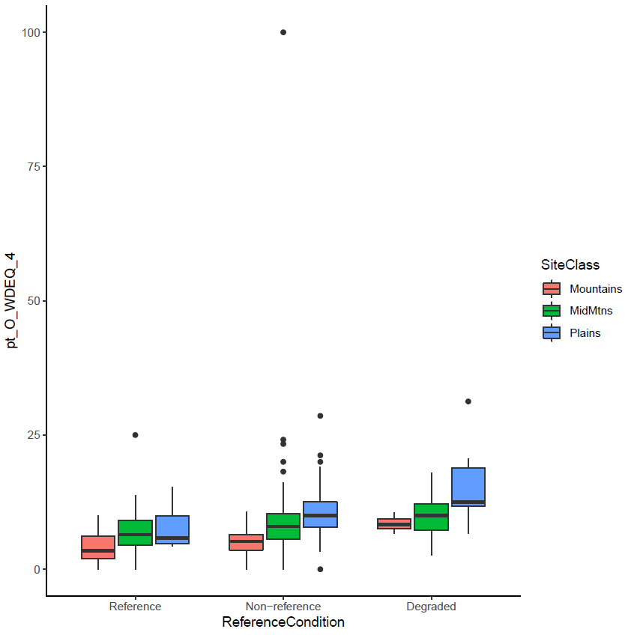***Dissolved Oxygen Affinity***

Figure 11. Box plots illustrating the percent of taxa with affinity for relatively low oxygen (pt_O_WDEQ_4) distributions among disturbance conditions and site types.

The oxygen affinity metric selected for the index is the percent of taxa with affinity for relatively low oxygen (pt_O_WDEQ_4). The metric was not adjusted to environmental variables, though there is some variation among site types, with lower metric values in the High Mountains. Metric values increase along the disturbance gradient in each site class (Figure 12).

Taxa with the O_WDEQ_4 trait are associated with environments having 30 – 50% dissolved oxygen saturation, as designated by van Dam and others (1994). As photosynthetic organisms, diatoms do not require oxygen. However, as with the saprobian system, dissolved oxygen concentrations are related to the organic material present, so taxa found with relatively low oxygen are presumably sensitive to higher organic enrichment.

# References Cited

Bahls, L.L., 1993, Periphyton bioassessment methods for Montana streams: Water Quality Bureau, Department of Health and Environmental Sciences, Helena, MT, 69 p.

Bailey, R.C., R.H. Norris, and T.B. Reynoldson. 2004. Bioassessment of freshwater ecosystems: using the reference condition approach. Kluwer Academic Publishers, New York.

Barbour, M.T., J. Gerritsen, B.D. Snyder, and J.B. Stribling. 1999. Rapid Bioassessment Protocols for Use in Streams and Wadeable Rivers: Periphyton, Benthic Macroinvertebrates and Fish, Second Edition. EPA 841-B-99-002. U.S. Environmental Protection Agency; Office of Water; Washington, D.C.

Besse-Lototskaya, A., P.F. Verdonschot, M. Coste, and B. Van de Vijver. 2011. Evaluation of European diatom trophic indices. *Ecological Indicators*, *11*(2), pp.456-467.

Blocksom, K.A. 2003. A Performance Comparison of Metric Scoring Methods for a Multimetric Index for Mid-Atlantic Highlands Streams. *Environmental Management,* 31**,** 670-682.

Cao, Y., C.P. Hawkins, J. Olson, and M.A. Kosterman. 2007. Modeling natural environmental gradients improves the accuracy and precision of diatom-based indicators. Journal of the North American Benthological Society 26(3), 566-585.

Carlisle, D.M., S.A. Spaulding, M.A. Tyree, N.O. Schulte, S.S. Lee, R.M. Mitchell, and A.A. Pollard. 2022. A web-based tool for assessing the condition of benthic diatom assemblages in streams and rivers of the conterminous United States. *Ecological Indicators*, *135*, p.108513.

Chapman, S.S., S.A. Bryce, J.M. Omernik, D.G. Despain, J. ZumBerge, and M. Conrad. 2004. Ecoregions of Wyoming (color poster with map, descriptive text, summary tables, and photographs): Reston, Virginia, U.S. Geological Survey (map scale 1:1,400,000).

Charles D.F., A.P. Tuccillo and T.J. Belton. 2019. Use of diatoms for developing nutrient criteria for rivers and streams: a biological condition gradient approach. Ecological Indicators 96: 258-269.

Cohen, J. 1992. A power primer. *Psychological Bulletin*, 112(1):155.

Fetscher, A.E., M.A. Sutula, L.B. Busse, and E.D. Stein. 2013. Condition of California perennial, wadeable streams based on algal indicators. California State Water Resources Control Board Surface Water Ambient Monitoring Program (SWAMP) Final Technical Report.

Fetscher, A.E., R. Stancheva, J.P. Kociolek, R.G. Sheath, E.D. Stein, R.D. Mazor, P.R. Ode, and L.B. Busse. 2014. Development and comparison of stream indices of biotic integrity using diatoms vs. non-diatom algae vs. a combination J Appl Phycol 26:433–450.

Flotemersch, J.E., J.B. Stribling, and M.J. Paul. 2006. Concepts and Approaches for the Bioassessment of Non-wadeable Streams and Rivers. US Environmental Protection Agency, Office of Research and Development.

Hargett, E. 2011. The Wyoming Stream Integrity Index (WSII) – Multimetric Indices for Assessment of Wadeable Streams and Large Rivers in Wyoming. Document #11-0787. Prepared by the Wyoming DEQ, Water Quality Division, Cheyenne, WY.

Hausmann, S., D.F. Charles, J. Gerritsen and T.J. Belton 2016. A diatom-based biological condition gradient (BCG) approach for assessing impairment and developing nutrient criteria for streams. Science of the Total Environment 562: 914-927.

Hering, D., R.K. Johnson, S. Kramm, S. Schmutz, K. Szoszkiewicz, and P.F.M. Verdonschot. 2006. Assessment of European streams with diatoms, macrophytes, macroinvertebrates and fish: a comparative metric‐based analysis of organism response to stress. Freshwater Biology, 51(9), pp.1757-1785

Hill, B.H., A.T. Herlihy, P.R. Kaufmann, R.J. Stevenson, F.H. McCormick, and C. Burch Johnson. 2000. Use of periphyton assemblage data as an index of biotic integrity. Journal of the North American Benthological Society, 19(1), 50-67.

Hill, R.A., M.H. Weber, S.G. Leibowitz, A.R. Olsen, and D.J. Thornbrugh, 2016. The Stream-Catchment (StreamCat) Dataset: A Database of Watershed Metrics for the Conterminous United States. Journal of the American Water Resources Association (JAWRA) 52:120-128. DOI: 10.1111/1752-1688.12372.

Hughes, R.M., D.P. Larsen, and J.M. Omernik. 1986. Regional reference sites: a method for assessing stream potentials. Environmental Management 10:629–635.

Jessup, B., B. Block, J. Stamp, and E. Leppo. 2021. Diatoms in Indiana Streams as Indicators of Biological Condition. Prepared for U.S. EPA Region 5, Chicago, IL and Indiana Department of Environmental Management, Indianapolis, IN.

Johnson R.K., D. Hering, M.T. Furse and R. Clarke. 2006a. Detection of ecological change using multiple organism groups: metrics and uncertainty. Hydrobiologia, 566, 115–137.

Johnson R.K., D. Hering, M.T. Furse and P.F.M. Verdonschot. 2006b. Indicators of ecological change: comparison of the early response of four organism groups to stress gradients. Hydrobiologia, 566, 139–152.

Justus, B. G., J.C. Petersen, S.R. Femmer, J.V. Davis, and J. E. Wallace. 2010. A comparison of algal, macroinvertebrate, and fish assemblage indices for assessing low-level nutrient enrichment in wadeable Ozark streams. Ecological Indicators, 10(3): 627-638.

Kelly, M. G., & Whitton, B. A. 1995. The trophic diatom index: a new index for monitoring eutrophication in rivers. Journal of Applied Phycology, 7(4), 433-444.

Kelly, M., Juggins, S., Guthrie, R., Pritchard, S., Jamieson, J., Rippey, B., Hirst, H. and Yallop, M., 2008. Assessment of ecological status in UK rivers using diatoms. Freshwater biology, 53(2), pp.403-422.

Kolkwitz, R., and M. Marrson. 1908. Ökologie der pflanzlichen Saprobien. Berichte der Deutschen Botanischen Gesellschaft 26a: 505–519. (Transl. 1967. Ecology of plant saprobia. In: Keup LE, Ingram WM, Mackenthun KM (eds) Biology of Water Pollution. Federal Water Pollution. Federal Water Pollution Control Admin., Washington DC: U.S. Dept. of the Interior, pp. 47–52).

Lange-Bertalot, H., 1979. Pollution tolerance of diatoms as a criterion for water quality estimation. Nova Hedwigia, Beih., 64:285-304.

Lavoie, I., S. Campeau, F. Darchambeau, G. Cabana, and P.J. Dillon. 2008. Are diatoms good integrators of temporal variability in stream water quality? Freshwater biology, 53(4), pp.827-841.

Lee, S.S.., I.W. Bishop, S.A. Spaulding, R.M. Mitchell, and L.L. Yuan. 2019. Taxonomic harmonization may reveal a stronger association between diatom assemblages and total phosphorus in large datasets. Ecol Indic. 2019 Jul 1;102:166-174. doi: 10.1016/j.ecolind.2019.01.061. PMID: 32802000; PMCID: PMC7425634.

Leland, H. V. & S. D. Porter, 2000. Distribution of benthic algae in the upper Illinois River basin in relation to geology and land use. Freshwater Biology 44: 279–301.

Liaw, A. and M. Wiener (2002). Classification and Regression by randomForest. R News 2(3), 18--22.

Maxted, J. R., M. T. Barbour, J. Gerritsen, V. Poretti, N. Primrose, A. Silvia, D. Penrose, and R. Renfrow. 2000. Assessment framework for mid-Atlantic coastal plain streams using benthic macroinvertebrates. *Journal of the North American Benthological Society,* 19(1):128-144.

McCormick, P.V., and J. Cairns. 1994. Algae as indicators of environmental change. Journal of Applied Phycology, 6(5-6), 509-526.

McCormick, P. V. and L. J. Scinto. 1999. Influence of phosphorus loading on wetlands periphyton assemblages: A case study from the Everglades. Boca Raton, CRC Press-Taylor & Francis Group.

Munn, M. D., R. W. Black & S. J. Gruber, 2002. Response of benthic algae to environmental gradients in an agriculturally dominated landscape. Journal of the North American Benthological Society 21: 221–237.

Newall, P. and C.J. Walsh. 2005. Response of epilithic diatom assemblages to urbanization influences. *Hydrobiologia*, *532*(1), pp.53-67.

Pan, Y., R.J. Stevenson, B.H. Hill, A.T. Herlihy, and G.B. Collins. 1996. Using diatoms as indicators of ecological conditions in lotic systems: a regional assessment. Journal of the North American Benthological Society, 15(4), 481-495.

Paul M.J., B. Jessup, L.R. Brown, J.L. Carter, M. Cantonati, D.F. Charles, J. Gerritsen, D.B. Herbst, R. Stancheva, J. Howard and B. Isham. 2020. Characterizing benthic macroinvertebrate and algal biological condition gradient models for California wadeable Streams, USA. Ecological Indicators 117: 106618.

Ponader, K.C. and M.G. Potapova. 2007. Diatoms from the genus *Achnanthidium* in flowing waters of the Appalachian Mountains (North America): Ecology, distribution and taxonomic notes. *Limnologica*, *37*(3):227-241.

Porter-Goff, E.R., P.C. Frost, and M.A. Xenopoulos. 2013 Changes in riverine benthic diatom community structure along a chloride gradient. Ecol. Indic. 32:97–106.

Porter, S.D., D.K. Mueller, N.E. Spahr, M.D. Munn and N.M. Dubrovsky. 2008. Efficacy of algal metrics for assessing nutrient and organic enrichment in flowing waters. Freshwater Biology 53, 1036–1054.

Potapova M., D.F. Charles, K.C. Ponader, and D.M. Winter. 2004. Quantifying species indicator values for trophic diatom indices: comparison of approaches. Hydrobiologia, 517: 25-41

Potapova, M., and D.F. Charles. 2003, Distribution of benthic diatoms in U.S. rivers in relation to conductivity and ionic composition: *Freshwater Biology*, v. 48, no. 8, p. 1311–1328.

Potapova, M., and D.F. Charles. 2007. Diatom metrics for monitoring eutrophication in rivers of the United States. Ecol. Indic. 7, 48–70.

R Core Team (2020). R: A language and environment for statistical computing. R Foundation for Statistical Computing, Vienna, Austria.URL <https://www.R-project.org/>.

Rott, E., H. C. Duthie and E. Pipp. 1998. Monitoring organic pollution and eutrophication in the Grand River, Ontario, by means of diatoms. *Canadian Journal of Fisheries and Aquatic Sciences* 55: 1443–1453

Smucker, N.J., and M.L. Vis. 2011. Diatom biomonitoring of streams: reliability of reference sites and the response of metrics to environmental variations across temporal scales. Ecological Indicators, 11(6), pp.1647-1657.

Sonneman, J. A., C. J. Walsh, P. F. Breen, and A. K. Sharpe. 2001. Effects of urbanization on streams of the Melbourne region, Victoria, Australia. II. Benthic diatom communities. *Freshwater Biology* 46:553–565.

Stevenson, R. J., Y. Pan, K. M. Manoylov, C. A. Parker, D. P. Larsen, and A. T. Herlihy 2008a. Development of diatom indicators of ecological conditions for streams of the western US. J. N. Am. Benthol. Soc., 2008, 27(4):1000–1016;

Stevenson, R. J., Hill, B. E., Herlihy, A. T., Yuan, L. L., and Norton, S. B. 2008b. Algae–P relationships, thresholds, and frequency distributions guide nutrient criterion development. *Journal of the North American Benthological Society*, 27, 259–75.

Stevenson, R. J., Michigan State, unpublished trait information;

Stevenson, R.J. 2014. Ecological assessments with algae: a review and synthesis. Journal of Phycology 50(3):437-461.

Stevenson, R.J., Y. Pan, & H. van Dam. 2010. Assessing environmental conditions in rivers and streams with diatoms. The Diatoms: Applications for the Environmental and Earth Sciences, 2nd ed. Cambridge University Press, Cambridge, 5785.

Stevenson, R.J. and J.P. Smol. 2003. Use of algae in environmental assessments. Academic Press, San Diego, CA.

Stevenson, R. J. and B. Wang. 2001. Developing and Testing Algal Indicators of Nutrient Status in Florida Streams. Final Report Prepared for Florida Department of Environmental Protection. October 31, 2001.

Stoddard, J.L., D.P. Larsen, C.P. Hawkins, R.K. Johnson, and R.H. Norris. 2006. Setting expectations for the ecological condition of running waters: the concept of reference condition. Ecological Applications 16:1267– 1276.

Tang, T., R.J. Stevenson, and D.M. Infante. 2016. Accounting for regional variation in both natural environment and human disturbance to improve performance of multimetric indices of lotic benthic diatoms. *Science of the Total Environment*, *568*:1124-1134

Teply, M., & Bahls, L. 2005. Diatom Biocriteria for Montana Streams. Prepared for the Montana Department of Environmental Quality by Larix Systems. Inc. of Helena, Montana.

Tyree, M.A., Carlisle, D.M. and Spaulding, S.A., 2020. Diatom enumeration method influences biological assessments of southeastern USA streams. Freshwater Science, 39(1), pp.183-195.

U.S. EPA (U.S. Environmental Protection Agency). 2000. Nutrient Criteria Technical Guidance Manual: Rivers and Streams. EPA-822-B-00-002. Office of Water, Office of Science and Technology. Washington, DC.

van Dam, H., A. Mertens, and J. Sinkeldam. 1994. A coded and ecological indicator values of freshwater diatoms from the Netherlands. Neth. J. Aquat. Ecol. 28, 117–133.;

Wang, Y.-K., R. J. Stevenson and L. Metzmeier. 2005. Development and evaluation of a diatom based index of biotic integrity for the Interior Plateau Ecoregion, USA. Journal of the North American Benthological Society 24(4): 990-1008.

WDEQ (Wyoming Department of Environmental Quality). 2010. Wyoming Water Quality Assessment and Impaired Waters List (2010 Integrated 305(b) and 303(d) Report). Wyoming Department of Environmental Quality, Water Quality Division, Cheyenne, Wyoming.

WDEQ (Wyoming Department of Environmental Quality). 2007. Wyoming Water Quality Rules and Regulations, Chapter 1, Wyoming Surface Water Quality Standards. Wyoming Department of Environmental Quality, Water Quality Division, Cheyenne, Wyoming.

# Appendix A. Metric Descriptions

# Appendix B. Initial Site Classification

# Appendix C. Random Forest Detailed Methods

Introduction

This document describes the rationale and process for adjusting diatom metrics to natural gradients with random forest (RF) prior to combining them into a multi-metric index. It utilizes real data from the WY DEQ diatom dataset to illustrate how the RF adjustment is applied to an individual sample. General understanding of classification and regression tree models (CART) is assumed.

Why adjust metrics?

Diatom communities are strongly influenced by natural factors including (Cao et al. 2007):

**Climate:** air temperature, precipitation

**Location:** latitude, longitude, elevation, watershed area

**Geology:** predicted rock hardness, predicted conductivity

Therefore, modelling diatom metrics in reference sites accounts for natural gradients and increases metric precision (decreases variation) (Figure ).

Figure __-1 Percent nitrogen tolerant diatom taxa (pt_Diatas_TN_1) metric after random forest (RF) adjustment as a function in its raw version (left). Distribution of pt_Diatas_TN_1 by reference status in raw (center) and RF adjusted (right) forms. Variation in reference sites is reduced after adjustment (center and right blue boxes).

What is a random forest?

A random forest is a set of 500 separate CART models, each built with subsets of the training data (data used to build a model, as opposed to testing the result). Each CART model (tree) is built with bootstrap samples from available metric data (about 2/3 of total number of samples) with the diatom metric value as the dependent variable. Each split in each of the 500 trees includes only a subset of the available predictors, selected randomly.

The final model consists of all 500 trees. Predictions for training or new data are calculated by using the sample’s predictors to identify the terminal node of each tree to which it belongs and averaging the diatom metric values associated with those nodes from each of the 500 trees.

What natural factors are important in Wyoming diatom communities?

Predictor choices were mostly limited to those available in the StreamCat dataset for ease of MMI application in the future. Among StreamCat variables (plus latitude, longitude and elevation), exploratory analyses showed several variables to be important predictors of diatom metrics in the current WY dataset (Table __-1).

Table __-1. Predictor variables used in the random forest metric adjustment process.

|  |  |  |
| --- | --- | --- |
| **Variable Name** | **Description** | **Data Source** |
| **Elevation** | Position above sea level in feet | WY DEQ |
| **RckDepWs** | Mean depth (cm) to bedrock of soils (STATSGO) within watershed | StreamCat: STATSGO_Set2_WY.csv |
| **BFIWs** | Baseflow Index (BFI) is the ratio of baseflow to total flow, expressed as a percentage, within watershed. | StreamCat: BFI_WY.csv |
| **KffactWs** | Mean soil erodibility (Kf) factor (unitless) of soils within watershed. The Kf factor is used in the Universal Soil Loss Equation (USLE) and represents a relative index of susceptibility of bare, cultivated soil to particle detachment and transport by rainfall. | StreamCat: Kffact_WY.csv |
| **Precip8110Ws** | PRISM climate data - 30-year normal mean precipitation (mm): Annual period: 1981-2010 within the watershed | StreamCat: PRISM_1981_2010_WY.csv |
| **Tmean8110Ws** | PRISM climate data - 30-year normal mean temperature (°C): Annual period: 1981-2010 within the watershed | StreamCat: PRISM_1981_2010_WY.csv |
| **Tmax8110Ws** | PRISM climate data - 30-year normal maximum temperature (°C): Annual period: 1981-2010 within the watershed | StreamCat: PRISM_1981_2010_WY.csv |
| **SWs** | Mean % of lithological sulfur (S) content in surface or near surface geology within watershed | StreamCat: GeoChemPhys1_WY.csv |

Using these predictors, a RF model was built to explain reference variability in each diatom metric. Metrics for which less than 20% of the variation was explained were left in their original (unadjusted) forms. Each metric for which greater than 20% of the variation was explained by the RF model was adjusted (Carlisle et al. 2022). Therefore, for each diatom metric that was strongly influenced by natural gradients, a RF model consisting of 500 trees was saved to adjust those and future sample metrics.

Example 3-tree forest

Each tree of the forest was built with 118 bootstrap samples from 177 total reference site observations. Each split looked at 5 of the possible predictors. The following figures represent a real RF model limited to only 3 trees that explains pt_H_WDEQ_34 (a salinity tolerance trait) on the basis of base-flow index, elevation, soil erodibility, precipitation, rock depth, and mean air temperature. Despite having only 3 trees, this forest explains 28% of the variation in pt_H_WDEQ_34. One sample was chosen to illustrate how the adjusted metric value is calculated ( Figure __-312).

**Sample data:**

|  |  |  |  |  |  |  |  |  |  |
| --- | --- | --- | --- | --- | --- | --- | --- | --- | --- |
| Station | SampID | Condition | Elevation | Baseflow index | KffactWs | Precip | Tmean | Rock Depth | pt_H_WDEQ_34 |
| MRC0127 | 465 | Reference | 5360 | 62.65 | 0.2 | 645 | 1.77 | 100 | 5.56 |

Most important predictor of pt_H_WDEQ_34 in these 118 reference bootstrap samples

Value of TmeanWs split (annual mean in ˚C)

**MRC0127 sample values follow blue shapes:**

**TmeanWS = 1.77**

**Elevation = 5360 ft**

**Prediction = 16.015**

Mean value of pt_H_WDEQ_34 in final node

*Figure __-2. Random forest of three trees. Red boxes denote general concepts; blue boxes follow above sample through forest.*

**MRC0127 sample values follow blue shapes:**

**PrecipWs = 645 mm annual mean**

**Base flow index = 62.65%**

**Prediction = 7.668**

**MRC0127 sample values follow blue shapes:**

**TmeanWS = 1.77**

**PrecipWs = 645 mm annual mean**

**Prediction = 11.913**

*Figure __-2, continued.*

For the Example, the predicted pt_H_WDEQ_34 value is based on the average of the values from the terminal nodes of each tree in the random forest *(= (16 + 7.7 + 11.9)/3 = 11.87)*.

Adjusted value (on a new scale centered ~0) = observed value – predicted value = 5.56-11.87 = - 6.31

Figure __-312. Random forest (RF) predictions (left) and final, adjusted metric values (right). Sample illustrated above in red.

Summary

To adjust diatom metrics with RF:

1. Build random forest (RF) models to predict reference site diatom metrics using natural factors as the predictors (Tang et al 2016)
2. If (and only if) RF model explains ≥ 20% of variation in metric at the reference site, use the adjusted form of the metric (Carlisle et al 2022)
3. Calculate adjusted (to site) diatom metrics:
   1. Using RF models from step 1, predict site specific metric values
   2. Use residual value as “adjusted” metric value:

**Adjusted valued = Observed value – predicted value**

The residual (adjusted) value can be thought of as the variation remaining after accounting for natural factors.

How many metrics should be included in an MMI?

Carlisle et al. (2022) generated all combinations of 2, 3, 4, 5, 6 and 7 metrics MMIs after excluding:

* metrics that were not different between ref and stressed sites
* Combinations with > 1 metric from same category
* Metrics with Pearson correlation > 0.70

The scale of this project overall was national, with all streams of the conterminous United States allocated into 1 of three regions, each of which had its own MMI. Eight-metric MMI calculations failed due to hardware (RAM) limitations. From all the 2-7 metric MMI combinations, they narrowed field of to the top 5% of MMIs by responsiveness, precision and sensitivity:

**Sensitivity**: percent of stressed sites with MMI < 5th percentile of reference sites

**Responsiveness**: t-statistic for difference between mean MMI scores in reference and stressed sites

**Precision**: standard deviation of MMI at reference sites

They concluded that there was minimal improvement in index performance when including more than 6 metrics (Figure 13).

References

Cao, Y., Hawkins, C.P., Olson, J., Kosterman, M.A., 2007. Modeling natural environmental gradients improves the accuracy and precision of diatom-based indicators for Idaho streams. Journal of the North American Benthological Society 26

Carlisle, D. M., Spaulding, S. A., Tyree, M. A., Schulte, N. O., Lee, S. S., Mitchell, R. M., & Pollard, A. A. (2022). A web-based tool for assessing the condition of benthic diatom assemblages in streams and rivers of the conterminous United States. *Ecological Indicators*, *135*, 108513.

Tang, T., R.J. Stevenson, and D.M. Infante. 2016. Accounting for regional variation in both natural environment and human disturbance to improve performance of multimetric indices of lotic benthic diatoms. *Science of the Total Environment*, *568*:1124-1134.

Figure 13. Figure from Carlisle et al. 2022 report showing how responsiveness, sensitivity and precision change with increasing numbers of metrics in the MMI. The 3 groups represent their three regions, each of which had an index built separately.

# Appendix D. Metric Discrimination

# Appendix E. Metric Correlations

# Appendix F. Wyoming Stream Diatom Index and Metric Scores

| Station | Collection Date | Disturbance Status | Samp_Rep | WY Stream Diatom Index | BC_12.pa_std | nt_Diatas_TN_2_RFadj_std | pt_H_WDEQ_34_RFadj_std | WA_Salinity_USGS_std | pt_O_WDEQ_4_std | pt_T_WDEQ_12_RFadj_std | pt_T_WDEQ_56_RFadj_std |
| --- | --- | --- | --- | --- | --- | --- | --- | --- | --- | --- | --- |
| SR0055 | 9/10/2007 | Non-Ref | 160_0 | 40.7 | 10.6 | 59.7 | 78.9 | 34.7 | 49.8 | 19.2 | 32.2 |
| SR0055 | 9/10/2007 | Non-Ref | 160_1 | 43.4 | 19.6 | 43.9 | 66.8 | 8.0 | 70.4 | 39.3 | 55.9 |
| WHP0051 | 10/4/2007 | Degraded | 169_0 | 1.9 | 0.0 | 0.0 | 0.0 | 8.4 | 0.0 | 1.4 | 3.7 |
| WHP0047 | 10/8/2007 | Degraded | 171_0 | 3.8 | 0.0 | 0.0 | 18.9 | 7.9 | 0.0 | 0.0 | 0.0 |
| MRW45 | 9/11/2007 | Reference | 183_0 | 44.2 | 37.9 | 30.9 | 60.2 | 39.2 | 33.1 | 57.3 | 50.8 |
| MRW45 | 9/11/2007 | Reference | 183_1 | 44.9 | 31.9 | 30.9 | 93.0 | 39.0 | 39.4 | 30.2 | 49.9 |
| WB0230 | 10/9/2007 | Degraded | 191_0 | 23.0 | 1.6 | 43.0 | 0.0 | 0.1 | 57.6 | 0.0 | 58.7 |
| WB0292 | 10/24/2007 | Reference | 194_0 | 51.1 | 35.7 | 47.5 | 71.5 | 48.4 | 100 | 9.3 | 45.0 |
| WB0292 | 10/24/2007 | Reference | 194_1 | 60.5 | 7.6 | 100 | 100 | 25.2 | 42.2 | 48.6 | 100 |
| MRW10 | 8/29/2007 | Reference | 201_0 | 68.7 | 70.7 | 72.5 | 89.1 | 24.7 | 83.3 | 62.9 | 77.6 |
| MRW10 | 8/29/2007 | Reference | 201_1 | 32.0 | 29.7 | 88.4 | 30.5 | 24.2 | 36.4 | 15.1 | 0.0 |
| WB0296 | 9/18/2007 | Non-Ref | 202_0 | 45.2 | 55.2 | 49.3 | 75.3 | 18.6 | 59.6 | 21.3 | 37.1 |
| WB0296 | 9/18/2007 | Non-Ref | 202_1 | 20.3 | 17.9 | 1.8 | 38.8 | 12.3 | 38.9 | 7.6 | 24.5 |
| WB223 | 8/25/2008 | Degraded | 223_0 | 27.3 | 3.9 | 0.0 | 50.6 | 32.6 | 40.0 | 29.3 | 34.6 |
| SRI9 | 9/16/2008 | Degraded | 228_0 | 33.0 | 28.5 | 72.4 | 60.2 | 22.3 | 33.1 | 0.0 | 14.6 |
| SRI9 | 9/16/2008 | Degraded | 228_1 | 27.8 | 9.4 | 9.1 | 76.1 | 21.4 | 47.0 | 1.4 | 30.0 |
| MRW18 | 8/28/2008 | Reference | 239_0 | 60.1 | 80.6 | 80.5 | 57.5 | 54.0 | 34.2 | 64.2 | 49.2 |
| MRW18 | 8/28/2008 | Reference | 239_1 | 64.9 | 74.6 | 64.7 | 80.2 | 29.0 | 61.9 | 78.6 | 65.0 |
| MRCI31 | 9/16/2008 | Non-Ref | 245_0 | 66.9 | 75.0 | 93.8 | 64.4 | 72.7 | 69.0 | 46.7 | 46.5 |
| MRCI31 | 9/16/2008 | Non-Ref | 245_1 | 69.2 | 82.7 | 62.1 | 79.5 | 100 | 40.9 | 64.9 | 54.0 |
| NGP23 | 9/25/2008 | Non-Ref | 253_0 | 61.2 | 72.3 | 78.4 | 16.0 | 83.8 | 47.0 | 76.3 | 54.2 |
| NGP23 | 9/25/2008 | Non-Ref | 253_1 | 39.6 | 45.8 | 62.6 | 0.0 | 48.1 | 20.5 | 58.3 | 41.9 |
| NGP0215 | 10/28/2008 | Non-Ref | 260_0 | 32.6 | 45.5 | 45.4 | 0.0 | 51.8 | 40.9 | 32.7 | 11.6 |
| NGP0215 | 10/28/2008 | Non-Ref | 260_1 | 29.9 | 24.7 | 61.2 | 0.0 | 34.3 | 10.8 | 38.0 | 40.6 |
| MRW22 | 10/1/2008 | Reference | 274_0 | 58.7 | 69.4 | 44.1 | 78.9 | 56.7 | 43.9 | 61.5 | 56.8 |
| MRW22 | 10/1/2008 | Reference | 274_1 | 49.4 | 44.2 | 59.9 | 60.2 | 59.4 | 20.5 | 66.2 | 35.0 |
| MRWI39 | 10/14/2008 | Reference | 275_0 | 41.7 | 10.2 | 57.9 | 50.4 | 38.5 | 36.4 | 58.1 | 40.3 |
| MRWI39 | 10/14/2008 | Reference | 275_1 | 47.1 | 8.0 | 57.9 | 80.7 | 39.8 | 58.5 | 45.3 | 39.6 |
| WB92 | 8/10/2009 | Non-Ref | 292_0 | 37.1 | 15.9 | 25.3 | 52.7 | 48.6 | 20.5 | 51.1 | 45.4 |
| WB92 | 8/10/2009 | Non-Ref | 292_1 | 51.6 | 16.3 | 25.3 | 72.7 | 73.7 | 57.6 | 43.2 | 72.6 |
| MRW11 | 9/1/2009 | Reference | 296_0 | 58.5 | 20.6 | 64.5 | 85.5 | 42.7 | 78.8 | 57.1 | 60.2 |
| MRW11 | 9/1/2009 | Reference | 296_1 | 59.7 | 13.6 | 48.6 | 78.0 | 33.7 | 100 | 66.0 | 78.2 |
| SR0059 | 6/29/2009 | Reference | 304_0 | 62.7 | 23.2 | 77.5 | 63.6 | 33.1 | 67.1 | 90.1 | 84.6 |
| SR0059 | 6/29/2009 | Reference | 304_1 | 50.4 | 25.6 | 100 | 53.9 | 40.5 | 38.5 | 55.4 | 38.7 |
| WB0323 | 8/26/2009 | Degraded | 313_0 | 49.0 | 16.2 | 100 | 50.5 | 33.8 | 50.1 | 39.5 | 53.1 |
| WB0323 | 8/26/2009 | Degraded | 313_1 | 53.8 | 19.4 | 89.5 | 63.6 | 31.8 | 47.0 | 70.6 | 54.6 |
| SR3 | 9/15/2009 | Reference | 319_0 | 74.4 | 100 | 72.2 | 71.1 | 100 | 47.0 | 66.9 | 63.4 |
| SR3 | 9/15/2009 | Reference | 319_1 | 78.1 | 100 | 88.0 | 65.6 | 100 | 100 | 40.7 | 52.2 |
| MRC22 | 9/3/2009 | Reference | 334_0 | 75.4 | 100 | 51.3 | 60.7 | 100 | 62.6 | 64.7 | 88.6 |
| MRC22 | 9/3/2009 | Reference | 334_1 | 66.7 | 100 | 67.1 | 71.7 | 100 | 51.1 | 29.4 | 47.6 |
| MRWI27 | 9/10/2009 | Reference | 338_0 | 65.6 | 99.0 | 67.7 | 72.5 | 77.2 | 42.2 | 51.1 | 49.4 |
| MRWI27 | 9/10/2009 | Reference | 338_1 | 61.2 | 97.3 | 83.5 | 61.5 | 68.1 | 56.6 | 11.8 | 49.4 |
| WB0359 | 8/10/2010 | Non-Ref | 351_0 | 53.5 | 2.5 | 53.0 | 96.8 | 33.1 | 43.5 | 100 | 45.7 |
| WB0359 | 8/10/2010 | Non-Ref | 351_1 | 40.6 | 0.6 | 53.0 | 70.3 | 35.8 | 11.3 | 67.9 | 45.6 |
| WB0365 | 9/1/2010 | Non-Ref | 356_0 | 57.3 | 78.0 | 73.3 | 38.5 | 61.0 | 30.9 | 52.5 | 66.6 |
| WB0365 | 9/1/2010 | Non-Ref | 356_1 | 47.8 | 99.5 | 57.5 | 33.1 | 91.8 | 18.5 | 18.3 | 15.9 |
| MRW0181 | 9/29/2010 | Reference | 363_0 | 45.8 | 18.2 | 45.2 | 79.8 | 34.1 | 57.6 | 37.9 | 48.0 |
| MRW0181 | 9/29/2010 | Reference | 363_1 | 48.9 | 18.8 | 61.0 | 59.1 | 17.5 | 51.1 | 63.4 | 71.2 |
| WB0323 | 8/31/2010 | Degraded | 381_0 | 52.2 | 25.0 | 57.8 | 75.5 | 45.9 | 35.1 | 57.9 | 68.3 |
| WB0323 | 8/31/2010 | Degraded | 381_1 | 31.4 | 28.9 | 10.3 | 40.3 | 45.3 | 2.2 | 66.9 | 25.7 |
| SR0068 | 9/20/2010 | Non-Ref | 385_0 | 55.5 | 66.2 | 100 | 73.0 | 21.9 | 52.0 | 22.1 | 53.0 |
| SR0068 | 9/20/2010 | Non-Ref | 385_1 | 55.8 | 46.0 | 100 | 48.9 | 20.8 | 69.0 | 48.0 | 58.1 |
| WB0348 | 8/9/2010 | Non-Ref | 393_0 | 28.6 | 5.6 | 31.8 | 22.8 | 48.4 | 7.3 | 72.0 | 12.6 |
| WB0348 | 8/9/2010 | Non-Ref | 393_1 | 20.7 | 3.7 | 31.8 | 27.2 | 43.6 | 0.0 | 38.5 | 0.0 |
| MRW0177 | 9/2/2010 | Non-Ref | 405_0 | 32.3 | 25.8 | 41.8 | 40.7 | 24.4 | 18.0 | 63.0 | 12.2 |
| MRW0177 | 9/2/2010 | Non-Ref | 405_1 | 39.2 | 32.0 | 41.8 | 53.2 | 19.6 | 15.2 | 94.7 | 17.8 |
| WB0340 | 10/11/2010 | Non-Ref | 414_0 | 47.8 | 38.1 | 46.3 | 61.3 | 63.6 | 45.9 | 44.6 | 34.6 |
| WB0340 | 10/11/2010 | Non-Ref | 414_1 | 53.7 | 38.7 | 14.6 | 87.8 | 64.4 | 49.8 | 76.1 | 44.6 |
| NGP0225 | 6/21/2011 | Reference | 427_0 | 43.8 | 14.0 | 71.0 | 48.0 | 29.9 | 33.1 | 57.6 | 53.4 |
| NGP0225 | 6/21/2011 | Reference | 427_1 | 36.0 | 16.0 | 23.5 | 57.3 | 26.1 | 18.0 | 53.9 | 57.2 |
| NGP0232 | 7/27/2011 | Non-Ref | 435_0 | 40.6 | 52.2 | 38.7 | 22.1 | 18.4 | 0.0 | 52.7 | 100 |
| NGP0232 | 7/27/2011 | Non-Ref | 435_1 | 43.1 | 59.2 | 86.1 | 8.6 | 14.9 | 0.0 | 52.7 | 80.0 |
| WB0378 | 9/27/2011 | Non-Ref | 443_0 | 43.5 | 20.5 | 49.5 | 36.0 | 48.0 | 49.5 | 35.5 | 65.3 |
| WB0378 | 9/27/2011 | Non-Ref | 443_1 | 51.5 | 16.6 | 100 | 46.5 | 44.1 | 47.0 | 20.0 | 86.6 |
| MRE0030 | 8/16/2011 | Non-Ref | 451_0 | 44.2 | 11.2 | 32.2 | 77.1 | 32.8 | 61.9 | 37.7 | 56.3 |
| MRE0030 | 8/16/2011 | Non-Ref | 451_1 | 37.6 | 12.3 | 63.8 | 55.8 | 30.2 | 35.1 | 20.8 | 44.9 |
| MRE0029 | 9/21/2011 | Degraded | 463_0 | 46.4 | 20.5 | 31.1 | 63.7 | 68.1 | 58.5 | 22.2 | 60.8 |
| MRE0029 | 9/21/2011 | Degraded | 463_1 | 53.1 | 25.0 | 0.0 | 98.2 | 80.3 | 67.4 | 25.6 | 75.0 |
| NGP0239 | 9/29/2011 | Non-Ref | 467_0 | 42.7 | 20.8 | 47.8 | 63.2 | 14.1 | 51.1 | 42.6 | 59.3 |
| NGP0239 | 9/29/2011 | Non-Ref | 467_1 | 47.1 | 14.0 | 63.6 | 83.9 | 5.7 | 72.4 | 28.2 | 62.1 |
| MRW0187 | 8/10/2011 | Reference | 473_0 | 58.4 | 42.3 | 81.0 | 79.7 | 38.3 | 49.1 | 57.5 | 60.8 |
| MRW0187 | 8/10/2011 | Reference | 473_1 | 48.8 | 47.1 | 33.5 | 66.5 | 27.1 | 42.2 | 65.4 | 60.1 |
| MREI1 | 10/4/2012 | Non-Ref | 484_0 | 52.6 | 6.7 | 71.0 | 75.4 | 29.1 | 51.1 | 62.0 | 72.8 |
| MREI1 | 10/4/2012 | Non-Ref | 484_1 | 52.4 | 10.9 | 71.0 | 69.5 | 37.4 | 45.9 | 69.1 | 63.2 |
| WB0398 | 8/9/2012 | Non-Ref | 497_0 | 23.4 | 1.7 | 28.5 | 40.9 | 36.3 | 14.1 | 41.4 | 0.8 |
| WB0398 | 8/9/2012 | Non-Ref | 497_1 | 22.4 | 3.1 | 28.5 | 51.1 | 28.3 | 7.0 | 39.1 | 0.0 |
| MRC6 | 10/9/2012 | Reference | 504_0 | 64.5 | 69.0 | 73.3 | 88.9 | 52.3 | 51.1 | 43.5 | 73.2 |
| MRC6 | 10/9/2012 | Reference | 504_1 | 60.4 | 66.7 | 57.5 | 69.4 | 56.8 | 39.4 | 84.7 | 48.2 |
| WB0385 | 8/1/2012 | Non-Ref | 506_0 | 47.4 | 9.5 | 57.0 | 78.0 | 35.5 | 71.7 | 21.6 | 58.1 |
| WB0385 | 8/1/2012 | Non-Ref | 506_1 | 43.3 | 7.9 | 88.6 | 76.1 | 25.9 | 62.6 | 17.1 | 24.7 |
| WB88 | 10/10/2012 | Reference | 515_0 | 52.9 | 72.6 | 66.3 | 65.0 | 38.9 | 42.2 | 39.6 | 46.1 |
| WB88 | 10/10/2012 | Reference | 515_1 | 49.4 | 74.6 | 34.6 | 86.1 | 8.9 | 74.6 | 12.8 | 54.1 |
| WB0346 | 8/5/2013 | Non-Ref | 616_0 | 39.5 | 11.4 | 58.5 | 57.6 | 36.6 | 27.7 | 78.1 | 6.7 |
| WB0346 | 8/5/2013 | Non-Ref | 616_1 | 28.5 | 6.3 | 42.7 | 62.6 | 19.3 | 0.0 | 68.6 | 0.0 |
| WB0398 | 8/7/2013 | Non-Ref | 621_0 | 31.0 | 0.0 | 28.5 | 74.4 | 45.2 | 25.2 | 43.4 | 0.0 |
| WB0398 | 8/7/2013 | Non-Ref | 621_1 | 23.3 | 0.0 | 60.1 | 30.9 | 37.7 | 16.3 | 18.0 | 0.0 |
| WB0386 | 7/31/2013 | Non-Ref | 630_0 | 12.9 | 1.3 | 17.4 | 0.0 | 0.0 | 27.7 | 44.1 | 0.0 |
| WB0386 | 7/31/2013 | Non-Ref | 630_1 | 22.0 | 0.0 | 1.6 | 45.2 | 7.1 | 48.4 | 51.5 | 0.0 |
| WB0413 | 9/9/2013 | Non-Ref | 635_0 | 52.1 | 37.4 | 48.0 | 78.8 | 63.8 | 52.9 | 39.8 | 43.8 |
| WB0413 | 9/9/2013 | Non-Ref | 635_1 | 55.0 | 40.6 | 79.7 | 82.0 | 74.8 | 49.1 | 7.8 | 51.2 |
| MRC16 | 10/2/2013 | Reference | 646_0 | 60.0 | 55.1 | 69.9 | 71.3 | 40.7 | 49.1 | 62.3 | 71.8 |
| MRC16 | 10/2/2013 | Reference | 646_1 | 56.7 | 67.8 | 54.0 | 97.7 | 58.0 | 56.6 | 9.6 | 53.3 |
| WB202 | 8/13/2013 | Non-Ref | 648_0 | 60.1 | 22.0 | 75.3 | 63.0 | 72.1 | 77.3 | 31.8 | 79.6 |
| WB202 | 8/13/2013 | Non-Ref | 648_1 | 63.6 | 17.9 | 91.1 | 65.9 | 71.9 | 69.7 | 69.6 | 59.0 |
| MRC38 | 10/8/2014 | Reference | 816_0 | 80.1 | 100 | 90.4 | 100 | 44.2 | 61.1 | 77.9 | 87.3 |
| MRC38 | 10/8/2014 | Reference | 816_1 | 71.5 | 91.4 | 42.9 | 86.1 | 50.5 | 69.7 | 95.5 | 64.6 |
| MRW35 | 9/24/2014 | Reference | 823_0 | 45.3 | 7.4 | 34.0 | 64.7 | 34.3 | 53.5 | 60.5 | 62.7 |
| MRW35 | 9/24/2014 | Reference | 823_1 | 56.8 | 5.7 | 65.6 | 100 | 32.8 | 81.8 | 46.7 | 65.1 |
| WB5 | 10/9/2014 | Reference | 832_0 | 56.1 | 47.3 | 54.5 | 74.7 | 49.2 | 63.3 | 43.8 | 60.3 |
| WB5 | 10/9/2014 | Reference | 832_1 | 56.8 | 35.6 | 38.6 | 100 | 49.1 | 63.3 | 43.8 | 67.4 |
| WB0443 | 8/5/2015 | Non-Ref | 949_0 | 50.4 | 5.6 | 62.4 | 79.9 | 61.4 | 42.2 | 76.6 | 24.6 |
| WB0443 | 8/5/2015 | Non-Ref | 949_1 | 51.4 | 0.0 | 62.4 | 93.4 | 70.9 | 18.5 | 68.6 | 46.1 |
| MRW0203 | 8/4/2015 | Non-Ref | 970_0 | 64.6 | 33.1 | 57.8 | 79.5 | 49.0 | 69.2 | 84.4 | 79.0 |
| MRW0203 | 8/4/2015 | Non-Ref | 970_1 | 68.2 | 45.9 | 73.6 | 69.5 | 42.5 | 63.1 | 100 | 82.7 |
| WB0450 | 8/31/2015 | Non-Ref | 981_0 | 44.5 | 20.5 | 33.2 | 67.2 | 73.6 | 40.9 | 47.6 | 28.5 |
| WB0450 | 8/31/2015 | Non-Ref | 981_1 | 45.1 | 35.0 | 49.1 | 60.4 | 34.9 | 100 | 7.3 | 29.0 |
| WB0457 | 10/15/2015 | Non-Ref | 991_0 | 46.1 | 54.9 | 81.4 | 75.1 | 29.5 | 40.9 | 20.6 | 19.9 |
| WB0457 | 10/15/2015 | Non-Ref | 991_1 | 50.3 | 58.1 | 65.5 | 75.1 | 25.7 | 55.6 | 60.9 | 11.3 |
| WB0466 | 8/17/2016 | Non-Ref | 997_0 | 51.4 | 10.0 | 43.5 | 78.3 | 34.3 | 53.9 | 55.0 | 84.6 |
| WB0466 | 8/17/2016 | Non-Ref | 997_1 | 49.2 | 4.4 | 91.0 | 34.0 | 28.5 | 57.6 | 52.0 | 76.9 |
| WB0462 | 8/30/2016 | Non-Ref | 1003_0 | 63.2 | 44.2 | 70.1 | 67.8 | 39.4 | 66.1 | 72.7 | 82.2 |
| WB0462 | 8/30/2016 | Non-Ref | 1003_1 | 66.9 | 54.8 | 100 | 85.5 | 47.6 | 60.3 | 46.8 | 72.9 |
| SR0092 | 9/13/2016 | Reference | 1007_0 | 68.1 | 30.7 | 57.0 | 80.1 | 59.4 | 87.8 | 84.4 | 77.6 |
| SR0092 | 9/13/2016 | Reference | 1007_1 | 65.4 | 16.8 | 25.3 | 95.3 | 42.9 | 85.5 | 95.0 | 97.0 |
| WB0476 | 8/2/2016 | Non-Ref | 1020_0 | 73.4 | 53.1 | 69.3 | 88.7 | 40.7 | 70.2 | 100 | 92.0 |
| WB0476 | 8/2/2016 | Non-Ref | 1020_1 | 58.7 | 63.3 | 53.5 | 65.2 | 38.0 | 55.4 | 68.6 | 67.0 |
| SR0099 | 8/23/2016 | Non-Ref | 1027_0 | 66.8 | 44.0 | 0.0 | 100 | 23.3 | 100 | 100 | 100 |
| SR0099 | 8/23/2016 | Non-Ref | 1027_1 | 56.8 | 30.3 | 0.0 | 88.7 | 23.1 | 68.2 | 100 | 87.0 |
| MRW0206 | 9/7/2016 | Non-Ref | 1030_0 | 66.1 | 50.4 | 17.3 | 80.2 | 47.1 | 81.3 | 99.7 | 86.4 |
| MRW0206 | 9/7/2016 | Non-Ref | 1030_1 | 74.9 | 54.3 | 17.3 | 100 | 52.8 | 100 | 100 | 99.7 |
| NGP0258 | 7/12/2016 | Non-Ref | 1036_0 | 50.2 | 0.0 | 81.6 | 57.9 | 25.0 | 54.6 | 75.7 | 56.7 |
| NGP0258 | 7/12/2016 | Non-Ref | 1036_1 | 54.0 | 0.8 | 65.7 | 73.7 | 20.4 | 71.1 | 72.9 | 73.1 |
| WHP0062 | 8/16/2016 | Non-Ref | 1042_0 | 36.8 | 3.1 | 24.3 | 96.2 | 26.2 | 62.6 | 10.9 | 34.3 |
| WHP0062 | 8/16/2016 | Non-Ref | 1042_1 | 34.9 | 3.9 | 56.0 | 58.1 | 26.0 | 59.0 | 13.3 | 28.3 |
| WB0490 | 7/17/2017 | Non-Ref | 1096_0 | 36.6 | 2.8 | 33.1 | 77.4 | 36.3 | 15.2 | 48.5 | 42.9 |
| WB0490 | 7/17/2017 | Non-Ref | 1096_1 | 40.4 | 0.0 | 33.1 | 85.5 | 27.2 | 31.9 | 50.6 | 54.4 |
| SR0106 | 8/30/2017 | Reference | 1102_0 | 54.3 | 20.4 | 33.5 | 75.2 | 63.4 | 64.7 | 81.8 | 41.1 |
| SR0106 | 8/30/2017 | Reference | 1102_1 | 48.7 | 30.0 | 1.8 | 84.3 | 62.9 | 79.5 | 49.2 | 33.1 |
| WB26 | 9/26/2017 | Reference | 1114_0 | 70.0 | 52.7 | 49.3 | 75.9 | 52.1 | 83.3 | 95.0 | 81.8 |
| WB26 | 9/26/2017 | Reference | 1114_1 | 53.7 | 51.8 | 65.2 | 56.6 | 38.4 | 81.8 | 53.3 | 28.7 |
| MRW0200 | 8/22/2017 | Non-Ref | 1117_0 | 61.1 | 3.8 | 0.0 | 92.6 | 31.4 | 100 | 100 | 100 |
| MRW0200 | 8/22/2017 | Non-Ref | 1117_1 | 71.7 | 14.0 | 47.2 | 92.6 | 48.1 | 100 | 100 | 100 |
| WB0492 | 7/17/2018 | Non-Ref | 1185_0 | 52.0 | 4.0 | 80.7 | 94.0 | 37.8 | 42.2 | 13.4 | 92.1 |
| WB0492 | 7/17/2018 | Non-Ref | 1185_1 | 57.0 | 2.9 | 96.5 | 100 | 33.4 | 52.9 | 13.4 | 100 |
| SR0107 | 8/13/2018 | Non-Ref | 1188_0 | 57.3 | 34.5 | 96.5 | 86.2 | 38.1 | 65.6 | 10.5 | 70.0 |
| SR0107 | 8/13/2018 | Non-Ref | 1188_1 | 51.7 | 31.2 | 80.7 | 59.7 | 45.2 | 70.4 | 4.0 | 70.9 |
| MRWI41 | 8/21/2018 | Reference | 1194_0 | 67.9 | 72.2 | 24.1 | 82.8 | 90.0 | 63.3 | 65.9 | 77.1 |
| MRWI41 | 8/21/2018 | Reference | 1194_1 | 66.5 | 72.4 | 39.9 | 100 | 99.3 | 52.0 | 30.1 | 71.6 |
| WB26 | 9/19/2018 | Reference | 1205_0 | 60.4 | 10.5 | 49.3 | 80.9 | 25.4 | 100 | 82.6 | 73.8 |
| WB26 | 9/19/2018 | Reference | 1205_1 | 39.9 | 26.9 | 49.3 | 70.4 | 11.5 | 54.6 | 3.9 | 63.0 |
| WB0346 | 8/1/2018 | Non-Ref | 1214_0 | 49.5 | 35.8 | 26.9 | 51.5 | 75.8 | 47.0 | 67.2 | 42.2 |
| WB0346 | 8/1/2018 | Non-Ref | 1214_1 | 40.3 | 20.6 | 11.1 | 52.5 | 53.8 | 26.6 | 85.7 | 31.9 |
| WB0311 | 9/17/2019 | Non-Ref | 1315_0 | 51.2 | 41.2 | 11.8 | 65.3 | 85.2 | 54.6 | 59.8 | 40.7 |
| WB0311 | 9/17/2019 | Non-Ref | 1315_1 | 46.8 | 45.4 | 43.4 | 36.0 | 91.4 | 13.3 | 57.9 | 40.2 |
| WB25 | 8/19/2019 | Reference | 1322_0 | 66.2 | 43.1 | 52.7 | 91.0 | 73.1 | 71.9 | 56.9 | 74.9 |
| WB25 | 8/19/2019 | Reference | 1322_1 | 63.6 | 39.5 | 68.5 | 96.8 | 71.3 | 51.8 | 45.7 | 71.4 |
| WB205 | 8/12/2020 | Non-Ref | 1502_0 | 75.9 | 19.6 | 90.7 | 91.3 | 58.5 | 71.1 | 100 | 100 |
| WB205 | 8/12/2020 | Non-Ref | 1502_1 | 76.9 | 33.0 | 74.8 | 100 | 66.5 | 63.7 | 100 | 100 |
| WB0281 | 7/16/2007 | Non-Ref | 148_0 | 53.0 | 5.5 | 63.5 | 78.3 | 100 | 45.5 | 15.2 | 62.6 |
| WB0282 | 7/16/2007 | Degraded | 149_0 | 39.8 | 0.1 | 65.9 | 50.4 | 87.7 | 27.3 | 21.7 | 25.4 |
| WB0283 | 7/17/2007 | Degraded | 150_0 | 44.7 | 100 | 54.1 | 79.6 | 20.9 | 0.0 | 42.5 | 15.8 |
| WB0284 | 7/18/2007 | Non-Ref | 151_0 | 46.4 | 89.6 | 54.3 | 19.9 | 15.7 | 52.9 | 49.9 | 42.8 |
| WB0285 | 7/23/2007 | Non-Ref | 152_0 | 50.1 | 20.8 | 53.7 | 65.4 | 13.8 | 15.2 | 95.7 | 86.3 |
| SR0054 | 7/24/2007 | Reference | 153_0 | 52.9 | 100 | 56.9 | 63.8 | 13.8 | 27.3 | 61.7 | 46.6 |
| WB184 | 8/20/2007 | Degraded | 154_0 | 25.7 | 4.3 | 0.4 | 51.9 | 41.7 | 33.8 | 16.8 | 31.1 |
|  |  |  | 155_1 | 38.9 | 25.5 | 32.0 | 56.3 | 40.2 | 49.1 | 16.0 | 53.3 |
| WB223 | 8/20/2007 | Degraded | 156_0 | 27.3 | 7.9 | 0.0 | 56.5 | 39.1 | 39.4 | 17.3 | 31.1 |
| SR23 | 8/28/2007 | Reference | 157_0 | 55.8 | 28.9 | 67.1 | 77.9 | 28.5 | 65.3 | 54.3 | 68.4 |
| WB0286 | 8/29/2007 | Non-Ref | 158_0 | 34.3 | 20.4 | 46.9 | 41.8 | 20.8 | 50.3 | 20.9 | 38.6 |
| SR8 | 9/6/2007 | Reference | 159_0 | 58.6 | 71.2 | 47.7 | 78.3 | 30.2 | 78.1 | 37.5 | 67.2 |
| WB0287 | 9/11/2007 | Reference | 161_0 | 55.3 | 57.8 | 51.4 | 71.5 | 82.4 | 36.4 | 38.9 | 48.5 |
| WHP0044 | 9/18/2007 | Reference | 162_0 | 67.4 | 44.9 | 71.0 | 83.8 | 38.2 | 72.9 | 86.6 | 74.2 |
| SR29 | 9/19/2007 | Reference | 163_0 | 53.8 | 29.5 | 55.4 | 77.2 | 20.2 | 71.1 | 57.5 | 65.9 |
| SR28 | 9/20/2007 | Non-Ref | 164_0 | 39.0 | 35.4 | 39.6 | 66.2 | 29.6 | 42.2 | 1.6 | 58.2 |
| SRI14 | 9/25/2007 | Reference | 165_0 | 49.8 | 19.8 | 66.5 | 61.7 | 24.4 | 34.2 | 84.1 | 58.1 |
| SRI11 | 9/26/2007 | Reference | 166_0 | 58.8 | 69.4 | 55.3 | 66.3 | 32.3 | 66.5 | 54.2 | 67.7 |
| SR12 | 9/27/2007 | Reference | 167_0 | 70.3 | 100 | 50.2 | 87.4 | 78.5 | 66.5 | 42.8 | 66.6 |
| WHP13 | 10/3/2007 | Non-Ref | 168_0 | 12.5 | 7.7 | 20.3 | 27.2 | 25.8 | 0.0 | 6.3 | 0.0 |
| WHP12 | 10/5/2007 | Degraded | 170_0 | 14.2 | 0.0 | 15.0 | 26.0 | 16.7 | 5.3 | 0.0 | 36.6 |
| WHP0046 | 10/9/2007 | Degraded | 172_0 | 2.2 | 0.0 | 0.0 | 14.4 | 0.0 | 0.0 | 0.0 | 0.8 |
| WHP11 | 10/10/2007 | Non-Ref | 173_0 | 3.8 | 10.6 | 0.0 | 0.0 | 0.0 | 0.0 | 0.0 | 15.9 |
| WHPI11 | 10/10/2007 | Degraded | 174_0 | 8.7 | 5.9 | 0.0 | 39.0 | 10.4 | 0.0 | 0.0 | 5.7 |
| WB0290 | 8/22/2007 | Degraded | 175_0 | 51.0 | 18.8 | 20.2 | 73.1 | 22.9 | 64.7 | 71.1 | 85.9 |
| WB0289 | 8/23/2007 | Degraded | 176_0 | 41.6 | 28.3 | 32.5 | 71.0 | 21.5 | 38.0 | 42.6 | 57.5 |
| WB0288 | 8/23/2007 | Non-Ref | 177_0 | 51.8 | 93.2 | 32.5 | 70.1 | 18.9 | 52.9 | 53.5 | 41.8 |
| MRC0114 | 8/29/2007 | Non-Ref | 178_0 | 57.7 | 100 | 32.8 | 93.6 | 21.2 | 26.6 | 63.9 | 66.1 |
| MRC0115 | 8/30/2007 | Non-Ref | 179_0 | 43.8 | 29.6 | 87.5 | 65.3 | 24.4 | 40.0 | 24.4 | 35.2 |
| MRW69 | 9/4/2007 | Reference | 180_0 | 54.4 | 38.8 | 54.4 | 78.5 | 27.7 | 43.5 | 62.9 | 74.9 |
| MRW18 | 9/5/2007 | Reference | 181_0 | 53.9 | 24.8 | 48.9 | 97.2 | 12.8 | 52.3 | 61.3 | 79.9 |
| MRW67 | 9/10/2007 | Reference | 182_0 | 64.7 | 37.7 | 78.3 | 73.9 | 54.0 | 68.2 | 70.2 | 70.9 |
| MRE1 | 9/17/2007 | Reference | 184_0 | 46.0 | 10.7 | 41.0 | 63.6 | 27.7 | 26.1 | 96.6 | 56.4 |
| MRE0023 | 9/18/2007 | Non-Ref | 185_0 | 33.4 | 19.0 | 3.7 | 78.0 | 37.9 | 18.5 | 28.9 | 48.1 |
| MRE7 | 9/18/2007 | Reference | 186_0 | 53.8 | 22.2 | 50.8 | 100 | 44.3 | 43.9 | 60.5 | 55.0 |
| MREI1 | 9/19/2007 | Non-Ref | 187_0 | 52.0 | 6.7 | 100 | 86.2 | 18.7 | 40.9 | 55.8 | 55.7 |
| MRE11 | 9/25/2007 | Reference | 188_0 | 54.1 | 25.8 | 66.3 | 81.5 | 33.0 | 57.6 | 37.2 | 77.2 |
| MRE0024 | 9/25/2007 | Non-Ref | 189_0 | 56.4 | 10.1 | 37.8 | 100 | 26.7 | 70.4 | 73.1 | 76.5 |
| MRC24 | 10/10/2007 | Reference | 192_0 | 58.9 | 53.3 | 54.9 | 67.2 | 53.2 | 80.1 | 44.0 | 59.7 |
| MRC18 | 10/17/2007 | Reference | 193_0 | 45.0 | 4.6 | 48.6 | 62.2 | 26.3 | 100 | 49.3 | 23.7 |
| MRE13 | 10/30/2007 | Non-Ref | 195_0 | 64.8 | 13.9 | 95.6 | 77.0 | 27.9 | 84.9 | 71.5 | 82.6 |
| MRWI41 | 9/25/2007 | Reference | 196_0 | 63.4 | 78.5 | 100 | 42.6 | 93.6 | 61.9 | 37.9 | 29.6 |
| WB47 | 10/1/2007 | Degraded | 197_0 | 49.5 | 100 | 38.9 | 32.6 | 71.9 | 45.5 | 10.5 | 47.2 |
| MRW0161 | 10/2/2007 | Non-Ref | 198_0 | 52.6 | 51.8 | 83.8 | 52.4 | 30.4 | 31.3 | 70.9 | 47.6 |
| MRW0160 | 10/10/2007 | Non-Ref | 200_0 | 34.6 | 14.7 | 31.5 | 33.5 | 4.0 | 40.9 | 71.3 | 46.6 |
| WB0294 | 7/16/2007 | Non-Ref | 203_0 | 25.6 | 40.4 | 0.0 | 54.5 | 20.3 | 7.0 | 15.7 | 41.2 |
| WB0295 | 7/18/2007 | Reference | 204_0 | 42.7 | 60.5 | 63.6 | 48.4 | 15.4 | 29.4 | 33.9 | 47.6 |
| WB0298 | 7/24/2007 | Non-Ref | 205_0 | 37.7 | 38.7 | 59.9 | 0.0 | 24.2 | 65.9 | 17.6 | 57.8 |
| WB92 | 8/15/2007 | Non-Ref | 206_0 | 39.4 | 28.4 | 56.9 | 66.6 | 30.3 | 45.5 | 17.1 | 30.9 |
| WB0301 | 8/14/2007 | Non-Ref | 207_0 | 35.8 | 28.7 | 56.1 | 59.6 | 25.9 | 29.4 | 4.4 | 46.4 |
| WBI06 | 8/9/2007 | Degraded | 208_0 | 37.7 | 60.5 | 71.1 | 35.6 | 25.4 | 23.3 | 20.6 | 27.6 |
| WB90 | 8/8/2007 | Non-Ref | 209_0 | 33.5 | 0.4 | 34.8 | 53.9 | 0.0 | 69.0 | 46.7 | 29.9 |
| MRW0158 | 8/27/2007 | Non-Ref | 210_0 | 58.5 | 44.7 | 39.5 | 100 | 27.4 | 100 | 38.6 | 58.9 |
| MRW1 | 8/28/2007 | Reference | 211_0 | 54.3 | 34.3 | 55.2 | 81.1 | 32.2 | 51.1 | 59.4 | 67.0 |
| MRW20 | 9/10/2007 | Reference | 212_0 | 55.9 | 42.1 | 55.8 | 68.6 | 34.9 | 75.5 | 65.4 | 48.7 |
| MRW48 | 9/11/2007 | Reference | 213_0 | 77.5 | 58.7 | 63.3 | 95.8 | 39.2 | 100 | 90.6 | 94.8 |
| MRW66 | 9/24/2007 | Reference | 214_0 | 52.3 | 40.4 | 64.5 | 70.1 | 28.6 | 47.7 | 58.1 | 56.4 |
| NGP0216 | 6/12/2008 | Non-Ref | 215_0 | 37.6 | 15.0 | 8.9 | 96.2 | 37.7 | 1.1 | 34.2 | 70.2 |
| WB0282 | 7/14/2008 | Degraded | 216_0 | 20.8 | 0.0 | 2.6 | 12.7 | 22.0 | 3.7 | 48.0 | 56.8 |
| WB0283 | 7/15/2008 | Degraded | 217_0 | 51.9 | 65.5 | 100 | 48.5 | 20.8 | 52.0 | 34.1 | 42.4 |
| WB0284 | 7/16/2008 | Non-Ref | 218_0 | 59.4 | 100 | 38.5 | 63.1 | 24.6 | 56.1 | 77.6 | 56.0 |
| WB0285 | 7/17/2008 | Non-Ref | 219_0 | 60.9 | 96.7 | 69.6 | 60.3 | 36.5 | 49.8 | 64.4 | 49.3 |
| NGP187 | 8/14/2008 | Reference | 220_0 | 64.8 | 33.4 | 98.9 | 90.4 | 41.8 | 70.2 | 49.0 | 70.0 |
| WB222 | 8/25/2008 | Degraded | 221_0 | 33.2 | 20.9 | 0.0 | 57.9 | 36.0 | 25.8 | 42.0 | 49.6 |
| WB184 | 8/25/2008 | Degraded | 222_0 | 53.3 | 30.1 | 16.2 | 69.4 | 38.9 | 55.4 | 89.9 | 73.3 |
| WHP0052 | 9/3/2008 | Non-Ref | 224_0 | 44.0 | 17.5 | 70.0 | 52.2 | 17.8 | 41.1 | 61.6 | 47.5 |
| SR0056 | 9/8/2008 | Reference | 225_0 | 53.6 | 70.4 | 57.2 | 85.3 | 3.0 | 60.3 | 51.6 | 47.8 |
| SR0057 | 9/15/2008 | Non-Ref | 226_0 | 59.4 | 67.5 | 97.3 | 94.9 | 26.1 | 70.4 | 23.4 | 36.3 |
| SR0058 | 9/16/2008 | Reference | 227_0 | 51.0 | 64.4 | 73.2 | 66.0 | 24.3 | 36.4 | 43.5 | 49.3 |
| SRI4 | 9/17/2008 | Degraded | 229_0 | 36.0 | 19.3 | 29.8 | 81.6 | 32.9 | 57.6 | 0.0 | 31.0 |
| SRI3 | 9/17/2008 | Degraded | 230_0 | 22.4 | 2.5 | 0.0 | 27.7 | 21.7 | 47.0 | 57.5 | 0.0 |
| SR11 | 9/24/2008 | Reference | 231_0 | 59.5 | 37.6 | 96.7 | 61.4 | 40.3 | 60.3 | 61.7 | 58.3 |
| SR19 | 10/15/2008 | Reference | 232_0 | 50.4 | 46.9 | 72.6 | 71.0 | 48.8 | 27.7 | 31.9 | 53.7 |
| WHPI7 | 10/20/2008 | Reference | 233_0 | 44.3 | 8.9 | 67.2 | 59.4 | 24.9 | 37.5 | 58.7 | 53.3 |
| WB0302 | 8/20/2008 | Non-Ref | 234_0 | 24.2 | 6.1 | 4.3 | 72.4 | 24.9 | 2.2 | 59.1 | 0.0 |
| WB0303 | 8/21/2008 | Non-Ref | 235_0 | 27.5 | 18.4 | 51.3 | 32.8 | 36.7 | 0.3 | 31.5 | 21.8 |
| WB0309 | 8/21/2008 | Non-Ref | 236_0 | 32.3 | 7.1 | 28.1 | 52.9 | 78.0 | 0.0 | 60.1 | 0.0 |
| WB0311 | 8/21/2008 | Non-Ref | 237_0 | 34.5 | 14.1 | 27.6 | 67.2 | 82.8 | 11.3 | 38.7 | 0.0 |
| WB0307 | 8/27/2008 | Non-Ref | 238_0 | 36.4 | 14.1 | 28.3 | 53.2 | 86.2 | 17.1 | 54.9 | 0.7 |
| MRW45 | 8/29/2008 | Reference | 240_0 | 60.3 | 30.6 | 100 | 80.1 | 46.3 | 46.1 | 62.4 | 56.8 |
| WB0297 | 9/3/2008 | Non-Ref | 241_0 | 41.5 | 54.0 | 58.5 | 11.7 | 46.8 | 38.5 | 50.3 | 30.6 |
| MRC63 | 9/10/2008 | Non-Ref | 242_0 | 65.5 | 50.1 | 100 | 77.5 | 30.6 | 70.7 | 71.6 | 58.1 |
| MRC26 | 9/11/2008 | Reference | 243_0 | 60.6 | 36.5 | 58.4 | 83.8 | 36.1 | 85.9 | 55.8 | 67.9 |
| MRCI28 | 9/15/2008 | Non-Ref | 244_0 | 50.7 | 5.0 | 51.1 | 100 | 25.1 | 51.1 | 37.9 | 84.5 |
| MRCI27 | 9/17/2008 | Non-Ref | 246_0 | 46.5 | 44.7 | 50.6 | 53.4 | 55.7 | 43.5 | 20.3 | 57.5 |
| MRCI29 | 9/17/2008 | Non-Ref | 247_0 | 67.6 | 3.6 | 85.8 | 93.4 | 15.5 | 81.8 | 100 | 93.5 |
| MRCI32 | 9/18/2008 | Degraded | 248_0 | 26.2 | 82.9 | 48.2 | 0.0 | 37.4 | 0.0 | 6.1 | 9.2 |
| NGP0212 | 9/22/2008 | Non-Ref | 249_0 | 13.2 | 0.6 | 45.6 | 1.7 | 0.0 | 19.1 | 25.4 | 0.0 |
| MRCI30 | 9/23/2008 | Degraded | 250_0 | 10.0 | 0.0 | 21.6 | 0.0 | 0.0 | 0.0 | 42.3 | 5.8 |
| NGP15 | 9/23/2008 | Non-Ref | 251_0 | 36.0 | 7.6 | 40.6 | 58.3 | 33.6 | 34.8 | 56.4 | 21.0 |
| NGP43 | 9/24/2008 | Non-Ref | 252_0 | 39.9 | 34.5 | 44.9 | 0.6 | 68.9 | 20.5 | 72.0 | 37.7 |
| MRE0025 | 10/6/2008 | Non-Ref | 254_0 | 74.1 | 59.5 | 77.8 | 47.0 | 76.8 | 57.6 | 100 | 100 |
| NGP0214 | 10/7/2008 | Non-Ref | 255_0 | 11.7 | 0.0 | 0.0 | 0.0 | 11.9 | 0.0 | 42.9 | 27.4 |
| NGP1 | 10/7/2008 | Reference | 256_0 | 32.1 | 0.8 | 52.6 | 71.7 | 0.0 | 3.0 | 41.5 | 54.9 |
| NGP0213 | 10/17/2008 | Non-Ref | 258_0 | 45.1 | 95.6 | 27.2 | 12.7 | 100 | 18.5 | 50.3 | 11.5 |
| WB0292 | 10/23/2008 | Reference | 259_0 | 59.7 | 5.2 | 63.3 | 88.9 | 36.3 | 56.1 | 98.8 | 69.4 |
| WB0313 | 9/8/2008 | Non-Ref | 261_0 | 69.4 | 36.5 | 96.3 | 71.7 | 43.1 | 74.0 | 78.8 | 85.5 |
| WB106 | 9/9/2008 | Non-Ref | 262_0 | 40.0 | 27.3 | 43.5 | 97.4 | 21.1 | 20.5 | 17.4 | 52.8 |
| WB28 | 10/6/2008 | Reference | 263_0 | 62.3 | 87.6 | 63.7 | 88.6 | 16.7 | 61.1 | 56.2 | 62.2 |
| WB0206 | 10/20/2008 | Reference | 264_0 | 70.6 | 87.0 | 62.2 | 73.4 | 77.8 | 52.9 | 74.1 | 67.1 |
| WB0312 | 8/12/2008 | Non-Ref | 265_0 | 49.3 | 29.8 | 79.8 | 41.0 | 31.5 | 37.5 | 72.5 | 52.8 |
| MRW0165 | 8/19/2008 | Non-Ref | 266_0 | 61.9 | 45.4 | 97.7 | 78.7 | 61.3 | 69.7 | 56.9 | 23.9 |
| MRW0166 | 9/15/2008 | Non-Ref | 267_0 | 33.6 | 13.8 | 0.0 | 61.2 | 38.1 | 44.7 | 28.2 | 48.9 |
| MRW0167 | 9/30/2008 | Non-Ref | 268_0 | 43.8 | 48.2 | 21.8 | 62.9 | 16.1 | 40.4 | 71.4 | 45.4 |
| MRW19 | 9/16/2008 | Reference | 269_0 | 62.3 | 66.1 | 61.4 | 76.3 | 29.9 | 53.8 | 76.9 | 71.9 |
| MRW17 | 9/22/2008 | Reference | 270_0 | 58.6 | 50.3 | 49.2 | 65.3 | 42.4 | 44.7 | 85.5 | 73.0 |
| MRW9 | 8/18/2008 | Reference | 271_0 | 74.6 | 94.5 | 47.5 | 77.9 | 100 | 81.3 | 71.1 | 50.1 |
| MRW5 | 10/15/2008 | Reference | 272_0 | 51.8 | 31.0 | 51.2 | 66.8 | 57.2 | 26.1 | 76.4 | 54.0 |
| WB0279 | 7/22/2008 | Reference | 273_0 | 57.5 | 69.5 | 56.7 | 70.6 | 12.0 | 40.0 | 77.9 | 75.9 |
| WB0280 | 7/23/2008 | Reference | 276_0 | 41.3 | 10.2 | 43.5 | 68.8 | 41.6 | 13.3 | 68.3 | 43.4 |
| WHP13 | 10/7/2008 | Non-Ref | 277_0 | 44.9 | 10.7 | 51.9 | 89.6 | 29.2 | 36.4 | 29.9 | 66.8 |
| WHP0051 | 10/8/2008 | Degraded | 278_0 | 12.8 | 1.3 | 15.3 | 38.1 | 0.0 | 27.7 | 0.0 | 7.0 |
| WHP12 | 10/8/2008 | Degraded | 279_0 | 21.0 | 1.0 | 15.0 | 49.1 | 5.1 | 20.5 | 0.0 | 55.9 |
| WHP0047 | 10/9/2008 | Degraded | 280_0 | 9.7 | 11.0 | 0.0 | 36.6 | 20.4 | 0.0 | 0.0 | 0.0 |
| WHP0046 | 10/10/2008 | Degraded | 281_0 | 10.9 | 0.0 | 15.0 | 28.4 | 0.0 | 0.0 | 24.0 | 8.9 |
| WHP11 | 10/13/2008 | Non-Ref | 282_0 | 1.1 | 7.6 | 0.0 | 0.0 | 0.0 | 0.0 | 0.0 | 0.4 |
| WHPI11 | 10/14/2008 | Degraded | 283_0 | 6.6 | 7.1 | 0.0 | 27.0 | 9.1 | 0.0 | 3.3 | 0.0 |
| WB0329 | 6/22/2009 | Reference | 284_0 | 55.4 | 10.6 | 87.6 | 85.8 | 19.3 | 29.4 | 67.9 | 87.3 |
| WB0239 | 6/23/2009 | Non-Ref | 285_0 | 44.1 | 10.8 | 64.8 | 77.6 | 4.9 | 30.9 | 85.1 | 34.6 |
| WB0330 | 6/24/2009 | Reference | 286_0 | 60.9 | 96.2 | 44.1 | 61.1 | 100 | 14.1 | 58.0 | 53.0 |
| WB25 | 7/20/2009 | Reference | 287_0 | 67.9 | 78.4 | 52.7 | 68.2 | 75.4 | 47.0 | 100 | 53.5 |
| MRW0130 | 7/27/2009 | Reference | 288_0 | 76.8 | 70.7 | 63.4 | 92.8 | 100 | 74.6 | 58.6 | 77.8 |
| WB90 | 8/4/2009 | Non-Ref | 289_0 | 18.9 | 0.0 | 34.8 | 0.0 | 0.0 | 2.2 | 71.1 | 24.0 |
| WBI06 | 8/5/2009 | Degraded | 290_0 | 33.8 | 3.3 | 55.3 | 41.3 | 32.2 | 16.3 | 74.0 | 14.2 |
| WB0301 | 8/6/2009 | Non-Ref | 291_0 | 21.3 | 0.8 | 71.9 | 14.3 | 27.4 | 0.0 | 29.2 | 5.7 |
| MRW0149 | 8/24/2009 | Reference | 293_0 | 53.7 | 38.8 | 75.2 | 59.4 | 27.5 | 26.6 | 73.7 | 74.3 |
| MRW0169 | 8/26/2009 | Reference | 294_0 | 63.5 | 53.0 | 71.9 | 70.7 | 86.0 | 39.4 | 53.2 | 70.0 |
| MRW0170 | 8/31/2009 | Reference | 295_0 | 45.4 | 13.4 | 30.6 | 67.0 | 40.3 | 60.3 | 61.2 | 44.8 |
| MRW0171 | 9/14/2009 | Non-Ref | 297_0 | 43.8 | 37.9 | 100 | 65.5 | 31.9 | 38.5 | 0.0 | 32.6 |
| MRW0154 | 9/15/2009 | Non-Ref | 298_0 | 53.1 | 41.6 | 100 | 64.1 | 37.5 | 35.3 | 51.6 | 41.8 |
| MRW0172 | 9/16/2009 | Non-Ref | 299_0 | 55.1 | 36.4 | 100 | 71.2 | 46.1 | 53.9 | 21.7 | 56.6 |
| WB0332 | 9/22/2009 | Reference | 300_0 | 47.6 | 10.3 | 55.3 | 66.3 | 27.8 | 42.2 | 72.2 | 59.3 |
| MRW4 | 10/7/2009 | Reference | 301_0 | 61.3 | 65.5 | 100 | 56.3 | 51.3 | 58.5 | 60.1 | 37.7 |
| MRW0174 | 10/13/2009 | Non-Ref | 302_0 | 71.5 | 86.2 | 42.3 | 75.4 | 100 | 72.4 | 37.8 | 86.2 |
| MRW25 | 10/14/2009 | Reference | 303_0 | 52.8 | 29.0 | 60.0 | 75.6 | 59.3 | 38.0 | 42.7 | 64.9 |
| SR0060 | 7/20/2009 | Non-Ref | 305_0 | 73.9 | 69.5 | 94.3 | 83.0 | 91.1 | 60.3 | 48.0 | 71.0 |
| WB0314 | 7/21/2009 | Non-Ref | 306_0 | 46.7 | 81.0 | 30.6 | 56.0 | 40.1 | 39.4 | 22.6 | 57.2 |
| WB0315 | 7/22/2009 | Degraded | 307_0 | 45.6 | 12.1 | 92.7 | 31.4 | 28.8 | 35.1 | 34.5 | 84.8 |
| WB0316 | 7/23/2009 | Degraded | 308_0 | 28.4 | 9.9 | 75.3 | 2.8 | 0.0 | 22.1 | 14.2 | 74.6 |
| WB0317 | 7/24/2009 | Degraded | 309_0 | 25.4 | 3.0 | 59.0 | 9.0 | 0.0 | 24.6 | 29.2 | 53.1 |
| WB0318 | 8/12/2009 | Degraded | 310_0 | 27.3 | 1.7 | 65.4 | 29.0 | 14.3 | 20.5 | 23.8 | 36.6 |
| SR0061 | 8/13/2009 | Reference | 311_0 | 76.8 | 88.9 | 68.2 | 76.3 | 92.9 | 61.1 | 79.3 | 71.0 |
| WB0324 | 8/25/2009 | Degraded | 312_0 | 21.6 | 9.7 | 31.3 | 41.1 | 23.4 | 11.3 | 22.9 | 11.8 |
| WB0322 | 8/27/2009 | Non-Ref | 314_0 | 45.0 | 38.1 | 100 | 43.4 | 44.2 | 40.4 | 22.5 | 26.3 |
| WB0321 | 8/28/2009 | Non-Ref | 315_0 | 73.0 | 69.8 | 70.2 | 94.4 | 74.0 | 53.8 | 69.5 | 79.0 |
| SR0062 | 9/2/2009 | Non-Ref | 316_0 | 44.9 | 25.8 | 76.5 | 82.4 | 0.0 | 43.5 | 38.4 | 47.6 |
| SR0063 | 9/3/2009 | Reference | 317_0 | 57.4 | 34.8 | 79.3 | 78.4 | 36.1 | 58.5 | 54.6 | 60.4 |
| SRI2 | 9/14/2009 | Reference | 318_0 | 54.7 | 13.2 | 64.1 | 79.6 | 10.8 | 70.4 | 77.3 | 67.8 |
| SR2 | 9/16/2009 | Reference | 320_0 | 55.6 | 44.6 | 61.4 | 62.6 | 28.8 | 85.9 | 47.4 | 58.3 |
| WB0325 | 9/17/2009 | Non-Ref | 321_0 | 61.9 | 71.2 | 75.0 | 58.0 | 58.4 | 31.3 | 65.0 | 74.6 |
| SR0059 | 9/21/2009 | Reference | 322_0 | 47.5 | 14.9 | 45.9 | 88.2 | 33.8 | 64.7 | 33.7 | 51.6 |
| SR0064 | 9/28/2009 | Reference | 323_0 | 56.1 | 30.0 | 62.8 | 82.8 | 31.5 | 64.7 | 54.2 | 66.6 |
| SR0065 | 9/29/2009 | Non-Ref | 324_0 | 69.8 | 60.0 | 90.3 | 74.1 | 47.8 | 46.1 | 100 | 70.5 |
| SR0066 | 9/30/2009 | Reference | 325_0 | 51.0 | 19.1 | 59.3 | 66.3 | 45.2 | 47.0 | 57.5 | 62.9 |
| WB3 | 10/15/2009 | Reference | 326_0 | 70.2 | 100 | 52.5 | 79.6 | 100 | 40.4 | 56.0 | 63.1 |
| WB0328 | 8/17/2009 | Non-Ref | 327_0 | 28.1 | 3.4 | 53.1 | 63.3 | 17.6 | 0.0 | 43.8 | 15.6 |
| WB0302 | 8/17/2009 | Non-Ref | 328_0 | 39.0 | 15.7 | 67.7 | 60.0 | 34.3 | 18.5 | 59.1 | 18.0 |
| WB0303 | 8/18/2009 | Non-Ref | 329_0 | 21.6 | 12.3 | 35.4 | 33.8 | 26.2 | 0.0 | 43.4 | 0.0 |
| WB0307 | 8/18/2009 | Non-Ref | 330_0 | 34.1 | 22.7 | 60.0 | 63.2 | 48.7 | 0.0 | 38.9 | 5.2 |
| WB0309 | 8/18/2009 | Non-Ref | 331_0 | 28.2 | 6.5 | 12.2 | 78.2 | 57.8 | 0.0 | 42.6 | 0.0 |
| WB0311 | 8/18/2009 | Non-Ref | 332_0 | 23.6 | 4.5 | 43.4 | 46.3 | 20.2 | 6.5 | 44.1 | 0.0 |
| MRC11 | 9/1/2009 | Non-Ref | 333_0 | 51.3 | 89.2 | 59.8 | 100 | 23.0 | 23.7 | 0.0 | 63.3 |
| MRW0168 | 9/8/2009 | Reference | 335_0 | 53.4 | 29.4 | 59.3 | 69.1 | 75.9 | 48.4 | 46.4 | 45.4 |
| MRW61 | 9/9/2009 | Reference | 336_0 | 55.5 | 74.3 | 60.1 | 68.0 | 74.9 | 13.3 | 41.4 | 56.3 |
| MRW60 | 9/10/2009 | Reference | 337_0 | 69.7 | 49.7 | 72.9 | 84.3 | 79.1 | 59.0 | 59.7 | 83.3 |
| MRE18 | 9/15/2009 | Reference | 339_0 | 74.9 | 69.0 | 90.2 | 74.7 | 69.0 | 71.1 | 72.1 | 78.2 |
| WB0327 | 9/17/2009 | Non-Ref | 340_0 | 39.9 | 62.0 | 60.0 | 18.8 | 66.1 | 27.7 | 39.6 | 5.3 |
| NGP3 | 9/21/2009 | Reference | 341_0 | 66.0 | 56.4 | 51.7 | 78.3 | 74.6 | 60.3 | 78.7 | 62.1 |
| MRE0026 | 9/22/2009 | Reference | 342_0 | 64.5 | 52.0 | 66.9 | 78.9 | 52.0 | 66.5 | 50.6 | 84.5 |
| MRC24 | 10/15/2009 | Reference | 343_0 | 74.5 | 74.9 | 70.7 | 82.4 | 87.3 | 60.3 | 71.1 | 75.1 |
| WB0326 | 10/22/2009 | Non-Ref | 344_0 | 45.4 | 18.8 | 8.1 | 100 | 5.1 | 54.6 | 68.9 | 62.1 |
| MRW0186 | 7/13/2010 | Non-Ref | 345_0 | 44.8 | 34.8 | 38.0 | 75.4 | 25.7 | 64.7 | 68.7 | 6.4 |
| WB0358 | 7/20/2010 | Non-Ref | 346_0 | 57.9 | 88.0 | 73.2 | 67.1 | 29.9 | 42.2 | 60.6 | 44.0 |
| WB0368 | 7/27/2010 | Non-Ref | 347_0 | 60.5 | 100 | 42.5 | 43.1 | 37.3 | 100 | 65.8 | 34.9 |
| WB0370 | 7/28/2010 | Non-Ref | 348_0 | 51.5 | 19.1 | 85.9 | 53.6 | 26.1 | 49.1 | 68.2 | 58.7 |
| WB0369 | 7/29/2010 | Non-Ref | 349_0 | 34.6 | 16.8 | 78.1 | 4.6 | 21.8 | 33.8 | 76.3 | 11.0 |
| WB0366 | 8/3/2010 | Non-Ref | 350_0 | 35.5 | 0.0 | 41.8 | 51.2 | 38.7 | 2.2 | 69.9 | 44.3 |
| WB0361 | 8/11/2010 | Non-Ref | 352_0 | 63.5 | 16.3 | 83.6 | 100 | 37.6 | 51.1 | 89.9 | 66.0 |
| MRW0180 | 8/18/2010 | Non-Ref | 353_0 | 71.7 | 81.3 | 17.2 | 87.1 | 100 | 66.5 | 100 | 49.7 |
| WB0371 | 8/24/2010 | Non-Ref | 354_0 | 56.1 | 51.0 | 92.5 | 57.1 | 10.3 | 71.1 | 81.4 | 29.4 |
| WB0363 | 8/31/2010 | Non-Ref | 355_0 | 27.0 | 12.3 | 69.7 | 46.4 | 17.2 | 0.0 | 43.5 | 0.0 |
| WB0364 | 9/2/2010 | Non-Ref | 357_0 | 54.7 | 100 | 73.0 | 27.0 | 44.7 | 73.5 | 37.6 | 27.5 |
| MRW0182 | 9/8/2010 | Non-Ref | 358_0 | 39.1 | 32.8 | 52.6 | 25.9 | 38.9 | 61.1 | 48.2 | 14.3 |
| WB0357 | 9/14/2010 | Non-Ref | 359_0 | 51.0 | 36.5 | 31.5 | 58.4 | 61.0 | 79.5 | 72.2 | 18.0 |
| MRW0185 | 9/15/2010 | Non-Ref | 360_0 | 31.0 | 30.3 | 45.8 | 33.9 | 32.2 | 74.0 | 0.0 | 1.0 |
| MRW0184 | 9/16/2010 | Non-Ref | 361_0 | 48.8 | 44.9 | 82.0 | 68.8 | 45.5 | 72.9 | 0.0 | 27.1 |
| WB0356 | 9/23/2010 | Non-Ref | 362_0 | 60.3 | 100 | 28.6 | 54.0 | 100 | 29.4 | 92.3 | 17.6 |
| MRW0183 | 9/30/2010 | Reference | 364_0 | 52.9 | 26.4 | 62.8 | 78.1 | 18.6 | 86.2 | 49.8 | 48.2 |
| WB0367 | 10/6/2010 | Non-Ref | 365_0 | 31.8 | 13.5 | 39.7 | 43.9 | 27.4 | 38.9 | 25.4 | 33.7 |
| WB0362 | 10/5/2010 | Non-Ref | 366_0 | 22.7 | 0.0 | 31.8 | 54.7 | 6.6 | 32.4 | 31.2 | 2.1 |
| WB0372 | 10/12/2010 | Non-Ref | 367_0 | 21.8 | 6.5 | 15.8 | 0.0 | 13.1 | 43.9 | 21.7 | 51.6 |
| WB0373 | 10/13/2010 | Non-Ref | 368_0 | 35.4 | 0.0 | 11.1 | 0.0 | 62.3 | 39.4 | 34.9 | 100 |
| WB0374 | 10/19/2010 | Non-Ref | 369_0 | 42.1 | 23.3 | 49.1 | 31.3 | 26.3 | 56.1 | 44.6 | 64.2 |
| WB0375 | 10/20/2010 | Non-Ref | 370_0 | 50.7 | 13.5 | 100 | 54.3 | 13.8 | 25.8 | 58.1 | 89.4 |
| WB0360 | 10/26/2010 | Non-Ref | 371_0 | 53.7 | 100 | 83.9 | 2.5 | 82.7 | 13.3 | 58.9 | 34.4 |
| WB0317 | 7/26/2010 | Degraded | 372_0 | 20.4 | 7.6 | 43.2 | 5.2 | 0.0 | 22.9 | 40.8 | 23.3 |
| WB0316 | 7/27/2010 | Degraded | 373_0 | 30.2 | 5.1 | 59.4 | 36.7 | 0.0 | 14.1 | 37.6 | 58.2 |
| WB0315 | 7/28/2010 | Degraded | 374_0 | 49.0 | 5.6 | 92.7 | 37.2 | 35.5 | 34.5 | 55.0 | 82.2 |
| WB0314 | 7/29/2010 | Non-Ref | 375_0 | 59.2 | 83.0 | 62.3 | 88.5 | 73.9 | 25.2 | 53.0 | 28.7 |
| SR0060 | 7/29/2010 | Non-Ref | 376_0 | 85.8 | 91.7 | 78.4 | 89.4 | 100 | 80.7 | 89.0 | 71.0 |
| WB0352 | 8/10/2010 | Non-Ref | 377_0 | 33.3 | 5.9 | 48.4 | 38.8 | 30.6 | 65.6 | 31.0 | 12.6 |
| SR0069 | 8/17/2010 | Non-Ref | 378_0 | 31.0 | 45.4 | 34.5 | 19.4 | 51.0 | 20.5 | 35.1 | 11.1 |
| WB0353 | 8/19/2010 | Reference | 379_0 | 47.6 | 2.8 | 46.3 | 85.7 | 26.2 | 51.1 | 70.6 | 50.4 |
| WB0324 | 8/30/2010 | Degraded | 380_0 | 37.5 | 0.0 | 47.1 | 70.2 | 25.0 | 17.1 | 60.5 | 42.5 |
| WB0322 | 9/1/2010 | Non-Ref | 382_0 | 61.0 | 36.7 | 100 | 56.0 | 66.5 | 43.1 | 61.3 | 63.2 |
| WB0321 | 9/2/2010 | Non-Ref | 383_0 | 50.5 | 70.7 | 54.4 | 29.3 | 71.6 | 49.1 | 22.3 | 56.1 |
| WB0354 | 9/9/2010 | Non-Ref | 384_0 | 31.1 | 22.4 | 36.9 | 51.0 | 22.8 | 16.0 | 32.5 | 36.2 |
| WHP21 | 9/28/2010 | Reference | 386_0 | 71.8 | 49.1 | 64.4 | 86.7 | 37.3 | 71.9 | 99.1 | 93.9 |
| WHP0053 | 9/29/2010 | Reference | 387_0 | 34.0 | 5.3 | 36.7 | 69.0 | 18.6 | 14.1 | 40.1 | 54.2 |
| SR0067 | 10/4/2010 | Non-Ref | 388_0 | 64.1 | 25.5 | 100 | 82.2 | 31.3 | 64.0 | 84.0 | 61.8 |
| WB0355 | 10/5/2010 | Non-Ref | 389_0 | 61.4 | 0.0 | 56.3 | 100 | 0.0 | 100 | 73.5 | 100 |
| SR6 | 10/6/2010 | Reference | 390_0 | 87.2 | 92.8 | 63.3 | 99.5 | 100 | 64.7 | 100 | 90.4 |
| MRC0119 | 8/3/2010 | Non-Ref | 391_0 | 53.6 | 70.1 | 13.7 | 100 | 27.6 | 57.6 | 37.9 | 68.2 |
| MRC0118 | 8/4/2010 | Non-Ref | 392_0 | 54.4 | 100 | 39.2 | 63.8 | 32.6 | 16.3 | 52.6 | 76.1 |
| WB0347 | 8/9/2010 | Non-Ref | 394_0 | 31.9 | 3.4 | 44.2 | 53.2 | 35.1 | 24.3 | 38.9 | 24.3 |
| WB0345 | 8/10/2010 | Non-Ref | 395_0 | 22.6 | 12.3 | 12.1 | 48.4 | 65.3 | 2.2 | 17.5 | 0.0 |
| WB0346 | 8/10/2010 | Non-Ref | 396_0 | 27.4 | 6.5 | 26.9 | 59.6 | 42.3 | 15.2 | 38.4 | 3.1 |
| MRC0117 | 8/12/2010 | Non-Ref | 397_0 | 62.6 | 42.3 | 89.8 | 76.7 | 67.4 | 60.9 | 31.7 | 69.6 |
| WB0335 | 8/17/2010 | Non-Ref | 398_0 | 57.2 | 96.5 | 48.8 | 70.7 | 43.7 | 52.3 | 42.6 | 45.7 |
| WB0336 | 8/18/2010 | Non-Ref | 399_0 | 40.0 | 11.2 | 60.0 | 56.0 | 36.4 | 0.0 | 79.4 | 37.1 |
| WB0350 | 8/25/2010 | Non-Ref | 400_0 | 70.7 | 100 | 37.3 | 100 | 100 | 47.0 | 10.4 | 100 |
| WB0334 | 8/26/2010 | Non-Ref | 401_0 | 44.0 | 16.3 | 58.9 | 46.5 | 21.9 | 45.5 | 58.0 | 60.8 |
| MRW0179 | 8/30/2010 | Non-Ref | 402_0 | 57.0 | 37.3 | 100 | 55.1 | 49.2 | 44.7 | 65.0 | 48.0 |
| MRW0175 | 8/31/2010 | Non-Ref | 403_0 | 54.3 | 21.6 | 79.0 | 93.7 | 31.2 | 29.4 | 51.3 | 74.1 |
| MRW0176 | 9/1/2010 | Non-Ref | 404_0 | 46.6 | 75.7 | 0.0 | 74.9 | 27.3 | 29.4 | 67.3 | 51.9 |
| WB0349 | 9/13/2010 | Non-Ref | 406_0 | 53.5 | 64.8 | 42.3 | 64.1 | 30.5 | 68.2 | 40.0 | 64.3 |
| WB0342 | 9/14/2010 | Non-Ref | 407_0 | 32.4 | 2.3 | 12.6 | 60.0 | 0.0 | 57.6 | 49.5 | 44.6 |
| MRW0178 | 9/15/2010 | Non-Ref | 408_0 | 52.9 | 19.1 | 35.9 | 75.1 | 20.4 | 78.8 | 75.9 | 65.2 |
| MRC0121 | 9/21/2010 | Non-Ref | 409_0 | 66.4 | 35.3 | 62.5 | 97.1 | 65.8 | 72.4 | 45.6 | 86.1 |
| MRC0120 | 9/22/2010 | Non-Ref | 410_0 | 60.4 | 28.6 | 42.4 | 84.9 | 54.9 | 82.3 | 58.6 | 71.2 |
| WB0337 | 9/28/2010 | Non-Ref | 411_0 | 67.8 | 100 | 0.0 | 100 | 100 | 100 | 0.0 | 74.5 |
| WB0343 | 9/29/2010 | Non-Ref | 412_0 | 34.7 | 22.4 | 53.6 | 38.0 | 34.1 | 19.3 | 47.3 | 28.4 |
| WB0344 | 10/6/2010 | Non-Ref | 413_0 | 14.6 | 5.9 | 3.8 | 26.4 | 30.9 | 2.2 | 33.4 | 0.0 |
| WB0341 | 10/12/2010 | Non-Ref | 415_0 | 43.3 | 38.7 | 30.4 | 67.4 | 64.9 | 36.4 | 29.4 | 35.8 |
| WB0351 | 10/20/2010 | Non-Ref | 416_0 | 23.6 | 7.6 | 23.8 | 52.6 | 32.2 | 27.3 | 7.1 | 14.8 |
| WB0338 | 10/26/2010 | Non-Ref | 417_0 | 62.6 | 75.1 | 100 | 63.9 | 98.5 | 43.2 | 9.0 | 48.3 |
| WB0339 | 10/27/2010 | Non-Ref | 418_0 | 48.0 | 85.2 | 52.6 | 0.0 | 88.5 | 17.6 | 47.3 | 44.6 |
| NGP0226 | 6/6/2011 | Non-Ref | 419_0 | 30.3 | 50.2 | 0.0 | 74.1 | 21.2 | 34.2 | 0.0 | 32.6 |
| NGP0217 | 6/7/2011 | Non-Ref | 420_0 | 23.0 | 9.3 | 0.0 | 4.1 | 18.4 | 49.1 | 50.2 | 29.9 |
| NGP0218 | 6/8/2011 | Non-Ref | 421_0 | 49.9 | 43.7 | 16.5 | 74.8 | 38.8 | 32.4 | 43.0 | 100 |
| NGP0219 | 6/9/2011 | Non-Ref | 422_0 | 28.6 | 19.9 | 0.0 | 21.5 | 14.7 | 29.4 | 67.8 | 46.9 |
| NGP0220 | 6/13/2011 | Non-Ref | 423_0 | 39.7 | 17.1 | 9.0 | 57.2 | 36.7 | 30.9 | 52.8 | 74.5 |
| WHP0054 | 6/14/2011 | Non-Ref | 424_0 | 41.7 | 19.4 | 13.0 | 88.1 | 18.7 | 47.0 | 65.2 | 40.5 |
| NGP0221 | 6/15/2011 | Reference | 425_0 | 54.3 | 16.6 | 62.1 | 56.2 | 16.2 | 65.3 | 89.4 | 74.1 |
| NGP0223 | 6/16/2011 | Non-Ref | 426_0 | 43.7 | 19.4 | 40.1 | 80.3 | 11.8 | 35.1 | 65.6 | 53.3 |
| NGP0224 | 6/22/2011 | Reference | 428_0 | 49.7 | 17.7 | 55.8 | 90.7 | 32.8 | 34.2 | 42.3 | 74.3 |
| WB0377 | 6/30/2011 | Non-Ref | 429_0 | 25.4 | 19.4 | 44.5 | 0.0 | 6.2 | 0.0 | 53.4 | 54.2 |
| NGP0228 | 7/6/2011 | Non-Ref | 430_0 | 31.4 | 0.0 | 42.8 | 17.8 | 0.0 | 11.7 | 47.8 | 100 |
| NGP0227 | 7/6/2011 | Non-Ref | 431_0 | 4.7 | 0.0 | 0.0 | 0.0 | 0.0 | 11.7 | 0.0 | 21.5 |
| NGP0229 | 7/7/2011 | Non-Ref | 432_0 | 30.7 | 0.0 | 50.3 | 0.0 | 0.0 | 43.5 | 56.2 | 65.2 |
| MRC0122 | 7/26/2011 | Non-Ref | 433_0 | 51.8 | 51.6 | 33.9 | 70.9 | 46.5 | 47.9 | 45.2 | 67.0 |
| NGP0231 | 7/27/2011 | Non-Ref | 434_0 | 39.6 | 10.9 | 86.1 | 10.0 | 0.0 | 52.0 | 37.4 | 80.6 |
| NGP0233 | 7/28/2011 | Non-Ref | 436_0 | 5.9 | 0.0 | 0.0 | 0.0 | 0.0 | 0.0 | 0.0 | 41.2 |
| NGP0234 | 8/1/2011 | Non-Ref | 437_0 | 21.6 | 14.3 | 0.0 | 0.0 | 8.6 | 33.1 | 43.5 | 51.6 |
| NGP0230 | 8/2/2011 | Reference | 438_0 | 72.0 | 66.2 | 77.5 | 96.1 | 56.9 | 68.2 | 66.7 | 72.4 |
| NGP0236 | 8/3/2011 | Non-Ref | 439_0 | 12.4 | 1.1 | 0.0 | 0.0 | 0.0 | 43.5 | 13.6 | 28.3 |
| NGP0235 | 8/3/2011 | Non-Ref | 440_0 | 23.7 | 0.0 | 52.7 | 0.0 | 0.0 | 53.5 | 16.1 | 43.8 |
| WB0376 | 8/4/2011 | Non-Ref | 441_0 | 35.0 | 43.5 | 29.1 | 0.0 | 34.9 | 18.0 | 30.0 | 89.6 |
| NGP0238 | 9/26/2011 | Non-Ref | 442_0 | 25.3 | 6.2 | 56.6 | 0.0 | 0.0 | 37.7 | 41.7 | 35.2 |
| NGP0237 | 9/28/2011 | Non-Ref | 444_0 | 39.9 | 16.8 | 70.4 | 27.8 | 48.7 | 27.0 | 22.2 | 66.1 |
| NGP0253 | 6/21/2011 | Non-Ref | 445_0 | 28.7 | 16.0 | 15.2 | 15.2 | 44.7 | 27.3 | 37.8 | 45.0 |
| MRE0027 | 6/22/2011 | Degraded | 446_0 | 16.8 | 1.7 | 11.2 | 0.0 | 0.0 | 22.5 | 64.5 | 17.9 |
| MRE0034 | 7/12/2011 | Non-Ref | 447_0 | 42.4 | 11.5 | 48.6 | 70.2 | 35.5 | 44.7 | 49.4 | 36.6 |
| MRE0028 | 7/13/2011 | Non-Ref | 448_0 | 33.6 | 1.1 | 54.3 | 59.2 | 25.3 | 23.7 | 35.7 | 36.1 |
| NGP0249 | 8/10/2011 | Non-Ref | 449_0 | 23.4 | 55.0 | 55.2 | 0.0 | 3.7 | 22.9 | 26.4 | 0.9 |
| NGP0250 | 8/15/2011 | Non-Ref | 450_0 | 17.6 | 9.8 | 39.5 | 0.0 | 12.9 | 25.2 | 14.1 | 21.4 |
| MRE0031 | 8/16/2011 | Non-Ref | 452_0 | 36.9 | 9.0 | 48.0 | 61.5 | 32.0 | 38.9 | 19.8 | 49.2 |
| NGP0251 | 8/17/2011 | Non-Ref | 453_0 | 19.0 | 0.0 | 0.0 | 1.0 | 0.0 | 57.6 | 37.7 | 36.9 |
| NGP0252 | 8/17/2011 | Non-Ref | 454_0 | 6.7 | 0.0 | 0.0 | 0.0 | 0.0 | 20.5 | 0.0 | 26.6 |
| MRC0125 | 8/29/2011 | Non-Ref | 455_0 | 47.4 | 42.6 | 33.3 | 75.7 | 46.5 | 48.1 | 28.3 | 57.1 |
| MRC0124 | 8/30/2011 | Non-Ref | 456_0 | 84.2 | 97.6 | 80.1 | 100 | 100 | 80.7 | 39.5 | 91.3 |
| MRC0126 | 9/6/2011 | Reference | 457_0 | 64.7 | 80.5 | 46.5 | 72.4 | 100 | 38.5 | 64.0 | 51.3 |
| MRC0123 | 9/7/2011 | Reference | 458_0 | 84.0 | 100 | 58.4 | 92.4 | 100 | 100 | 46.6 | 90.5 |
| NGP0243 | 9/12/2011 | Non-Ref | 459_0 | 55.2 | 100 | 62.4 | 64.7 | 50.3 | 40.0 | 54.7 | 14.4 |
| NGP0244 | 9/13/2011 | Non-Ref | 460_0 | 30.1 | 24.1 | 26.8 | 17.0 | 22.7 | 43.1 | 30.2 | 47.1 |
| MRE0033 | 9/19/2011 | Reference | 461_0 | 51.3 | 2.3 | 53.7 | 82.2 | 35.1 | 78.8 | 52.8 | 54.5 |
| MRE0032 | 9/20/2011 | Non-Ref | 462_0 | 62.2 | 11.8 | 54.3 | 100 | 29.6 | 69.0 | 75.1 | 95.7 |
| NGP0248 | 9/26/2011 | Non-Ref | 464_0 | 45.1 | 41.5 | 68.3 | 34.4 | 8.0 | 55.4 | 39.4 | 68.6 |
| MRC0127 | 9/27/2011 | Reference | 465_0 | 73.5 | 28.0 | 54.0 | 98.0 | 88.1 | 100 | 67.3 | 78.9 |
| NGP0240 | 9/28/2011 | Non-Ref | 466_0 | 35.7 | 43.7 | 57.7 | 46.4 | 14.0 | 63.3 | 11.2 | 13.8 |
| NGP0247 | 10/3/2011 | Reference | 468_0 | 62.2 | 48.0 | 62.0 | 49.9 | 88.0 | 64.7 | 60.8 | 62.1 |
| NGP0245 | 10/12/2011 | Non-Ref | 469_0 | 54.4 | 97.3 | 45.4 | 0.0 | 100 | 52.0 | 45.5 | 40.7 |
| NGP0246 | 10/13/2011 | Non-Ref | 470_0 | 53.1 | 56.4 | 11.9 | 49.2 | 95.1 | 32.4 | 60.8 | 65.7 |
| NGP0242 | 10/25/2011 | Non-Ref | 471_0 | 23.9 | 3.7 | 47.8 | 0.0 | 7.2 | 57.6 | 15.4 | 35.8 |
| NGP0241 | 10/26/2011 | Non-Ref | 472_0 | 32.9 | 10.4 | 62.9 | 6.0 | 51.6 | 39.4 | 3.4 | 56.7 |
| WB0379 | 9/12/2011 | Non-Ref | 474_0 | 52.6 | 8.1 | 100 | 92.4 | 40.3 | 40.9 | 47.5 | 39.0 |
| MRW0188 | 9/21/2011 | Reference | 475_0 | 63.0 | 39.3 | 61.7 | 81.4 | 52.9 | 77.3 | 49.1 | 79.2 |
| WB0381 | 10/25/2011 | Non-Ref | 476_0 | 77.7 | 100 | 68.5 | 74.8 | 100 | 57.6 | 57.1 | 85.6 |
| WB0382 | 10/25/2011 | Non-Ref | 477_0 | 54.4 | 100 | 32.7 | 78.2 | 100 | 13.3 | 16.6 | 39.8 |
| WB0383 | 10/26/2011 | Non-Ref | 478_0 | 71.7 | 100 | 28.5 | 100 | 100 | 100 | 17.8 | 55.4 |
| SR0075 | 9/25/2012 | Reference | 479_0 | 88.8 | 87.2 | 66.4 | 88.4 | 100 | 88.4 | 98.0 | 93.3 |
| SR0070 | 9/25/2012 | Non-Ref | 480_0 | 90.0 | 83.3 | 82.3 | 100 | 100 | 69.7 | 100 | 94.8 |
| SR0071 | 9/25/2012 | Non-Ref | 481_0 | 64.9 | 51.0 | 3.1 | 93.8 | 72.0 | 72.4 | 69.8 | 92.1 |
| SR0072 | 9/26/2012 | Non-Ref | 482_0 | 75.0 | 57.5 | 35.0 | 98.5 | 92.7 | 74.6 | 84.6 | 82.1 |
| MRE1 | 10/3/2012 | Reference | 483_0 | 50.2 | 2.8 | 56.9 | 98.9 | 47.4 | 57.6 | 15.2 | 72.6 |
| MRE0035 | 10/4/2012 | Non-Ref | 485_0 | 36.9 | 2.8 | 52.0 | 43.2 | 32.3 | 35.3 | 44.8 | 48.1 |
| WB0390 | 8/6/2012 | Non-Ref | 486_0 | 40.6 | 18.5 | 18.3 | 55.2 | 14.1 | 82.8 | 35.8 | 59.5 |
| WB0302 | 8/6/2012 | Non-Ref | 487_0 | 39.2 | 6.2 | 20.2 | 73.2 | 25.9 | 17.1 | 100 | 32.2 |
| WB0307 | 8/7/2012 | Non-Ref | 488_0 | 29.0 | 0.0 | 44.2 | 68.9 | 19.8 | 35.1 | 34.9 | 0.0 |
| WB0311 | 8/7/2012 | Non-Ref | 489_0 | 20.1 | 2.5 | 27.6 | 41.3 | 27.4 | 0.0 | 42.0 | 0.0 |
| WB0346 | 8/7/2012 | Non-Ref | 490_0 | 30.9 | 4.2 | 26.9 | 69.2 | 41.0 | 33.1 | 41.9 | 0.0 |
| WB0394 | 8/7/2012 | Degraded | 491_0 | 24.6 | 9.8 | 26.1 | 43.8 | 35.7 | 16.3 | 40.3 | 0.0 |
| WB0392 | 8/7/2012 | Non-Ref | 492_0 | 31.3 | 10.4 | 42.6 | 55.8 | 43.3 | 26.1 | 38.1 | 2.5 |
| WB0401 | 8/8/2012 | Non-Ref | 493_0 | 23.4 | 5.1 | 29.1 | 21.9 | 36.6 | 27.3 | 43.7 | 0.0 |
| WB0399 | 8/8/2012 | Non-Ref | 494_0 | 27.2 | 0.0 | 28.4 | 58.7 | 42.7 | 0.0 | 39.8 | 21.1 |
| WB0395 | 8/8/2012 | Non-Ref | 495_0 | 29.2 | 2.8 | 43.7 | 37.7 | 31.5 | 47.0 | 41.9 | 0.0 |
| WB0397 | 8/9/2012 | Non-Ref | 496_0 | 24.4 | 6.5 | 28.3 | 40.8 | 45.1 | 14.1 | 17.4 | 18.2 |
| WB0403 | 8/9/2012 | Non-Ref | 498_0 | 14.3 | 5.1 | 28.6 | 3.0 | 44.3 | 0.0 | 19.0 | 0.0 |
| WB0348 | 8/10/2012 | Non-Ref | 499_0 | 18.6 | 6.2 | 31.8 | 18.8 | 35.3 | 0.0 | 38.0 | 0.0 |
| WB0405 | 8/10/2012 | Non-Ref | 500_0 | 29.4 | 5.1 | 41.8 | 57.5 | 29.9 | 13.3 | 57.9 | 0.0 |
| MRCI35 | 9/4/2012 | Reference | 501_0 | 74.3 | 68.1 | 72.5 | 89.6 | 70.7 | 76.0 | 69.1 | 73.9 |
| MRC5 | 9/19/2012 | Reference | 502_0 | 54.0 | 5.1 | 37.8 | 68.9 | 25.6 | 64.7 | 100 | 75.6 |
| MRC54 | 10/3/2012 | Reference | 503_0 | 59.1 | 14.3 | 63.3 | 93.4 | 37.6 | 44.7 | 91.5 | 69.2 |
| WB0384 | 8/7/2012 | Non-Ref | 505_0 | 58.5 | 27.5 | 57.5 | 75.7 | 100 | 84.5 | 12.1 | 52.2 |
| WB0386 | 8/2/2012 | Non-Ref | 507_0 | 24.1 | 0.0 | 33.2 | 20.2 | 40.4 | 31.9 | 35.7 | 7.0 |
| WB0369 | 7/30/2012 | Non-Ref | 508_0 | 35.7 | 40.9 | 46.5 | 16.3 | 40.1 | 35.3 | 33.5 | 37.3 |
| WB0388 | 7/31/2012 | Non-Ref | 509_0 | 25.4 | 22.4 | 45.1 | 3.8 | 29.4 | 52.9 | 18.6 | 5.9 |
| WB0389 | 8/8/2012 | Non-Ref | 510_0 | 47.5 | 36.2 | 79.2 | 0.0 | 54.0 | 59.0 | 56.7 | 47.4 |
| MRW59 | 10/2/2012 | Reference | 511_0 | 55.3 | 33.4 | 59.3 | 76.0 | 38.2 | 61.9 | 61.1 | 57.5 |
| MRWI40 | 10/3/2012 | Reference | 512_0 | 61.2 | 68.1 | 61.5 | 75.1 | 57.8 | 58.3 | 49.9 | 57.3 |
| MRW6 | 10/4/2012 | Reference | 513_0 | 57.7 | 21.0 | 76.9 | 83.9 | 49.0 | 73.5 | 44.6 | 55.0 |
| WB2 | 10/8/2012 | Reference | 514_0 | 69.8 | 58.3 | 80.4 | 84.8 | 53.7 | 89.0 | 53.6 | 68.9 |
| MRW50 | 10/11/2012 | Reference | 516_0 | 69.8 | 100 | 48.1 | 83.9 | 100 | 50.1 | 52.7 | 54.0 |
| WB0311 | 8/5/2013 | Non-Ref | 615_0 | 49.4 | 20.3 | 43.4 | 63.6 | 57.6 | 59.4 | 73.8 | 27.9 |
| WB0394 | 8/6/2013 | Degraded | 617_0 | 38.0 | 9.6 | 57.8 | 51.2 | 13.6 | 38.0 | 59.8 | 36.1 |
| WB0392 | 8/6/2013 | Non-Ref | 618_0 | 41.0 | 18.5 | 58.5 | 67.4 | 39.2 | 31.3 | 64.8 | 7.6 |
| WB0395 | 8/6/2013 | Non-Ref | 619_0 | 36.9 | 5.3 | 43.7 | 64.6 | 37.5 | 29.4 | 65.9 | 11.8 |
| WB0403 | 8/6/2013 | Non-Ref | 620_0 | 30.8 | 0.7 | 60.3 | 48.4 | 48.0 | 16.3 | 41.8 | 0.0 |
| WB0397 | 8/7/2013 | Non-Ref | 622_0 | 33.3 | 0.0 | 28.3 | 60.1 | 44.4 | 6.5 | 93.8 | 0.0 |
| WB0401 | 8/7/2013 | Non-Ref | 623_0 | 39.2 | 0.0 | 29.1 | 65.7 | 37.3 | 47.0 | 91.1 | 4.2 |
| WB0405 | 8/8/2013 | Non-Ref | 625_0 | 26.1 | 1.9 | 26.0 | 39.2 | 28.8 | 42.2 | 44.7 | 0.0 |
| WB0348 | 8/8/2013 | Non-Ref | 626_0 | 31.0 | 0.8 | 31.8 | 91.5 | 45.3 | 0.0 | 45.8 | 1.7 |
| WB0388 | 7/30/2013 | Non-Ref | 628_0 | 40.2 | 16.1 | 76.8 | 24.2 | 8.2 | 53.8 | 65.5 | 36.6 |
| WB0389 | 7/31/2013 | Non-Ref | 629_0 | 30.5 | 37.3 | 31.7 | 0.0 | 9.4 | 66.5 | 46.5 | 21.9 |
| WB0385 | 8/5/2013 | Non-Ref | 631_0 | 52.7 | 24.6 | 72.8 | 73.4 | 32.6 | 74.0 | 36.1 | 55.1 |
| WB0384 | 8/6/2013 | Non-Ref | 632_0 | 48.1 | 43.1 | 57.5 | 54.1 | 52.4 | 64.7 | 20.9 | 43.7 |
| WBI25 | 9/9/2013 | Degraded | 633_0 | 41.5 | 4.6 | 31.8 | 90.5 | 54.1 | 54.6 | 28.3 | 26.4 |
| WB64 | 9/9/2013 | Non-Ref | 634_0 | 63.2 | 53.9 | 100 | 71.8 | 51.6 | 65.3 | 39.0 | 60.8 |
| WB0410 | 9/10/2013 | Non-Ref | 636_0 | 41.3 | 16.4 | 60.9 | 65.9 | 58.8 | 40.9 | 32.5 | 13.5 |
| WB0412 | 9/10/2013 | Non-Ref | 637_0 | 50.9 | 16.8 | 59.8 | 98.1 | 40.1 | 81.3 | 40.8 | 19.1 |
| WB0414 | 9/10/2013 | Non-Ref | 638_0 | 37.4 | 4.7 | 16.4 | 92.0 | 32.3 | 26.1 | 68.2 | 22.3 |
| MRW53 | 9/23/2013 | Reference | 639_0 | 74.8 | 100 | 54.5 | 80.3 | 83.8 | 83.3 | 51.1 | 71.1 |
| MRW8 | 9/24/2013 | Reference | 640_0 | 67.9 | 100 | 82.6 | 74.0 | 38.1 | 66.5 | 51.4 | 62.8 |
| MRC48 | 8/15/2013 | Reference | 642_0 | 75.0 | 49.0 | 72.5 | 87.4 | 62.8 | 78.4 | 98.4 | 76.6 |
| MRW31 | 9/9/2013 | Reference | 643_0 | 66.4 | 77.4 | 58.6 | 66.6 | 83.1 | 67.4 | 55.7 | 56.3 |
| MRW44 | 9/10/2013 | Reference | 644_0 | 64.0 | 15.6 | 72.8 | 84.3 | 41.2 | 73.5 | 74.3 | 86.6 |
| MRW45 | 9/11/2013 | Reference | 645_0 | 55.0 | 15.7 | 46.8 | 87.7 | 34.9 | 51.1 | 55.6 | 93.3 |
| WB201 | 8/12/2013 | Non-Ref | 647_0 | 55.9 | 36.7 | 63.6 | 87.7 | 69.2 | 73.5 | 0.0 | 60.4 |
| WB0417 | 8/13/2013 | Non-Ref | 649_0 | 37.7 | 9.3 | 76.6 | 46.3 | 31.4 | 64.7 | 7.5 | 28.0 |
| WU0003 | 8/14/2013 | Non-Ref | 650_0 | 72.2 | 49.3 | 45.1 | 88.6 | 66.2 | 100 | 68.6 | 87.5 |
| WB26 | 9/30/2013 | Reference | 651_0 | 64.8 | 100 | 81.0 | 76.4 | 100 | 44.7 | 3.9 | 47.5 |
| WB27 | 10/1/2013 | Reference | 652_0 | 67.5 | 60.0 | 64.9 | 91.9 | 49.9 | 71.7 | 60.8 | 73.6 |
| SR17 | 8/26/2013 | Reference | 653_0 | 56.6 | 15.8 | 66.8 | 78.8 | 35.0 | 53.8 | 80.6 | 65.8 |
| SR0078 | 8/27/2013 | Reference | 654_0 | 59.8 | 19.9 | 72.1 | 81.8 | 45.1 | 57.6 | 69.9 | 72.0 |
| MRC0105 | 8/6/2014 | Non-Ref | 814_0 | 80.9 | 100 | 93.8 | 100 | 97.7 | 75.5 | 22.3 | 76.9 |
| WB201 | 8/18/2014 | Non-Ref | 817_0 | 47.1 | 37.3 | 63.6 | 47.7 | 55.5 | 64.0 | 28.9 | 32.4 |
| WB0417 | 8/19/2014 | Non-Ref | 819_0 | 32.4 | 3.0 | 29.1 | 59.8 | 38.7 | 59.4 | 28.3 | 8.3 |
| WU0003 | 8/20/2014 | Non-Ref | 820_0 | 55.8 | 34.3 | 60.9 | 70.8 | 64.5 | 59.4 | 26.8 | 73.7 |
| WB0425 | 8/25/2014 | Reference | 821_0 | 54.8 | 37.6 | 73.4 | 78.6 | 45.3 | 24.3 | 53.6 | 71.1 |
| MRW15 | 9/25/2014 | Reference | 824_0 | 57.8 | 10.7 | 67.6 | 77.2 | 38.8 | 71.7 | 78.4 | 60.5 |
| MRW192 | 10/7/2014 | Reference | 825_0 | 64.7 | 62.5 | 52.8 | 77.3 | 33.5 | 100 | 56.7 | 70.0 |
| MRW193 | 10/8/2014 | Reference | 826_0 | 82.2 | 100 | 50.7 | 84.6 | 100 | 100 | 71.9 | 68.3 |
| SR10 | 8/25/2014 | Reference | 827_0 | 46.4 | 16.7 | 52.0 | 70.9 | 49.3 | 46.1 | 28.8 | 61.3 |
| SR1 | 8/26/2014 | Reference | 828_0 | 61.9 | 32.4 | 56.8 | 82.2 | 25.8 | 77.3 | 81.3 | 77.7 |
| SR4 | 8/26/2014 | Reference | 829_0 | 67.5 | 36.3 | 76.7 | 70.9 | 49.2 | 100 | 72.0 | 67.6 |
| SR24 | 9/10/2014 | Reference | 830_0 | 47.8 | 19.2 | 87.4 | 57.6 | 11.6 | 61.9 | 49.5 | 47.5 |
| SR14 | 9/18/2014 | Reference | 831_0 | 58.7 | 67.6 | 77.7 | 67.4 | 19.6 | 40.9 | 62.7 | 74.9 |
| WB0444 | 7/16/2015 | Reference | 943_0 | 33.4 | 9.5 | 50.0 | 61.0 | 0.0 | 12.3 | 45.9 | 55.3 |
| wb0436 | 7/28/2015 | Non-Ref | 944_0 | 53.2 | 62.4 | 47.6 | 76.9 | 27.3 | 38.5 | 41.1 | 78.2 |
| WB0429 | 8/3/2015 | Non-Ref | 947_0 | 42.2 | 4.5 | 80.7 | 60.8 | 32.5 | 32.4 | 38.1 | 46.4 |
| WB0442 | 8/4/2015 | Non-Ref | 948_0 | 44.6 | 0.0 | 37.4 | 67.0 | 34.2 | 35.1 | 53.6 | 85.2 |
| WB0428 | 8/6/2015 | Reference | 950_0 | 46.0 | 8.9 | 54.3 | 53.6 | 48.9 | 43.9 | 50.7 | 61.4 |
| WB0431 | 8/17/2015 | Non-Ref | 951_0 | 59.8 | 59.4 | 95.6 | 59.2 | 51.3 | 55.6 | 63.9 | 33.8 |
| SR0079 | 8/20/2015 | Non-Ref | 952_0 | 57.7 | 27.1 | 100 | 93.1 | 44.4 | 55.6 | 4.2 | 79.6 |
| WB0434 | 8/24/2015 | Non-Ref | 953_0 | 44.9 | 77.3 | 42.8 | 45.3 | 46.0 | 16.3 | 52.8 | 33.6 |
| WB0440 | 8/25/2015 | Non-Ref | 954_0 | 58.3 | 45.8 | 20.9 | 66.8 | 44.3 | 76.9 | 60.8 | 93.0 |
| WB0433 | 8/26/2015 | Non-Ref | 955_0 | 59.1 | 100 | 60.0 | 68.2 | 38.2 | 80.1 | 20.9 | 46.3 |
| WB0432 | 9/1/2015 | Non-Ref | 956_0 | 46.2 | 46.3 | 60.5 | 77.9 | 23.3 | 42.2 | 34.3 | 38.9 |
| WB0441 | 9/2/2015 | Reference | 957_0 | 73.9 | 73.3 | 82.8 | 82.9 | 44.5 | 89.6 | 74.1 | 70.4 |
| WU0007 | 9/3/2015 | Reference | 958_0 | 53.7 | 45.2 | 55.9 | 87.0 | 24.5 | 85.9 | 22.7 | 54.9 |
|  |  |  | 959_1 | 61.1 | 47.3 | 28.7 | 100 | 27.7 | 54.6 | 100 | 69.3 |
| SR0083 | 9/16/2015 | Reference | 960_0 | 64.5 | 31.4 | 37.3 | 88.3 | 35.9 | 78.1 | 100 | 80.6 |
| SR0080 | 9/21/2015 | Non-Ref | 961_0 | 55.9 | 45.7 | 100 | 69.1 | 39.8 | 51.1 | 0.0 | 85.3 |
| WB0437 | 9/22/2015 | Non-Ref | 962_0 | 54.2 | 100 | 48.2 | 15.4 | 100 | 57.6 | 2.7 | 55.5 |
|  |  |  | 963_1 | 44.5 | 33.6 | 0.0 | 22.5 | 86.3 | 36.4 | 64.9 | 67.9 |
| SR0082 | 9/23/2015 | Non-Ref | 964_0 | 42.8 | 33.8 | 46.4 | 57.0 | 36.8 | 56.6 | 23.1 | 45.7 |
| WB0430 | 9/28/2015 | Non-Ref | 965_0 | 60.1 | 41.5 | 93.7 | 71.3 | 28.4 | 77.3 | 23.4 | 85.1 |
| WB0426 | 9/29/2015 | Non-Ref | 966_0 | 21.9 | 0.0 | 16.5 | 1.9 | 13.6 | 0.0 | 76.1 | 44.9 |
| WB0447 | 7/14/2015 | Non-Ref | 967_0 | 55.7 | 35.5 | 100 | 36.9 | 22.5 | 43.2 | 77.0 | 75.1 |
| WB0456 | 7/15/2015 | Non-Ref | 968_0 | 69.1 | 42.8 | 100 | 98.2 | 54.4 | 53.2 | 58.9 | 75.8 |
| WB0445 | 8/3/2015 | Non-Ref | 969_0 | 62.1 | 76.4 | 89.6 | 42.4 | 52.4 | 60.3 | 43.4 | 69.8 |
| WB0460 | 8/12/2015 | Non-Ref | 971_0 | 40.3 | 12.5 | 55.9 | 48.0 | 44.3 | 67.1 | 10.5 | 43.6 |
| MRW0197 | 8/12/2015 | Non-Ref | 972_0 | 48.5 | 18.8 | 61.2 | 83.0 | 30.8 | 59.0 | 0.0 | 86.9 |
| WB0459 | 8/14/2015 | Non-Ref | 973_0 | 69.4 | 60.8 | 100 | 82.6 | 50.2 | 60.3 | 32.9 | 99.1 |
| MRW0199 | 8/17/2015 | Non-Ref | 974_0 | 56.8 | 28.2 | 92.5 | 65.5 | 51.1 | 57.6 | 26.7 | 75.7 |
| MRW0195 | 8/18/2015 | Non-Ref | 975_0 | 60.6 | 35.0 | 70.7 | 96.6 | 36.9 | 47.0 | 55.1 | 83.1 |
| MRW0194 | 8/18/2015 | Non-Ref | 976_0 | 44.2 | 2.8 | 57.5 | 85.6 | 32.9 | 48.1 | 19.8 | 62.5 |
| MRW0201 | 8/19/2015 | Non-Ref | 977_0 | 64.5 | 66.6 | 100 | 71.3 | 88.7 | 35.1 | 26.9 | 63.1 |
| WB0449 | 8/24/2015 | Non-Ref | 978_0 | 65.5 | 36.6 | 98.9 | 93.5 | 34.3 | 59.4 | 80.8 | 54.8 |
| MRW0198 | 8/25/2015 | Non-Ref | 979_0 | 64.4 | 39.1 | 51.8 | 74.6 | 42.3 | 80.7 | 100 | 62.5 |
| MRW0196 | 8/26/2015 | Non-Ref | 980_0 | 57.7 | 100 | 39.3 | 95.4 | 24.4 | 61.5 | 13.6 | 70.0 |
| WB0451 | 9/1/2015 | Non-Ref | 982_0 | 43.8 | 5.0 | 82.2 | 63.2 | 30.7 | 74.6 | 6.1 | 44.8 |
| MRW0200 | 9/14/2015 | Non-Ref | 983_0 | 66.4 | 26.0 | 63.0 | 92.6 | 31.5 | 74.6 | 97.5 | 79.6 |
| WB0452 | 9/15/2015 | Non-Ref | 984_0 | 59.9 | 66.3 | 87.6 | 67.1 | 61.5 | 41.1 | 22.5 | 73.3 |
| WB0455 | 9/21/2015 | Non-Ref | 985_0 | 68.2 | 62.4 | 64.3 | 84.8 | 69.9 | 67.4 | 77.0 | 51.6 |
| WB0454 | 9/22/2015 | Non-Ref | 986_0 | 57.4 | 55.4 | 59.1 | 59.8 | 63.4 | 68.2 | 31.8 | 63.8 |
| WB0458 | 9/23/2015 | Non-Ref | 987_0 | 50.3 | 64.1 | 17.8 | 54.4 | 42.2 | 54.6 | 62.5 | 56.6 |
| WB0453 | 9/23/2015 | Non-Ref | 988_0 | 60.6 | 81.3 | 74.0 | 69.0 | 48.0 | 84.9 | 15.6 | 51.4 |
| WB0446 | 9/29/2015 | Non-Ref | 989_0 | 48.4 | 35.4 | 78.9 | 59.7 | 34.7 | 32.4 | 33.8 | 63.7 |
| WB0448 | 9/30/2015 | Non-Ref | 990_0 | 51.5 | 41.9 | 0.0 | 78.5 | 47.6 | 58.5 | 61.6 | 72.0 |
| MRW5 | 10/6/2015 | Reference | 992_0 | 56.7 | 9.3 | 82.8 | 85.5 | 30.5 | 69.0 | 38.1 | 81.3 |
| MRW0202 | 10/7/2015 | Reference | 993_0 | 54.6 | 9.4 | 57.9 | 76.8 | 44.0 | 43.5 | 65.6 | 85.2 |
| WHP0061 | 8/3/2016 | Non-Ref | 994_0 | 46.2 | 30.0 | 52.7 | 73.0 | 21.9 | 63.3 | 17.6 | 65.2 |
| SR0086 | 8/15/2016 | Reference | 995_0 | 45.6 | 3.6 | 49.5 | 72.4 | 39.8 | 71.7 | 26.1 | 55.9 |
| WB0465 | 8/16/2016 | Non-Ref | 996_0 | 58.9 | 25.1 | 83.8 | 36.7 | 34.5 | 58.7 | 91.0 | 82.1 |
| WB0463 | 8/17/2016 | Non-Ref | 998_0 | 57.3 | 13.9 | 69.8 | 22.1 | 76.9 | 66.5 | 80.6 | 71.6 |
| SR0089 | 8/18/2016 | Non-Ref | 999_0 | 59.6 | 45.5 | 60.6 | 100 | 34.1 | 77.3 | 0.0 | 100 |
| SR0090 | 8/24/2016 | Non-Ref | 1000_0 | 51.7 | 15.4 | 6.7 | 100 | 38.4 | 49.8 | 51.5 | 100 |
| SR0096 | 8/25/2016 | Non-Ref | 1001_0 | 47.7 | 13.1 | 2.7 | 93.2 | 34.3 | 71.1 | 38.8 | 81.0 |
| SR0093 | 8/29/2016 | Reference | 1002_0 | 54.9 | 15.6 | 36.8 | 84.1 | 49.0 | 70.4 | 55.0 | 73.1 |
| SR0087 | 8/31/2016 | Non-Ref | 1004_0 | 42.9 | 3.6 | 26.5 | 69.0 | 38.1 | 57.6 | 27.4 | 78.3 |
| SR0095 | 9/1/2016 | Non-Ref | 1005_0 | 60.5 | 25.8 | 48.9 | 91.8 | 51.8 | 52.0 | 70.6 | 82.9 |
| SR0091 | 9/12/2016 | Reference | 1006_0 | 56.1 | 14.3 | 61.8 | 77.5 | 40.4 | 100 | 35.8 | 62.9 |
| SR0084 | 9/14/2016 | Non-Ref | 1008_0 | 60.8 | 57.3 | 100 | 78.7 | 39.1 | 64.2 | 16.5 | 70.0 |
| SR0085 | 9/14/2016 | Non-Ref | 1009_0 | 63.0 | 43.2 | 100 | 78.1 | 42.4 | 61.2 | 31.6 | 84.7 |
| WB0461 | 9/15/2016 | Non-Ref | 1010_0 | 53.9 | 59.7 | 48.2 | 73.9 | 66.6 | 55.6 | 0.0 | 73.2 |
| WB0464 | 10/3/2016 | Non-Ref | 1011_0 | 49.3 | 13.5 | 73.6 | 61.1 | 23.5 | 46.1 | 34.1 | 93.4 |
| MRW0208 | 10/12/2016 | Non-Ref | 1012_0 | 59.1 | 49.6 | 82.6 | 64.2 | 75.9 | 47.9 | 18.1 | 75.3 |
| MRW0207 | 10/13/2016 | Non-Ref | 1013_0 | 60.5 | 21.0 | 75.2 | 100 | 11.4 | 86.2 | 42.3 | 87.7 |
| WB0473 | 7/13/2016 | Non-Ref | 1014_0 | 50.2 | 15.9 | 69.6 | 80.8 | 21.7 | 66.5 | 25.4 | 71.2 |
| WB0475 | 7/14/2016 | Non-Ref | 1015_0 | 68.2 | 48.9 | 72.1 | 87.7 | 28.6 | 69.2 | 100 | 70.6 |
| WB0481 | 7/25/2016 | Non-Ref | 1016_0 | 25.8 | 12.8 | 45.5 | 27.1 | 24.3 | 33.1 | 0.1 | 38.1 |
| WB0470 | 7/26/2016 | Non-Ref | 1017_0 | 49.1 | 17.3 | 47.6 | 49.1 | 27.4 | 56.6 | 80.7 | 65.3 |
| WB0479 | 7/27/2016 | Non-Ref | 1018_0 | 80.2 | 98.8 | 40.4 | 100 | 74.8 | 52.3 | 95.2 | 100 |
| WB0467 | 8/1/2016 | Non-Ref | 1019_0 | 62.3 | 33.7 | 56.2 | 42.1 | 56.4 | 67.1 | 80.5 | 99.9 |
| MRW0205 | 8/3/2016 | Non-Ref | 1021_0 | 36.7 | 16.6 | 36.1 | 61.7 | 39.8 | 25.2 | 16.2 | 61.1 |
| WB0477 | 8/4/2016 | Non-Ref | 1022_0 | 57.4 | 35.3 | 69.3 | 54.3 | 47.5 | 52.9 | 76.1 | 66.4 |
| WB0480 | 8/8/2016 | Non-Ref | 1023_0 | 70.2 | 30.1 | 97.5 | 74.6 | 63.3 | 75.1 | 71.2 | 79.5 |
| WB0468 | 8/9/2016 | Non-Ref | 1024_0 | 63.4 | 16.8 | 64.8 | 100 | 37.3 | 64.7 | 70.5 | 89.8 |
| WB0469 | 8/10/2016 | Non-Ref | 1025_0 | 52.0 | 10.1 | 61.2 | 55.0 | 35.2 | 40.9 | 77.3 | 84.5 |
| WB0478 | 8/22/2016 | Non-Ref | 1026_0 | 61.4 | 28.8 | 44.8 | 78.5 | 63.6 | 64.7 | 83.0 | 66.3 |
| SR0098 | 8/24/2016 | Non-Ref | 1028_0 | 86.2 | 73.9 | 76.0 | 82.5 | 70.7 | 100 | 100 | 100 |
| SR0097 | 8/24/2016 | Non-Ref | 1029_0 | 67.4 | 31.7 | 37.9 | 74.5 | 60.0 | 67.4 | 100 | 100 |
| MRW0204 | 9/8/2016 | Reference | 1031_0 | 56.3 | 40.2 | 48.7 | 68.7 | 38.0 | 82.8 | 67.4 | 47.9 |
| wb0472 | 9/12/2016 | Non-Ref | 1032_0 | 39.9 | 19.9 | 41.8 | 22.5 | 47.6 | 41.4 | 42.7 | 63.5 |
| WB0474 | 9/13/2016 | Non-Ref | 1033_0 | 66.2 | 51.6 | 77.7 | 90.6 | 51.3 | 40.4 | 89.6 | 62.1 |
| WB0471 | 9/20/2016 | Non-Ref | 1034_0 | 65.6 | 52.3 | 100 | 62.5 | 34.1 | 87.8 | 55.4 | 67.1 |
| SR0094 | 9/21/2016 | Reference | 1035_0 | 62.3 | 32.3 | 53.6 | 83.9 | 16.3 | 84.1 | 85.4 | 80.5 |
| SR0102 | 7/13/2016 | Reference | 1037_0 | 67.7 | 20.7 | 60.9 | 94.0 | 36.0 | 88.6 | 73.5 | 100 |
| NGP0259 | 8/1/2016 | Non-Ref | 1038_0 | 29.4 | 1.1 | 37.9 | 52.0 | 31.1 | 42.2 | 41.1 | 0.0 |
| NGP0257 | 8/2/2016 | Non-Ref | 1039_0 | 79.1 | 70.3 | 100 | 83.6 | 54.5 | 87.5 | 73.2 | 84.8 |
| WB0484 | 8/8/2016 | Non-Ref | 1040_0 | 38.1 | 32.8 | 7.4 | 64.2 | 17.9 | 13.3 | 79.9 | 51.3 |
| SR0101 | 8/10/2016 | Non-Ref | 1041_0 | 41.1 | 4.5 | 49.7 | 12.5 | 31.6 | 71.1 | 75.1 | 43.1 |
| SR0100 | 8/22/2016 | Reference | 1043_0 | 51.4 | 24.6 | 62.6 | 57.8 | 0.0 | 80.1 | 74.0 | 60.6 |
| WB0482 | 8/23/2016 | Non-Ref | 1044_0 | 40.8 | 18.3 | 73.2 | 14.3 | 15.8 | 37.5 | 75.6 | 51.0 |
| WB0483 | 8/24/2016 | Non-Ref | 1045_0 | 60.9 | 30.8 | 91.8 | 74.1 | 23.3 | 67.4 | 96.5 | 42.5 |
| NGP0260 | 10/10/2016 | Non-Ref | 1046_0 | 41.8 | 1.7 | 39.4 | 41.4 | 23.6 | 51.1 | 93.0 | 42.3 |
| WHP0059 | 7/19/2016 | Non-Ref | 1047_0 | 38.1 | 27.7 | 66.0 | 42.9 | 77.0 | 38.9 | 0.0 | 14.3 |
| WHP0060 | 7/21/2016 | Non-Ref | 1048_0 | 41.2 | 48.8 | 34.6 | 51.9 | 94.3 | 26.1 | 0.0 | 33.0 |
| WHP0055 | 7/27/2016 | Non-Ref | 1049_0 | 60.6 | 55.4 | 85.5 | 48.9 | 57.8 | 73.5 | 38.6 | 64.6 |
| SR0088 | 7/28/2016 | Non-Ref | 1050_0 | 53.5 | 62.5 | 82.7 | 90.5 | 33.3 | 54.6 | 14.7 | 35.9 |
| WHP0057 | 8/1/2016 | Non-Ref | 1051_0 | 76.4 | 52.8 | 86.6 | 100 | 80.4 | 100 | 27.5 | 87.6 |
| WHP0058 | 8/2/2016 | Non-Ref | 1052_0 | 73.8 | 40.8 | 71.9 | 87.1 | 74.1 | 79.2 | 77.5 | 85.8 |
| WB0492 | 7/18/2017 | Non-Ref | 1097_0 | 53.2 | 1.4 | 49.0 | 100 | 61.7 | 38.5 | 69.3 | 52.5 |
| WB0443 | 7/19/2017 | Non-Ref | 1098_0 | 45.9 | 0.0 | 62.4 | 74.8 | 25.0 | 26.6 | 90.8 | 41.4 |
| WB0491 | 7/20/2017 | Reference | 1099_0 | 60.4 | 15.4 | 62.1 | 85.3 | 42.9 | 65.6 | 72.3 | 79.2 |
| SR0104 | 8/28/2017 | Reference | 1100_0 | 67.1 | 35.1 | 76.1 | 77.5 | 82.2 | 64.0 | 65.9 | 68.5 |
| SR0107 | 8/29/2017 | Non-Ref | 1101_0 | 67.6 | 24.1 | 64.8 | 86.2 | 52.0 | 65.6 | 80.7 | 100 |
| sr0105 | 8/31/2017 | Reference | 1103_0 | 57.0 | 35.3 | 58.9 | 49.1 | 59.9 | 69.7 | 65.9 | 60.0 |
| SR0108 | 8/31/2017 | Reference | 1104_0 | 77.1 | 59.5 | 32.2 | 85.2 | 94.6 | 100 | 100 | 68.2 |
| SRI8 | 9/7/2017 | Reference | 1105_0 | 42.5 | 9.8 | 42.6 | 68.2 | 31.8 | 42.2 | 53.6 | 49.3 |
| WB0302 | 11/6/2017 | Non-Ref | 1106_0 | 37.7 | 2.3 | 4.3 | 70.4 | 45.2 | 16.3 | 83.1 | 42.0 |
| WB0311 | 11/6/2017 | Non-Ref | 1107_0 | 26.4 | 1.7 | 27.6 | 65.3 | 15.2 | 20.5 | 54.7 | 0.0 |
| WB0307 | 11/7/2017 | Non-Ref | 1108_0 | 35.4 | 12.8 | 12.5 | 18.8 | 91.4 | 57.6 | 46.1 | 8.2 |
| MRW4 | 9/18/2017 | Reference | 1109_0 | 52.7 | 8.5 | 3.2 | 73.0 | 35.0 | 100 | 75.4 | 73.7 |
| WB0452 | 9/19/2017 | Non-Ref | 1110_0 | 63.4 | 34.5 | 56.0 | 78.9 | 35.8 | 88.8 | 49.5 | 100 |
| MRW50 | 9/19/2017 | Reference | 1111_0 | 67.8 | 27.5 | 63.9 | 81.3 | 46.0 | 78.1 | 89.2 | 88.9 |
| WB0494 | 9/25/2017 | Non-Ref | 1112_0 | 61.1 | 49.4 | 52.7 | 74.5 | 57.4 | 76.5 | 57.0 | 60.1 |
| WB0453 | 9/20/2017 | Non-Ref | 1113_0 | 70.4 | 59.8 | 0.0 | 95.4 | 84.6 | 81.3 | 71.3 | 100 |
| MRW0212 | 8/23/2017 | Reference | 1115_0 | 68.8 | 22.2 | 85.3 | 73.0 | 38.5 | 84.5 | 100 | 78.0 |
| MRW0213 | 8/24/2017 | Non-Ref | 1116_0 | 69.9 | 43.2 | 24.9 | 78.1 | 42.8 | 100 | 100 | 100 |
| MRWI41 | 8/25/2017 | Reference | 1118_0 | 87.8 | 59.1 | 55.8 | 100 | 100 | 100 | 100 | 100 |
| MRW0203 | 8/28/2017 | Non-Ref | 1119_0 | 64.2 | 30.2 | 26.1 | 91.7 | 51.6 | 76.5 | 73.0 | 100 |
| MRW0216 | 8/31/2017 | Non-Ref | 1120_0 | 68.4 | 51.9 | 50.6 | 55.3 | 69.8 | 51.1 | 100 | 100 |
| MRW0214 | 8/16/2017 | Reference | 1121_0 | 68.0 | 21.1 | 66.5 | 71.4 | 37.2 | 100 | 100 | 79.7 |
| MRW0215 | 8/17/2017 | Reference | 1122_0 | 84.4 | 78.0 | 69.9 | 70.1 | 93.1 | 89.2 | 100 | 90.3 |
| WB0490 | 7/16/2018 | Non-Ref | 1184_0 | 46.5 | 16.7 | 49.0 | 63.5 | 38.6 | 42.2 | 39.3 | 76.0 |
| WB0443 | 7/18/2018 | Non-Ref | 1186_0 | 47.0 | 0.0 | 62.4 | 66.0 | 33.6 | 49.8 | 47.0 | 70.6 |
| WB0491 | 7/18/2018 | Reference | 1187_0 | 55.0 | 18.7 | 62.1 | 79.6 | 55.2 | 58.5 | 44.3 | 66.4 |
| SR0106 | 8/14/2018 | Reference | 1189_0 | 79.5 | 49.8 | 96.8 | 94.0 | 76.8 | 85.9 | 52.9 | 100 |
| SRI8 | 8/14/2018 | Reference | 1190_0 | 68.7 | 24.1 | 74.2 | 97.5 | 36.9 | 87.3 | 69.9 | 91.1 |
| SR0108 | 8/15/2018 | Reference | 1191_0 | 55.6 | 18.0 | 79.7 | 83.7 | 60.3 | 76.9 | 3.7 | 67.1 |
| sr0105 | 8/15/2018 | Reference | 1192_0 | 57.6 | 29.6 | 58.9 | 97.2 | 35.4 | 58.5 | 55.1 | 68.5 |
| SR0104 | 8/16/2018 | Reference | 1193_0 | 54.3 | 31.4 | 44.4 | 73.7 | 58.3 | 68.2 | 38.1 | 65.9 |
| MRW0216 | 8/27/2018 | Non-Ref | 1195_0 | 65.6 | 36.4 | 82.3 | 72.0 | 60.1 | 69.0 | 62.4 | 77.2 |
| MRW0213 | 8/20/2018 | Non-Ref | 1196_0 | 54.6 | 35.5 | 0.0 | 76.3 | 62.0 | 65.6 | 85.0 | 57.7 |
| MRW0200 | 8/21/2018 | Non-Ref | 1197_0 | 60.1 | 23.1 | 47.2 | 92.6 | 57.8 | 100 | 0.0 | 100 |
| MRW0212 | 8/22/2018 | Reference | 1198_0 | 53.6 | 31.3 | 53.7 | 84.8 | 52.0 | 84.5 | 0.0 | 69.0 |
| MRW0203 | 8/28/2018 | Non-Ref | 1199_0 | 66.0 | 19.2 | 57.8 | 93.5 | 45.6 | 67.1 | 79.1 | 100 |
| MRW0214 | 8/14/2018 | Reference | 1200_0 | 52.9 | 19.8 | 50.7 | 87.5 | 47.1 | 86.2 | 18.8 | 60.4 |
| MRW0215 | 8/13/2018 | Reference | 1201_0 | 54.2 | 35.8 | 69.9 | 85.4 | 48.4 | 87.8 | 1.8 | 50.5 |
| MRW4 | 9/11/2018 | Reference | 1202_0 | 59.4 | 15.0 | 34.9 | 100 | 39.4 | 100 | 33.7 | 92.9 |
| MRW50 | 9/13/2018 | Reference | 1203_0 | 56.1 | 53.2 | 63.9 | 62.2 | 32.5 | 87.0 | 37.8 | 56.2 |
| WB0453 | 9/17/2018 | Non-Ref | 1204_0 | 64.7 | 64.6 | 74.0 | 58.9 | 45.1 | 88.4 | 42.2 | 80.0 |
| WB0494 | 9/18/2018 | Non-Ref | 1206_0 | 62.6 | 80.3 | 68.5 | 64.3 | 77.7 | 64.0 | 25.5 | 57.7 |
| WB0452 | 9/12/2018 | Non-Ref | 1207_0 | 57.9 | 43.5 | 24.3 | 85.9 | 37.8 | 76.9 | 37.1 | 100 |
| MRW0146 | 8/29/2018 | Non-Ref | 1208_0 | 53.2 | 72.8 | 51.8 | 31.1 | 85.2 | 77.3 | 0.0 | 54.5 |
| MRW20 | 9/5/2018 | Reference | 1209_0 | 60.5 | 27.2 | 71.6 | 87.3 | 35.3 | 100 | 19.5 | 82.6 |
| MRW47 | 10/11/2018 | Reference | 1210_0 | 77.7 | 94.7 | 76.8 | 74.4 | 68.7 | 77.7 | 62.4 | 89.1 |
| WB0405 | 8/1/2018 | Non-Ref | 1211_0 | 48.5 | 15.4 | 41.8 | 69.7 | 41.7 | 34.8 | 85.1 | 51.0 |
| WB0489 | 8/1/2018 | Non-Ref | 1212_0 | 45.7 | 5.0 | 0.2 | 84.8 | 49.9 | 39.4 | 79.7 | 61.0 |
| WB0487 | 8/1/2018 | Non-Ref | 1213_0 | 59.7 | 41.8 | 28.3 | 94.5 | 80.2 | 66.5 | 63.8 | 42.5 |
| WB0302 | 8/2/2018 | Non-Ref | 1215_0 | 47.1 | 42.1 | 20.2 | 58.8 | 80.8 | 22.9 | 67.2 | 37.8 |
| WB0498 | 8/2/2018 | Non-Ref | 1216_0 | 51.0 | 31.3 | 43.1 | 63.4 | 69.0 | 45.5 | 67.7 | 37.3 |
| WB0311 | 8/2/2018 | Non-Ref | 1217_0 | 64.0 | 39.2 | 27.6 | 94.1 | 74.2 | 54.6 | 100 | 58.3 |
| WB0307 | 8/6/2018 | Non-Ref | 1218_0 | 59.2 | 30.5 | 44.2 | 87.4 | 75.6 | 47.0 | 89.4 | 40.6 |
| WB0488 | 8/6/2018 | Non-Ref | 1219_0 | 54.7 | 28.2 | 60.1 | 95.2 | 62.9 | 47.0 | 54.0 | 35.8 |
| WB0405 | 9/16/2019 | Non-Ref | 1309_0 | 53.6 | 30.5 | 41.8 | 67.4 | 65.5 | 49.8 | 64.1 | 56.0 |
| WB0489 | 9/16/2019 | Non-Ref | 1310_0 | 46.1 | 20.8 | 31.8 | 53.1 | 64.8 | 47.0 | 53.9 | 51.1 |
| WB0488 | 9/16/2019 | Non-Ref | 1311_0 | 51.3 | 25.8 | 44.3 | 76.4 | 60.7 | 39.4 | 59.2 | 53.4 |
| WB0487 | 9/16/2019 | Non-Ref | 1312_0 | 41.2 | 23.0 | 28.3 | 74.6 | 44.6 | 53.5 | 18.3 | 46.3 |
| WB0346 | 9/16/2019 | Non-Ref | 1313_0 | 58.7 | 30.0 | 26.9 | 86.6 | 68.3 | 53.5 | 82.5 | 63.5 |
| WB0498 | 9/17/2019 | Non-Ref | 1314_0 | 43.5 | 34.2 | 43.1 | 58.4 | 78.5 | 22.9 | 18.3 | 48.8 |
| WB0307 | 9/17/2019 | Non-Ref | 1316_0 | 49.6 | 34.0 | 44.2 | 86.1 | 77.9 | 32.4 | 35.7 | 36.9 |
| WB0302 | 9/17/2019 | Non-Ref | 1317_0 | 53.4 | 8.4 | 4.3 | 84.1 | 43.8 | 52.9 | 100 | 80.2 |
| WB0518 | 9/17/2019 | Reference | 1318_0 | 61.5 | 58.8 | 61.2 | 71.5 | 64.9 | 69.0 | 41.0 | 63.9 |
| WB0477 | 8/14/2019 | Non-Ref | 1319_0 | 64.2 | 27.0 | 85.1 | 80.8 | 50.9 | 63.1 | 58.7 | 84.0 |
| WB0500 | 8/15/2019 | Degraded | 1320_0 | 86.6 | 57.5 | 100 | 100 | 76.2 | 90.8 | 81.8 | 100 |
| WB0478 | 8/16/2019 | Non-Ref | 1321_0 | 62.3 | 86.5 | 44.8 | 85.7 | 40.7 | 85.9 | 22.1 | 70.4 |
| MRW0232 | 8/20/2019 | Non-Ref | 1323_0 | 68.1 | 23.0 | 42.5 | 92.7 | 43.5 | 100 | 100 | 75.0 |
| MRW0226 | 8/20/2019 | Reference | 1324_0 | 69.4 | 47.1 | 61.4 | 82.0 | 54.2 | 100 | 70.2 | 70.7 |
| MRW0206 | 8/20/2019 | Non-Ref | 1325_0 | 81.7 | 72.7 | 96.5 | 100 | 91.7 | 100 | 11.0 | 100 |
| WB205 | 8/21/2019 | Non-Ref | 1326_0 | 78.5 | 33.7 | 74.8 | 100 | 70.5 | 70.7 | 100 | 100 |
| MRW0206 | 8/10/2020 | Non-Ref | 1498_0 | 78.8 | 85.4 | 49.0 | 100 | 100 | 100 | 17.6 | 99.7 |
| MRW0226 | 8/11/2020 | Reference | 1499_0 | 55.7 | 26.0 | 61.4 | 78.7 | 42.5 | 83.7 | 28.3 | 69.6 |
| MRW0232 | 8/11/2020 | Non-Ref | 1500_0 | 57.5 | 13.7 | 26.7 | 92.7 | 35.1 | 100 | 54.6 | 79.6 |
| WB0500 | 8/11/2020 | Degraded | 1501_0 | 83.4 | 37.5 | 100 | 98.8 | 75.2 | 72.4 | 100 | 100 |
| WB25 | 8/13/2020 | Reference | 1503_0 | 56.4 | 23.3 | 84.3 | 76.7 | 58.1 | 53.2 | 18.7 | 80.3 |
| WB0477 | 8/13/2020 | Non-Ref | 1504_0 | 57.6 | 37.7 | 37.6 | 66.1 | 78.2 | 65.9 | 26.9 | 90.9 |
| WB0478 | 8/14/2020 | Non-Ref | 1505_0 | 69.3 | 31.0 | 76.5 | 98.9 | 52.6 | 71.1 | 55.3 | 100 |

1. [StreamCat Dataset | US EPA](https://www.epa.gov/national-aquatic-resource-surveys/streamcat-dataset-0)
2. [Diatoms of North America](https://diatoms.org/)
3. [BioData (usgs.gov)](https://apps.usgs.gov/biodata/)
4. [StreamCat Dataset | US EPA](https://www.epa.gov/national-aquatic-resource-surveys/streamcat-dataset-0)
5. <https://diatoms.org/projects/national-multimetric-index-mmi-for-diatoms>
6. RShiny App (<https://tetratech-wtr-wne.shinyapps.io/Shiny/>) for viewing relationships between diatom metrics and natural variables.