Assignment 2
DeFi Protocol Development (AMM / DEX)
SE-2413
Piriyev Erkhan

PART 1 —
Advanced Testing with Foundry
Task 1: Foundry Project Setup & Fuzz Testing
Test Results
Run forge test -vv and take a screenshot of the terminal output showing all 20 tests passed. The results include 15 unit tests, 2 fuzz tests with 1000 runs each, and 3 invariant tests with 3840 calls each. Total: 20 passed, 0 failed.
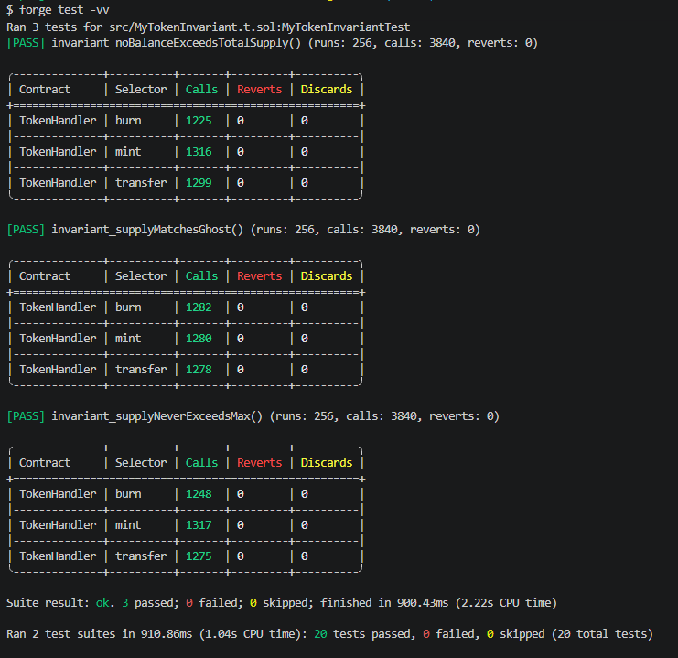
Coverage Report
Run forge coverage --report summary and take a screenshot. MyToken.sol shows 100% line coverage, 100% statement coverage, and 100% function coverage. Overall project coverage is 95.12%.
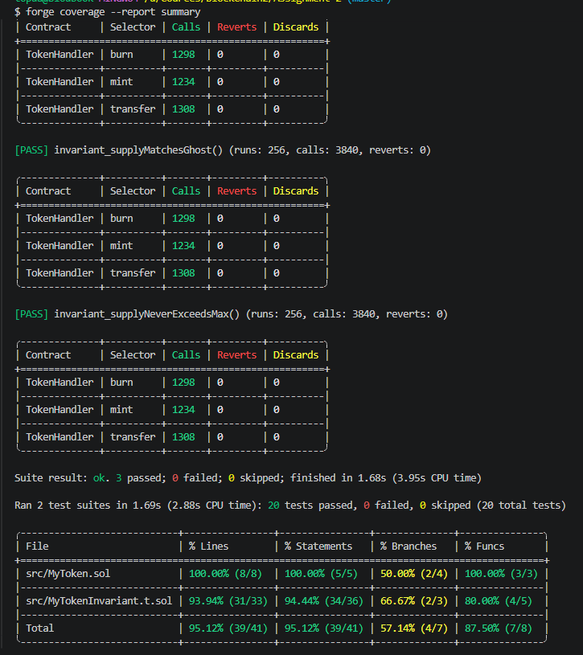
Fuzz Testing vs Unit Testing
Unit tests verify specific values that the developer writes manually. For example, transfer(erkhan, 1000) checks one exact scenario. They are fast and precise but only cover cases the developer thinks of.
Fuzz tests let Foundry automatically generate 1000 random inputs for each test. For example, testFuzzTransfer ran 1000 times with completely different addresses and amounts each run. This finds edge cases like amount equal to zero, amount equal to maximum uint256, or recipient being a contract address — bugs that a human tester would never think to check manually.

Task 2: Fork Testing Against Mainnet
Use Foundry’s fork testing to interact with deployed mainnet contracts
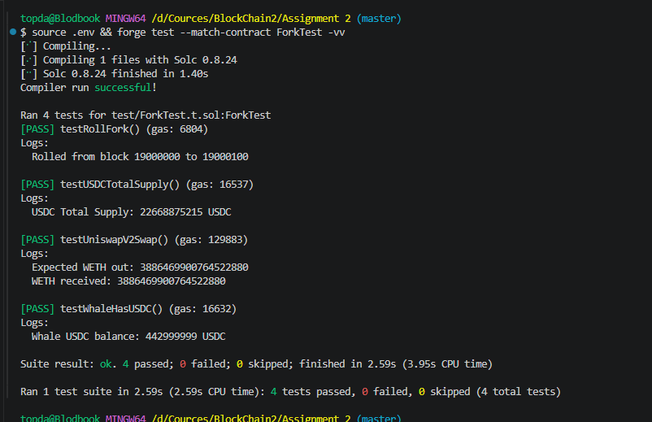Test descriptions:
testUSDCTotalSupply — reads real USDC total supply from mainnet. Result: 22,668,875,215 USDC in circulation at block 19000000.
testWhaleHasUSDC — reads real USDC balance of a known whale address. Result: 442,999,999 USDC.
testUniswapV2Swap — simulates a real swap of 10,000 USDC to WETH using the live Uniswap V2 router. Result: received 3.886 WETH, swap executed successfully.
testRollFork — demonstrates vm.rollFork by changing the fork from block 19000000 to block 19000100.
How vm.createSelectFork and vm.rollFork work
vm.createSelectFork takes an RPC URL and a block number. It creates a local snapshot of Ethereum mainnet state at that exact block, meaning every contract, balance, and storage slot is exactly as it was on mainnet at that moment. All tests run against this snapshot without touching real mainnet.
vm.rollFork changes the fork to a different block number. This lets you test how contract state changes over time, for example reading a value at block 19000000 then rolling to 19000100 to see if anything changed.
Benefits and Limitations of Fork Testing (0.5 page)
Benefits: Fork testing lets you test against real deployed contracts like USDC and Uniswap without deploying anything yourself. You get accurate real-world state including actual liquidity, actual token balances, and actual contract logic. Tests are fully reproducible because you pin a specific block number. You can impersonate any address using vm.prank, which lets you simulate whale transactions or test admin functions without owning those accounts.
Limitations: Fork tests are significantly slower than regular tests because they fetch state from a remote RPC endpoint. They depend on a third-party RPC provider like Alchemy being available, so if the provider is down your tests fail. Free RPC plans have rate limits that can cause tests to fail under heavy load. Additionally, forked state does not reflect real-time mainnet, so results may differ from what would actually happen live if market conditions changed between the pinned block and now.

PART 2 —
AMM (Automated Market Maker) Development
Task 3: Build a Constant Product AMM
Implement a fully functional AMM smart contract based on the constant product formula x * y = k.
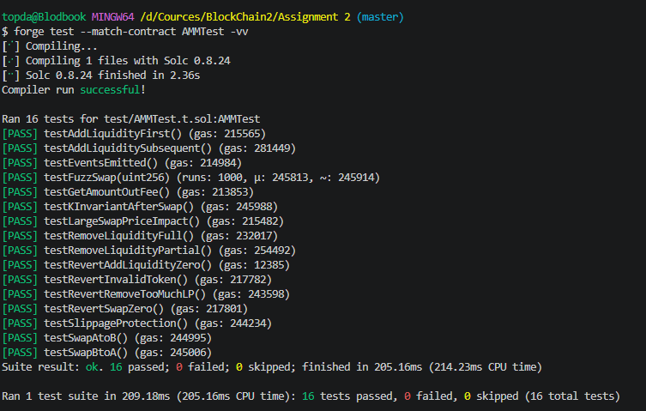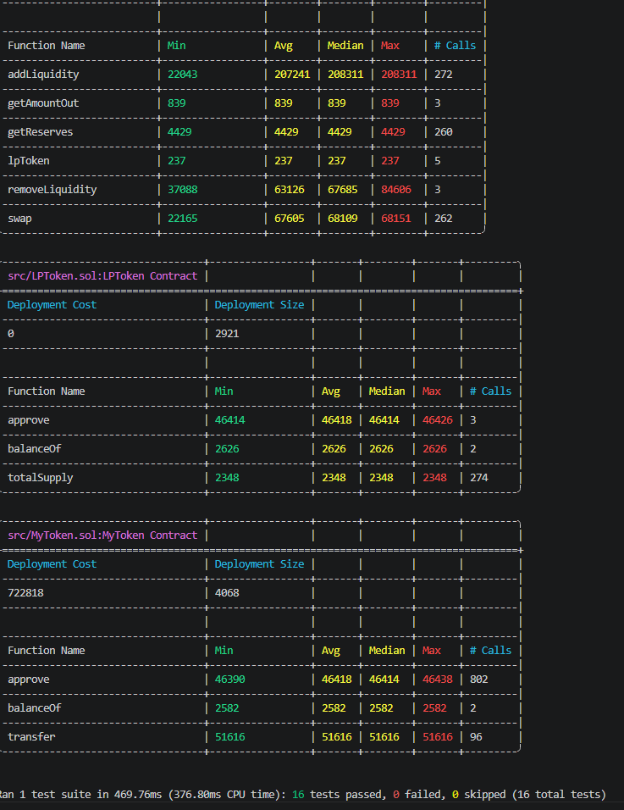
Test descriptions:
testAddLiquidityFirst — first liquidity provider deposits tokens, receives LP tokens proportional to sqrt(amountA * amountB).
testAddLiquiditySubsequent — second provider adds liquidity, receives LP tokens proportional to existing reserves.
testRemoveLiquidityPartial — provider burns half their LP tokens, receives proportional share of both tokens back.
testRemoveLiquidityFull — provider burns all LP tokens, reserves go to zero.
testSwapAtoB — user swaps token A for token B, balance increases correctly.
testSwapBtoA — user swaps token B for token A, balance increases correctly.
testKInvariantAfterSwap — verifies that k = reserveA * reserveB never decreases after a swap due to the 0.3% fee.
testSlippageProtection — swap reverts when output is below the minimum specified by the user.
testRevertAddLiquidityZero — adding zero amount reverts.
testRevertSwapZero — swapping zero amount reverts.
testRevertInvalidToken — swapping an unknown token reverts.
testLargeSwapPriceImpact — large swaps receive worse rate per token than small swaps, confirming price impact.
testGetAmountOutFee — getAmountOut returns a value less than input due to 0.3% fee.
testRevertRemoveTooMuchLP — removing more LP than owned reverts.
testEventsEmitted — LiquidityAdded event is emitted correctly.
testFuzzSwap — Foundry auto-generates 1000 random swap amounts, verifying k invariant holds in all cases.
Task 4: AMM Mathematical Analysis
Derivation of the Constant Product Formula
An Automated Market Maker based on the constant product model maintains a single invariant: the product of the two token reserves must remain constant after every swap. If the pool holds reserve x of token A and reserve y of token B, the invariant is written as x * y = k, where k is a constant determined at the time liquidity is first added.
When a trader wants to buy some amount of token B by sending in an amount dx of token A, the pool must satisfy the invariant after the trade. Before the trade the state is x * y = k. After receiving dx the new reserve of A becomes x + dx. To keep the product constant the new reserve of B must satisfy (x + dx) * y_new = k, which gives y_new = k / (x + dx). The amount of token B the trader receives is dy = y - y_new = y - (x * y) / (x + dx), which simplifies to dy = (y * dx) / (x + dx).
This formula works without any external price oracle. The price emerges naturally from the ratio of the reserves. When the reserves are equal the price is 1:1. As traders buy token B the reserve of B decreases and the reserve of A increases, making token B more expensive. This self-correcting mechanism ensures the pool always has liquidity at some price, no matter how large the trade.
How the 0.3% Fee Affects the Invariant k Over Time
In practice every swap charges a 0.3% fee. The fee is not extracted from the pool but stays inside it, meaning after each swap k actually increases slightly. The implementation achieves this by applying the fee to the input amount before computing the output. The effective input used in the formula is amountIn * 997 / 1000 instead of the full amountIn.
The output formula becomes: amountOut = (amountIn * 997 * reserveOut) / (reserveIn * 1000 + amountIn * 997).
Because only 99.7% of the input is used to compute the output, the pool retains a small surplus of token A on every trade. This surplus causes k to grow after each swap. Over time as trading volume accumulates the value of k increases, which means liquidity providers earn more tokens when they eventually remove their liquidity. This fee mechanism is the primary source of yield for liquidity providers.
Impermanent Loss
Impermanent loss occurs when the price ratio of the two tokens changes after a liquidity provider deposits. The provider would have been better off simply holding the tokens rather than depositing them into the pool.
Derivation: assume a provider deposits at price p0 where the pool holds equal value of both tokens. After the market price changes to p1 the pool automatically rebalances through arbitrage trading. The value of the position inside the pool becomes 2 * sqrt(p1) * sqrt(initial_value), while holding the original tokens would give a value proportional to (1 + p1/p0) / 2.
The impermanent loss as a percentage is: IL = 2 * sqrt(r) / (1 + r) - 1, where r = p1 / p0 is the price ratio.
For a 2x price change, r = 2. Substituting: IL = 2 * sqrt(2) / (1 + 2) - 1 = 2 * 1.4142 / 3 - 1 = 2.8284 / 3 - 1 = 0.9428 - 1 = -0.0572. This means a liquidity provider suffers approximately 5.72% impermanent loss when the price of one token doubles relative to the other. The loss is called impermanent because if the price returns to the original ratio the loss disappears entirely.
Price Impact as a Function of Trade Size
Price impact refers to how much a trade moves the market price. For a constant product AMM the price impact grows nonlinearly with trade size relative to pool reserves.
For a small trade of size dx relative to reserve x the output is approximately dy = y * dx / x, which gives a price close to y/x. But for a large trade the denominator x + dx grows significantly and the output dy becomes much smaller per unit of input. The effective price paid is amountIn / amountOut, which increases as trade size increases.
For example in a pool with 10,000 tokens on each side, swapping 100 tokens gives roughly 99 tokens out, a price impact of about 1%. Swapping 5,000 tokens gives only about 3,322 tokens out, a price impact of over 33%. Traders should always check the expected output before executing large trades and use slippage protection parameters to avoid receiving far less than expected.
Comparison with Uniswap V2
Our AMM implements the core constant product formula and 0.3% fee identical to Uniswap V2. However several important features are missing.
Uniswap V2 locks a minimum liquidity of 1000 LP tokens to address(0) on the first deposit to prevent division-by-zero attacks and pool manipulation. Our implementation does not do this.
Uniswap V2 uses a time-weighted average price oracle that accumulates price data every block, allowing other contracts to read a manipulation-resistant historical price. Our implementation has no price oracle.
Uniswap V2 handles tokens that charge transfer fees by measuring actual received amounts rather than trusting the input value. Our implementation assumes no transfer fees.
Uniswap V2 has flash swap functionality allowing users to borrow tokens from the pool within a single transaction as long as they are returned with the fee. Our implementation does not support flash swaps.
Uniswap V2 also splits the 0.3% fee, allowing a protocol fee of up to 0.05% to be turned on by governance. Our implementation sends the full 0.3% to liquidity providers.

PART 3 — Lending Protocol Simulation
Task 5: Build a Basic Lending Pool
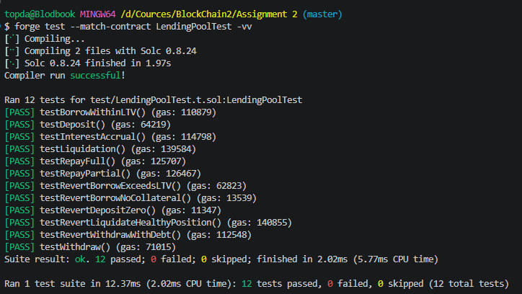
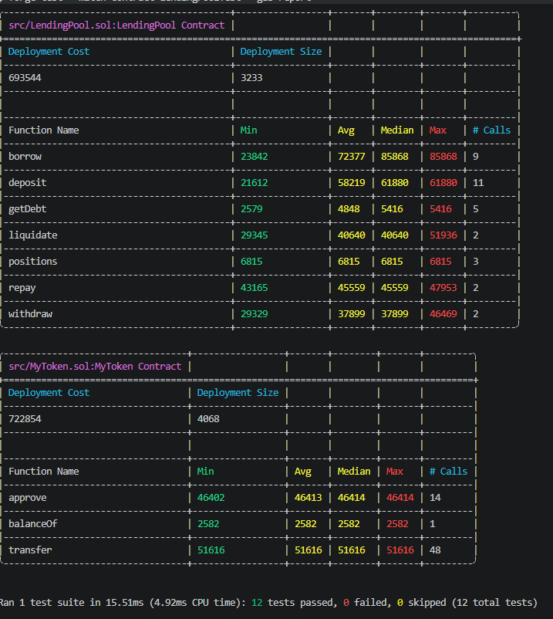
Test descriptions:
testDeposit — user deposits tokens as collateral, position is recorded correctly.
testWithdraw — user withdraws part of their deposit when no debt exists.
testBorrowWithinLTV — user borrows 70% of collateral value, within the 75% LTV limit.
testRevertBorrowExceedsLTV — borrowing 80% of collateral reverts because it exceeds 75% LTV.
testRevertBorrowNoCollateral — borrowing without any deposit reverts.
testRepayFull — user repays entire debt, debt becomes zero.
testRepayPartial — user repays part of debt, remaining debt decreases correctly.
testLiquidation — user borrows at 75% LTV, time is warped 2 years using vm.warp to accrue interest above 80% threshold, liquidator repays debt and receives collateral.
testRevertLiquidateHealthyPosition — position at 50% LTV cannot be liquidated.
testInterestAccrual — debt grows by approximately 5% after one year using vm.warp, confirming linear interest model.
testRevertWithdrawWithDebt — withdrawing collateral that would push LTV above 75% reverts.
testRevertDepositZero — depositing zero amount reverts.
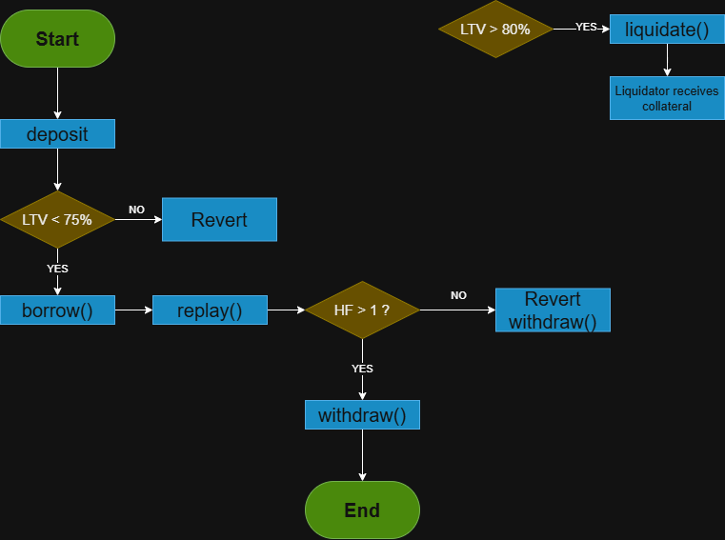

PART 4 — CI/CD Pipeline
Task 6: GitHub Actions for Smart Contracts
Create a CI pipeline configuration for your project.
Pipeline Simulation Results
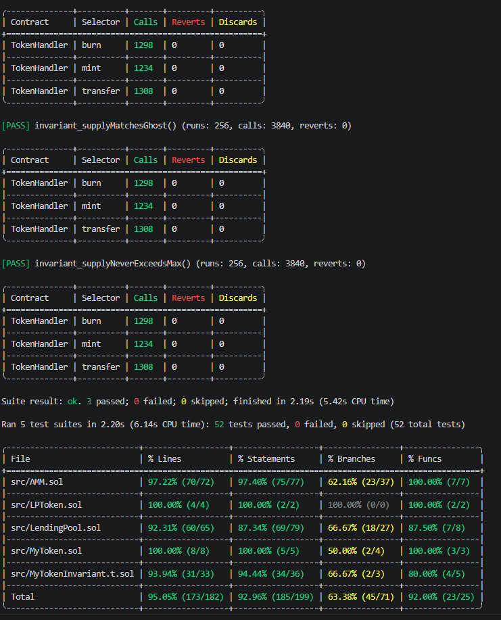Final test count across all suites: 52 tests passed, 0 failed.
MyToken tests: 17 passed including 2 fuzz tests with 1000 runs each and 3 invariant tests with 3840 calls each.
ForkTest: 4 passed including real USDC supply read and Uniswap V2 swap simulation.
AMMTest: 16 passed including 1 fuzz test with 1000 runs.
LendingPoolTest: 12 passed.
Coverage total: 95.05% lines, 92.96% statements.

