**Assignment 1 – Report**

**Objective**

**This site I made for assignment 1. This site contain basic information about me and contact form for further cooperation.**

**Description of steps**

**Step 1 - Navigation**

**Firstly I made a Navigation for easier find the required information.**

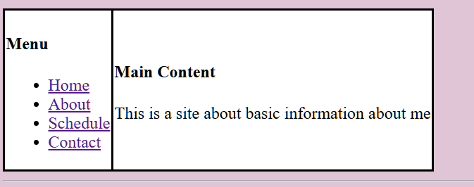

**Step 2 – Basic Info**

**Then I write a basic information like my avatar my name and bio.**

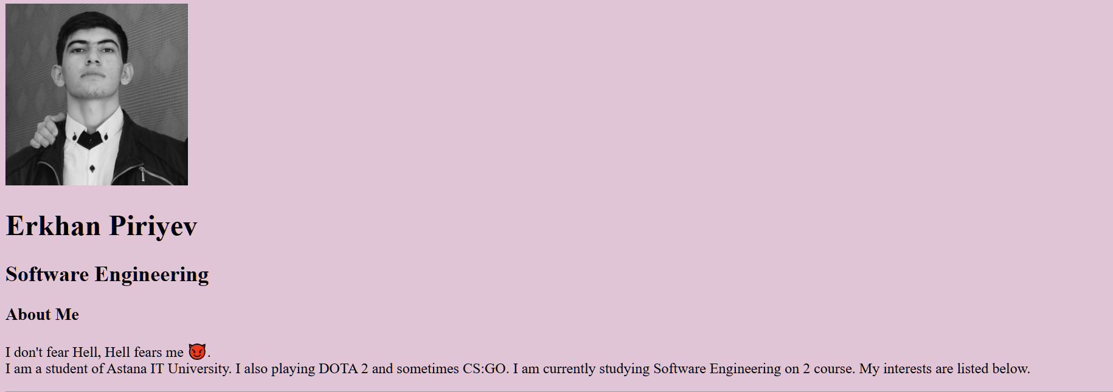

**Step 3 - Lists**

**After that I did two un/sorted lists about my hobbies and my liked websites.**

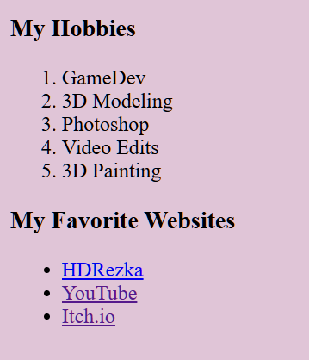

**Step 4 - Schedule**

**Then I showed schedule in order for people to understand when I am busy.**

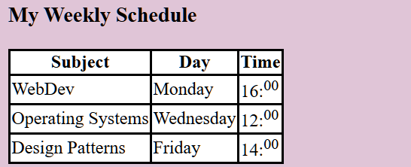

**Step 5 – Contact Form**

**And finally I did a contact form for feedback about me and for suggestions.**

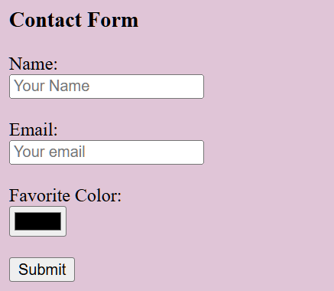

**Final Reflection**

By doing this assignment I studied different tags, both basic like <p> , <h1> , <img> and addition like <sup> , <hr>. And I've become familiar with html and I'm waiting to start learning СSS.