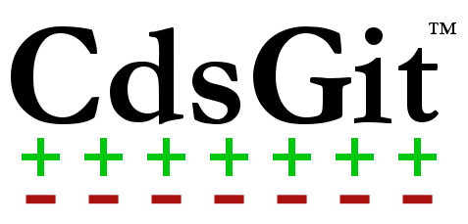

**Basic Usage Guide**

Published 3/10/2014

CdsGit Revision 1.0

Keywords: CdsGit Basic Usage Tutorial

A beginner’s guide to using CdsGit in Cadence Virtuoso.

# Table of Contents

1 Introduction 3

2 Git Basics 4

3 Your First Repository 5

4 CdsGit in the Library Manager 6

5 CdsGit in Virtuoso 7

6 8

# Introduction

**Welcome to CdsGit!**

The following guide will help you get up and running fast with CdsGit. The goal of this guide is to provide a step by step introduction to using the tool. By the end of the guide, you should be able to perform all of the basic tasks involved in managing a CdsGit repository

# Git Basics

# Your First Repository

# CdsGit in the Library Manager

# CdsGit in Virtuoso

# 