**PIVPN**

**Which Android Studio version is Needed?**

Latest Android Studio version is recommended, which can be downloaded from here:<https://developer.android.com/studio>

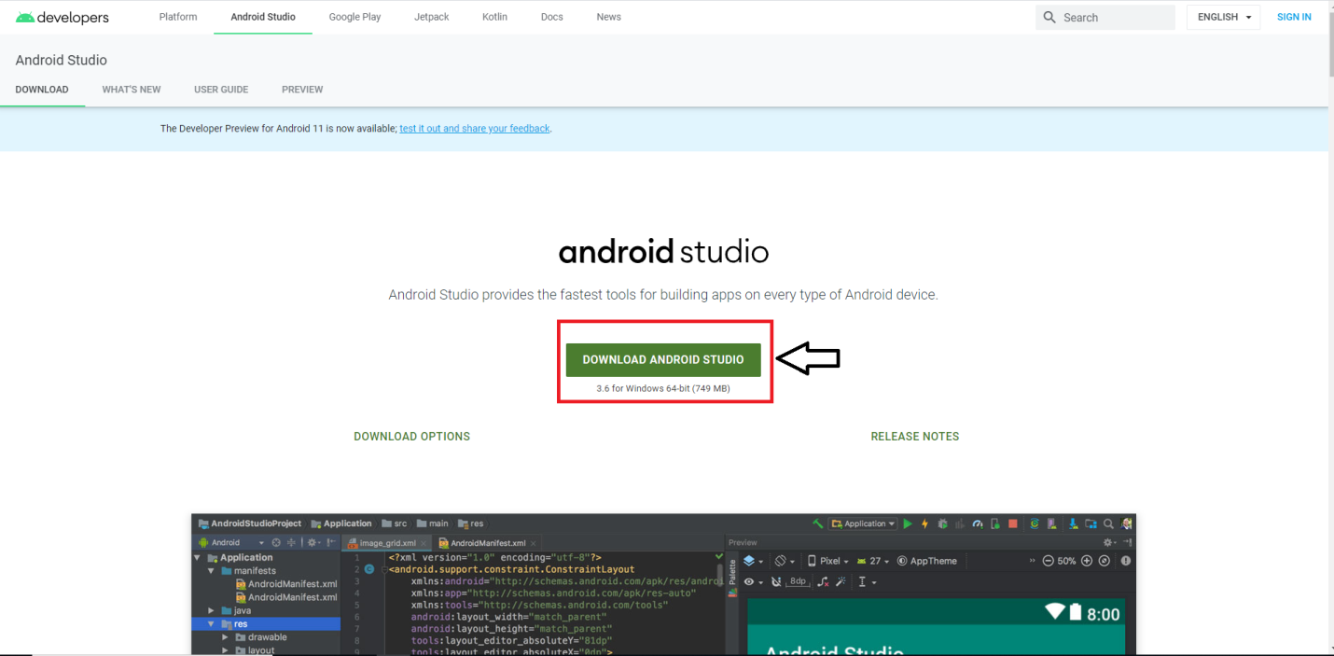

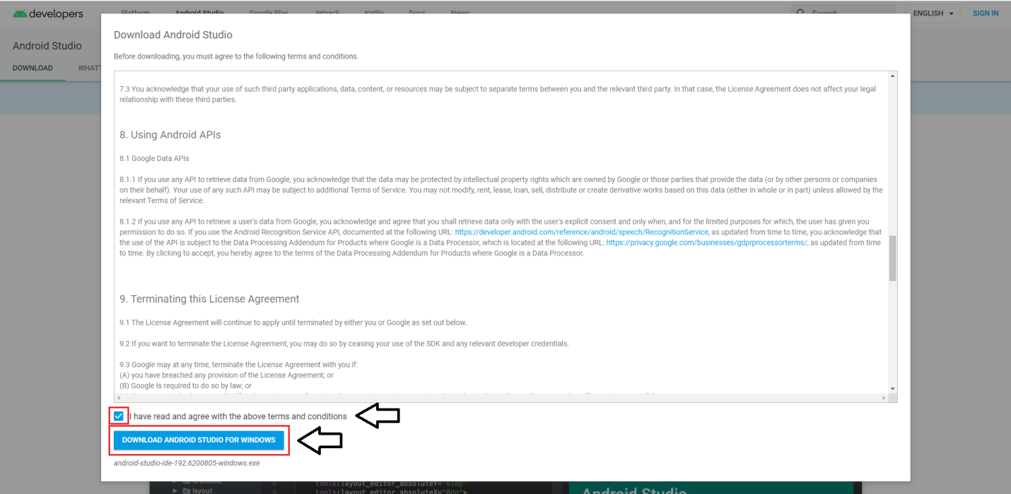

**How to open the project in Android Studio?**

* Open Android Studio > Open an Existing Android Studio Project

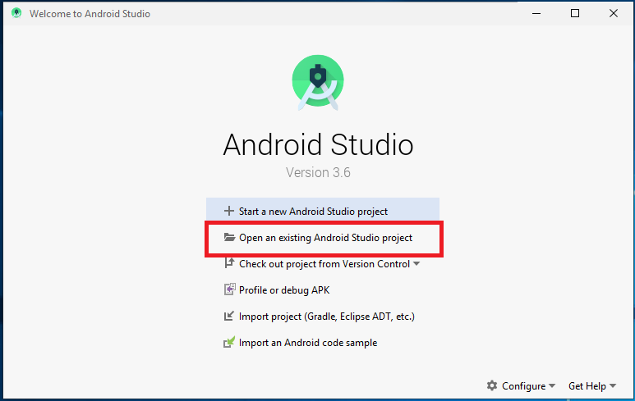

* Select PIVPN Project file > OK

**How to change the Package name?**

Use Android official doc for this by this link :<https://developer.android.com/studio/build/application-id>

**How to change the App name?**

* Open Android Studio >PIVPN> app > res > values > strings.xml
* Enter your app name inside "app_name" string tag:

**How to change the App Icon?**

To change your App icon open project >PIVPN> then open <app> then open <src> then open<main> and then open <res> and there you find different types of mipmap folder and each folder contains an icon image. So you change this icons like below given size

* Replace the ic_launcher.png image by your icon to mipmap-ldpi folder with name ic_launcher.png and size 36px x 36px
* Replace the ic_launcher.png image by your icon to mipmap-mdpi folder with name ic_launcher.png and size 48px x 48px
* Replace the ic_launcher.png image by your icon to mipmap-hdpi folder with name ic_launcher.png and size 72px x 72px
* Replace the ic_launcher.png image by your icon to mipmap-xhdpi folder with name ic_launcher.png and size 96px x 96px
* Replace the ic_launcher.png image by your icon to mipmap-xxhdpi folder with name ic_launcher.png and size 144px x 144px
* Replace the ic_launcher.png image by your icon to mipmap-xxxhdpi folder with name ic_launcher.png and size 192px x 192px

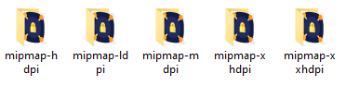

**How to change Ads Id?**

* Open Android Studio >PIVPN> app > res > values > strings.xml
* Enter your Admob App ID inside "admob_app_ID" string tag:



* Open Android Studio >PIVPN> Gradle Scripts>build.gradle (Module: app)
* Change value of “FACEBOOK_AD” to true if you need to load Facebook ads
* Change value of “GOOGLE_AD” to true if you need to load Google ads
* Enter your Facebook Banner Ad ID inside "FACEBOOK_BANNER" field
* Enter your Facebook Interstitial Ad ID inside "FACEBOOK_INTERSTITIAL" field
* Enter your Admob Banner Ad ID inside "GOOGLE_BANNER" field
* Enter your Admob Interstitial Ad ID inside "GOOGLE_INTERSTITIAL" field

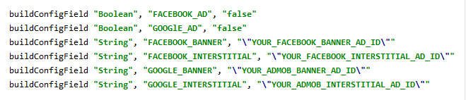

**How to change OneSignal Id?**

* Open Android Studio >PIVPN> Gradle Scripts>build.gradle (Module: app)
* Enter your OneSignal Application Id inside “onesignal_app_id” field

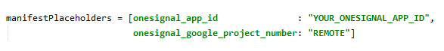

**How to change the App Link, Privacy Policy and Terms to Use?**

* To Add Privacy Policy File open project >PIVPN> then open <app> then open <src> then open<main> and then open <assets> and Add Your Privacy Policy html file.

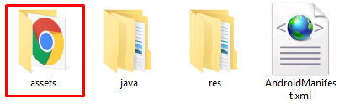

* Open Android Studio >PIVPN> Gradle Scripts>build.gradle (Module: app)
* Enter your Application Link inside “APP_LINK” field
* Change the “YOUR_PRIVACY_POLICY_HTML_FILE_NAME” with your Application Privacy Policy html file name inside “PRIVACY_POLICY” field
* Change the “YOUR_TERMS_TO_USE_HTML_FILE_NAME” with your Application Terms to Use html file name inside “TERMS_TO_USE” field



**How to change In-AppPurchase Keys?**

* Open Android Studio >PIVPN> Gradle Scripts>build.gradle (Module: app)
* Change value of “USE_IN_APP_PURCHASE” to true if you need to add In-App Purchase
* Enter your In-AppPurchase Key inside “IN_APPKEY” field
* Enter your Monthly Subscription Key inside “MONTHLY” field
* Enter your Six Months Subscription Key inside “SIX_MONTH” field
* Enter your Yearly Subscription Key inside “YEARLY” field

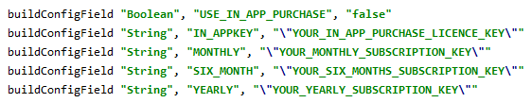

**How to change Publisher Id?**

* Open Android Studio >PIVPN>app >src>main >java >com >creativestudio>PIVPN> activity > UIActivity.java
* Replace “YOUR_PUBLISHER_ID” value with your Publisher Id as shown below

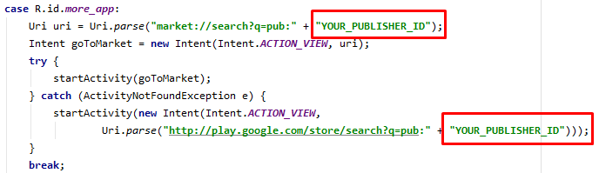

**How to change Firebase json File?**

* To Add Firebase json File open project >PIVPN> then open <app> and Add Your “google-services.json” file.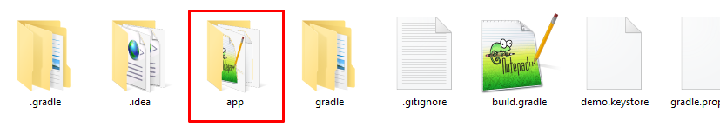

**How to change the Carrier ID ?**

* Open AnchorFree Developer Portal by this link : <https://developer.anchorfree.com/>
* Sign up to Create Project

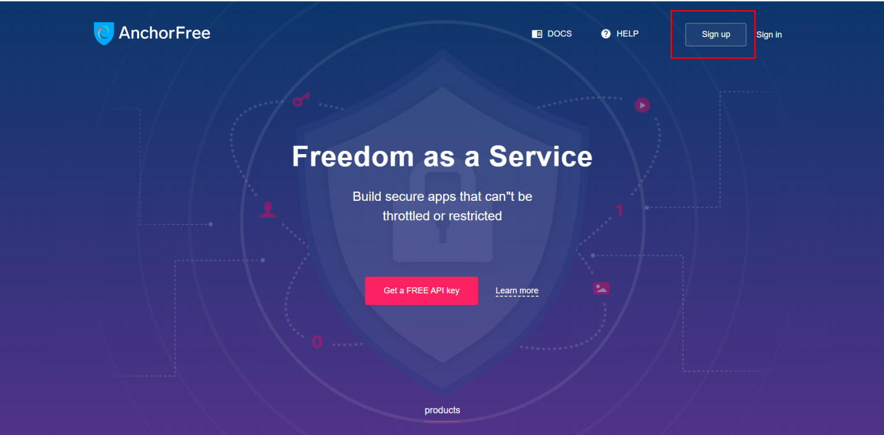

* Add the Details and Sign Up

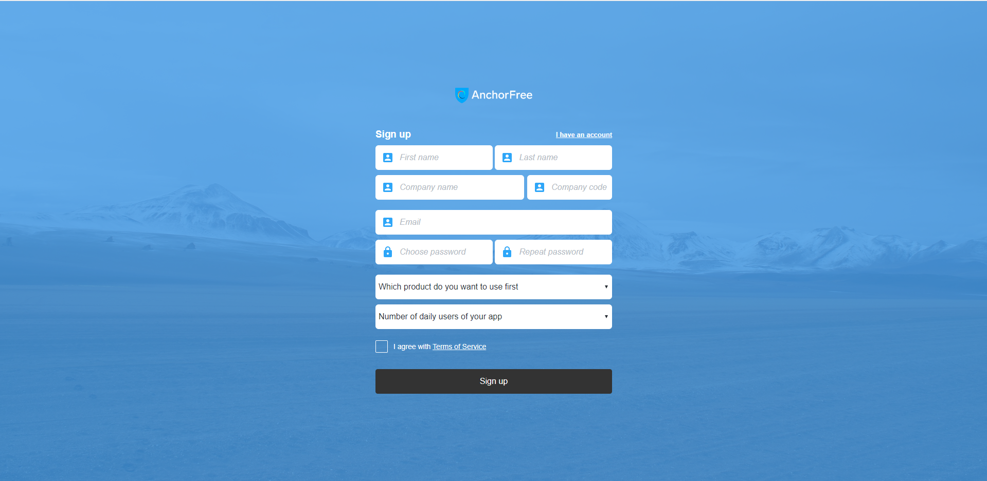

* Sign In Using link Sent to specified Mail

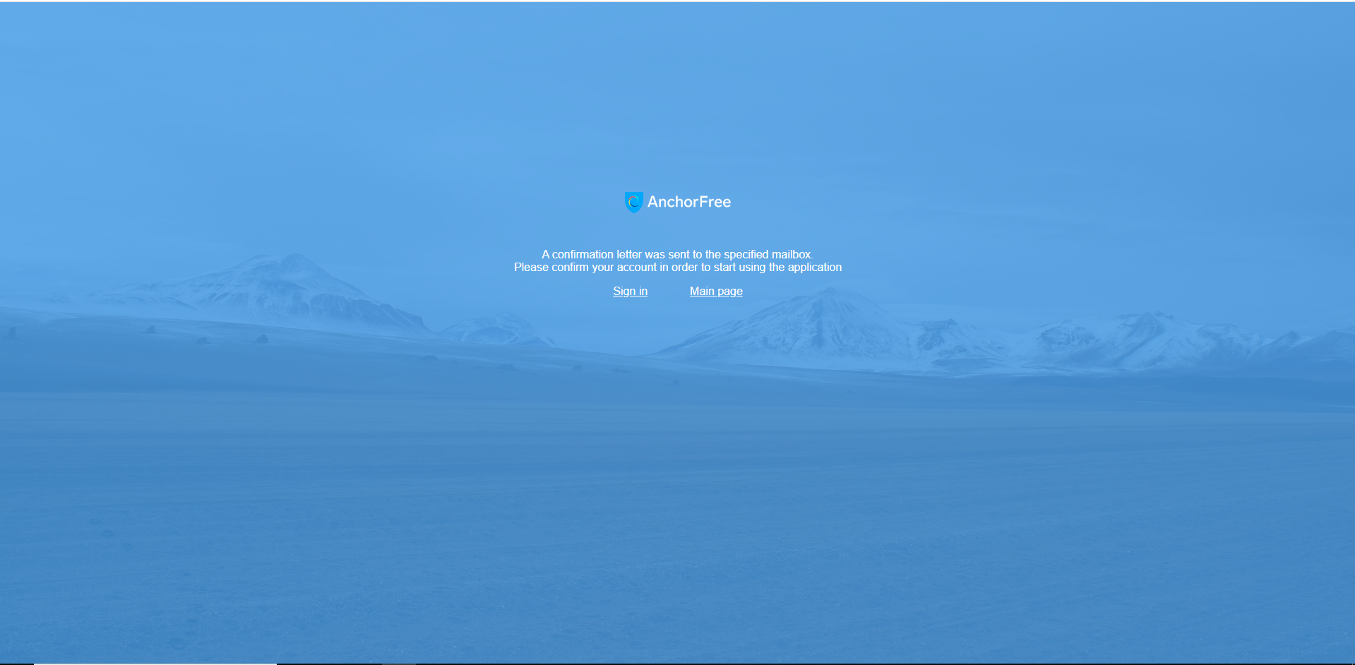

* Then Create Project by filling All required Details

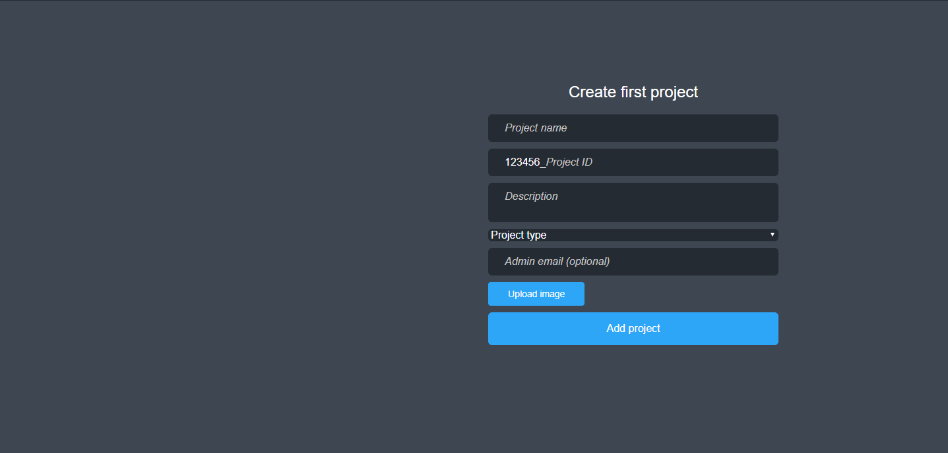

* After Successful Project Creation,On Dashboard click on List at Upper-Right corner



* The Project_ID of your project will be used for your Final Project id

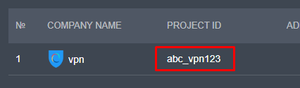

* Your Final Project id will be your_company_code + project id i.e full project id including company code you added while creating account

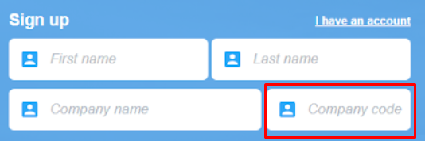

* Open Android Studio >PIVPN> Gradle Scripts>build.gradle (Module: app)
* Enter your Final Project Id inside “BASE_CARRIER_ID” field



* Open Android Studio >PIVPN>app >src>main >java >com >creativestudio>PIVPN> MainApplication.java
* Replace “YOUR_FINAL_PROJECT_ID” value with your Final Project Id as shown below



**How to add Server Locations ?**

* Open Network Tab from left panel and Click on Add Location at Upper Right Corner

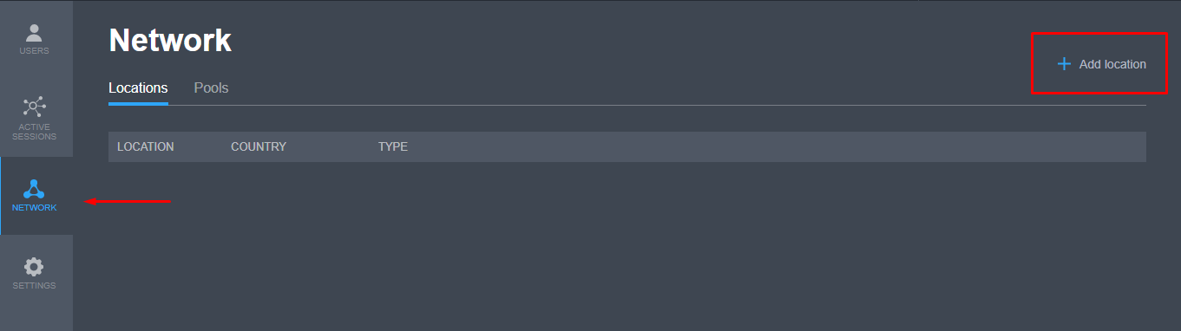

* Then Click on Location Menu and Select the Server Location you want to add

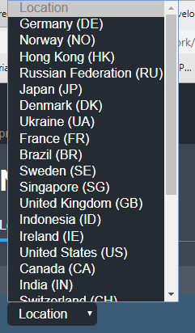  
  
  
  
  
  
  
**SHARED ON CODELIST.CC**