**Purchase update**

1.In this “application\view\admin\tasks\task.php”

Add hooks: below line 252

<?php hooks()->do_action('task_related_to_select', $rel_type); ?>

Image:

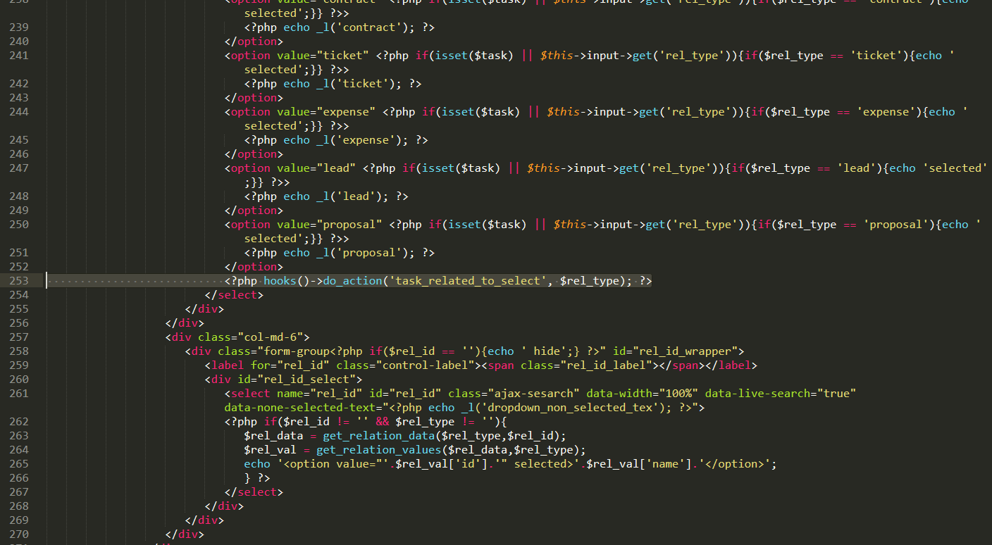

2.In this file “application\helpers\relation_helper.php”

Add hooks below line 322: in function get_relation_values

$values = hooks()->apply_filters('before_return_relation_values', [

'id' => $id,

'name' => $name,

'link' => $link,

'addedfrom' => $addedfrom,

'subtext' => $subtext,

'type' => $type,

], $relation);

return hooks()->apply_filters('relation_values', $values);

and comment hooks

return hooks()->apply_filters('relation_values', [

'id' => $id,

'name' => $name,

'link' => $link,

'addedfrom' => $addedfrom,

'subtext' => $subtext,

'type' => $type,

]);

Images:

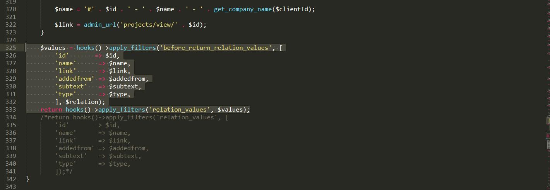

Add hooks in function: get_relation_data

Below line:138

$data = hooks()->apply_filters('before_return_relation_data', $data, $type, $rel_id, $q);

return hooks()->apply_filters('relation_data', $data);

and remove code: return $data;

image:

