Open API interface
2021.5 Version
█▬▬◣Section 1, Preface
1. Preface [Please read the entire preface carefully before you start]
Please read the entire preface carefully before you start!
Please read the entire preface carefully before you start! !
Please read the entire preface carefully before you start! ! !

2. Main text

▬◣illustrate | This document provides convenience for third-party developers to implement GPS positioning services in App, Web and WeChat. Please prepare your own domain name (called URL) and be sure to organize the request link according to the request parameters in the document, especially pay attention to the case of the request parameters(Capitalization issues).
▬◣process | Preparation: Open this document and display the directory first.  ●wps When the software opens, please click View - Navigation Pane.。  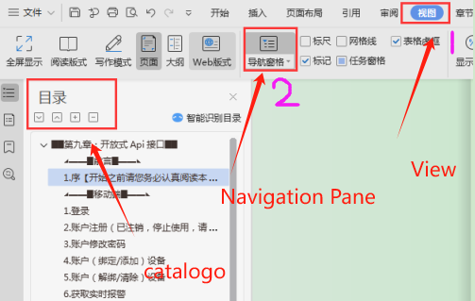  ●Office To open it, press and hold Ctrl+F, the following picture will appear, and click the circled button.  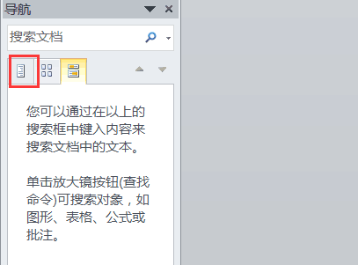  First: Use your account and password to get mds through the login interface, whether you are logging in by account (unit user) or device number.  Second: Get the two values ​​mds and id returned by the login interface (this id is consistent with the login type, account login is the unit id, and device number login returns the device id). These two values ​​are very important.  Third: Officially enter the link of calling the function interface. With the above two values, you can get a series of operations such as the unit list or device list.  Fourth: However, if you want to use the interface for getting the latest location and getting the historical trajectory, you must first call the "Get Device List" interface, because there is a corresponding relationship between macid (device number) and device id.  Fifth: The following figure is the order of precedence, which is also the interpretation of the above 4 sentences.：  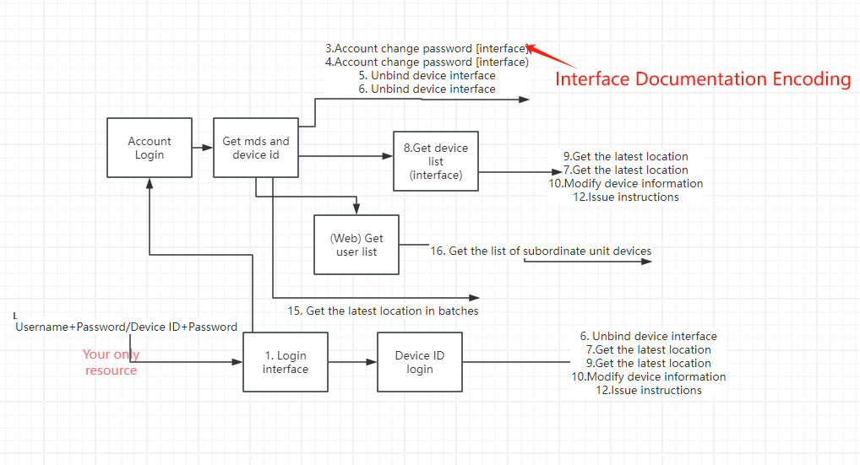
◣Glossary◥ | ●mds：Token. About 98% of the interface calls must carry this parameter. Obtained through the login interface. When the API call returns 403, there is only one meaning: the token has expired.，The token is valid for 20 minutes. If you keep requesting data, the expiration time will be extended from the last request. If it is really expired, log in again!  ●unit id：The user database primary key (database index unique value) is a 32-bit Guid. (Unit user) can get this value when calling the [Login] interface. A series of interfaces related to the login user involve this id.  ●equipment id：the user database primary key (database index unique value) is a 32-bit Guid. (Unit user) can get this value when calling the [Login] interface. A series of interfaces related to the login user involve this id.  ●设备号：It is a string of 8 to 15 characters, which is one of the credentials for identifying terminal devices and has a wide range of uses, The device list interface can be used to obtain this value. Its location on the Web platform is shown in the figure below:  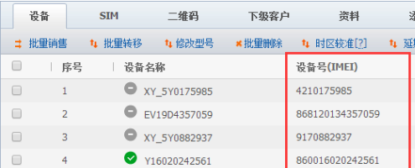  ●UTC timestamp：All platforms use the 13-digit UTC timestamp in milliseconds, which is multiplied by 1000 based on the seconds. The following figure shows the timestamp obtained by JavaScript on the web page.  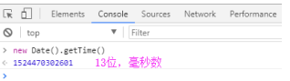  ●Request method：The request method given at the beginning of the table is not fixed. You can choose get or post according to your needs.
Temporary url | apitest.18gps.net（If there is no special requirement, it is recommended to use the following formal url）
Formal url | api.18gps.net
◣Map Type◥ | The values ​​of MapType in all platforms are as follows:  GOOGLECN  BAIDU  GAODE  QQ  They represent Google Maps, Baidu Maps, Amap, and Tencent Maps.
►▬▬◣Alarm number and description◥▬▬◄
NO. | coding | meaning
0 | 0x00 | Reserve | 21 | 0x15 | Driving tired
1 | 0x01 | SOS | 22 | 0x16 | Gateway(X)
2 | 0x02 | Anti-theft | 23 | 0x17 | Trailer(X)
3 | 0x03 | out of bounds | 24 | 0x18 | Over-stop
4 | 0x04 | Inbounds | 25 | 0x19 | 4s rescue
5 | 0x05 | Power failure | 26 | 0x1A | OBD fault
6 | 0x06 | High speed/speeding | 27 | 0x1B | Oil level alarm
7 | 0x07 | Low speed | 28 | 0xlc | Safe driving tips
8 | 0x08 | Low power | 29 | 0xld | High voltage
9 | 0x09 | Vibration | 30 | 0xle | OBD serious fault
10 | 0x0A | Movement | 31 | 0x1F | Disconnection alarm
11 | 0x0B | Reset | 32 | 0x20 | Bluetooth module alarm
12 | 0x0C | Entering blind spot | 33 | 0x21 | GPS signal interference alarm
13 | 0x0D | Exiting blind spot | 34 | 0x22 | GSM signal interference alarm
14 | 0x0E | Opening door | 35 | 0x23 | Photoelectric alarm
15 | 0x0F | Close door | 36 | 0x24 | Abnormal alarm
16 | 0x10 | Bike started | 37 | 0x25 | Offline alarm
17 | 0x11 | Collision | 38 | 0x26 | Disassembly alarm
18 | 0x12 | Rollover | 39 | 0x27 | Parking alarm
19 | 0x13 | GEO(X) | 40 | 0x28 | Interference alarm
20 | 0x14 | Idle | 41 | 0x29 | Illegalactivation of alarm
42 | 0x2A | The skylight is not closed | 61 | 0x3D | Insurance expiration
43 | 0x2B | Window not closed | 62 | 0x3E | Maintenance expiration reminder
44 | 0x2C | Door not locked | 63 | 0x3F | Mileage maintenance reminder
45 | 0x2D | Lights not turned off | 64 | 0x40 | Second-point exit alarm
46 | 0x2E | Bike not armed | 65 | 0x41 | Route deviation alarm
47 | 0x2F | Plug and unplug alarm | 66 | 0x42 | Route speed limit alarm
48 | 0x30 | Magnetic alarm | 67 | 0x43 | Loss of connection alarm
49 | 0x31 | Move reminder | 68 | 0x44 | Fake base station
50 | 0x32 | High temperature alarm | 69 | 0x45 | Wire cutting alarm
51 | 0x33 | Low temperature alarm | 70 | 0x46 | Timeout alarm
52 | 0x34 | Flat leak alarm | 71 | 0x47 | Bike idling reminder
53 | 0x35 | Low tire pressure | 72 | 0x48 | Bike water temperature is too high
54 | 0x36 | High tire pressure | 73 | 0x49 | Sudden acceleration reminder
55 | 0x37 | Power-on reminder | 74 | 0x4A | Sudden deceleration reminder
56 | 0x38 | Enter at the second checkpoint | 75 | 0x4B | Sudden turn reminder
57 | 0x39 | Stop at the second check-in point | 76 | 0x4C | Quick lane change reminder
58 | 0x3A | Equipment separation alarm | 77 | 0x4D | Route restriction alarm
59 | 0x3B | Address false alarm | 78 | 0x4E | Manhole cover open alarm
60 | 0x3C | Annual inspection expired | 79 | 0x4F | Manhole cover closed alarm
80 | 0x50 | Sudden brake reminder
81 | 0x51 | Bike defense | 101 | 0x65 | Battery pressure difference is too large
82 | 0x52 | Bike has been ignited | 102 | 0x66 | Charging failure
83 | 0x53 | "Discharge overcurrent  Charge overcurrent  NOS overtemperature  Low capacity alarm  BMS fault alarm" | 103 | 0x67 | LED failure
84 | 0x54 |  | 104 | 0x68 | GNSS module failure
85 | 0x55 |  | 105 | 0x69 | GNSS antenna is not connected or is blocked
86 | 0x56 |  | 106 | 0x6A | Abnormal fuel consumption
87 | 0x57 |  | 107 | 0x6B | Low fuel alarm
88 | 0x58 | Operation abnormality | 108 | 0x6C | SD collision alarm
89 | 0x59 | Operation normal | 109 | 0x6D | Brake warning
90 | 0x5A | Device plugged in | 110 | 0x6E | Operation license annual inspection reminder
91 | 0x5B | Device unplugged | 111 | 0x6F | Operation license expiration reminder
92 | 0x5C | Voice control alarm | 112 | 0x70 | Stay inside the fence
93 | 0x5D | Bike has been ignited | 113 | 0x71 | Stay outside the fence
94 | 0x5E | Battery overtemperature | 114 | 0x72 | Door open alarm
95 | 0x5F | Magnetic induction alarm | 115 | 0x73 | Door closed alarm
96 | 0x60 | Anti-shielding alarm | 101 | 0x65 | Battery pressure difference is too large
97 | 0x61 | Shielding oil cut alarm | 102 | 0x66 | Charging failure
98 | 0x62 | "Charging NOS tube fault  Discharging MOS tube fault  Battery low temperature" | 103 | 0x67 | LED failure
99 | 0x63
100 | 0x64
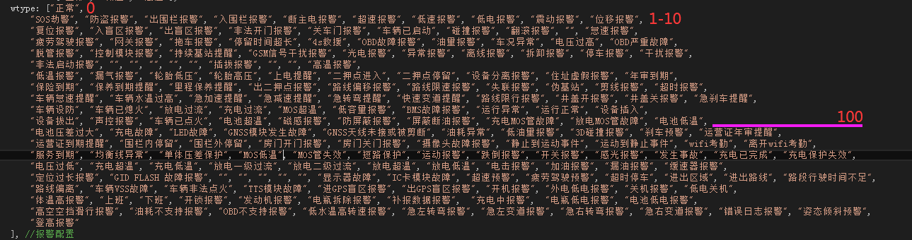

►▬▬◣Error code correspondence table◥▬▬◄
 |  |  |  |  |  | 设备
Error code | Meaning |  | Error code | Meaning |  | Error code | Meaning
200 | Success |  | 1000 | User does not exist |  | 2000 | Device does not exist
400 | Username already exists [Langxing only] |  | 1001 | Username already exists |  | 2001 | Cannot add device
401 | Experience account verification (cannot be operated) |  | 1002 | Superior unit does not exist, no parent |  | 2002
403 | MDS verification error/authentication failure |  | 1003 | Wrong answer to question 1 |  | 2003 | Device already exists
500 | Failure |  | 1004 | Wrong answer to question 2 |  | 2004 | Vehicle file does not exist
505 | Login type does not exist |  | 1005 | Account or password cannot be empty |  | 2005 | Vehicle frame number verification failed
506 | Security question not set |  |  |  |  | 2006 | Engine number verification failed
507 | Verification information failed [?] |  |  |  |  | 2007 | License plate number verification failed
508 | Receipt number expired |  |  |  |  | 2008 | Bike file already exists
509 | App does not need to be updated
510 | Please wait for the previous order to be completed
511 | Verification code error
512 | Verification code invalid
513 | Already bound by someone else
514 | The operation object does not exist

█▬▬◣Section 2: Mobile

1.Log in
Interface name  Request method  Request example | url/GetDateServices.asmx/loginSystem
 | HTTP GET
 | http://apitest.18gps.net/GetDateServices.asmx/loginSystem?LoginName=fangbing&LoginPassword=123456&LoginType=ENTERPRISE&language=cn&ISMD5=0&timeZone=+08&apply=APP&loginUrl=http://vipapi.18gps.net/
parameter | type | Required | Describe
LoginName | String | YES | Login account
LoginPassword | String | YES | Login Password
LoginType | String | YES | Login type [Entity user: ENTERPRISE/Device login: USER]
language | String | YES | Language type [cn, Chinese; en, English]
timeZone | Int | YES | Time zone [default 8]
apply | String | YES | Application Type [Default APP]
ISMD5 | Int | No | MD5 verification [default 0 no verification]
loginUrl | String | No | http://appzzl.18gps.net/
R&D Notes
1. [Note] This is the first interface that everyone comes into contact with in this document. All subsequent interfaces have similar structures. If there are any unclear points, please promptly feedback to the project initiator.
2. [Purpose] It is to obtain the value of the token, that is, mds (mds can be understood as a symbol of the identity of the login user). If errorCode=403 is returned when using other interfaces, it means that mds has expired and you need to call the login interface again to obtain a new mds.
2. [Request] Required means that a value must be given. If it is not given, an error will be reported. The default value is also acceptable. If no, it can be filled in or not, depending on the specific situation.
3. [Reply] The returned data is largely a standard json object string, but it is not absolute. Pay attention to the example and refer to the returned result.
The most common problem is that some people always mistake the returned id as the device id to obtain the latest location. In fact, when the login type is "ENTERPRISE", the returned id is the unit id. If the login type is USER, it is the device id. Please note that

Request results
成功/success：
{
"id": "5aa9e28a-80e3-4e29-b2b1-02774724d0", //The id of the login user (depending on the login type, here is the unit id)
"success": "true", //Is the login successful
"mds": "令牌用户身份标识/Token user identity", //Token
"LoginType": "ENTERPRISE", //Login type: Organization user login
"grade": 4, //Account Level
"msg": "登录成功/Login successful", //Error description
"errorCode": 200 //错误码/Error Code
}
失败：
{
"id": "00000000-0000-0000-0000-000000000000",
"success": "false",
"mds": null,
"LoginType": "ENTERPRISE",
"grade": -2000,
"msg": "用户名或密码错误/Wrong username or password",
"errorCode": 404
}

Account registration (including equipment)

Interface name  Request method  Request example | HTTP GET
 | http://apitest.18gps.net//GetDateServices.asmx/GetDate?method=RegisterUser&macid=xy1610100063&loginName=17150310018&password=123456&repassword=123456
parameter | type | Required | Describe
method | String | YES | Interface Name
macid | String | YES | Device number (IMEI）
loginName | String | YES | username
password | String | YES | password
repassword | String | YES | Confirm Password
R&D Notes
If you need such registration on the App or WeChat, you can use this interface

Request results
General interface:
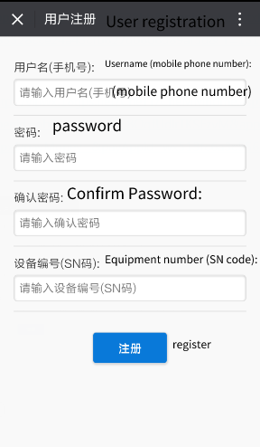

Account change password
Interface name  Request method  Request example | modifyEnterprisePwd
 | HTTP GET
 | http://apitest.18gps.net//GetDateServices.asmx/GetDate?method=modifyEnterprisePwd&reg_pass=1234&reg_olbpass=123456&mds=c74c94d2c9da4ec49cdc3f2795b71dc1
parameter | type | Required | Describe
method | String | YES | Interface Name
mds | String | YES | Token
reg_pass | String | YES | New Password
reg_olbpass | String | YES | Old/ Previous Password
ISMD5 | Int | No | 0 No verification/1 Verification
R&D Notes
- Regardless of whether MD5 authentication is enabled, the new password reg_pass must be in plain text
- MD5 verification must pass an uppercase value (the encrypted password must be uppercase)

Request results
成功/success：
{
"success": "true",
"errorCode": "200",
"errorDescribe": "修改成功/Modification successful"
}
失败/fail：
{
"success": "false",
"errorCode": "500",
"errorDescribe": "描述/describe"
}

4.Account (binding) device
Interface name  Request method  Request example | ActiveAndAddDevice
 | HTTP GET
 | http://apitest.18gps.net//GetDateServices.asmx/GetDate?method=ActiveAndAddDevice&login_id=3dfca26777e549338a72e03e1c354d65&mds=e4495806ce1a4d42a7f6eba2f9d36ef0&FullName=H25685&Macid=011610300002
parameter | type | Required | Describe
method | String | YES | Interface Name
mds | String | YES | Token
login_id | Guid | YES | Unit ID
Macid | String | YES | Device Number（IMEI）
Platenumber | String | NO | License plate number
FullName | String | NO | Device Name (Nickname)
R&D Notes
Add a device to the account. The value of the parameter login_id is taken from the id field in the data returned when logging in.
Purpose:
Subordinate customers or end users bind devices. It is not to add a new device directly to the platform.

Process:
10,000 devices are added to account A.
All subordinates of account A can bind to their own accounts by device number.
If they are not subordinates of account A, it will prompt 1, insufficient permissions.
R&D Notes
成功/success：
{
"success": "true",
"errorCode": "200",
"errorDescribe": "",
"data": [{"user_id": "476f61b2c6c349f3a9fc3e727090cb7a"}]
}
失败：
{
"success": "false",
"errorCode": "9",//已被别人绑定/Already bound by someone else
"errorDescribe": "BoundedByOther",
"data": []
}

5. Account (unbinding) device
Interface name  Request method  Request example | unbundlingDevice
 | HTTP GET
 | http://apitest.18gps.net//GetDateServices.asmx/GetDate?method=unbundlingDevice&mds=e4495806ce1a4d42a7f6eba2f9d36ef0&macid=011610300002
parameter | type | Required | Describe
method | String | YES | Interface Name
mds | String | YES | Token
login_id | Guid | YES | Unit id
macid | String | YES | Device Number（IMEI）
R&D Notes
The function is opposite to the binding interface. Unbinding does not mean that the device is completely deleted, but it returns to the account where the device was first added. It can be retrieved through the binding interface.。
Request results
成功/success：
{
"success": "true",
"errorCode": "200",
"errorDescribe": "",
"data": []
}

Get real-time alerts
Interface name  Request method  Request example | queryLocalAlarmInfoUtc
 | HTTP GET
 | http://apitest.18gps.net//GetDateServices.asmx/GetDate?timestamp=1508228270718&method=queryLocalAlarmInfoUtc&callback=timeWarnOBJ.loadDataCallBack&school_id=754a5a28-8f24-47ff-908f-c363663db852&mds=72311ebde9e94e1292152436303362ff&max_time=1508103827687&type=custom
parameter | type | Required | Describe
method | String | YES | Interface Name
mds | String | YES | Token
school_id | Guid | YES | Unit ID/Device ID
type | String | YES | Fixed value "custom”
max_time | Long | YES | Last alarm time (Utc timestamp in milliseconds, controls the acquisition range)
timestamp | Long | NO | Random number (used to refresh cache)
callback | String | NO | Callback method name
R&D Notes
school_id It can be one of the two login types.
The maximum number of alarms that can be obtained by unit login is 150, and the maximum number of alarms that can be obtained by device login is 60. The data comes from the cache.
If you want to obtain historical alarm records, please use Section 20. Get alarm details.

How to achieve real-time acquisition?
1. The key is the max_time field.
2. When accessing the interface for the first time, assign a default value to max_time. For example, at 12 noon yesterday, the alarm data obtained will be from max_time (12 noon yesterday) to now.
3. If there is data returned (total is not equal to 0), it means that there is an alarm during this period. When organizing the data, compare max_time and send_time, assign the largest value to max_time, and let max_time always be the time of the last alarm.
4. Set a timer to poll the interface every 10 seconds. As long as the returned data is not empty, the value of max_time will change. If it is empty, it will not change to achieve real-time.
5. If you do not need to use jsonp for callback, remove callback, and the returned object will be a json object

Request results
成功/success：
timeWarnOBJ.loadDataCallBack(
{
"total": 1,
"rows": [
{
"id": "1c20ee64-8eff-43aa-b77c-2a00c57cf3ce",// Alarm number (database primary key)
"macid": "864306200010433",// Equipment No.
"course": 0,// direction
"gps_status": "Expired today", // Description
"gps_time": 1508203827687,// Time when the alarm data is received
"jingdu": 113.853685,// longitude
"weidu": 22.5890067,// latitude
"send_time": 1508203827687,// Alarm time
"speed": "0",// speed
"status": 0,// Whether to process, 0 means not processed
"type_id": 61,// Alarm Type
"classifyDescribe": 0,// Secondary classification description, plays a supplementary role
"user_id": "75b9aca9-108a-43d5-90da-60095e6c6006",// equipment ID（Guid）
"user_name": "GT03Y0010433",// Device Name
"macname": "GT03Y"// Device Model
}
],
"success": true
})

7.Get historical track
Interface name  Request method  Request example | getHistoryMByMUtcNew/getHistoryMByMUtc/
 | HTTP GET
http://apitest.18gps.net//GetDateServices.asmx/GetDate?method=getHistoryMByMUtcNew&mds=457672d6a837446ba3ca7aa9fde8f4c5&playLBS=true&macid=9180144748&mapType=BAIDU&from=1521129600000&to=1521215940000

http://apitest.18gps.net//GetDateServices.asmx/GetDate?method=getHistoryMByMUtc&mds=457672d6a837446ba3ca7aa9fde8f4c5&playLBS=true&userID=5d6fe45c-55cc-4345-a60a-46721eaf0b08&mapType=BAIDU&from=1521129600000&to=1521215940000
parameter | type | Required | Describe
method | String | YES | Interface Name
mds | String | YES | Token
macid | String | YES | Device ID (IMEI)
mapType | String | YES | Map type (BAIDU)
from | Long | YES | Utc Timestamp in milliseconds (start time)
to | Long | YES | Utc Timestamp in milliseconds (end time)
playLBS | Bool | NO | Whether to obtain base station trajectory points
R&D Notes
1.The front-end method of from and to values ​​is as follows. There are conversion methods for various programming environments. Search Baidu
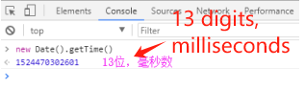
2.The returned Point field is of string type
3.Only 1000 data points can be obtained. If less than 1000 data points are returned, all data points have been retrieved. If the data points are equal to 1000 data points, there are still tracks to be retrieved.
4.If the data is not fully retrieved, the maximum time of the first acquisition of 1000 data items is used as the start time of the second acquisition and this interface is called again until the number of acquired items is less than 1000.
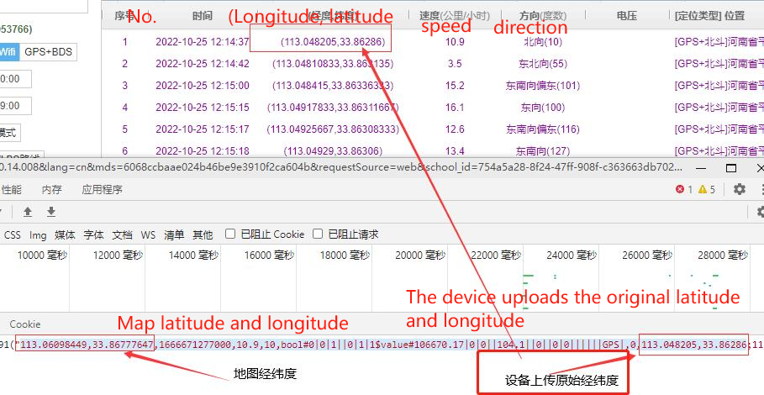

Request results
成功/success：
"113.0820431,33.8673257,1513126704000,10.9,37,bool#1|0|1||0|1|1$value#253781.84|0|||||||0|0||||||GPS|,0;113.0821168,33.8673128,1513126720000,0.2,0,bool#1|0|1||0|1|1$value#253781.84|0|||||||0|0||||||GPS|,0;113.0821572,33.8672707,1513126729000,11.4,131,bool#1|0|1||0|1|1$value#253781.85|0|||||||0|0||||||GPS|,0"
Detailed Description：
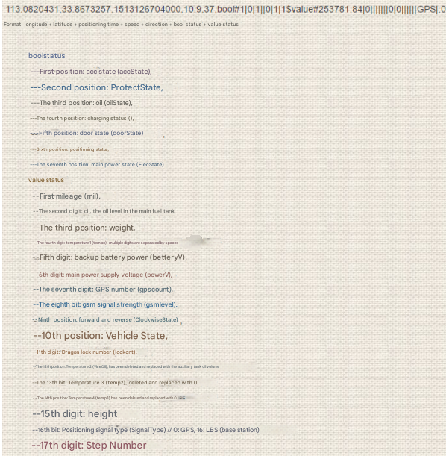
Failed:
""
R&D Notes:
Someone asked how to parse the data inside?
First, use the ";" symbol to separate all the data to get the total number of data items, which is an array A
Second, loop this array to get A[i];
Third, assume a=A[i]="108.380335, 22.761847, 1557959518000, 38.89, 45, bool#1|0|1||0|1|1$value#10473.23||||100||||||||||GPS|, 0";
Fourth, use bool# to separate a single item, take the first digit after separation, and continue to separate with | to get a bool value array
Fifth, then use value# to separate a single item, take the first digit after separation, and continue to separate with | to get a value value array
Sixth, pay attention, the fourth and fifth should be written separately, remember! ! !

Attach a picture
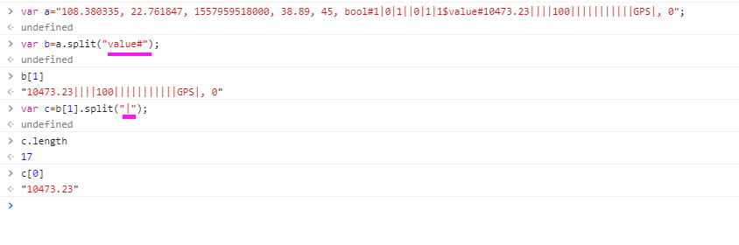

8.Get device list
Interface name  Request method  Request example | getDeviceList
 | HTTP GET
 | http://apitest.18gps.net//GetDateServices.asmx/GetDate?method=getDeviceList&mds=3f8a8c56a7df4be0b7561e44c13fa069
parameter | type | Required | Describe
method | String | YES | Interface Name
mds | String | YES | Token
id | Guid | NO | Subordinate unit ID [backup]
R&D Notes
Get the device information directly belonging to your own account. (Not including subordinates)
Request results
Success: offline 0 offline 1 online stationary 2 online driving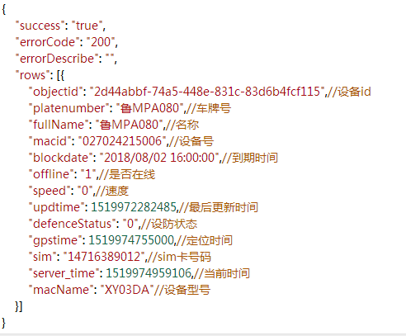

9.Get the latest location (single device)
Interface name  Request method  Request example | getUserAndGpsInfoByIDsUtc
 | HTTP GET
http://apitest.18gps.net/GetDateServices.asmx/GetDate?mapType=BAIDU&mds=0e41931ac2654d2e839d29847c385ad8&method=getUserAndGpsInfoByIDsUtcNew
&option=cn&user_id=c0095ae6-db7d-4932-8cb5-5b1531ed3637

接口名称：getUserAndGpsInfoByIDsUtcNew
parameter | type | Required | Describe
method | String | YES | interface name
mds | String | YES | token
mapType | String | YES | map type "BAIDU"
option | String | YES | language "cn"
user_id | Guid | YES | device id
R&D Notes
How to judge whether it is online?
Compare the signal time (serial number 7) and the server time (serial number 15). If the difference is 25 minutes, it is offline. If it is less than 25 minutes, it is online. If the speed is 0, it is stationary. If it is not 0, it is moving.

How to calculate how long it has been stationary or offline?
Static time = server_time (system time) - datetime (update time)
Offline time = server_time (system time) - heart_time (device heartbeat time)
Note: The calculated values ​​are all in milliseconds, which can be divided by 1000 to get seconds. Both app development and h5 have conversion codes, so search online.

Disabled judgment: speed equals -9 and offline time (server_time - heart_time) > 25 minutes
Expired judgment: server_time (system time) - expire_date (expiration time, serial number 17)）

Request results
Success:
The data in key is explanatory. Each value in each array in records array is really useful to you. For example, status corresponds to "status [status as follows]", which is generally used like this: records[0][status]. In addition, if the records array is empty, it means that this account has no device.
{
"success": "true",
"errorCode": "200",
"errorDescribe": "",
"data": [

{
"key": { //The key is the detailed remarks of the records group below
"sys_time": 0, //Device positioning time
"user_name": 1, //Device name
"jingdu": 2, //Longitude (GPS positioning)
"weidu": 3, //Latitude (GPS positioning)
"datetime": 6, //Data update time (server receiving time)
"heart_time": 7, //Device heartbeat time (signal time)
"su": 8, //Speed ​​
"status": 9, //Status group [status as shown in the following table]
"hangxiang": 10, //Direction
"sim_id": 11, //Device number
"user_id": 12, //Device id
"sale_type": 13, //Sales type - no use
"iconType": 14, //Icon
"server_time": 15, //System time (current time)
"product_type": 16, //Device type
"expire_date": 17, //Expiration time
"group_id": 18, //Monitoring group ID
"statenumber": 19, //Information group [status as shown in the following table]
"electric": 20,
describe": 21, //Device description information (usually stores some operating parameters uploaded by the device)
"sim": 22, //sim card
"precision": 23 //Precision error (Lbs/WiFi) When the value is 10, it means GPS positioning, no precision [invalid]
isFollow":24,"Whether it is a follow device
plateNumber":25,"License plate number
auth":26,"Authority
authList":27,"Authority list
deptname":28"Department name
（202211/11 added)
The actual value, there is one more bit here, whether to pay attention, whether to authorize, no use },
"records": [
[
1505987223000, //Device positioning time (utc timestamp)
"Device name",
113.8272056,
22.6993799,
113.8272056,
22.6993799,
1505987173965,
1506325381478,
"0",
"1010000",
0,
"Device number",
"a12e71f7a9b248df91fcbc65cbd9649",
1,
"01",
1506399055758,
"T3",
1516233600000,
"0",
"2435.99,0,0,,0,0,0,0,0,0,0,0,0,0,0,0", 0, "", "", 10 ] ], "groups": [] } ]
}
status (description): eight consecutive characters
---First digit: acc state (accState 1 on 0 off),
---Second digit: device's own defense state (ProtectState 1 defense 0 disarm),
---Third digit: oil and electricity (oilState 1 on 0 off),
---Fourth digit: charging state (),
---Fifth digit: door state (1 on 0 off),
---Sixth digit: positioning state (1 positioning 0 not positioning) [meaningless]
---Seventh digit: main power state (ElecState)
---Eighth digit: platform defense state (defend) [meaningless]
---Ninth digit: platform stealth state (gpsOnOff) (1 is stealth)
Statenumber (description): 16 consecutive comma-separated characters
--First digit: Mileage (mil),
---Second digit: Oil (oil),
---Third digit: Weight (weight),
---Fourth digit: Temperature 1 (tempc),
---Fifth digit: Backup battery power (betteryV)，There are two ways to express the power: 1 is a percentage 2 is V (volts) When the power is greater than 100, -100 is used to get the V unit, and less than 100 is used as a percentage
---Sixth digit: main power supply voltage (powerV)，Unit: V
---Seventh digit: GPS count (gpscount),
---Eighth digit: GSM signal strength (gsmlevel),
---Ninth digit: ClockwiseState,
---Tenth digit: Vehicle state (VehicleState),
---Eleventh digit: Lockcnt,
---Twelfth digit: Temperature 2 (temp1),
---Thirteenth digit: Temperature 3 (temp2),
---Fourteenth digit: Temperature 4 (temp3)
---Fifteenth digit: Height (height)
---Sixteenth digit: Positioning signal type (SignalType) 0: Beidou GPS 1: Wifi positioning 16: Base station positioning
---Seventeenth digit: Step number (StepNumber)
---Eighteenth digit: Vehicle frame number

Research and development supplement:
{"key":{"sys_time":0,"user_name":1,"jingdu":2,"weidu":3,"ljingdu":4,"lweidu":5,"datetime":6,"heart_time":7,"su":8,"status":9,"hangxiang":10,"sim_id":11,"user_id":12,"sale_type":13,"iconType":14,"server_time":15,"product_type":16,"expire_date":17,"group_id":18,"statenumber":19,"electric":20,"describe":21,"sim":22,"precision":23,"isFollow":24},"records":[[1557712988,"59号",121.527837,31.100259,121.527837,31.100259,1557712988000,1557713134721,"0","10000010",124.0,"8629640236329","fdd70e9ebc6c4559aca661e49e",0,"22",1557713139056,"GS05B",2204150400000,"0","4.59,0,0,,6,0,12,4,0,0,0,0,0,0,0,0,",6.0,"ICCID:89860412101","",10,"0"]],"groups":[]}

The blue part is useful, the others are comments
[ //Corresponding to the comments above
1557712988,
"59号",
121.527837,
31.100259,
121.527837,
31.100259,
1557712988000,
1557713134721,
"0",
"10000010",
124.0,
"8629640236329",
"fdd70e9ebc6c4559aca661e49e",
0,
"22",
1557713139056,
"GS05B",
2204150400000,
"0",
"4.59,0,0,,6,0,12,4,0,0,0,0,0,0,0,0,",
6.0,
"ICCID:89860412101",
"",
10, //When the value is 10, it means GPS positioning, no (base station/wifi) accuracy；
"0" //Do you care about [No use]
]

Note that there is a logic: first determine whether it has expired, then determine whether it has been positioned, then determine the positioning method, and finally organize the corresponding display effect.

Modify device information
Interface name  Request method  Request example | SetGpsUserFullNameAndPlateNumber
 | HTTP GET
 | url/DataService.ashx/GetDate?method=SetGpsUserFullNameAndPlateNumber&macid=Device number &fullName=device name &plateNumber=plate number &mds=(obtained through login interface)
parameter | type | Required | Describe
method | String | YES | Interface Name
mds | String | YES | Token
macid | String | YES | Device number (IMEI)
fullName | String | YES | Device name
plateNumber | String | YES | License plate number
LinkName | String | NO | Contact person
LinkTel | String | NO | Contact number
sim | String | NO | Device SIM card number
R&D Notes
Note that the last three fields are not mandatory, you can fill them in and modify them if necessary.
Request results
Success:
{
"data": [],
"success": "true",
"errorCode": "200",
"errorDescribe": "Modification successful"
}

11.Log out
Interface name  Request method  Request example | LoginOut
 | HTTP GET
 | http://apitest.18gps.net//GetDateServices.asmx/GetDate?method=LoginOut&mds=(Login interface acquisition)
parameter | type | Required | Describe
method | String | YES | Interface Name
mds | String | YES | Token
R&D Notes
Function:
Clear mds cache to ensure information security;
Clear pushId pushed by app (including push function).
Request results
Success：
{
"data": [],
"success": "true",
"errorCode": "200",
"errorDescribe": "Modification successful"
}

12.Issue instructions
Interface name  Request method  Request example | SendCommands
 | HTTP GET
 | http://apitest.18gps.net//GetDateServices.asmx/GetDate?method=SendCommands&macid=00005581D8F3&cmd=GETVERSION&param=&pwd=&sendTime=&mds=6efb1fda32bb4416a7a29e54a1b045d1
parameter | type | Required | Describe
method | String | YES | Interface name
macid | String | YES | Device number (IMEI)
mds | String | YES | Token
cmd | String | YES | Command name
param | String | NO | Send parameters, separated by commas
pwd | String | NO | Device password
sendTime | DateTime | NO | Set send time
研发备注
After the command is successfully issued, the command receipt number "CmdNo" is returned.

var backMess = { flowID: 'serial number', SEND_SUCCESS: 'Operation successful', SEND_FAIL: 'Operation failed', PWD_ERROR: 'Wrong password', NOT_CUSTOMER: 'Customer does not exist', USER_LEAVE: The current device is offline and has been scheduled to be executed after it comes online.', 'Not Online': 'The current device is offline.Arranged to be executed after going online. ', 'PERMISSIONS': 'Experience account, cannot send commands', Nonsupport: 'Command is not supported, please contact support', SEND_OK: 'Command sent successfully', Fail: 'Command sent failed', DeviceNot: 'Device does not exist', Cmd_ExceedLength: 'Warning: The queue is full, please go to the [Command-Send Record] page to check! ' };

Arm cmd: SAFEON (generally, special commands may not have this value)
Disarm cmd: SAFEOFF (generally, special commands may not have this value)
Pass-through cmd: PASSTHROUGH (parameter "0,5554" means text is sent 5554; "1,5554" means hexadecimal is sent 0x55 0x54)
Request results
success:
{
"success": "true",
"errorCode": "200",
"errorDescribe": "",
"data": [{
"CmdNo": "e2b6b72c-27a3-4b86-9da0-477aa43a3518",//Receipt Number
"ReturnMsg": "USER_LEAVE"
}]
}

13.Query the result of issuing instructions
Interface name  Request method  Request example | GetCommandResults
 | HTTP GET
 | http://apitest.18gps.net//GetDateServices.asmx/GetDate?method=GetCommandResults&macid=00005581D8F3&cmdNo=e2b6b72c-27a3-4b86-9da0-477aa43a3518&mds=6efb1fda32bb4416a7a29e54a1b045d1
parameter | type | Required | Describe
method | String | YES | Interface name
macid | String | YES | Device number (IMEI)
mds | String | YES | Token
cmdNo | String | YES | Receipt number
R&D Notes
Nothing
Request results
success:
：
------

14.Request latitude and longitude
Interface name  Request method  Request example | ---
 | HTTP GET
 | http://poi.18gps.net/POI?lat=22.36&lon=114.256&map=BAIDU
parameter | type | Required | Describe
lat | Double | YES | Latitude
lon | Double | YES | Longitude
map | String | YES | Map Type
Development Notes
See the preface for map types.
Request results
success:
Floor 26B2, Lane 7, Village, Ho Chung, Sai Kung District, Hong Kong Special Administrative Region. It is 197 meters away from Liu Ren Yi Ke Shan Shan (northwest)

Get the latest location in batches
Interface name  Request method  Request example | getDeviceListByCustomId
 | HTTP GET
 | http://apitest.18gps.net//GetDateServices.asmx/GetDate?method=getDeviceListByCustomId&mds=a1324221c41d44a08f93445b1bec63dd&id=e9c939f1-9c06-4312-b295-47f0162b4176&mapType=BAIDU
parameter | type | Required |  | Describe
method | String | YES |  | Interface Name
id | Guid | YES |  | Unit ID
mds | String | YES |  | Token
mapType | String | YES |  | Map Type
R&D Notes
Return data Notes are the same as those for getting the latest location (single device).
Map type Fill in the blanks to get WGS84 coordinates longitude and latitude
Request results
成功：{"success":"true","errorCode":"200","errorDescribe":"","data":[{"key":{"sys_time":0,"user_name":1,"jingdu":2,"weidu":3,"ljingdu":4,"lweidu":5,"datetime":6,"heart_time":7,"su":8,"status":9,"hangxiang":10,"sim_id":11,"user_id":12,"sale_type":13,"iconType":14,"server_time":15,"product_type":16,"expire_date":17,"group_id":18,"statenumber":19,"electric":20,"describe":21,"sim":22,"precision":23,"isFollow":24},"records":[[1444202949000,"天翼卡",114.046648,22.652224,114.046648,22.652224,1444202951657,1444202951657,"5","00000100",319.0,"383715011929452","1fe02b6045a4477aae90e66a7c2218de",0,"24",1547696829997,"GT003",2565648000000,"0","0.42,0,0,,0,6,0,86,0,0,0,0,0,0,0,0",0.0,"","",10,"0"],[1538011845000,"SC2082204818",116.158823,34.279542,116.158823,34.279542,1538012061443,1538012061443,"57.7","10100110",22.0,"993182204818","8d54f75b3469471face04d88f57cda03",0,"01",1547696829997,"SC20",1553529600000,"0","0,0,0,,0,14.39,11,22,0,1,0,0,0,0,0,0",0.0,"","",10,"0"]],"groups":[],"followCount":0,"deviceCount":23}]}

16.Get the list of subordinate unit devices
Interface name  Request method  Request example | getDeviceListByCustomId
 | HTTP GET
 | http://apitest.18gps.net//GetDateServices.asmx/GetDate?method=getDeviceListByCustomId&mds=9309428153234490931b3923d170cd40&id=334f2e92-787d-45e8-bf5c-3b500a8c787d
parameter | type | Required | Describe
method | String | YES | Interface name
mds | String | YES | Token
id | Guid | YES | Subordinate unit ID
mapType | String | NO | Map type (default Baidu "BAIDU")
R&D Notes
Get the device list of the subordinate unit.
Request results
成功：
{
"success": "true",
"errorCode": "200",
"errorDescribe": "",
"data": [{
"key": { //详见最新位置单个（第二节，第9个接口）
"sys_time": 0,
"user_name": 1,
"jingdu": 2,
"weidu": 3,
"ljingdu": 4,
"lweidu": 5,
"datetime": 6,
"heart_time": 7,
"su": 8,
"status": 9,
"hangxiang": 10,
"sim_id": 11,
"user_id": 12,
"sale_type": 13,
"iconType": 14,
"server_time": 15,
"product_type": 16,
"expire_date": 17,
"group_id": 18,
"statenumber": 19,
"electric": 20,
"describe": 21,
"sim": 22,
"precision": 23,
"isFollow": 24
},
"records": [
[1482596907000, "601603080377", 114.231935, 22.667007, 114.231935, 22.667007, 1482591004402, 1482596908894, "0", "00000100", 134.0, "601603080377", "2f45ed3a309744c5b9da11cc5bd3d5dd", 0, "22", 1551926835558, "DXMKT", 2141959763770, "1830a1e7cf8a4790b10e3bab2e7c2406", "813312.57,0,0,,0,0,5,26,0,0,0,0,0,0,0,0,", 0.0, "", "1234458373", 10, "0"],
[1511853204362, "902B75072918", 114.223921, 22.665438, 114.223921, 22.665438, 1511853204362, 1511853767987, "0", "00000000", 0.0, "391517075072918", "6a33f9dc7418430ba5388dba4cdc9f33", 0, "22", 1551926835558, "902B", 1544515200000, "0", "0,0,0,,6,0,0,100,0,0,0,0,0,0,0,16,", 6.0, "", "", 550, "0"],
[0, "DXMKT7908511", 0.0, 0.0, 0.0, 0.0, 0, 0, "-9", "00000000", 0.0, "867273027908511", "559d5b39f46c4790b729d2a86f5bef31", 0, "01", 1551926835558, "DXMKT", 1542240000000, "0", "0,0,0,,0,0,0,0,0,0,0,0,0,0,0,0,", 0.0, "", "", 10, "0"]
],
"groups": [],
"followCount": 0, //关注个数
"deviceCount": 3 //设备个数
}]
}

17.Bind device interface [spare]
Interface name  Request method  Request example | MoveDevice
 | HTTP GET
 | http://apitest.18gps.net//GetDateServices.asmx/GetDate?method=MoveDevice&mds=9309428153234490931b3923d170cd40&id=334f2e92-787d-45e8-bf5c-3b500a8c787d&macid=027028656666
parameter | type | Required |  | Describe
method | String | YES |  | Interface name
mds | String | YES |  | Token
id | Guid | YES |  | Unit ID (write your own)
macid | String | YES |  | Device number
R&D Notes
If you have already registered an account and need to add another device to your account.
Request results
success：

18.Set alarm filtering [common to device login and account login]
Interface name  Request method  Request example | setFilterAlarmInfo
 | HTTP GET
 | http://apitest.18gps.net//GetDataService.aspx?method=setFilterAlarmInfo&custid=754a5a28-8f24-47ff-908f-c363663db702&mds=314dc945b0ea498b81b6de21f47f178e&alarmType=,0,3,7,
parameter | type | Required | Describe
method | String | YES | Interface name
mds | String | YES | Token
custid | Guid | YES | Unit ID (login ID)
alarmType | String | YES | Filtered alarm types, comma separated
R&D Notes
The items that are checked by default are those that require an alarm. If you do not want to report this type of alarm, you need to uncheck it.
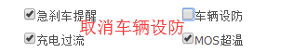
Request results
成功：
{
success: "true",
msg: 1,
filterObj: ",0,3,7,"} //过滤的报警类型

19.Get the filter alarm number
Interface name  Request method  Request example | GetPushAlarmSwitch
 | HTTP GET
 | http://apitest.18gps.net//GetDataService.aspx?method=GetPushAlarmSwitch&mds=314dc945b0ea498b81b6de21f47f178e
parameter | type | Required | Describe
method | String | YES | Interface Name
mds | String | YES | Token
研发备注/R&D Notes
Query the alarm type number for which filtering is set.
请求结果/ Request results
成功：
{
success: "true",
errorCode: "200",
errorDescribe: "",
data: [
[
0,
3,
7
]
]}

20.Get alarm details
接口名称  请求方式  请求示例 | alarmOperation
 | HTTP GET
 | http://apitest.18gps.net//GetDataService.aspx?method=alarmOperation&mds=314dc945b0ea498b81b6de21f47f178e&alarmType=1,2,3,4,6,7,8,9,10,11,14,38&enterprise_id=e0329898-4eaa-4612-9f69-00986998d89b&userid=72b92fe0-34ca-483b-b0f9-27e4c7ee3d92&beginTime=1587916800000&endTime=1587951883000
parameter | type | Required | Describe
method | String | YES |  | Interface name
mds | String | YES |  | Token
alarmType | String | YES |  | Alarm type
enterprise_id | Guid | YES |  | Unit ID (Login ID)
userid | Guid | YES |  | Device ID
beginTime | Long | YES |  | Utc timestamp milliseconds (start time)
endTime | Long | YES |  | Utc timestamp milliseconds (end time)
研发备注
See the sixth interface for the return result notes.
请求结果
成功：{
success: "true",
errorCode: "200",
errorDescribe: "",
data: [
{
id: "efe0fb98-7e86-4a94-bdab-642ae07898cc",
fullname: "皖A （压车）",
classify: 38,
lon: 117.203048,
lat: 31.926648,
addtime: "2020/04/27 08:31:57",
ptime: "2020/04/27 08:31:44",
status: 0,
speed: 0,
macid: "09103****855",
userid: "72b92fe0-34ca-483b-b0f9-27e4c7ee3992",
macname: "JT808",
NumberId: 3,
Notea: ""
}
]}

21.Device password change
接口名称  请求方式  请求示例 | modifyUserPwd
 | HTTP GET
parameter | type | Required | Describe
method | String | YES | Interface Name
mds | String | YES | Token
macid | String | YES | Device Number
pwd | Guid | YES | New Password
oldPwd | Guid | YES | Old Password
研发备注
无。
请求结果
成功：{
success: "true",
errorCode: "200",
errorDescribe: "",
data: []
}

22.Send command history
接口名称  请求方式  请求示例 | GetSendCmdList
 | HTTP GET
 | http://api.18gps.net//GetDataService.aspx?method=GetSendCmdList&mds=a544e41669d6455f84b862f666eaffdd&macid=027045307931&count=&_t=1614219663391
parameter | type | Required | Describe
method | String | YES |  | Interface name
mds | String | YES |  | Token
macid | String | YES |  | Device number
count | int | no |  | Number of entries
研发备注
无。
请求结果
成功：
{
"success": "true",
"errorCode": "200",
"errorDescribe": "",
"data": [{
"Describe": "GETVERSION",//指令字（指令类型）需字典转换
"Param": "",//指令内容
"IsOK": "Null",//状态
"Msg": "",//响应信息
"SendTime": 1614219644177,//发送时间
"AddTime": 1614219644192,//添加时间
"ExtData": {
"source": "web:web"//来源
}
}]
}

23.Clear command
Interface name  Request method  Request example | ClearCmdList
 | HTTP GET
 | http://api.18gps.net//GetDataService.aspx?method=ClearCmdList&mds=a544e41669d6455f84b862f666eaffdd&macid=027045307931
parameter | type | Required | Describe
method | String | YES | Interface Name
mds | String | YES | Token
macid | String | YES | Device Number
R&D Notes
Clear all command records with one click, including two aspects:
1. Clear the sending history (clear the successful commands)
2. Clear the queued commands (cancel the sending of unsuccessful or queued commands).
Request results
success：{
success: "true",
errorCode: "200",
errorDescribe: "",
data: []
}

24.Get stop points
Interface name  Request method  Request example | StayDetail
 | HTTP GET
 | http://api.18gps.net/GetDataService.aspx?method=StayDetail&mds=4be0dc807a164c54affba098fe29ebd4&beginTime=1621227915000&endTime=1621231515000&userid=badda545-a4c7-459f-9600-b4729abaeee3&mapType=GAODE
parameter | type | Required | Describe
method | String | YES | Interface name
mds | String | YES | Token
beginTime | Long | YES | Utc timestamp milliseconds (start time)
endTime | Long | YES | Utc timestamp milliseconds (end time)
userid | Guid | YES | Device id
mapType | String | YES | Map type
 |  |  | Interface name
研发备注
无。

请求结果
成功：
[
{
"id": 1, //序号
"fullName": "测试专用",//名称
"beginDate": "2021/5/17 12:40:58",
"endDate": "2021/5/17 13:58:40",
"lon": 103.77622606,
"lat": 35.98225666,
"stopCar": "1Hour17Minute42second" //停留时间
}
]

▬▬◣Recording related

1.Get multimedia records (real time)
Interface name  Request method  Request example | GetMultimediaRecords
 | HTTP GET
 | http://api.18gps.net//GetDataService.aspx?method=GetMultimediaRecords&mds=4708977a492c472288b178ef5ca7f977&target=6020036221&userId=e0329898-4eaa-4612-9f69-00986998d89b&maxTime=0
parameter | type | Required | Describe
method | String | YES | Interface name
mds | String | YES | Token
target | String | YES | Device number
userId | Guid | YES | Login ID (ID returned by the login interface)
maxTime | Long | YES | Maximum time (Utc timestamp milliseconds)
研发备注
If maxTime is 0, the records obtained are the 50 records closest to the current time.
If maxTime is a specific time, then all records between this time point and the current time are obtained.

Return data:
Id message number
UserId account ID
Target device number or user ID or channel ID
Content content
FileName file name
Url file address
InfoType message type [0: voice, 1: video, 2: picture, 3: text]
IsUser indicates whether the user sent the message, 0 indicates device upload
Addtime indicates the time of adding the message
Request results
Sucess：{
success: "true",
errorCode: "200",
errorDescribe: "",
data: []
}

2.Get voice history (paginated)
Interface name  Request method  Request example | GetVoiceHistory
 | HTTP GET
 | http://api.18gps.net//GetDataService.aspx?method=GetVoiceHistory&mds=4708977a492c472288b178ef5ca7f977&macid=6020036221&loingId=3975226d-d106-47c1-8cc5-17ebc42818bb&minTime=0&count=10
parameter | type | Required | Describe
method | String | YES | Interface name
mds | String | YES | Token
macid | String | YES | Device number
loingId | Guid | YES | Login ID (ID returned by the login interface)
minTime | Guid | YES | Minimum time (Utc timestamp in milliseconds)
count | Int | NO | Number of entries (default 20)
R&D Notes
Get macid device, count data after minTime.

Return data:
Id message number
UserId account ID
Target device number or user ID or channel ID
Content content
FileNamefile name
Url File address
InfoType message type [0: voice, 1: video, 2: picture, 3: text]
IsUser whether it is sent by the user, 0 is device upload
Addtime add time
请求结果
成功：{
success: "true",
errorCode: "200",
errorDescribe: "",
data: []
}

3.Delete recordings (supports multiple)
Interface name  Request method  Request example | DeleteSingleVoice
 | HTTP GET
 | http://api.18gps.net//GetDataService.aspx?method=DeleteSingleVoice&mds=4708977a492c472288b178ef5ca7f977&ids=c0095ae6-db7d-4932-8cb5-5b1531ed3637,c0095ae6-db7d-4932-8cb5-5b1531ed3638&loingId=3975226d-d106-47c1-8cc5-17ebc42818bb
parameter | type | Required | Describe
method | String | YES | Interface name
mds | String | YES | Token
ids | String | YES | Message number, recording number, Guid format, multiple numbers are concatenated with “,”
loingId | Guid | YES | Login ID (ID returned by the login interface)
R&D Notes
Do you remember the data format of the obtained records? The first Id field (Guid format) can be used for deletion. When deleting in batches, just separate them with English commas.
Request results
成功：{
success: "true",
errorCode: "200",
errorDescribe: "",
data: []
}

▬▬◣Round fence CFEN
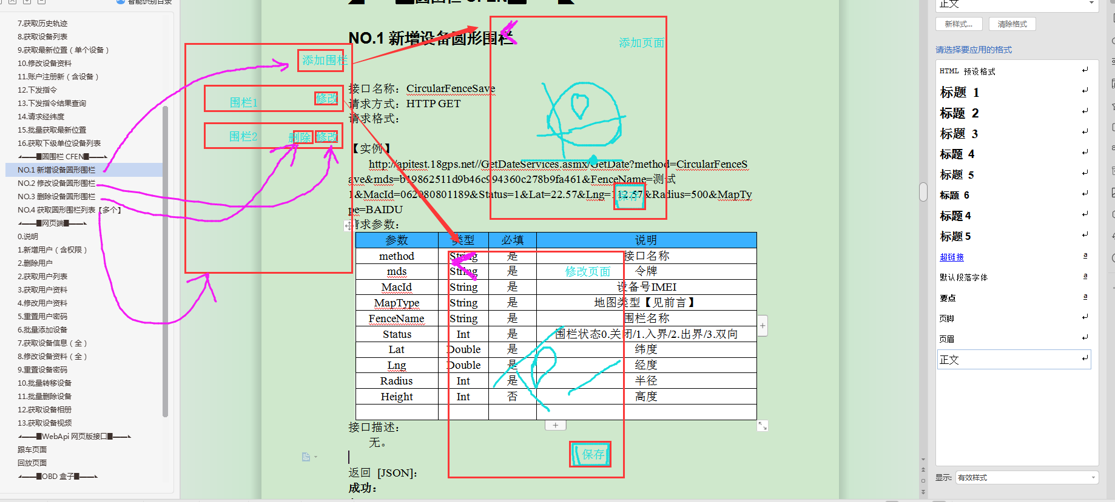

NO.1New equipment circular fence

Interface name: CircularFenceSave
Request method: HTTP GET
Request format:

【Example】
http://apitest.18gps.net//GetDateServices.asmx/GetDate?method=CircularFenceSave&mds=b19862511d9b46c994360c278b9fa461&FenceName=测试1&MacId=062080801189&Status=1&Lat=22.57&Lng=112.57&Radius=500&MapType=BAIDU

Request parameters:

parameter | type | Required | Describe
method | String | YES | Interface name
mds | String | YES | Token
MacId | String | YES | Device number IMEI
MapType | String | YES | Map type [see preface]
FenceName | String | YES | Fence name
Status | Int | YES | Fence status 0. Closed/1. Inbounds/2. Outbounds/3. Bidirectional
Lat | Double | YES | Latitude
Lng | Double | YES | Longitude
Radius | Int | YES | Radius
Height | Int | NO | Height
Interface description:
None.
Return: [JSON]：
success：
{
"success": "true",
"errorCode": "200",
"errorDescribe": "",
"data": []
}
fail：
{

}

NO.2 Modify equipment circular fence
Interface name: CircularFenceModify
Request method: HTTP GET
Request format:

【Example】
http://apitest.18gps.net//GetDateServices.asmx/GetDate?method=CircularFenceModify&mds=b19862511d9b46c994360c278b9fa461&FenceName=我3被修改了&MacId=865609163017108&Status=0&Lat=22.57&Lng=112.57&Radius=1200&MapType=BAIDU&Id=9bf3165f-616b-45f9-8c56-b5210145893c

Request parameters:
parameter | type | Required | Describe
method | String | YES | Interface name
mds | String | YES | Token
MapType | String | YES | Map type [see preface]
FenceName | String | YES | Fence name
Status | Int | YES | Fence status 0. Closed/1. Inbound/2. Outbound/3. Bidirectional
Lat | Double | YES | Latitude
Lng | Double | YES | Longitude
Radius | Int | YES | Radius
Height | Int | NO | Height
Id | Guid | YES | Fence Id
接口描述：
无。

返回 [JSON]：
成功：
{
}
失败：
{
}

NO.3Remove the device circular fence
Interface name: CircularFenceDelete
Request method: HTTP GET
Request format:
【Example】http://apitest.18gps.net//GetDateServices.asmx/GetDate?method=CircularFenceDelete&mds=b19862511d9b46c994360c278b9fa461&MacId=062080801189&Id=4147d849-dbb6-4fd2-833d-6d2f5ffa08a4

Request parameters:
parameter | type | Required | Describe
method | String | YES | Interface Name
mds | String | YES | Token
MacId | String | YES | Device Number IMEI
Id | Guid | YES | Fence Id
Interface description: None.

Return [JSON]:
Success:
{
}
Failure:
{
}

NO.4Get a list of circular fences [multiple]
Interface name: CircularFenceGetList
Request method: HTTP GET
Request format:

【Example】
http://apitest.18gps.net//GetDateServices.asmx/GetDate?method=CircularFenceGetList&mds=b19862511d9b46c994360c278b9fa461&MacId=062080801189&MapType=BAIDU

Request parameters:

parameter | type | Required |  | Describe
method | String | YES |  | Interface name
mds | String | YES |  | Token
MacId | String | YES |  | Device number IMEI
MapType | String | YES |  | Map type [see preface]
Interface description:
None.

Return [JSON]：
success:
{
"success": "true",
"errorCode": "200",
"errorDescribe": "",
"data": [{
"Id": "935bd0f5-c123-485b-b963-afd9f9ada48c", //围栏id
"UserId": "00000000-0000-0000-0000-000000000000", //暂无用途
"MacId": "062080801189", //设备号
"FenceName": "Test 2", //Fence name "Status": 1, //Fence status 0. Closed/1. Inbound alarm/2. Outbound alarm/3. Bidirectional
"Lat": 22.566695, //纬度
"Lng": 112.558606, //经度
"Radius": 800, //半径
"Height": 0, //高度（3维围栏，暂无用途）
"MapType": null //地图类型，null时，代表地图原始坐标
}, {
"Id": "0c0ae4ff-f662-4fb1-adfb-70c9be96231d",
"UserId": "00000000-0000-0000-0000-000000000000",
"MacId": "062080801189",
"FenceName": "测试3",
"Status": 1,
"Lat": 22.566695,
"Lng": 112.558606,
"Radius": 1000,
"Height": 0,
"MapType": null
}]
}

失败：
{
}

▬▬◣Authorization Function

NO.5Add device function authorization
Interface name  Request method  Request example | EmpowerAdd
 | HTTP GET
 | http://api.18gps.net//GetDateServices.asmx/GetDate?method=EmpowerAdd&Macid=868120167290847&Authorized=13009400093&mds=3aa6da273ae8402a9291fe3ab1966512&StartTime=1561685418156&EndTime=1561785418156&FunctionList=1,2
parameter | type | Required | Describe
method | String | YES | Function call
mds | String | YES | Token
Authorized | String | YES | Authorized person
Macid | String | YES | Device number
StartTime | long | YES | Start time (UTC milliseconds)
EndTime | long | YES | End time (UTC milliseconds)
FunctionList | String | YES | Function list (cannot be empty)
研发备注
FunctionList detailed description
1 Position
2 Switch lock/find car
3 Start and stop
4 Track
- You cannot authorize yourself
- After authorizing others, they are not allowed to authorize again
- Error code 1007: cannot operate on oneself, error code 50019: insufficient authority.

请求结果
成功：
{
"success": "true",
"errorCode": "200",
"errorDescribe": "",
"data": []
}

NO.6Cancel device function authorization
接口名称  请求方式  请求示例 | EmpowerDelete
 | HTTP GET
 | http://api.18gps.net//GetDateServices.asmx/GetDate?method=EmpowerDelete&EmpowerId=6615f5270d7f44fb9318e18257b8c304&mds=3aa6da273ae8402a9291fe3ab1966512
parameter | type | Required | Describe
method | String | YES | Function call
mds | String | YES | Token
EmpowerId | Guid | YES | Authorization ID
研发备注
请求结果
成功：
{
"success": "true",
"errorCode": "200",
"errorDescribe": "",
"data": []
}

NO.7 Get authorization list [owner identity]
Interface name  Request method  Request example | EmpowerGetList
 | HTTP GET
 | http://api.18gps.net//GetDateServices.asmx/GetDate?method=EmpowerGetList&type=0&mds=3aa6da273ae8402a9291fe3ab1966512
parameter | type | Required | Describe
method | String | YES | Function call
mds | String | YES | Token
type | String | NO | Type (0 gets valid authorization by default, 1 gets expired authorization)
研发备注
- Get my own authorized information, and then add:
- Authorizer's mobile number/account number //CustName
- Mobile phone number/account number of the authorized person//AuthorizedName
- Vehicle Name //VehicleName
- License plate number //PlateNumber
请求结果
成功：
{
"success": "true",
"errorCode": "200",
"errorDescribe": "",
"data": [{
"EmpowerId": "6615f5270d7f44fb9318e18257b8c304", //授权id
"CustId": "e9c939f19c064312b29547f0162b4176", //授权人id
"Authorized": "ff1fffe199fd49ea8f31bcc47cbe3f4f", //被授权人id
"Macid": "868120167290847", //设备号
"EquipmentId": "bf06541f33874c00903c15ec2879a4d0",//设备id
"IsExpire": 0, //是否过期0否 1是
"StartTime": 1561685418156, //开始时间
"EndTime": 1561785418156, //结束时间
"FunctionList": [1, 2], //功能列表
"AddTime": 1561686728650 //授权时间
}]
}

NO.8Get the list of authorized persons [Guest Identity]
接口名称  请求方式  请求示例 | EmpowerGetAuthorizedList
 | HTTP GET
 | http://api.18gps.net//GetDateServices.asmx/GetDate?method=EmpowerGetAuthorizedList&mds=50e8b54c44c24a1fa73a07dac977949a
parameter | type | Required | Describe
method | String | YES | Function call
mds | String | YES | Token
R&D Notes
As a guest, obtain authorized device information and permissions.
Request results
成功：
{
"success": "true",
"errorCode": "200",
"errorDescribe": "",
"data": [{
"EmpowerId": "1a3d61b377324578ab671568da6c1736",
"CustId": "e9c939f19c064312b29547f0162b4176",
"Authorized": "ff1fffe199fd49ea8f31bcc47cbe3f4f",
"Macid": "868120167290847",
"EquipmentId": "bf06541f33874c00903c15ec2879a4d0",
"IsExpire": 0,
"StartTime": 1561685418156,
"EndTime": 1561785418156,
"FunctionList": [1, 2],
"AddTime": 1561687437463
}]
}

▬▬◣OBD盒子
OBD是英文On-Board Diagnostics的缩写，中文翻译为“车载诊断系统”，
长的就是下图这种样子，安装位置在驾驶席刹车左上方如第二张图，这种设备以上次故障码，车况数据，行程数据而驰名。
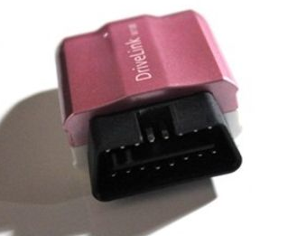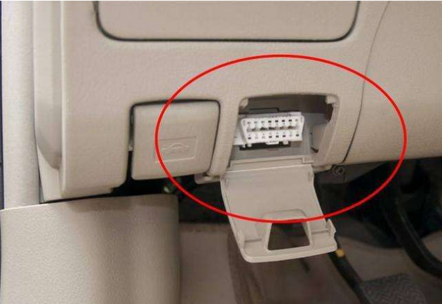

NO.1Get fault code data [2018]

接口名称  请求方式  请求示例 | getCurCodeV3
 | HTTP GET
 | http://api.18gps.net//GetDateServices.asmx/GetDate?method=getCurCodeV3&macid=601602230004&mds=cb445c3a41d940f69aa5c636d0cf2274
parameter | type | Required | Describe
method | String | YES | Function call
mds | String | YES | Token
macid | String | YES | Device number
研发备注
When data is an empty array "[]", it means that no fault code is detected.
请求结果
成功：
{
"success": "true",
"errorCode": "200",
"errorDescribe": "",
"err": "",
"info": "",
"data": [
{
"sysId": "2", //无意义
"obdcode": "P0205", //故障码名称
"obdcodestr": "P0205", //故障码名称
"obddescription": "喷油器电路/开路-第5缸", //故障码翻译
"obddescription_en": ""
},
{
"sysId": "0",
"obdcode": "P0308",
"obdcodestr": "P0308",
"obddescription": "第8缸检测到失火",
"obddescription_en": ""
}
],
"obdSys": [
{
"sysId": "0", //无意义
"obdTitle": "点火系统", //属于哪个系统（底部有16个系统标题）
"obdCount": 1 //本系统有多少个故障码
},
{
"sysId": "1",
"obdTitle": "车身电脑控制系统",
"obdCount": 0
},
{
"sysId": "2",
"obdTitle": "燃油和空气侦测系统",
"obdCount": 1
},
{
"sysId": "3",
"obdTitle": "废气控制系统",
"obdCount": 0
},
{
"sysId": "4",
"obdTitle": "变速箱控制系统",
"obdCount": 0
},
{
"sysId": "5",
"obdTitle": "燃油和空气侦测系统",
"obdCount": 0
},
{
"sysId": "6",
"obdTitle": "车速怠速控制系统",
"obdCount": 0
},
{
"sysId": "7",
"obdTitle": "电脑控制系统",
"obdCount": 0
},
{
"sysId": "8",
"obdTitle": "网路系统",
"obdCount": 0
},
{
"sysId": "9",
"obdTitle": "底盘电脑控制系统",
"obdCount": 0
},
{
"sysId": "10",
"obdTitle": "其它系统",
"obdCount": 0
}
],
"fraction": 80
}

故障码系统分为16类：
车身系统
底盘系统
燃油空气或排放控制
燃油或空气
点火系统
排放控制
车速及怠速控制
计算机或辅助输出电路
变速箱
混合动力系统
动力总成系统
辅助输入
计算机或辅助输出
气缸停缸
网络通讯系统
其它系统

NO.2Get the latest vehicle condition data [2018]

接口名称  请求方式  请求示例 | OBDLatestCarCondition
 | HTTP GET
 | http://api.18gps.net//GetDateServices.asmx/GetDate?method=OBDLatestCarCondition&macid=601804250020&mds=c8837ff880e4453ca2b168041b64e46d
parameter | type | Required | Describe
method | String | YES | Function call
mds | String | YES | Token
macid | String | YES | Device number
R&D Notes
无。
Request results
成功：
{
"success": "true",
"errorCode": "200",
"errorDescribe": "",
"data": [{
"Number": "P_01",
"Key": "车速",
"Value": "0 km/h"
}, {
"Number": "P_02",
"Key": "发动机转速",
"Value": "601 rpm"
}, {
"Number": "P_03",
"Key": "发动机冷却液温度",
"Value": "74 ℃"
}, {
"Number": "P_10",
"Key": "发动机负荷计算值",
"Value": "16 %"
}, {
"Number": "P_13",
"Key": "瞬时油耗",
"Value": "100 L/100km"
}, {
"Number": "P_18",
"Key": "控制模块电压",
"Value": "27 V"
}, {
"Number": "P_19",
"Key": "油门踏板绝对位置D",
"Value": "0 %"
}, {
"Number": "P_21",
"Key": "刹车状态",
"Value": "刹车不动作"
}, {
"Number": "P_23",
"Key": "瞬时油耗",
"Value": "2 L/h"
}, {
"Number": "P_26",
"Key": "OBD模块状态",
"Value": "行程中"
}]
}

NO.3 Get the last trip [2018] (single)

接口名称  请求方式  请求示例 | getStrokeData
 | HTTP GET
 | http://api.18gps.net//GetDateServices.asmx/GetDate?method=getStrokeData&mds=befcda89ec02489f9f6f76695a94cb3d&user_id=20992b1f-315b-4920-b9a4-d3509f33a3c2
parameter | type | Required | Describe
method | String | YES | Function call
mds | String | YES | Token
user_id | Guid | YES | Device id
研发备注
无。
请求结果
成功：
{
"id": "bd1382e2-af21-44b6-ba00-c2c62e49c3f3",
"btime": 1533254331000,
"etime": 1533263282000,
"distance": 46.42,
"maxspeed": 62.0,
"totalSpeedoverSeconds": null,
"brakeTimes": 0,
"emergencyBrakeTimes": 0,
"speedupTimes": 0,
"emergencySpeedupTimes": 0,
"speed": 18,
"maxTempc": 0.0,
"maxEngRPM": 1977,
"powerv": 0.0,
"totalfuelUsed": 18.737,
"fuelHKM": 0.0,
"overtimeDriverMinutes": 0,
"extend": [{
"Number": "T_01",
"Key": "行驶时间",
"Value": "4934 s"
}, {
"Number": "T_03",
"Key": "行程时间",
"Value": "8951 s"
}, {
"Number": "T_08",
"Key": "ECU总里程",
"Value": "4463300 km"
}, {
"Number": "T_15",
"Key": "平均转速",
"Value": "88300 rpm"
}, {
"Number": "T_16",
"Key": "平均油门",
"Value": "1200 %"
}, {
"Number": "T_17",
"Key": "平均负荷",
"Value": "2500 %"
}, {
"Number": "T_21",
"Key": "制动次数",
"Value": "202 次"
}]
}

NO.4 Get itinerary
Interface name: getStrokeV3/getStrokeV3_extend
Request method: HTTP GET
Request format:

【Examples】
http://apitest.18gps.net//GetDateServices.asmx/GetDate?method=getStrokeV3&macid=xy1610100063&beginTime=1517129108109&endTime=1517129208109

请求参数：
parameter | type | Required | Describe
method | String | YES | Interface name
mds | String | YES | Token
macid | String | YES | Device number
beginTime | Long | YES | Utc timestamp (start time)
endTime | Long | YES | Utc timestamp (end time)
 |  |  | Interface name
接口描述：

返回 [JSON]：

成功：
{
"success": "true",
"errorCode": "200",
"errorDescribe": "",
"data": [{
"rows": [{
"totalfuelUsed": "0.5", //行驶总油耗
"distance": "3.3", //行驶距离
"fuelHKM": "15.2",//百公里油耗
"totalSpeedoverSeconds": null,//超速行驶时间
"maxspeed": "61",//最大次数
"brakeTimes": 0,//停留时间
"emergencyBrakeTimes": 0,//急减速次数
"speedupTimes": 0,//急加速时长
"emergencySpeedupTimes": 0,//急加速次数
"speed": "0",//平均车速
"maxTempc": 86,//最高水温
"btime": "7:21",//开始时间
"etime": "7:34",//结束时间
"strokeTime": "2018/12/13",//日期
"jsType": 2,//
"driveTime": 780.0,//行驶时间（秒）
"fraction": 100.0,//
"random": "95%",//
"coulometric": 0,//
"ExtendedData": {//扩展数据
"SpeedLimitFuel": 0,
"SpeedLimitMil": 0,
"SpeedLimitTime": 0,
"HighSpeedFuel": 0,
"HighSpeedMil": 0,
"HighSpeedTime": 0,
"MediumSpeedFuel": 0,
"MediumSpeedMil": 0,
"MediumSpeedTime": 0,
"LowSpeedFuel": 0,
"LowSpeedMil": 0,
"LowSpeedTime": 0,
"IdleSpeedFuel": 0,
"IdleSpeedTime": 0,
"SharpTurnCount": 0,
"SpeedLimitCount": 0,
"FastTrackCount": 0
},
"BeginTime": 1544656903000,//utc
"EndTime": 1544657683000//utc
}],
"avgFuel": "12.45",//本次查询平均油耗
"totalfuel": "2.9",//本次查询总油耗
"totalmil": "23.3",//本次查询总里程
"totalDriveTime": "6198",//本次查询总行驶时间（秒）
"totalCoulometric": "0",//。。
"oilPrice": 0.0//。。
}]
}
失败：
{

}

NO.5Batch acquisition of itineraries (supports single) D platform support
接口名称：BatchGetTrips
请求方式：HTTP GET
请求格式：

【实例】
http://apitest.18gps.net//GetDateServices.asmx/GetDate?method=BatchGetTrips&macids=xy1610100063,601603080472&beginTime=1519780593918&endTime=1519803593918&mds=268cf32b992e4504b8d4f692446afe82
请求参数：
parameter | type | Required |  | Describe
method | String | YES |  | Interface name
mds | String | YES |  | Token
macids | String[] | YES |  | Device list
beginTime | Long | YES |  | Utc timestamp (start time)
endTime | Long | YES |  | Utc timestamp (end time)
接口描述：

返回 [JSON]：
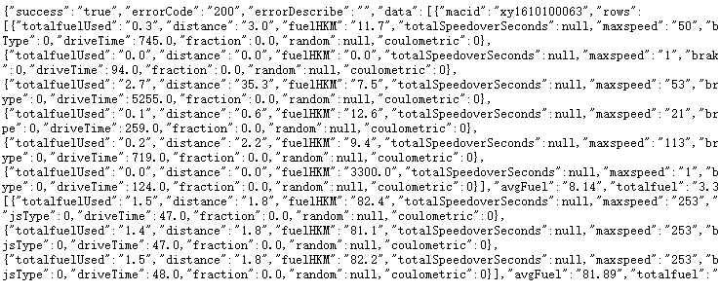

{
"totalfuelUsed": "0.3", //总油耗
"distance": "3.0", //距离（km）
"fuelHKM": "11.7", //百公里油耗
"totalSpeedoverSeconds": null, //超速行驶时间
"maxspeed": "50", //最大速度
"brakeTimes": 0, //停留时间（单位：秒）
"emergencyBrakeTimes": 1, //急减速次数
"speedupTimes": 0, //急加速时间（单位：秒）
"emergencySpeedupTimes": 0, //急加速次数
"speed": "14", //平均速度
"maxTempc": 68, //最高水温
"maxEngRPM": 1500, //最高发动机转速
"powerv": 14.2, //电压
"overtimeDriverMinutes": 1500, //疲劳驾驶（秒）
"btime": "10:49:25", //开始时间
"etime": "11:02:23", //结束时间
"strokeTime": "2018/2/28", //日期
"jsType": 0, //0：急先锋1：标准型2：稳重型3：慢羊羊
"driveTime": 745.0, //行驶总秒数
"fraction": 0.0,
"random": null,
"coulometric": 0
},

成功：
{
}
失败：
{

}

█▬▬◣Section 3: PC
- Description

The web version is suitable for operators' self-operated platforms. The front-end page is built on the operator's own server for users to access. It does not support the 18gps platform.

1.Add new users (including permissions)
Interface name  Request method  Request example | registerCustomer
 | HTTP GET
 | http://apitest.18gps.net/GetDateServices.asmx/GetDate?method=registerCustomer&mds=368867d0b6cc49af8e2685ff471e4cf2&name=上海科大&schoolID=754a5a28-8f24-47ff-908f-c363663ab225&loginName=skd&pwd=123456&repwd=123456&grade=2&contact=&phone=&addr=
parameter | type | Required | Describe
method | String | YES | Interface name
mds | String | YES | Token
schoolID | Guid | YES | Parent unit id
name | String | YES | Customer name/unit name
loginName | String | YES | Login account
pwd | String | YES | Password
repwd | String | YES | Confirm password
grade | Int | YES | Customer type
contact | String | NO | Contact person
phone | String | NO | Phone number
addr | String | NO | Address
研发备注
Here you must pay attention to the parameter "grade" of customer type. There is no unified standard for its value and it needs to be queried in the server database. If you need to use it, please consult the business department.
请求结果
成功：
{
"id": "cfd2722a-4db6-47ab-974e-d0b6d30a7ecd",//为新账户分配的guid
"result": 1, //0代表失败
"success": true//true代表成功
}

2.Deleting a User
接口名称  请求方式  请求示例 | deleteEnterprise
 | HTTP GET
 | http://apitest.18gps.net/GetDateServices.asmx/GetDate?method=deleteEnterprise&mds=368867d0b6cc49af8e2685ff471e4cf2&id=cfd2722a-4db6-47ab-974e-d0b6d30a7ecd
parameter | type | Required | Describe
method | String | YES | Interface name
mds | String | YES | Token
id | Guid | YES | Unit id
研发备注
The following two situations cannot be deleted: the user device list is not empty, and there are other users under the user。
请求结果
成功：
{
"success": "true",
"status": 1
}
失败：
{
"success": "false",
"errorCode": "500",
"errorDescribe": "未将对象引用设置到对象的实例。",//找不到此用户
"data": []
}

2.Get User List
接口名称  请求方式  请求示例 | GetCustomTreeById
 | HTTP GET
 | http://apitest.18gps.net/GetDateServices.asmx/GetDate?method=GetCustomTreeById&mds=31532675bc4841ceacf0b1c2ed874946&id=e9c939f1-9c06-4312-b295-47f0162b4176
parameter | type | Required | Describe
method | String | YES | Interface name
mds | String | YES | Token
id | Guid | YES | Unit id
研发备注
无。
请求结果
成功：
{
"success": "true",
"errorCode": "200",
"errorDescribe": "",
"data": [{
"id": "3dfca267-77e5-4933-8a72-e03e1c354d65",//下级单位id
"deptName": "千百次回眸不笑(2/2)",//客户名称/单位名称
"deviceCount": 2, //设备总数
"userName": "baidu",//登录账号
"pId": "e9c939f1-9c06-4312-b295-47f0162b4176", //父级id
"isParent": 0 //是否是父级节点，0不是（代表没有下级了）
}, {
"id": "7ba648da-ad90-4a34-8788-822bcf666665",
"deptName": "秋明山上(0/0)",
"deviceCount": 0,
"userName": "qiuqiu",
"pId": "e9c939f1-9c06-4312-b295-47f0162b4176",
"isParent": 0
}, {
"id": "a615be7b-4f73-4267-a686-6ad5902e6ac3",
"deptName": "手表(1/1)",
"deviceCount": 1,
"userName": "shoubiao",
"pId": "e9c939f1-9c06-4312-b295-47f0162b4176",
"isParent": 0
}]
}

3.Get user information
接口名称  请求方式  请求示例 | getEnterpriseByID
 | HTTP GET
 | http://apitest.18gps.net/GetDateServices.asmx/GetDate?method=getEnterpriseByID&id=cfd2722a-4db6-47ab-974e-d0b6d30a7ecd&mds=368867d0b6cc49af8e2685ff471e4cf2
parameter | type | Required | Describe
method | String | YES | Interface name
mds | String | YES | Token
id | Guid | YES | Unit id
研发备注
无。
请求结果
成功：
{
"success": "true",
"errorCode": "200",
"errorDescribe": "",
"data": [{
"id": "cfd2722a-4db6-47ab-974e-d0b6d30a7ecd",
"name": "上海科大",
"phone": null,
"addr": null,
"contact": null, //联系人
"loginName": "skd", //登录账号
"company": "上海科大", //客户名称/单位名称
"state": "",
"area": "",
"permission": 2, //树层级
"grade": 2, //账户类型
"artificial_person": "skd",
"office_tel": null,
"office_phone": null,
"credit_grade": "0", //无
"status": false, //是否接收下级报警
"balance": 0.0, //无
"helpTel": "", //无
"alarmSound": false //开启报警声音
}]
}

4.Modify user information
接口名称  请求方式  请求示例 | modifyEnterprise
 | HTTP GET
 | http://apitest.18gps.net/GetDateServices.asmx/GetDate?method=modifyEnterprise&id=cfd2722a-4db6-47ab-974e-d0b6d30a7ecd&mds=368867d0b6cc49af8e2685ff471e4cf2&company=北京科大&loginName=skd&grade=2&contact=&phone=&addr=
parameter | type | Required | Describe
method | String | YES | Interface name
mds | String | YES | Token
id | Guid | YES | Unit id
loginName | String | YES | Login account
grade | String | YES | Customer type
contact | String | NO | Contact person
phone | String | NO | Phone number
addr | String | NO | Address
company | String | NO | Customer name/Unit name
status | Int | NO | Whether to accept lower-level alarms
研发备注
Note: loginName represents the company name during registration, but represents the login account in this interface.
请求结果
成功：
{
"success": true
}

5.Reset user password
接口名称  请求方式  请求示例 | resetCustomerPWD
 | HTTP GET
 | http://apitest.18gps.net/GetDateServices.asmx/GetDate?method=resetCustomerPWD&mds=368867d0b6cc49af8e2685ff471e4cf2&school_id=cfd2722a-4db6-47ab-974e-d0b6d30a7ecd
parameter | type | Required | Describe
method | String | YES | Interface name
mds | String | YES | Token
school_id | Guid | YES | Unit id
研发备注
There is permission verification here. If school_id is not within the management scope of the token, the interface is invalid.
请求结果
成功：
{
"success": true,
"Pwd": "123456"
}

Add devices in batches
接口名称  请求方式  请求示例 | importIMEI
 | HTTP
 | http://apitest.18gps.net/GetDateServices.asmx/GetDate?method=importIMEI&mds=8b12225ee675411ba2f01a519c7d1d7c&macidsandsims=1990041401,;1990041402,;1990041403,&remark=&objectID=9d6ec2fe-a531-49e9-ac92-8a173c2fe428&product_type=218HY
parameter | type | Required | Describe
method | String | YES | Interface name
mds | String | YES | Token
objectID | Guid | YES | Unit id
product_type | String | YES | Device model
macidsandsims | String | YES | Device number string [Device number, sim card; Device number, sim card;]
remark | String | NO | Service provider description
研发备注
Three points:
First, interface permission verification. Users without permission to add devices cannot add them.
Second, Post request.
Third, the device number string format must contain punctuation in English.
The method for obtaining the model number is attached later.
请求结果
成功：
{
"success": true,
"interance": [], //失败列表
"result": [{ //成功列表
"sim_id": "1990041401"
}, {
"sim_id": "1990041402"
}, {
"sim_id": "1990041403"
}],
"num": 3, //成功个数
"balance": 0, //价格
"errorCode": null, //错误描述
"OrderId": null //订单号
}

请求示例 | http://apitest.18gps.net//GetDateServices.asmx/GetDate?method=getUserTypes&mds=c3769e91764d4e10b2a7be75e9e4954d
parameter | type | Required | Describe
method | String | YES | Interface Name
mds | String | YES | Token
请求结果
成功：
{
"success": "true",
"errorCode": "200",
"errorDescribe": "",
"data": [{
"Id": "218HY", //型号就是这个字段
"name": "218HY",
"WeightNumber": 0,
"MilNumber": 0,
"OilNumber": 1,
"LatlngNumber": 0,
"TempcNumber": 1,
"BetteryVNumber": 0,
"GpsCountNumber": 0,
"PowerVNumber": 0,
"GsmLevelNumber": 0,
"Door": 0,
"Acc": 1,
"Sim": 0,
"Guard": 0,
"OilElec": 1,
"Charger": 0,
"MacType": 17,
"Clockwise": 1,
"Vehicle": 0,
"Lockcnt": 0,
"TimeZone": 0,
"HeightNumber": 0,
"IsOBDDevice": 0,
"Describe": "ok",
"Stroke": 0,
"Photo": 0,
"Cmd": 1,
"Money": 1,
"SignalType": 0,
"MacTypeId": "XY318",
"SaveWifiData": false,
"SaveLbsData": false,
"CanFilter": true,
"CanExplainLBS": 0,
"CanSaveHisState": 0,
"Rental": false,
"Video": 0,
"Pressure": 0
}]
}

7.Get device information (full)
接口名称  请求方式  请求示例 | loadUser
 | HTTP GET
 | http://apitest.18gps.net/GetDateServices.asmx/GetDate?method=loadUser&user_id=e9acf370-9cb7-4d38-9089-97a96f4ad040&mds=8b12225ee675411ba2f01a519c7d1d7c
parameter | type | Required | Describe
method | String | YES | Interface name
mds | String | YES | Token
user_id | Guid | YES | Device id
研发备注
无。
请求结果
成功：
{
"success": "true",
"errorCode": "200",
"errorDescribe": "",
"data": [{
"user_name": "艾玛", //设备名称
"sys_time": "2015/09/23 11:45:27", //最近定位时间
"datetime": "2015/10/26 16:33:48", //最近位置更新时间
"heart_time": "2015/10/26 16:33:48", //最近信号时间
"sudu": 0.0, //超速设置值
"status": "", //无
"create_time": "2058/04/21", //平台到期时间
"remark": "", //备注
"use_time": "2014/11/29", //激活时间
"factory_date": "2014/11/28", //出厂时间
"tel": " ", //电话
"sex": "粤B96853", //车牌号
"sim_id": "049021604295", //设备号
"phone": "185794666", //sim卡
"user_id": "e9acf370-9cb7-4d38-9089-97a96f4ad040",
"grade": 0, //无
"sale_type": 0, //无
"service_flag": "", //无
"product_type": "XY218C", //型号
"iconType": "01", //图标序号
"out_time": "2058/04/21", //用户到期时间
"jingdu": 114.035221666667, //经度
"weidu": 22.6485566666667, //纬度
"su": null, //iccid
"owner": " ", //联系人
"jingwei": "114.035221666667;22.6485566666667",
"alarm": 0, //离线报警开关，0关
"deviceRemark": " ", //服务商描述
"alarmFuel": "", //无
"fuelPerHKM": "", //无
"fuelSize": "", //无
"maxFuelV": "", //无
"minFuelV": "", //无
"macVersion": null, //设备软件版本号
"FuelTotalHeight": "", //无
"carColor": "", //无
"VideoConfig": null, //视频地址
"HighTempAlarm": 0.0, //高温报警值
"LowTempAlarm": 0.0, //低温报警值
"VendorCode": "", //厂商编码
"OwnerId": "", //业主ID
"PColour": 0, //车牌颜色
"TerminalType": "", //终端类型
"DeviceCode": "" //设备编码
}]
}

8.1【Account Login】Modify device information (full)
接口名称  请求方式  请求示例 | modifyUser
 | HTTP
 | http://apitest.18gps.net/GetDateServices.asmx/GetDate?method=modifyUser&mds=77915529595c4b438c9759d23f11490d&info=2
parameter | type | Required | Describe
method | String | YES | Interface name
mds | String | YES | Token
user_id | Guid | YES | Device ID
info | Int | YES | Modification type [2 has the right to modify user expiration, 1 has no right]
sex | String | NO | License plate number
user_name | String | NO | Device name
remark | String | NO | Remarks
owner | String | NO | Contact person
tel | String | NO | Contact number
phone | String | NO | SIM card
out_time | String | NO | User expiration time
alarm | Int | NO | Offline alarm switch [0 off 1 on]
sudu | Double | NO | Overspeed setting value
iconType | String | NO | Icon serial number
HighTempAlarm | Double | NO | High temperature alarm value
LowTempAlarm | Double | NO | Low temperature alarm value
研发备注
无。
请求结果
成功：
{
"success": true
}

8.2【Device login】Modify device information (full)
接口名称  请求方式  请求示例 | modifyUser
 | HTTP
 | http://apitest.18gps.net/GetDateServices.asmx/GetDate?method=modifyUser&mds=77915529595c4b438c9759d23f11490d&info=3
parameter | type | Required | Describe
method | String | YES | Interface name
mds | String | YES | Token
user_id | Guid | YES | Device ID
info | Int | YES | Modification type [3]
sex | String | NO | License plate number
user_name | String | NO | Device name
remark | String | NO | Remarks
owner | String | NO | Contact person
tel | String | NO | Contact number
phone | String | NO | SIM card
alarm | Int | NO | Offline alarm switch [0 off 1 on]
sudu | Double | NO | Overspeed setting value
iconType | String | NO | Icon number
HighTempAlarm | Double | NO | High temperature alarm value
LowTempAlarm | Double | NO | Low temperature alarm value
研发备注
Compare the differences in account login modifications:
1. The value of info is different and is fixed at 3;
2. The modified content is different.
请求结果
成功：
{
"success": true
}

9.Reset device password
接口名称  请求方式  请求示例 | resetUserPWD
 | HTTP GET
 | http://apitest.18gps.net/GetDateServices.asmx/GetDate?method=resetUserPWD&user_id=9235223f-4907-4904-bbbc-c92110321541&mds=31532675bc4841ceacf0b1c2ed874946
parameter | type | Required | Describe
method | String | YES | Interface name
mds | String | YES | Token
user_id | Guid | YES | Device id
研发备注
There is permission verification here. If the user_id is not within the management scope of the token, the interface is invalid.
请求结果
成功：
{
"success": true,
"pwd": "123456"
}

10.Batch transfer equipment
接口名称  请求方式  请求示例 | moveUser
 | HTTP
http://apitest.18gps.net/GetDateServices.asmx/GetDate?
method=moveUser&cust_id=d7bab2a7-dc43-4546-b9f4-e1bd8d37d774&sim_ids=358740056033425,456456456&mds=77915529595c4b438c9759d23f11490d
parameter | type | Required | Describe
method | String | YES | Interface name
mds | String | YES | Token
cust_id | Guid | YES | Unit id (to whom it is transferred)
sim_ids | String | YES | Device number string [device number, device number, device number]
研发备注
无。
请求结果
成功：
{
"success": true,
"num": 2, //成功个数
"result": [{ //成功列表
"sim_id": "358740056033425"
}, {
"sim_id": "456456456"
}],
"interance": [] //失败列表
}

11.Deleting Devices in Bulk
接口名称  请求方式  请求示例 | batchDeleteProduct
 | HTTP
 | http://apitest.18gps.net/GetDateServices.asmx/GetDate?method=batchDeleteProduct&logn_id=754a5a28-8f24-47ff-908f-c363663ab225&sim_ids=067045065689,358740056031254&custid=e9c939f1-9c06-4312-b295-47f0162b4176&mds=77915529595c4b438c9759d23f11490d
parameter | type | Required | Describe
method | String | YES | Interface name
mds | String | YES | Token
logn_id | Guid | YES | Unit id [login user]
custid | Guid | YES | Unit id [operated user, can be yourself]
sim_ids | String | YES | Device number string [device number, device number, device number]
 |  |  | Interface name
研发备注
无。
请求结果
成功：
{
"success": "true"
}

12.Get device photo album
接口名称  请求方式  请求示例 | GetPictureList
 | HTTP GET
 | http://apitest.18gps.net//GetDateServices.asmx/GetDate?&method=GetPictureList&macid=078561000561&Count=15&MinTime=1531535062243&mds=7cace7a6f275496ba5065336c1a16bb2
parameter | type | Required | Describe
method | String | YES | Interface name
mds | String | YES | Token
macid | Guid | YES | Device number
MinTime | Long | YES | Utc timestamp milliseconds (control acquisition range)
Count | Int | YES | How many pictures to get
研发备注
How to show more?
Set minTime to tomorrow when getting the first time. If there are 10 pictures, it means there are more to come. Design a drop-down or more button, assign the one with the smallest adding time among the 10 pictures just now to minTime, and continue to call this interface to get more. By analogy, you can get all the pictures.
请求结果
成功：
{
"success": "true",
"errorCode": "200",
"errorDescribe": "",
"data": [{
"Id": "08ded06e-6b4c-4b3f-a8fd-b94ac36283f0",
"Macid": "078561000561",
"PicName": "http://vipapi.18gps.net/GetDateServices.asmx/GetDate?method=DownLoadPicOrVideo&fileName=078561000561_201802020855539804.jpg&mds=7cace7a6f275496ba5065336c1a16bb2",
"Addtime": "2018/02/02 16:55:55",
"Lat": 22.701765,
"Lon": 113.821802,
"Time": 1517561755295
}, {
"Id": "305bf138-05e1-4a42-a2e6-75fcdb473cb6",
"Macid": "078561000561",
"PicName": "http://vipapi.18gps.net/GetDateServices.asmx/GetDate?method=DownLoadPicOrVideo&fileName=078561000561_201802020855336913.jpg&mds=7cace7a6f275496ba5065336c1a16bb2",
"Addtime": "2018/02/02 16:55:35",
"Lat": 22.701765,
"Lon": 113.821802,
"Time": 1517561735001
}, {
"Id": "fc64de3d-7a48-4033-9874-b9ba409585e5",
"Macid": "078561000561",
"PicName": "http://vipapi.18gps.net/GetDateServices.asmx/GetDate?method=DownLoadPicOrVideo&fileName=078561000561_201802020855096289.jpg&mds=7cace7a6f275496ba5065336c1a16bb2",
"Addtime": "2018/02/02 16:55:11",
"Lat": 22.701765,
"Lon": 113.821802,
"Time": 1517561711460
}, {
"Id": "94219176-fd25-4a4b-b686-56f5406ed75c",
"Macid": "078561000561",
"PicName": "http://vipapi.18gps.net/GetDateServices.asmx/GetDate?method=DownLoadPicOrVideo&fileName=078561000561_201802020854248323.jpg&mds=7cace7a6f275496ba5065336c1a16bb2",
"Addtime": "2018/02/02 16:54:27",
"Lat": 22.701765,
"Lon": 113.821802,
"Time": 1517561667196
}]
}

13.Get device video
接口名称  请求方式  请求示例 | GetVideoList
 | HTTP GET
 | http://apitest.18gps.net//GetDateServices.asmx/GetDate?&method=GetVideoList&macid=078561000561&Count=10&MinTime=1531535094212mds=7cace7a6f275496ba5065336c1a16bb2
parameter | type | Required | Describe
method | String | YES | Interface name
mds | String | YES | Token
macid | Guid | YES | Device number
MinTime | Long | YES | Utc timestamp milliseconds (control acquisition range)
Count | Int | YES | How many pictures to get
研发备注
无。
请求结果
成功：
{
"success": "true",
"errorCode": "200",
"errorDescribe": "",
"data": [{
"Id": "413ac1cc-5796-4c53-9bf1-1574049c602c",
"Macid": "078561000561",
"VideoName": "http://vipapi.18gps.net/GetDateServices.asmx/GetDate?method=DownLoadPicOrVideo&video=078561000561_201802020856222301.mp4&mds=7cace7a6f275496ba5065336c1a16bb2",
"Addtime": "2018/02/02 16:56:25",
"Lat": 22.701765,
"Lon": 113.821802,
"Time": 1517561785131
}, {
"Id": "4266c302-f49b-47a8-881b-3a1c616201fc",
"Macid": "078561000561",
"VideoName": "http://vipapi.18gps.net/GetDateServices.asmx/GetDate?method=DownLoadPicOrVideo&video=078561000561_201802020854457805.mp4&mds=7cace7a6f275496ba5065336c1a16bb2",
"Addtime": "2018/02/02 16:54:48",
"Lat": 22.701765,
"Lon": 113.821802,
"Time": 1517561688710
}]
}

█▬▬◣Section 4. WebApi web version interface
This is the web version of the interface. You can get the web page by providing parameters.
http://www.18gps.net/GetDataService.aspx?method=loginSystem&LoginName=nunu&LoginPassword=123456&LoginType=ENTERPRISE&language=cn&ISMD5=0&timeZone=8&apply=APP&loginUrl=

1. Follow the car page
Interface name: Follow
Request method: HTTP GET
Request format:

【Example】http://www.18gps.net:8028/RouterPass.ashx?method=Follow&mds=2ae501b9a238468b9715e8c5a90fc476&custid=1a9b8748-ff05-450a-9edd-9dfebbf0fbae&mapType=BAIDU&deviceid=7a01aa2e-0df2-43d7-8b03-2bea882f336b&deviceName=郭sir

Request parameters:

parameter | type | Required | Describe
method | String | YES | Interface name
mds | String | YES | Token
custid | Guid | YES | Unit id
mapType | String | YES | Map type (BAIDU)
deviceid | Guid | YES | Device id
deviceName | String | NO | Device name
接口描述：无。

2.Playback Page
Interface name: Playback
Request method: HTTP GET
Request format:
【Example】
http://www.18gps.net:8028/RouterPass.ashx?method=Playback&mds=2ae501b9a238468b9715e8c5a90fc476&custid=1a9b8748-ff05-450a-9edd-9dfebbf0fbae&mapType=BAIDU&deviceid=7a01aa2e-0df2-43d7-8b03-2bea882f336b&deviceName=郭sir

请求参数：
parameter | type | Required | Describe
method | String | YES | Interface name
mds | String | YES | Token
custid | Guid | YES | Unit id
mapType | String | YES | Map type (BAIDU)
deviceid | Guid | YES | Device id
deviceName | String | no | Device name
接口描述：无。

