
PES UNIVERSITY, BANGALORE
Department of Computer Science and Engineering

Software Unit Test Report
Blood Bank Management System
Version 1.0 proved
Prepared by Team 9-Prakruti Prasanna Bhat
PES1UG24CS330
F-Section PES University
02/11/2026

Revision History
Version | Date | Details
1.0 | 02/11/2026 | Initial report based on the completed BBMS test runs.

1. Introduction

1.1 Purpose
This report records the unit and component-level testing carried out for the Blood Bank Management System (BBMS). The tests check inventory calculations, validation of blood issue quantities, and role-based access rules.

1.2 Scope
Fourteen focused tests were run separately. The complete Django test suite was also executed to check that the wider project tests still passed. The full suite includes unit, integration, security, performance, and browser-related tests, so it is shown as supporting evidence rather than counted entirely as unit testing.

1.3 Reference Documents
BBMS Software Requirements Specification (SRS), Version 1.0.
BBMS Software Test Plan (STP), Version 1.0.
BBMS source code, Git revision 61d576d.

2. Test Environment
Parameter | Details
Operating system | Windows; Command Prompt
Python | 3.14.6 (.venv)
Django | 5.2.18
Testing tool | Django TestCase / test runner
Database | In-memory SQLite test database
Source revision | 61d576d (GitHub main baseline)
System check | No issues reported (0 silenced)

Django created a temporary database for each run, applied the required migrations, and removed the test database after execution. The main application database was not used for these tests.

3. Testing Method
The selected tests use both valid and invalid inputs. Boundary values were included for blood quantity and expiry dates. Permission tests checked that the correct user role could access a protected function and that other roles were denied.
Some checks use Django models and a test database. For this reason, they are referred to as unit/component-level tests rather than fully isolated tests.

4. Focused Unit / Component Test Results
The following three test classes were executed together. All 14 tests passed.
Test class | Passed | Failed | Skipped
InventoryServiceTests | 5 | 0 | 0
StockValidationTests | 6 | 0 | 0
RoleRequiredDecoratorTests | 3 | 0 | 0
Total | 14 | 0 | 0

Execution time: 1.547 seconds. Result: OK. Process exit code: 0.

4.1 Individual Test Cases
ID | Check | Expected behavior | SRS reference | Status
UT-01 | Available units exclude expired donations | Expired and pending units are not counted as available. | FR-4.5 / FR-5.3 | PASS
UT-02 | Inventory contains all blood groups | All eight standard blood groups appear. | FR-3.1 / DR-01 | PASS
UT-03 | Near-expiry units within seven days | A unit expiring in seven days is flagged; eight days is not. | FR-4.3 | PASS
UT-04 | Expired donations are reported | An expired unit appears in the expired-donation list. | FR-4.2 | PASS
UT-05 | Low stock below five units | Four units and zero units are flagged as low stock. | FR-4.4 | PASS
UT-06 | Issue allowed when stock is sufficient | Request for three units is allowed when five are available. | FR-7.3 | PASS
UT-07 | Issue allowed at available quantity | Request for five units is allowed when five are available. | FR-7.3 | PASS
UT-08 | Issue rejected for insufficient stock | Request for seven units is rejected when five are available. | FR-7.4 | PASS
UT-09 | Issue rejected when stock is zero | Request for unavailable A+ stock is rejected. | FR-7.4 | PASS
UT-10 | Zero requested units rejected | A zero-unit request raises a validation error. | Input validation | PASS
UT-11 | Negative requested units rejected | A negative-unit request raises a validation error. | Input validation | PASS
UT-12 | User profile created automatically | A profile is created for a new user. | Account setup | PASS
UT-13 | Authorized staff role permitted | The protected view returns HTTP 200 for Staff. | FR-9.7 / SEC-02 | PASS
UT-14 | Hospital role denied staff access | The protected view denies Hospital Staff access. | FR-9.7 / SEC-02 | PASS

5. Full Automated Suite Results
The full Django suite was run after the individual module tests. Django discovered 131 tests. Of these, 129 passed, and two were skipped. No test failed.
Module / test group | Tests found | Passed | Skipped
Authentication and accounts | 6 | 6 | 0
Donor management | 10 | 10 | 0
Donation recording | 4 | 4 | 0
Inventory services | 5 | 5 | 0
Blood availability search | 10 | 10 | 0
Blood requests: submit/review | 29 | 29 | 0
Blood requests: status tracking | 12 | 12 | 0
Blood issue and fulfilment | 40 | 39 | 1
Reports and history | 13 | 13 | 0
Blood search performance | 1 | 1 | 0
Browser portability | 1 | 0 | 1
Total | 131 | 129 | 2

Recorded result: Ran 131 tests in 68.791 seconds - OK (skipped=2). The process finished with exit code 0. The 14 focused checks are already included in these 131 tests.

6. Skipped Tests and Observations
Test | Reason recorded by Django
Concurrent blood issue test | Skipped because it requires PostgreSQL; the test run used SQLite.
Automated browser portability test | Skipped because Playwright browsers and the browser-test setting were not enabled.

Both tests were skipped, not passed. The browser checks carried out manually are separate from this automated run and should be recorded in the System Validation Report.
The test runs did not report any failures. The results do not indicate statement or branch coverage; those measurements belong in the separate coverage reports.

7. Conclusion
All 14 selected unit/component tests passed. The complete Django test suite also finished without failures: 129 tests passed and two were skipped for environment-related reasons. The results support the tested BBMS functions at revision 61d576d. PostgreSQL concurrency and automated browser testing were not verified in this run.

Appendix A. Test Execution Screenshots
The screenshots below are from the test commands run during verification on 5 November 2026. Each shows the relevant output and result summary. The complete command output was also saved as unit-test-execution.txt and unit-focused-execution.txt.
Figure A1. Donor management - 10 tests passed
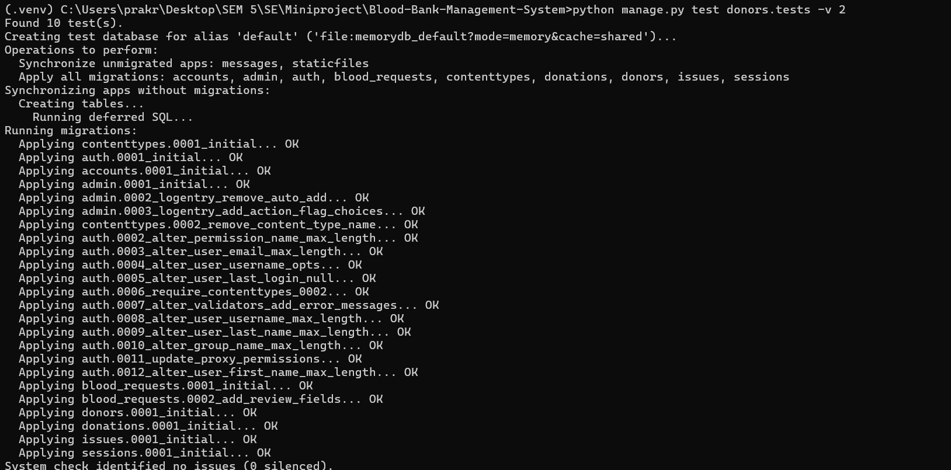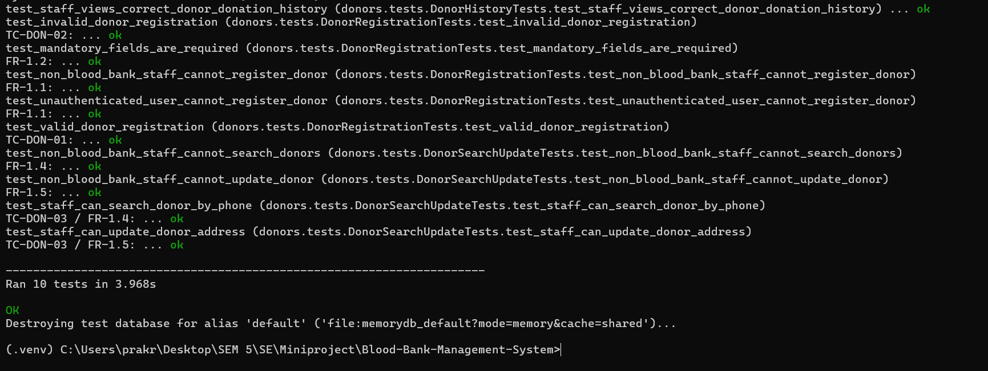
Figure A2. Donation recording - 4 tests passed
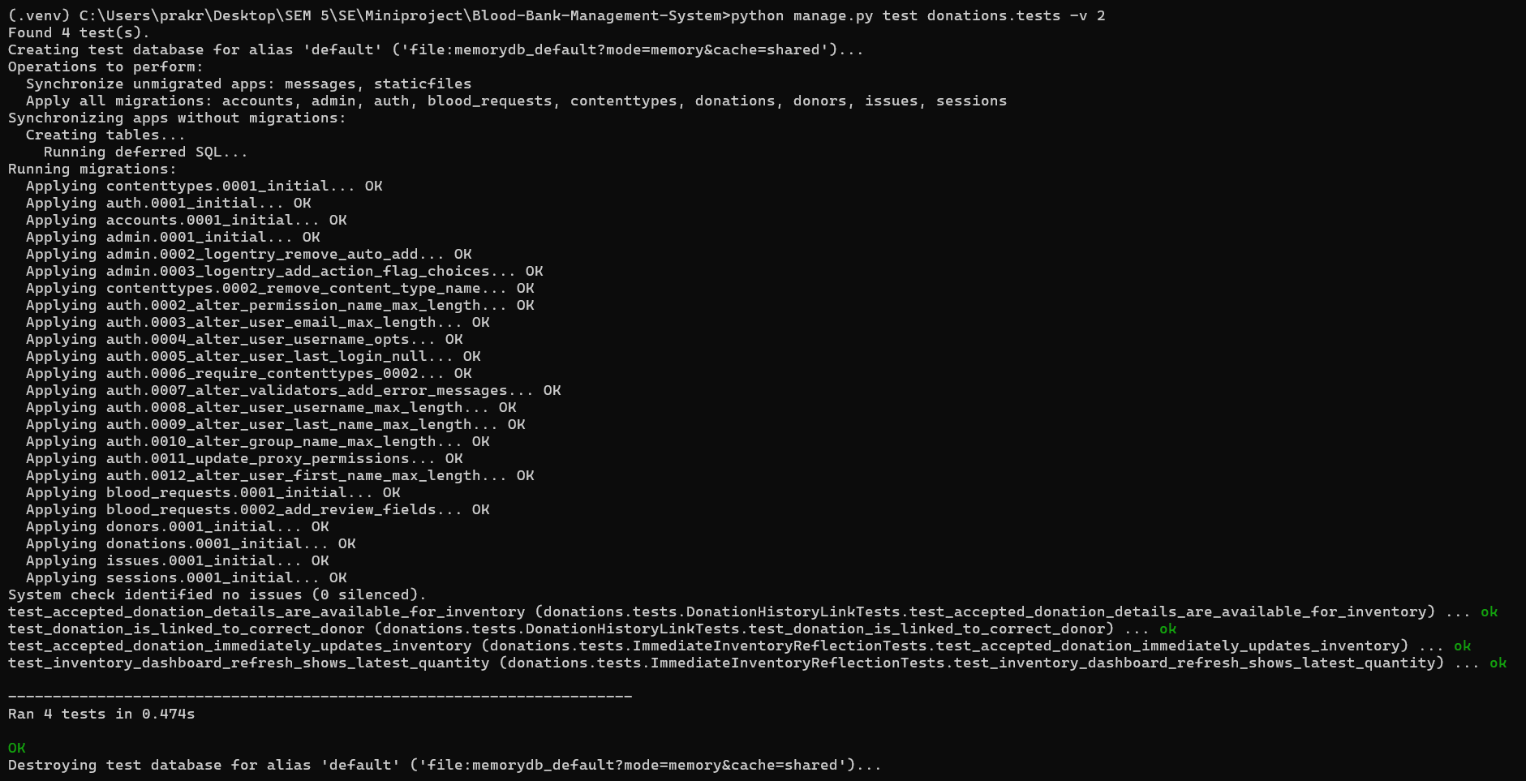
Figure A3. Blood inventory - 5 tests passed
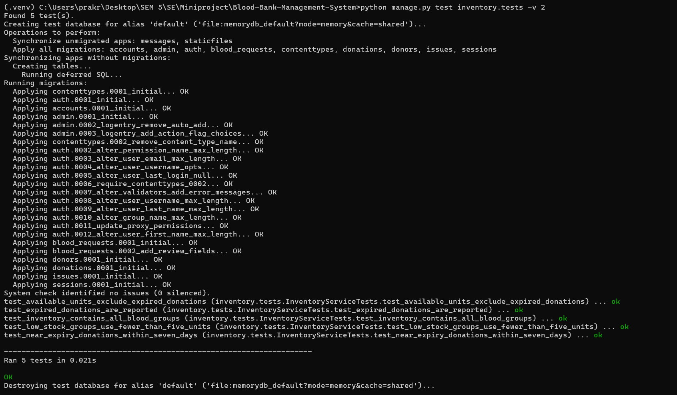
Figure A4. Blood availability search - 10 tests passed
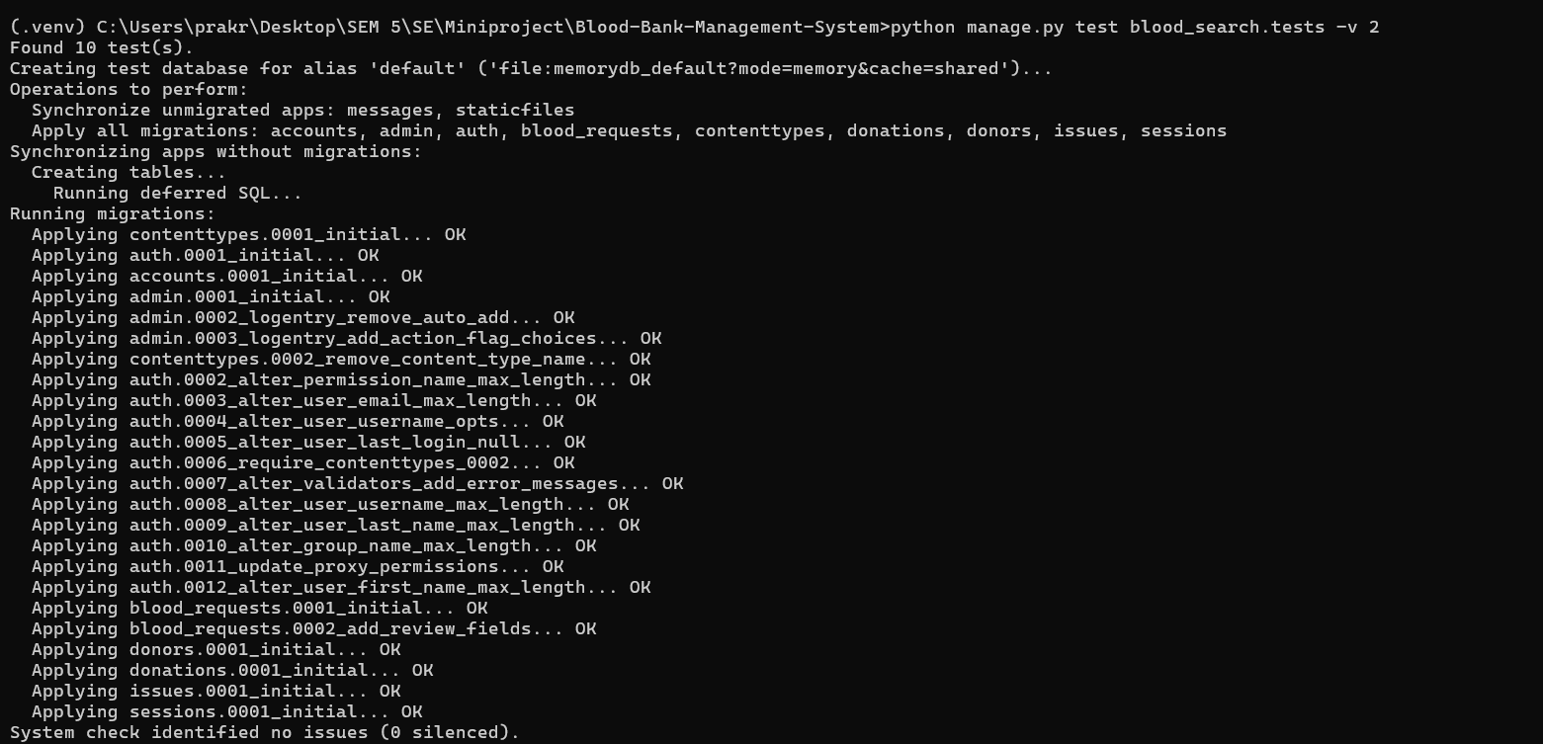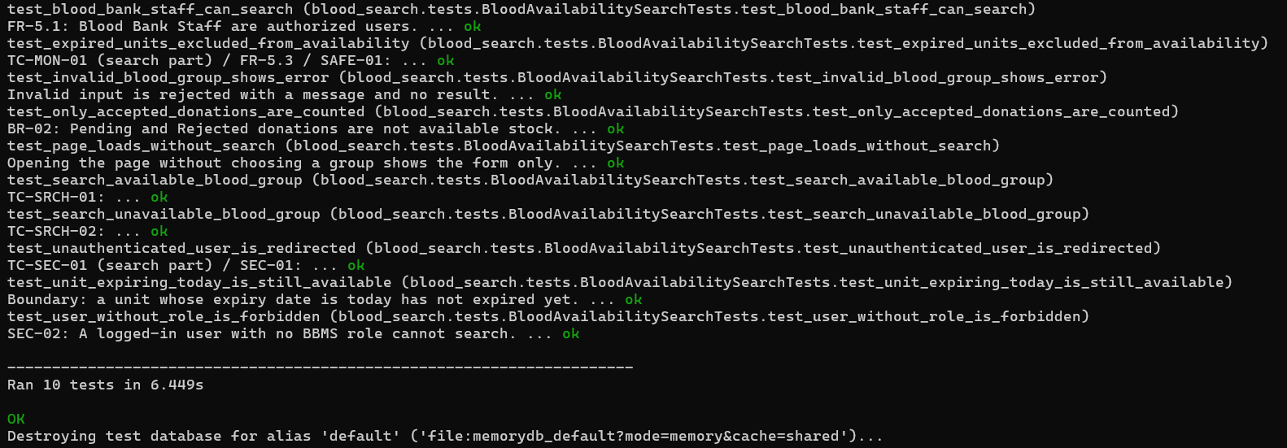
Figure A5. Authentication - 6 tests passed
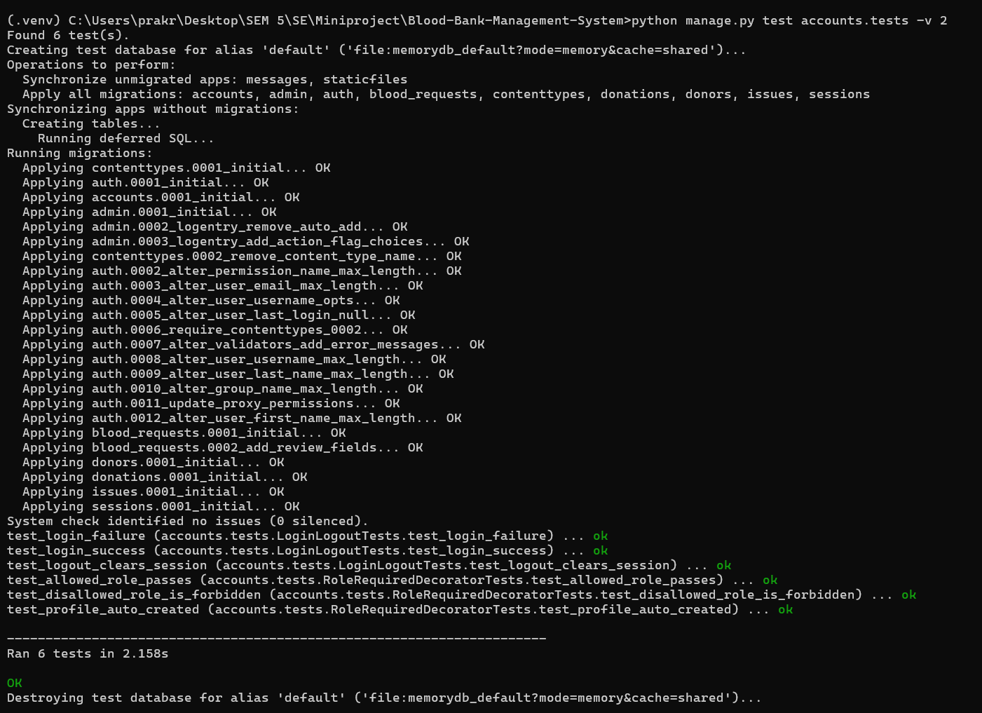
Figure A6. Blood requests - 29 tests passed
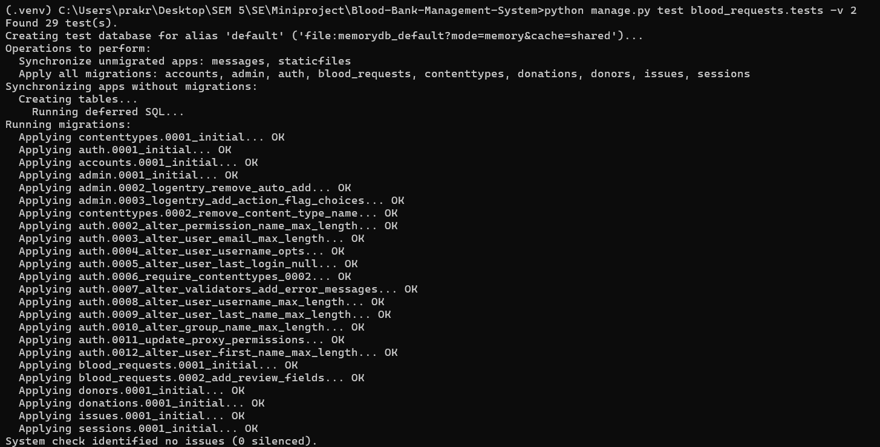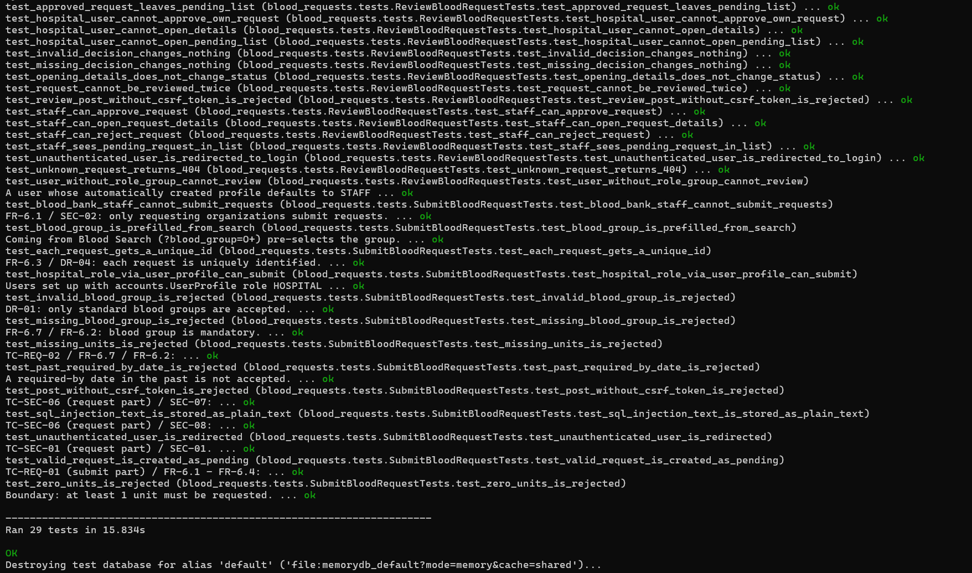
Figure A7. Blood issuance - 39 passed, 1 skipped
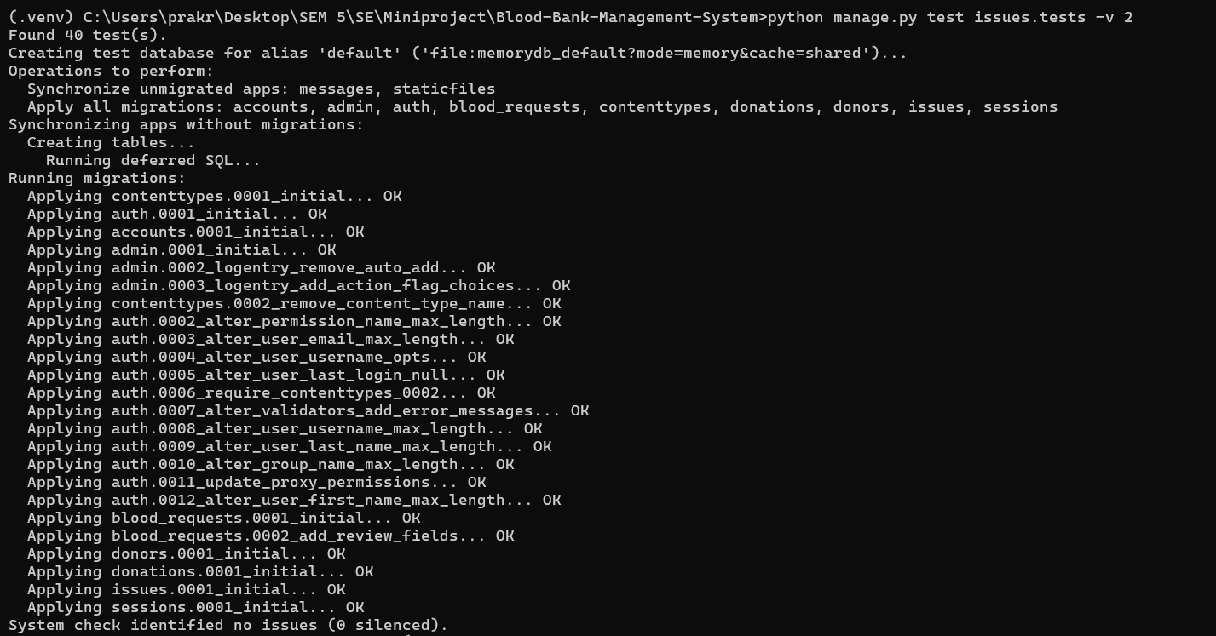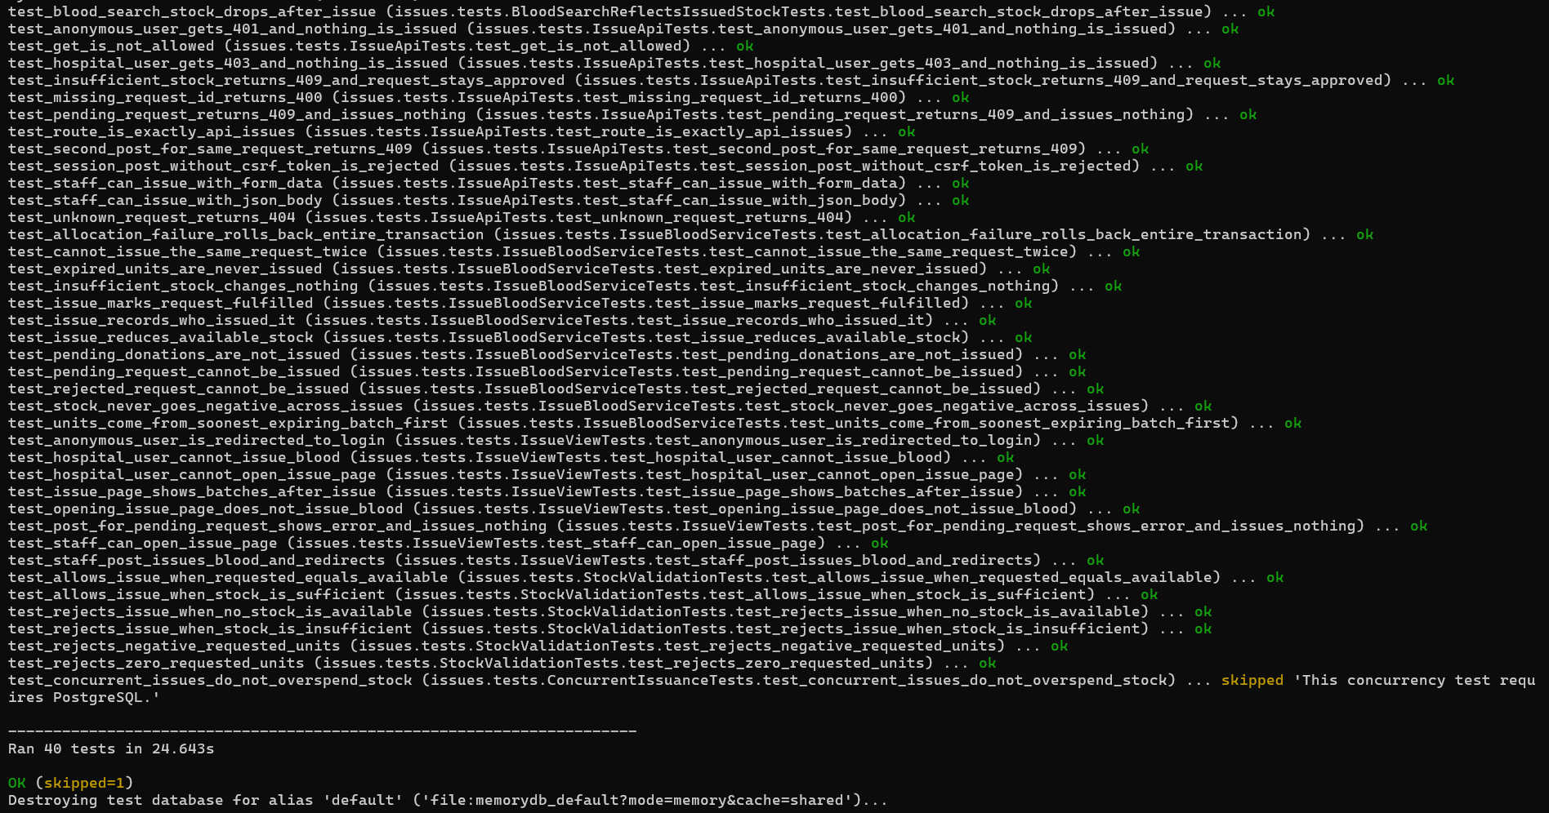
Figure A8. Reports and history - 13 tests passed
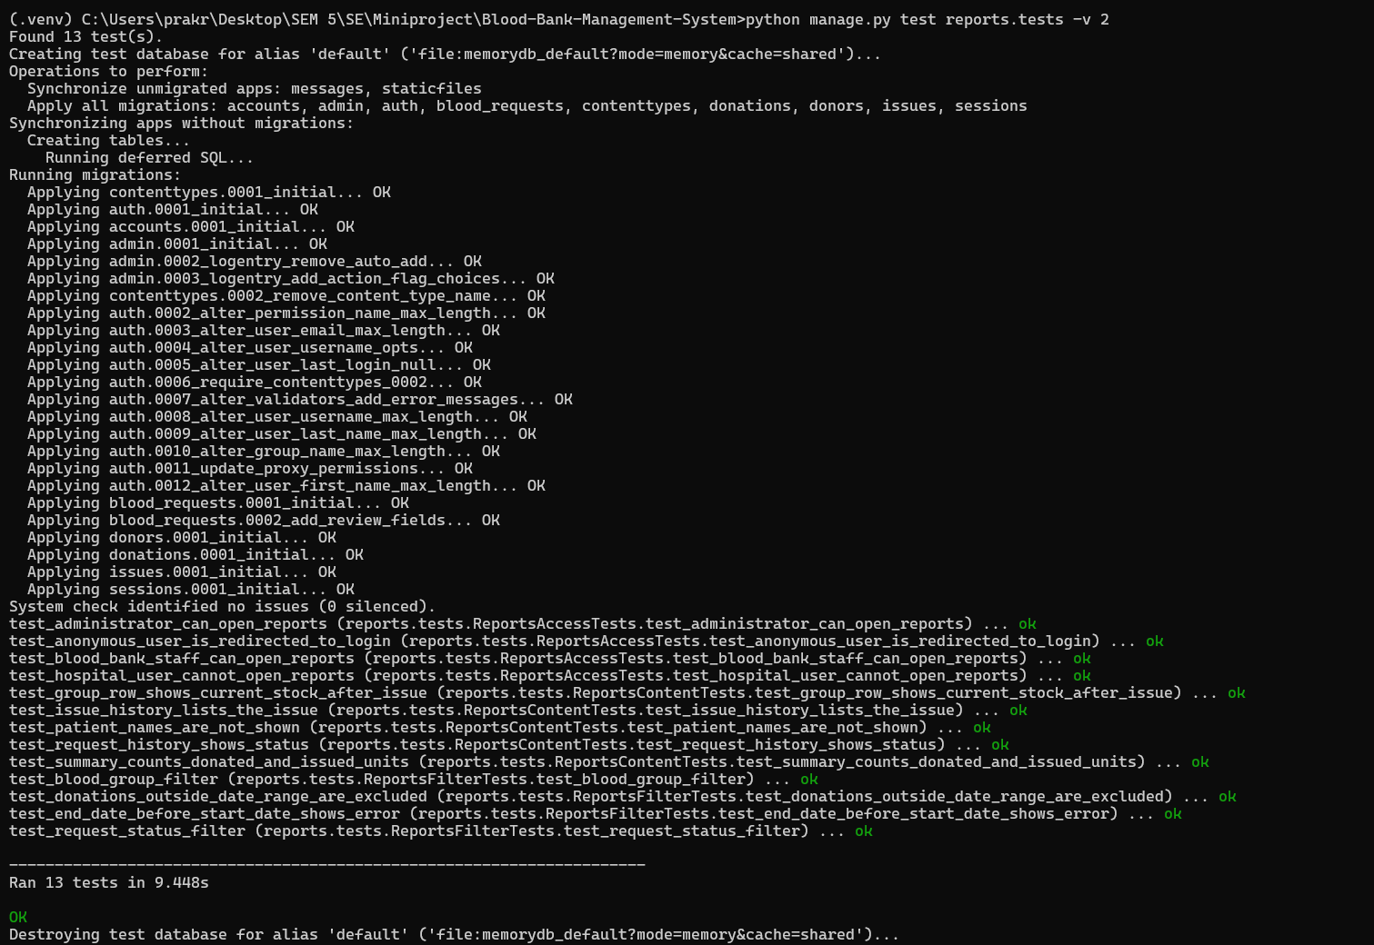
Figure A9. Focused run - 14 tests passed
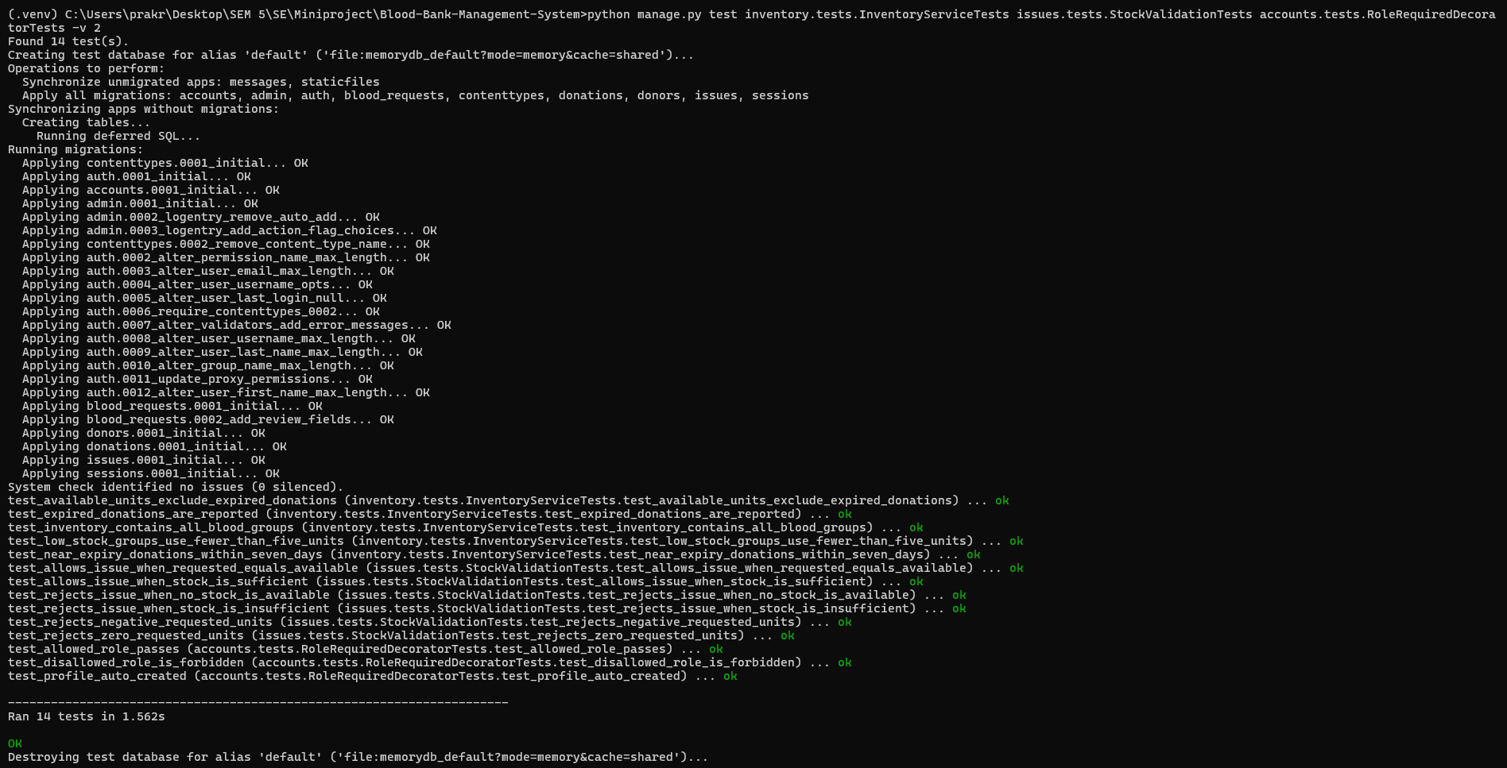
Figure A10. Full-suite run - 129 passed, 2 skipped


