
PES UNIVERSITY, BANGALORE
Department of Computer Science and Engineering
Code Coverage Report
Blood Bank Management System
Version 1.0
Prepared by Team 9 — Purav N Khincha (PES1UG24CS349)
Testing & QA Lead
F-Section, PES University
05/11/2026
Tested commit: 61d576d (main)

Revision History
Version | Date | Details
1.0 | 05/11/2026 | Initial statement coverage report for BBMS at commit 61d576d.

Summary
Item | Result
Tested commit | 61d576d — Merge pull request #50 (E5-S3 reports and history), 01/11/2026
Test run | 131 tests run — 129 passed, 0 failed, 2 skipped (exit code 0)
Overall statement coverage | 89.47% (756 of 845 statements)
Apps meeting the 80% target | 8 of 9
App below target | issues — 69.96%, caused entirely by the performance-data seeding command seed_perf_data.py (0 of 57 statements run). Without that tooling file: 93.98%.

1. Objective and Scope

1.1 Objective
This report measures how much of the BBMS application code is executed by the automated Django test suite, using statement (line) coverage from coverage.py. It checks each Django app against the Software Test Plan target of at least 80% statement coverage per app (STP v1.0, Section 5 Test Levels and Section 14 Test Metrics), and lists the lines that are not executed together with proposed tests.

1.2 Scope
Included: all nine BBMS application packages — accounts, donors, donations, inventory, monitoring, blood_search, blood_requests, issues and reports.
Excluded: database migrations (*/migrations/*), test files (*/tests.py, */test_*.py), the Django project settings package (config), the virtual environment and third-party libraries. Branch (decision) coverage is reported separately in the Branch Coverage Report.

1.3 Reference Documents
- BBMS Software Requirements Specification (SRS), Version 1.0.
- BBMS Software Architecture and Design Specification (SAD), Version 1.0.
- BBMS Software Test Plan (STP), Version 1.0 — Sections 5 and 14 (coverage target and metrics).
- BBMS Unit Test Report, Version 1.0 (same commit 61d576d).
- BBMS source code, Git revision 61d576d4caa3d6fac55a9ccd4205509ae8bfe1cd.

2. Test Environment
Parameter | Details
Operating system | Linux (x86-64), command-line run
Python | 3.13.16 (virtual environment)
Django | 5.2.18
Coverage tool | coverage.py 7.16.2 (C extension)
Test runner | Django test runner (manage.py test), Django TestCase
Database | SQLite test database created and destroyed by Django for the run (USE_SQLITE=True)
Source revision | 61d576d4caa3d6fac55a9ccd4205509ae8bfe1cd (GitHub main)
Run date | 05/11/2026
Settings | DEBUG=False, ALLOWED_HOSTS=127.0.0.1,localhost,testserver, local test secret key

No real donor or patient data was used. Django created a temporary test database, applied all migrations and removed it after the run.

3. Test Method

3.1 Commands
The full automated suite was run under coverage.py with the scope given in Section 1.2, then text, JSON and HTML reports were generated:
python -m coverage erase
python -m coverage run --source=accounts,donors,donations,inventory,monitoring,
blood_search,blood_requests,issues,reports
--omit="*/migrations/*,*/tests.py,*/test_*.py" manage.py test
python -m coverage report -m
python -m coverage json -o Docs/Testing/Evidence/CodeCoverage/statement_coverage.json
python -m coverage html -d htmlcov

Branch tracking was not enabled in this run, so every percentage below is pure statement coverage (no combined statement/branch score).

3.2 Calculation
Statement coverage = covered statements ÷ total executable statements × 100.
Per-app figures were calculated by summing covered_lines and num_statements across every measured file of that app in the coverage JSON, then dividing. Empty __init__.py files contain 0 statements and therefore do not affect the result. A file-level percentage is never used as an app percentage.

3.3 Pass criterion
An app meets the target when its statement coverage is ≥ 80%, as defined in STP Sections 5 and 14.

4. Results

4.1 Test run
The coverage-instrumented run executed 131 tests in 103.0 s — OK (skipped=2). No test failed. The two skipped tests are the PostgreSQL-only concurrent-issue test and the browser portability test (needs BROWSER_TESTS and Playwright); this matches the Unit Test Report for the same commit.

4.2 Statement coverage by Django app
Django app | Covered | Total | Missed | Statement % | vs. 80% target
accounts | 48 | 50 | 2 | 96.00% | Meets
donors | 96 | 98 | 2 | 97.96% | Meets
donations | 75 | 85 | 10 | 88.24% | Meets
inventory | 49 | 51 | 2 | 96.08% | Meets
monitoring | 6 | 7 | 1 | 85.71% | Meets
blood_search | 38 | 39 | 1 | 97.44% | Meets
blood_requests | 187 | 191 | 4 | 97.91% | Meets
issues | 156 | 223 | 67 | 69.96% | Below target
reports | 101 | 101 | 0 | 100.00% | Meets
Total (all 9 apps) | 756 | 845 | 89 | 89.47% | —

Overall: 756 of 845 statements executed — 89.47%. 8 of 9 apps meet the 80% target. The issues app is below target only because of one tooling file (Section 5.1).

4.3 Files with missed statements
All other measured application files reached 100% statement coverage. The table lists every file with at least one missed statement, the exact line numbers and what that code does.
File | Stmt % | Missing lines | What the missed code is
accounts/models.py | 91% | 29 | UserProfile.__str__ (display text)
accounts/views.py | 0% | All (1) | Default placeholder import; app has no view code
blood_requests/models.py | 97% | 112 | BloodRequest.__str__ (display text)
blood_requests/permissions.py | 88% | 23, 26, 62 | user_has_role(): anonymous and superuser shortcuts; can_review_request(): anonymous shortcut
blood_search/views.py | 96% | 24 | Superuser shortcut in can_search_availability()
donations/forms.py | 93% | 39 | Error when expiry date is before donation date
donations/models.py | 93% | 25, 72 | Future donation-date validator; Donation.__str__
donations/views.py | 77% | 27, 53, 55–56, 58, 60–61 | 403 for non-staff; loop that turns form errors into messages
donors/models.py | 97% | 78 | Donor.__str__ (display text)
donors/views.py | 98% | 95 | 403 when non-staff opens donor history
inventory/services.py | 96% | 29 | Invalid blood group returns 0 units
inventory/views.py | 92% | 26 | 403 for users with no BBMS role
issues/admin.py | 78% | 12, 15, 46, 49, 52 | Read-only admin: block add/change/delete of issue records
issues/issuance.py | 97% | 108 | Defensive break when the remaining need is already 0
issues/management/commands/seed_perf_data.py | 0% | All 57 (1–182) | Whole file — performance-test data seeding command, never run by tests
issues/models.py | 93% | 67, 95 | BloodIssue / allocation __str__ (display text)
issues/views.py | 96% | 71–72 | Malformed JSON body in POST /api/issues
monitoring/views.py | 0% | All (1) | Default placeholder import; app has no view code

5. Findings and Gaps

5.1 App below target: issues (69.96%)
issues/management/commands/seed_perf_data.py contributes 57 of the 67 missed statements in the issues app. It is a developer tool that generates bulk synthetic data (performance/perf_config.json) for the Locust load test (TC-PERF-01, 20-user part); it is not part of any user-facing workflow and no automated test calls it.
Excluding this file, the issues app's application code is at 93.98% (156 of 166), and the overall figure would be 95.94%. Both numbers are given for transparency; the official measured value in this report remains 69.96%, because the file is inside the agreed measurement scope.
Recommended action (either):
- Add one smoke test that runs call_command("seed_perf_data", ...) with a very small data size and checks the created records and config file, or
- Agree as a team to classify management commands used only for load-test setup as tooling and add them to the coverage omit list, recording the decision in the Test Plan.

5.2 Untested negative paths
Gap | Where | Proposed additional test
Non-staff user records a donation (403) | donations/views.py:27 | POST /api/donations as Hospital Staff → expect 403 and no Donation created (TC-SEC-02)
Invalid donation submitted through the view shows error messages | donations/views.py:53–61 | POST with units = 0 through the view → expect error message and no record (TC-DNT-02)
Expiry date earlier than donation date | donations/forms.py:39 | Form with expiry < donation date → expect error on expiry_date
Donation date in the future (model validator) | donations/models.py:25 | Call full_clean() on a Donation dated tomorrow → expect ValidationError
Non-staff user opens donor history (403) | donors/views.py:95 | GET /api/donors/<id> as Hospital Staff → expect 403
User without a BBMS role opens inventory (403) | inventory/views.py:26 | GET /inventory/ as a user with no group → expect 403
Invalid blood group passed to availability service | inventory/services.py:29 | get_available_units("XYZ") → expect 0
Malformed JSON body sent to issue API | issues/views.py:71–72 | POST /api/issues with body "{bad" → expect 400-style error, no stock change
Superuser / anonymous shortcuts in role helpers | blood_requests/permissions.py:23, 26, 62; blood_search/views.py:24 | Direct unit tests of user_has_role(), can_review_request() and can_search_availability() for anonymous and superuser users

5.3 Low-risk uncovered code
- `__str__` methods — accounts/models.py:29, blood_requests/models.py:112, donations/models.py:72, donors/models.py:78, issues/models.py:67, 95. Only used for display in the admin; one assertEqual(str(obj), ...) per model would cover them.
- Read-only admin permissions — issues/admin.py:12, 15, 46, 49, 52. These block add/change/delete of issue records in the Django admin. A small admin test as a superuser would confirm the audit trail cannot be edited.
- Defensive `break` — issues/issuance.py:108. Reached only when the allocation plan contains more batches than needed; a test with three small batches for a two-unit issue would execute it.
- Empty placeholder views — accounts/views.py and monitoring/views.py contain only the default Django import line (no view code). Monitoring is implemented in the inventory app's services and dashboard.

5.4 Limitations
- Coverage was measured on the SQLite test database. The PostgreSQL-only concurrent-issue test was skipped, so any code that runs only under PostgreSQL row locking is not reflected.
- The browser portability test was skipped in this run; the views it drives are already covered by Django test-client tests.
- Statement coverage shows which lines ran, not that every decision outcome was checked; see the Branch Coverage Report.

5.5 STP exit criterion — code coverage
Criterion (STP Section 14) | Status | Evidence
Statement coverage ≥ 80% per Django app | Partially met — 8 of 9 apps | Section 4.2; statement_coverage.json
issues app ≥ 80% | Not met (69.96%) — 93.98% excluding tooling file | Section 5.1

6. Conclusion
At commit 61d576d, the automated suite (131 tests, 0 failures, 2 environment-related skips) executes 89.47% of BBMS application statements. Eight of the nine apps meet the Test Plan's 80% statement coverage target, with reports, blood_requests, donors, blood_search, accounts and inventory all above 96%.
The issues app is measured at 69.96%, below target, because its performance-data seeding command is never run by the tests; its user-facing issue workflow code is above 93%. Adding one smoke test for that command, plus the negative-path tests in Section 5.2, would bring every app above 80% and close the remaining permission-denied and invalid-input gaps.

Appendix A. Coverage Terminal Report
Output of python -m coverage report -m for the run described in this report (saved as Evidence/CodeCoverage/statement_summary.txt).
Name Stmts Miss Cover Missing
----------------------------------------------------------------------------
accounts/__init__.py 0 0 100%
accounts/admin.py 6 0 100%
accounts/apps.py 6 0 100%
accounts/decorators.py 14 0 100%
accounts/models.py 11 1 91% 29
accounts/signals.py 8 0 100%
accounts/urls.py 4 0 100%
accounts/views.py 1 1 0% 1
blood_requests/__init__.py 0 0 100%
blood_requests/admin.py 8 0 100%
blood_requests/apps.py 4 0 100%
blood_requests/forms.py 24 0 100%
blood_requests/models.py 33 1 97% 112
blood_requests/permissions.py 24 3 88% 23, 26, 62
blood_requests/services.py 12 0 100%
blood_requests/urls.py 4 0 100%
blood_requests/views.py 82 0 100%
blood_search/__init__.py 0 0 100%
blood_search/admin.py 1 0 100%
blood_search/apps.py 4 0 100%
blood_search/models.py 1 0 100%
blood_search/services.py 6 0 100%
blood_search/urls.py 4 0 100%
blood_search/views.py 23 1 96% 24
donations/__init__.py 0 0 100%
donations/admin.py 1 0 100%
donations/apps.py 4 0 100%
donations/forms.py 15 1 93% 39
donations/models.py 30 2 93% 25, 72
donations/urls.py 4 0 100%
donations/views.py 31 7 77% 27, 53-61
donors/__init__.py 0 0 100%
donors/admin.py 1 0 100%
donors/apps.py 4 0 100%
donors/forms.py 10 0 100%
donors/models.py 30 1 97% 78
donors/urls.py 4 0 100%
donors/views.py 49 1 98% 95
inventory/__init__.py 0 0 100%
inventory/admin.py 1 0 100%
inventory/apps.py 4 0 100%
inventory/models.py 1 0 100%
inventory/services.py 28 1 96% 29
inventory/urls.py 4 0 100%
inventory/views.py 13 1 92% 26
issues/__init__.py 0 0 100%
issues/admin.py 23 5 78% 12, 15, 46, 49, 52
issues/apps.py 4 0 100%
issues/issuance.py 39 1 97% 108
issues/management/__init__.py 0 0 100%
issues/management/commands/__init__.py 0 0 100%
issues/management/commands/seed_perf_data.py 57 57 0% 1-182
issues/models.py 28 2 93% 67, 95
issues/permissions.py 3 0 100%
issues/services.py 9 0 100%
issues/urls.py 4 0 100%
issues/views.py 56 2 96% 71-72
monitoring/__init__.py 0 0 100%
monitoring/admin.py 1 0 100%
monitoring/apps.py 4 0 100%
monitoring/models.py 1 0 100%
monitoring/views.py 1 1 0% 1
reports/__init__.py 0 0 100%
reports/admin.py 1 0 100%
reports/apps.py 4 0 100%
reports/forms.py 21 0 100%
reports/models.py 1 0 100%
reports/permissions.py 3 0 100%
reports/services.py 39 0 100%
reports/urls.py 4 0 100%
reports/views.py 28 0 100%
----------------------------------------------------------------------------
TOTAL 845 89 89%

Appendix B. HTML Coverage Report Screenshots
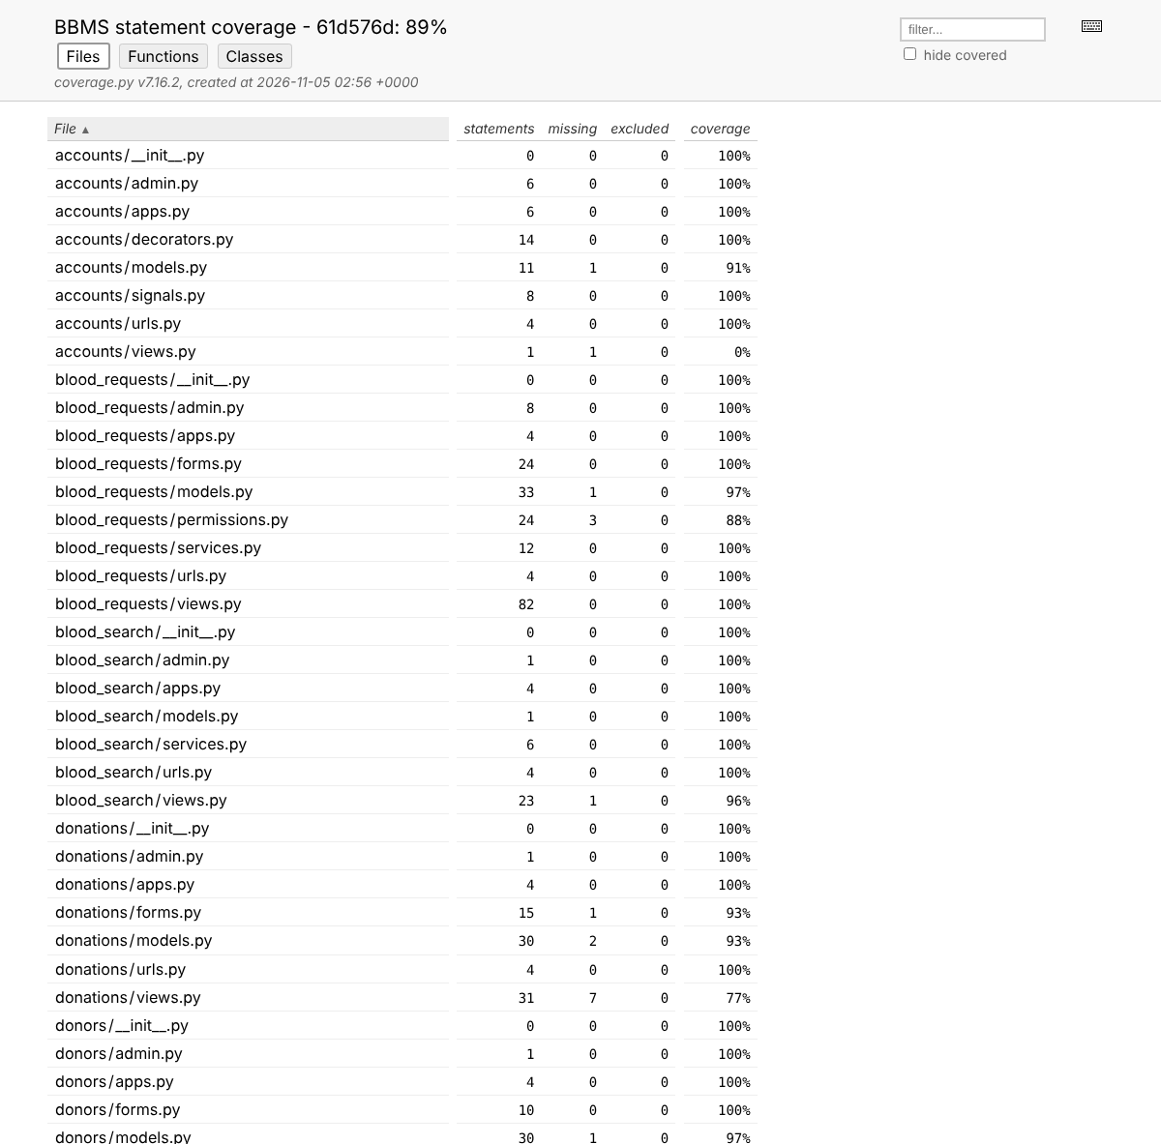
Figure B1. coverage.py HTML index — files A to I
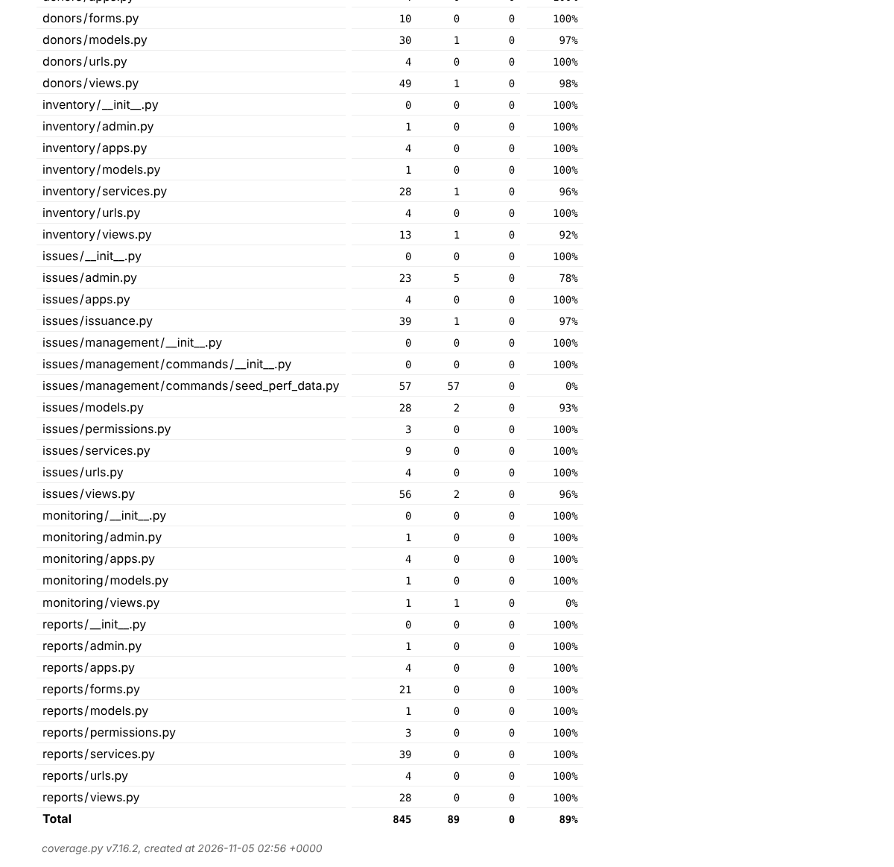
Figure B2. coverage.py HTML index — files I to Z and total
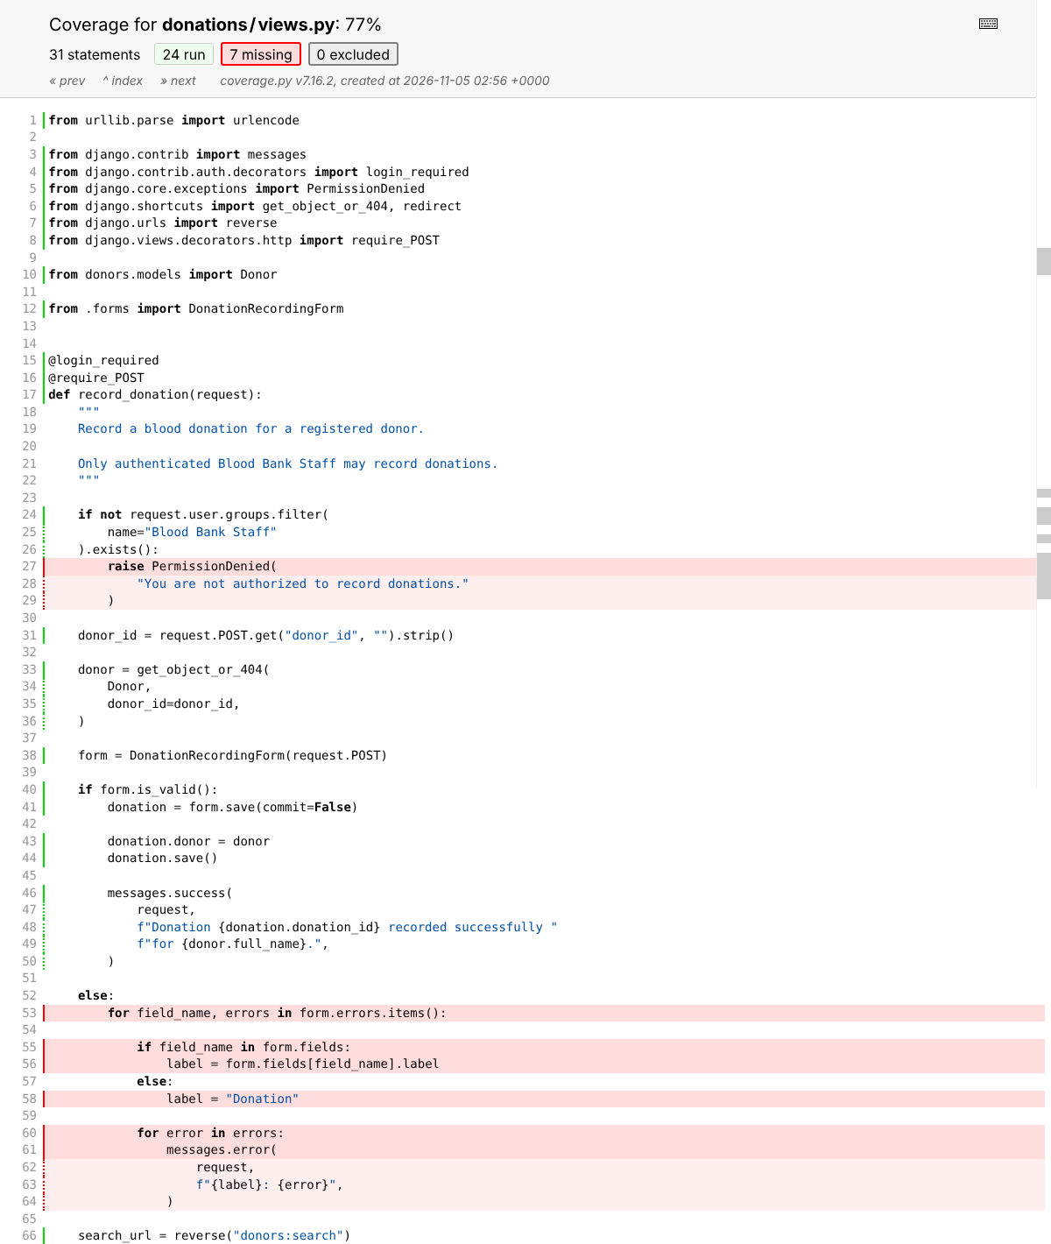
Figure B3. donations/views.py — missed lines highlighted in red (permission denied and form-error branch)
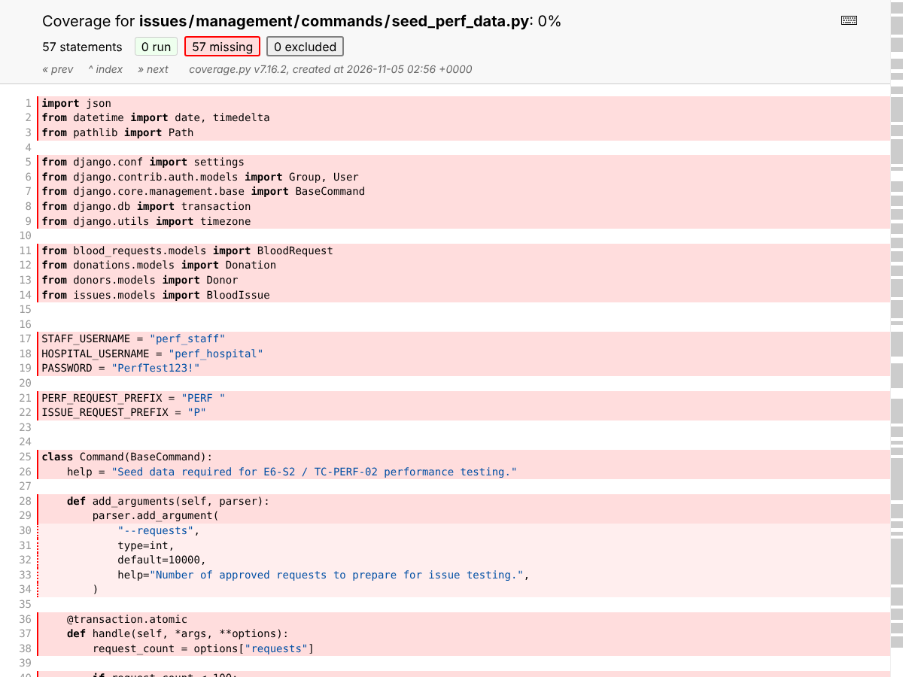
Figure B4. issues/management/commands/seed_perf_data.py — not executed by the test suite

Appendix C. Evidence Files
File (Docs/Testing/Evidence/CodeCoverage/) | Contents
statement_summary.txt | Terminal coverage report with missing line numbers
statement_coverage.json | Machine-readable coverage data (per-file covered/missing lines and totals)
B1_coverage_index.png | Screenshot of the HTML report index
B2_donations_views.png | Screenshot of donations/views.py coverage view
B3_seed_perf_data.png | Screenshot of seed_perf_data.py coverage view

The full HTML report (htmlcov/) is not committed because it is generated output and is listed in .gitignore; it can be regenerated with the commands in Section 3.1.

