Software Architecture and Design Specification
Blood Bank Management System (BBMS)

Version 2.0
Document Date: 03-11-2026

PES University
Team 1 -- Blood Bank Management System

Team Members
PES2UG24CS314 -- Nidhi Karkada
PES2UG24CS361 -- Pramay Dubey
PES2UG24CS343 -- Pavan E Naik
PES2UG24CS326 -- Nishit Suresh

Table of Contents
Right-click and choose "Update Field" (or press F9) in Microsoft Word to generate the Table of Contents.

Revision History
Version | Date | Author(s) | Description of Changes
1.0 | Original submission date | Nidhi Karkada, Pramay Dubey, Pavan E Naik, Nishit Suresh | Original SAD. Described a component diagram and technology stack referencing Node.js for "supporting backend services" and assumed a relational DBMS such as MySQL; described a REST-style API design (Section 4.3).
2.0 | 03-11-2026 | Nidhi Karkada, Pramay Dubey, Pavan E Naik, Nishit Suresh | Reconciled against the final implemented Django application. Corrects the Node.js and MySQL assumptions, replaces the REST-API interface design with the actual Django URL-routed view design, adds the final component/sequence/ER diagrams, and documents the real security, database-integrity and theming architecture, all verified by direct code inspection.

Approvals
Name | Role | Signature | Date
Nidhi Karkada | Student Author
Pramay Dubey | Student Author
Pavan E Naik | Student Author
Nishit Suresh | Student Author
Course Coordinator / Reviewer | Reviewer | -- | --

1. Introduction

1.1 Purpose
This document is Version 2.0 of the Software Architecture and Design Specification (SAD) for the Blood Bank Management System (BBMS). It describes the architecture and detailed design of the system as it is actually implemented and tested, superseding Version 1.0's planned architecture where the two differ, and preserving Version 1.0's IEEE-style organization and intent.

1.2 Scope
This document covers the system's architecture (goals, constraints, component structure, technology stack, data stores, security architecture, database architecture, and UI/theming architecture) and detailed design (URL/interface design, error handling, UX design, deployment architecture, and known limitations), for the final Django application delivered by Team 1.

1.3 References
- Software Requirements Specification (SRS) -- Blood Bank Management System, Version 2.0 (BBMS_SRS_V2.docx).
- Software Test Plan -- Blood Bank Management System, Version 2.0 (BBMS_TEST_PLAN_V2.docx).
- The final project codebase (BBMS_FINAL_COMPLETE_PROJECT).

2. Document Overview
Section 3 describes the system's architecture: its goals and constraints, stakeholders, the updated component diagram, component descriptions, the chosen architecture pattern, the actual technology stack, risks, requirement traceability, security architecture, database architecture, and UI/theme management. Section 4 covers detailed design: the UML sequence diagrams, the actual URL/interface design, error handling and logging, UX design, deployment architecture, and limitations/future enhancements. Section 5 holds appendices (glossary, references, tools). Section 6 restates the Division of Work.

3. Architecture

3.1 Goals and Constraints

Goals
- A single, consistent source of truth for blood inventory, updated atomically by every module that changes stock.
- Clear role-based separation between donor, staff and administrator capabilities, enforced server-side on every view, not only hidden from navigation.
- A complete, append-only audit trail of state-changing actions.
- A simple, maintainable Django MVT structure with one app per functional area, suitable for a college mini-project team of four.

Constraints
- No separate backend service or REST API layer (see Section 3.6 for why this corrects Version 1.0).
- No JavaScript framework; vanilla JS only, used solely for the theme switcher.
- No OAuth/JWT/MFA/cloud security services -- Django's own session authentication only.
- SQLite as the only configured database (see Section 3.6).

3.2 Stakeholders and Concerns
Stakeholder | Primary concern
Donor | Simple registration, accurate own-history visibility, no exposure of other donors' data.
Requester | Easy request submission and status tracking without requiring an account.
Staff | Accurate, consistent inventory; a clear approval/issue workflow; audit accountability.
Administrator | Safe user/role management with no risk of locking out all administrators.
Course evaluator | A defensible, honestly documented system matching what the code actually does.

3.3 Updated UML Component Diagram
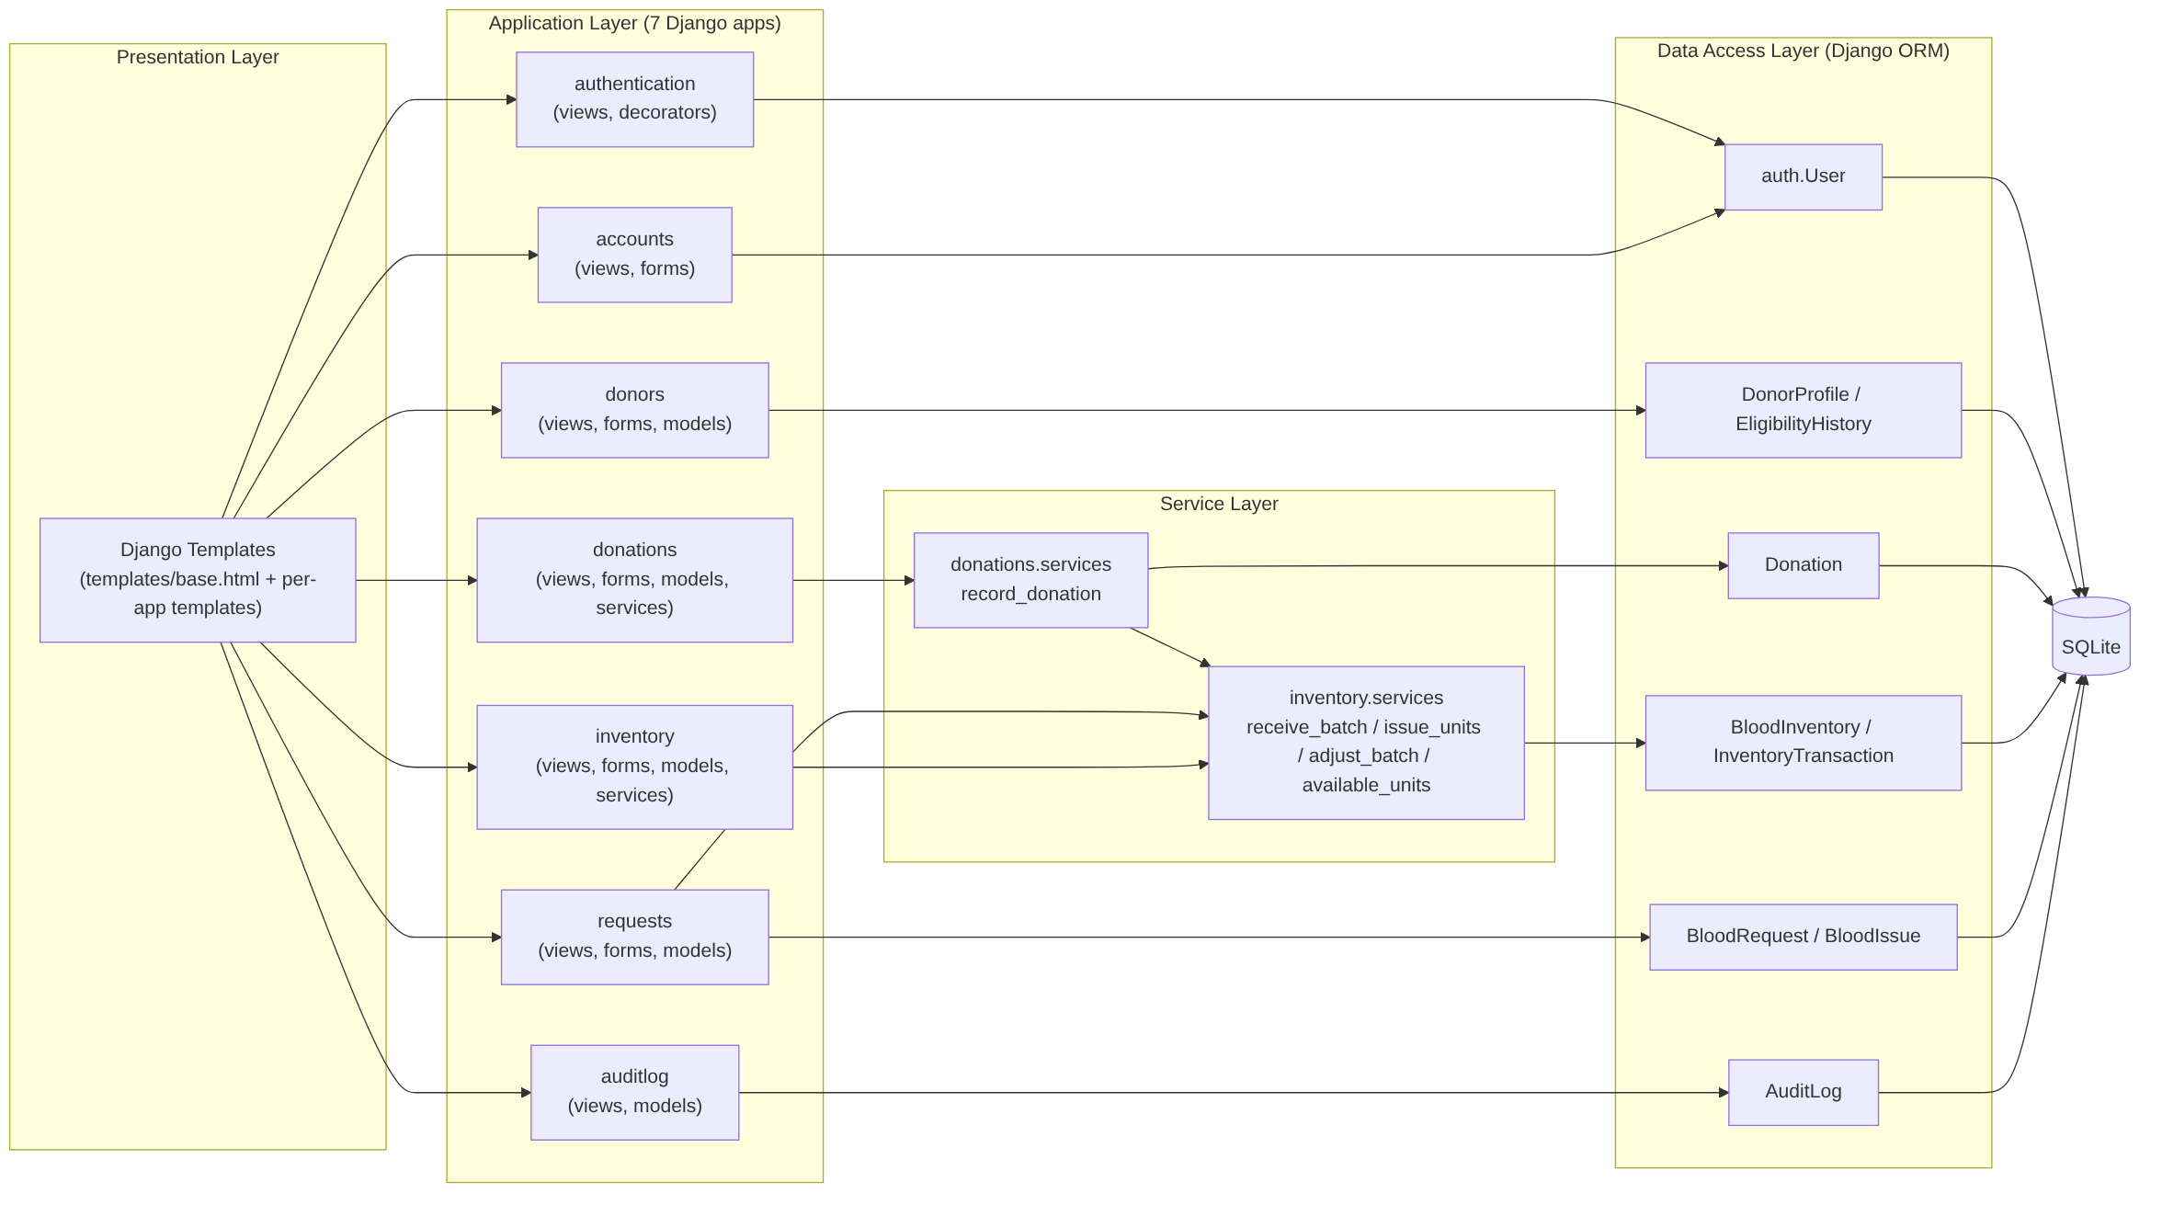
Figure 1 -- UML component diagram of the final system: presentation, application (7 apps), service and data-access layers.
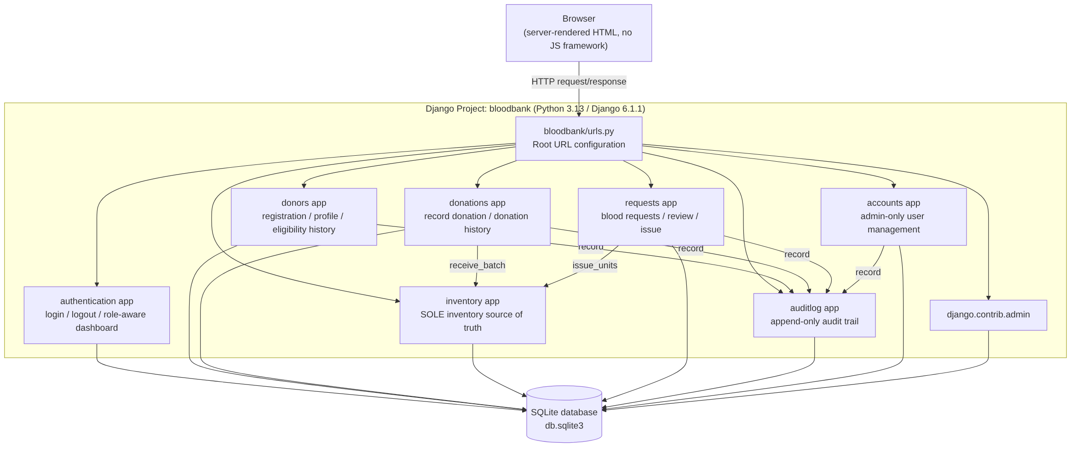
Figure 2 -- System architecture diagram: Django project, its seven installed apps, and the single SQLite database.

3.4 Component Descriptions
Component (Django app) | Responsibility | Key design points
authentication | Session login/logout and the role-aware dashboard. | No model of its own -- uses Django's built-in auth.User. Views: LoginView (accepts username or e-mail), home (branches by role). Decorators: staff_required, admin_required -- the single RBAC enforcement point every other app's staff/admin views use.
donors | Donor self-registration, self-service profile, staff donor directory and eligibility workflow. | Models: DonorProfile, EligibilityHistory. set_eligibility() is one atomic transaction updating the summary fields, writing a history row, and writing an audit entry.
donations | Staff recording of blood donations; donor/staff donation history. | Model: Donation, with a unique collection_reference as the duplicate-submission guard. Service: record_donation() -- atomic; credits inventory and audit-logs only on a RECORDED outcome.
inventory | The system's single source of truth for blood stock. | Models: BloodInventory (per-batch), InventoryTransaction (append-only ledger). Services: available_units(), receive_batch(), issue_units() (FIFO by expiry, select_for_update), adjust_batch().
requests | Blood request submission, staff review, blood issue/distribution. | Models: BloodRequest (UUID tracking_id), BloodIssue. issue_blood calls inventory.services.issue_units() and guards against a second issue against the same request.
auditlog | The single append-only audit trail every other app writes to. | Model: AuditLog, 14 action types. record() is a module-level function, not a model method, so every app writes through one code path. Registered read-only in the admin site.
accounts | Administrator-only CRUD on user accounts and roles. | No new models -- operates on auth.User. Forms translate a validated role field into is_staff/is_superuser; never reads those fields directly from POST data.

3.5 Chosen Architecture Pattern and Rationale
The system uses Django's Model-View-Template (MVT) pattern throughout, with one addition over a bare MVT split: a thin service layer (inventory/services.py, donations/services.py) for operations that must touch more than one table atomically (crediting inventory from a donation; debiting inventory on issue). Views call services or the ORM directly and render a template; there is no repository/DAO layer, no separate REST API, and no SPA frontend. This pattern was chosen because it matches Django's own idioms directly, needs no additional framework or build tooling, and keeps the codebase small enough for a four-person team to maintain within a single academic term, while the service layer still gives the one genuine cross-cutting concern (atomic multi-table writes) a single, testable home instead of duplicating transaction logic across views.

3.6 Actual Technology Stack and Data Stores
Layer | Version 1.0 (original) | Final implementation (verified)
Backend language/framework | Python (Django) | Python 3.13, Django 6.1.1 -- unchanged
Supporting backend service | JavaScript (Node.js) | Does not exist. No separate service of any kind; requirements.txt lists only asgiref, Django, sqlparse, tzdata.
Database | Relational DBMS (e.g. MySQL) | SQLite (django.db.backends.sqlite3) -- the project's only configured database, in bloodbank/settings.py.
Frontend | Not fully specified | Server-rendered Django templates; vanilla CSS and JavaScript (theme switcher only); no frontend framework or build step.
Authentication | Not fully specified | Django's built-in session authentication (django.contrib.auth, django.contrib.sessions); no OAuth/JWT/MFA.
This correction is the most important architectural reconciliation in this document: Version 1.0's title page and SAD both referenced Node.js and assumed MySQL. Neither exists anywhere in the delivered codebase, confirmed by inspecting requirements.txt, the full project directory tree, and bloodbank/settings.py directly.

3.7 Risks and Mitigations
Risk | Impact | Mitigation (as actually applied)
Two independent inventory models could silently disagree. | High -- would have caused donor-visible stock counts to differ from what staff could actually issue. | Resolved before Donation Management was built: the duplicate requests.BloodInventory model was removed, with a data migration that converts any existing aggregate rows into the unified inventory.BloodInventory batch table.
A management command could import a model removed earlier in development and fail at the one path no automated test exercises. | High -- the documented demo-readiness defect (DEFECT-04). | Found and fixed during final verification; the seed command now goes through the same service layer the real views use, so it is exercised the same way production code paths are.
A merge could silently drop a security setting. | Medium -- occurred once in this project's history (HTTPS settings briefly lost from main). | Found by diffing the pre-merge and merge commits directly, and restored; documented as a process lesson for future merges.
Limited team time across four members with other coursework. | Medium | Modules kept small and independently testable per app, so partial progress on one module does not block the others.

3.8 Updated Requirement Traceability
See BBMS_SRS_V2.docx Section 8 for the full Requirements Traceability Matrix connecting every requirement to its design component and test evidence; it is not duplicated here to avoid maintaining two copies of the same table. The summary below maps each architectural component to the requirement groups it satisfies.
Component | Requirement groups satisfied
authentication | BBMS-F-001, BBMS-F-002, BBMS-SR-001, BBMS-SR-004
donors | BBMS-F-003 to BBMS-F-006, BBMS-SR-002
donations | BBMS-F-007 to BBMS-F-009
inventory | BBMS-F-010 to BBMS-F-013, BBMS-F-022, BBMS-NF-005
requests | BBMS-F-014 to BBMS-F-019
accounts | BBMS-F-020, BBMS-SR-002
auditlog | BBMS-SR-005

3.9 Security Architecture
No OAuth, JWT, multi-factor authentication, cloud security service, or enterprise security tooling is used anywhere in this project -- unchanged from Version 1.0's own stated scope.
Control | Implementation
Authentication | Django's built-in session authentication (django.contrib.auth/sessions). No custom token or JWT handling anywhere.
Role-based access control | Two decorators: staff_required (checks is_staff) and admin_required (checks is_superuser, used only by accounts). Every staff/admin-only view across every app applies one of these server-side -- navigation hiding a link is a convenience only, never the real access control.
CSRF protection | Django's CsrfViewMiddleware, on by default and never disabled (no csrf_exempt anywhere in the project); {% csrf_token %} present in every form template.
IDOR prevention (authenticated users) | donors.views.profile and donations.views.my_donation_history never accept an ID from the URL at all -- they always resolve to request.user's own record. This is a structural defense, not a permission check that could be forgotten.
IDOR / bearer-link model (anonymous requesters) | requests.models.BloodRequest.tracking_id is a UUID, not the row's integer primary key. Anyone holding the link can view that request -- a deliberate bearer-token trust model for an un-authenticated requester role, not an authentication-equivalent control. Documented explicitly as a limitation, not claimed as login-equivalent security.
Privilege escalation prevention | Role is only ever set through accounts.forms.AdminUserCreateForm's validated role ChoiceField or RoleChangeForm, both reachable only via admin_required views. No code path reads is_staff/is_superuser directly from request data.
Self-lockout prevention | accounts.views._active_superuser_count() blocks any role change or deactivation that would leave zero active superusers.
Password storage | Django's default password hashing; verified in tests that the stored value is not plaintext.
Audit logging | auditlog.models.record(), a single module-level function called by every state-changing operation across donors, donations, inventory, requests and accounts -- 14 distinct action types.
HTTPS | Settings exist (SECURE_SSL_REDIRECT, SESSION_COOKIE_SECURE, CSRF_COOKIE_SECURE, HSTS), gated on DEBUG. No-ops in local development; no deployment in this project serves HTTPS. A genuine, documented open item, not claimed as resolved.

3.10 Database Architecture and Data Integrity
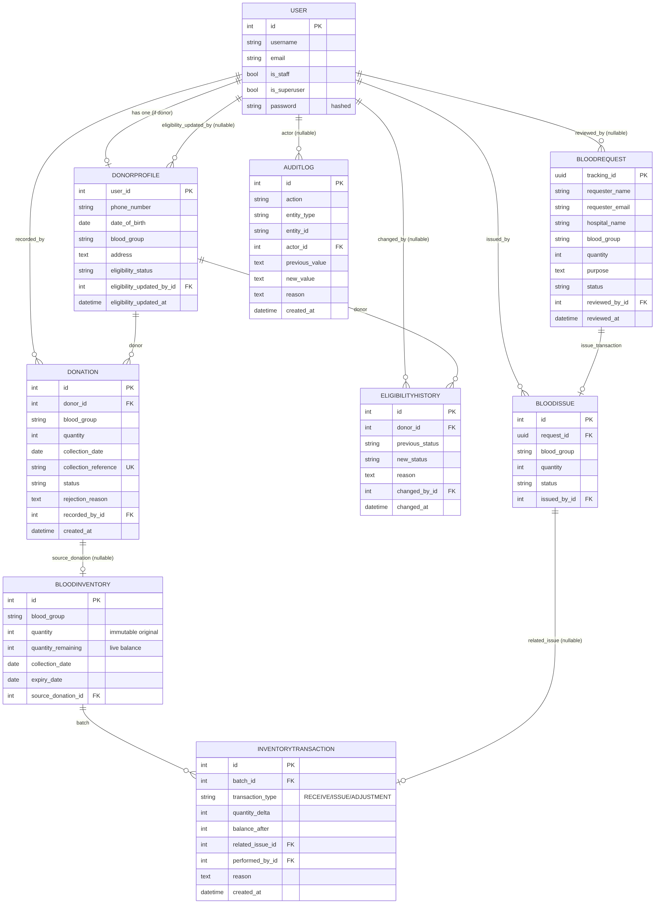
Figure 3 -- Entity-relationship diagram of the final system.
inventory.BloodInventory is the single source of truth for blood stock, read and written exclusively through inventory/services.py. Every stock-changing operation (receive, issue, manual adjustment) is wrapped in transaction.atomic() with select_for_update() locking on the affected batch rows, and writes a matching InventoryTransaction ledger row -- so the running balance can always be reconstructed and audited independently of the live BloodInventory.quantity_remaining value. issue_units() selects candidate batches FIFO by expiry_date, so older stock is issued before newer stock, and raises before any write at all if requested quantity exceeds availability -- no partial or negative-balance write is possible. donations.services.record_donation() and DonorProfile.set_eligibility() both wrap their multi-table writes (donation/audit, or status/history/audit respectively) in a single atomic transaction, so a donation is never recorded with its inventory credit silently missing, and an eligibility change is never recorded without its history/audit trail.
Earlier in this project's development, two independent BloodInventory models existed (one in inventory, one in requests) with no synchronization between them -- a genuine correctness risk once Donation Management needed to credit stock. This was resolved before Donation Management was built: the requests app's aggregate model was removed, with a data migration (requests/migrations/0003_remove_duplicate_inventory.py) that converts any existing aggregate counts into the unified batch table first, so no deployment's existing stock numbers would be lost.

3.11 UI Architecture and Theme Management
Every template in the project extends one shared, project-level templates/base.html. It defines the page shell, a consistent design-token palette, a role-aware navigation bar (donor/staff/admin links hidden from the nav as a convenience -- never the actual access control, which is always re-checked server-side), and a light/dark/system theme switcher: a blocking inline <script> in <head>, before any stylesheet, reads localStorage (falling back to prefers-color-scheme) and sets data-theme on <html> before first paint, so there is no flash of the wrong theme; a second script at the end of <body> wires the three-button switcher and a live matchMedia listener for "system" mode. No external font or CDN dependency is used -- system font stacks and vanilla JavaScript only, consistent with the project's stated technical constraints.

4. Detailed Design

4.1 Design Overview
Each app follows the same internal shape: models.py (data), forms.py (validated input), views.py (request handling, calling services.py where a multi-table atomic write is needed), urls.py (one namespaced URLconf per app), and templates/<app>/ (page templates extending the shared base). This consistent shape is what makes the system maintainable by four people working on largely independent modules.

4.2 UML Sequence Diagrams
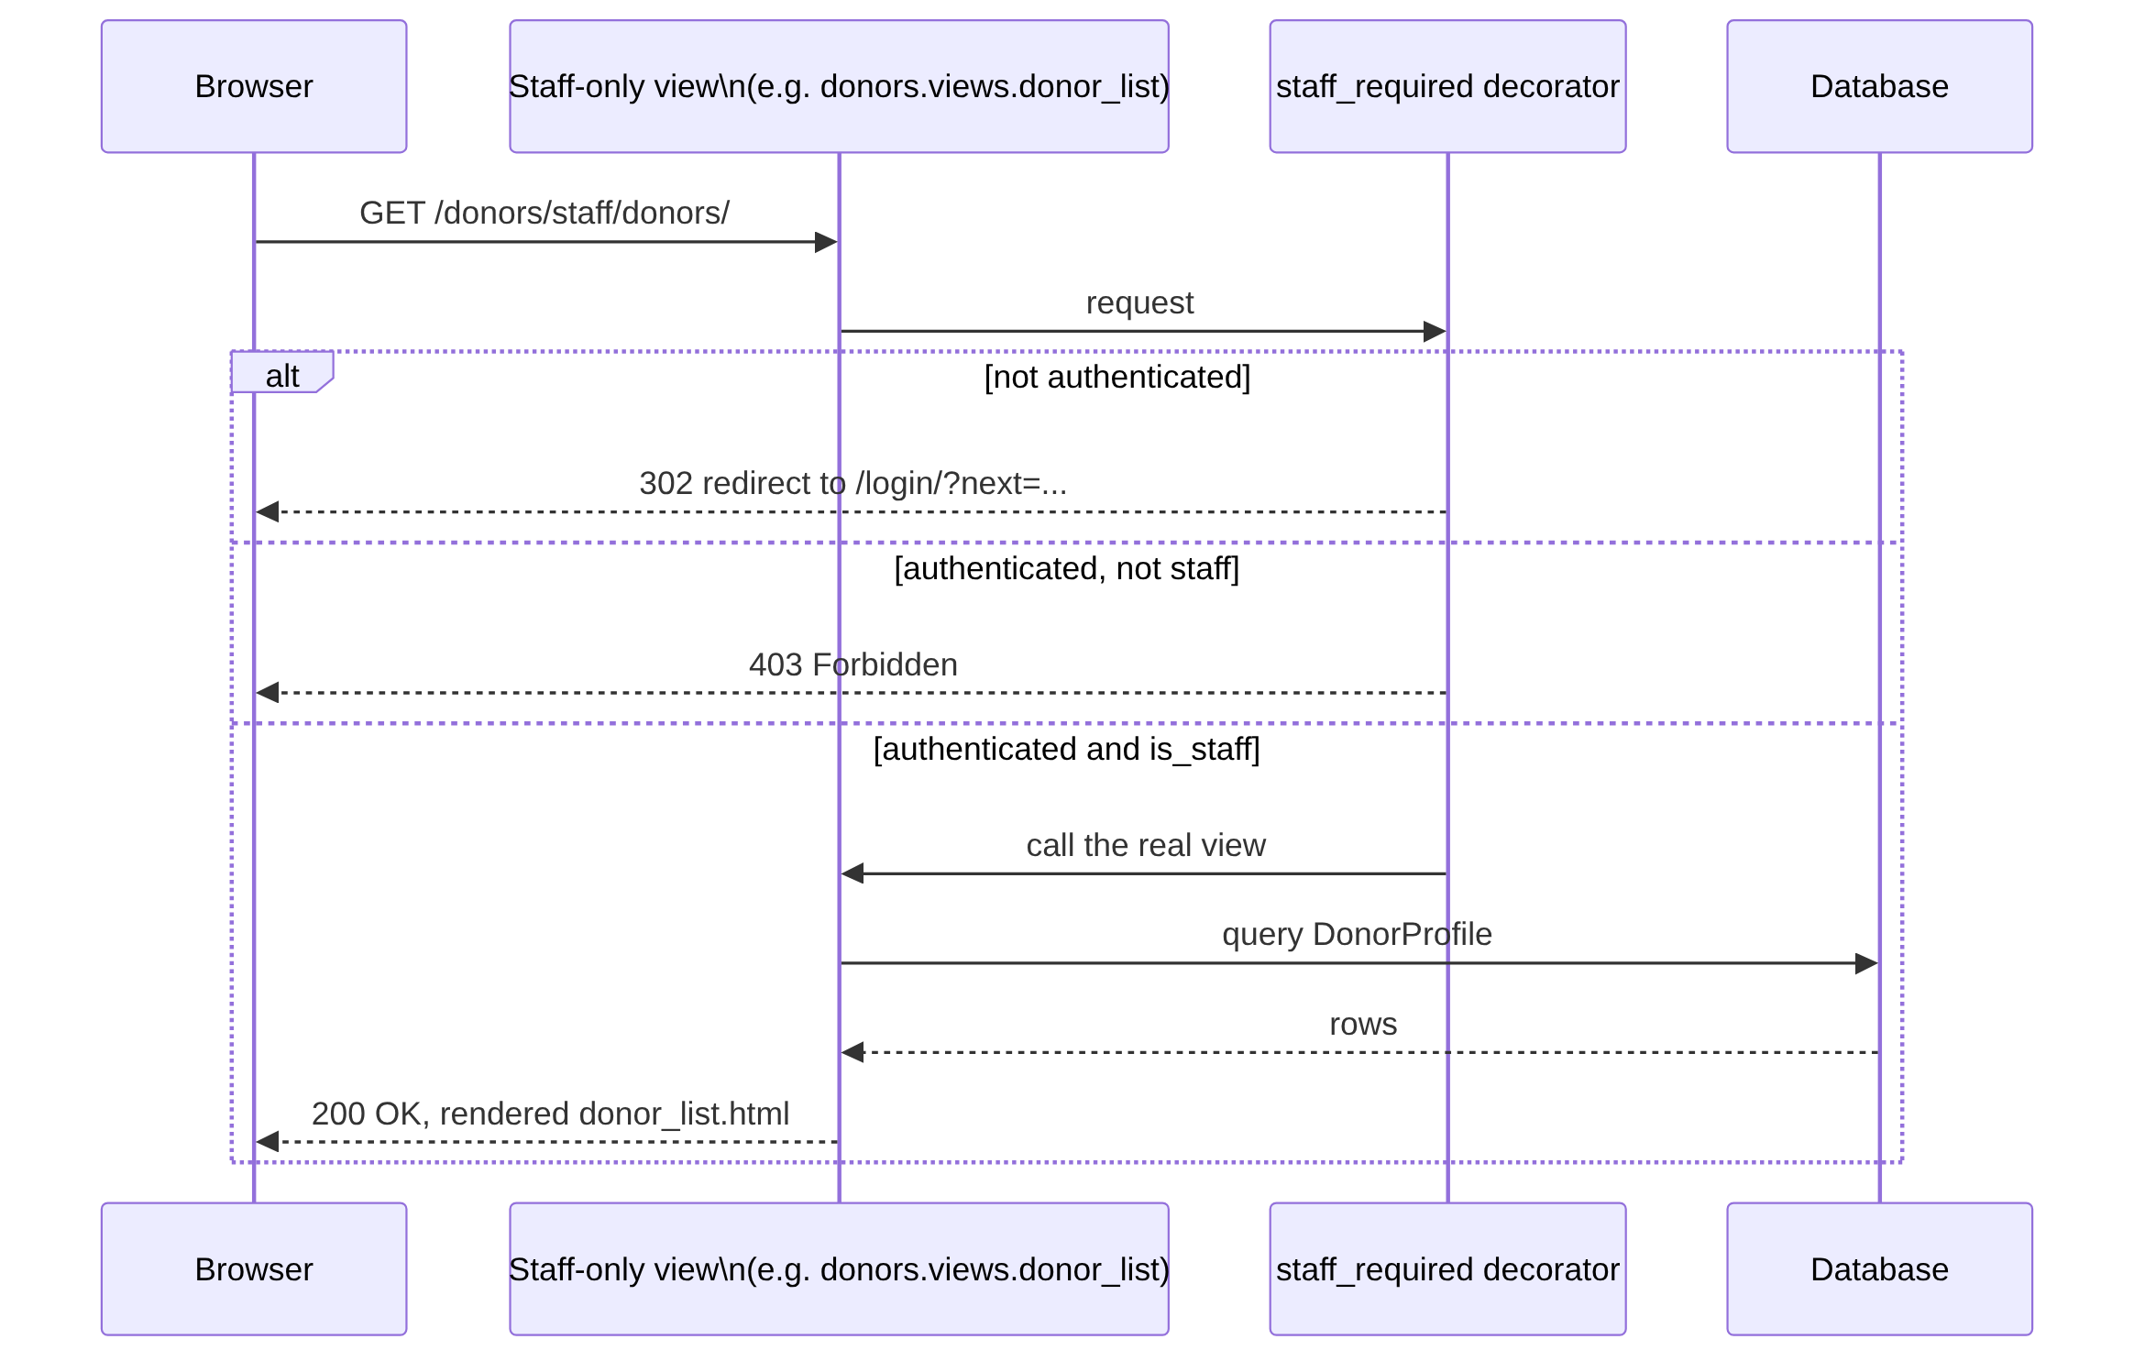
Figure 4 -- Authentication and authorization sequence (a staff-only view).
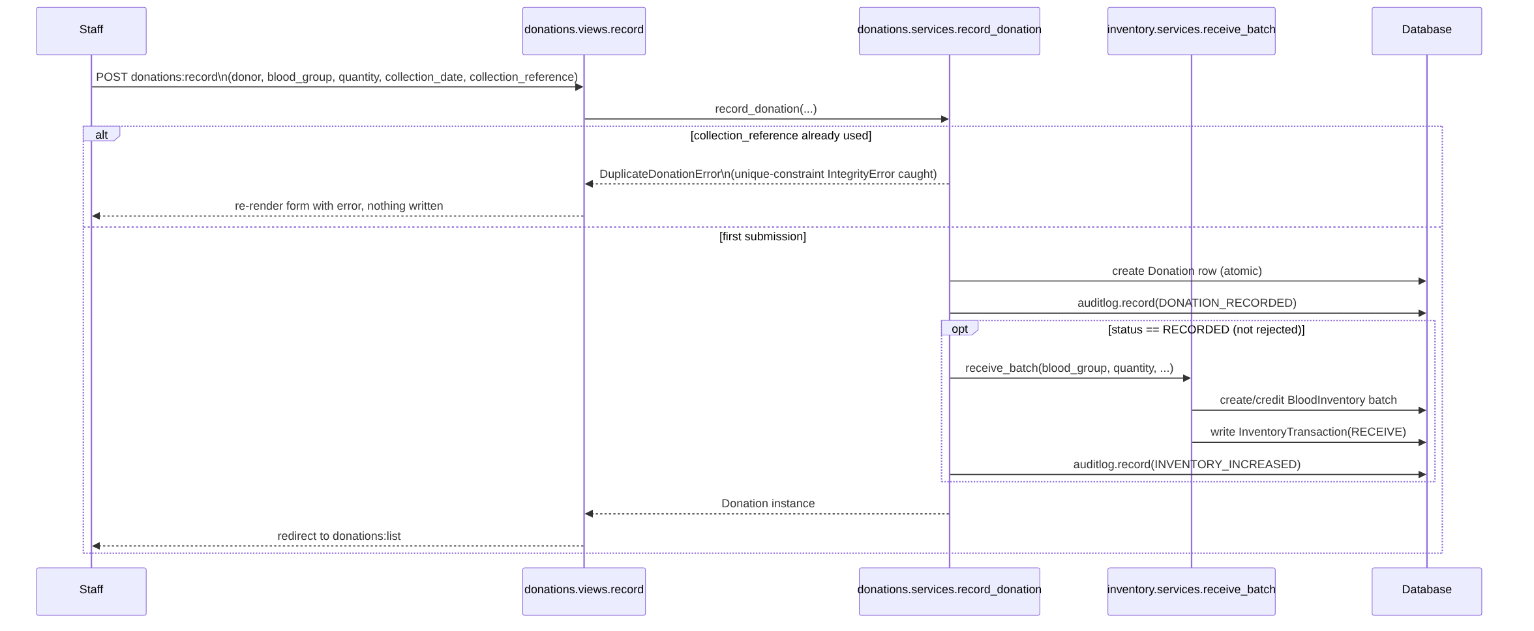
Figure 5 -- Donation-to-inventory sequence (recording a donation credits inventory atomically).

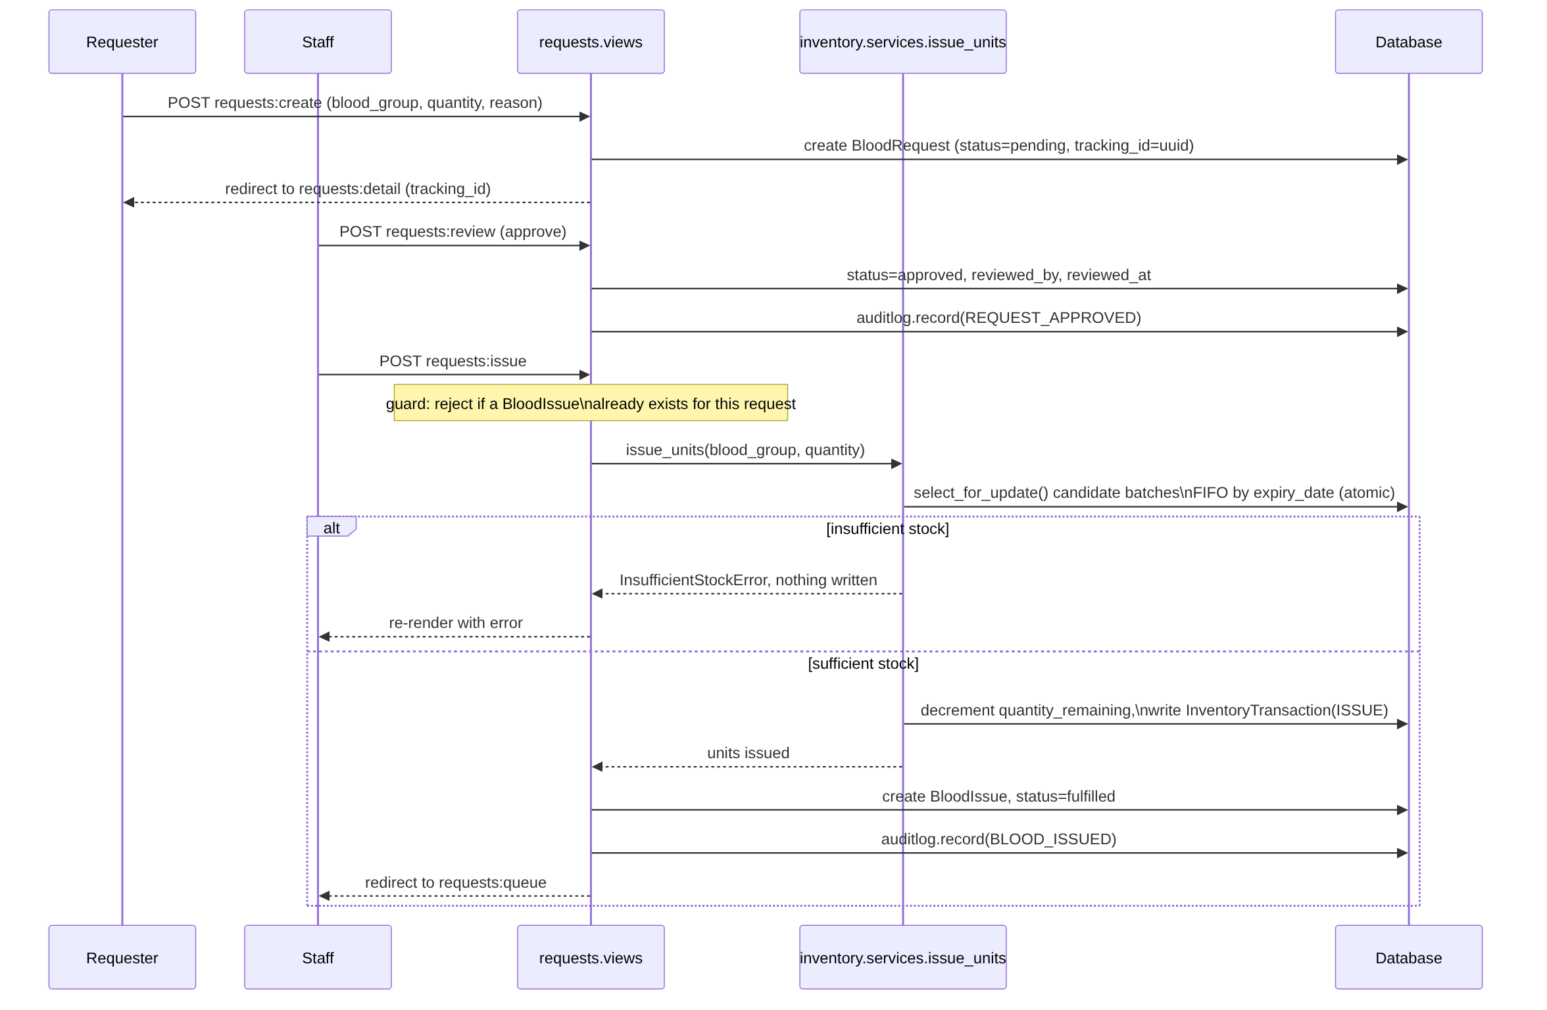
Figure 6 -- Blood request approval and issue sequence (issuing debits inventory atomically).
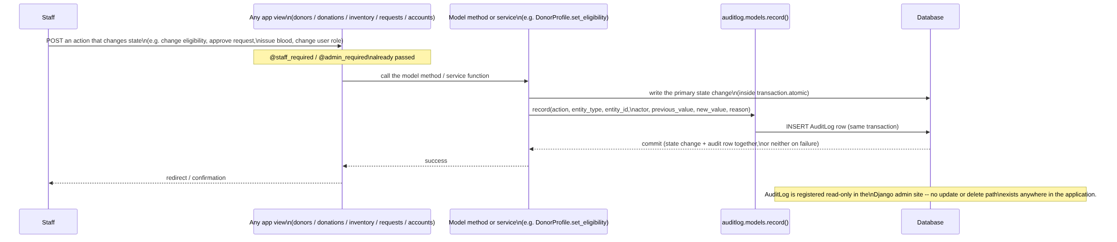
Figure 7 -- Audit logging sequence (the single code path every state-changing action writes through).

4.3 Actual URL and Interface Design
Version 1.0's SAD described a REST-style API (POST /login, GET /donors/{id}, POST /donations, GET /inventory, GET /availability, POST /requests, PUT /requests/{id}/status, POST /issues). This API was not built. The final system instead uses server-rendered Django views reached through named, namespaced URL routes -- there is no JSON API layer and no separate frontend consuming one. The table below replaces Version 1.0 Section 4.3 with the actual routing.
URL pattern | App / namespace | Purpose
/login/, /logout/, /home/ | authentication | Login, logout (POST-only), role-aware dashboard.
/donors/register/, /donors/profile/ | donors | Public self-registration; own-profile view/update.
/donors/staff/donors/, /donors/staff/donors/<pk>/ | donors | Staff-only donor directory and detail/eligibility (staff-only).
/donations/record/, /donations/ | donations | Staff-only: record a donation; donation list.
/donations/my-history/ | donations | Donor's own history -- no ID parameter.
/availability/ | inventory | Authenticated availability search.
/inventory/batches/, /inventory/batches/<pk>/ | inventory | Staff-only batch list/detail with manual adjustment.
/inventory-summary/, /expired-units/ | inventory | Staff-only summary and expired-stock views.
/requests/ | requests | Public request submission.
/requests/requests/<uuid:tracking_id>/ | requests | Public status tracking by UUID link.
/requests/staff/requests/ | requests | Staff-only request queue (filterable).
/audit-log/ | auditlog | Staff-only audit log (filterable, paginated).
/administration/users/, /administration/users/<pk>/ | accounts | Administrator-only user list/detail/create.
/admin/ | django.contrib.admin | Django's built-in admin site (superuser only).
Note: the accounts app is mounted at administration/users/, not admin/users/, because Django's own admin.site.urls already consumes the entire admin/ prefix earlier in the root URLconf -- a real defect (a 404 on every administrative page) was found and fixed during this project's development by moving the mount point; see the Test Plan's Defect Management section.

4.4 Error Handling, Logging and Monitoring
Scenario | Handling
Form validation errors | Django Form/ModelForm field validation; the form is re-rendered with inline field errors. No raw request.POST is read without going through form validation first.
Duplicate donation submission | donations.services.record_donation catches the database's own unique-constraint IntegrityError on collection_reference and raises a domain-specific DuplicateDonationError; the view re-renders the form with an error, and nothing is written.
Insufficient inventory on issue | inventory.services.issue_units raises before any write if requested quantity exceeds available stock (checked inside the same locked transaction, so a concurrent issue cannot race past this check).
Unauthorized access | staff_required/admin_required return a 302 redirect to login for an anonymous user, or raise Django's PermissionDenied (403) for an authenticated but unauthorized user -- the two cases are distinguished, not collapsed into one response.
Last-superuser lockout | accounts.views blocks the change and redirects back with a django.contrib.messages error, rather than allowing a state with zero active administrators.
Application logging / monitoring | No dedicated logging framework (e.g. structured logging to a file or external service) or monitoring/alerting tool is configured in this project; the auditlog app serves as the system's business-level activity record, not as technical/error logging. This is stated here as a scope boundary, not claimed as monitoring.

4.5 UX Design
- One shared design system (templates/base.html) across every page -- consistent spacing, typography and a single oxblood/crimson/ivory/porcelain/charcoal/champagne/rose colour-token palette.
- Light/dark/system theme switcher with no flash of the wrong theme on load.
- A role-aware dashboard (authentication:home) showing different KPI tiles for staff versus donors, each figure computed from a live query, not a hardcoded value.
- Responsive table overflow handling and focus-visible outlines for keyboard navigation; a global prefers-reduced-motion rule.
- No browser-automation or manual cross-device walkthrough was performed to verify the above visually -- see Section 4.7.

4.6 Deployment Architecture
The only deployment configuration present in this project is the Django development server (python manage.py runserver), used for local development and for the project demo. There is no WSGI server configuration, reverse proxy, containerization, CI/CD pipeline, or cloud hosting target in this repository. This is an accurate statement of the current scope, not a gap introduced by this documentation revision -- Version 1.0 did not specify a concrete deployment target either.

4.7 Limitations and Future Enhancements
- Eligibility is staff-set, not fully auto-derived from donation history (see SRS v2.0 Section 9.2).
- The request tracking link's bearer-token trust model could be strengthened with a short-lived token or a second factor (e.g. re-entering the requester's e-mail) without requiring every requester to hold an account.
- HTTPS is configured in settings but not served by any deployment in this project -- a future enhancement would add a reverse proxy or PaaS target with a certificate.
- A dependency/vulnerability scan (e.g. pip-audit) was not run and would be a reasonable addition.
- No performance testing against a production WSGI server exists; current performance figures measure the Django test client only.
- The UI redesign covers the shared design system and dashboard, not a bespoke sidebar/breadcrumb shell for every page.

5. Appendices

5.1 Glossary
Term | Definition
Batch | One received quantity of blood of a given group, with its own collection and expiry date (inventory.BloodInventory row).
FIFO issuing | Issuing from the batch with the nearest expiry date first, to minimize wastage.
Tracking ID | The UUID a requester uses to look up their blood request's status without logging in.
Audit entry | One immutable AuditLog row recording an action, its actor, and before/after values.

5.2 References
- Django documentation, docs.djangoproject.com (version 6.1).
- BBMS_SRS_V2.docx, BBMS_TEST_PLAN_V2.docx.
- The project's own README.md and docs/ARCHITECTURE.md.

5.3 Tools
- Python 3.13, Django 6.1.1.
- SQLite (bundled with Python).
- Django's built-in test runner (python manage.py test).

6. Division of Work
Preserved from Version 1.0, which already matches the actual composition of this document's sections.
Team Member | Responsibility
Nidhi Karkada | Architecture overview, component architecture, requirements traceability
Pramay Dubey | Design overview, UML sequence diagrams, API/interface design
Pavan E Naik | Security architecture, error handling, logging, risks
Nishit Suresh | Technology stack, UX design, appendices, references
Note: the updated technology-stack corrections (Section 3.6), the database-integrity description (Section 3.10) and the final URL/interface design (Section 4.3) required direct code verification beyond what any one original section owner could certify alone; this verification work is recorded in BBMS_Documentation_Change_Log.docx rather than reassigning the table above.

