**HARVARD UNIVERSITY EXTENSION SCHOOL**

PSYCE-1609

The Neuroscience of Learning: An Introduction to Mind, Brain, Health and Education

Submission 5

The Neuroscience of Flow

Ria Cheruvu

5/7/2018

Table of Contents

Introduction 3

Background 4

Psychology of Flow 5

Neuroscience of Flow 5

The Problem 5

Research Question 6

Literature Review 7

Literature Genres 7

The Psychology of Flow 7

Attentional Processes 8

Activities and Tools for Measuring/Stimulating Flow 9

Qualitative Interviews 10

Questionnaires 11

Experience Sampling Method 11

The Neuroscience of Flow 12

MRI and fMRI imaging and Flow 13

fNIRS imaging and Flow 15

Appreciating the Complexities of Flow Theory 19

Disaggregating Flow into Attention and Motivation 20

Methodology 22

Analysis 22

Details of the Analysis 22

Conclusions 26

Answer to the Research Question 26

Limitations of the Study and Recommendations for Future Studies 27

General Summary 28

Introduction

Research suggests that flow states can lead to the development of complex patterns of thought, behavior, and creativity by enabling self-motivated optimal experiences (Csikszentmihalyi, 2014c). Flow states are states of consciousness involving deep absorption during the passionate pursuit of an *autotelic activity*, which involves “doing primarily for the sake of the experience itself” (Engeser, 2012, p. vi). Flow is differentiated from other forms of attention and motivation due to its multiple conditions or sub-elements. These conditions or sub-elements include the construction and achievement of clear goals, reception of immediate feedback from the environment, a balance between an activity’s challenges and the flow participant’s skillset, high concentration, distortion of time, negligence of meta-representations of the self, and transformation of the present experience to an autotelic activity (Csikszentmihalyi, 1996). **Figure 1** summarizes the antecedents, attentional processes, and experiential components that contribute to the flow experience. The complexity of flow, which has elements of both motivation and attention, implies that the measurement of the physiological correlates of flow encompass measurement of numerous networks and subsystems.

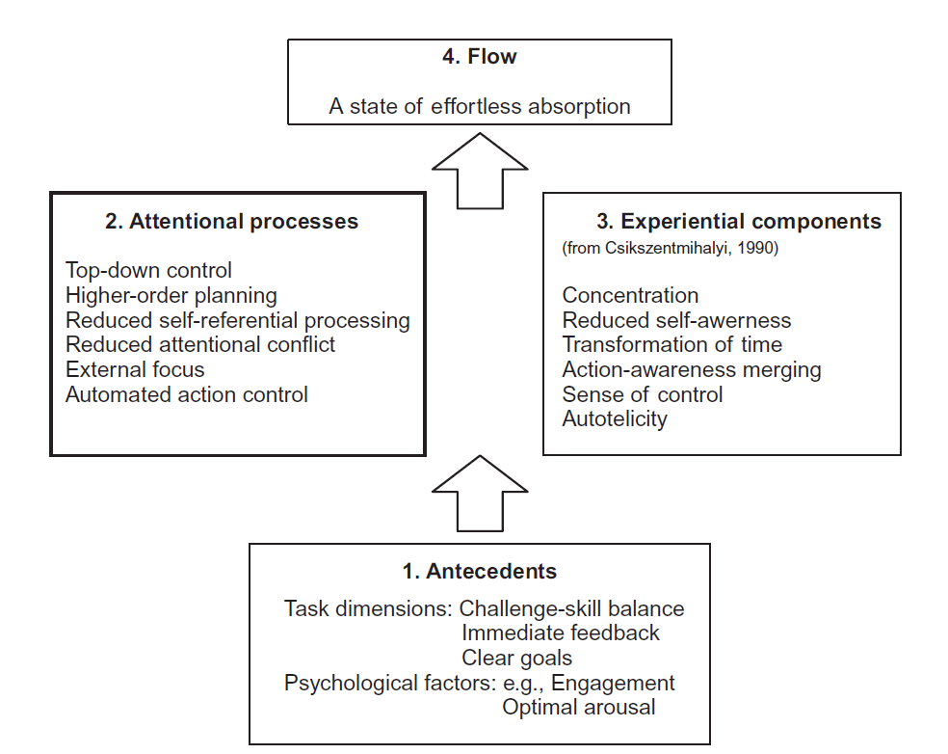

Figure 1. Schematic representation of the processes composing the flow experience. (Harris, 2017, p. 223).

Background

Psychology of Flow

Csikszentmihalyi’s contemporary theory of flow, originally established in 1975, is defined as “intense experiential involvement in moment-to-moment activity” (Csikszentmihalyi, 2014b, p. 15). Csikszentmihalyi’s definition of flow theory is a well-accepted concept in psychological literature, and has been employed by psychology researchers to study the qualities/characteristics of flow states (Engeser, 2012). Psychology researchers often study how activities stimulate flow using self-report measurement tools that prompt participants to reflect on flow experiences in order to determine individuals’ behaviors, mental states, and emotions during flow.

Neuroscience of Flow

While significant advances have been made in the field of neuroscience for studying the neurophysiological outcomes of activities similar to flow (e.g., Harris, 2017), such as meditation, research on the neural correlates of flow is still in the early stages. Neuroscience researchers are beginning to explain particular sub-elements of flow by measuring brain activity through neuroimaging (e.g., Yoshida et al., 2014), recording electroencephalographic dynamics in the brain (e.g., Cheron, 2016), or measuring neurochemical changes (e.g., Keeler, et al., 2015). The limited findings in existing literature have led to mixed and contradictory results on the attentional processes/networks related to flow, key brain hubs for flow, and the consistency/distinction of neurophysiological outcomes across multiple autotelic activities and environments.

The Problem

The complexity of flow states is caused by the strong correlations between the components, antecedents, and consequences of flow. Furthermore, since flow is a subjective experience (Harmat, Andersen, Ullén, Wright, & Sadlo, 2016), the components and conditions of flow differ depending on the type of autotelic activity (Csikszentmihalyi, 2014b) and the participant’s interests, history, and skillset (Engeser, 2012). The complexity of flow leads to challenges related to capturing/quantifying the multifaceted and subjective flow experiences. While psychology researchers are capable of leveraging the delineation of the sub-elements of flow to measure the dimensions/conditions of flow (Harmat, Andersen, Ullén, Wright, & Sadlo, 2016), the complex nature of flow with multiple, overlapping networks/subsystems makes the physiological correlates of flow challenging to measure with a single tool.

Research Question

How and to what extent can flow be explained through neuroscience using neuroimaging techniques? Technologies such as brain imaging allow neuroscience researchers to assess key indicators and brain activity during flow. This approach may produce a more reliable measurement that can be used to validate psychological measures of flow (Engeser, 2012). By complementing psychological literature with concrete neurophysiological outcomes, flow researchers may be able to form a bio-behavioral theory that integrates cognitive, neurological, and behavioral variables to understand the characteristics of flow (Engeser, 2012).

Literature Review

Literature Genres

The research was performed using Google Scholar and Harvard University’s online library catalog to find relevant comprehensive literature reviews, journal articles on flow and neuroimaging from peer-reviewed journals, and books from prominent authors in the field. As most articles and books on flow coming from psychology literature emerged from before 2014, no parameters were set for the years of publication during the search. Most studies discussed in this paper consider psychology and neuroscientific literature and observe the effects of flow on 26-year-old to 50-year-old female and male individuals. The research was used to establish common definitions of terms such as flow and describe the empirical and theoretical support behind psychological/neuroscientific findings. The goal of the chosen literature is to map findings from existing neuroscientific literature to validate psychological claims regarding flow experiences.

To answer this research question, this literature review is organized into three topics: The Psychology of Flow, the Neuroscience of Flow, and Appreciating the Complexities of Flow Theory.

The Psychology of Flow

Precursors of flow from Western psychological traditions include theories on *self-actualization* (Maslow, 1959) from the humanistic tradition of psychology and research on *intrinsic motivation* (Ryan & Deci, 2000). Flow theory considers an individual’s interaction with his/her environment through the expression of intense concentration on the task being performed, lack of self-consciousness, and feelings of distortion of time during participation in specific activities (e.g. ironing clothes or mountain-climbing), depending on the challenge level and participant’s skill set (Csikszentmihalyi, 2014b). Psychology researchers often study how activities stimulate flow to determine individuals’ behaviors, mental states, and emotions during flow. Researchers from psychology characterize flow as a state when an individual has high concentration and strikes a balance between skill set and challenge level (Csikszentmihalyi, 2014b; Havitz & Mannell, 2005; Yeh, Lai, & Lin, 2016; Zaman, Anandarajan, & Dai, 2010). Activities as varied as gaming (Yeh, Lai, Lin, 2016), learning in a classroom setting (Csikszentmihalyi, 2014c), and sports (Harris, 2017) yield the same conditions of flow, including deep absorption, loss of self-consciousness, and distortion of time. The theory of flow authored by Csikszentmihalyi (1996) and considered by many psychology researchers (e.g., Havitz & Mannell, 2005; Yeh, Lai, & Lin, 2016; Zaman, Anandarajan, & Dai, 2010) involves nine sub-elements/conditions. This section will focus on one of those sub-elements, the *attentional processes* of flow.

Attentional Processes

The flow experience necessitates undivided attention directed at the task at hand and exclusion of distractions (tangential thoughts that direct attention away from the task). During flow, an individual’s perception of the difficulty of a task is greatly reduced. Dormashev (2010) explains that the flow model involves *attention selectivity*, characterized as the direction of attentional resources to a particular task, and *intensity*, characterized as a feeling of deep absorption. Consequently, extreme focus and lack of perceived effort during flow necessitates the direction of attentional resources towards relevant stimuli rather than thoughts/events that are tangential to the task at hand. Csikszentmihalyi and Nakamura (2010) suggest that flow involves striking a balance between attentional effort and automatic processing of sequences, enabling the direction of more attention towards important details. Harris (2017) describes that an individual in flow neglects meta-representations of the self (self-awareness) since attentional resources are directed towards the autotelic activity, rather than towards awareness of the self. The suggestion that flow involves lack of awareness of the self has also been demonstrated through the quantitative reviews conducted by Csikszentmihalyi (1996), who reported that flow participants reported lack of feeling conscious willing during flow. The dimensions of flow often overlap and contain numerous contradictions, since they attempt to characterize the changing feelings of an individual in flow. For example, intense involvement in an activity entails the sense of control over actions, which contradicts the theory that total concentration cannot involve control over one’s actions due to the consequent splitting of attention between performance and feelings of control (Csikszentmihalyi, 1996).

Activities and Tools for Measuring/Stimulating Flow

Most theories and studies on the training and measurement of flow have remained in the psychological realm (e.g., Havitz & Mannell, 2005; Zaman, Anandarajan, & Dai, 2010) and involve the assessment of qualities and behavioral outcomes of the flow experience by using self-report instruments *after* an individual’s participation in the activity. However, measuring outcomes after the flow state, as done in psychological literature, may not allow researchers to observe meaningful information regarding the microprocesses (e.g. intensity and stability) and the effects of flow (Engeser, 2012). Csikszentmihalyi (2014b) breaks down commonly used methods for measuring flow in psychology into three categories: a) qualitative interviews encouraging subjects to provide practical examples of flow experiences, b) questionnaires for measuring sub-elements of flow experiences in specific contexts, and c) the Experience Sampling Method for collecting and studying systematic self-reports of flow experiences. The following section will explain the usage of the three tools for measuring flow:

Qualitative Interviews

The qualitative interview method (e.g. Csikszentmihalyi, 1996; Swann, Keegan, Crust, & Piggott, 2016) measures the dimensions, characteristics, and emotions associated with the flow experience as perceived by the participant in real-life situations and activities by asking participants to recall their experiences. Csikszentmihalyi (2014b) claims that semi-structured qualitative interviews are commonly used by researchers seeking holistic descriptions/accounts of the flow experience. The benefits of qualitative interviews include the ability to acquire a detailed description of antecedents/consequences of flow experiences, the degree of control over the task, and other factors that psychology researchers can use to understand the factors that impact and are impacted by the flow experience. The disadvantage of interviews is that the methods prompt the participant to recollect past experiences, which leaves the possibility for individuals to erroneously recollect false qualities/characteristics of the flow state. Biased recall of experiences and vague definitions of terms such as ‘ego’ in interviews can cause researchers to form incomplete conclusions on the qualities/characteristics of the flow state.

Questionnaires

Questionnaires, such as the Flow State Scale, are commonly used by psychology researchers studying flow in applications such as sports (e.g. Jackson & Eklund, 2002) and gaming (Yoshida et al., 2014). The tool measures differences of flow states across diverse contexts, past participation in the flow state, and the frequency and intensity of past flow experiences. Measurements are taken through paper-and-pencil measures asking participants about the characteristics of past participation in flow states and the frequency of an individual experiencing each of the sub-elements/conditions of flow (Csikszentmihalyi, 2014b). The benefits of the method include the reliability of measurements of flow across multiple autotelic activities and the ability to investigate potential relationships between flow and concepts such as creativity (Harmat, Andersen, Ullén, Wright, & Sadlo, 2016). The disadvantages of the method include that questionnaires attempt to categorize individuals’ thoughts and feelings into agreement/disagreement with commonly defined statements, which do not take into account mental states and behaviors specific to a particular individual/task/context (Harmat, Andersen, Ullén, Wright, & Sadlo, 2016). Furthermore, similar to qualitative interviews, questionnaires also prompt the participant to recollect past experiences after the activity, which could potentially result in collection of erroneous data (Harmat, Andersen, Ullén, Wright, & Sadlo, 2016).

Experience Sampling Method

The Experience Sampling Method (ESM), used by researchers to measure flow in everyday activities (e.g. Havitz & Mannell, 2005), measures individual’s mental states and health at particular times throughout the day. The ESM measures flow by prompting the subject to complete a questionnaire with a paging device when the conditions for flow exist. Csikszentmihalyi’s research (2014b) demonstrates that the benefits of ESM include that it allows researchers to overcome the disadvantages of interviews and questionnaires, and study the mechanisms and characteristics of flow in daily life both during and after the flow experience. The disadvantages of ESM include that it might interrupt the participant during the flow experience by causing the individual to stop task execution, self-reflect, and record thoughts and emotions, which makes the usage of this method in natural environments (e.g. a sports competition) difficult (Harmat, Andersen, Ullén, Wright, & Sadlo, 2016).

The Neuroscience of Flow

Researchers have attempted to deconstruct the psychological theory of flow into neural processes that can be detected by functional magnetic resonance imaging (fMRI) (e.g., Klasen, Weber, Kircher, Mathiak, & Mathiak, 2011), magnetic resonance imaging (MRI) (e.g., Ulrich, Keller, Hoenig, Waller, & Grön, 2014), and functional near-infrared spectroscopy (fNIRS) (e.g., Yoshida et al., 2014). Neuroscientific literature involves the study of flow theory using a variety of autotelic activities and measurement tools, encompassing fMRI, MRI, and fNIRS technologies, to stimulate and observe the brain mechanisms associated with flow (e.g., Cheron, 2016; Keeler, et al., 2015). Neuroscience differs in the units of analysis of psychology, since psychology researchers study subjective measurements of flow based on an individual’s feelings and emotions. However, neuroscience researchers attempt to objectivize measurements of flow by measuring the neural patterns underlying the observable aspects of flow that are not specific to an individual and might be similar across multiple autotelic activities (Engeser, 2012). A thorough review of the neuroscientific research on flow revealed that the emergence of flow *during* participation in an activity cannot be directly measured using existing neuroimaging technologies and research methods. The neural correlates of flow experiences have only been studied in periods of time where probability of the emergence of flow was increased (which was confirmed by asking participants to complete self-report measures) after the flow activity.

MRI and fMRI imaging and Flow

MRI imaging involves the use of a magnetic field to produce detailed images of the brain (Ulrich, Keller, Hoenig, Waller, & Grön, 2014). fMRI imaging uses MRI in real-time by measuring blood oxygenation level-dependent (BOLD) signals in the brain (Harmat, Andersen, Ullén, Wright, & Sadlo, 2016). Researchers studied 27 male participants using MRI imaging technologies during the performance of mental arithmetic tasks (Ulrich, Keller, Hoenig, Waller, & Grön, 2014). The authors found deactivation of the medial prefrontal cortex and the amygdala. The results of the study also demonstrated increased activation of the inferior frontal gyri, anterior insula, and putamen. The authors confirmed that the study measured the neural correlates of flow as opposed to measuring brain activity in response to mental arithmetic by demonstrating that findings such as lower rCBF levels in regions of the prefrontal cortex were not present in non-flow experiences (low task difficulty or boredom and high task difficulty or overload conditions).

Klasen, Weber, Kircher, Mathiak, and Mathiak (2011) conducted fMRI research on 13 male volunteers participating in a first-person shooter game. The authors demonstrated that there is a high likelihood that the data on the neural correlates of flow was not corrupted by the confounding activities (gaming) by measuring brain activity during periods of time when the probability for the appearance of flow was increased. They found deactivation of the orbitofrontal cortex and the anterior cingulate cortex, regions of the prefrontal cortex, as well as increased activation of the putamen, located at the base of the forebrain. Ulrich, Keller, and Gron (2016b) measured the neural correlates of flow during 23 male participants’ performance of mental arithmetic tasks using fMRI imaging technologies. They found that deactivation of the medial prefrontal cortex; reduced activity in the amygdala, orbitofrontal regions, and anterior cingulate cortex; and activation of the inferior frontal gyri was prevalent in flow conditions, but was not prevalent in non-flow experiences (low task difficulty or boredom and high task difficulty or overload conditions). The authors claim the mental arithmetic tasks are autotelic activities they designed to stimulate flow through varying difficulty levels in response to a participant’s skillset. Furthermore, Ulrich, Keller, and Gron (2016) utilized the same experimental setup as the study described above by Ulrich, Keller, and Gron (2016b) and demonstrated deactivation of the medial prefrontal cortex.

Landau and Limb (2017) assert that during musical improvisation, musicians enter into flow states. Limb and Braun (2008) conducted research on six healthy male professional musicians participating in musical improvisation. The authors found evidence of deactivation of the dorsolateral prefrontal cortex (PFC), ventrolateral PFC, amygdala, and orbitofrontal regions of the brain. They found activation of regions of the anterior cingulate cortex during flow. The literature survey of MRI and fMRI studies suggest that deactivation of regions of the frontal cortex is characteristic of flow states, although there is no conclusive evidence demonstrating common patterns of deactivation/activation among the studies. Furthermore, the literature suggests that the inferior frontal gyri and the medial frontal regions might be key hubs for flow, and reduced activity in regions such as the amygdala and regions of the orbitofrontal cortex might be potential neural correlates of flow.

fNIRS imaging and Flow

fNIRS imaging involves studying cerebral hemodynamics in the brain. fNIRS is a technology that is not susceptible to errors due to head and body motion as is common in fMRI studies, and is also favored as it has high temporal resolution (Yoshida et al., 2014). Research using fNIRS technologies such as Yoshida and colleagues’ study (2014) and Harmat and colleagues’ study (2015) demonstrate that overall deactivation of the frontal cortex might not be true during flow states. Yoshida and colleagues (2014) used fNIRS to study the neural correlates of flow in 20 university students during participation in a Tetris® computer gaming task that was set at a challenge level matching the participant’s skillset. The authors detected increased activation in the dorsolateral PFC and the inferior frontal gyri. The authors also administered the Flow State Scale (a questionnaire designed to measure psychological outcomes of the flow experience), and the results showed a high score on the Flow State Scale during the flow condition. These results confirmed that the gaming task specifically induced flow and the measured brain activity was prevalent in flow conditions but was not prevalent in non-flow experiences (low task difficulty or boredom conditions). This is relevant for the research question, since findings from Yoshida and colleagues’ study (2014) contradict the deactivation of the frontal cortex identified in fMRI studies, as the authors claim attentional mechanisms of flow could be associated with functions of the prefrontal cortex. In another revealing study on the brain activity associated with flow, Harmat and colleagues (2015) conducted an fNIRS imaging study on 77 individuals participating in a Tetris® computer gaming task. The authors found no relationship between activity in the frontal cortex and flow. They confirmed that the study’s findings were focused on flow by demonstrating distinct brain activity patterns when participants participated in optimal flow conditions as opposed to participating in easy/difficult gaming tasks (non-flow experiences). The authors evaluated individuals’ flow experiences by reporting the balance between the subjects’ skillset and challenge level. **Table 1** illustrates findings on activated/deactivated brain regions during flow based on the experiments discussed in the literature review. Regions of the brain that were not studied in the papers discussed in the literature review are marked as “Not considered” in the table.

Table 1. Potential activated/deactivated brain regions during flow.

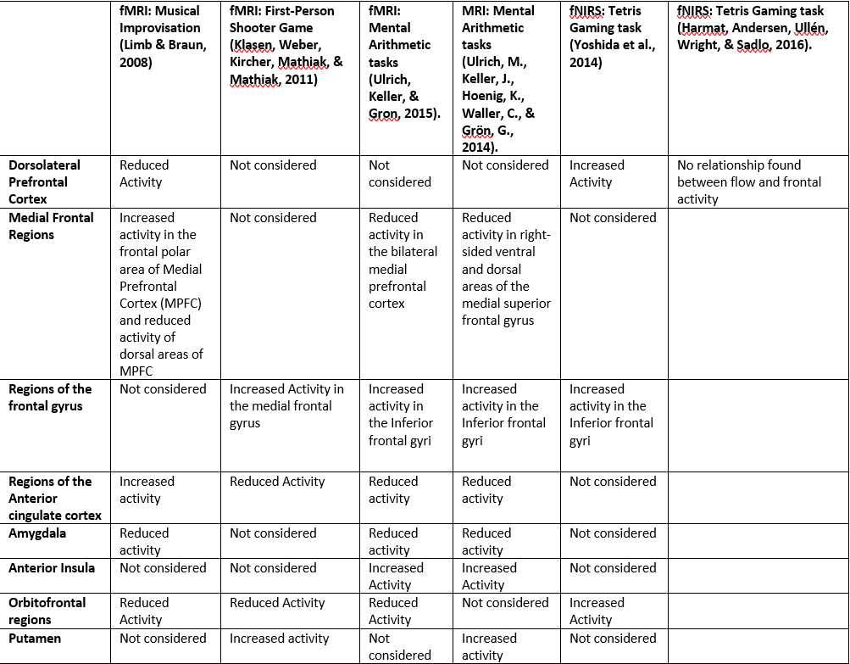

Source: Author, based on Harmat, Andersen, Ullén, Wright, and Sadlo (2016), Klasen, Weber, Kircher, Mathiak, and Mathiak (2011), Limb and Braun (2008), Ulrich, Keller, and Gron (2016b), Ulrich, M., Keller, J., Hoenig, K., Waller, C., and Grön, G. (2014), and Yoshida et al. (2014).

In summary, findings regarding key brain hubs for flow (e.g. the inferior frontal gyri and the medial frontal regions) and reduced activity in regions such as the amygdala seem to vary according to the type of autotelic activity being performed and the associated attentional effort demanded by the task. fMRI and MRI studies support the belief that deactivation of certain regions of the prefrontal cortex is associated with flow. However, fNIRS studies indicate that regions of the prefrontal cortex, such as the dorsolateral prefrontal cortex, are key hubs for flow.

Appreciating the Complexities of Flow Theory

Psychological literature takes into account the complex nature associated with the multiple, overlapping subsystems/networks of flow theory by adopting the lens of complexity theory. Complexity theory involves the study of *emergent* events (e.g., creativity or learning) arising from interactions between multiple interconnected units/elements (Ambrose, Sriraman, & Pierce, 2014). The theory proposes that emergent events cannot be understood by simplifying phenomena into individual components/units, and that the interplay between the individual units is more significant than the units themselves (Poutanen, 2013). Researchers from psychology have employed complexity theory during the measurement of flow by emphasizing the importance of identifying and studying the interplay of the conditions/sub-elements of flow, as opposed to separately studying the components of flow.

Neuroscience researchers face numerous challenges and mixed results when using traditional research methods that do not measure emergent events at appropriate levels of complexity. Therefore, the application of complexity theory to appreciate the complex nature of emergent events has applications in neuroscience. In the context of flow, most neuroscientific research attempting to define the neural correlates of the flow experience involves using approaches focusing on only one mechanism of measuring flow and/or one sub-element of flow. However, these approaches may be insufficient for explaining flow states (Engeser, 2012; Harmat, Andersen, Ullén, Wright, and Sadlo). Based on the approach taken by psychology researchers, it is possible that by disaggregating flow into separate constructs and analyzing the interplay between the elements, the difficulties associated with the measurement of flow could be avoided.

Disaggregating Flow into Attention and Motivation

The sub-elements of flow can be disaggregated into at least two main global domains, attention (e.g., Harris, 2017) and motivation (e.g., Csikszentmihalyi, 2014b), as shown in **Table 2**.

Table 2

The attentional and motivational elements of flow

|  |  |  |
| --- | --- | --- |
| Attentional elements of Flow | Motivational elements of Flow |  |
| High concentration | Construction and achievement of clear goals |  |
| Distortion of time | Reception of immediate feedback from the environment |  |
| Exclusion of distractions and worry of failure | Coordination of skills and challenges |  |
| Loss of self-consciousness | Transformation of the present experience to an autotelic activity |  |  |

Source: Author, based on Connolly & Tenenbaum (2010), Domenico and Ryan (2017), Csikszentmihalyi (2014a), Csikszentmihalyi (2014b), Keller & Bless (2007), Kowal & Fortier (2000), Swann, Keegan, Piggott, & Crust (2012).

The disaggregation of flow into attention and motivation stems from the definition of the flow experience as a “prototypical experience of intrinsic motivation [behavior driven by internal rewards]” (Csikszentmihalyi, 2014a, p. 24) and the importance of attention for entering/maintaining flow states (Csikszentmihalyi, 2014b). **Figure 1** outlines key attentional processes of flow that contribute to flow experiences in conjunction with experiential components. The attentional and motivational processes of flow contribute to the experiential components of the flow experience (e.g., lack of self-consciousness and distortion of time) identified through psychological self-report instruments. Psychology studies (e.g., Connolly & Tenenbaum, 2010; Swann, Keegan, Piggott, & Crust, 2012) and neuroimaging studies (e.g., Ulrich, Keller, & Gron, 2016b) focusing on the attentional processes of flow demonstrate that effective attentional control might be a key facilitator of experiential components of the flow experience, such as high concentration and elimination of distracting, tangential thoughts. Harris (2017) suggests that identifying the attentional mechanisms of flow using findings from neuroscientific research can help explain the key features of flow and allow researchers to understand the complexities of flow.

Psychology studies focusing on the motivational mechanisms of flow (e.g., Keller & Bless, 2007; Kowal & Fortier, 2000), such as coordination of skills and challenges and transformation of the present experience to an autotelic activity, suggest that there is a strong correlation between motivational elements (e.g. intrinsic motivation or self-determined motivation) and flow; the studies suggest studying the sub-elements of flow related to motivation can lead to meaningful conclusions on the emergence of flow. In terms of neuroscientific literature on the motivational processes of flow, Domenico and Ryan (2017) suggest that the activity in certain regions of the brain associated with intrinsic motivation could be consistent with the neural correlates of flow. The authors suggest studying the neural correlates of intrinsic motivation in relation to flow research is an important agenda for future research. While the neurophysiological basis of attentional and motivational mechanisms have been studied in detail, a deeper understanding of the relationship/interplay between these processes could help researchers identify measurable elements of flow.

Methodology

A search regarding the different forms/expressions of creativity in a variety of contexts (e.g. education, poetry, sports) gave way to further research on the topic of optimal experiences or states of high concentration that might be related to creative processes. The search was expanded to consider neuroscientific literature considering multiple types of activities/contexts for stimulating flow, as the number of journal articles on the neural correlates of flow are limited. The search progressed as the concept of flow was disaggregated into sub-elements related to Attention and Motivation, and a transdisciplinary vision of flow theory was gleaned through knowledge obtained from psychology and neuroscientific literature on flow.

Analysis

Details of the Analysis

The literature review reveals that existing neuroimaging studies do not show a measurable method for evaluating flow, as existing studies measure the neural correlates of flow states in different autotelic activities and provide contradictory findings. However, there seems to be evidence to justify a new model of flow measurement involving disaggregation of flow into attentional and motivational processes. The following section describes key findings from the literature that provide insight regarding what is now understood about the research question, in addition to important implications for researchers, practitioners, and the field of research. The perspective purported by psychological literature is that the flow experience and the associated attentional processes and lack of self-awareness is pervasive across culture, age, gender, and multiple types of autotelic activities and use of tools/methods for measuring flow (Csikszentmihalyi, 2014b). Neuroimaging studies demonstrate that the neural correlates of experimentally induced flow experiences might not be similar across multiple autotelic activities. Consequently, it appears that while overall deactivation of certain regions of the frontal cortex could be characterized as a neural correlate of flow, the specific regions of the brain that are deactivated are not consistent across multiple autotelic activities and environments. For example, flow experienced through participation in tasks such as gaming might require different attentional processes, more vigilance, and rapid decision making (Yoshida et al., 2014) compared to flow in activities such as musical improvisation, which requires the use of spontaneous artistic creativity (Limb and Braun, 2008).

The varying autotelic activities and associated attentional and motivational processes lead to activation/deactivation of different regions of the brain in relation to participation in different tasks. There is limited evidence proving that the data gathered by neuroimaging is not corrupted by the confounding autotelic activities that are studied. Furthermore, existing neuroscientific studies use small sample sizes that lend to the questionability of the authors’ claims. For example, studies on musical improvisation (e.g., Limb & Braun, 2008) do not indicate how the findings on the neural correlates of flow are not corrupted by the effects of musical improvisation. This finding is relevant to researchers since it illustrates that it is important to confirm that the autotelic activities are successfully stimulating flow, and prove that data gathered by neuroimaging is not corrupted by the confounding activities that are studied. Practitioners should consider structuring interventions targeted at facilitating flow based on environmental conditions/situations and an individual’s history, interests, and expertise (Engeser, 2012).

The literature review revealed that current neuroscientific studies only consider single research methods (e.g. fMRI vs. fNIRS) rather than employing a combination of research tools. The research fails to provide conclusive evidence for brain patterns/hubs for flow, and effectively capture the complexity associated with the multiple subsystems of flow. For example, while measuring flow during a gaming task, Ulrich, Keller, and Gron (2016b) did not consider the distortion of time and feelings of deep absorption/immersion associated with the flow experience. Furthermore, while the authors confirmed the balance between the participants’ skillset and the activity’s challenge level, the authors did not consider other motivational elements of flow, such as the construction and achievement of clear goals, in their study. It is important for the literature to capture flow theory’s complexity in order to explain flow states and help elucidate conclusions from psychological literature by establishing concrete bio-behavioral/physiological evidence for the sub-elements of flow (Engeser, 2012).

An acceptable measurement of flow could be determined by accepting the complexities of flow theory and considering the measurement of flow through the lens of complexity theory. By disaggregating the attentional and motivational processes central to flow and considering the interconnections between these two domains that gives rise to flow experiences, researchers can develop measurement tools and protocols that efficiently capture/quantify the dynamic complexity of flow in terms of physiological outcomes. Practitioners can then leverage these measurement tools and protocols to effectively manage and enhance flow participants’ experiences, performance, and learning. For example, if a measure of flow was the motivational measure of construction and achievement of clear goals, then researchers could identify neurophysiological outcomes and form conclusions on the extent to which conscious control and decision making in conjunction with feelings of task difficulty and enjoyment contribute to the flow experience. Another example related to attention: If a measure of flow was the attentional measure of reduced self-referential processing and automated action control, then researchers might be able to solve the anomalies/paradoxes of flow theory, such as the contradiction between greater use of attentional resources in the brain and the perceived effortlessness associated with flow (Harris, 2017). Furthermore, the disaggregation of flow could bridge the gap between psychological units of analysis (related to mental states) and neuroscientific units of analysis (related to molecular changes) of flow by allowing researchers to study how the interplay of attentional and motivational processes contribute to the experiential components of flow. This finding is relevant to research-practitioners since it illustrates the importance of considering a transdisciplinary perspective integrating approaches from multiple disciplines (e.g., cognitive, neurological, and behavioral perspectives) when measuring task-specific neural correlates of flow and devising flow-enhancing interventions. The finding also demonstrates the importance of using multiple imaging technologies and psychological measures to confirm that the autotelic activities are successfully stimulating flow, since sub-elements of flow such as high concentration and coordination between skillset and challenge level are challenging to measure using a single neuroimaging technology.

Conclusions

Answer to the Research Question

This paper sought to answer the question, “How and to what extent can flow be explained through neuroscience using neuroimaging techniques?” The evidence from the literature supports the idea that key hubs for flow in the brain that correspond to the sub-elements of flow established in the psychological literature are not commonly established in neuroimaging studies. Neuroscientific literature offers contradictory evidence regarding activity in particular regions of the brain and neural processes associated with flow. For example, fMRI and MRI studies (e.g. Klasen et al., 2011; Ulrich, Keller, Hoenig, Waller, and Grön, 2014) support the theory that flow involves an *overall* deactivation of multiple regions of the frontal cortex contra fNIRS studies, which indicate that attentional mechanisms of flow involve specific activation of certain regions of the frontal cortex serving as brain hubs for attention (Yoshida et al., 2014). This paper proposes that complexity theory can be applied towards the measurement of neurophysiological outcomes of flow through the disaggregation of flow into attentional and motivational processes. Evidence from psychology and neuroscience research (e.g., Domenico and Ryan, 2017; Swann, Keegan, Piggott, & Crust, 2012; Harris, 2017) suggests that this new model of flow measurement would allow researchers to understand the complexities/paradoxes associated with multiple subsystems/networks of flow, such as the participant’s perception of participation in objectively difficult tasks as effortless (Harris, 2017). The model could potentially lead to more accurate measurements/interpretations of the sub-elements of the multifaceted and subjective flow experience.

Limitations of the Study and Recommendations for Future Studies

The neuroscientific literature on the neural correlates of specific sub-elements of flow (e.g. Klasen et al., 2011) is limited, which impacts the scope of neuroscientific literature this paper can cover. This paper did not cover studies on the neurochemistry of flow; growing research on this topic (e.g., Manzano, Cervenka, Jucaite, Hellenäs, Farde, & Ullén, 2013; Keeler, et al., 2015) suggests that neurochemicals play an important role in an individual’s *subjective* participation in an autotelic activity or unique proneness to flow, which is beyond the scope of this paper. This paper did not cover research conducted on the electroencephalography dynamics associated with flow, which offers an additional neuroscientific perspective on the psychological construct of flow, through observation of brain oscillations related to attention during flow (e.g. Cheron, 2016; Wang & Hsu, 2014). In order to confirm that the neural activity identified in research correlates with the sub-elements of flow theory, researchers have linked activity in key brain hubs for flow to behavioral outcomes. For example, Ulrich, Keller, Hoenig, Waller, & Grön (2014) links deactivation of the prefrontal cortex, which the authors claim is a hub for self-referential processing, to lack of self-consciousness during flow. Therefore, it is recommended that future studies consider validating claims regarding certain regions of the brain serving as key structures/hubs for outcomes such as redirection of attention.

General Summary

Flow is a state of deep absorption when individuals are able to function at their optimal capacity and tackle challenging endeavors with ease (Csikszentmihalyi, 1996). Empirical research demonstrating neural correlates of the flow state has developed over the past decade (Harmat, L., Andersen, F. Ø, Ullén, F., Wright, J., & Sadlo, G., 2016), and attempts to provide evidence of changes in neural activity in response to participation in flow. This study sought to summarize what is known about neuroscientific literature on flow by mapping findings from existing neuroscientific literature to explain psychological claims regarding flow experiences. It was found that there is no conclusive evidence for the neuroscience of flow, as neuroimaging studies demonstrate contradictory findings on key brain hubs for flow that vary according to the activity being performed during flow. The paper proposes that the difficulties associated with measuring the neurophysiological correlates of multiple sub-systems/networks associated with flow states could be avoided by adopting the lens of complexity theory and disaggregating flow into attentional and motivational processes. Future studies should include validation of claims regarding the behavioral outcomes associated with activation/deactivation of key hubs for flow in the brain. The growing neuroscientific research addressed in this paper proposes exciting discoveries targeted at answering questions on the neural correlates of flow. The answers to these questions will catalyze a greater understanding of the brain’s unique responses to optimal experiences.

**References**

Ambrose, D., Sriraman, B., & Pierce, K. M. (2014). A critique of creativity and complexity: Deconstructing clichés. Rotterdam, The Netherlands: Sense Publishers.

Beaty, R. E., Benedek, M., Silvia, P. J., & Schacter, D. L. (2016). Creative cognition and brain network dynamics. Trends in Cognitive Sciences, 20(2), 87-95. doi:10.1016/j.tics.2015.10.004

Bengtsson, S. L., Csikszentmihalyi, M., & Ullén, F. (2014). Cortical regions involved in the generation of musical structures during improvisation in pianists. The Systems Model of Creativity, 257-278. doi:10.1007/978-94-017-9085-7_16

Byrne, C., Macdonald, R., & Carlton, L. (2003). Assessing creativity in musical compositions: Flow as an assessment tool. British Journal of Music Education, 20(3), 277-290. doi:10.1017/s0265051703005448

Connolly, C. T., & Tenenbaum, G. (2010). Exertion-Attention-Flow Linkage Under Different Workloads. Journal of Applied Social Psychology, 40(5), 1123-1145. doi:10.1111/j.1559-1816.2010.00613.x

Cheron, G. (2016). How to measure the psychological “Flow”? A neuroscience perspective. Frontiers in Psychology, 7. doi:10.3389/fpsyg.2016.01823

Csikszentmihalyi, M. (1996). Creativity: Flow and the psychology of discovery and invention. New York: Harper Collins Publishers.

Csikszentmihalyi, M. (2014a). Applications of flow in human development and education: The collected works of Mihaly Csikszentmihalyi. Dordrecht, The Netherlands: Springer.

Csikszentmihalyi, M. (2014b). Flow and the foundations of positive psychology: The collected works of Mihaly Csikszentmihalyi. Dordrecht, The Netherlands: Springer.

Csikszentmihalyi, M. (2014c). The systems model of creativity: The collected works of Mihaly Csikszentmihalyi. Dordrecht, The Netherlands: Springer.

Csikszentmihalyi, M., & Nakamura, J. (2010). Effortless attention in everyday life: A systematic phenomenology. Effortless Attention, 179-190. doi:10.7551/mitpress/9780262013840.003.0009

Domenico, S. I., & Ryan, R. M. (2017). The Emerging Neuroscience of Intrinsic Motivation: A New Frontier in Self-Determination Research. Frontiers in Human Neuroscience, 11. doi:10.3389/fnhum.2017.00145

Engeser, S. (2012). Advances in flow research. Boston, MA: Springer US.

Harmat, L., Andersen, F. Ø, Ullén, F., Wright, J., & Sadlo, G. (2016). Flow experience: Empirical research and applications. Switzerland: Springer.

Harmat, L., Manzano, Ö D., Theorell, T., Högman, L., Fischer, H., & Ullén, F. (2015). Physiological correlates of the flow experience during computer game playing. International Journal of Psychophysiology, 97(1), 1-7. doi:10.1016/j.ijpsycho.2015.05.001

Harris, D. J., Vine, S. J., & Wilson, M. R. (2017). Neurocognitive mechanisms of the flow state. Progress in Brain Research Sport and the Brain: The Science of Preparing, Enduring and Winning, Part B, 221-243. doi:10.1016/bs.pbr.2017.06.012

Havitz, M. E., & Mannell, R. C. (2005). Enduring involvement, situational involvement, and flow in leisure and non-leisure activities. Journal of Leisure Research, 37(2), 152-177. doi:10.1080/00222216.2005.11950048

Jackson, S. A., & Eklund, R. C. (2002). Assessing flow in physical activity: The Flow State Scale-2 and Dispositional Flow Scale-2. Journal of Sport and Exercise Psychology, 24(2), 133-150. doi:10.1123/jsep.24.2.133

Keeler, J. R., Roth, E. A., Neuser, B. L., Spitsbergen, J. M., Waters, D. J., & Vianney, J. (2015). The neurochemistry and social flow of singing: bonding and oxytocin. Frontiers in Human Neuroscience, 9. doi:10.3389/fnhum.2015.00518

Keller, J., & Bless, H. (2007). Flow and Regulatory Compatibility: An Experimental Approach to the Flow Model of Intrinsic Motivation. Personality and Social Psychology Bulletin, 34(2), 196-209. doi:10.1177/0146167207310026

Klasen, M., Weber, R., Kircher, T. T., Mathiak, K. A., & Mathiak, K. (2011). Neural contributions to flow experience during video game playing. Social Cognitive and Affective Neuroscience, 7(4), 485-495. doi:10.1093/scan/nsr021

Kowal, J., & Fortier, M. S. (2000). Testing Relationships from the Hierarchical Model of Intrinsic and Extrinsic Motivation Using Flow as a Motivational Consequence. Research Quarterly for Exercise and Sport, 71(2), 171-181. doi:10.1080/02701367.2000.10608895

Landau, A. T., & Limb, C. J. (2017). The neuroscience of improvisation. Music Educators Journal, 103(3), 27-33. doi:10.1177/0027432116687373

Limb, C., & Braun, A. (2008). Neural substrates of spontaneous musical performance: An fMRI study of jazz improvisation. PLoS ONE, 3(2), E1679.

Manzano, Ö D., Cervenka, S., Jucaite, A., Hellenäs, O., Farde, L., & Ullén, F. (2013). Individual differences in the proneness to have flow experiences are linked to dopamine D2-receptor availability in the dorsal striatum. NeuroImage, 67, 1-6. doi:10.1016/j.neuroimage.2012.10.072

Maslow, A. H. (1959). Cognition of being in the peak experiences. Journal of Genetic Psychology, 94, 43–66.

Poutanen, P. (2013). Creativity as seen through the complex systems perspective. Interdisciplinary Studies Journal, 2(3), 207-221.

Ryan, R. M., & Deci, E. L. (2000). Self-determination theory and the facilitation of intrinsic motivation, social development, and well-being. American Psychologist, 55(1), 68-78. doi:10.1037//0003-066x.55.1.68

Seger, J., & Potts, R. (2012). Personality correlates of psychological flow states in videogame play. Current Psychology, 31(2), 103-121. doi:10.1007/s12144-012-9134-5

Swann, C., Keegan, R., Crust, L., & Piggott, D. (2016). Psychological states underlying excellent performance in professional golfers: “Letting it happen” vs. “making it happen”. Psychology of Sport and Exercise, 23, 101-113. doi:10.1016/j.psychsport.2015.10.008

Swann, C., Keegan, R. J., Piggott, D., & Crust, L. (2012). A systematic review of the experience, occurrence, and controllability of flow states in elite sport. Psychology of Sport and Exercise, 13(6), 807-819. doi:10.1016/j.psychsport.2012.05.006

Ulrich, M., Keller, J., & Grön, G. (2016). Dorsal raphe nucleus down-regulates medial prefrontal cortex during experience of flow. Frontiers in Behavioral Neuroscience, 10. doi:10.3389/fnbeh.2016.00169

Ulrich, M., Keller, J., & Grön, G. (2016). Neural signatures of experimentally induced flow experiences identified in a typical fMRI block design with BOLD imaging. Social Cognitive and Affective Neuroscience, 11(3), 496-507. doi:10.1093/scan/nsv133

Ulrich, M., Keller, J., Hoenig, K., Waller, C., & Grön, G. (2014). Neural correlates of experimentally induced flow experiences. NeuroImage, 86, 194-202. doi:10.1016/j.neuroimage.2013.08.019

Wang, C., & Hsu, M. (2014). An exploratory study using inexpensive electroencephalography (EEG) to understand flow experience in computer-based instruction. Information & Management, 51(7), 912-923. doi:10.1016/j.im.2014.05.010

Yeh, Y., Lai, S. C., & Lin, C. (2016). The dynamic influence of emotions on game-based creativity: An integrated analysis of emotional valence, activation strength, and regulation focus. Computers in Human Behavior, 55, 817-825. doi:10.1016/j.chb.2015.10.037

Yoshida, K., Sawamura, D., Inagaki, Y., Ogawa, K., Ikoma, K., & Sakai, S. (2014). Brain activity during the flow experience: A functional near-infrared spectroscopy study. Neuroscience Letters, 573, 30-34. doi:10.1016/j.neulet.2014.05.011

Zaman, M., Anandarajan, M., & Dai, Q. (2010). Experiencing flow with instant messaging and its facilitating role on creative behaviors. Computers in Human Behavior, 26(5), 1009-1018. doi:10.1016/j.chb.2010.03.001