# Resharper

## Settings

[Link](https://www.jetbrains.com/help/resharper/Sharing_Configuration_Options.html)

So with settings they have this strange concept.

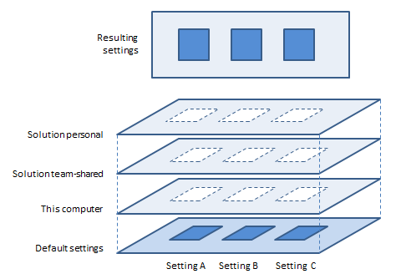

### Export settings

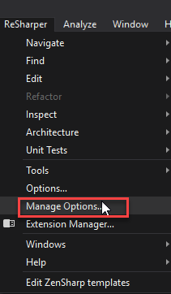

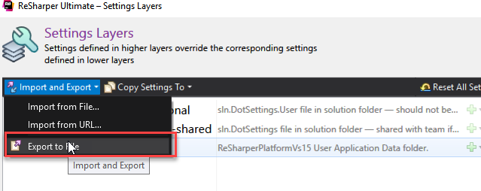

## Bug

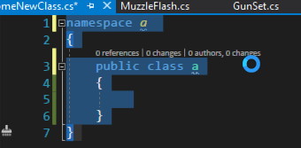

So that what happened when I generate new class with resharper.

So the problem was in UnityVS

Fix is to change setting of unity VS I do not use them to much so I just changed them .

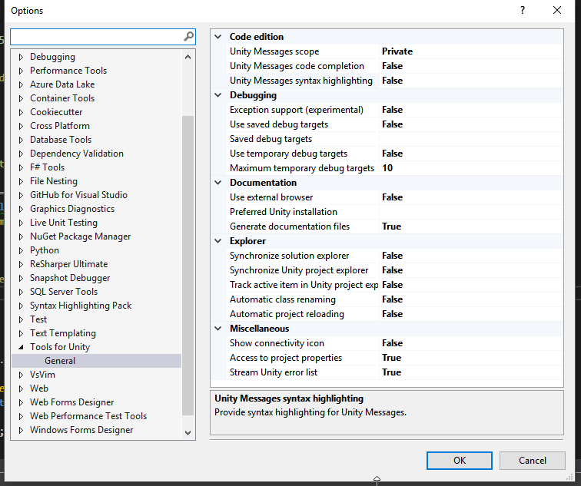

# Coloring methods

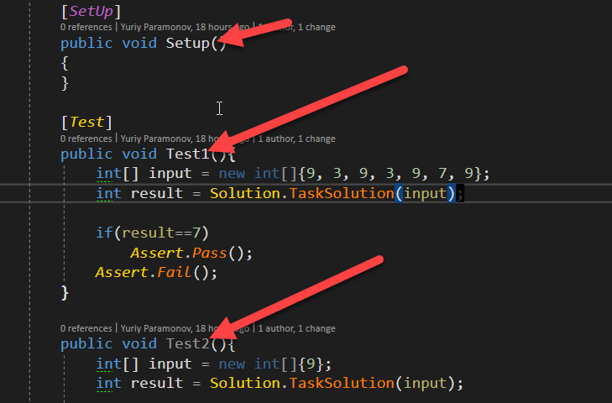

In end of 2018 I discovered that methos coloring gone so I go to use this extension to fix it.

<https://marketplace.visualstudio.com/items?itemName=StanislavKuzmichArtStea1th.EnhancedSyntaxHighlighting>

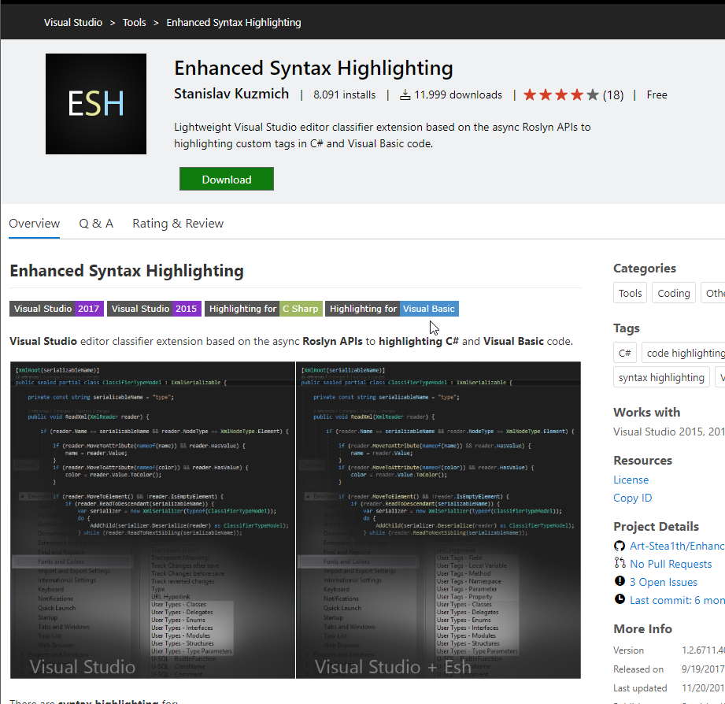

I found in user tags methos and change color to the one I get use to.

# Making Visual Studio Extension

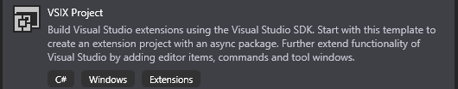

Starts with making WSIX project.

[VSIX documentation rom Microsoft](https://docs.microsoft.com/ru-ru/visualstudio/extensibility/getting-started-with-the-vsix-project-template?view=vs-2019)

[How to code extension](https://docs.microsoft.com/en-gb/visualstudio/extensibility/starting-to-develop-visual-studio-extensions?view=vs-2019)

## For Ideas

You can unpack .vsix file as .zip archive. And use dnSpy to reverse engenire it and then use it for crating your own extension.

# Visual Studio

## Using commands in console

<https://docs.microsoft.com/en-us/visualstudio/ide/reference/visual-studio-command-aliases?view=vs-2019>

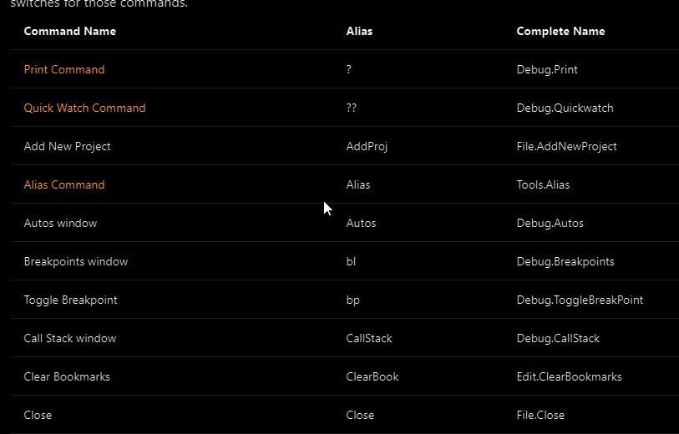

# VsVim

## VsVim and suggestions

After googling for a while I found this guyt

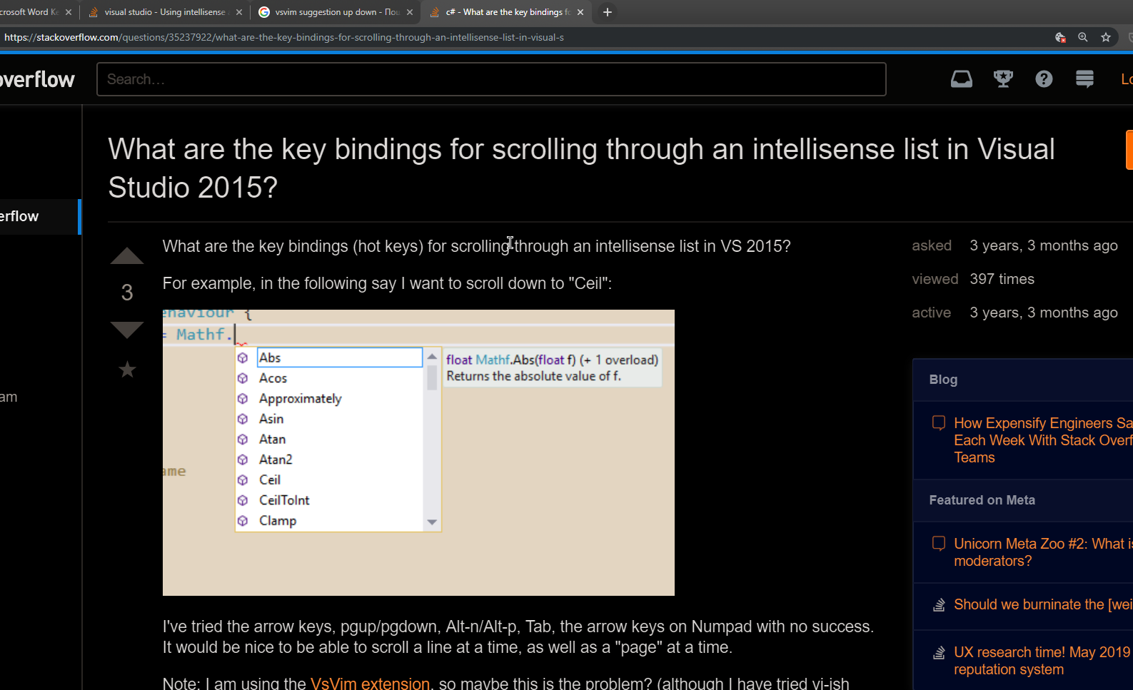

So he says is Edit.LineDown and Edit.LineUp

In order to get result I desire I’ve remove all CTrl+J

And all Ctrl+K usages from default visual studio shortcuts.

And remal them form Line up and Line down still not perfect but get’s better step by stop

# Clear view



This thing is really bother me.

So the extension hide ui is sort of helped me to clean it up. From all this trash.