1 Images are super usfuel

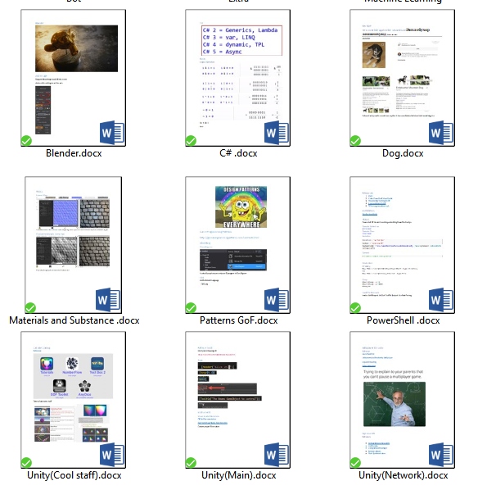

2 Sometimes just don’t forces yourself if you don’t like it.



3 Use mind maps

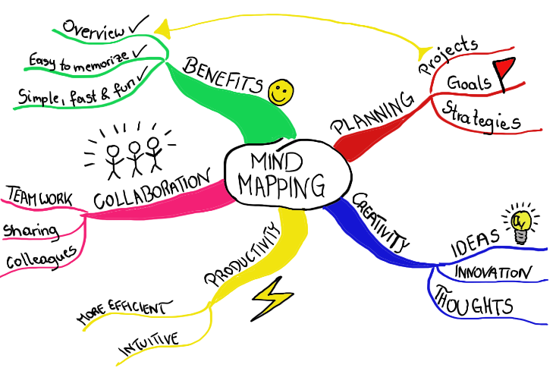 Or just Visiso version of it

1. Do not copy paste write notes. Event twice king love to write twice.
2. Clear mind. Be king.(If some bad thoughts are districting you Image I happens in your way this in past or imagen great future.)
3. Focus on Keyword ( SEX,SEX,SEX) or (Patterns, Patterns, Patterns)
4. Learn most importing thing first.