|  |  |
| --- | --- |
| 1. | Flex is a Transducer. Explain what this means and, in the context of a programming language, why it is important.  A transducer, in the context of computer science, refers to a device or an algorithm that transforms input data into a different form or representation. Flex, also known as the Fast Lexical Analyzer, is a specific kind of transducer known as a lexical analyzer or lexer. It converts a sequence of input characters (usually source code) into a sequence of tokens.  Tokens are meaningful units in a programming language, such as keywords, identifiers, literals, and operators. The lexer's primary role is to simplify the job of the parser, which processes tokens according to a set of grammar rules and builds an abstract syntax tree (AST) that represents the structure of the input code. This AST can then be used for further processing, such as semantic analysis, optimization, and code generation.  In the context of a programming language, a lexer like Flex is important for several reasons:   * Tokenization: Lexers convert raw input text into a structured sequence of tokens, making it easier for the parser to understand and analyze the input.   Error detection: While tokenizing the input, a lexer can also detect and report lexical errors, such as invalid character sequences or unclosed strings.   * Efficiency: By breaking down the input into tokens, a lexer helps improve the overall efficiency of the compilation process. Lexers are typically designed for fast and efficient scanning of the input text, enabling quicker parsing and code generation. * Modularity: Separating lexical analysis from parsing allows for a more modular and maintainable compiler design. Changes to the language's syntax or token set can be isolated to the lexer, without affecting the parser or other components.   In summary, Flex and other transducers are essential components in the design of programming language compilers and interpreters, as they help convert raw input text into structured tokens, enabling more efficient and modular processing of code. |
| 2. | Discuss the role the y.tab.h file plays in a FLEX/BISON parser.  In a Flex/Bison parser, the y.tab.h file plays a crucial role in facilitating communication between the lexer (generated by Flex) and the parser (generated by Bison). It serves as a bridge that allows both components to work together seamlessly.  When you create a grammar using Bison, it generates two files: y.tab.c and y.tab.h. The y.tab.c file contains the actual parser code, while the y.tab.h file contains definitions, declarations, and other necessary information for the lexer to interact with the parser.  Here are some key aspects of the y.tab.h file in a Flex/Bison parser:   * Token Definitions: The y.tab.h file contains definitions of the tokens used by the parser. These tokens are typically represented by integer constants and are generated by Bison based on the grammar rules you provide. The lexer uses these token definitions to classify and return the appropriate token types when it encounters them in the input text. * Semantic Values: The y.tab.h file also includes the definition of the YYSTYPE union. This union is used to store the semantic values (or attributes) associated with the tokens. When the lexer recognizes a token, it can attach additional information to it, such as the actual value of a number or the string representation of an identifier. This information is then used by the parser to build the abstract syntax tree (AST) or perform other actions based on the grammar rules. * Function Prototypes: The y.tab.h file contains the prototypes for the yylex() and yyerror() functions. yylex() is the function generated by Flex that the parser calls to fetch the next token, while yyerror() is a user-defined function that handles parsing errors. Including these prototypes in the y.tab.h file ensures that the parser can correctly call these functions during the parsing process.   In summary, the y.tab.h file acts as an interface between the lexer and parser in a Flex/Bison combination. It contains token definitions, semantic value structures, and function prototypes that enable smooth interaction between the two components, ensuring the correct and efficient parsing of the input text. |

1. Explain the roles of yytext and yyin in a parser built using Flex and Bison.

In a parser built using Flex and Bison, yytext and yyin are variables used by the lexer (generated by Flex) to manage the input text and the input stream, respectively. Here's a brief explanation of their roles:

* yytext: yytext is a pointer to a null-terminated character array (a C-style string) that contains the text of the most recently matched token. When the lexer recognizes a token in the input stream, it stores the corresponding character sequence in yytext. The parser or other parts of the lexer may then access this text to perform further processing or store additional information. For example, when the lexer encounters an identifier, it can use yytext to pass the identifier's name to the parser, which can then be used for semantic analysis, symbol table management, or other tasks.
* yyin: yyin is a file pointer (of type FILE*) that points to the input stream from which the lexer reads its input. By default, yyin is set to stdin, which means that the lexer reads from the standard input. However, you can change the value of yyin to point to a different input source, such as a file or a memory buffer, by assigning it a new file pointer. This flexibility allows you to easily adapt the lexer to read input from various sources without modifying its internal logic. For example, if you want to read input from a file, you can open the file using the fopen() function and assign the resulting file pointer to yyin before calling the yylex() function to start the lexical analysis.

In summary, yytext and yyin are essential variables in a Flex-generated lexer that help manage the input text and input stream, respectively. They provide a means to access the matched tokens' text and control the source of input for the lexer, allowing for efficient and flexible lexical analysis in a Flex and Bison-based parser.

1. Explain how Lex (or Flex) and Yacc (or Bison) achieve a common knowledge of their tokens' names and their tokens' types.

Lex (or Flex) and Yacc (or Bison) achieve a common knowledge of their tokens' names and types through a shared header file. This header file is typically generated by the parser generator (Yacc or Bison) and includes token definitions and data type declarations that both the lexer and parser can use.

Here's a step-by-step explanation of how the process works:

* 1. **Define tokens in the parser file**: In the Yacc or Bison parser input file (.y), you define the tokens and their corresponding names. This is done using the `%token` directive, followed by the token names. Additionally, you can use `%left`, `%right`, or `%nonassoc` directives to specify associativity and precedence for tokens representing operators.
* 2. **Generate the header file**: When you run Yacc or Bison on the parser input file, it generates two files: a parser implementation file (y.tab.c or a similar name) and a header file (y.tab.h or a similar name). The header file contains the token definitions as integer constants, along with any data type declarations for the semantic values associated with the tokens (such as YYSTYPE).
* 3. **Include the header file in the lexer**: In the Lex or Flex lexer input file (.l), you include the generated header file using the C preprocessor directive `#include`. This makes the token definitions and data type declarations available to the lexer, allowing it to classify and return the appropriate token types and values when it encounters them in the input text.
* 4. **Use token names in the lexer**: After including the header file, the lexer can use the token names defined in the parser file to return tokens to the parser. When the lexer recognizes a token, it returns the corresponding integer constant, which the parser then uses to match grammar rules and perform actions.
* 5. **Semantic value types**: In the parser file, you can define the data types for semantic values using the `%union` directive. The YYSTYPE data type is then defined as a union of these types. The lexer and parser use YYSTYPE to store and exchange the semantic values associated with tokens.

By following these steps, Lex (or Flex) and Yacc (or Bison) establish a shared understanding of token names and types, ensuring seamless communication between the lexer and parser components. The generated header file acts as a bridge between the two, providing the necessary definitions and declarations for efficient and accurate token processing.

1. Describe the guidelines you should adhere to when creating (pseudo) code for a recursive descent grammar that uses a look-ahead of 1.

A recursive descent parser is a top-down parsing technique that starts with the start symbol of the grammar and attempts to generate the input string by applying grammar rules recursively. For a recursive descent grammar with a look-ahead of 1, the parser uses a single token of look-ahead to decide which production rule to apply at each step. Here are some guidelines to follow when creating (pseudo) code for a recursive descent parser with a look-ahead of 1:

One function per nonterminal: Create a separate function for each nonterminal in the grammar. Each function is responsible for recognizing the language generated by the corresponding nonterminal and applying the appropriate production rules.

Predictive parsing: Make sure the grammar is suitable for predictive parsing, which means that there should be no left recursion or common prefixes in the production rules. This ensures that the parser can unambiguously determine which rule to apply based on the current look-ahead token.

Handle terminals: Within each nonterminal function, use conditional statements (e.g., if or switch) to check the current look-ahead token and determine which production rule to apply. If the look-ahead token matches a terminal in the grammar, consume the token and update the look-ahead.

Recursive calls: When a production rule consists of a sequence of nonterminals, make recursive calls to the corresponding nonterminal functions in the order they appear in the rule. This allows the parser to process the input according to the grammar's structure.

Error handling: Implement error handling mechanisms to provide meaningful error messages when the input doesn't conform to the grammar. This may involve detecting unexpected tokens, synchronizing the parser to a known point in the input, and reporting the error to the user.

End of input: Ensure that the parser correctly detects the end of the input stream. When the parser reaches the end of the input, it should confirm that the entire input has been successfully processed, and no unmatched tokens remain.

|  |  |  |
| --- | --- | --- |
| 6. | LR(1) is infeasible as a basis for parsing real-life programming languages. Explain why, illustrating your answer by means of example (partial) Finite State Machines  . | |
|  | 7.Describe the LALR(1) and SLR(1) alternatives to LR(1), illustrating how they deal with the problem. | |
|  |  | |
|  | 8. Explain, again by means of an example, the common-prefix problem in LL(1) parsing, and how it might be overcome. | |
| 1. Detail the three sections of the YACC/Bison file in terms of what they provide for the generated C file   A YACC (Yet Another Compiler Compiler) or Bison file consists of three sections, each serving a specific purpose in the generation of the C file containing the parser code. These sections are separated by the %% delimiter. Here is a detailed overview of the three sections:  Definitions Section: The first section of the YACC/Bison file is the definitions section, where you can define various constructs to be used by the parser, including:   * Token names and types: You can define token names using the %token directive, which will be recognized by the parser and used in grammar rules. You can also define token types using %left, %right, or %nonassoc directives to specify precedence and associativity for tokens representing operators. * Union declarations: You can define the data types for the semantic values associated with the tokens using the %union directive. This will create a YYSTYPE union in the generated C file to store and exchange the semantic values between the lexer and parser. * Start symbol: You can define the start symbol of the grammar using the %start directive, which tells the parser where to begin parsing.   Precedence and associativity: You can set the precedence and associativity levels of operators using the %prec directive.   * C code: You can include C code, such as header file includes, function prototypes, global variable declarations, or helper functions, within the %{ ... %} block. This code will be copied verbatim to the generated C file and be accessible to the parser. * Rules Section: The second section of the YACC/Bison file contains the grammar rules. Each rule consists of a nonterminal symbol, followed by the : symbol, a sequence of terminal and nonterminal symbols, and an action enclosed in curly braces { ... }. The action is C code that will be executed when the parser applies the corresponding rule. The rules section allows you to define the structure of the language being parsed and specify the actions to be taken during parsing, such as building an abstract syntax tree (AST), evaluating expressions, or managing a symbol table. * User Code Section: The third section of the YACC/Bison file contains additional C code that will be copied to the generated C file. This code is typically used to define the main() function, error-reporting functions (such as yyerror()), or other helper functions required by the parser. The user code section allows you to integrate the generated parser code with other parts of your application.   In summary, the three sections of a YACC/Bison file provide the necessary constructs, rules, and user code for generating the C file containing the parser code. The definitions section allows you to set up tokens, data types, and other parser-related constructs, the rules section defines the grammar rules and actions to be taken during parsing, and the user code section provides additional code for integration with your application. | |
| 1. Discuss the role that yytext and YYSTYPE plays in FLEX/BISON parsers   yytext is a global variable provided by FLEX, the lexer. It is a pointer to a null-terminated string that contains the text of the matched token. Whenever FLEX recognizes a token from the input stream according to the lexer rules, it stores the token's text in yytext. In the actions associated with lexer rules, yytext can be used to access the actual text of the token for further processing or to assign a semantic value to the token.  YYSTYPE is a macro used in BISON parsers to define the data type of semantic values associated with tokens and nonterminal symbols. By default, YYSTYPE is defined as an alias for int. However, you can redefine it using the %union directive in the BISON file to create a union of different data types that can be used for semantic values. | |
| 11 | Describe the core problem associated with top-down parsing, giving examples | |
| 12. | Describe the core problem associated with bottom-up parsing, giving examples  R(1)解析器通常对大部分文法工作得很好，但在某些情况下，它可能无法很好地解决某些问题。主要问题是LR(1)解析器在处理某些文法时可能会生成庞大的解析表，这会导致以下问题：  内存消耗：大量的状态和项目可能会导致解析表占用大量内存，这可能成为资源受限环境中的问题。  复杂性：管理LR(1)项目和状态之间的转换的复杂性可能使解析器更难理解、实现和维护。  编译时间：构建LR(1)解析表可能在计算上相当昂贵，这可能导致依赖LR(1)解析器的语言的编译时间较长。  因此，LR(1)解析器可能无法很好地解决解析实际编程语言时遇到的大解析表和高内存消耗等问题。为了解决这些问题，通常使用其他技术，如LALR(1)或SLR(1)解析器。这些解析器通过合并相似状态或使用更简单的前瞻令牌处理规则来减少状态和项目的数量，从而实现更高效和实用的解析器。 | |

13 Detail the role that y.tab.h plays in Lex/Yacc parser construction and the flag required for it’s creation.

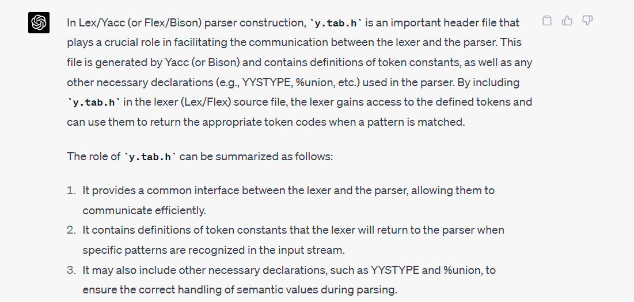

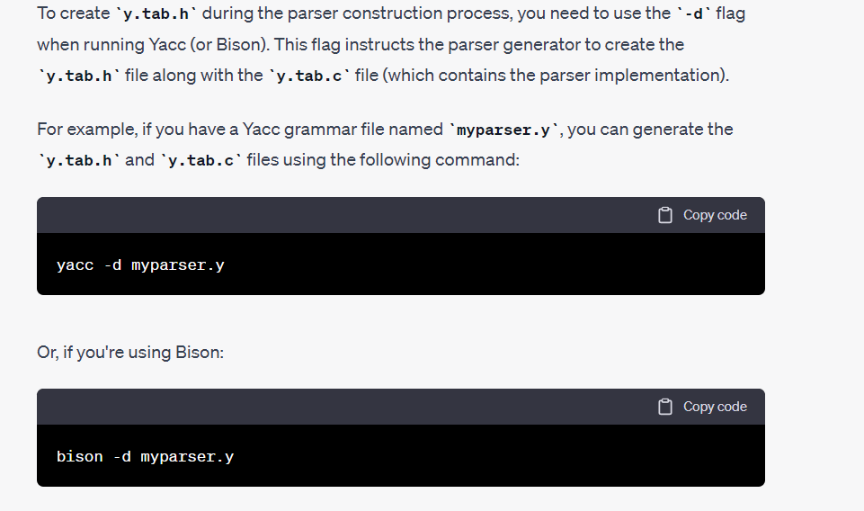

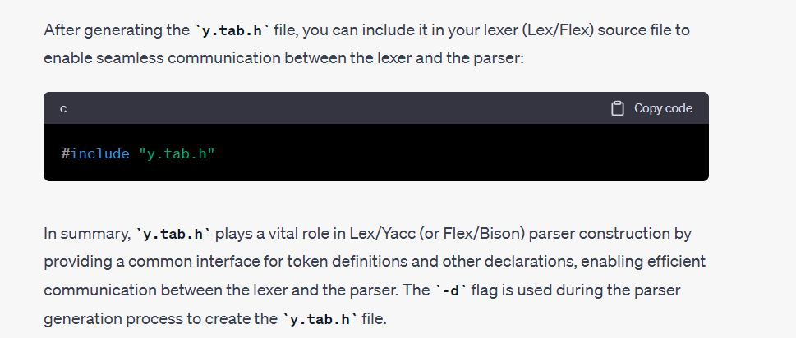

14 Describe how you can achieve case-insensitive variable names, method names, class names etc., in a lexer.

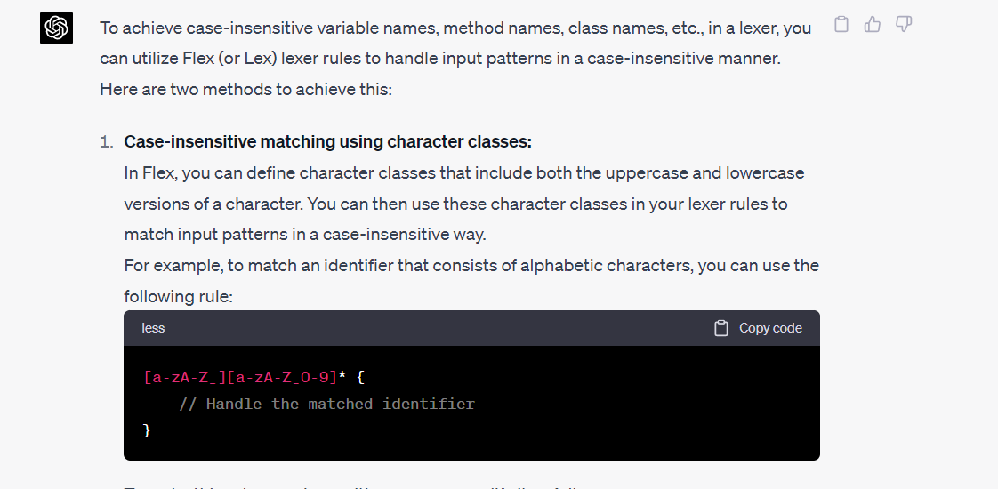

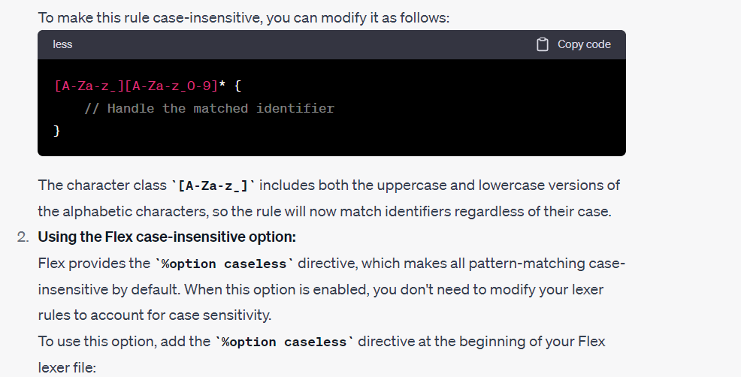

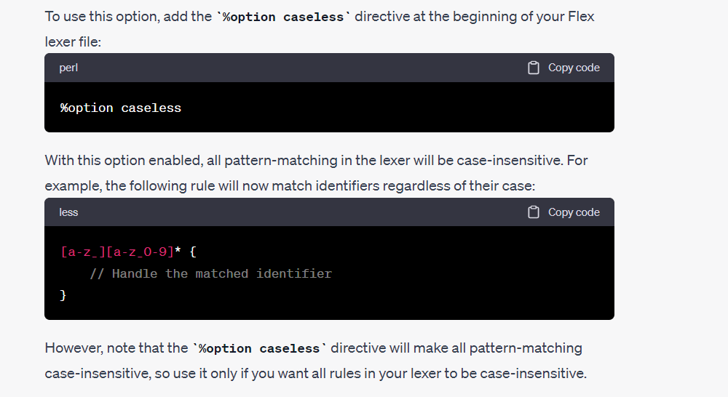

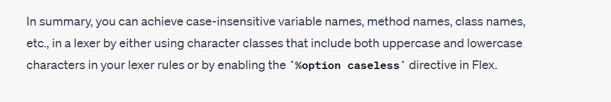

15 Describe three of Chomsky’s core breakthroughs in the field of parsing