Additional file list
Table S1. Results of the three Mendelian randomization methods in the discovery phase.
Table S2. Results of MR Egger intercept horizontal pleiotropy test at the discovery stage level
Table S3. Results of heterogeneity test at the discovery phase.
Table S4. Results of the three Mendelian randomization methods in the replication phase.
Table S5. Results of MR Egger intercept horizontal pleiotropy test at the replication stage level
Table S6. Results of heterogeneity test at the replication phase.
Figure S1-S14. PheWAS results for each gene.

Table S1. Results of the three Mendelian randomization methods in the discovery phase.
Gene | Methods | No.SNPs | Beta | SE | P Value
ANTXR2 | MR Egger | 16 | -0.12636 | 0.07913 | 0.132609
ANTXR2 | Weighted median | 16 | -0.19622 | 0.051499 | 0.000139
ANTXR2 | IVW | 16 | -0.17462 | 0.038879 | 7.08E-06
APP | MR Egger | 21 | 0.078384 | 0.103002 | 0.456002
APP | Weighted median | 21 | 0.181168 | 0.059953 | 0.002512
APP | IVW | 21 | 0.238295 | 0.045501 | 1.63E-07
ATP2A1 | IVW | 2 | 0.607882 | 0.13608 | 7.93E-06
BRSK1 | MR Egger | 5 | 0.065398 | 0.460402 | 0.896047
BRSK1 | Weighted median | 5 | -0.25737 | 0.096046 | 0.007371
BRSK1 | IVW | 5 | -0.33664 | 0.074662 | 6.52E-06
C5 | MR Egger | 21 | -0.06275 | 0.086034 | 0.474656
C5 | Weighted median | 21 | -0.09412 | 0.027754 | 0.000696
C5 | IVW | 21 | -0.10751 | 0.02508 | 1.81E-05
CCR6 | MR Egger | 16 | 0.539383 | 0.094837 | 5.61E-05
CCR6 | Weighted median | 16 | 0.50607 | 0.065593 | 1.21E-14
CCR6 | IVW | 16 | 0.4029 | 0.054052 | 9.06E-14
CD226 | MR Egger | 31 | -0.02262 | 0.058786 | 0.703267
CD226 | Weighted median | 31 | -0.15613 | 0.036704 | 2.10E-05
CD226 | IVW | 31 | -0.17504 | 0.028449 | 7.62E-10
CD28 | IVW | 2 | 0.706546 | 0.158581 | 8.37E-06
CDK4 | Wald ratio | 1 | -1.30714 | 0.298156 | 1.16E-05
CTLA4 | MR Egger | 5 | -0.58647 | 0.976461 | 0.590448
CTLA4 | Weighted median | 5 | -0.4832 | 0.112742 | 1.82E-05
CTLA4 | IVW | 5 | -0.62627 | 0.111769 | 2.10E-08
CYP21A2 | Wald ratio | 1 | 0.45379 | 0.06338 | 8.08E-13
DNMT3A | MR Egger | 9 | -0.43661 | 0.261043 | 0.138333
DNMT3A | Weighted median | 9 | -0.37642 | 0.128494 | 0.003395
DNMT3A | IVW | 9 | -0.45764 | 0.096719 | 2.23E-06
FCGR2B | MR Egger | 21 | 0.133806 | 0.039844 | 0.003302
FCGR2B | Weighted median | 21 | 0.09758 | 0.025495 | 0.000129
FCGR2B | IVW | 21 | 0.103828 | 0.02037 | 3.45E-07
FEN1 | Wald ratio | 1 | 1.944697 | 0.372785 | 1.82E-07
GAK | MR Egger | 6 | -0.0227 | 0.291178 | 0.941594
GAK | Weighted median | 6 | -0.44411 | 0.149249 | 0.002924
GAK | IVW | 6 | -0.47916 | 0.110262 | 1.39E-05
GPNMB | MR Egger | 10 | -0.11704 | 0.094492 | 0.250606
GPNMB | Weighted median | 10 | -0.11885 | 0.032075 | 0.000211
GPNMB | IVW | 10 | -0.12711 | 0.027856 | 5.03E-06
HLA-DPA1 | MR Egger | 4 | 0.260747 | 0.090807 | 0.1029
HLA-DPA1 | Weighted median | 4 | 0.392726 | 0.020296 | 2.06E-83
HLA-DPA1 | IVW | 4 | 0.412114 | 0.042424 | 2.62E-22
HLA-DRB1 | Wald ratio | 1 | -0.91368 | 0.029095 | 1.85E-216
HLCS | MR Egger | 39 | -0.06307 | 0.052786 | 0.239775
HLCS | Weighted median | 39 | -0.09484 | 0.034767 | 0.006373
HLCS | IVW | 39 | -0.1077 | 0.023363 | 4.02E-06
HSPA1B | Wald ratio | 1 | 1.177701 | 0.104664 | 2.26E-29
IFNGR2 | MR Egger | 17 | -0.19952 | 0.043097 | 0.000327
IFNGR2 | Weighted median | 17 | -0.16884 | 0.024551 | 6.11E-12
IFNGR2 | IVW | 17 | -0.17077 | 0.020903 | 3.09E-16
ITGA9 | MR Egger | 23 | 0.28827 | 0.11857 | 0.02409
ITGA9 | Weighted median | 23 | 0.208665 | 0.057686 | 0.000298
ITGA9 | IVW | 23 | 0.234941 | 0.041333 | 1.31E-08
ITPR3 | MR Egger | 27 | -0.32213 | 0.143901 | 0.034327
ITPR3 | Weighted median | 27 | -0.23358 | 0.030993 | 4.82E-14
ITPR3 | IVW | 27 | -0.25617 | 0.057732 | 9.11E-06
LGALS9 | MR Egger | 16 | 0.073046 | 0.033853 | 0.048806
LGALS9 | Weighted median | 16 | 0.066431 | 0.019089 | 0.000501
LGALS9 | IVW | 16 | 0.071545 | 0.015812 | 6.05E-06
MAST2 | MR Egger | 7 | 0.175848 | 0.226825 | 0.473241
MAST2 | Weighted median | 7 | 0.392007 | 0.105839 | 0.000212
MAST2 | IVW | 7 | 0.405627 | 0.093559 | 1.45E-05
MMEL1 | MR Egger | 13 | 0.005057 | 0.072804 | 0.945871
MMEL1 | Weighted median | 13 | 0.179664 | 0.025958 | 4.48E-12
MMEL1 | IVW | 13 | 0.163914 | 0.034959 | 2.75E-06
NOTCH4 | Wald ratio | 1 | 0.893053 | 0.157564 | 1.45E-08
OPRL1 | MR Egger | 9 | -0.14981 | 0.138931 | 0.316648
OPRL1 | Weighted median | 9 | -0.14201 | 0.035568 | 6.54E-05
OPRL1 | IVW | 9 | -0.1324 | 0.030936 | 1.87E-05
PAM | MR Egger | 35 | -0.05642 | 0.033972 | 0.106229
PAM | Weighted median | 35 | -0.07081 | 0.014348 | 8.02E-07
PAM | IVW | 35 | -0.06811 | 0.01138 | 2.17E-09
PSMB7 | IVW | 2 | -0.50319 | 0.103329 | 1.12E-06
SIGLEC6 | MR Egger | 5 | -0.24957 | 0.260662 | 0.408968
SIGLEC6 | Weighted median | 5 | -0.35222 | 0.08529 | 3.63E-05
SIGLEC6 | IVW | 5 | -0.383 | 0.070977 | 6.81E-08
TSSK6 | Wald ratio | 1 | 0.50027 | 0.10524 | 2.00E-06

Table S2. Results of MR Egger intercept horizontal pleiotropy test at the discovery stage level
Gene | Intercept | SE | P Value
CTLA4 | -0.00547 | 0.133114 | 0.969781
MMEL1 | 0.068101 | 0.028509 | 0.035941
MAST2 | 0.02271 | 0.020422 | 0.316715
APP | 0.022155 | 0.012802 | 0.099746
HLA-DPA1 | 0.116093 | 0.065096 | 0.216455
PAM | -0.0072 | 0.019678 | 0.716929
HLCS | -0.01079 | 0.011446 | 0.351785
CD226 | -0.02999 | 0.010359 | 0.007128
OPRL1 | 0.00601 | 0.046642 | 0.901096
ANTXR2 | -0.0101 | 0.014419 | 0.495312
LGALS9 | -0.00078 | 0.015493 | 0.960513
GPNMB | -0.00356 | 0.031928 | 0.913884
DNMT3A | -0.00156 | 0.018039 | 0.933321
FCGR2B | -0.01379 | 0.015724 | 0.391306
CCR6 | -0.02108 | 0.012361 | 0.110137
ITGA9 | -0.00657 | 0.013693 | 0.636284
GAK | -0.04526 | 0.026719 | 0.16556
ITPR3 | 0.024254 | 0.048328 | 0.620163
IFNGR2 | 0.012821 | 0.016803 | 0.457295
SIGLEC6 | -0.01606 | 0.029999 | 0.629448
C5 | -0.01618 | 0.029699 | 0.592218

Table S3. Results of heterogeneity test at the discovery phase
Gene | Methods | Q Value | Q df | P Value
ITPR3 | IVW | 532.9502 | 26 | 5.23E-96
ITPR3 | MR Egger | 527.6347 | 25 | 1.42E-95
HLA-DPA1 | IVW | 17.30186 | 3 | 0.000613
C5 | MR Egger | 42.42904 | 19 | 0.001551
C5 | IVW | 43.09188 | 20 | 0.001988
MMEL1 | IVW | 29.23627 | 12 | 0.003634
CTLA4 | MR Egger | 12.83029 | 3 | 0.005018
CTLA4 | IVW | 12.83752 | 4 | 0.012098
HLA-DPA1 | MR Egger | 6.679496 | 2 | 0.035446
MMEL1 | MR Egger | 19.25038 | 11 | 0.056745
CCR6 | IVW | 23.04562 | 15 | 0.083176
PAM | MR Egger | 42.134 | 33 | 0.132402
FCGR2B | MR Egger | 25.69854 | 19 | 0.13881
FCGR2B | IVW | 26.73944 | 20 | 0.142755
PAM | IVW | 42.30475 | 34 | 0.155162
CCR6 | MR Egger | 19.08036 | 14 | 0.161901
CD226 | IVW | 35.47713 | 30 | 0.225694
CD28 | IVW | 1.22813 | 1 | 0.267771
SIGLEC6 | MR Egger | 3.494629 | 3 | 0.321459
PSMB7 | IVW | 0.927918 | 1 | 0.335404
OPRL1 | MR Egger | 7.705909 | 7 | 0.359239
LGALS9 | MR Egger | 14.50871 | 14 | 0.412539
SIGLEC6 | IVW | 3.828689 | 4 | 0.429686
OPRL1 | IVW | 7.724187 | 8 | 0.460866
APP | IVW | 19.93938 | 20 | 0.461728
LGALS9 | IVW | 14.51135 | 15 | 0.487153
HLCS | MR Egger | 36.16993 | 37 | 0.507772
HLCS | IVW | 37.05923 | 38 | 0.512801
ANTXR2 | MR Egger | 13.15423 | 14 | 0.514417
ATP2A1 | IVW | 0.406904 | 1 | 0.523545
GAK | IVW | 3.995711 | 5 | 0.550034
ANTXR2 | IVW | 13.64442 | 15 | 0.55265
BRSK1 | MR Egger | 2.091199 | 3 | 0.553695
CD226 | MR Egger | 27.0944 | 29 | 0.566612
BRSK1 | IVW | 2.874341 | 4 | 0.57907
APP | MR Egger | 16.94467 | 19 | 0.593617
MAST2 | IVW | 3.574965 | 6 | 0.733971
DNMT3A | MR Egger | 4.07695 | 7 | 0.770873
MAST2 | MR Egger | 2.338358 | 5 | 0.800617
IFNGR2 | MR Egger | 9.653961 | 15 | 0.840924
DNMT3A | IVW | 4.084471 | 8 | 0.849423
IFNGR2 | IVW | 10.23613 | 16 | 0.854009
GPNMB | MR Egger | 3.830347 | 8 | 0.872096
GAK | MR Egger | 1.126856 | 4 | 0.889988
GPNMB | IVW | 3.842803 | 9 | 0.921451
ITGA9 | MR Egger | 11.94748 | 21 | 0.941025
ITGA9 | IVW | 12.17775 | 22 | 0.953599

Table S4. Results of the three Mendelian randomization methods in the replication phase.
Gene | Methods | No.SNPs | Beta | SE | P Value
ATP2A1 | IVW | 2 | 0.823317 | 0.169218 | 1.14E-06
C5 | MR Egger | 20 | -0.06638 | 0.0674 | 0.337725
C5 | Weighted median | 20 | -0.14064 | 0.026469 | 1.08E-07
C5 | IVW | 20 | -0.12278 | 0.019135 | 1.39E-10
CCR6 | MR Egger | 16 | 0.609868 | 0.131378 | 0.000381
CCR6 | Weighted median | 16 | 0.541994 | 0.073855 | 2.16E-13
CCR6 | IVW | 16 | 0.373677 | 0.075262 | 6.87E-07
CTLA4 | MR Egger | 4 | 0.018632 | 1.5952 | 0.991741
CTLA4 | Weighted median | 4 | -0.65166 | 0.157539 | 3.53E-05
CTLA4 | IVW | 4 | -0.69408 | 0.188987 | 0.00024
FCGR2B | MR Egger | 20 | 0.112895 | 0.049665 | 0.035504
FCGR2B | Weighted median | 20 | 0.122985 | 0.026914 | 4.89E-06
FCGR2B | IVW | 20 | 0.133333 | 0.025303 | 1.37E-07
FEN1 | Wald ratio | 1 | 2.124276 | 0.545901 | 9.97E-05
HLA-DPA1 | MR Egger | 4 | 0.127964 | 0.074185 | 0.226681
HLA-DPA1 | Weighted median | 4 | 0.306453 | 0.028923 | 3.12E-26
HLA-DPA1 | IVW | 4 | 0.326198 | 0.046162 | 1.59E-12
HLA-DRB1 | MR Egger | 5 | -0.31091 | 0.694482 | 0.684731
HLA-DRB1 | Weighted median | 5 | -0.41914 | 0.047675 | 1.48E-18
HLA-DRB1 | IVW | 5 | -0.5122 | 0.145203 | 0.00042
HLCS | MR Egger | 42 | 0.118136 | 0.046523 | 0.015099
HLCS | Weighted median | 42 | 0.085206 | 0.031705 | 0.0072
HLCS | IVW | 42 | 0.067785 | 0.02096 | 0.001221
IFNGR2 | MR Egger | 19 | -0.12639 | 0.041933 | 0.007817
IFNGR2 | Weighted median | 19 | -0.07331 | 0.026207 | 0.005155
IFNGR2 | IVW | 19 | -0.06857 | 0.020249 | 0.000708
ITPR3 | MR Egger | 27 | -0.20533 | 0.206121 | 0.328719
ITPR3 | Weighted median | 27 | -0.29446 | 0.043842 | 1.86E-11
ITPR3 | IVW | 27 | -0.28573 | 0.08269 | 0.000549
OPRL1 | MR Egger | 8 | -0.34406 | 0.115889 | 0.024994
OPRL1 | Weighted median | 8 | -0.13297 | 0.035448 | 0.000176
OPRL1 | IVW | 8 | -0.12019 | 0.031268 | 0.000121

Table S5. Results of MR Egger intercept horizontal pleiotropy test at the replication stage level
Gene | Intercept | SE | P Value
HLA-DRB1 | -0.15643 | 0.524219 | 0.784864
HLA-DPA1 | 0.153152 | 0.05364 | 0.1039
C5 | -0.02153 | 0.024666 | 0.39433
OPRL1 | 0.075527 | 0.037993 | 0.093988
HLCS | -0.01236 | 0.010194 | 0.232511
CCR6 | -0.0344 | 0.016377 | 0.054295
IFNGR2 | 0.024929 | 0.015833 | 0.133796
FCGR2B | 0.009425 | 0.019562 | 0.635751
ITPR3 | -0.02977 | 0.069695 | 0.672912

Table S6. Results of heterogeneity test at the replication phase.
Gene | Methods | Q Value | Q df | P Value
HLA-DRB1 | MR Egger | 684.6334 | 3 | 4.51E-148
HLA-DRB1 | IVW | 704.9555 | 4 | 2.95E-151
HLA-DPA1 | MR Egger | 1.209811 | 2 | 0.546126
HLA-DPA1 | IVW | 9.36182 | 3 | 0.024848
C5 | MR Egger | 10.42776 | 18 | 0.917046
C5 | IVW | 11.18933 | 19 | 0.917305
ATP2A1 | IVW | 0.815084 | 1 | 0.366621
OPRL1 | MR Egger | 5.198683 | 6 | 0.518595
OPRL1 | IVW | 9.150466 | 7 | 0.242033
CTLA4 | MR Egger | 12.28836 | 2 | 0.002146
CTLA4 | IVW | 13.53874 | 3 | 0.003605
HLCS | MR Egger | 33.08064 | 40 | 0.772645
HLCS | IVW | 34.55031 | 41 | 0.751347
CCR6 | MR Egger | 25.34462 | 14 | 0.031314
CCR6 | IVW | 33.33109 | 15 | 0.004223
IFNGR2 | MR Egger | 11.59525 | 17 | 0.824003
IFNGR2 | IVW | 14.07432 | 18 | 0.724234
FCGR2B | MR Egger | 38.50571 | 18 | 0.003318
FCGR2B | IVW | 39.00229 | 19 | 0.004414
ITPR3 | MR Egger | 665.1171 | 25 | 2.83E-124
ITPR3 | IVW | 669.9718 | 26 | 1.42E-124

Figure S1-S14. Results of PheWAS analysis for 7 genes. The bottom dashed line represents the Suggestive line and the top dashed line is the Significant line. Traits that exceeded the significant line were considered to be significantly associated with a gene. As can be seen, there were no significantly associated traits for any of the genes except ATP2A1, and information on traits significantly associated with ATP2A1 is shown in Table S7.
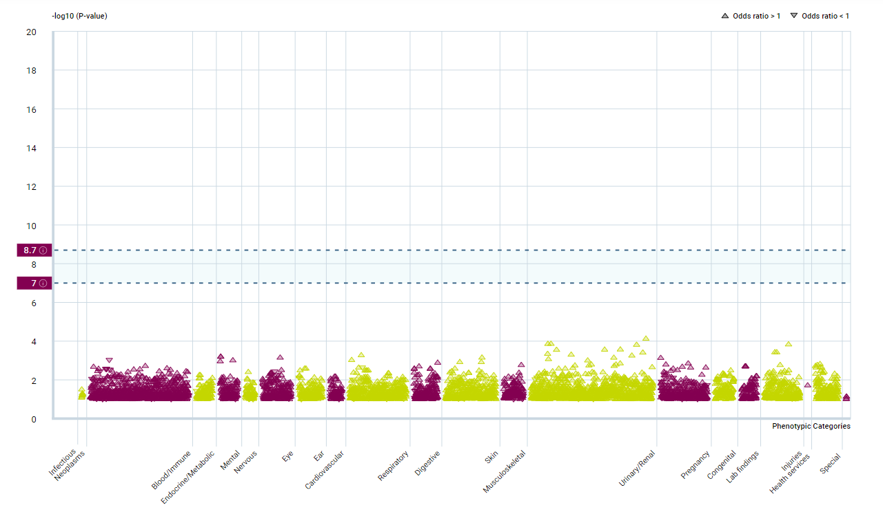
Figure S1.Binary traits PheWAS association with CCR6
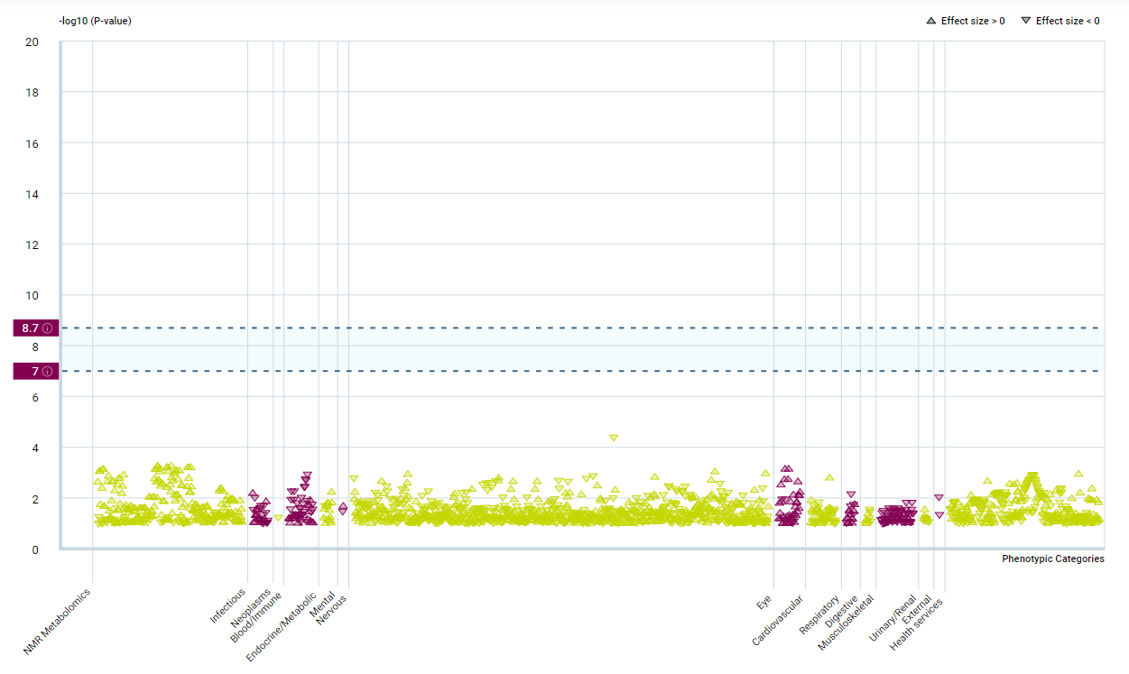
Figure S2. Continuous traits PheWAS association with CCR6
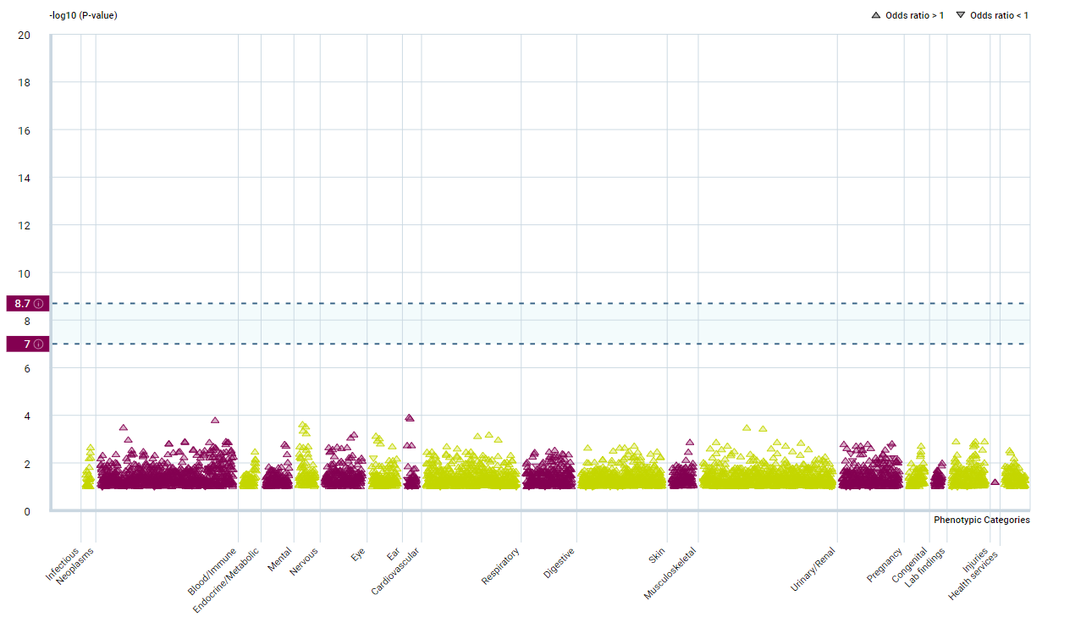 Figure S3. Binary traits PheWAS association with HLA-DPA1
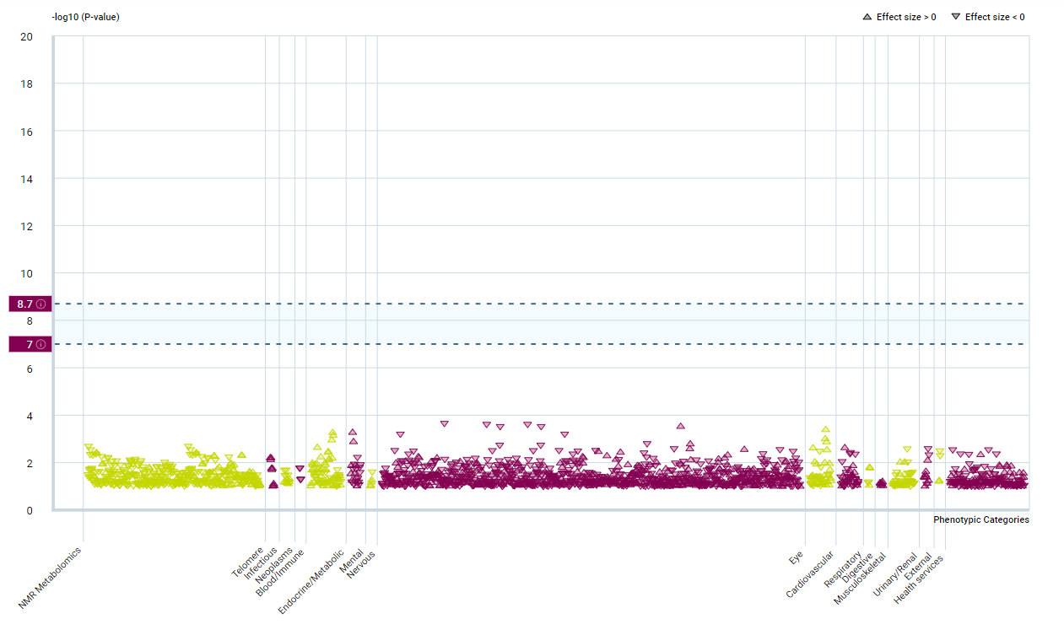
Figure S4. Continuous traits PheWAS association with HLA-DPA1

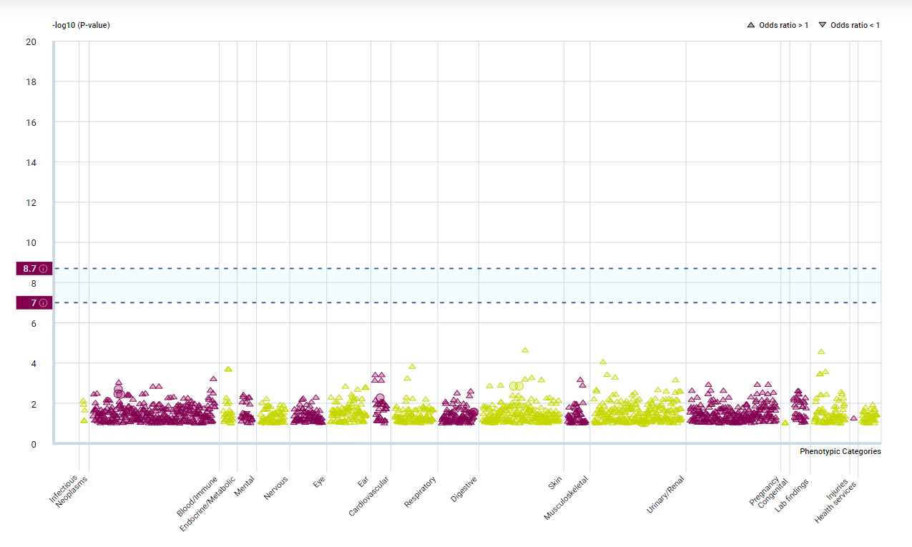
Figure S5. Binary traits PheWAS association with HLA-DRB1
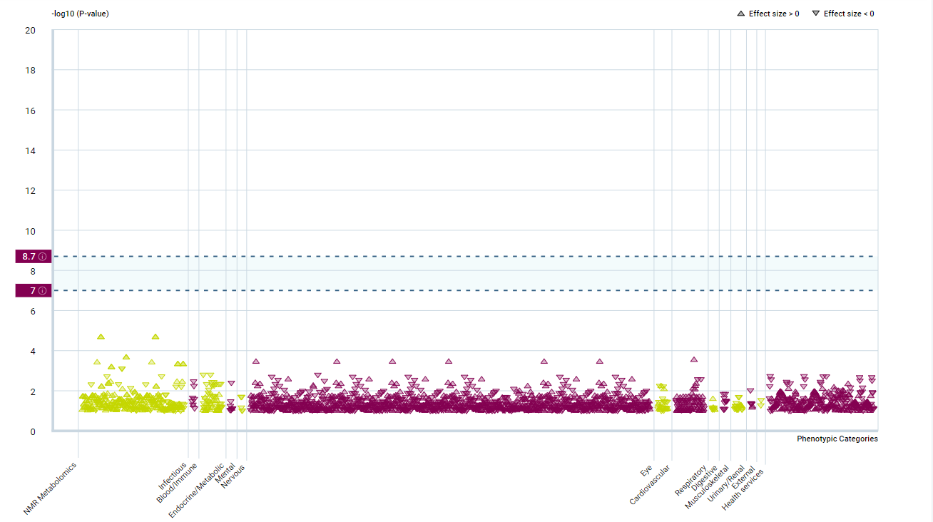
Figure S6. Continuous traits PheWAS association with HLA-DRB1
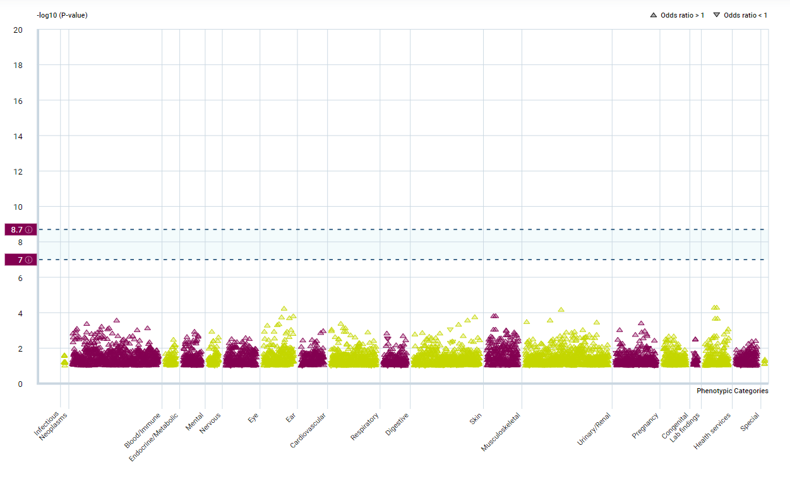
Figure S7. Binary traits PheWAS association with IFNGR2
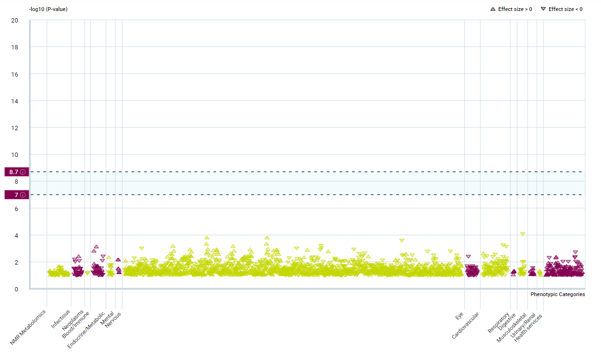
Figure S8. Continuous traits PheWAS association with IFNGR2
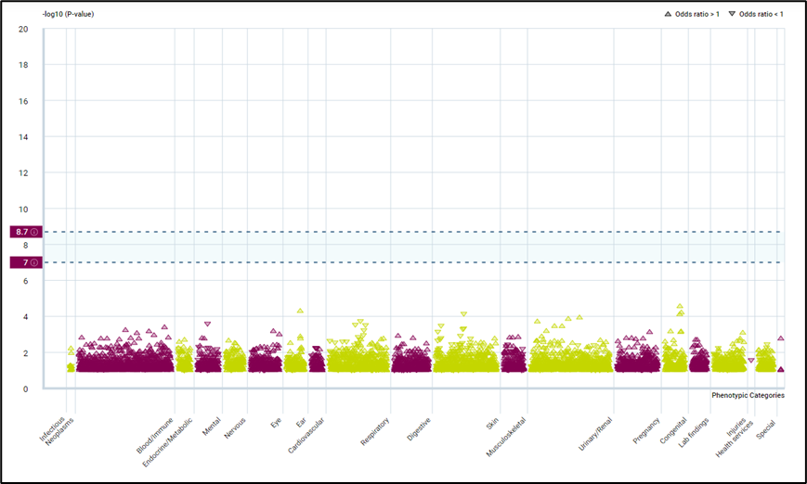Figure S9. Binary traits PheWAS association with C5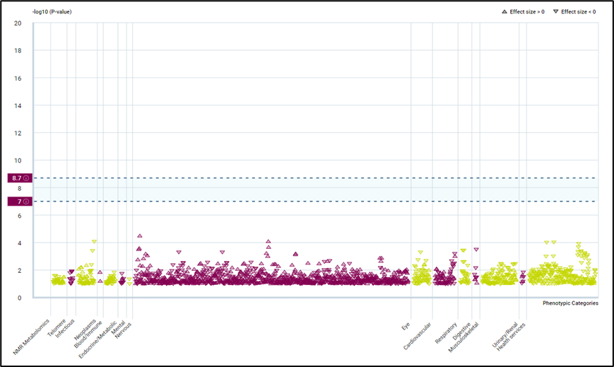
Figure S10. Continuous traits PheWAS association with C5

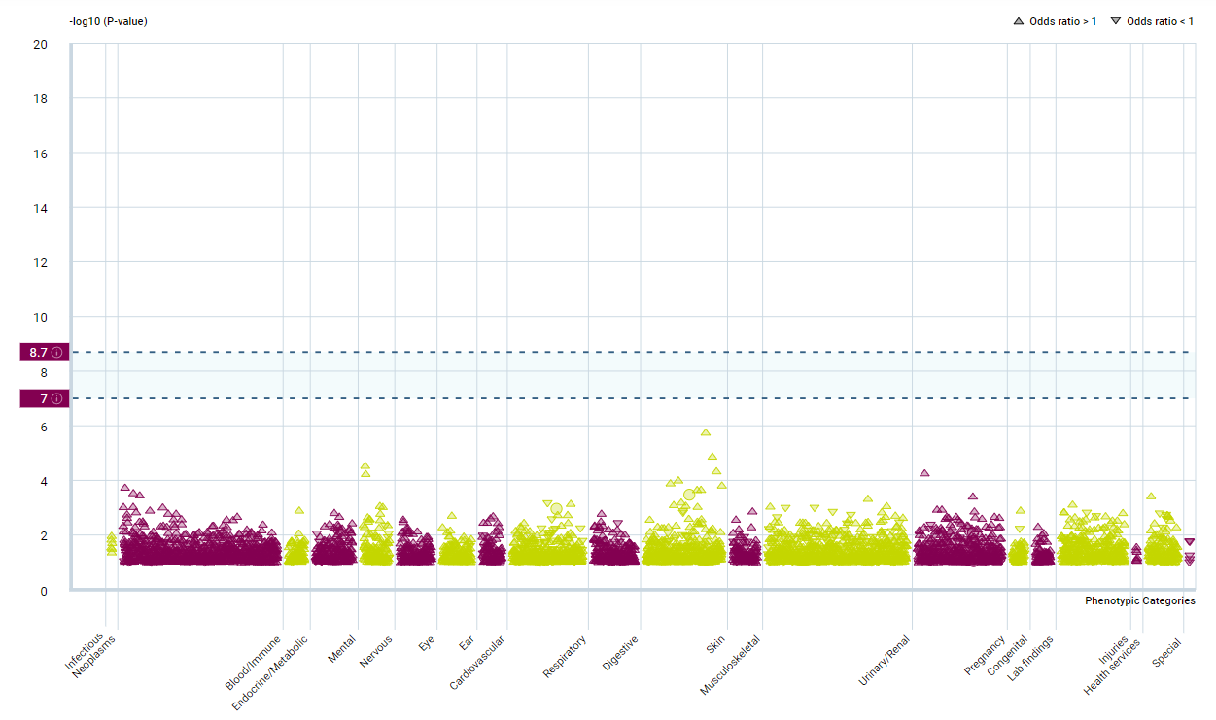
Figure S11. Binary traits PheWAS association with FEN1
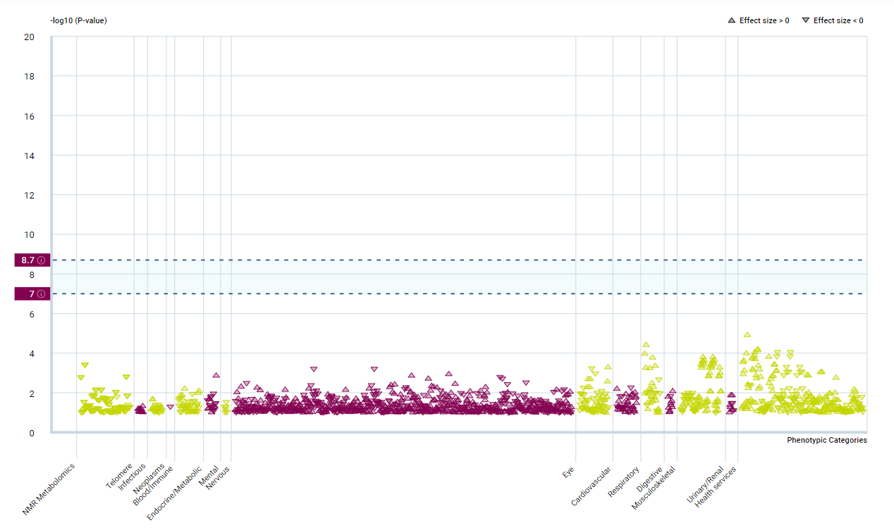 Figure S12. Continuous traits PheWAS association with FEN1
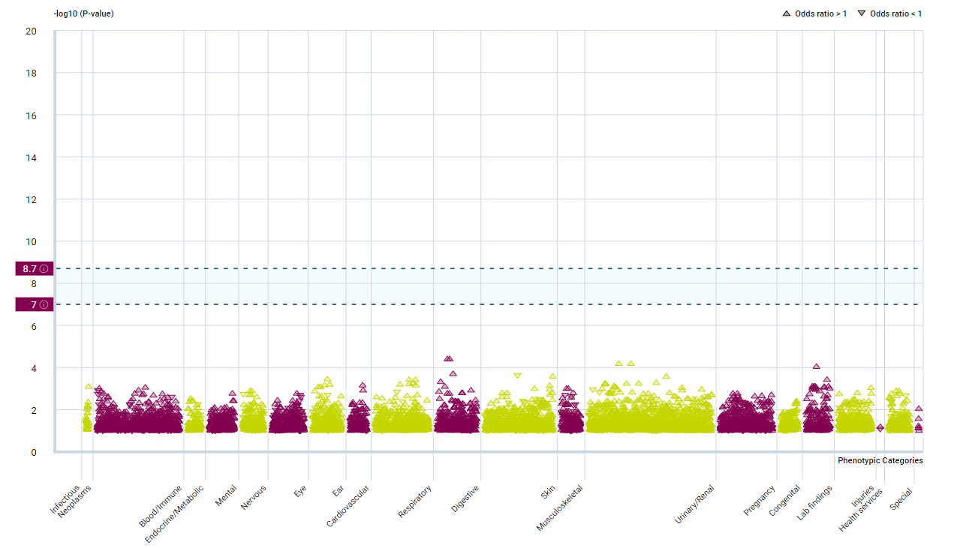
Figure S13. Binary traits PheWAS association with ATP2A1
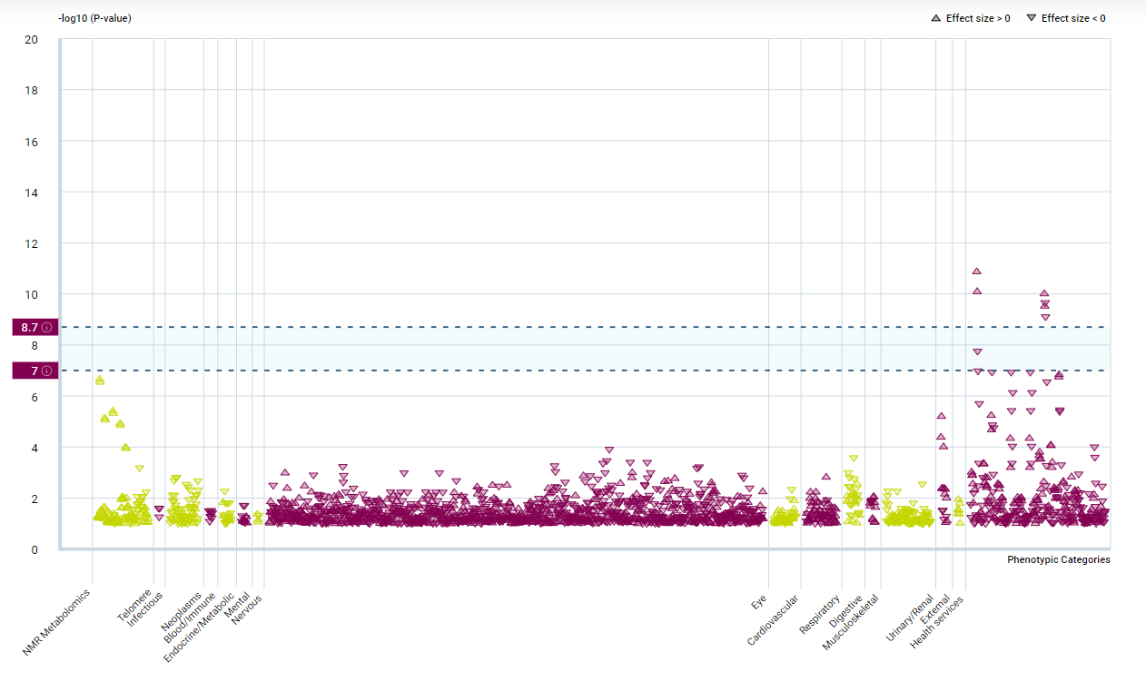
Figure S14. Continuous traits PheWAS association with ATP2A1

