
Liber version 2.1.1

Table of Contents
Sanguine Modules Mutants 1
The Modules 1
Aleae – Bernoulli Gates 1
The Controls 1
Knobs and buttons 2
Inputs and outputs 2
Apices – Multifunction Gap Filler 4
The Controls 4
Knobs and buttons 4
Inputs and outputs 7
The context menu 7
Bouncing ball mode 7
Parameters 8
Mutants Blank – Rack sleekerizer 9
Funes – Macro oscillator 10
The Controls 10
Knobs 10
Inputs and outputs 12
The context menu 14
Acknowledgments & thanks 16
Contact 17
Disclaimer 17
Licenses & Copyrights 18

Sanguine Modules Mutants
It is our sincere hope these modules excite you as much as they did us when creating them and fuel all your musical ventures!
In a hurry? If you are looking for the instructions for a specific module, use the handy provided table of contents. The modules are presented in alphabetical order.

The Modules

Aleae – Bernoulli Gates
A two channel randomizer for your voltages. Whenever a trigger is received in one of the two inputs, a virtual coin is tossed, its results affecting the output in different ways.
This handy utility module is great for generative patches or adding movement to your existing one.
This module can be driven at audio levels to create a noise generator.
This module is polyphonic and will produce a different coin toss for every channel present in the input.
We aim for this module to serve your chaotic needs!
Based on Mutable Instruments’ Branches.

The Controls
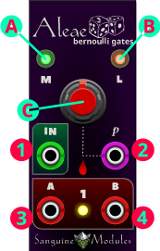
Aleae consists of two identical sections at the top and at the bottom, only the top section is pictured here.

Knobs and buttons
- COIN MODE: this button selects between the two available “coin toss” modes:
  - Direct mode: the LED in the coin mode button is lit green. Whenever a trigger is received, a virtual coin is tossed, if it lands on “heads” OUTPUT A (3) gets a trigger or gate (if LATCH MODE (B) is enabled); if the result is “tails” the trigger or gate goes to OUTPUT B (4).
  - Toggle mode: the LED in the coin mode button is lit red. In this mode the outcome of the coin toss works as follows:
    - “Heads”: continue sending the trigger to the same output it was being sent to after the last toss.
    - “Tails”: the trigger is now sent to the opposite output until a new tails result is obtained.
When the PROBABILITY KNOB (C) is set to its maximum value a trigger toggles between the two outputs.
- LATCH MODE: this button toggles LATCH MODE on and off. When LATCH MODE is enabled the button glows orange.
When this mode is off and a trigger is received, a trigger is, in turn, sent to the output decided by the coin toss depending on the COIN MODE (A) setting.
When this mode is on, a gate is sent to one of the outputs and remains open (or high) until a trigger is received and a new output is selected, or this mode is disabled.
- PROBABILITY KNOB: this knob changes the odds to obtain a particular result from the coin toss.
In Direct mode turning it all the way counter-clockwise makes every trigger go to OUTPUT A (3) (“heads”) and turning it completely clockwise selects OUTPUT B (4) (“tails”) every time.
In Toggle mode turning it all the way to the left makes every trigger go to OUTPUT A (3) and setting it to its maximum value to the right makes outputs switch on every coin toss.

Inputs and outputs
- Trigger input: a trigger here makes the module throw a virtual coin and send a trigger or gate to one of the outputs depending on the result and your settings.
- Probability CV input: change the odds of getting “heads” or “tails” along with the PROBABILITY KNOB (C).
3 and 4. Outputs: a trigger or gate, depending on your LATCH MODE (B) settings, will be sent to one of these, according to the rules stated above, whenever a trigger is received in Trigger input (1).

Apices – Multifunction Gap Filler
A two-channel multi-mode trigger/gate processor and noise maker. This fun module offers a lot of functionality that is made easier with our no holds barred interface. We hope this module can keep your beats kicking!
Based on Mutable Instruments’ Peaks.
This manual covers basic operation; but some modes are better understood by connecting the module to a scope and experimenting with it.

The Controls
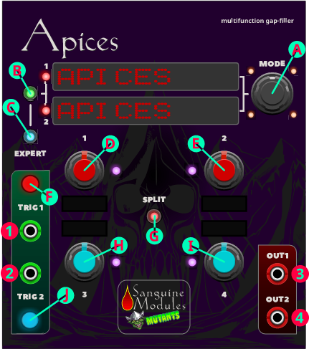

Knobs and buttons
- MODE: selects one of the ten available modes for both channels or the currently selected channel (EXPERT MODE (B) and (C) dependent).
The selected mode is displayed for each channel using one of the displays to the left of the MODE knob and the LEDs around it.
The modes and their display are as follows (hardware easter-egg modes are marked with ▀ in the display; hardware secret modes are marked with &, and hardware disabled modes enabled in Apices are marked with @)
MODE | DISPLAY
Envelope | ENVELOPE
LFO | LFO
TAP LFO | TAP LFO
Drum generation | DRUM GENERAT
Sequencer | SEQUENCER▀
Trigger delay/shaper | TRG. SHAPE▀
Trigger stream randomizer | TRG. RANDOM▀
Digital drum synth | DIGI. DRUMS▀
Number station | NUMBER STAT&
Bouncing ball | BOUNCE BALL@

- CHANNEL SELECT: selects between channels 1 and 2 when EXPERT MODE (C) is enabled, when it is disabled this button has no function.
The selected channel is shown using the red LEDs to the left of the mode displays: both LEDs are lit when EXPERT MODE is disabled, and either 1 or 2 blink using different rhythms when EXPERT is enabled to indicate the channel you are currently editing.
When EXPERT MODE is enabled this button glows either green or yellow depending on the channel selected for edition; the LEDs around SPLIT (G) (see below) change color, following this button, to show the channel the knobs are affecting.
- EXPERT MODE TOGGLE: enables and disables EXPERT MODE.
This module is quite versatile: when operating in standard mode (EXPERT MODE disabled) whatever mode you set using the knob is applied to both channels (indicated by both red LEDs next to the mode displays staying steadily lit). EXPERT MODE lets you control each channel independently, selecting modes and parameters separately for each one without affecting the other (check the Context menu section below for a note about the knobs).
When this mode is enabled the button glows blue and the CHANNEL SELECT button is ready for action, glowing either green or yellow depending on the channel selected for edition.
This mode offers complete, granular control of every parameter for each channel at the expense of complexity.
D, E, H, I: these red and blue knobs set the parameters for the currently selected mode and are dependent on it. The OLED displays adjacent to each knob display terse descriptions of which parameter a given knob affects and to which channels it applies, according to mode selections.
Examples:
- The module is set to standard mode (see above) twin (see below) LFO mode: the knob labeled “1” affects the Frequency for both channels and its display reads “1&2. Frequency”, while the knob labeled “3” affects the waveform variation for both channels and its display reads “1&2. Wave. Var.”.
- The module is set to standard mode (see above) SPLIT (G) (see below) Drum generation mode: the knob labeled “1” affects the tone for the bass drum in channel 1 and its display reads “1. BD Tone”, while the knob labeled “3” affects the tone for the snare drum in channel 2 and its display reads “2. SD Tone”.
- The module is set to EXPERT MODE (C) (see above); channel 2 is selected, and its mode is Envelope: all knobs affect only this channel and, in this case, the knob labeled “1” affects the envelope’s attack, its display reads “2. Attack”, and the knob labeled “3” affects the envelope’s sustain, it’s display reads “2. Sustain”.
For a detailed explanation of the regular, easter egg and secret modes present in unmodified hardware, please refer to the original hardware’s manuals found at:
- For regular and easter egg modes:
https://pichenettes.github.io/mutable-instruments-documentation/modules/peaks/manual/
- For number station mode:
https://pichenettes.github.io/mutable-instruments-documentation/modules/peaks/secrets/
An explanation of the bouncing ball mode is found below.
F, J: manual triggers for channel 1 and 2, respectively.
- SPLIT MODE: this button switches standard mode (see above) between twin and split modes. When SPLIT MODE is enabled this button glows red. It is disabled in EXPERT MODE (see above).
When the module is set to twin mode (SPLIT MODE red light is off) both red knobs and both blue knobs affect different parameters for both channels of the currently selected mode. The LEDs beside the knobs glow purple to show both channels are combined. In this mode you get more control over every parameter but less granularity between channels.
When the module is set to SPLIT MODE the button glows red, the red knobs affect parameters for channel 1 while the blue knobs affect parameters for channel 2. The LEDs next to the red knobs glow red to indicate those knobs affect channel 1 and the LEDs next to the blue knobs glow blue to convey those knobs affect channel 2. In this mode you get more granularity over channel parameters at the expense of less control over individual parameters. For complete control… use EXPERT MODE!

Inputs and outputs
- Trigger 1 input: receives trigger signals for channel 1.
- Trigger 2 input: receives trigger signals for channel 2.
- Channel 1 output: emits channel 1 signals.
- Channel 2 output: emits channel 2 signals.

The context menu
Apices offers the standard VCV Rack standard context menu with one addition:
- Knob pickup (snap): when using EXPERT mode and switching between the two channels the knobs immediately affect the parameters of the newly selected channel with their current positions. To prevent this and make the knobs affect the parameters of the newly selected channel only after they have been moved to their previous value within that channel enable this menu option (disabled by default).

Bouncing ball mode
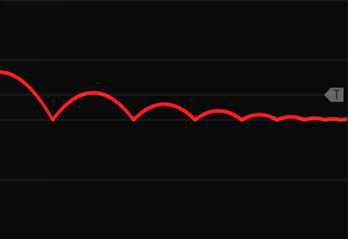
This envelope generator produces signals not unlike bouncing a ball in a basketball court.
Experiment with the parameters and an oscilloscope to get a feel (and visual representation) of how the different parameters affect the envelope.

Parameters
- Gravity: how fast the ball drops to the ground: the further clockwise the knob is, the floatier the ball gets.
- Bounce: how much potential energy the ball keeps when falling to the ground. Setting the knob to high clockwise values can make your ball bounce forever (paired with a high gravity this can also make your ball bounce really high!).
- Amplitude: how much force is applied to the initial ball throw. The further the knob is counterclockwise the lower the ball starts when triggered. A fully counterclockwise knob means the ball doesn’t get off the ground at all.
- Velocity: how much the ball travels forward initially. Lower, counterclockwise values, produce envelopes with an initial sharper peak.

Mutants Blank – Rack sleekerizer
It’s not Mutable or Audible; but who doesn’t want a lovely goblin sitting on their Rack along with the Mutants logo?
Makes your Rack look sleek.
Mutants don’t need no controls.
Bypassing the module turns its lights off

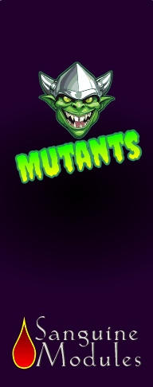
.

Funes – Macro oscillator
Featuring twenty four synthesis models that range from filtered classic wave shapes to synthetic hi-hats, Funes is a polyphonic macro oscillator that caters to your every musical need.
Funes is based on Mutable Instruments’ well known macro oscillator “Plaits”, with the latest 1.2 released firmware.
This manual covers basic operation; but a lot of enjoyment comes from experimentation and discovery. Have fun!

The Controls
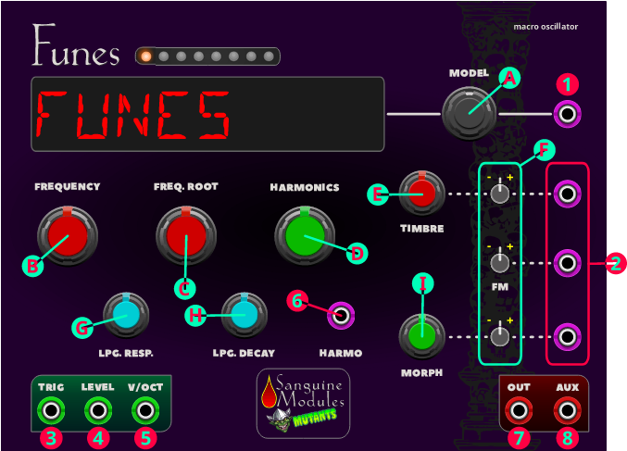

Knobs
- MODEL: twist it back and forth to select the synthesis model. The available models are separated in three banks of eight.
Each of the LEDs at the top represent one of the models and reflect both the selected model and the bank it’s contained in using one of three colors.
The model banks are separated as follows: pitched (green LEDs), noise/percussive (red LEDs) and new synthesis (orange LEDs). The character display uses an eight letter code to present your selection.
The available synthesis models are:
Model # | Model | Display | LEDs color | Note
1 | Classic waveshapes with filter. | FLTRWAVE | Orange | C0
2 | Phase distortion | PHASDIST | Orange | C#0
3 | 6-operator FM 1 | 6 OP.FM1 | Orange | D0
4 | 6-operator FM 2 | 6 OP.FM2 | Orange | D#0
5 | 6-operator FM 3 | 6 OP.FM3 | Orange | E0
6 | Wave terrain synthesis | WAVETRRN | Orange | F0
7 | String machine | STRGMACH | Orange | F#0
8 | Chiptune | CHIPTUNE | Orange | G0
9 | Pair of classic waveforms | DUALWAVE | Green | G#0
10 | Waveshaping oscillator | WAVESHAP | Green | A0
11 | Two operator FM | 2 OP.FM | Green | A#0
12 | Granular formant oscillator | GRANFORM | Green | B0
13 | Harmonic oscillator | HARMONIC | Green | C1
14 | Wavetable oscillator | WAVETABL | Green | C#1
15 | Chords | CHORDS | Green | D1
16 | Vowel and speech synthesis | VOWLSPCH | Green | D#1
17 | Granular cloud | GR.CLOUD | Red | E1
18 | Filtered noise | FLT.NOIS | Red | F1
19 | Particle noise | PRT.NOIS | Red | F#1
20 | Inharmonic string modeling | STG.MODL | Red | G1
21 | Modal resonator | MODALRES | Red | G#1
22 | Analog bass drum | BASSDRUM | Red | A1
23 | Analog snare drum | SNARDRUM | Red | A#1
24 | Analog hi-hat | HI-HAT | Red | B1

Synthesis models can also be selected directly using the context menu (see below).
Depending on the selected model, the module controls change different parameters.
For a detailed explanation of the specific models and how the controls behave when they are selected, please refer to the original “Plaits” manual and its 1.2 firmware addendum.
Plaits manual (covers Pitched and Noise/percussive models): https://pichenettes.github.io/mutable-instruments-documentation/modules/plaits/manual/
Plaits firmware addendum (including New synthesis models manual):
https://pichenettes.github.io/mutable-instruments-documentation/modules/plaits/firmware/
- FREQUENCY (coarse): its range can be adjusted using the “Frequency mode” item in the context menu. By default it is eight octaves (C0-C8). It also offers “Octaves” and “LFO” modes.
- FREQUENCY ROOT: when “Octaves” is selected as the “Frequency mode” this knob controls the root note.
- HARMONICS: model dependent tone control. In general it controls the frequency spread in the tone.
- TIMBRE: model dependent tone control. In general it controls the “darkness” of the tone.
- Attenuverters for the TIMBRE, FM and MORPH CV inputs. When the TRIGGER (3) input is patched and the corresponding CV is left unpatched, the attenuverters adjust the modulation amount from the internal decaying envelope generator. So… be warned, if you disconnect a CV input and the TRIGGER (3) patched, any attenuverter value other than “0” will allow the internal envelope to take over.
- LOW PASS GATE RESPONSE: controls the response of the internal low pass gate from VCFA (counter clockwise) to VCA (clockwise).
- LOW PASS GATE DECAY: adjusts the ringing time of the internal low pass gate and the decay time of the internal envelope.
- MORPH: model dependent tone control. In general it controls lateral timbral variations.

Inputs and outputs
- MODEL selection CV: this input has two modes of operation that depend on your context menu selection:
  - C0 model modulation (monophonic) unchecked (default): when the input is patched, two or more LEDs (depending on polyphony) light up. The blinking LED indicates the central value (the selected model) while the steady LEDs indicate the currently active one for each polyphonic channel. The input voltage functions as an offset to the currently selected central value: negative voltages decrease it and positive voltages increase it. This behavior is the closest to the original “Plaits” with the addition of polyphony.
  - C0 model modulation (monophonic) checked: when the input is patched, the notes C0 to B1 select the current model. Selection is absolute and not influenced by the manually selected model.
In both modes the display updates, by default, to reflect the currently active model for the first, if polyphonic, or only channel connected to the input. This behavior can be disabled in the context menu (see below).
- CV Inputs for the TIMBRE, FM and MORPH parameters.
- TRIGGER: serves four different purposes:
  - Triggers the internal decaying envelope generator.
  - Excites the physical and percussive models.
  - If the LEVEL input (4) is not patched, it strikes the internal low-pass gate.
  - Samples and holds the value of the MODEL CV input (1).
- LEVEL: opens the internal low pass gate; it also acts as an accent control when triggering physical or percussive models.
- V/Oct: controls the fundamental frequency of the produced sound, from -3 to +7 octaves relative to the root note set by the FREQUENCY (B) knob.
- CV Input for the HARMONICS (D) parameter.
- OUT: main output signal (model dependent).
- AUX: carries a variant or by-product dependent on the OUT (7) output signal (model dependent).

The context menu
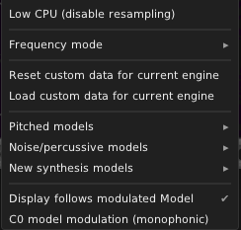

The Funes context menu offers the standard VCV Rack standard context menu with several additions:
- Low CPU (disable resampling): if your computer is struggling enabling this will save some CPU at the expense of sound quality.
- Frequency mode: sets the mode for the FREQUENCY (B) knob.
- Reset custom data for the current engine: some of the models in the “New synthesis models” bank allow the use of custom data. This menu option clears it and loads the built-in default.
- Load custom data for current engine: loads custom data for one of the following models:
  - 6-operator FM models.
  - Wave terrain synthesis.
  - Wavetable synthesis.
Data must be prepared as a .bin file using the editor available here:
https://github.com/tobiza/Plaits-Editor/tree/8190119e5c0e06b495e46eef62d8ed5ce874b53b
In order to use the editor you need to download the code and run it locally in your web browser (tested with Firefox).
- Pitched models, Noise/percussive models and New synthesis models: the items in the sub-menus directly select an specific synthesis model.
- Display follows modulated model: when enabled, the LED display changes to reflect the model currently selected by the voltage present in the MODEL CV input (1). If you want the display to only reflect the model selected using the knob or don’t like the effect, disable this option. Enabled by default.
- C0 model modulation (monophonic): when enabled, the selected model is changed by sending note voltage values to the MODEL CV input. Selection is absolute. This disables the default Plaits-like behavior and is monophonic only. Disabled by default.

Acknowledgments & thanks
Mutable Instruments for designing such wonderful modules.
Tobi for the work on getting the 1.2 Plaits firmware in VCV Rack.
Hemmer for the work on getting Peaks working in VCV Rack.
jpnielsen for helping with builds.
VCV Rack, MindMeld, Venom and Sapphire modules and their authors whose sources inspired the solutions for some of the graphical effects present in the Sanguine Modules plugins.
Everyone in the VCV Rack forum who got excited with my first “Funes” release.
Christy Marx for making me laugh, to this day, whenever I look at the Conquests of Camelot manual cover (and, in turn, inspiring the cover for this one).

Contact
Found a bug? Have a suggestion? A fix?
Please use the issues section at
https://github.com/Bloodbat/SanguineMutants/

Disclaimer
This software is provided "as is", without warranty of any kind, express or implied, including; but not limited, to the warranties of merchantability, fitness for a particular purpose and noninfringement. In no event shall the authors or copyright holders be liable for any claim, damages or other liability, whether in an action of contract, tort or otherwise, arising from, out of or in connection with the software or the use or other dealings in the software.
Slight discrepancies between the images on the package, this manual and the final plugin are possible and should not affect functionality in any way.

Licenses & Copyrights
Sanguine Modules; Sanguine Modules Mutants; Sanguine Modules Monsters, and their respective logos, branding and indications are copyright © 2024 Bloodbat / La Serpiente y la Rosa Producciones.
Mutable Instruments is a registered trademark.
This manual is © Bloodbat and licensed under CC BY-NC 4.0. Non-commercial use is allowed with appropriate credit and indication of the original license.
This plugin is free software: you can redistribute it and/or modify it under the terms of the GNU General Public License as published by the Free Software Foundation, either version 3 of the License, or (at your option) any later version.
The panel graphics and logos in the res/ folder are copyright © Bloodbat and licensed under CC BY-NC 4.0. Non-commercial use is allowed with appropriate credit and indication of the original license.
The component graphics in the res/components/ directory are copyright © VCV, modified by Bloodbat and licensed under CC BY-NC 4.0. Non-commercial use is allowed with appropriate credit and indication of the original license.
Dependencies included in the binary distribution may have other licenses. See LICENSE-dist.txt for a full list.
Copyright © 2024 Bloodbat / La Serpiente y la Rosa Producciones.

Only available when “C0 model modulation” is checked in the context menu.

