Evaluating the Effectiveness of Game-Oriented Learning for Early Childhood Development

Aarya Gupta
Kiet group of institutions Delhi-NCR, Ghaziabad, India aaryag438@gmail.com
Gaurav Rajesh
Kiet group of institutions Delhi-NCR, Ghaziabad, India
gauravrajesh1752003@gmail.com
Ankit Patel
Kiet group of institutions Delhi-NCR, Ghaziabad, India ankitone701@gmail.com
Umang Kant
Kiet group of institutions Delhi-NCR, Ghaziabad, India umang.kant@kiet.edu
Aryan Gupta
Kiet group of institutions Delhi-NCR, Ghaziabad, India aryandev8396@gmail.com
Rekha Kashyap Kiet group of institutions
Delhi-NCR, Ghaziabad, India rekha.kashyap@kiet.edu

Abstract-There are lots of tools for teaching and supporting of children’s learning, and games are becoming one of the common tools. Games in general makes kids more attentive and motivated, so when lessons are integrated into games, they make the process enjoyable. Children’s cognitive, social and emotional growth are supported by Games. This paper examines research done on games influence on learning for young children. The findings show evidence that games positively impact children’s thinking, social skills, emotions, motivation, and engagement. Educators who are looking for the overall development of the children find games a useful resource. The given findings are helpful for wide range of people such as teachers, administrators, and game developers who are interested in using games to support young children’s healthy development. Keywords—Game-oriented education, early childhood education, social interaction, emotional growth, children engagement

- Introduction
Digital learning done through game involves the combination of digital technologies – such as tablets, computers, and mobile devices - to provide education through interactive gameplay [6]. The broader concept of game-based learning involves both digital and traditional game formats. Earlier the educational games included board games, puzzles, and manipulative problem-solving task games. The growth of computer technology in the late twentieth century we saw a shift toward digital learning media. Titles such as “Reader Rabbit” and “Math Blaster” were early attempts in combination with entertainment with learning by engaging young minds with interactive, content-focused gameplay.
The expansion of touchscreen technologies, especially tablets and smartphones, enhanced accessibility and interactivity for children. These advancements helped them adaptive learning systems capable of providing personalized experiences and real-time feedback.

- Materials And Methods
This study takes a systematic review and meta-analytical approach to synthesize and examine currently existing research on the outcome of learning done through games in children education or games in general on children. The main aim of this paper is to showcase the effectiveness of game- based education on multiple things such as cognitive, social, and emotional growth, as well as its impact on the learners’ motivation and engagement during educational activities.

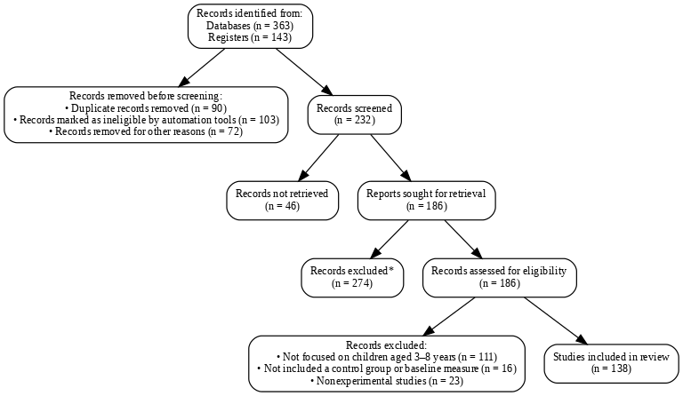

- A Systematic Review
This paper uses the major electronic databases, including Scopus, web of Science, PsycINFO, and ERIC, to look for studies examining the impact of game-based learning in early childhood education, as shown in Fig. 1. Doing This Systematic analysis and review provides many advantages. First, it allows us a complete understanding of the gathered evidence and gives us a thorough analysis of the effects of game-oriented learning given in the childhood context. Second, The Amount of collected data through size estimation gives us a precise model to evaluate the overall efficacy of game-based learning methods. Finally, it highlights the drawbacks or the inconsistencies, so that future academic research can find it helpful to their cause.
Various studies were identified and selected based on the given criteria. While data extraction, the major focus was to extract the key information related to study design, participant characteristics, game attributes, and measured outcomes. To make sure there is variability in the reporting, outcomes were organized into diverse categories. The data synthesis process used both qualitative analysis and quantitative analysis to determine the average effect of game-based learning methods. Sensitivity analyses were used to check the robustness of the findings. The results were formulated based on the idea of the research, i.e. emphasizing strengths, potential limitations, and future direction. This Methodology allowed for an in-depth analysis of the overall development of the children and the effect the game-based learning has on them.

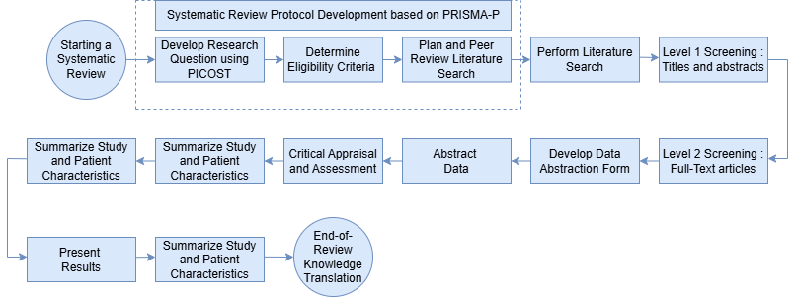

- Risk of Bias and Sensitivity Analyses
The sensitivity analyses showcase that the effects of game-based education on cognitive and social and emotional products remained consistent through varying study characteristics. The studies that were done with larger group of people produced some positive effects on the children’s motivation.
Getting some reliable or validity criteria is important as it allows us to get systematic review and showcase our finding. In this study we used the revised Cochrane Risk of Bias tool from the randomized trials (Rob 2) (n=136) [21]. The review looks at multiple aspects of a study such as sample size, the bias for selection, performance bias, detection bias, attrition and reporting bias as shown in Fig.3.This allowed for a systematic way to get what are the sources of bias and how it affected the results.
This way of examination allowed for a better approach where a low risk showed a well-designed study but a high risk shoed that it might be limited by its bias nature. This Detection of bias review told the outcome [23], showing what is actually important in minimizing the bias to get an accurate result. Attrition bias shoes incomplete data or participation loss which could tell that the study might be compromised or simply lost. And lastly, reporting bias analyzes the selective nature of results, where high risk indicates variation of findings. Reducing these biases is important to increase the result of any study [21].
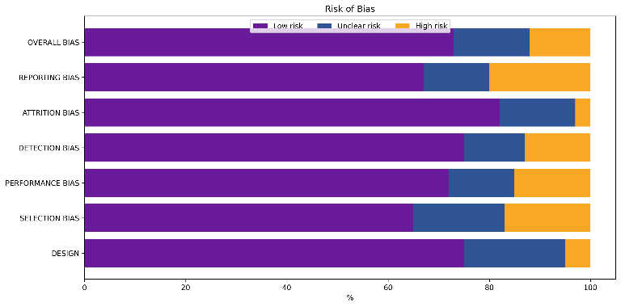

- Results
This search through the study showed 232 studies out of which 136 met the baseline criteria. Most of these studies were published over the last decade (2015-2025), where total of 1426 people participated. And the sample size of any study generally had somewhere from 20 to 112 participants, with a median of sample size of 40. In the studies 96 followed experimental designs where 40 used quasi- experimental methods. The research also showed many diversities where the study was conducted across multiple regions, such as Africa, Latin America, The Middle East, North America, along with UK. This range shows that game-based learning is popular and people are taking more and more interest in it and what potential it holds over the future where game-based learning will get popular.

- Discussion
The Combined findings show that game-based learning is highly effective to increase effectiveness of learning if we start from an early learning, it increases numeracy, literacy, collaboration, and perseverance. Out of all the format of the game-based learning, Digital game formats such as mini-games, interactive software were among the most popular way to effectively promote cognitive development, problem solving abilities and the overall creative aspect of the learners. On a broader term education-oriented gaming maximized the learning gains which ensured children do not just engage with the learning gains but also are receptive to the teachings by the use of feedback [7], [11], [15].
But even if there are so many promising advantages of these learning the industry faces many challenges. One of the main concerns is that the games designed are age appropriate for the target children and not something which might be hard to grasp by them. Properly analyzing these problems is hard and requires a thoughtful combination of game-based learning and the support of a teacher so that we get some good result [3], [17].

- Cognitive Development
The first research question focused on the analysis of the effect of game-oriented education on cognitive development in children. Many have researched this field, but it generally yielded mixed but positive outcomes. Many studies reported that game-based learning allows children to improve cognitive skills such as attention, memory, and problem-solving by allowing children to interact with interactive and goal-oriented tasks [4], [7], [11]. This digital learning usually has immediate feedback and adaptive challenges so that the children will grow according to his / her own capacity.
But a smaller no. of studies found no improvement, but that was associated with the lack of longer-term plan or usually small group size [3], [14]. Overall, the studies indicate that the game-based system enhances the overall development of the children in the cognitive development

- Social Development
The second research question shows effect of such learning on minds of early learners. Multiple studies have shown that it can affect young learners, including cooperation, communication, empathy, and conflict resolution. For instance, Craig et al. (2016) reported that structured game- based procedures significantly improved social interaction and cooperative behaviors among preschool children. Similarly, Al Saud (2017) observed that participation in a game-based program enhanced collaboration among children while simultaneously reducing aggressive behaviors.

- Emotional Development
The third research examines the influence of game-oriented learning on the emotional aspect of the children. Gerkushenko et al. (2013) suggested that video
games can effectively grow social–emotional skills by engaging children in emotionally meaningful scenarios. Similarly, Chao-Fernández et al. (2020) demonstrated that game-based learning can enhance empathy, self-awareness, self-regulation, and motivation.
Some of the study was taken from the study of Toh and Kirschner (2020), where they developed and implemented a game-based program which aims to improve the children’s social and emotional learning. They Showcased a great method of improvement of self-awareness, emotional regulation, and empathy of the participant when they regularly started to use the game-based learning. Another similar case was of Hausknecht et al. (2017) who showed the impact of such learning on the interaction of children with the teacher in classrooms where it was found out that it most definitely increases the interaction [26].

- Motivation Development
Then the analysis of the effect of learning with games and how it motivates children was performed. Existing evidence shows it indeed helps the children with their motivation if they use game-based learning methods.
Liu and Chen (2013) were the first few people who investigated this; they examined the impact of these game- based learning on elementary students. This study showed that these methods significantly improve motivation among children.

- Engagement Development
Engagement is very important in the learning process of children education, as it directly affects their learning curve and motivation [22]. In recent years game-based learning has shown some promising results when it comes to children and their learning process.
One of the earliest studies was done by Lester et al (2013) where the study was focused on the impact of such learning on the mathematical skills of such learning on elementary school. The study showed that these learning methods are highly effective compared to traditional method.
Nevertheless, as noted by Hamari et al. (2016), the degree to which game-based learning enhances the attributes depends on multiple factors, including game design, learners’ prior knowledge and skills, and the learning objectives. Overall, these components increase the potential of well-structured game-based approaches to create more engaging, motivating learning experiences in early childhood education.

- Tools and Software
Adaptive technology has continuously optimized and enhanced game-based software. The tools are now much more powerful than ever before and can handle complex mechanisms with ease. The game engines such as Unity, Unreal engine, and Godot game engine have proven to improve overtime by providing high end gaming experience with optimal performance.

With the usage of AI and Cloud, the game-based intervention is now more engaging and device-friendly and now with the Virtual headsets we can experience 3D environment while being at our home. The continuous
advancements are making the experience more realistic and immersive.

- Conclusion
Game-based learning shows a very huge potential for the overall development of children from their cognitive to social to emotional development. Findings from this review give very strong evidence that game-oriented learning is effective in the development of children in their early stage of development. The overall positive impact of the findings can help in finding new ways to enhance the education system [27].
The Different study points out that game-based learning proves out to be an import aspect of learning for the educators. But even after all these the effectiveness of such learning is dependent on type of game, the child’s prior knowledge, their skill level and the learning curve. But still the results provided are a lot useful for policymakers and researchers alike. There are also many studies done which focus on these learning on the developmental of children [28]. But because each person has differences among themselves, further studies should be on exploring how different factors affect the learning and how impactful it is.
References

- L.Abeysekera and P.Dawson, Higher Education Research & Development,vol.34,pp.1-14,2015,doi: 10.1080/07294360.2014.934336.
- A. F. Al Saud, European Journal of Education Studies, vol.4, pp.32–47,2017, doi: 19044/ejes.v4no2a3.
- A. All, E. N. P. Castellar, and J. Van Looy, “Digital game-based learning effectiveness assessment: reflections on study design,” vol. 167, 2021, doi: 10.1016/j.compedu.2021.104160.
- T. Anastasiadis, G. Lampropoulos, and K. Siakas, “Digital game- based learning and serious games in education,” vol. 4, pp. 139–144, 2018, doi: 10.31695/IJASRE.2018.33016.
- A. H. Bang, “The restorative and transformative power of the arts in conflict resolution,” Journal of Transformative Education, vol. 14,
pp. 355–376, 2016, doi: 10.1177/1541344616655886.
- N. Behnamnia, A. Kamsin, and M. A. B. Ismail, “The landscape of research on the use of digital game-based learning apps to nurture creativity among young children: a review,” Thinking Skills and Creativity, vol. 37, 2020, doi: 10.1016/j.tsc.2020.100666.
- N. Behnamnia, A. Kamsin, M. A. B. Ismail, and S. A. Hayati, “A review of using digital game-based learning for preschoolers,” vol. 10,
pp. 603–636, 2022, doi: 10.1007/s40692-022-00240-0.
- A. Brennan, T. McDonagh, M. Dempsey, and J. McAvoy, “Cosmic sounds: a game to support phonological awareness skills for

children with dyslexia,” vol. 15, pp. 301–310, 2022, doi: 10.1109/TLT.2022.3170231.
- B. Brezovszky, J. McMullen, K. Veermans, M. M. Hannula- Sormunen, G. Rodríguez-Aflecht, N. Pongsakdi, et al., “Effects of a mathematics game-based learning environment on primary school students' adaptive number knowledge,” Computers & Education, vol. 128, pp. 63–74, 2019, doi: 10.1016/j.compedu.2018.09.011.
- J. Byun and E. Joung, “Digital game-based learning for K–12 mathematics education: a meta-analysis,” School Science and Mathematics, vol. 118, pp. 113–126, 2018, doi: 10.1111/ssm.12271.
- Z. Cai, P. Mao, D. Wang, J. He, X. Chen, and X. Fan, “Effects of scaffolding in digital game-based learning on student’s achievement: a three-level meta-analysis,” Educational Psychology Review, vol. 34, pp. 537–574, 2022, doi: 10.1007/s10648-021-09655-
0.
- L. Castillo-Cuesta, “Using digital games for enhancing EFL grammar and vocabulary in higher education,” International Journal of Emerging Technologies in Learning, vol. 15, pp. 116–129, 2020, doi: 10.3991/ijet.v15i20.16159.
- C. C. Chang and S. T. Yang, “Learners’ positive and negative emotion, various cognitive processing, and cognitive effectiveness and efficiency in situated task-centered digital game-based learning with different scaffolds,” Interactive Learning Environments, pp. 1– 20, 2023, doi: 10.1080/10494820.2023.2209600.
- R. Chao-Fernández, V. Gisbert-Caudeli, and R. Vázquez- Sánchez, “Emotional training and modification of disruptive behaviors through computer-game-based music therapy in secondary education,” vol. 10, 1796, 2020, doi: 10.3390/app10051796.
- C. H. Chen and V. Law, “Scaffolding individual and collaborative game-based learning in learning performance and intrinsic motivation,” vol. 55, pp. 1201–1212, 2016, doi: 10.1016/j.chb.2015.03.010.
- A. B. Craig, E. R. Brown, J. Upright, and M. E. DeRosier, “Enhancing children’s social emotional functioning through virtual game-based delivery of social skills training,” vol. 25, pp. 959–968, 2016, doi: 10.1007/s10826-015-0274-8.
- M. Dabbous, A. Kawtharani, I. Fahs, Z. Hallal, D. Shouman, M. Akel, et al., “The role of game-based learning in experiential education: tool validation, motivation assessment, and outcomes evaluation among a sample of pharmacy students,” vol. 12, 434, 2022, doi: 10.3390/educsci12070434.
- J. L. Derevensky, V. Hayman, and L. Gilbeau, “Behavioral addictions: excessive gambling, gaming, internet, and smartphone use among children and adolescents,” Pediatric Clinics, vol. 66, pp. 1163– 1182, 2019, doi: 10.1016/j.pcl.2019.08.008.
- P. A. Di Tore, S. Di Tore, L. A. Ludovico, and G. R. Mangione, “Madrigale: a multimedia application for dyslexia and reading improvement gamifying learning experience,” in Proc. 2014 Int. Conf. on Intelligent Networking and Collaborative Systems, pp. 486– 491, IEEE, 2014.
- S. E. Domoff, K. Harrison, A. N. Gearhardt, D. A. Gentile, J. C. Lumeng, and A. L. Miller, “Development and validation of the problematic media use measure: a parent report measure of screen media ‘addiction’ in children,” Psychology of Popular Media Culture, vol. 8, pp. 2–11, 2019, doi: 10.1037/ppm0000163.
- A. Lundh and P. C. Gøtzsche, “Recommendations by Cochrane Review Groups for assessment of the risk of bias in studies,” BMC Medical Research Methodology, vol. 8, no. 22, pp. 1–6, 2008, doi: 10.1186/1471-2288-8-22.
- R. Lamrani and E. H. Abdelwahed, “Game-Based Learning and Students’ Motivation: A Systematic Review,” International Journal of Emerging Technologies in Learning (iJET), vol. 15, no. 14, pp. 238– 249, 2020, doi: 10.3991/ijet.v15i14.14917.
- Mahmoud, Amena, et al. "Machine Learning-Driven Condition Monitoring and Fault Detection in Manufacturing." 2024 IEEE 9th International Conference on Engineering Technologies and Applied Sciences (ICETAS). IEEE, 2024.
- Awad, Nancy Awadallah, et al. "The Impact of Employee’s Awareness of Food Safety in Egyptian Hotels: Machine Learning Approach." Procedia Computer Science 259 (2025): 182-192.
- Chauhan, Yashika, et al. "Fine-Tuned EfficientNetB0 Model for Accurate Bird Species Identification and Multi-Classification." 2025 7th International Conference on Signal Processing, Computing and Control (ISPCC). IEEE, 2025.
- Dhanaraj, Rajesh Kumar, et al., eds. Digital Twins in Industrial Production and Smart Manufacturing: An Understanding of Principles, Enhancers, and Obstacles. John Wiley & Sons, 2024.
- Sathyamoorthy, Malathy, et al. "Introduction to Cyborgization Systems." Artificial Intelligence in IoT and Cyborgization. Singapore: Springer Nature Singapore, 2023. 1-15.
- Arvindhan, M., and D. Rajesh Kumar. "Analysis of load balancing detection methods using hidden markov model for secured cloud computing environment." Applications of Computational Methods in Manufacturing and Product Design: Select Proceedings of IPDIMS 2020. Singapore: Springer Nature Singapore, 2022. 565-580.

