AI Medical Diagnosis Expert System with PROLOG

*IN THE PARTIAL FULFILLMENT FOR THE AWARD*

*OF THE DEGREE OF*

MASTER’S OF SCIENCE (INFORMATION TECHNOLOGY)



POST GRADUATE GOVERNMENT COLLEGE, SECTOR 11, CHANDIGARH (2020-21)

AFFILIATED TO



**SUBMITTED BY:                                                           SUBMITTED TO:**

**Dhruv Kaith                                                                  Dr. Puneet Modgil**

**Roll - 4503**

CONTENTS

|  |  |  |
| --- | --- | --- |
| S.NO | TOPICS | PAGE NO. |
| 1 | **Preface** | *3* |
| 2 | **Declaration** | *4* |
| 3 | **Acknowledgement** | *5* |
| 4 | **Certificate** | *6* |
| 5 | **Project Description** | *7* |
| 6 | **Future scope** | *8* |
| 7 | **About PROLOG** | *8* |
| 8 | **Flowchart** | *9* |
| 9 | **Screenshots** | *10-11* |

**PREFACE**

This project report is submitted in partial fulfilment of the requirements for the award of the degree of “Master of Computer Science (Information Technology)”

 The project report is prepared for the project completed during the course of M.SC.(IT),1ST Semester undertaken at Post Graduate Government College, Sector 11 as a part of the M.SC.(IT),1ST Semester curriculum as prescribed by Panjab University, Chandigarh. The project report includes some background information about the college and information about the services in which the college deals in.

The purpose of this report is to assemble under one cover a sufficient body of knowledge about management and development of a successful project. The following quotes outline the basic idea behind this technical report. This report assembles various functions like planning, organizing, designing, testing, and maintenanceof the Sports club management developed during the training.

This report is about the adaptation of the techniques of project development and reflects the practice and methods of this project.-

DECLARATION

I declare that the Project Report on **“**AI Medical Diagnosis Expert System**”**  is the result of the original work done by us and to the best of our knowledge.

I have undergone all the necessary requirements and formalities with the college that are necessary for the submission of this Project Report.

This Project Report is submitted for partial fulfilment of all wards of the degree of **“M.SC. (IT), 1ST Semester”** under Panjab University, Chandigarh.

**Dhruv 4503**

Above statement by the candidates is true to the best of my knowledge.

**(Dr. Puneet Modgil)**

**ACKNOWLEDGEMENT**

A formal statement of acknowledgement is hardly sufficient to express our gratitude towards the personalities who have helped us to undertake and carry out this project. I hereby convey my thankfulness and obligation to all those who are providing us valuable help, support and guidance to carry on this project.

First and foremost, I express my gratitude towards **Dr. Puneet**. His keen interest and encouragement has been of immense help to me. He gave me unending support and helped me in numerous ways from the stage when the idea of the project was conceived. He was always there to hear me and to give advice. He taught me how to ask questions and express my ideas. He showed me different ways to approach a research problem and the need to be persistent to accomplish any goal. He had taken pain to go through the project and make necessary corrections as and when needed. We express our thanks to the principal of our college Dr Rama Arorafor extendingher support.

**NAME      ROLL NO.**

Dhruv 4503

**CERTIFICATE**

To whom it may concern

This is to certify that the project has been submitted by Dhruv Kaith pursuing MSC.IT(1st semester) at PGGC-11 Chandigarh, undertook a project entitled “AI Medical Diagnosis Expert System” which is a record of  Bonafede  work carried out by them under my supervision. In my knowledge, this work has not been submitted, either in part or in full, to any other University or institute for the award of degree. They had submitted the report in time. They have done good work and have fulfilled all the requirements.

Project Guide:

Dr Puneet Modgil

Assistant Professor

PGGC-11

Chandigarh

PLACE : CHANDIGARH

DATE :

**Project Description**

**AI Medical Diagnosis Expert System**

Click here to open Project Repository - [link](https://github.com/BloodyScythe/DiseaseDiagnosis)

Click here to run the program [Online](https://swish.swi-prolog.org/p/Dhruv_diagnosis.pl)

Overview Of The Project

User enters the symptoms to this program try to match those symptoms to those available in it’s record to give a diagnosis of the disease, to give an accurate diagnosis. The expert system then recommends medication and precautions to help cure the disease however, they should be confirmed from a licensed medical practitioner.

  Future scope of the project

Further development can be made to this project to improve it. The expert system currently does not provide the confirmatory tests for the given diagnosis. It can also be modified to take into account the region specific diseases. Eg- The system will ask if the patient has visited Africa recently if patient experiences Insomnia, as it can be African Trypanosomiasis.

About PROLOG

**Introduction :**

Prolog is a logic programming language. It has important role in artificial intelligence. Unlike many other programming languages, Prolog is intended primarily as a declarative programming language. In prolog, logic is expressed as relations (called as Facts and Rules). Core heart of prolog lies at the **logic** being applied. Formulation or Computation is carried out by running a query over these relations.

**Advantages :**  
**1.** Easy to build database. Doesn’t need a lot of programming effort.  
**2.** Pattern matching is easy. Search is recursion based.  
**3.** It has built in list handling. Makes it easier to play with any algorithm involving lists.

**Disadvantages :**  
**1.** LISP (another logic programming language) dominates over prolog with respect to I/O features.  
**2.** Sometimes input and output is not easy.

**Applications :**

Prolog is highly used in artificial intelligence(AI). Prolog is also used for pattern matching over natural language parse trees.

Flow chart

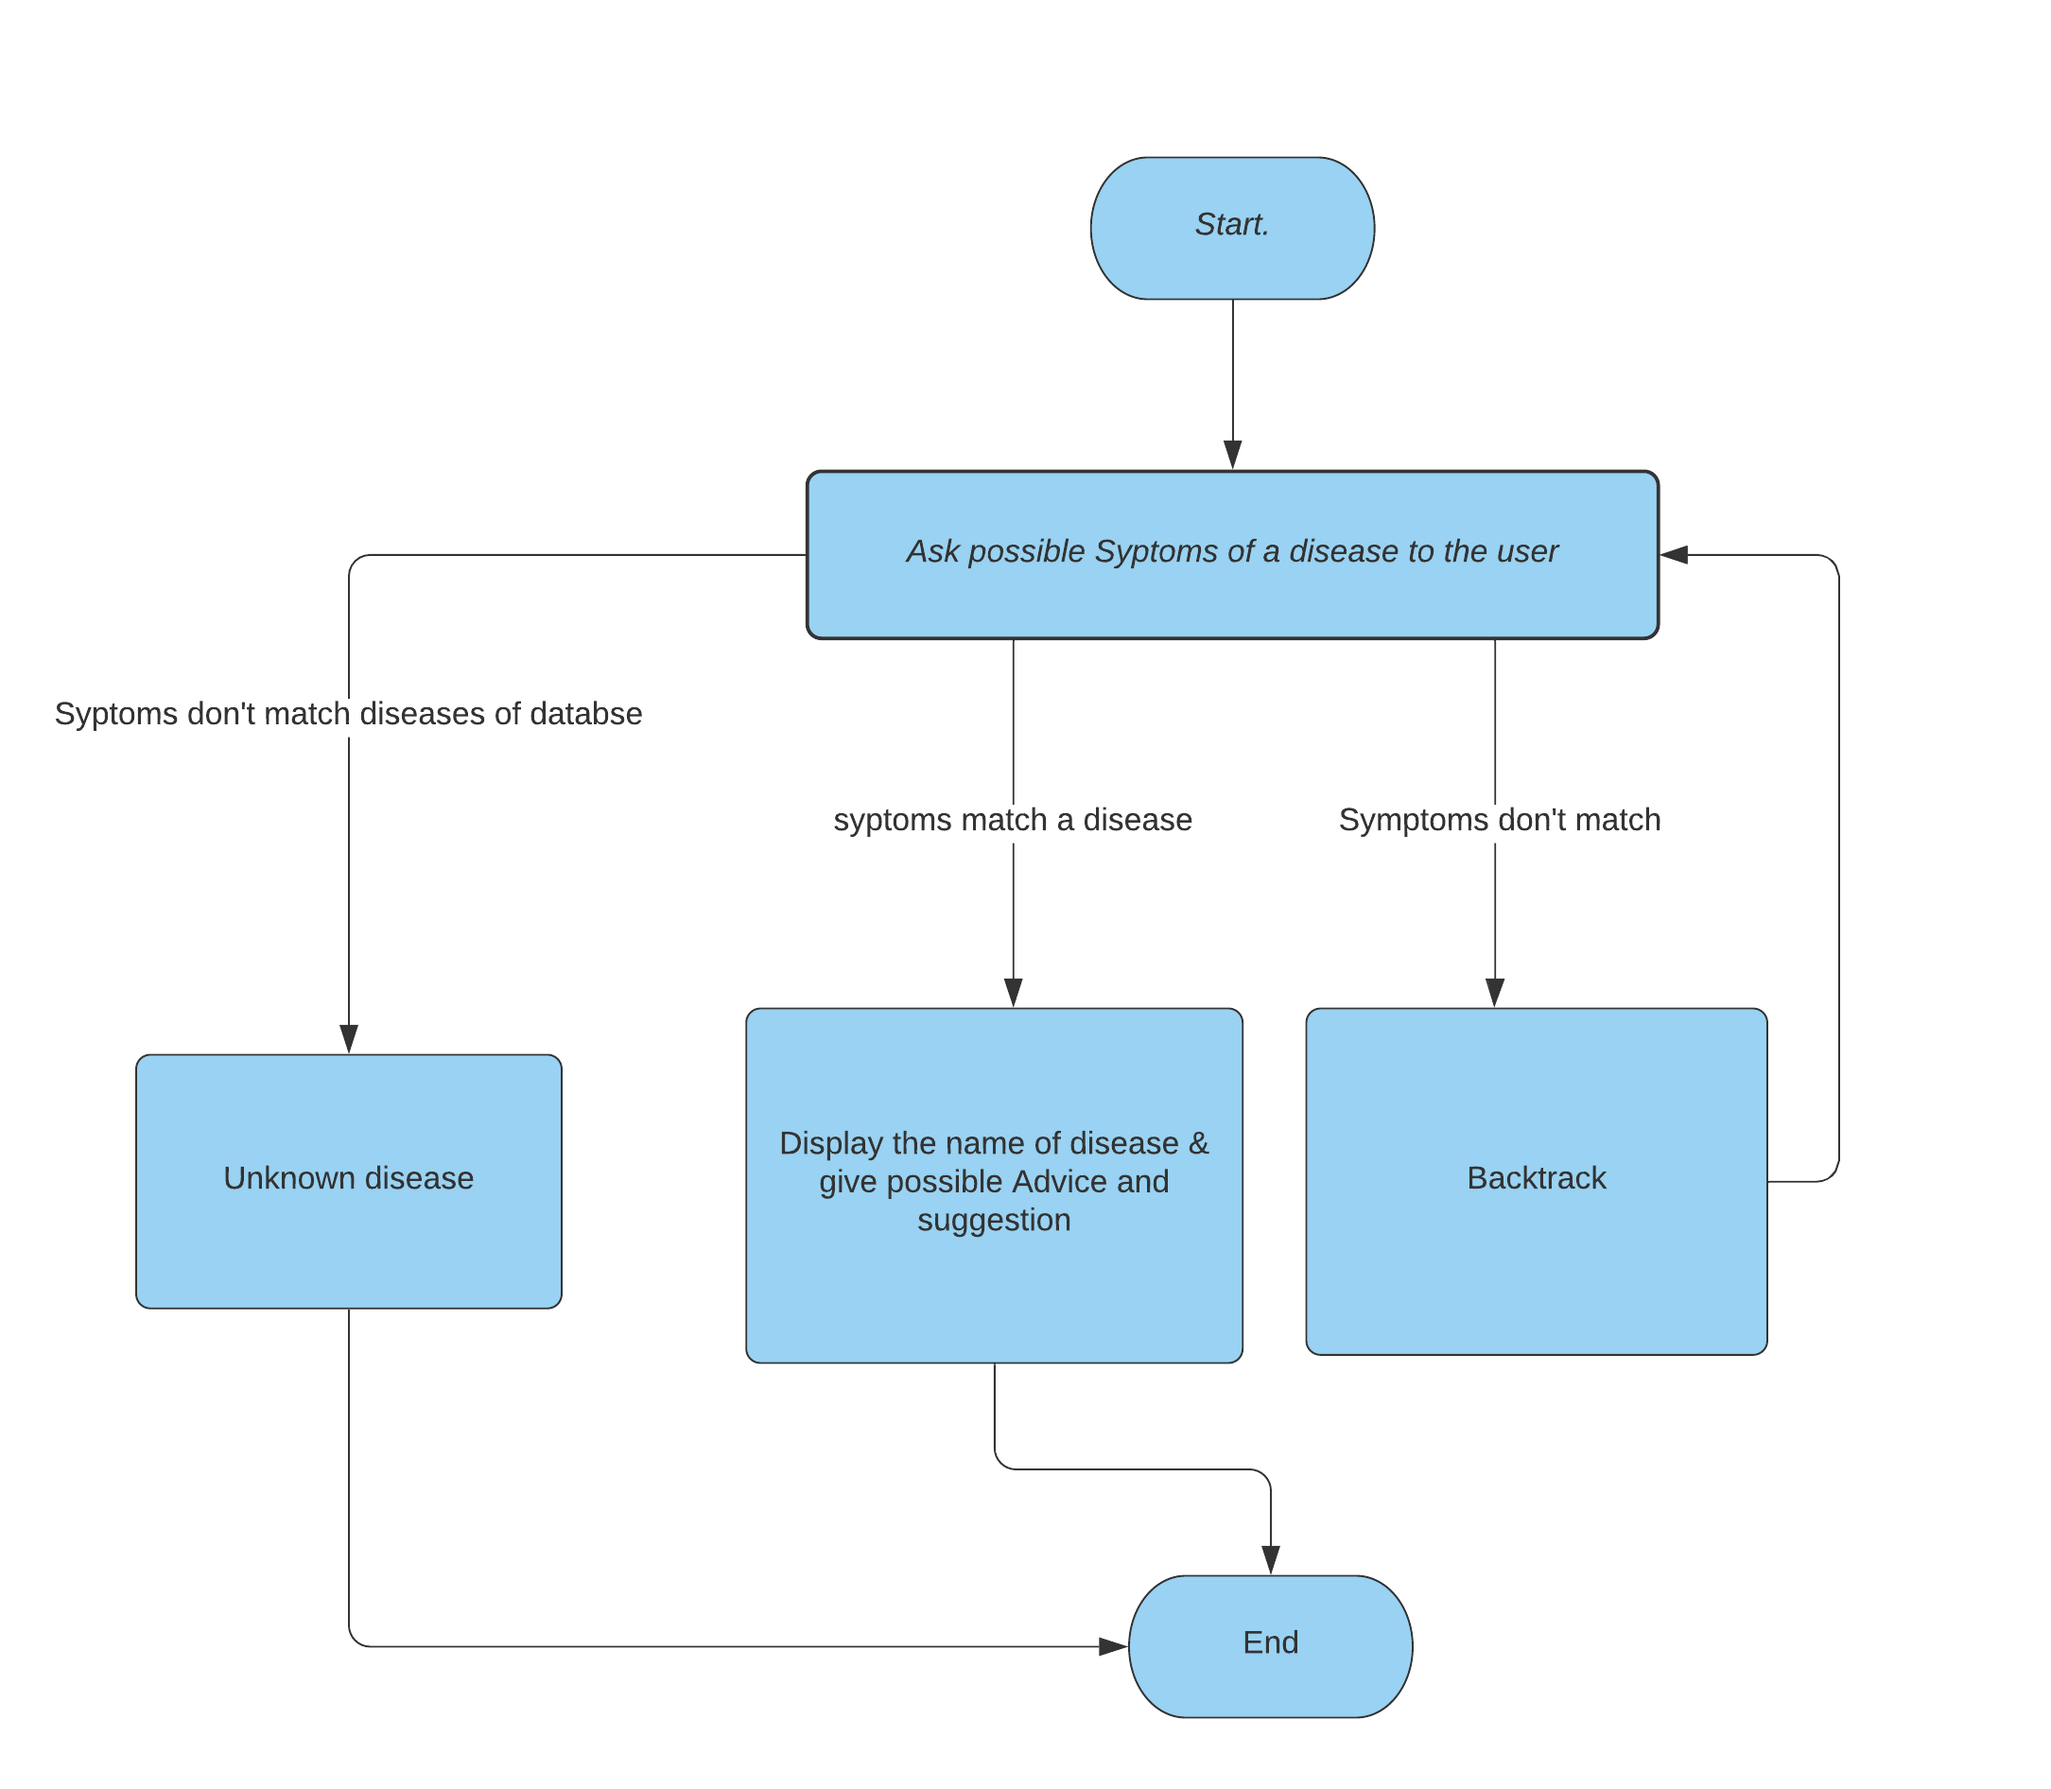

ScreenShots

