## Email Invitations

**Function Description**

Let people to send request an email invitation from website.

**Scenarios**

1. When user click Request an invite button, a popup shows containing the Full name, Email and Confirm Email

2. User needs to fill in all three fields.

3. Full Name needs to be at least 3 characters long

4. Email needs to be in validation email format

5. Confirm Email needs to match Email

6. The app should not call backend when field(s) do not validate

7. Use [usedemail@airwallex.com](mailto:usedemail@airwallex.com) to trigger a specific error.

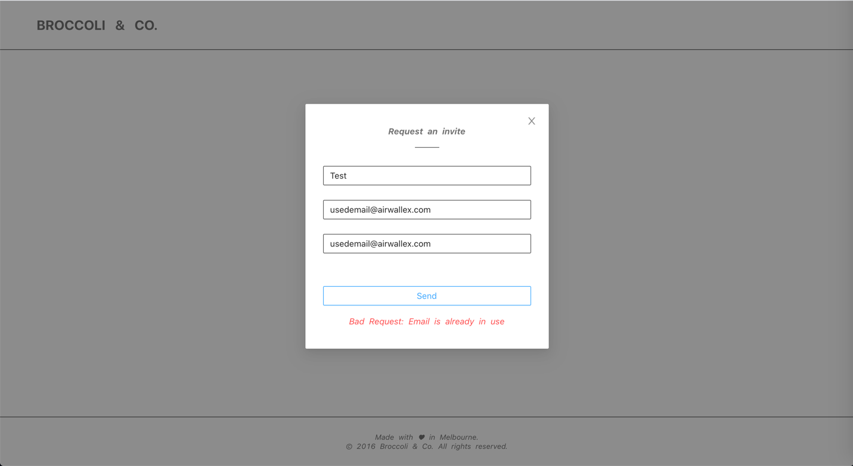

8. Switch to success popup when everything went through OK

9. This popup can be dismissed and revealing the homepage.