# Programming an ATTiny85 with an Arduino

Arduino software: <http://arduino.cc>

Wiring (for programming)

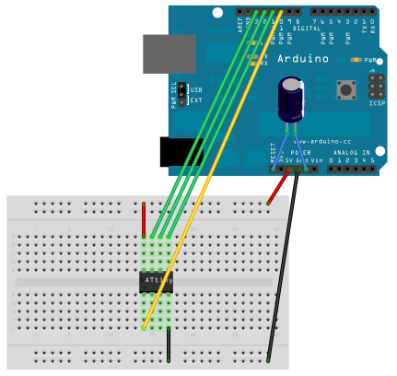

Pin connections:

* ATtiny Pin 2 to Arduino Pin 13 (or SCK of another programmer)
* ATtiny Pin 1 to Arduino Pin 12 (or MISO of another programmer)
* ATtiny Pin 0 to Arduino Pin 11 (or MOSI of another programmer)
* ATtiny Reset Pin to Arduino Pin 10 (or RESET of another programmer)

(from: <http://highlowtech.org/?p=1706>)

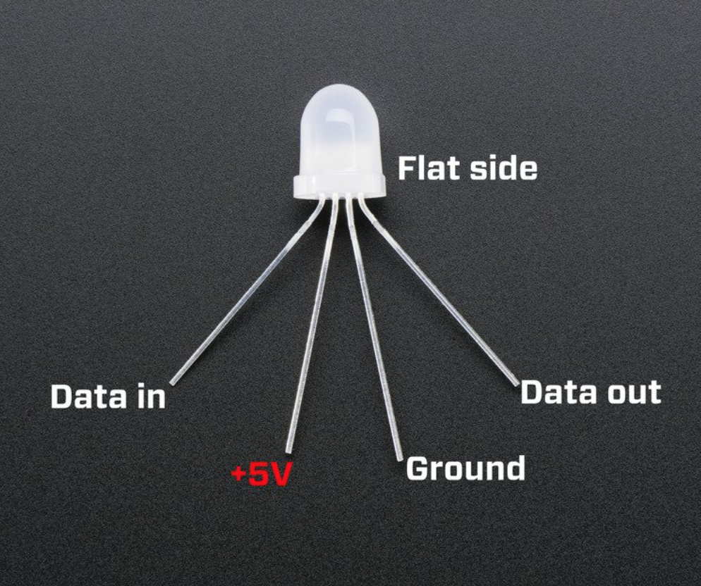

# Boards Manager Installation

This core can be installed using the boards manager. The boards manager URL is: <https://raw.githubusercontent.com/damellis/attiny/ide-1.6.x-boards-manager/package_damellis_attiny_index.json>

1. File -> Preferences ((Arduino->Preferences on Mac), enter the above URL in "Additional Boards Manager URLs"
2. Tools -> Boards -> Boards Manager.
3. Search "ATTiny”, find the one by David Mellis, and click "Install".

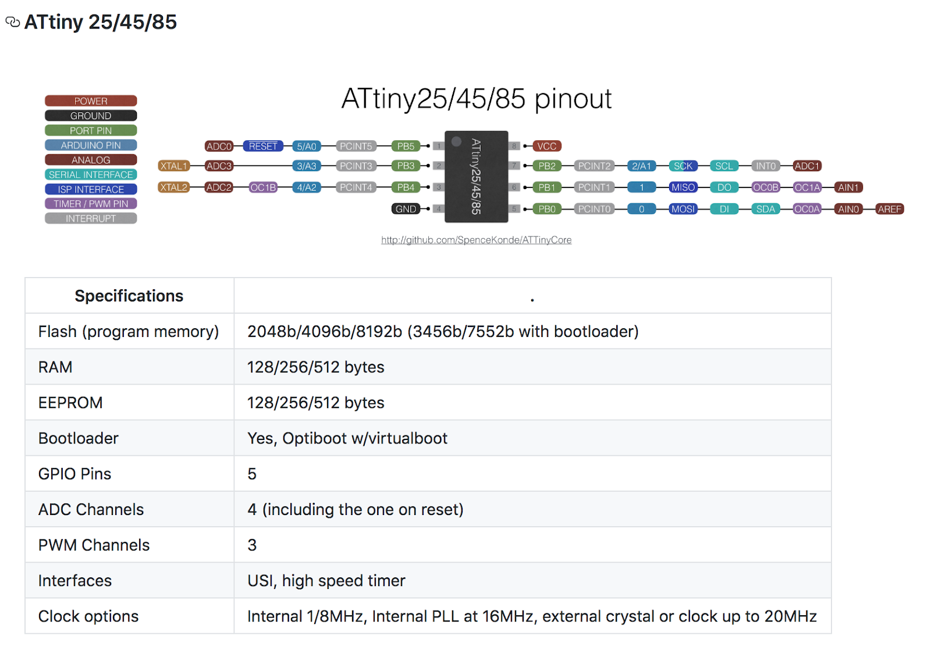

You need to ‘burn bootloader’ to get it to run at the right speed (8MHz):

