 | You can check your membership  dues balance online:  https://www.bloominglabs.org/dues  (Note the https, login is bloominglabs/bloominglabs)  You can pay by cash or check by leaving dues in an envelope in the donation box by the front door (write your name on it).  Credit card payments can by made using Square on the phone above the couch. | 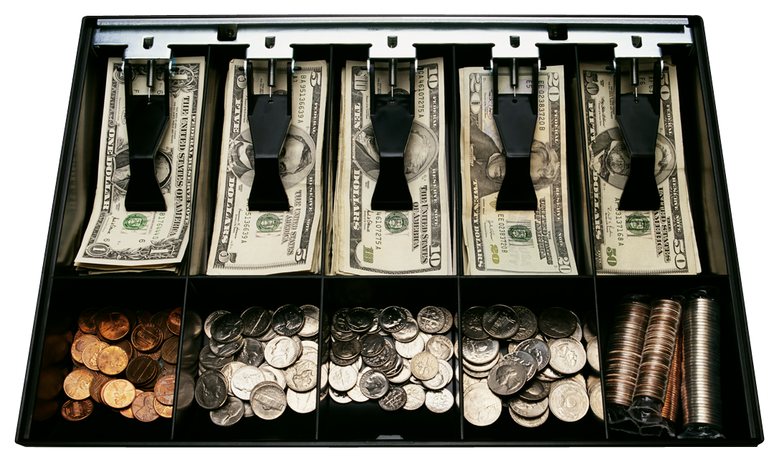
------------------------------------------------------------------------------------------------------------
 | Our Dumpster is behind the space next to the garage door.  Please make sure to ONLY use our dumpster and not ones near other buildings.
------------------------------------------------------------------------------------------------------------
Green stickers on a piece of junk = Free for any use
Red/Pink stickers on a piece of junk = Hands off or ask before repurposing
(Stickers are on top of the green filing cabinet near the front door)

QR code asset tags can be created here: https://www.bloominglabs.org/assets
------------------------------------------------------------------------------------------------------------

Our WiFi SSID is “Bloominglabs” and the WPA2 key is “hackerspace123”

------------------------------------------------------------------------------------------------------------
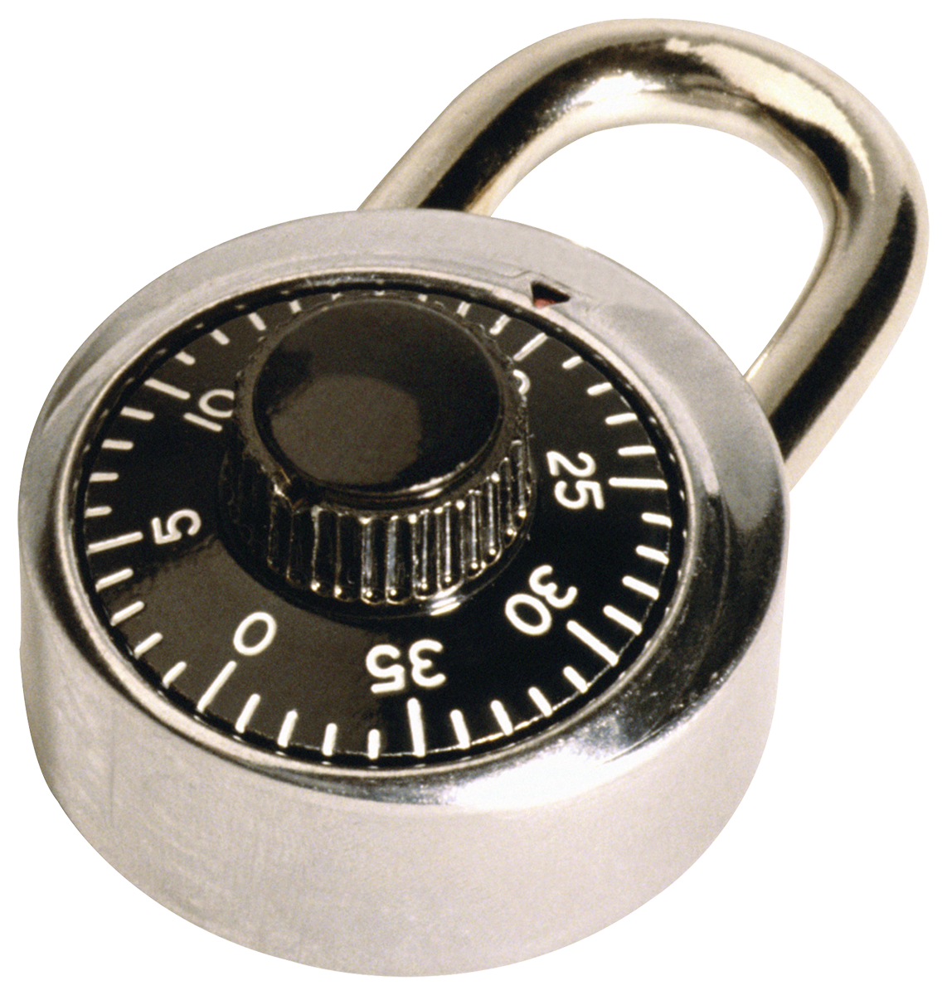 | We have a Lock Picking group!  The Fraternal Order Of Lock Sport  www.bloomingtonfools.org  Ask “dosman” for details | 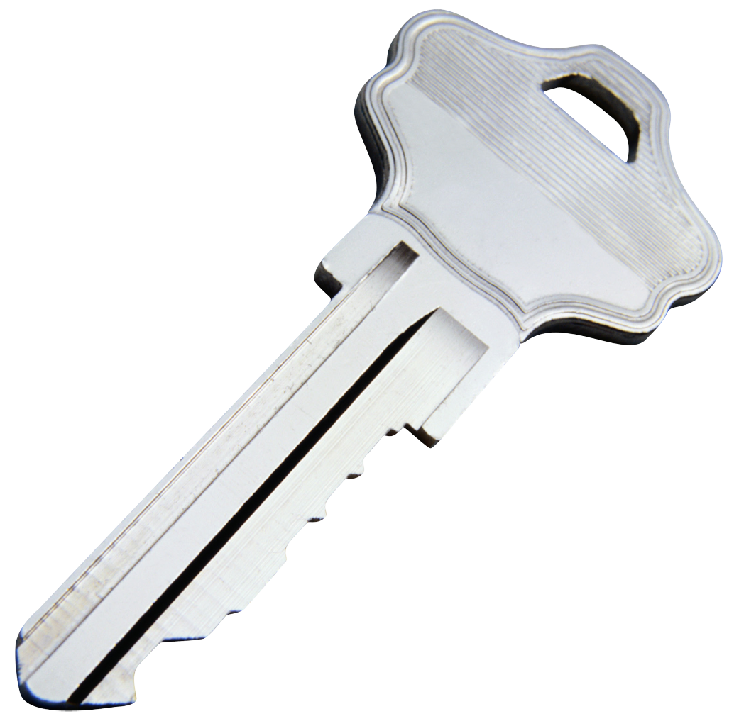
------------------------------------------------------------------------------------------------------------

Bloominglabs can accept tax-deductible equipment donations. A clipboard with the form to fill out hangs under the donation box next to the front door. Please don’t accept inkjet printers, these multiply when left alone.

------------------------------------------------------------------------------------------------------------

We all need to ensure that new people visiting the space fill out a liability waiver, these are on a clipboard on top of the green filing cabinet near the front door.

