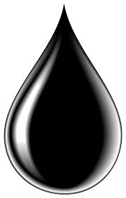

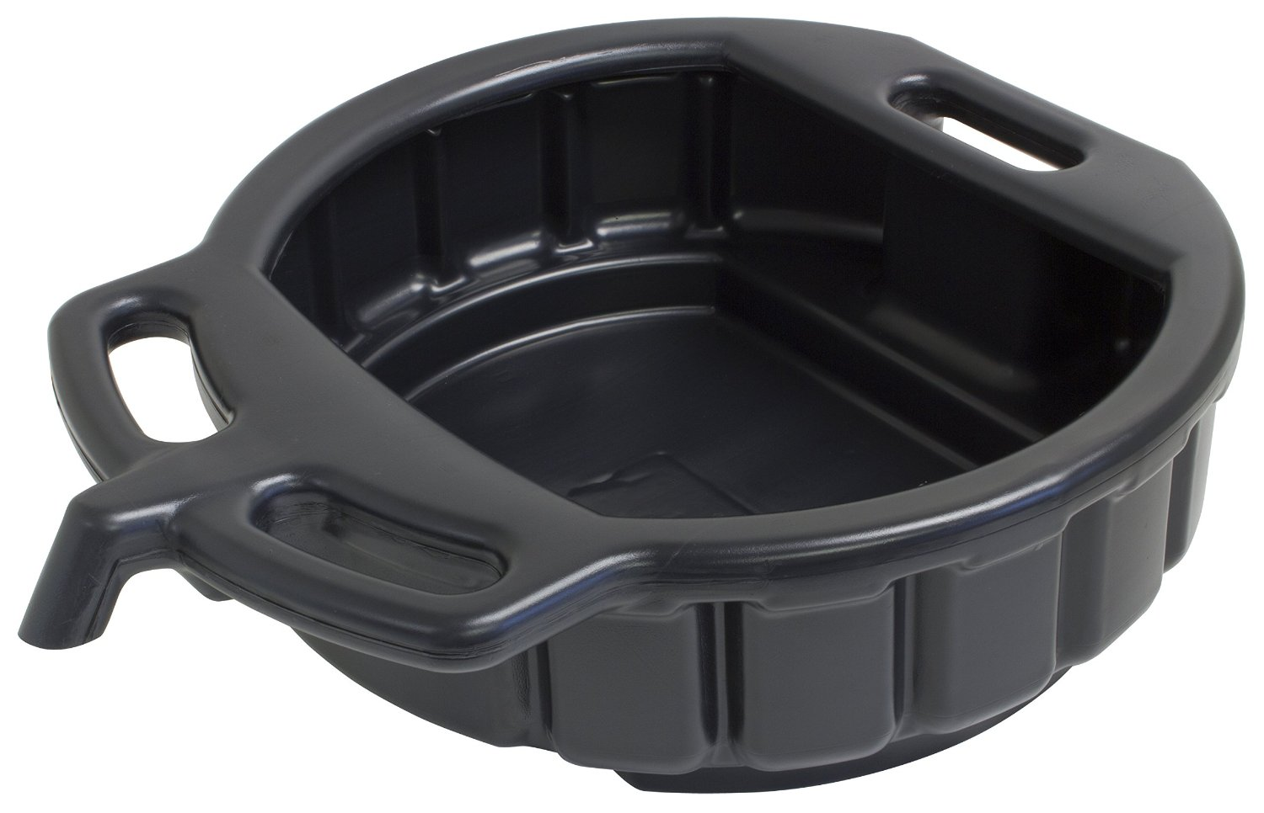

Never start a fluid change of any kind unless you are prepared with your own liquid waste containers. No vehicular waste fluids of any kind may be stored at Bloominglabs. Thanks!

