Don’t maroon tools on uncharted workspaces.

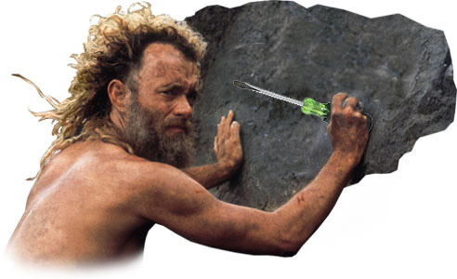

Someone may need them after you!

