Hey you there! You know what keeps our doors open and our lights on? Memberships and Donations!

Want to make a quick tax-deductible donation via PayPal? Hit up this giant QR code and do it!

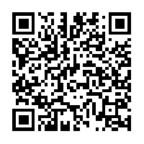



Don’t like PayPal or you want to make a donation by cash or check? Please ask to see a Bloominglabs officer.

Don’t care about the tax-deduction? Anonymous cash donations can be deposited in the donation box next to the front door.

Bloominglabs Incorporated is a 501(c)3 charitable organization.

Thank You!

