Medición de prueba 2026-II · Planta Norte (sintético)
Reporte provisional — sin equivalencia oficial
Generado el 14/08/2026 21:05

Estado metodológico
Versión: SHORT. Scoring: Bloqueado. Equivalencia oficial: No habilitada.
Bloqueos: QUESTIONS_COUNT_MISMATCH, DESCRIPTIVE_COUNT_MISMATCH, DIMENSIONS_COUNT_MISMATCH, SCORED_QUESTIONS_OUTSIDE_DIMENSION_TREE, MISSING_VALIDATED_SCORING_RULES
Advertencias: OFFICIAL_BAREM_NOT_AVAILABLE, OFFICIAL_EQUIVALENCE_DISABLED

Ficha técnica
Estudio | Medición de prueba 2026-II · Planta Norte (sintético)
Tipo de estudio | CENSO
Estado | OPEN
Respuestas completadas | 100
N mínimo publicable | 5
Baremo aplicado | Baremo provisional Colmena (terciles muestrales)
Versión de algoritmo | likert-baremos-v1

Resultados de baremación
Dimensión | N válido | Media | Mediana | Prioridad
project_root · CENSOPAS-COPSOQ · Prueba 2 | 100 | 51.30 | 51.70 | 1

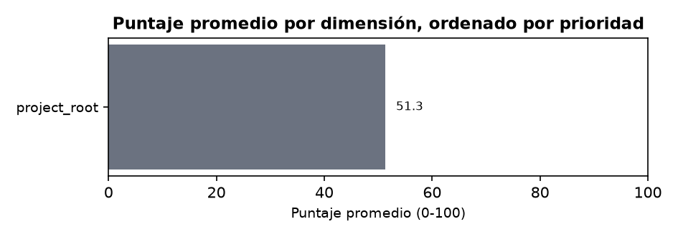

Resultados de análisis estadístico
Código | Tipo | N válido | Valor | Estadístico | p | Tamaño de efecto
AREA | FREQUENCY | 101 | — | — | — | —
CONTRACT | FREQUENCY | 100 | — | — | — | —
WEEK_HOURS | FREQUENCY | 100 | — | — | — | —
CONTRACT | FREQUENCY | 100 | — | — | — | —
WEEK_HOURS | FREQUENCY | 100 | — | — | — | —
project_root_by_SCHEDULE | KRUSKAL_WALLIS | 97 | — | 2.70 | 0.2598 | 0.01
project_root_by_WEEK_HOURS | KRUSKAL_WALLIS | 99 | — | 4.34 | 0.1141 | 0.02
project_root_by_SCHEDULE | KRUSKAL_WALLIS | 97 | — | 2.70 | 0.2598 | 0.01
project_root_by_CONTRACT | KRUSKAL_WALLIS | 99 | — | 2.56 | 0.2785 | 0.01
project_root_by_AREA | GROUP_COMPARISON_SUPPRESSED | 100 | — | — | — | —
project_root_by_AGE | KRUSKAL_WALLIS | 99 | — | 0.59 | 0.7442 | -0.01
project_root_by_AGE | KRUSKAL_WALLIS | 99 | — | 0.59 | 0.7442 | -0.01
project_root_by_AGE | KRUSKAL_WALLIS | 99 | — | 0.59 | 0.7442 | -0.01
project_root_by_SEX | MANN_WHITNEY | 98 | — | 1222.00 | 0.8109 | -0.03
WEEK_HOURS_x_AGE | SPEARMAN | 98 | — | 0.00 | 0.9872 | 0.00
project_root_x_AGE | SPEARMAN | 99 | — | 0.07 | 0.4756 | 0.07
project_root_x_WEEK_HOURS | SPEARMAN | 99 | — | 0.20 | 0.0450 | 0.20

Analítica premium
11 resultados publicables; 0 con p ajustado o p menor a 0.05. Métodos: KRUSKAL_WALLIS, MANN_WHITNEY, SPEARMAN.
Código | Método | N | Estadístico | p ajustado | Efecto | IC
project_root_by_SCHEDULE | KRUSKAL_WALLIS | 97 | 2.70 | 0.2598 | 0.01 · NEGLIGIBLE | [—, —]
project_root_by_WEEK_HOURS | KRUSKAL_WALLIS | 99 | 4.34 | 0.1141 | 0.02 · NEGLIGIBLE | [—, —]
project_root_by_SCHEDULE | KRUSKAL_WALLIS | 97 | 2.70 | 0.2598 | 0.01 · NEGLIGIBLE | [—, —]
project_root_by_CONTRACT | KRUSKAL_WALLIS | 99 | 2.56 | 0.2785 | 0.01 · NEGLIGIBLE | [—, —]
project_root_by_AGE | KRUSKAL_WALLIS | 99 | 0.59 | 0.7442 | -0.01 · NEGLIGIBLE | [—, —]
project_root_by_AGE | KRUSKAL_WALLIS | 99 | 0.59 | 0.7442 | -0.01 · NEGLIGIBLE | [—, —]
project_root_by_AGE | KRUSKAL_WALLIS | 99 | 0.59 | 0.7442 | -0.01 · NEGLIGIBLE | [—, —]
project_root_by_SEX | MANN_WHITNEY | 98 | 1222.00 | 0.8109 | -0.03 · NEGLIGIBLE | [—, —]
WEEK_HOURS_x_AGE | SPEARMAN | 98 | 0.00 | 0.9872 | 0.00 · DESPRECIABLE | [—, —]
project_root_x_AGE | SPEARMAN | 99 | 0.07 | 0.7134 | 0.07 · DESPRECIABLE | [—, —]
project_root_x_WEEK_HOURS | SPEARMAN | 99 | 0.20 | 0.1350 | 0.20 · DÉBIL | [—, —]
Limitaciones: Los resultados premium complementan y no modifican el semáforo CENSOPAS. Las asociaciones no demuestran causalidad. K-means es exploratorio y no publica asignaciones individuales. La regresión no debe utilizarse para decisiones laborales individuales.

Plan de acción y seguimiento
No hay planes de acción registrados para este estudio.

Anexo de trazabilidad
Versión del instrumento | SHORT
Hash del manifiesto | —
Linaje | responses.raw_code → response_scores.risk_value → response_scores.score_0_100 → construct_scores.score_0_100 → construct_results → report_run
N mínimo publicable | 5
Registros individuales incluidos | No
Baremo | Baremo provisional Colmena (terciles muestrales) · prov-1
Hash del baremo | —
Fuente del baremo | Provisional: NO equivale al baremo oficial CENSOPAS/INS

Ejecuciones analíticas
Tipo | Estado | Motor | Algoritmo | Hash de entrada
LIKERT_SCORING | COMPLETED | PYTHON scipy | likert-baremos-v1 | —
LIKERT_SCORING | COMPLETED | PYTHON scipy | likert-baremos-v1 | —
LIKERT_SCORING | COMPLETED | PYTHON scipy | likert-baremos-v1 | —
LIKERT_SCORING | COMPLETED | PYTHON scipy | likert-baremos-v1 | —
LIKERT_SCORING | COMPLETED | PYTHON scipy | likert-baremos-v1 | —
SPEARMAN_MATRIX | COMPLETED | PYTHON scipy | analytics-v1 | —
CONSTRUCT_COMPARE_GROUPS | COMPLETED | PYTHON scipy | analytics-v1 | —
CONSTRUCT_COMPARE_GROUPS | COMPLETED | PYTHON scipy | analytics-v1 | —
CONSTRUCT_COMPARE_GROUPS | COMPLETED | PYTHON scipy | analytics-v1 | —
CONSTRUCT_COMPARE_GROUPS | COMPLETED | PYTHON scipy | analytics-v1 | —
CONSTRUCT_COMPARE_GROUPS | COMPLETED | PYTHON scipy | analytics-v1 | —
CONSTRUCT_COMPARE_GROUPS | COMPLETED | PYTHON scipy | analytics-v1 | —
CONSTRUCT_COMPARE_GROUPS | COMPLETED | PYTHON scipy | analytics-v1 | —
CONSTRUCT_COMPARE_GROUPS | COMPLETED | PYTHON scipy | analytics-v1 | —
CONSTRUCT_COMPARE_GROUPS | COMPLETED | PYTHON scipy | analytics-v1 | —
DESCRIPTIVE | FAILED | PYTHON | — | —
FREQUENCIES | COMPLETED | PYTHON | — | —
FREQUENCIES | COMPLETED | PYTHON | — | —

