Jared **Holland**

## Sylva, North Carolina 28779

### About me

A results-driven engineering professional with a strong foundation in Mechanical Engineering and a keen interest in the advancement of aerospace technology, seeking to leverage my years of hands-on industry experience and education to contribute to the NASA Langley Research Center.

### Areas of specialization

3D CAD Software • CFD Simulation • FEA Analysis

* Python • MATLAB/Octave • 3D Printing Technology • Mechanical Drawings • CNC Machining

**Soft Skills**

Teamwork Oriented • Strong Communicator • Leadership

* Organized

### Interests

Blacksmithing, 3D printing, Robotics, CNC Machining, Hiking, Plants, Guitar

# GS-12 QUALIFICATIONS

This is my application for the Engineering Technician position at NASA Langley Research Center (Job Code: 797724800). I have accumulated experience in various industries of engineering. I have developed products and aerospace frames, carefully analyzing safety, cost, and manufacturability or ease of hard-ware construction. I have How Many Years? experience in fabricating using metal, composites, and wood. Electrical systems is where most of my engineering career started and has grown with me into the present day.

All of the projects I have been apart of required proper communication and documentation. Many times during my TekTone: Sound & Signal years, I adopted the use of many software that allowed me to share my findings and conclusions (of what) effectively. During my undergraduate education, I further refined and used *What skills?” skills to great effect. This was (this what) often was commended on all accounts. *Try to talk to about any leadership skills you have. ~~I humbly state that in my 5 years of working in engineering~~, I have the skills required to perform the duties listed in the job description. (DELETE}~~I appreciate your time and implore you to continue reading about my experiences. Thank you.~~

VJOunLe 2U0N23TE**W**E**e**R**ste**W**rn C**O**ar**R**oli**K**na University: Weather Balloon Launch**

* + Cullowhee, NC
    - Assisted in the setup of a weather balloon equipped with temperature, Geiger counter, and camera.
    - Was part of the recovery team that chased the balloon from Western’s campus to Greer, South Carolina.

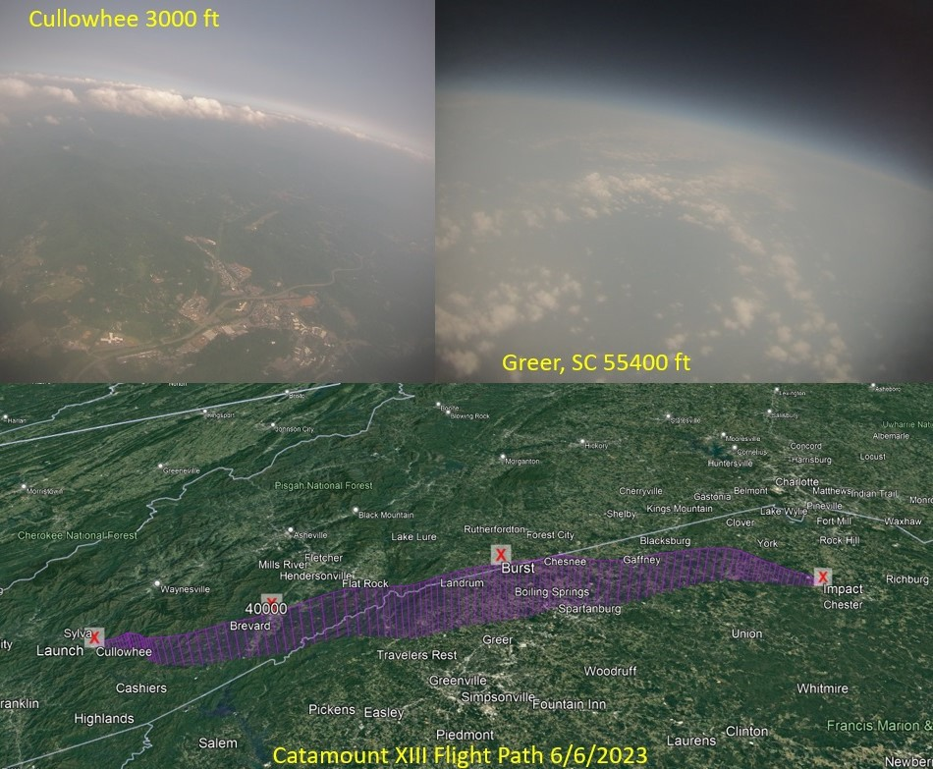

[jsholland231@gmail.com](mailto:jsholland231@gmail.com)

\. 828-342-7788

EMPLOYMENT HISTORY

2023–2024 **Leidos: Power Distribution**

POWER DISTRIBUTION ENGINEER *·* Asheville, NC

* + - * Developed power pole layouts in collaboration with Duke Energy, demonstrating expertise in **engineering design principles** and **adher- ence to industry standards**.
      * Managed bill of materials to ensure the **reliability** and **efficiency** of dis- tribution circuits, contributing to the seamless operation of the North Carolina power grid.
      * Utilized **Maximo** to facilitate effective communication and coordination of permitting efforts and vital design information, optimizing construc- tion processes for field personnel and minimizing project delays.
      * Performed field survey work to inspect and gather data on each power pole assigned to the Leidos Asheville office so that the engineering team had sufficient data to start their designs.
      * Leveraged **ArcGIS** to generate preliminary designs, proactively identify- ing and addressing potential environmental, structural, and permitting challenges before initiating the formal design processes.

2022–2023

### TekTone: Sound & Signal

MECHANICAL ENGINEERING INTERN *·* Franklin, NC

* Led the mechanical design for two anti-vandal nurse call stations, over- seeing the entire life cycle from conceptualization to successful product launch. **Gantt Project** was utilized heavily for efficient project manage- ment during this assignment. It was indispensable in properly allocating team resources and ensuring the timely achievement of project mile- stones.
* Spearheaded the usage of 3D printing technology for use in the **fabri- cation** of high-quality **test fixtures** that enhanced production processes and turnaround times. During the design phase collaboration with the production floor workers and machine shop personnel was instrumen- tal in ensuring that **each test article** or **tool** was built to fit their design needs and to ensure manufacturability.
* Implemented 3D printing technology that aided in producing corrective parts for high-volume products resulting in savings; avoiding shipping issues and lead times in injection mold fabrication.
* Conducted research projects using the **scientific method** that involved root cause analysis among other optimization studies. These projects used software tools such as **R Studio**, **Python**, and **MATLAB/Octave** to produce high-quality graphs and figures that were then organized in **LATEX** for presentation to management and interested parties.

2019–2022

### TekTone: Sound & Signal

MANUFACTURING ENGINEERING INTERN *·* Franklin, NC

* Worked with other technicians to run various parts of the automation line to ensure we met the production quota. This fostered a culture among the automated assembly line workers of **inclusiveness**, **excel- lence**, and **teamwork**. We viewed our fellow workers’ success as our own success. Our technician lead never had to worry about our com- petence.
* Trained to **operate** and **maintain** the **Panasonic pick n place equip- ment**, **Automated Optical Inspection equipment**, and **SPEA 4080** high-production flying probe tester.
* Developed Python script modules for KiCAD circuit board design soft- ware, enabling seamless communication between engineering and production teams. These modules generated usable files for the **Pana- sonic automation line** and the **SPEA 4080**, **improving design effi- ciency**, and **reducing errors in manufacturing**.
* Demonstrated initiative and dedication, progressing from an electron- ics assembly worker to a Manufacturing Engineering Intern within 2 months, showcasing adaptability and a strong work ethic.

# EDUCATION

2019–2023 **Bachelors In Mechanical Engineering**

WESTERN CAROLINA UNIVERSITY *·* Cullowhee, NC

### CubeSat Capstone Project

*fall and spring senior semesters*

* + Hand-picked by the WCU rapid center staff for my demonstrated knowledge and competence in heat transfer analysis and structural de- sign.
  + Led a multidisciplinary team in developing the mechanical design for the CubeSat frame.
  + Conducted extensive preliminary research in **CubeSat operational sys- tems**. We took the necessary time to evaluate CubeSat flight system hardware devices such as **boosters**, **reaction wheels**, **magnetorquers**, **Inertial Measurement Units**, and **Startracker** amongst some of the **spacecraft systems** we reviewed. This contributed to successfully im- plementing hardware within our allocated time frame without wasting our budget or time.
  + Utilized programming skills in VS Code to **support electrical engineer- ing team members** with logic board programming and **conducted de- sign audits of circuit boards** assessing **system performance**, **layout**, **operational limits**, **reliability**, and **manufacturability** using KiCAD cir- cuit board design software.
  + Preformed the design and **fabrication** of the mechanical frame in the **Western Carolina University machine shop**, ensuring compliance with project requirements and specifications provided by **ISO17770**.
  + Facilitated **communication** with sponsors and engineering mentors, providing regular updates on the firmware, mechanical design, and fab- rication progress. This communication was pivotal in guiding project di- rection so that our team met sponsor objectives.

### Academic Achievements

* + Dean’s List recognition for outstanding academic performance.
  + Graduated with a minor in math.

### Technical Skills Acquired

* + Proficiency in **Finite Element Analysis (FEA)** for gantries and steel struc- tures in both **CREO parametric** and **Ansys**.
  + Advanced proficiency in 3D modeling and assembly using Creo Para- metric and Autodesk Inventor.
  + Foundational understanding of **Computational Fluid Dynamics (CFD)**

analysis using **Ansys software**.

* + Hands-on experience in **waterjet cutting** production process and main- tenance.
  + Conducted an **independent study with Tektone: Sound & Signal** to determine the thermal loads on their nurse call system hardware. This required extensive use of **MATLAB** and **FLIR** devices to determine if the electronics needed extra ventilation or cooling in extreme heat from poorly designed server rooms.
  + Assisted in **repair**, **modification**, and **maintenance** of 3D printers within the 3D print lab.
  + Utilized CNC Machining for milling **wood** and **plastic** parts.
  + Learned Aluminum **TIG welding** for the CubeSat project.

2015–2019

### Associates in Science

SOUTHWESTERN COMMUNITY COLLEGE *·* Sylva, NC

* Developed proficiency in **3D printer design and modification**, culmi- nating in the construction of a customized 3D printer from scratch.
* Applied knowledge in hobby electronics and utilized **KiCAD** for elec- tronics design projects.
* Acquired practical skills in **metalworking** and **blacksmithing**, including basic practices for **MIG** and **ARC** welding techniques.
* Gained proficiency in programming languages including **C++**, **C#**, **Python**, **Arduino**, and **G-code**, enabling customization of custom 3D printer firmware.
* Developed strong foundations in 3D CAD software such as **FreeCAD**, **Autodesk Inventor**, and **Blender**, utilizing these skills to design and pro- duce 3D printable products that funded workshop upgrades and ma- terials.

# SOFTWARE EXPERIENCE AND TECHNICAL SKILLS

|  |  |  |  |
| --- | --- | --- | --- |
| Python | LaTeX | CREO Parametric | KiCAD |
| FreeCAD | CREO: FEA analysis | ANSYS | Fabrication |
| R Studio | Octave | MATLAB | C++ |
| (FDM) 3D Printing | Maximo | Water Jet Cutting | Product Development |
| Mechanical Drawings | VS Code | 3 Axis CNC Machining | Circuit Board Manufacturing |

CERTIFICATES

**June 2023** 6 Axis Robotic Arms: ASME

**Jan 2023-Feb 2023** Water Jet Cutting: Western Carolina University

**June 2024** OnShape: Detailed Drawings

**June 2024** OnShape: Simulation

# REFERENCES

Leidos| Hank Seaman (Distribution Mentor): 980-253-5045

Tektone| Kim Hammaker (VP manufacturing): 828-371-4654

WCU| Wes Stone (Director of Engineering + Technology): [wstone@email.wcu.edu,](mailto:wstone@email.wcu.edu) 828-227-2181

WCU| Enrique Gomez (CubeSat Project Sponsor): [egomez@email.wcu.edu,](mailto:egomez@email.wcu.edu) 828-227-2718

WCU| Scott Rowe (Fluid Dynamics Professor): [srowe@email.wcu.edu,](mailto:srowe@email.wcu.edu) 314-601-4836