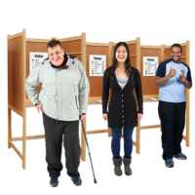

**Feedback from voters using support to vote**

We would like to hear about your experience of voting.

Telling us about your views and experiences will help us to improve the services we provide at future elections.

1. Did you find it easy to vote today?

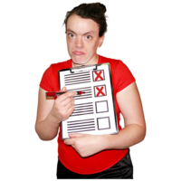You can put an X in the box to mark your answer.

|  |  |
| --- | --- |
| Yes |  |
| No |  |
| Don’t know |  |

1. If you did not find it easy, why was that?

You can use this box to write out your answer.

|  |
| --- |
|  |

1. Did you use any of the support available in the polling station? Please tick any support you used.

|  |  |
| --- | --- |
| Parking bay disabledDisabled parking space |  |
| ChairChairs/seating |  |
| BrailleTactile voting device |  |
| Magnifying glassMagnifiers |  |
| Electric wheelchairVoting Booth 1Polling booth at wheelchair level |  |
| PencilPencil grip |  |
| Election Access 1Entrance/doorway ramps |  |
| Bus bell ringEntrance doorbell/alerter |  |
| Hearing ImpairmentHearing induction loop |  |
| Hearing Test PhonesAudio device |  |
| Easy Read Logo 2Easy read information |  |
| Large printLarge print information |  |
| Text sizeLarge print reference ballot paper |  |
| Form Peer SupportSupport from a companion (friend, family, support worker) |  |
| TorchUse of mobile phone app (magnifier, torch) |  |
| HelloPolling Station SignSupport from polling station staff |  |
| Any Other BusinessOther (please say what this was) |  |

1. 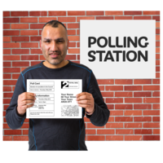Is there any other support you needed that was not available in the polling station?

You can use this box to write out your answer.

|  |
| --- |
|  |

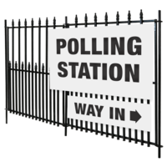

1. Were the polling station staff helpful?

You can put an X in the box to mark your answer.

|  |  |
| --- | --- |
| Yes |  |
| No |  |
| I did not ask for help |  |

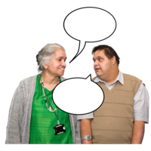

1. Is there anything else you’d like to share about your experience of voting today?

You can use this box to write out your answer.

|  |
| --- |
|  |

Made with thanks to Photosymbols.