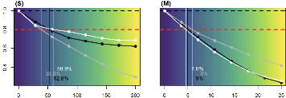
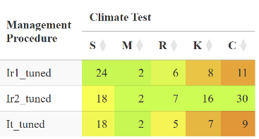
Step 2. Tune Management Procedures
MPs are tuned to have identical future outcomes.
Step 1. Prepare Operating Models
Any existing climate impacts are removed.
Step 4. Summarize Results
Concise and informative data, tables & figures.

Operating models with increasing climate impacts
Step 3. Run Climate Test Scenarios
MPs are projected under various climate tests.
Operating models without climate impacts

