Technical Specifications Document
  - Southern Atlantic Albacore MSE
2025-08-17

Introduction
This document describes the technical details of the management strategy evaluation (MSE) framework being developed for the Southern Atlantic albacore (SALB) tuna fishery.
See the SALB MSE Homepage for more general information on the SALB MSE Project.
This is a living document and will be continually updated as the project progresses.
Currently the model uses SALB data up to 2018. It will be updated with the most recent fishery data one the demonstration MSE framework has been reviewed by representatives of the managers and stakeholders.
Similarly, the life-history parameters and other technical specifications of the model (documented below) have not been reviewed by the SCRS or other interested stakeholders, and may be revised and updated once the initial framework has been reviewed.

Data
The operating models have been conditioned using the same data used in the most recent stock assessments, conducted in 2020 with data up to 2018 (Winker et al. 2020; Matsumoto 2020).

Catch
The SALB catches have been organized into 5 fleets (Table @ref(tab:catch-table); Figure @ref(fig:catch-plot)).
The five fleets used for the SALB catch data.
Fleet
Nations
Time.Period
1
Chinese Taipei (LL), Korea (LL)
1964 – 2018
2
China (LL), E. C. Spain (LL), E. C. Portugal (LL), Japan (LL), Philippines (LL), St Vincent and Grenadier (LL), USA (LL), Vanuatu (LL), Honduras (LL), Nei (LL), Côte D’Ivoire (LL), EU.United Kingdom (LL), Seychelles (LL), UK.Sta Helena (LL), Angola (LL), Senegal (LL), Trinidad and Tobago (LL)
1956 – 2018
3
Brazil (LL, SU), Panama (LL), South Africa (LL, UN), Argentina (LL, TW, UN), Belize (LL), Cambodia (LL), Cuba (LL, UN), Namibia (LL)
1959 – 2018
4
Brazil (BB, GN, HL, PS, TW, UN), E. C. Spain (PS), E. C. France (BB, PS), E. C. Portugal (BB, PS), Japan (BB, PS), Namibia (BB), Korea (BB) ,Maroc (PS), Panama (PS), South Africa (BB, HL, PS, RR, SP), USA (PS), USSR (SU, UN), UK St Helena (BB, RR), Chinese Taipei (GN), Nei (BB, PS), Argentina (PS), Belize (PS), Cape Verde (PS), Curaçao (PS), Guatemala (PS), Côte D’Ivoire (PS), Ghana (BB, PS), Guinea Ecuatorial (UN, HL), Guinée Rep. (PS), St. Vincent and Grenadines (PS), Guinea Ecuatorial (HL)
1964 – 2018
5
Uruguay (LL)
1981 – 2013
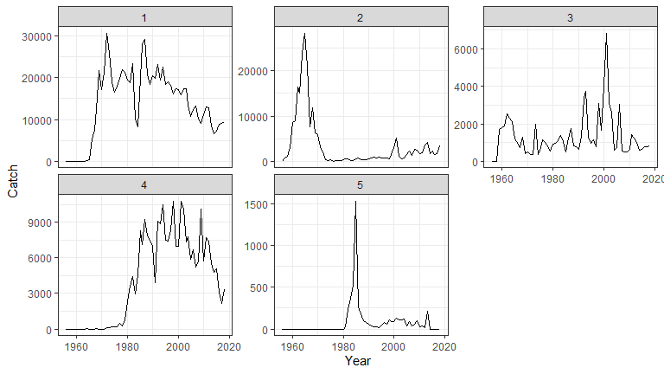
Time series plot of the SALB catch data by fleet.

Indices
Three indices of abundance were used in the SALB assessment (Table @ref(tab:index-table); Figure @ref(fig:index-plot)).
The three indices of abundance.
Fleet
Nations
Time.Period
1
Chinese Taipei (LL)
1967 – 2018
2
Japan (LL)
1976 – 2011
3
Uruguay (LL)
1983 – 2011
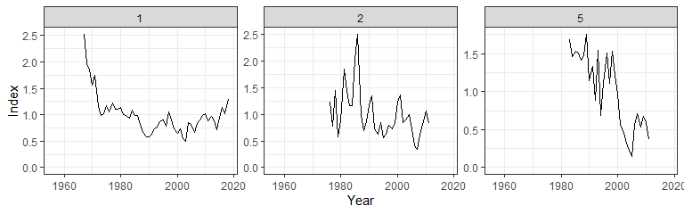
Time series plot of the SALB index data by fleet.

Composition Data
Catch-at-length data was aggregated using the same fleet structure used for catch (Figure @ref(fig:cal-plot))
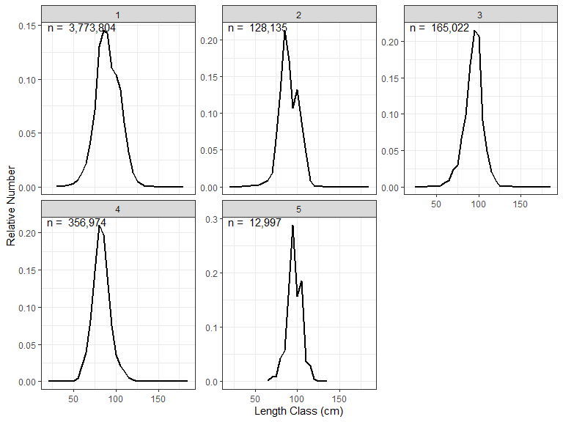
Length composition data for the 8 fleets. The catch-at-length data has been summed over all years and standardized by dividing by total number of samples (n) for each fleet.

Base Life-History Parameters
Table @ref(tab:LH-base-case) shows the base case values of the life history parameters.
Life history parameters for the Base Case Operating Model
Parameter
Description
Value
Reference
$M$
Natural mortality rate
0.35
ICCAT (2016); ICCAT (2004)
$L_{∞}$
von Bertalanffy asymptotic length
147.5
Lee and Yeh (2007)
$K$
growth coefficient
0.126
Lee and Yeh (2007)
$t_{0}$
expected age at L=0
-1.89
Lee and Yeh (2007)
$a$
length-weight relationship; average weight at L=1
1.37e-05
Penney (1994)
$b$
length-weight relationship exponent
3.09773
Penney (1994)
$L_{50}$
Length corresponding with 50% probability of maturity
89.7
Travassos et al. (2024)
$L_{95}$
Length corresponding with 95% probability of maturity
94
Travassos et al. (2024)
$h$
Steepness of Beverton-Holt SRR
0.8
Assumed based on Merino et al. (2020)
$σ_{R}$
Standard deviation of the log-normally distributed recruitment deviations
0.3
Assumed

Uncertainties in Life-History Parameters
The SALB MSE currently considers two axes of uncertainty in the life-history parameters (see Base Life-History Parameters):
- Natural mortality (M)
- Steepness of the Beverton-Holt stock-recruit relationship (h)
Potential additional uncertainties could include:
- Additional uncertainties that could be considered for the life-history parameters are:
- Uncertainty in the von Bertalanffy growth parameters
- Variation in the maturity parameters (e.g., bounded by the confidence intervals reported by Travassos et al. (2024))
- Variation in the recruitment deviations $\left(σ_{R}\right)$
The uncertainty in the continuous life-history parameters was deal with in two ways:
- Stochastic sampling of the life-history parameters from a multivariate distribution, and
- A discrete uncertainty grid following the methodology used in other ICCAT MSE processes (see the ICCAT MSE webpage for details <https://iccat.github.io/iccat-mse-web/>).
The latter approach has been used in several other ICCAT MSE processes, and the approach may be more familiar to ICCAT, the SCRS, and other stakeholders who have been involved in those MSE processes. However, the former approach is much more computationally efficient than the latter, and has the advantage that is can account for both down-weighting of less likely life-history parameters and correlations between life-history parameters.
An objective in this initial stage of the SALB MSE project is to demonstrate the advantages of the Stochastic Sampling approach and have this approach adopted by the SCRS for the development of the SALB MSE.

Stochastic Sampling
The Stochastic Sampling approach involved sampling 200 values of the life-history parameters from a multivariate distribution, and running the OM Conditioning model (see next section) for each simulation. A single OM was then generated, incorporating the output of the 200 fits to the data with the stochastic life-history parameters.
The methodology for sampling the life-history parameters was based on the methodology developed by N. G. Taylor (2024) for the Southern Atlantic Swordfish.
The life-history parameters were assumed to be log-normally distributed (Table @ref(tab:LH-stochastic)), and were sampled from a multivariate distribution truncated at 1.96 standard deviations. The truncation was used to exclude extreme values from the tails of the distribution.
The covariance matrix for the multivariate distribution was generated by using the correlation between M and h reported by the FishLife package (Thorson et al. 2023) for Thunnus alalunga.
Figure @ref(fig:stochastic-plot) shows a scatterplot and marginal histograms of the 200 samples of the stochastic life-history parameters.
The mean and standard deviation used to generate the stochastic life-history parameters.
Parameter
Mean
SD
$M$
0.35
0.1
$h$
0.80
0.1
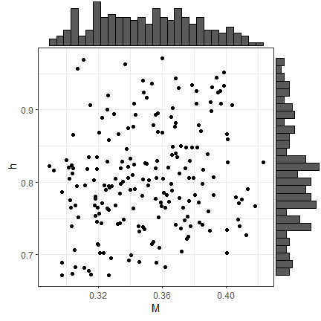
Scatterplot with marginal histograms of the samples of the stochastic life-history parameters.

Discrete Uncertainty Grid
The Discrete Uncertainty Grid assumed three levels for the two life-history parameters, resulting in 9 individual operating models, each with discrete values from the factorial combinations of the axes and levels of uncertainty (Table @ref(tab:LH-grid)).
The analysis of the Discrete Uncertainty Grid involves running the MSE for each of the OMs in the grid, and then calculating the performance metrics over the combined MSE results.
The values used in the discrete uncertainty grid.
OM
M
h
1
0.30
0.7
2
0.35
0.7
3
0.40
0.7
4
0.30
0.8
5
0.35
0.8
6
0.40
0.8
7
0.30
0.9
8
0.35
0.9
9
0.40
0.9

OM Conditioning
The Operating Models were conditioned with Stock Synthesis 3 (SS3). The operating models had 200 simulations and a 30-year projection period.

Stock Synthesis 3 Specifications
A one-area, combined sex, yearly structured model was implemented for the SALB stock using SS3 version 3.30.23.1 (Methot and Wetzel 2013). The available time series of catch, abundance indices, and length composition data considered in the SS3 model runs were assigned to specific “fleets” and “surveys”, with the survey structure used to incorporate the abundance index associated with each fleet (see Section @ref(data) above). The model was configured to cover the period from 1956 to 2018, using the same datasets applied in the most recent stock assessments (Winker et al. 2020; Matsumoto 2020) for conditioning.
Recruitment was modeled using a Beverton–Holt stock–recruitment relationship. Preliminary SS3 outputs examined with the r4ss package (I. G. Taylor et al. 2021) indicated limited recruitment information prior to ~1966, when only one fleet provided length compositions and no abundance indices were available. Consequently, estimation of main recruitment deviations began in 1967, with early deviations starting six years earlier, and was truncated in 2015 to reduce potential bias from the limited length data near the terminal year.
Fecundity was modeled as female spawning stock biomass (weight-at-age × maturity ogive) and assumed proportional to length (eggs = a × Lᵇ). Length composition data from ICCAT were assigned to fleets 1–5, excluding years with <100 measured fish. To reduce the influence of extreme annual sample sizes, original values (ONsamps) were rescaled using a power function (Nsamps = ONsamps^{0.25}). The assessment used 36 length bins (20–195 cm FL, 5 cm intervals). A double normal selectivity function was fitted in SS3 for all fleets, with initial parameters obtained by visually fitting curves to each fleet’s data using the R Shiny Stock Assessment Continuum Tool (Cope 2025).
A two-stage data weighting approach (Francis 2011), following Courtney et al. (2017), was applied. In stage one, a minimum average SE (log scale) for each abundance index was set in SS3, estimated from the residual variance of a smoothed CPUE series, with a minimum SE of 0.2 enforced (values below this threshold fixed at 0.2). In stage two, effective sample sizes for length compositions were derived from SS3 residuals using the Francis (2011) method.

Reference Operating Models
The Reference OMs spanned the primary uncertainties in the life-history parameters for this stock (see Section @ref(uncertainties-in-life-history-parameters)).
Reference OMs were generated using both the Stochastic Sampling and Discrete Uncertainty Grid approaches described above.

Stochastic Sampling
The Stochastic Sampling approach involved running the SS3 model for each of the 200 samples of the life-history parameters, and then generating a single OM with 200 predictions of the historical fishery dynamics; i.e., a single OM that includes the stochastic variability in the life-history parameters.

Uncertainty Grid
The Uncertainty Grid approach involved generating 9 OMs from the factorial grid (Table @ref(tab:LH-grid)).

Robustness Operating Models
Robustness OMs have not yet been developed for SALB.
Potential Robustness OMs may include:
- uncertainty in TAC implementation (e.g., overages in TAC)
- impacts of climate change (e.g., time-varying life-history parameters)

Historical Fishery Dynamics
TBD

Candidate Management Procedures
TBD

Performance Metrics
TBD

References
Cope, Jason. 2025. The Stock Assessment Continuum Tool (Previously Stock Synthesis Data-Limited Tool). https://github.com/shcaba/SS-DL-tool.
Courtney, Dean, Enric Cortés, and Xinsheng Zhang. 2017. “Stock Synthesis (SS3) Model Runs Conducted for North Atlantic Shortfin Mako Shark.” Collect. Vol. Sci. Pap. ICCAT, SCRS/2027/125, 74 (4): 1759–1821.
Francis, R. I. C. Chris. 2011. “Data Weighting in Statistical Fisheries Stock Assessment Models.” Edited by Ray Hilborn. Canadian Journal of Fisheries and Aquatic Sciences 68 (6): 1124–38. https://doi.org/10.1139/f2011-025.
ICCAT. 2004. “2003 ICCAT ALBACORE STOCK ASSESSMENT SESSION.” Collect. Vol. Sci. Pap. ICCAT 56 (4): 1223–1311.
———. 2016. “ICCAT Manual.” https://www.iccat.int/en/iccatmanual.html.
Lee, Liang-Kang, and Shean-Ya Yeh. 2007. “Age and Growth of South Atlantic Albacore A Revision After the Revelation of Otolith Daily Ring Counts.” Collect. Vol. Sci. Pap. ICCAT 60 (2): 443–56.
Matsumoto, Takayuki. 2020. “Stock Assessment for South Atlantic Albacore Using a Non-Equilibrium Production Model.” Collect. Vol. Sci. Pap. ICCAT 77 (7): 275–318.
Merino, G, L T Kell, H Arrizabalaga, and J Santiago. 2020. “Consolidated Report for North Atlantic Abacore Management Strategy Evaluation.” Collect. Vol. Sci. Pap. ICCAT 76 (8): 51–74.
Methot, Richard D., and Chantell R. Wetzel. 2013. “Stock Synthesis: A Biological and Statistical Framework for Fish Stock Assessment and Fishery Management.” Fisheries Research 142 (May): 86–99. https://doi.org/10.1016/j.fishres.2012.10.012.
Penney, Andrew J. 1994. “Morphometric Relationships, Annual Catches and Catch-at-Size for South African Caught South Atlantic Albacore (Thunnus Alalunga).” Collect. Vol. Sci. Pap. ICCAT 42 (1): 371–82.
Taylor, Ian G., Kathryn L. Doering, Kelli F. Johnson, Chantel R. Wetzel, and Ian J. Stewart. 2021. “Beyond Visualizing Catch-at-Age Models: Lessons Learned from the R4ss Package about Software to Support Stock Assessments.” Fisheries Research 239 (July): 105924. https://doi.org/10.1016/j.fishres.2021.105924.
Taylor, Nathan G. 2024. “An Overview of the Southern Swordfish Closed-Loop Simulation Approach.” Collect. Vol. Sci. Pap. ICCAT, no. in prep.
Thorson, James T., Aurore A. Maureaud, Romain Frelat, Bastien Mérigot, Jennifer S. Bigman, Sarah T. Friedman, Maria Lourdes D. Palomares, Malin L. Pinsky, Samantha A. Price, and Peter Wainwright. 2023. “Identifying Direct and Indirect Associations Among Traits by Merging Phylogenetic Comparative Methods and Structural Equation Models.” Methods in Ecology and Evolution 14 (5): 1259–75. https://doi.org/10.1111/2041-210X.14076.
Travassos, P, P Souza, S Kerwath, A Domingo, R Forselledo, N-J Su, F Santana, and C Jagger. 2024. “Thunnus Alalunga (Bonaterre 1788) Reproductive Biology Study in South Atlantic.” Collect. Vol. Sci. Pap. ICCAT 81 (3): 1–16.
Winker, Henning, Bruno Mourato, Denham Parker, Rodrigo Sant’Ana, Ai Kimoto, and Mauricio Ortiz. 2020. “Preliminary Stock Assessment of South Atlantic Albacore Tuna (Thunnus Alalunga) Using the Bayesian State-Space Surplus Production Model JABBA.” Collect. Vol. Sci. Pap. ICCAT 77 (7): 352–76.

