

**《C++语言程序设计》实验报告**

**姓 名：李剑寒**

**学 号：Y0914541**

**座 位 号： 92**

**专业班级： 网络空间安全**

**实验日期：2021/4/15**

**安徽大学互联网学院**

**实验内容**

**一、实验要求：**

1. 利用所学的函数知识求解cos(x)+ex，计算精度为10-10，x∈(−∞, +∞)的值由键盘输入，cos(x)的泰勒级数为：

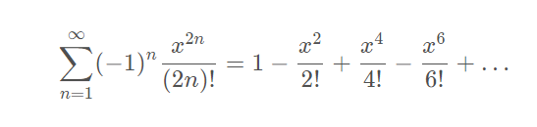

ex的泰勒级数为：

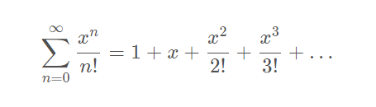

2. 利用函数重载完成三个比较大小的Compare函数，供主函数调用。三个Compare函数功能符合下列A、B中的之一。

A. 两个整数、两个字符、两个Person对象（按Person的年龄进行比较）.

B. 两个整数、两个字符、两个字符串（利用字符数组，返回值是char *）的比较。

**二、设计思路及程序代码**

**1.**

#include<iostream>

#include<cmath>

using namespace std;

double cos(double x)

{

double g = 1;

double t = -(x*x)/2;

int n = 1;

do{

g += t;

n++;

t = -t*(x*x) / ((2*n)*(2*n - 1));

} while (fabs(t) >= 1e-10);

return g;

}

double e(double x)

{

double g=1;

double t = x;

int n = 1;

do{

g += t;

n++;

t = (t*x) / n;

} while (fabs(t) >= 1e-10);

return g;

}

int main()

{

double x;

cout << "x= " << endl;

cin >> x;

double a = cos(x) + e(x);

cout << "cos(x)= " << cos(x) << ";" << "e(x)= " << e(x) << endl;

cout << "cos(x)+e(x)=" << a<< endl;

system("pause");

return 0;

}

**2.**

#include<iostream>

using namespace std;

int compare(int a, int b)

{

if (a < b)

cout << "a<b" << endl;

else if (a>b)

cout << "a>b" << endl;

else

cout << "a=b" << endl;

return 0;

}

char compare(char a, char b)

{

if (a < b)

cout << "a<b" << endl;

else if (a>b)

cout << "a>b" << endl;

else

cout << "a=b" << endl;

return 0;

}

class person

{

public:

int age;

void compare(int a, int b);

void setAge();

};

void person::compare(int a, int b)

{

if (a < b)

cout << "a<b" << endl;

else if (a>b)

cout << "a>b" << endl;

else

cout << "a=b" << endl;

}

void person::setAge()

{

int x;

cout << "Person's age" << endl;

cin >> x;

age = x;

}

int main()

{

int a, b;

cout << "a= " ;

cin >> a;

cout << "b= ";

cin >> b;

compare(a,b);

char x, y;

cout << "a= ";

cin >> x;

cout << "b= ";

cin >> y;

compare(x, y);

person personA;

person personB;

personA.setAge();

personB.setAge();

compare(personA.age, personB.age);

system("pause");

return 0;

}

**三、运行结果及分析**

**1.**

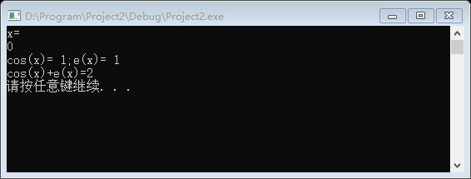

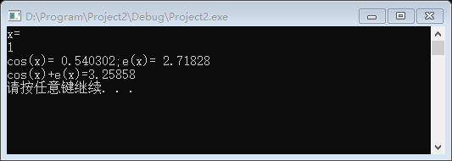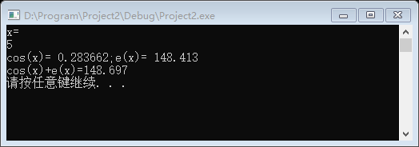

**2.**

