**第一次作业**

李剑寒 Y01914541 网络空间安全

**1-7**

控制信息和数据信息，其中控制信息可分为指令和控制字，数据信息可分为数值信息和非数值信息。

**1-8**

二进制是基数为2每位的权是以2为底的幂的进制，遵循逢二进一的原则，基本符号为零和一。优点：易于物理实现；二进制数运算简单；机器可靠性高；通用性强。缺点：表示数的容量较小，表示同一个数，二进制需要更多的位数。

**1-9**

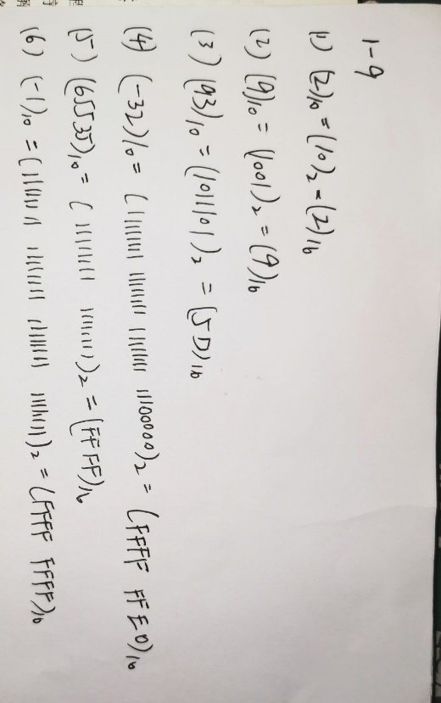

**1-10**

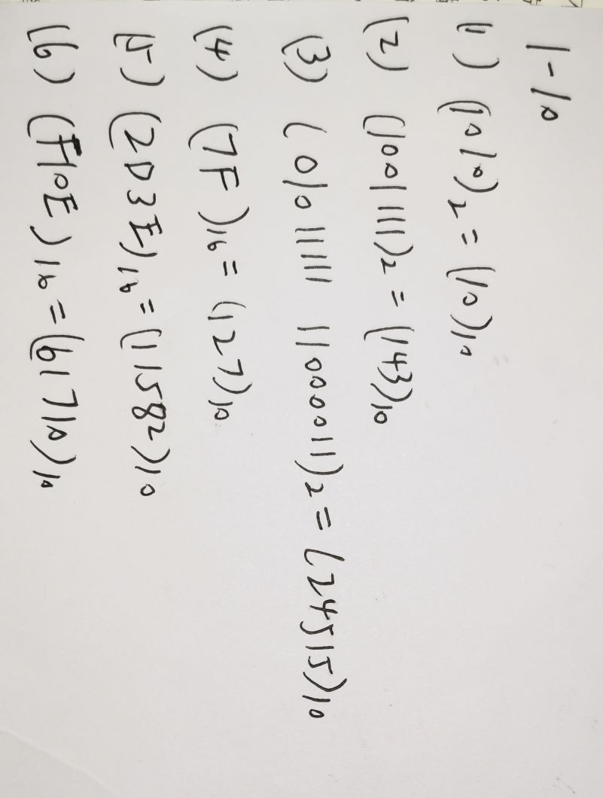

**2-14**

#include<iostream>

using namespace std;

int main()

{

int i;

int j;

i = 10;

j = 20;

cout << "i+j=" << i + j;

system("pause");

return 0;

}

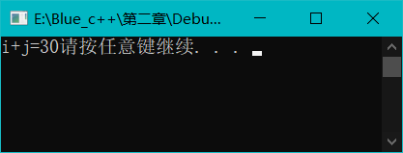

**2-18**

#include<iostream>

using namespace std;

int main()

{

unsigned int x;

unsigned int y = 100;

unsigned int z = 50;

x = y - z;

cout << "Different is:" << x << endl;

x = z - y;

cout << "\nNow difference is:" << x << endl;

system("pause");

return 0;

}

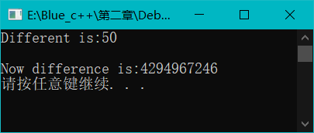

**2-19**

#include<iostream>

using namespace std;

int main()

{

int myage = 39;

int yourage = 39;

cout << "i am: " << myage << " years old." << endl;

cout << "you are: " << yourage << " years old." << endl;

myage++;

++yourage;

cout << "one year passes..." << endl;

cout << "i am: " << myage << " years old." << endl;

cout << "you are: " << yourage << " years old." << endl;

cout << "another year passes..." << endl;

cout << "i am: " << myage++ << " years old." << endl;

cout << "you are: " << ++yourage << " years old." << endl;

cout << "let's print it again" << endl;

cout << "i am: " << myage << " years old." << endl;

cout << "you are: " << yourage << " years old." << endl;

system("pause");

return 0;

}

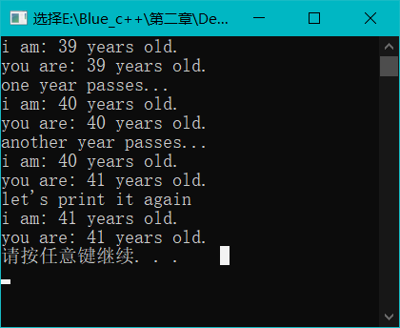

**2-26**

#include<iostream>

using namespace std;

int main()

{

cout << "How many marks did you get in the exam?" << endl;

int mark;

cin >> mark;

if (mark > 100 || mark < 0)

cout << "Your mark must be between 0 to 100!" << endl;

else{

switch (mark / 10){

case 10:

case 9:cout << "excellent" << endl;

break;

case 8:cout << "good" << endl;

break;

case 7:

case 6:cout << "medium" << endl;

break;

default:cout << "bad" << endl;

break;

}

}

system("pause");

return 0;

}

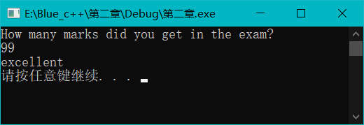

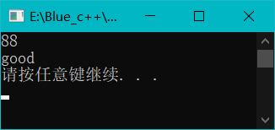

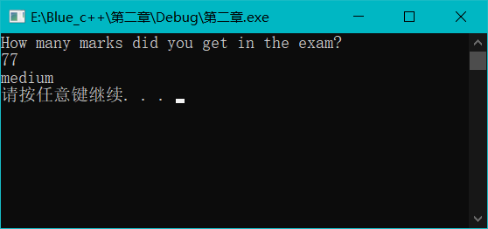

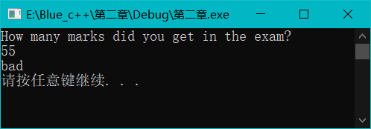

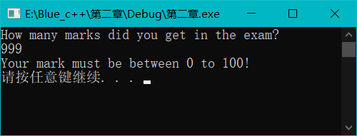

**2-27**

(1)

#include<iostream>

using namespace std;

int main()

{

cout << "Menu: A(dd) D(elete) S(ort) Q(uit),Select one:" << endl;

char c;

while (1)

{

cin >> c;

if (c == 'a' || c == 'A')

{

cout << "The data has been added!" << endl;

continue;

}

else if (c == 'd' || c == 'D')

{

cout << "The data has been deleted!" << endl;

continue;

}

else if (c == 's' || c == 'S')

{

cout << "The data has been sorded!" << endl;

continue;

}

else if (c == 'q' || c == 'Q')

break;

else

cout << "Please input a correct command!" << endl;

}

system("pause");

return 0;

}

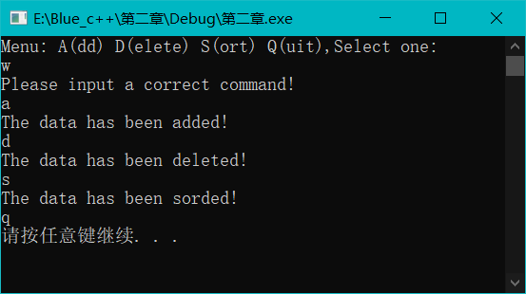

(2)

#include<iostream>

using namespace std;

int main()

{

cout << "Menu: A(dd) D(elete) S(ort) Q(uit),Select one:" << endl;

char c;

while (1)

{

cin >> c;

switch (c)

{

case'a':

case'A':cout << "The data has been added!" << endl;

break;

case'd':

case'D':cout << "The data has been deleted!" << endl;

break;

case's':

case'S':cout << "The data has been sorted!" << endl;

break;

case'q':

case'Q':system("pause");

exit(0);

break;

default:

cout << "Please input a correct command!" << endl;

}

}

system("pause");

return 0;

}

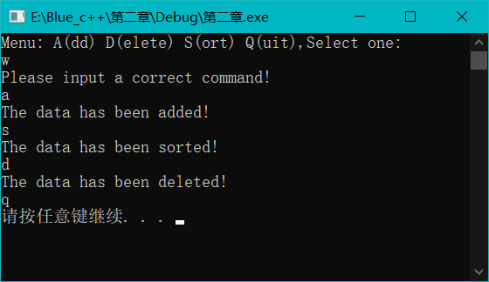

**2-28**

（1）

#include<iostream>

#include<cmath>

using namespace std;

int main()

{

int n = 3,s,m;

cout << 2 << endl;

cout << 3 << endl;

while (n <= 100)

{

m = 2;

s = sqrt(n);

while (m <=s)

{

if (0 == n%m)

break;

else

m += 1;

if (m > s)

cout << n << endl;

}

n += 2;

}

system("pause");

return 0;

}

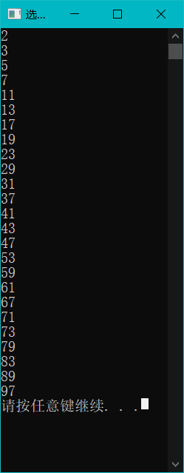

**2-33**

#include<iostream>

#include<cmath>

using namespace std;

int main()

{

for (int a = 1; a <= 9; a++)

{

for (int b = 1; b <= a; b++)

{

cout << b << " * " << a << " = " << a*b << endl;

}

}

system("pause");

return 0;

}

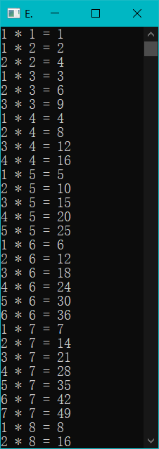

**3-2**

#include<iostream>

#include<cmath>

using namespace std;

int main()

{

int intOne;

int &rSomeRef = intOne;

intOne = 5;

cout << "intOne:\t" << intOne << endl;

cout << "rSomeRef:\t" << rSomeRef << endl;

int intTwo = 8;

rSomeRef = intTwo;

cout << "\nintOne:\t" << intOne << endl;

cout << "intTwo:\t" << intTwo << endl;

cout << "rSomeRef:\t" << rSomeRef << endl;

system("pause");

return 0;

}

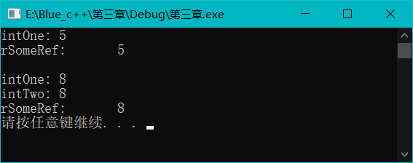

**3-7**

#include<iostream>

using namespace std;

int fun(unsigned short int a, unsigned short int b)

{

if (0==b)

return-1;

else

return a / b;

}

int main()

{

unsigned short int a;

unsigned short int b;

cout << "input a: " << endl;

cin >> a;

cout << "input b: " << endl;

cin >> b;

cout << fun(a, b) << endl;

system("pause");

return 0;

}

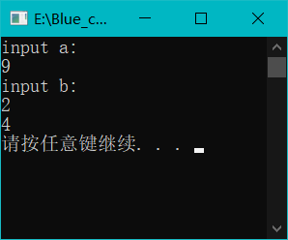

**3-8**

#include<iostream>

using namespace std;

int fun(float f)

{

float c;

c = (5*(f - 32)) / 9;

return c;

}

int main()

{

float f;

cout << "input F: " << endl;

cin >> f;

cout << "F= " << f << endl;

cout << "C= "<<fun(f) << endl;

system("pause");

return 0;

}

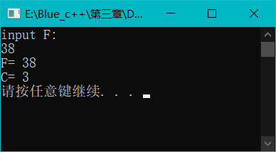

**3-13**

#include<iostream>

using namespace std;

int fun(int n)

{

int sum;

if (2 == n||1==n)

sum=1;

else

sum = fun(n - 1) + fun(n - 2);

return sum;

}

int main()

{

int n;

cout << "input n = " << endl;

cin >> n;

if (n <= 2)

cout << "n >2!" << endl;

else

{

cout <<fun(n) << endl;

}

system("pause");

}

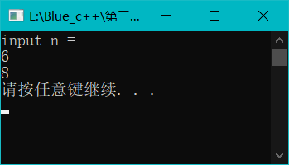

**3-14**

#include<iostream>

using namespace std;

double pn(int x,int n)

{

if (0 == n)

return 1;

else if (1 == n)

return x;

else

return ((2 * n - 1)*x*pn(x, n - 1) - (n - 1)*pn(x, n - 2)) / n;

}

int main()

{

int x;

int n;

cout << "x=" << endl;

cin >> x;

cout << "n=" << endl;

cin >> n;

cout << "P" << n << "(" << x << ")" << "=" << pn(x, n) << endl;

system("pause");

}

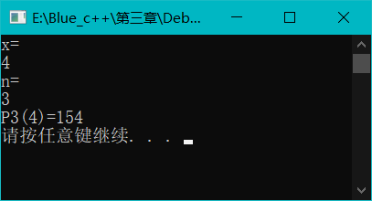

**3-15**

#include<iostream>

#include<cmath>

using namespace std;

int getpower(int x, int y)

{

if (y < 0)

return 0;

else if (1 == y)

return x;

else if (0 == y)

return 1;

else

return x*getpower(x, y - 1);

}

double getpower(double x, int y)

{

if (y < 0)

return 1 / (getpower(x, -y));

else if (1 == y)

return x;

else if (0 == y)

return 1;

else

return x*getpower(x, y - 1);

}

int main()

{

int a, m;

double b;

cout << "整数a=" << endl;

cin >> a;

cout << "实数b=" << endl;

cin >> b;

cout << "整数m=" << endl;

cin >> m;

cout << "a^m= " << getpower(a, m) << endl;

cout << "b^m= " << getpower(b, m) << endl;

system("pause");

}

