Names: Blue Barracudas Analysts

**Problem Analysis**

|  |  |  |  |
| --- | --- | --- | --- |
| **Description**  **(What’s the problem?)** | **Cause**  **(What causes the problem?)** | **Symptoms**  **(How do we know the problem exists?)** | **Impact**  **(Why is this important? What are the consequences?)** |
| The students have a hard time of finding a job. | There is no central online system where students can apply for a job. | Students have to go to the company to apply. | Going to a company to apply for a job is time consuming. The students’ time will not be fully utilized. |
|  |  |  |  |
|  |  |  |  |
|  |  |  |  |
|  |  |  |  |

**Visualize the Process**

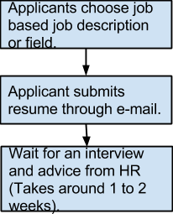

**What’s the business goal? Why do they need software?**

**To give an advantage and privilege to all Experts Academy’s alumni and to provide their corporate partners with credible and certified applicants.**

**What characteristics should the software have?**

**It should be able to handle at least 3000 users and be deployed in a web-based platform. It should be user friendly and effecient.**