I’m a README, so you should read me.

How to run a PHP file

* 1. Download WAMP
  2. Start WAMP
  3. Create a folder under c://wamp/www
  4. Load said folder in your browser: localhost/’name of folder’/’name of driver’

Load: main-login.php

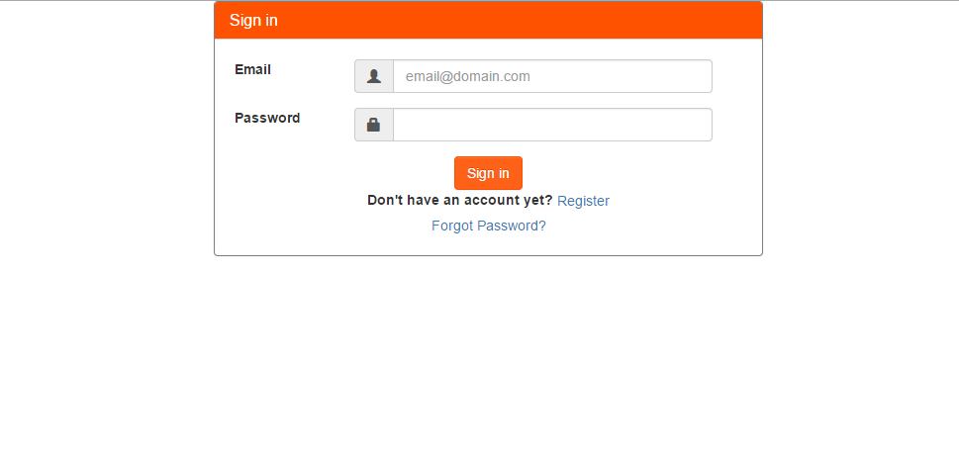

When signing in as an applicant



You will be redirected to this page, on the upper right hand side will display the applicant’s name. Under Profile, the user can set their personal information. Applicants can log out under the name.

When signing in as a company



You will be redirected to this page, on the upper right hand side will display the company’s name. Under company’s name can be found a account settings where the company can set their personal information. Log out under the name.