DS性能优化汇总

一、网络同步

1. ReplicationGraph

（1）分块同步
ReplicationGraph是UE引擎层提供的一个网络分块同步优化的技术方案(PUBG是自己实现了一个九宫格分块同步算法，算法原理类似)，可以减少同步量，降低DS的同步开销
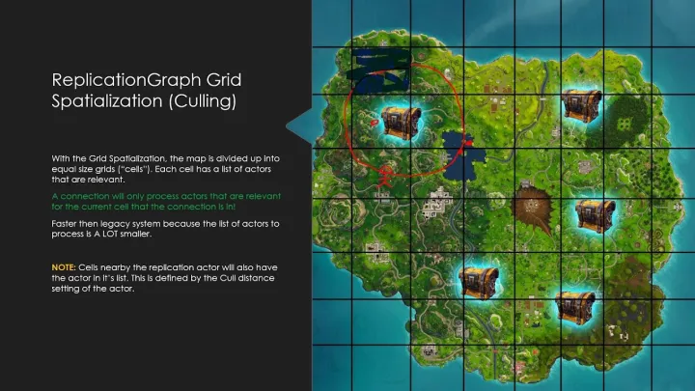

（2）应用代码
C++
/**
* GameReplicationGraph
**/
UCLASS(transient, config = Engine)
class UGameReplicationGraph :public UBasicReplicationGraph
{
GENERATED_BODY()
public:
UGameReplicationGraph();
virtual void InitGlobalActorClassSettings() override;
virtual void InitGlobalGraphNodes() override;
protected:
UPROPERTY(Config)
TArray<FRepListSizeLevel> RepListSizeConfigs;
UPROPERTY(Config)
float GridCellSize = 10000.f;
};

（3）展望
目前我们联机地图还没涉及大世界地图的规模，地图不够大，因此RG的优化有一定效果，但不是特别明显

2. AbilityAttributes同步

（1）FastArray
UE提供的一种优化同步数组的数据结构，可以做差量同步，但就算这样AbilityAttributes同步量依然很高

（2）主要优化内容
- 合并同步
修改FastArray同步机制，加一个缓冲合并同步的处理算法
C++
/*
* FAbilityAttributeArray
* 技能角色属性自定义同步数组
*
* 数据同步更新:
* (1) MarkItemDirty: 会及时写入网络同步buffer中, 同步量较大, 不推荐用此方式 (除非是需要及时同步的数据)
* (2) MarkItemToBeReplicated: 通过网络同步时间间隔控制, 合并一段时间的数据更新, 减少网络同步量对网络同步更友好, 优先采用此方式
*/
USTRUCT(BlueprintType)
struct FAbilityAttributeArray : public FFastArraySerializer {
}
- 同步item和非同步item分离
C++
USTRUCT(BlueprintType)
struct FAbilityAttributeArray : public FFastArraySerializer {
...
bool NetDeltaSerialize(FNetDeltaSerializeInfo& DeltaParams) {
// 只需要同步RepAttributes
return FastArrayDeltaSerialize<FAbilityAttributeItem, FAbilityAttributeArray>(RepAttributes, DeltaParams, *this);
}
...
private:
...
// 同步item
UPROPERTY(Transient)
TArray<FAbilityAttributeItem> RepAttributes;
// 非同步item(仅DS端使用)
UPROPERTY(Transient)
TArray<FAbilityAttributeItem> NotRepAttributes;
...
};
- 同步去重，减少冗余同步
重载==，比较当前状态和最新状态是否存在差异
- 去掉无需同步的Item属性
不需要同步的Item属性选择NotReplicated => 段

（3）优化效果
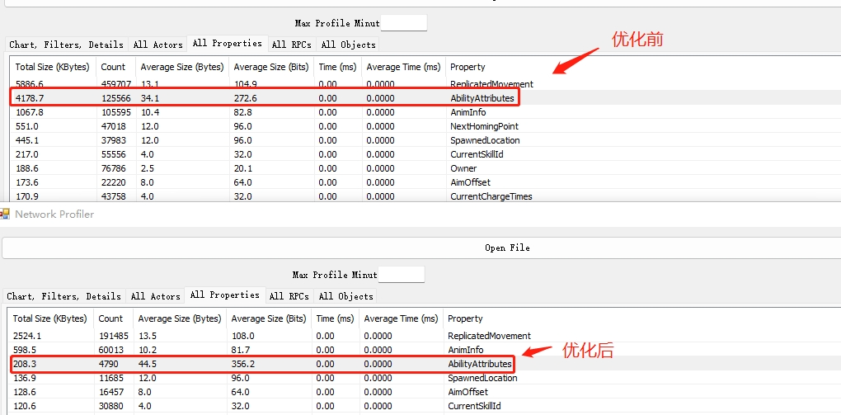

3. UnmappedObjects

（1）问题
前同事针对Actor和Owner之间存在强依赖关系的，将Owner的NetGuid映射Bunch中，保证Owner先同步到客户端处理
这种做法一方面会增加客户端处理UnmappedObjects的开销(特别是频繁创建的Skill Actor)，另一方面也会增加同步量

（2）优化方案
- 直接去掉Actor Owner的映射机制
- 业务层做好判空处理 & 必要逻辑可以写在OnRep_Owner回调函数中
C++
void UWaitOwnerActorChannel::AppendMustBeMappedGuids(FOutBunch* Bunch) {
// // Actor第一次同步到客户端时, 将Owner的NetGuid映射到Bunch中, 客户端会等待Owner的Bunch到了之后再处理自身
// if ((Bunch->bOpen) && Actor && Actor->GetOwner() && !Actor->GetOwner()->IsA<AController>()) {
// UPackageMapClient* PackageMapClient = CastChecked< UPackageMapClient >(Connection->PackageMap);
// TArray< FNetworkGUID >& MustBeMappedGuidsInLastBunch = PackageMapClient->GetMustBeMappedGuidsInLastBunch();
// const FNetworkGUID OwnerNetGuid = PackageMapClient->GetNetGUIDFromObject(Actor->GetOwner());
//
// MustBeMappedGuidsInLastBunch.Add(OwnerNetGuid);
// Super::AppendMustBeMappedGuids(Bunch);
//
// return;
// }
Super::AppendMustBeMappedGuids(Bunch);
}

二、移动同步

1. 子弹移动优化

（1）Player子弹
Bullet实体对象改为射线子弹，去掉角色bullet的创建和同步 => 段

（2）Monster子弹
1> 初步优化
- 重构子弹移动组件逻辑, 使用引擎层UProjectileMovementComponent(抛体移动组件)
- 模拟端插值平滑 & 模拟补偿
- DS端降低同步频率
C++
/**
* 抛体移动组件基类
* - 包含引擎层ProjectileMovementComponent的所有功能
* - 加入客户端插值算法(优化客户端平滑表现)
* - 加入客户端模拟补偿算法(可减少Actor移动同步且不影响客户端表现, 包括弱网下的较极端的情况)
*/
UCLASS()
class GAME_API UGameProjectileMovementComponent : public UProjectileMovementComponent {
GENERATED_BODY()
public:
/**
* 是否启动模拟补偿.
* - 在插值平滑算法处理结束且未收到DS最新状态的时间段内, 进行模拟补偿,
* 以减少客户端与DS的状态差异, 提升客户端表现.
*/
UPROPERTY(EditAnywhere, BlueprintReadWrite, Category=ProjectileInterpolation)
bool bSimulateCompensation;
UGameProjectileMovementComponent(const FObjectInitializer& ObjectInitializer);
virtual void TickComponent(float DeltaTime, ELevelTick TickType, FActorComponentTickFunction* ThisTickFunction) override;
protected:
// 插值平滑
virtual void TickInterpolation(float DeltaTime) override;
// 模拟补偿
virtual void SimulateMoveOnClientSide(float DeltaTime);
};
void UGameProjectileMovementComponent::TickComponent(float DeltaTime, ELevelTick TickType, FActorComponentTickFunction* ThisTickFunction) {
Super::TickComponent(DeltaTime, TickType, ThisTickFunction);
// 插值结束后启动模拟补偿
if (bInterpMovement &&
bSimulateCompensation &&
bInterpolationComplete && IsNetMode(NM_Client)) {
SimulateMoveOnClientSide(DeltaTime);
}
}
void UGameProjectileMovementComponent::TickInterpolation(float DeltaTime) {
if (!bInterpolationComplete) {
if (USceneComponent* InterpComponent = GetInterpolatedComponent()) {
const float InterpMoveDistance = Velocity.Size() * DeltaTime;
const float LeftInterpMoveDistance = InterpLocationOffset.Size();
// 位移插值
if (InterpMoveDistance < LeftInterpMoveDistance) {
InterpLocationOffset = InterpLocationOffset.GetSafeNormal() * (1 - InterpMoveDistance / LeftInterpMoveDistance);
} else {
InterpLocationOffset = FVector::ZeroVector;
}
// 旋转插值
if (DeltaTime < InterpRotationTime && bInterpRotation) {
InterpRotationOffset = FQuat::FastLerp(InterpRotationOffset, FQuat::Identity, DeltaTime / InterpRotationTime).GetNormalized();
} else {
InterpRotationOffset = FQuat::Identity;
}
...
} else {
ResetInterpolation();
bInterpolationComplete = true;
}
}
if (bInterpolationComplete && bAutoUpdateTickRegistration && (UpdatedComponent == nullptr)) {
UpdateTickRegistration();
}
}
void UGameProjectileMovementComponent::SimulateMoveOnClientSide(float DeltaTime) {
...
// 移动模拟补偿
const FVector& CurrentLocation = UpdatedComponent->GetRelativeLocation();
const FVector& CurrentVelocity = RepMovement.LinearVelocity;
const FVector& NewLocation = CurrentLocation + CurrentVelocity * DeltaTime;
// 旋转模拟补偿
const FRotator& CurrentRotation = UpdatedComponent->GetRelativeRotation();
const FVector& CurrentAngularVelocity = RepMovement.AngularVelocity;
const FRotator& NewRotation = CurrentRotation + CurrentAngularVelocity.Rotation() * DeltaTime;
UpdatedComponent->SetRelativeLocationAndRotation(NewLocation, NewRotation);
}
2> 进一步优化
- DS统一发射Bullet并同步初始位置到各个模拟端
- 模拟端根据DS同步相同的初始状态，并用相同的计算过程进行模拟子弹移动
- 模拟端只模拟表现，不参与逻辑计算(碰撞 / 伤害)
- DS端关闭子弹移动同步
- DS最终同步Bullet Apply的效果
C++
void ABullet::OnComponentBeginOverlap(UPrimitiveComponent* OverlappedComp, AActor* Other,
...
// DS端Apply, 然后同步结果到模拟端
if (HasAuthority() != false) {
Apply(Other, Hit);
}
...
}
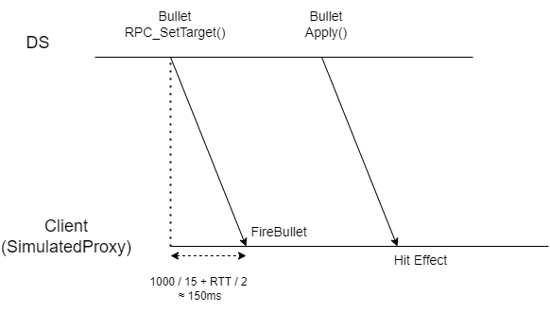

（3）优化效果
优化前
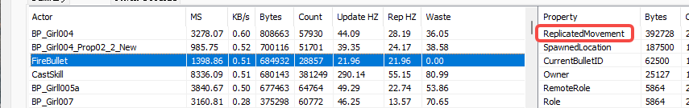
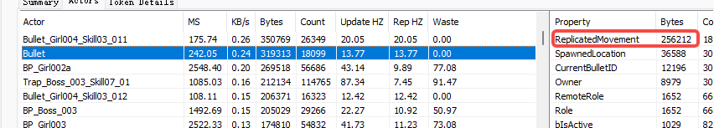

优化后
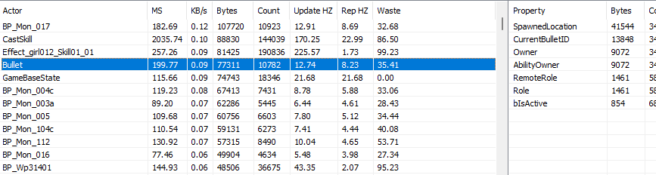

2. 角色移动优化

（1）问题
- 角色静止状态的移动包同步频率极高，并包太少
- 角色运动状态的移动包同步频率过高，并包太少
以上均导致DS端ServerMovePacked RPC处理耗时较高

（2）优化方案
- 引擎层
PendingMove的延迟时间上限和下限改到ini配置
C++
class ENGINE_API AGameNetworkManager : public AInfo
{
GENERATED_UCLASS_BODY()
...
/** ClientMinNetSendMoveDeltaTime is used clamped ClientNetSendMoveDeltaTime */
UPROPERTY(GlobalConfig)
float ClientMinNetSendMoveDeltaTime;
/** ClientMaxNetSendMoveDeltaTime is used clamped ClientNetSendMoveDeltaTime */
UPROPERTY(GlobalConfig)
float ClientMaxNetSendMoveDeltaTime;
...
};
void UCharacterMovementComponent::ReplicateMoveToServer(float DeltaTime, const FVector& NewAcceleration)
{
...
// Add NewMove to the list
if (CharacterOwner->IsReplicatingMovement())
{
...
if (bCanDelayMove && ClientData->PendingMove.IsValid() == false)
{
// Decide whether to hold off on move
const AGameNetworkManager* GameNetworkManager = (const AGameNetworkManager*)(AGameNetworkManager::StaticClass()->GetDefaultObject());
const float NetMoveDelta = FMath::Clamp(GetClientNetSendDeltaTime(PC, ClientData, NewMovePtr), GameNetworkManager->ClientMinNetSendMoveDeltaTime, GameNetworkManager->ClientMaxNetSendMoveDeltaTime);
if ((MyWorld->TimeSeconds - ClientData->ClientUpdateTime) * MyWorld->GetWorldSettings()->GetEffectiveTimeDilation() < NetMoveDelta)
{
// Delay sending this move.
ClientData->PendingMove = NewMovePtr;
return;
}
}
}
...
}
- 项目层
- 增加SendMove的最大上限延迟时间
- 增加运动时SendMove延迟时间
- 静止时SendMove的延迟时间设为最大上限
保证PendingMove合并最大化，优化客户端流量的同时优化DS端处理Move的耗时
C++
[/Script/Engine.GameNetworkManager]
;主控端同步SendMove的最大延迟时间(默认0.2)
ClientMaxNetSendMoveDeltaTime=1
;主控端同步SendMove的延迟时间
ClientNetSendMoveDeltaTime=0.066 // (PlayerCount < 10), 和DS更新频率一致
ClientNetSendMoveDeltaTimeThrottled=0.066 // (PlayerCount >= 10), 和DS更新频率一致
;主控端角色静止时同步SendMove的延迟时间
ClientNetSendMoveDeltaTimeStationary=1

（3）优化效果
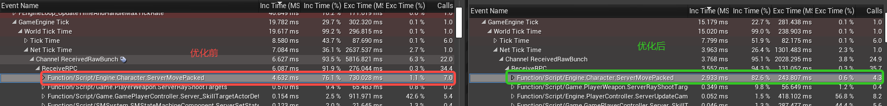
[优化前] [优化后]
4.632ms => 2.933ms

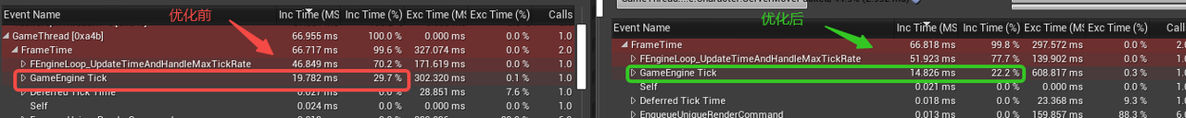

三、动画

1. 主控端动画和移动同步合并

（1）同步机制
ServerRPC Replication
AutonomousProxy ======> Authority(DS) ======> SimulateProxy

（2）实现代码(部分)
C++
/*
* 主控端玩家移动数据
* - Client -> Server
* - 动画同步数据和移动同步数据整合在一起, 方便优化
*/
struct FCustomCharacterMoveData : public FCharacterNetworkMoveData
{
public:
virtual void ClientFillNetworkMoveData(const FSavedMove_Character& ClientMove, ENetworkMoveType MoveType) override;
...
// 动画数据合并
uint8 bHasAnimInfoNet;
FAnimInfoNet AnimInfoNet;
...
};
void FCustomCharacterMoveData::ClientFillNetworkMoveData(const FSavedMove_Character& ClientMove, ENetworkMoveType MoveType) {
Super::ClientFillNetworkMoveData(ClientMove, MoveType);
...
// 动画数据合并
if (UGameCharacterAnimInstance* AnimInstance = Cast<UGameCharacterAnimInstance>(CharacterOwner->GetGameAnimInstance())) {
const FAnimInfoNet& NewAnimNetInfo = CharacterOwner->GetAnimInfo();
bHasAnimInfoNet = (NewAnimNetInfo != AnimInfoNet);
if (bHasAnimInfoNet) {
AnimInfoNet.CopyData(NewAnimNetInfo);
AnimInfoNet.TimeStamp = TimeStamp;
}
}
}

（3）合并同步
- 解决一些因动画和移动状态不同步导致模拟端表现异常的问题
- 减少相同属性的同步，优化流量开销

2. 骨骼更新优化

（1）动画Tick更新选项
C++
/** Skinned Mesh Animation Tick option based on rendered or not. This dictates "TickPose and RefreshBoneTransforms" */
UENUM(BlueprintType)
enum class EVisibilityBasedAnimTickOption : uint8
{
/** Always Tick and Refresh BoneTransforms whether rendered or not. */
AlwaysTickPoseAndRefreshBones,
/** Always Tick, but Refresh BoneTransforms only when rendered. */
AlwaysTickPose,
/**
When rendered Tick Pose and Refresh Bone Transforms,
otherwise, just update montages and skip everything else.
(AnimBP graph will not be updated).
*/
OnlyTickMontagesWhenNotRendered,
/** Tick only when rendered, and it will only RefreshBoneTransforms when rendered. */
OnlyTickPoseWhenRendered,
};

（2）优化思路
引擎默认选项AlwaysTickPoseAndRefreshBones，这会导致骨骼每帧都会更新，目前改成AlwaysTickPose，然后提供api根据需要打开骨骼更新
C++
/*
* DS端性能优化接口：动态开启/关闭骨骼更新
*/
void UGameLibrary::SetAnimationTickEnableOnDS(const AActor* InActor, const bool bEnable) {
if (!InActor || !InActor->IsNetMode(NM_DedicatedServer)) return;
...
SkeletalMeshCmp->VisibilityBasedAnimTickOption = bEnable ?
EVisibilityBasedAnimTickOption::AlwaysTickPoseAndRefreshBones:
EVisibilityBasedAnimTickOption::AlwaysTickPose;
}

（3）优化效果
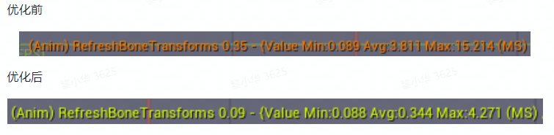

四、对象池

1. RepList Pool

（1）问题
RepList Pool用于存储DS端同步Actor时需要保存的相关信息，引擎默认pool的size比较小，当Actor同步量增加后，会导致RepList Pool扩容(memory copy)，开销较高(200ms+，最高甚至能到1000ms+)

（2）优化
RepList Pool分四档，按照缓存档位分配，目前最高档是能满足现有需求
C++
[/Script/Game.GameReplicationGraph]
+RepListSizeConfigs=(ListSize=3, NumLists=12)
+RepListSizeConfigs=(ListSize=6, NumLists=12)
+RepListSizeConfigs=(ListSize=128, NumLists=64)
+RepListSizeConfigs=(ListSize=256, NumLists=12)

C++
FPool& GetOrCreatePoolForListSize(int32 ExpectedMaxSize, bool ForPreAllocation=false)
{
// 按照缓存档位分配
FPool* Pool = PoolTable.FindByPredicate([&ExpectedMaxSize](const FPool& InPool) { return ExpectedMaxSize <= InPool.ListSize; });
if (!Pool)
{
...
Pool = new (PoolTable) FPool( ExpectedMaxSize );
}
return *Pool;
}

2. 对象池系统

（1）ObjectPoolSystem
- 引擎底层嵌套实现对象池系统
- 针对Actor只需要实现IReusable，即可无感的使用SpawnActor从对象池创建actor & DestroyActor将actor回收到对象池
- 针对联机的Actor，也是花了一些时间去解决优化网络相关的问题
- ActorChannel未关闭，导致客户端无法正常走到DestroyActor阶段(不会发Close Bunch)
- ActorChannel回收
- 因GuidCache导致客户端无法正常SpawnActor
- 因GuidCache导致open过的Actor的ReplicatedComponents无法同步到客户端的问题
- 客户端Actor被网络裁剪后，导致rep的子对象无法同步到客户端
- 同时还支持预加载，自动扩容等常规功能

（2）子弹使用对象池(例)
C++
/**
* Bullet base for this game.
*/
UCLASS(BlueprintType)
class GAME_API ABullet : public AGameProjectileBase, public IRelationshipInterface, public IReusable {
/**
* 对象池接口：OnSpawn
*/
virtual void OnSpawn_Implementation() override;
/**
* 对象池接口：OnRecycle
*/
virtual void OnRecycle_Implementation() override;
}

五、数据压缩

1. 网络数据类型压缩

（1）UE底层针对不同数据类型网络传输的处理
- int8 / int16 / int32 / float / double
按照实际类型长度的字节序列化，无压缩
C++
// Used internally only to control the amount of generated code/type under control.
template<typename T>
FArchive& ByteOrderSerialize(T& Value)
{
static_assert(!TIsSigned<T>::Value, "To reduce the number of template instances, cast 'Value' to a uint16&, uint32& or uint64& prior to the call or use ByteOrderSerialize(void*, int32).");
if (!IsByteSwapping()) // Most likely case (hot path)
{
Serialize(&Value, sizeof(T));
return *this;
}
return SerializeByteOrderSwapped(Value); // Slowest and unlikely path (but fastest than SerializeByteOrderSwapped(void*, int32)).
}
- uint32
提供两种压缩算法
C++
/**
* 按实际占位长度序列化, 但需要指定Max
*
* 只在一些特定场景使用(PackedVector/FixedFloat/NameIndex/)
*/
virtual void SerializeInt(uint32& Value, uint32 Max) override;
/**
* 按实际字节长度序列化(大部分场景使用)
*
* [0, 2^7 - 1] 1byte
* [2^7, 2^14 - 1] 2byte
* [2^14, 2^21 - 1] 3byte
* [2^21, 2^28 - 1] 4byte
* [2^28, 2^32 - 1] 5byte
*/
virtual void SerializeIntPacked(uint32& Value) override;
- FString
C++
FArchive& operator<<( FArchive& Ar, FString& A )
{
// > 0 for ANSICHAR, < 0 for UTF16CHAR serialization
static_assert(sizeof(UTF16CHAR) == sizeof(UCS2CHAR), "UTF16CHAR and UCS2CHAR are assumed to be the same size!");
if (Ar.IsLoading())
{
...
}
else
{
A.Data.CountBytes(Ar);
const bool bSaveUnicodeChar = Ar.IsForcingUnicode() || !FCString::IsPureAnsi(*A);
if (bSaveUnicodeChar)
{
// Note: This is a no-op on platforms that are using a 16-bit TCHAR
FTCHARToUTF16 UTF16String(*A, A.Len() + 1); // include the null terminator
int32 Num = UTF16String.Length() + 1; // include the null terminator
int32 SaveNum = -Num;
Ar << SaveNum;
if (Num)
{
if (!Ar.IsByteSwapping())
{
Ar.Serialize((void*)UTF16String.Get(), sizeof(UTF16CHAR) * Num);
}
else
{
TArray<UTF16CHAR> Swapped(UTF16String.Get(), Num);
for (int32 CharIndex = 0; CharIndex < Num; ++CharIndex)
{
Swapped[CharIndex] = ByteSwap(Swapped[CharIndex]);
}
Ar.Serialize((void*)Swapped.GetData(), sizeof(UTF16CHAR) * Num);
}
}
}
else
{
int32 Num = A.Data.Num();
Ar << Num;
if (Num)
{
Ar.Serialize((void*)StringCast<ANSICHAR>(A.Data.GetData(), Num).Get(), sizeof(ANSICHAR) * Num);
}
}
}
return Ar;
}
- FName
C++
bool UPackageMap::StaticSerializeName(FArchive& Ar, FName& InName)
{
if (Ar.IsLoading())
{
...
}
else if (Ar.IsSaving())
{
const EName* InEName = InName.ToEName();
uint8 bHardcoded = InEName && ShouldReplicateAsInteger(*InEName);
Ar.SerializeBits(&bHardcoded, 1);
if (bHardcoded && /* silence static analyzer */ InEName)
{
// send by hardcoded index
checkSlow(InName.GetNumber() <= 0); // hardcoded names should never have a Number
uint32 NameIndex = *InEName;
Ar.SerializeIntPacked(NameIndex);
}
else
{
// send by string
FString OutString = InName.GetPlainNameString();
int32 OutNumber = InName.GetNumber();
Ar << OutString << OutNumber;
}
}
return true;
}
- FText
FText主要用于本地化多语言，因此相比FName和FString存在很多额外信息，就算一个Empty的FText在进行网络传输时也会占用100-200bit，因此网络里是要严禁使用FText
C++
void FText::SerializeText(FStructuredArchive::FSlot Slot, FText& Value)
{
...
const int32 OriginalFlags = Value.Flags;
if(UnderlyingArchive.IsSaving())
{
Value.TextData->PersistText(); // We always need to do this when saving so that we can save the history correctly
if(UnderlyingArchive.IsPersistent())
{
Value.Flags &= ~(ETextFlag::ConvertedProperty | ETextFlag::InitializedFromString); // Remove conversion flag before saving.
}
}
Record << SA_VALUE(TEXT("Flags"), Value.Flags);
...
if (UnderlyingArchive.IsSaving())
{
Value.Flags = OriginalFlags;
}
if (UnderlyingArchive.UE4Ver() >= VER_UE4_FTEXT_HISTORY)
{
bool bSerializeHistory = true;
if (UnderlyingArchive.IsSaving())
{
// Skip the history for empty texts
bSerializeHistory = !Value.IsEmpty() && !Value.IsCultureInvariant();
if (!bSerializeHistory)
{
int8 HistoryType = (int8)ETextHistoryType::None;
Record << SA_VALUE(TEXT("HistoryType"), HistoryType);
bool bHasCultureInvariantString = !Value.IsEmpty() && Value.IsCultureInvariant();
Record << SA_VALUE(TEXT("bHasCultureInvariantString"), bHasCultureInvariantString);
if (bHasCultureInvariantString)
{
FString CultureInvariantString = Value.GetSourceString();
Record << SA_VALUE(TEXT("CultureInvariantString"), CultureInvariantString);
}
}
}
else if (UnderlyingArchive.IsLoading())
{
...
}
if(bSerializeHistory)
{
FTextHistory& MutableTextHistory = Value.TextData->GetMutableTextHistory();
MutableTextHistory.Serialize(Record);
if (Value.TextData->OwnsLocalizedString())
{
MutableTextHistory.SerializeForDisplayString(Record, Value.TextData->GetMutableLocalizedString());
}
}
}
...
if( Value.ShouldGatherForLocalization() )
{
UnderlyingArchive.ThisRequiresLocalizationGather();
}
}
- FVector / FRotator / FQuat
C++
// FVector无压缩
bool FVector::NetSerialize(FArchive& Ar, class UPackageMap* Map, bool& bOutSuccess)
{
Ar << X;
Ar << Y;
Ar << Z;
return true;
}
// FRotator(Pitch/Yaw/Roll[0, 360)), 使用了uint16进行压缩
bool FRotator::NetSerialize(FArchive& Ar, class UPackageMap* Map, bool& bOutSuccess)
{
SerializeCompressedShort( Ar );
bOutSuccess = true;
return true;
}
// FQuat无压缩
bool FQuat::NetSerialize(FArchive& Ar, class UPackageMap*, bool& bOutSuccess)
{
FQuat Q;
if (Ar.IsSaving())
{
...
}
Ar << Q.X << Q.Y << Q.Z;
if ( Ar.IsLoading() )
{
...
}
bOutSuccess = true;
return true;
}
- 支持网络传输的UObject指针引用(包括UActor/UActorComponent)
① FNetworkGUID(最多32位)
C++
friend FArchive& operator<<( FArchive& Ar, FNetworkGUID& G )
{
Ar.SerializeIntPacked(G.Value);
return Ar;
}
② ExportPathName(可选)
C++
/**
* This is the meat of the PackageMap class which serializes a reference to Object.
*/
bool UPackageMapClient::SerializeObject( FArchive& Ar, UClass* Class, UObject*& Object, FNetworkGUID *OutNetGUID)
{
...
if (Ar.IsSaving())
{
...
// Write object NetGUID to the given FArchive
InternalWriteObject( Ar, NetGUID, Object, TEXT( "" ), NULL );
// If we need to export this GUID (its new or hasnt been ACKd, do so here)
if (!NetGUID.IsDefault() && ShouldSendFullPath(Object, NetGUID))
{
check(IsNetGUIDAuthority());
if ( !ExportNetGUID( NetGUID, Object, TEXT(""), NULL ) )
{
UE_LOG( LogNetPackageMap, Verbose, TEXT( "Failed to export in ::SerializeObject %s"), *Object->GetName() );
}
}
return true;
}
else if (Ar.IsLoading())
{
...
}
return true;
}
③ 属性同步
- FStructProperty
① 如果有实现了NetSerialize接口，会调用NetSerialize进行序列化
② 如果没有实现NetSerialize接口，默认按照UPROPERTY属性(且没标记NotReplicated)定义顺序BuildSharedData，然后进行序列化同步
③ 如果Struct嵌套Struct成员属性，循环继续上述过程

（2）数据类型同步压缩优化
- float / double =》uintxx
浮点数在网络传输时是无法压缩的，因此可考虑根据实际情况转换成整型
例如：float [0, 1] - 32bit，通过scale=100的倍率缩放改成, uint8 [0, 100] - 8bit
- int8 / int16 / int32 / int64 =》uint8 / uint16 / uint32 / uint64
符号整型在网络传输时也是无法压缩的，因此也需要考虑换成对应长度的无符号整型
- FText / FName / FString =》uintxx
FName和FString在UE里大多数情况都是wchar(双字节字符)，并且UE底层在传输FString类型未做任何压缩处理，如果传输频率较高，流量消耗也会很高
例如：骨骼槽位BoneName可以改成BoneIndex
- FQuat =》FVector =》FVector_NetQuantize / FVector_NetQuantize10 / FVector_NetQuantize100
C++
/**
* FVector_NetQuantize
*
* 0 decimal place of precision.
* Up to 20 bits per component.
* Valid range: 2^20 = +/- 1,048,576
*
* Note: this is the historical UE format for vector net serialization
*
*/
USTRUCT()
struct FVector_NetQuantize : public FVector
/**
* FVector_NetQuantize10
*
* 1 decimal place of precision.
* Up to 24 bits per component.
* Valid range: 2^24 / 10 = +/- 1,677,721.6
*
*/
USTRUCT()
struct FVector_NetQuantize10 : public FVector
/**
* FVector_NetQuantize100
*
* 2 decimal place of precision.
* Up to 30 bits per component.
* Valid range: 2^30 / 100 = +/- 10,737,418.24
*
*/
USTRUCT()
struct FVector_NetQuantize100 : public FVector

六、Tick

1. DS动态帧率优化

（1）前序
引擎层有提供动态修改帧率的接口，但实测下来不起效，通过研究引擎源码发现有很多会影响DS帧率的接口，其中CVarMaxFPS是导致不起效的真正原因，这个Console变量主要是表现层那边在调用（但因为DS比较难debug，因此具体原因目前还未排查到）
C++
float UEngine::GetMaxTickRate(float DeltaTime, bool bAllowFrameRateSmoothing) const
{
float MaxTickRate = 0;
if (bAllowFrameRateSmoothing && IsAllowedFramerateSmoothing())
{
// Work in FPS domain as that is what the function will return.
MaxTickRate = 1.f / RunningAverageDeltaTime;
// Clamp FPS into ini defined min/ max range.
if (SmoothedFrameRateRange.HasLowerBound())
{
MaxTickRate = FMath::Max( MaxTickRate, SmoothedFrameRateRange.GetLowerBoundValue() );
}
if (SmoothedFrameRateRange.HasUpperBound())
{
MaxTickRate = FMath::Min( MaxTickRate, SmoothedFrameRateRange.GetUpperBoundValue() );
}
}
...
if (CVarUnsteadyFPS.GetValueOnAnyThread())
{
...
MaxTickRate = FMath::Clamp(LastMaxTickRate + RandDelta, 8.f, 32.f);
...
}
// 导致DS帧率不起效的可能性最大
else if (CVarMaxFPS.GetValueOnAnyThread() > 0)
{
MaxTickRate = CVarMaxFPS.GetValueOnAnyThread();
}
return MaxTickRate;
}
float UGameEngine::GetMaxTickRate(float DeltaTime, bool bAllowFrameRateSmoothing) const
{
float MaxTickRate = 0.f;
...
// See if the code in the base class wants to replace this
float SuperTickRate = Super::GetMaxTickRate(DeltaTime, bAllowFrameRateSmoothing);
if(SuperTickRate != 0.0)
{
MaxTickRate = SuperTickRate;
}
return MaxTickRate;
}

（2）修改引擎层，强制应用DS的动态帧率
C++
float UGameEngine::GetMaxTickRate(float DeltaTime, bool bAllowFrameRateSmoothing) const
{
float MaxTickRate = 0.f;
if (FPlatformProperties::SupportsWindowedMode() || IsRunningDedicatedServer())
{
// This applies for "non-console" platforms...
... other code
if( World )
{
UNetDriver* NetDriver = World->GetNetDriver();
// In network games, limit framerate to not saturate bandwidth.
if( NetDriver && (NetDriver->GetNetMode() == NM_DedicatedServer || (NetDriver->GetNetMode() == NM_ListenServer && NetDriver->bClampListenServerTickRate)))
{
// We're a dedicated server, use the LAN or Net tick rate.
MaxTickRate = FMath::Clamp( NetDriver->NetServerMaxTickRate, 1, 1000 );
// Force to apply 'NetDriver->NetServerMaxTickRate' on dedicated server
if (NetDriver->bForceToApplyNetServerMaxTickRate &&
(IsRunningDedicatedServer() || NetDriver->GetNetMode() == NM_DedicatedServer))
{
return MaxTickRate;
}
}
}
}
// See if the code in the base class wants to replace this
float SuperTickRate = Super::GetMaxTickRate(DeltaTime, bAllowFrameRateSmoothing);
if(SuperTickRate != 0.0)
{
MaxTickRate = SuperTickRate;
}
return MaxTickRate;
}

（3）DS动态帧率调整
- 动态调整接口
从GS发送的CmdLine中获取ServerTickRate参数，因此可根据线上实际情况动态调整
C++
bool USeasunNetDriver::InitListen(FNetworkNotify* InNotify, FURL& ListenURL, bool bReuseAddressAndPort, FString& Error) {
const bool bRet = Super::InitListen(InNotify, ListenURL, bReuseAddressAndPort, Error);
// DS InitListen阶段动态调整DS帧率
if (this->IsServer()) {
ApplyConsoleServerTickRate();
}
return bRet;
}
void USeasunNetDriver::ApplyConsoleServerTickRate() {
int32 ConsoleNetServerMaxTickRate = -1;
const bool bHasConsoleVar = FParse::Value(FCommandLine::Get(), TEXT("ServerTickRate="), ConsoleNetServerMaxTickRate);
if (bHasConsoleVar && ConsoleNetServerMaxTickRate > 0 && ConsoleNetServerMaxTickRate != this->NetServerMaxTickRate) {
this->NetServerMaxTickRate = ConsoleNetServerMaxTickRate;
}
}
- DS帧率默认从30调整到15
C++
[/Script/OnlineSubsystemUtils.IpNetDriver]
NetServerMaxTickRate=15
bForceToApplyNetServerMaxTickRate=true

（4）优化效果
内网测试数据：
- 单核CPU占用率
[30帧] [20帧] [15帧]
41.9% => 34.5% => 28.5%

七、Actor/ActorComponent专项

1、SetReplicates(false)
当不需要网络同步时，关闭同步

2、NetUpdateFrequency
网络同步频率，针对同步需求小的Actor可降低同步频率

3、Relevancy
网络相关性，通常除非特别需要，bAwaysRelevant设为false

4、NetCullDistanceSquared
网络裁剪距离，根据实际情况进行调整
例：Bunker等可交互物动态生成，可以优化客户端Actor数量 (闫乐)

5、Reliable RPC
客户端效果相关的RPC原则上一律采用Unreliable，影响逻辑的再用Reliable
C++
void UChannel::ReceivedRawBunch( FInBunch & Bunch, bool & bOutSkipAck )
{
...
if ( Bunch.bReliable && Bunch.ChSequence != Connection->InReliable[ChIndex] + 1 )
{
...
if ( NumInRec >= RELIABLE_BUFFER )
{
Bunch.SetError();
UE_LOG( LogNetTraffic, Error, TEXT( "UChannel::ReceivedRawBunch: Too many reliable messages queued up" ) );
return;
}
checkSlow(NumInRec<=RELIABLE_BUFFER);
//AssertInSequenced();
}
...
}
void UNetConnection::ReceivedPacket( FBitReader& Reader, bool bIsReinjectedPacket)
{
...
// Dispatch the raw, unsequenced bunch to the channel.
bool bLocalSkipAck = false;
Channel->ReceivedRawBunch( Bunch, bLocalSkipAck ); //warning: May destroy channel.
...
// Disconnect if we received a corrupted packet from the client (eg server crash attempt).
if ( !Driver->ServerConnection && ( Bunch.IsCriticalError() || Bunch.IsError() ) )
{
UE_LOG( LogNetTraffic, Error, TEXT("Received corrupted packet data from client %s. Disconnecting."), *LowLevelGetRemoteAddress() );
Close();
return;
}
...
}

6、子对象(DefaultSubObject)
子对象(DefaultSubObject)作为UProperty属性时，如果bReplicates设为true，就不需要选择Replicated
C++
UPROPERTY(Transient /*, Replicated*/ )
class UTeamAbilityComponent* TeamAbilityComponent;

引擎层的处理：
- ReplicateProperties：Actor属性同步
- ReplicateSubobjects：子对象同步
如果Actor子对象(ActorComponent)被标记为Replicate的属性，且本身打开了网络同步，就会被视为子对象和属性同步两次
C++
int64 UActorChannel::ReplicateActor()
{
...
if (!bIsNewlyReplicationPaused)
{
{
UE_NET_TRACE_OBJECT_SCOPE(ActorReplicator->ObjectNetGUID, Bunch, GetTraceCollector(Bunch), ENetTraceVerbosity::Trace);
// 属性同步
WroteSomethingImportant |= ActorReplicator->ReplicateProperties(Bunch, RepFlags);
}
// 子对象同步
WroteSomethingImportant |= Actor->ReplicateSubobjects(this, &Bunch, &RepFlags);
...
}
...
}

7、StaticMeshComponent
Mesh组件不需要勾选bReplicates，可以在业务层Actor的Native代码中强制关闭，避免策划随意乱改
C++
void AGameSkillInteractorBase::HandlePerformance_DS() const {
// 关闭StaticMeshComp的网络同步
TArray<UActorComponent*> StaticMeshComps;
GetComponents(UStaticMeshComponent::StaticClass(), StaticMeshComps);
if (StaticMeshComps.Num() > 0) {
for (UActorComponent* StaticMeshComp: StaticMeshComps) {
if (IsValid(StaticMeshComp)) {
StaticMeshComp->SetIsReplicated(false);
}
}
}
...
}

8、关闭骨骼更新
如果Actor不需要骨骼更新，建议在Native代码中直接关闭，在蓝图中按需打开
C++
void AGameSkillInteractorBase::HandlePerformance_DS() const {
...
// 去掉骨骼更新
USkeletalMeshComponent* SkeletalMeshComponent = Cast<USkeletalMeshComponent>(GetComponentByClass(USkeletalMeshComponent::StaticClass()));
if (SkeletalMeshComponent) {
SkeletalMeshComponent->VisibilityBasedAnimTickOption = CVarEnableBonesUpdateOnDS.GetValueOnGameThread() ?
EVisibilityBasedAnimTickOption::AlwaysTickPoseAndRefreshBones:
EVisibilityBasedAnimTickOption::AlwaysTickPose;
}
...
}

9、关闭移动
不需要移动的，关闭移动组件Tick/Replicate
C++
void AGameSkillInteractorBase::HandlePerformance_DS() const {
...
// 关闭移动组件
if (GetCharacterMovement() != nullptr) {
GetCharacterMovement()->SetIsReplicated(false);
GetCharacterMovement()->SetComponentTickEnabled(false);
GetCharacterMovement()->Deactivate();
}
}

