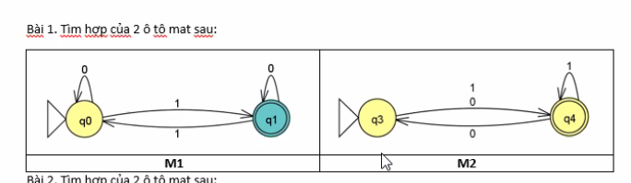

M1 = {{q0,q1}, {0,1}, δ, {q0} , {q1}}

M2 = {{q3,q4}, {0,1}, δ, {q3} , {q4}}

Q = {q­0q3, q0q4, q1q3, q1q4}

q = {q0 q3}

F = { q0q4, q1q3, q1q4}

|  |  |  |
| --- | --- | --- |
|  | 0 | 1 |
| q­0q3 | q0q4 | q1q4 |
| q0q4 | q­0q3 | q1q4 |
| q1q3 | q1q4 | q0q4 |
| q1q4 | q1q3 | q0q4 |

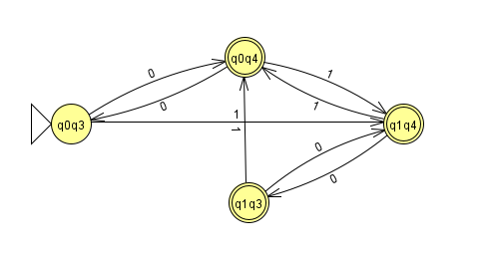

B2

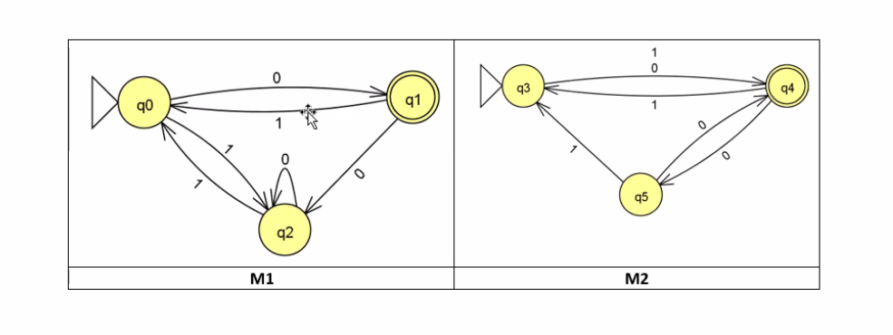

M1 = {{q0,q1,q2}, {0,1}, δ, {q0} , {q1}}

M2 = {{q3,q4,q5}, {0,1}, δ, {q3} , {q4}}

Q = {q­0q3, q0q4, q0q5, q­1q3, q1q4, q1q5, q­2q3, q2q4, q2q5 }

q = {q0 q3}

F = { q0q4, q1q4, q2q4, q­1q3, q1q5 }

|  |  |  |
| --- | --- | --- |
|  | 0 | 1 |
|  |  |  |
|  |  |  |
|  |  |  |
|  |  |  |
|  |  |  |
|  |  |  |
|  |  |  |
|  |  |  |
|  |  |  |