**HandInHand软件**

**使用手册**

**目 录**

1. **系统概述······················································································· 3**

**1.1软件功能概述·········································································· 3**

**1.2运行环境·················································································· 3**

**1.3软件安装·················································································· 3**

1. **软件启动与退出············································································ 3**

**2.1启动························································································· 3**

**2.2退出························································································· 3**

1. **软件功能操作················································································ 3**

**3.1注册和登陆·············································································· 3**

3.1.1注册**················································································· 3**

3.1.2登陆**················································································· 4**

**3.2浏览、搜索、关注······································································· 4**

3.2.1浏览**················································································· 4**

3.2.2搜索**················································································· 5**

3.2.3关注**················································································· 6**

**3.3提问、回答、评论······································································· 6**

3.3.1提问**················································································· 6**

3.3.2回答**················································································· 6**

3.3.3评论**················································································· 7**

**3.4个人信息浏览及修改······························································· 7**

1. **系统概述**
2. **软件功能概述**

HandInhand是一个基于安卓平台的校园问答软件，通过提问、回答、评论等形式，为在校师生提供一个在学习、生活、情感、就业等多方面都可以自由交流的平台。同时，以问题为导向，将校园独有的各类信息整合在一起，形成一个可方便查询的校园资源库。

1. **运行环境**
2. Android 4.0以上版本的移动设备上
3. 为保证最佳的显示效果，需在大于等于4.3英寸的显示屏上使用
4. **软件安装**

目前软件通过直接下载apk文件的方式在手机、平板等移动设备上安装。

1. **软件启动与退出**
2. **启动**

软件成功安装后只需点击图标，即可启动软件。（见下图）



1. **退出**

根据不同设备的具体情况而定，可以点击返回或者home键即可退出。

1. **软件功能操作**
2. **注册和登陆**

用户可以实现注册账户和登陆的功能，随便看看可以在不登陆的状态下进入首页，但是无法进行提问和回答等。

1. 注册

用户提供用户名、昵称、密码（填写两遍），在没有已经占有该用户名的用户存在的时候，点击确认即可注册。会提示注册成功，注册成功后会直接进入首页。当用户名重复时，会进行提示，用户需更改用户名再次注册。

  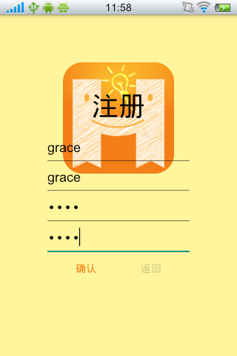

1. 登陆

用户提供用户名和密码，当用户名存在且密码正确时，便可登陆，登陆后会进入首页，反之，会提示登陆失败。

  

1. **浏览、搜索、关注**
2. 浏览

用户可以浏览问题，问题按照自身的属性，更需要时效性的问题被放置在30分钟紧急问题区，而更需要内容性值得长期讨论的问题被放在非紧急区的首页上。

30分钟紧急问题区内的问题，自带时间属性。当问题发布后就会进行30分钟的倒计时，当到时间后，该问题被标记为过期问题，会从紧急区移出，不过在搜索和用户的个人信息内仍然存在。这一区是为一些用户希望在短时间内迅速得到问题的答案准备的，如在期末复习时图书馆往往一座难求，一个用户在出发前决定是去图书馆还是别的教室自习时，就可以发一个问题到紧急区，来了解图书馆的拥挤程度，以便他在短时间内可以做出决定，但如果该问题过了一定的时间再得到回答，如一天后，那么这个答案对该用户已经没有意义了。

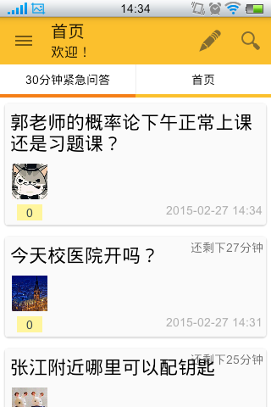

首页中的问题主要是一些对时间并没那么敏感的问题，用户把问题放到这往往更希望获得更多层次角度的回答。如一个用户希望听听其他人关于某个专业的看法和评价等。为了方便使用，首页中的问题进行了分类，共有今日热门、学海无涯、校园生活、情感大话、职业发展、吃喝玩乐、杂七杂八这七大类。

 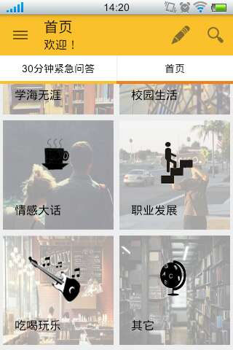 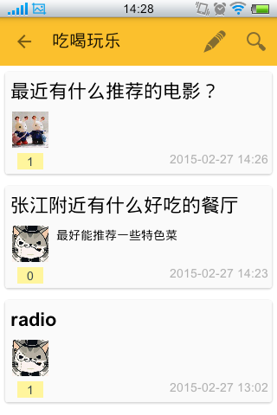

1. 搜索

用户可以对某个关键词进行搜索，搜索得到的结果会按照其出现的位置，被放置在问题、回答、评论三个区进行显示。(此处“搜索”按钮是由于手机屏幕大小的限制，当屏足够大的时候即可完全显示)

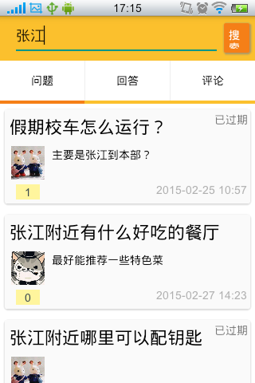 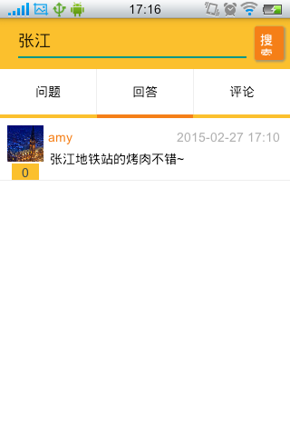 

1. 关注

用户可以对某个问题和某个人进行关注，以了解这些问题或人的最新情况。

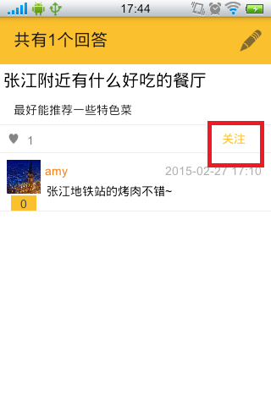 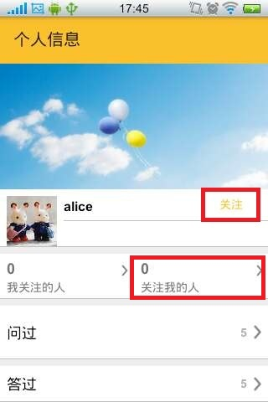 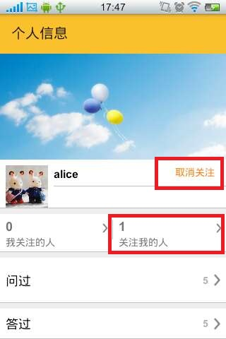

1. **提问、回答、评论**

用户可以提出问题、回答问题、评论问题

1. 提问

用户可以编辑自己的问题，填写问题的标题和内容，并选择相应的分类，即可发布问题。

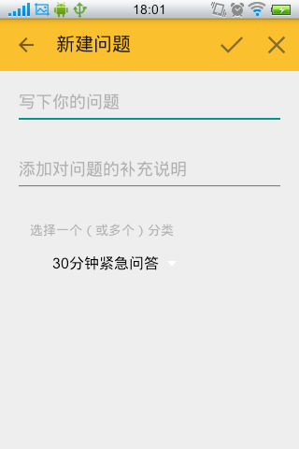 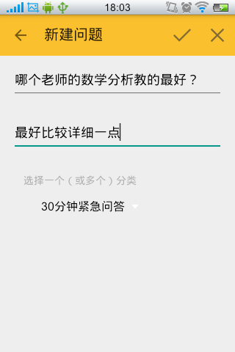

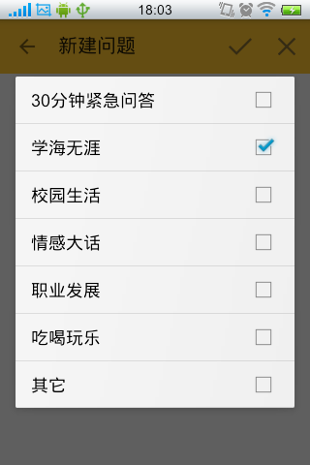 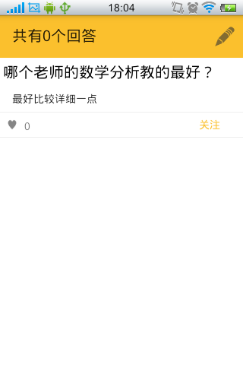

1. 回答

用户可以对浏览的问题进行回答。

  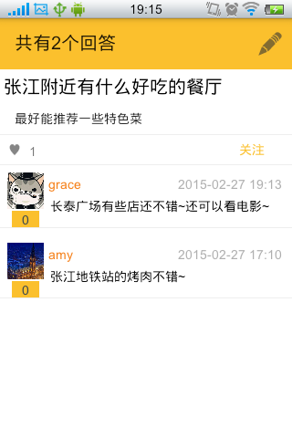

1. 评论（点赞）

用户可以对某个问题的回答进行点赞或评论。

点赞

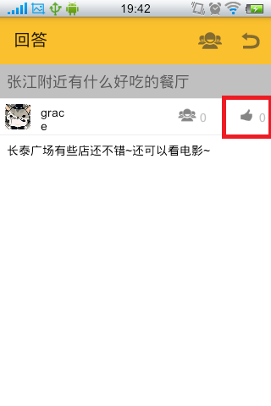 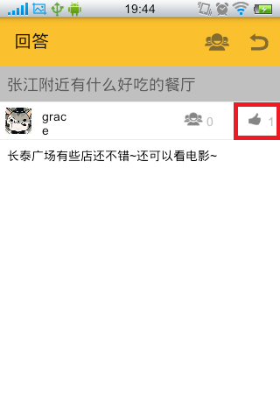

评论

  

1. **个人信息浏览及修改**

用户登陆后既可以在侧边栏中看到自己的昵称，点击后即可进入个人信息页面，此页面可以编辑用户的头像、昵称、个人简介，可以查看自己关注的人、关注自己的人、自己问过的问题、答过的问题。

