
jstal-tagger
User manual
MP3 & MP4 tag maintenance for the jukebox · version 2.3
October 2026
In the app: the ℹ️ button (top right) shows this manual in a window over the page.
Address: http://<server>:5080/manual.pdf · Word file: /manual.docx
Contents
1. What it does 3
2. Starting and the header 3
3. Settings (.env) 4
4. Libraries, folders and listing 5
5. The file grid 6
6. Selecting songs 7
7. Listening to a song 8
8. Editing tags (drafts) 8
9. Covers 8
10. Lookup data (online sources) 9
11. The YouTube counter 9
12. Saving 10
13. Wiping tags 10
14. ReplayGain and mp3rgain 11
15. Report and export 12
16. Safety, backups, restore 12
17. Messages and troubleshooting 13
18. Quick reference 15
Version markers: V2.1, V2.2 and V2.3 in green show what was added in that version.

jstal-tagger is a small web application that checks and maintains the tags of the MP3 and MP4 files in your music and video folders, so the files are ready for the jukebox application. It runs in Docker on your own server (port 5080). There is no login: use it on your own network only, never on the internet.
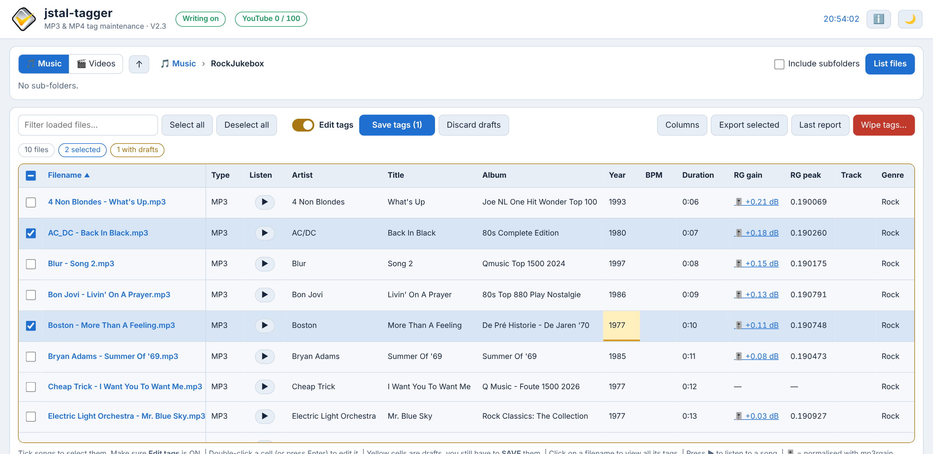
The main screen (light theme): one folder listed, two songs selected, one draft (yellow cell), the ReplayGain columns.

1. What it does
- Browse the music folder and the video folder V2.3 and list the MP3 and MP4 files with their tags in a grid.
- Edit tags one cell at a time. Edits are kept as drafts in the browser (yellow cells) until you save them.
- Look up missing data online: year, cover, comment, YouTube link and lyrics.
- Listen to a song in the browser before you decide about its tags. V2.1
- Save the drafts of the selected songs, after a confirmation window that shows exactly what changes.
- Wipe chosen tag fields from the selected songs.
- Report the result per file, export the tags as JSON.
- Read this manual in a window over the page, without leaving it. V2.2
- See the ReplayGain values of files that were normalised with mp3rgain (equal volume for all songs). They are read only and are never removed. V2.3
Every write first makes a verified backup copy and changes only the fields you approved; the audio data of a file never changes (see 16. Safety, backups, restore).
What it does not do: rename or move files, convert audio, change the volume or the ReplayGain values, write anything to files outside the music and video folders, or write anything at all while the app is in read-only mode.

2. Starting and the header
Open http://<server>:5080 in a browser (Chrome, Edge or Firefox). After an update press Ctrl + F5 once so the browser loads the new page files.
The header.
Item | Meaning
Writing on / Read-only | Whether the server may write to the files of the library that is open (Music or Videos). Read-only means ENABLE_TAG_WRITES=false or a read-only music / video folder (MUSIC_READ_ONLY / VIDEO_READ_ONLY): you can still list, edit drafts, look up data and check plans, but nothing is written.
YouTube 0 / 100 V2.1 | YouTube searches used today and the daily limit. Only shown when a YouTube key is configured. Click it to refresh. See 11. The YouTube counter.
Clock | The time in the browser.
ℹ️ User manual V2.2 | Opens this manual in a window over the page (see below). Until V2.1 this was the 📖 button, which opened a separate manual page in a new tab.
☀ / 🌙 | Switches between the dark and the light theme (remembered by the browser).

The user manual window V2.2
The title bar of the manual window.
- Click ℹ️ in the header. This manual (a PDF) opens in a window over the page, in the browser's own PDF viewer: scroll, search with Ctrl + F , zoom, print, and the contents panel (☰) to jump to a chapter.
- Close it with ✕ , with Esc , or by clicking the dark area around the window. You are back on the same page: the folder, the listed songs, the selection, your drafts and a playing song are untouched. No second copy of the app is opened.
- Open in new tab shows the PDF in its own browser tab (handy to keep it next to the app, or to save or print it). Close that tab when you are done: the app tab is not affected. Ctrl +click on ℹ️ does the same.
- Download .docx downloads the same manual as a Word file.
- A browser without a built-in PDF viewer (some phones) shows these two links in the window instead.
- The old address http://<server>:5080/manual (a bookmark from V2.1) now opens the PDF.
After you click inside the PDF, the PDF viewer receives the keys, so Esc may not close the window. Use ✕ or click outside the window.

3. Settings (.env)
All settings are in the .env file next to docker-compose.yml (an example with every setting explained is in env.example). After a change run docker compose up -d --force-recreate.
Setting | Meaning
MUSIC_HOST_PATH | The music folder on the server (mounted as /music).
VIDEO_HOST_PATH V2.3 | The video folder on the server (mounted as /videos), shown as 🎬 Videos in the page. Required: docker compose does not start without it. Example: /srv/videos.
BACKUP_HOST_PATH | The backup folder, outside the music and video folders (mounted as /backups).
ENABLE_TAG_WRITES | false (default) = read-only. Writing needs true and MUSIC_READ_ONLY=false (for Music) or VIDEO_READ_ONLY=false (for Videos).
MUSIC_READ_ONLY | true (default) mounts the music folder read-only.
VIDEO_READ_ONLY V2.3 | true (default) mounts the video folder read-only. false = the MP4 files can be tagged.
KEEP_BACKUPS | false (default): the backups of a save in which every file was saved and verified are removed afterwards. Wipe backups and saves with a failed file are always kept. true keeps every backup.
EDIT_MODE_DEFAULT V2.1 | true (default): the page starts with Edit tags switched on. false: it starts switched off, as in V2.
LOOKUP_USER_AGENT | Required by MusicBrainz, LRCLIB and Megalobiz: jstal-tagger/2.3 (mailto:you@example.com) with your real contact.
YOUTUBE_API_KEY | YouTube Data API v3 key. Empty = the YouTube lookup is off (shown as "not configured").
YOUTUBE_REGION | Two-letter country code for the YouTube search, default BE.
YOUTUBE_PREFERRED_CHANNELS | Channel names that are ranked higher, separated by |.
YOUTUBE_DAILY_LIMIT V2.1 | Searches per day before the app refuses further YouTube lookups, default 100 (the free quota).
DISCOGS_TOKEN | Discogs personal access token. Empty = the Discogs lookup is off.
DISCOGS_MASTER_OVERRIDES | JSON {"artist|title": master id} for songs that Discogs matches wrongly.
MEGALOBIZ_API_KEY V2.1 | Optional. Megalobiz works without a key (30 requests a minute, 1000 a day); a free key raises the limits.

4. Libraries, folders and listing
The folder bar starts with the two libraries, 🎵 Music and 🎬 Videos V2.3. Then it shows where you are (the breadcrumb 🎵 Music › RockJukebox) and the sub-folders as chips.
- Click 🎵 Music or 🎬 Videos to switch between the music folder and the video folder. A library that is not mounted is greyed out. V2.3
- Click a folder chip to open it; click a part of the breadcrumb or ↑ to go back.
- Tick Include subfolders to list the files of all sub-folders as well.
- Click List files . Every file is read and hashed, so a large folder takes a moment (about 100 songs in half a second). Files that cannot be read get a red Read error.
Listed in both libraries: files with the extension .mp3, .mp4, .m4a and .m4v V2.3. Symbolic links and files outside the music and video folders are ignored.
Changing the folder or the library, or listing again, discards unsaved drafts (the page asks first).

The last folder is remembered V2.3
The browser remembers the library, the folder and the Include subfolders tick. The next time you open the app it opens that folder again; the status line says "Last folder opened again (Videos › Clips). Click List files." Click List files to read it (the files are not read automatically, because a big folder takes a moment).
- A folder that no longer exists opens the top of its library; when Videos is no longer mounted the app opens Music.
- It is remembered per browser (like the hidden columns): another PC, phone or browser starts in its own last folder.

5. The file grid
Column | Shows
Filename | Click it for all tags of the file (ID3 or MP4), the ReplayGain values, the drafts and the SHA-256 (with a JSON download).
Type V2.3 | MP3, MP4, M4A or M4V.
Listen V2.1 | ▶ plays the song (see 7. Listening to a song).
Artist, Title, Album | TPE1, TIT2, TALB. Several values in one tag are shown as "Toto / Guest Singer".
Year | TDRC (ID3v2.4) or TYER (ID3v2.3). Four digits.
BPM, Track, Genre | TBPM, TRCK, TCON.
Duration | The measured audio time. Editing it only changes the stored TLEN value (milliseconds).
RG gain V2.3 | The ReplayGain track gain (read only), for example 🎚️ +0.21 dB. 🎚️ = mp3rgain changed the volume inside the file; the value is the small rest. Without 🎚️ only the tags were written. — = no ReplayGain. Click the value for all ReplayGain values (see 14).
RG peak V2.3 | The ReplayGain track peak (read only): the loudest sample, 1.0 = full scale.
Cover | A thumbnail of the embedded front cover (APIC). Click it to see it large.
Lyrics | LRC (synchronised, lines like [01:23.45] text), Plain, or nothing (USLT).
YouTube URL (TVSHOW) | The link the jukebox uses for the video (custom tag TXXX:TVSHOW).
VIDEO | Tick box: ticked = TXXX:VIDEO is "Yes", unticked = the tag is removed.
Comment | COMM (English, without description).
Other tags | The number of tags that have no column: ID3 frames or MP4 atoms (URLs, key, disc number, rating, compilation, custom TXXX, unknown frames). Not the ReplayGain values: those are in RG gain / RG peak. Click the number for the list.
Relative path, Read error | Where the file is, and why it could not be read.

- Sort: click a column title (again for the other direction).
- Filter loaded files: only files that contain all typed words (in any column) stay visible. The filter does not change the selection.
- Columns hides or shows columns; the choice is remembered by the browser.
- The counters under the toolbar show the number of files, how many are shown, selected, with drafts, and with read errors.

MP4 files V2.3
An MP4, M4A or M4V file has iTunes-style tags (atoms) instead of ID3 frames. The columns are the same; the app reads and writes these atoms:
Column | MP3 (ID3) | MP4 (atom)
Artist | TPE1 | ©ART
Title | TIT2 | ©nam
Album | TALB | ©alb
Year | TDRC / TYER | ©day
BPM | TBPM | tmpo (a whole number)
Duration | TLEN (stored value) | — (an MP4 file has none)
Track | TRCK | trkn
Genre | TCON | ©gen (also the old numeric gnre)
Cover | APIC | covr
Lyrics | USLT / SYLT | ©lyr
YouTube URL | TXXX:TVSHOW | tvsh
VIDEO | TXXX:VIDEO | ----:com.apple.iTunes:VIDEO
Comment | COMM | ©cmt

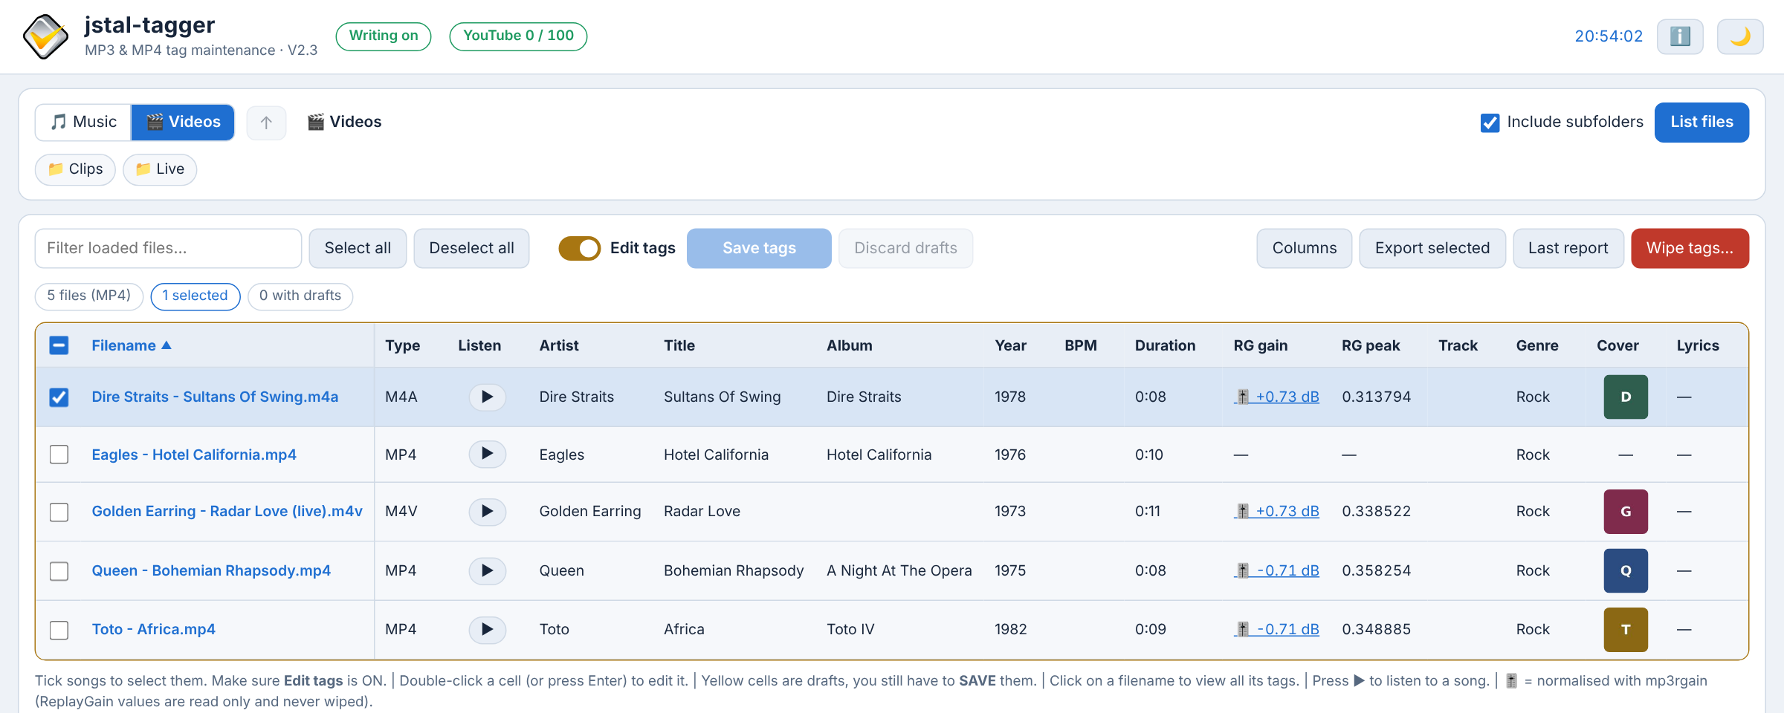
The Videos library: MP4, M4A and M4V files with their tags and ReplayGain values.

6. Selecting songs
Saving, wiping and exporting work on the selected songs (blue rows).
- Tick the box at the start of a row. The box in the column header selects or deselects all shown songs.
- Select all / Deselect all in the toolbar also include songs hidden by the filter.
- A song with a draft is selected automatically, so Save tags includes it.
- After a successful save the saved songs are deselected, so a wipe that follows cannot hit them by accident.

7. Listening to a song V2.1
Click ▶ in the Listen column. A player bar appears above the grid with the artist and title and the browser's own play / pause, position and volume controls. The same button (now ⏸ ) pauses and resumes; click ▶ on another row to switch songs; ✕ closes the player.
In the tag editor the ▶ Listen button next to the file name does the same, which is handy when you check lyrics or a YouTube result.
Listening is read-only: the server streams the file as it is, nothing is changed and the song keeps playing while you edit, save or wipe (and while you read this manual). The browser can seek (jump) inside the song.
An MP4 or M4V video plays its sound in the player bar (the picture is not shown). V2.3

8. Editing tags (drafts)

Edit mode
Editing is possible when the Edit tags switch is on. Since V2.1 the page starts with it on (EDIT_MODE_DEFAULT). The grid gets a yellow border and editable cells show a dashed outline when you hover.

Changing a cell
- Double-click a cell (or click it and press Enter ). The tag editor opens with the current value.
- Type the new value, or use Lookup data (see 10. Lookup data).
- OK makes a draft: the cell turns yellow. Nothing is written yet. Cancel or Esc closes without a draft.
- OK without a change makes no draft; typing the old value back removes the draft.
- Clear field makes a draft that deletes the field when saving ("(cleared)").
- When a cell has a draft, the editor also shows the value that is saved in the file.
- VIDEO is a tick box in the grid itself (in edit mode): ticked = Yes, unticked = the tag is removed.
- Duration: the editor changes only the stored TLEN value (milliseconds); the measured time stays. An MP4 file has no stored duration: that cell cannot be edited there. V2.3
- Year: four digits. Track: a number or number/total (6/12). BPM: a number (an MP4 file: a whole number).
- Lyrics: saving replaces all lyrics of the file, also synchronised (SYLT) ones.
- A tag with several values (shown with " / ") keeps them when you press OK without a change; a changed text is saved as one value.
- RG gain and RG peak cannot be edited (they are not tags you set by hand). V2.3
Drafts live in the browser. They are lost when you reload or close the page (the browser warns), and when you change the folder or list again. Discard drafts throws them away on purpose. Opening and closing the manual window does not touch them.

9. Covers
Double-click the Cover cell (edit mode) or click the thumbnail. In the cover editor you can:
- Choose a picture on this computer (JPEG, PNG or WEBP, up to 25 MiB). Big pictures are made smaller in the browser (at most 600 × 600, never enlarged); the server stores a JPEG and replaces all embedded pictures with that one front cover.
- Use Lookup data to find a cover on MusicBrainz (Cover Art Archive) or Discogs, click Use on a result and OK. The cover is downloaded by the server (artwork sites only) as a 600 px JPEG draft.
- MusicHoarders opens in a new tab: download a cover there, then choose it with "Choose a picture".
- Clear field removes all pictures when saving.

10. Lookup data (online sources)
For the fields Year, Cover, Comment, YouTube URL and Lyrics the tag editor has a Lookup data section.
- Adjust the Artist and Title used for the search if needed (this does not change the tags).
- Tick the sources and click Lookup Data . Each source shows its results in its own column.
- Click Use on a result: it fills the field (or shows the cover). You can still change the text before OK.
- Click OK to make the draft.
Field | Sources | Notes
Year | MusicBrainz, Discogs | The earliest year found is filled in already; check the View source link.
Cover | MusicBrainz / Cover Art Archive, Discogs, MusicHoarders (browser tab) | Front covers of matching releases.
Comment | MusicBrainz + Wikipedia, Discogs artist profile | A short artist / recording text.
YouTube URL | YouTube, Discogs release videos | Public, embeddable music videos ranked on title, artist, duration and "official" wording. Live and concert uploads are skipped. Counted by the daily counter.
Lyrics | LRCLIB, Megalobiz V2.1 | Synchronised (LRC) lyrics are preferred over plain text. Megalobiz only returns LRC sheets.

Megalobiz V2.1
Megalobiz (megalobiz.com) is a large collection of user-made synchronised lyrics. The app uses its public API: it searches on artist, title and duration and fetches the best matching sheets (at most 3). A sheet is only shown when artist and title match closely (90 %) and the duration is within 3 seconds; sheets without timestamps are skipped. Because the sheets are timed by hand, play the song ( ▶ Listen ) and check that the lines keep up before you save. The View source link opens the sheet's page on Megalobiz.
Matches are heuristic for every source. Always look at the source link before you save; "Use" and OK only make a draft.

11. The YouTube counter V2.1
The YouTube Data API gives 10 000 quota units a day; one search costs 100 units, so about 100 searches a day are possible. The header shows YouTube n / 100: the searches used today and the limit (YOUTUBE_DAILY_LIMIT, default 100).
- The badge is green, turns orange when fewer than about 15 % are left and red when the limit is reached.
- When the limit is reached the app does not call YouTube any more: the lookup column says why, a message pops up, and the YouTube source is unticked in the lookup section (it says "daily limit reached").
- If Google itself reports that the quota is used up (it also counts calls from other programs with the same key), the badge shows that too.
- Google resets the quota at midnight Pacific time (about 09:00 in Belgium); the badge's tooltip shows the local time. Click the badge to refresh it.
- A result that is still in the cache (six hours) costs nothing.
- The counter is saved in .jstal-tagger/youtube-quota.json in the backup folder, so it survives a restart of the container.

12. Saving
- Make drafts (yellow cells). The Save tags (n) button shows how many selected songs have drafts.
- Click it. The server checks every file and value and shows a confirmation window: per song a table Field · Now in the file · New; covers as pictures. The raw plan is under "Technical details".
- Click Save these changes . A progress bar shows "Saving 3 / 8".
- Saved songs are read again, their drafts disappear and they are deselected. A message shows the result; if a file failed, the Last report opens.
- At most 100 songs per save. A prepared plan is valid for 30 minutes and can be used once.
- A file that changed since it was listed is refused ("File changed since it was listed"): list the folder again.
- Cancel — nothing is written closes the window without writing.
- In read-only mode you can prepare and check a plan, but the save button stays disabled.

13. Wiping tags
Wiping removes chosen fields from the selected songs. Save or discard your drafts first.
- Select the songs and click Wipe tags… .
- Tick the fields to remove. Artist, Title and Album are unticked by default (protected). Select all and Deselect all V2.1 tick or untick every field at once; Default choice restores the default. The line at the bottom shows how many fields are ticked and warns when Artist, Title or Album is among them.
- Click Prepare wipe... . The confirmation window lists per song the exact tags that are removed (ID3 frames or MP4 atoms), the fields that stay protected and, in green, the ReplayGain values that are kept. V2.3
- The confirmation text WIPE SELECTED TAGS is already filled in V2.1. Check the list, then click Wipe these tags . (If you change the text, the button is disabled until it matches again.)
- Other tags removes every tag that has no column: URLs, key, disc number, rating, compilation, custom TXXX and unknown frames, but never the ReplayGain values (see 14). V2.3
- An MP3 file can have an APEv2 tag at the end (mp3rgain keeps its undo information there). The app never writes it. A wipe of Other tags refuses a file whose APEv2 tag holds other items than ReplayGain values, rather than leave hidden tags behind.
- Duration only removes the stored TLEN value (MP3); VIDEO removes the TXXX:VIDEO tag (MP4: the VIDEO atom).
- Wipe backups are always kept (see 16).
A wipe is a real change to your files. The protection is the exact list in the confirmation window — read it.

14. ReplayGain and mp3rgain V2.3
mp3rgain makes all songs about equally loud. With mp3rgain -r it changes the volume inside the MP3 or AAC audio frames (lossless, without encoding again) and stores in tags what it did. jstal-tagger shows these values and makes sure that no save or wipe removes them.

What the columns show
- RG gain with 🎚️ (for example 🎚️ +0.21 dB): mp3rgain changed the volume in the file. The gain is only the small rest that could not be applied (less than 0.75 dB, one mp3rgain step is 1.5 dB). The file is ready: the jukebox plays it at the right volume.
- RG gain without 🎚️ (for example +24.42 dB): only the tags were written (mp3rgain -r --tags-only). The volume in the file was not changed; only a player that reads ReplayGain uses it. Run mp3rgain again without --tags-only if the volume itself should change.
- —: no ReplayGain values (the file was not normalised).
- Click the value for the ReplayGain (read only) part of the details window: track and album gain and peak, the algorithm (ITU-R BS.1770 = ReplayGain 2.0), whether the volume in the file was changed, the undo value, and every stored value with where it is.
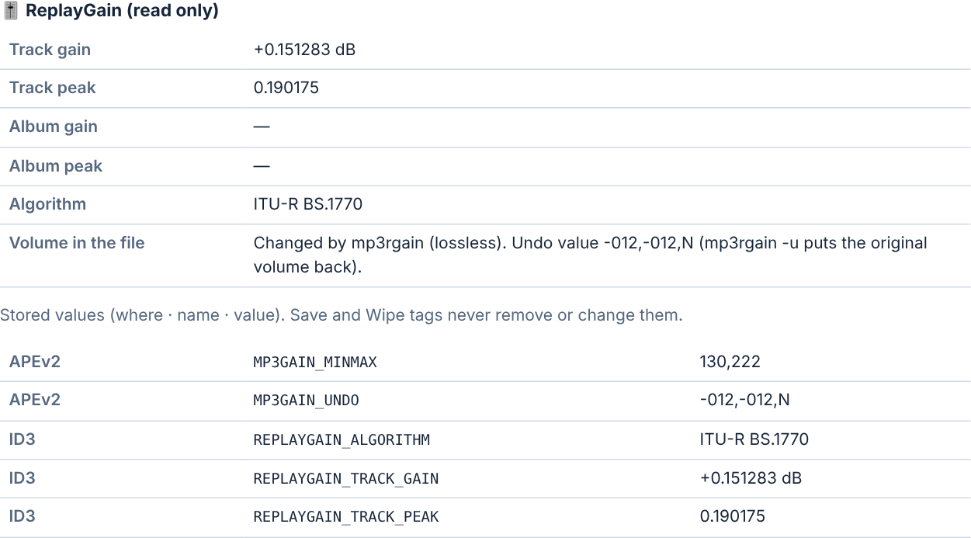
The ReplayGain part of the details window of a song normalised with mp3rgain.

Which tags are kept (never wiped)
mp3rgain 3.12 was tested with its default settings and with -s i, -s a and --tags-only. These tags are protected: a save does not touch them, a wipe (also with every field ticked) leaves them, and the safety check refuses a file in which one of them would change.
Where | Tags | Meaning
MP3: ID3 (TXXX) | REPLAYGAIN_TRACK_GAIN, REPLAYGAIN_TRACK_PEAK, REPLAYGAIN_ALBUM_GAIN, REPLAYGAIN_ALBUM_PEAK, REPLAYGAIN_ALGORITHM | Gain (dB) and peak per track / album, the method.
MP3: APEv2 tag | MP3GAIN_UNDO, MP3GAIN_MINMAX, MP3GAIN_ALBUM_MINMAX | How mp3rgain changed the frames. MP3GAIN_UNDO is needed for mp3rgain -u (back to the original volume).
MP3: ID3 (TXXX), with -s i | MP3GAIN_UNDO, MP3GAIN_MINMAX | The same, stored in ID3 instead of APEv2.
MP3: APEv2, with -s a | all of the above | Everything in the APEv2 tag (as the old mp3gain).
MP3: other players | RVA2, COMM:iTunNORM | Volume values of other programs (iTunes Sound Check).
MP4 / M4A / M4V | ----:com.apple.iTunes:replaygain_track_gain, …_track_peak, …_album_gain, …_album_peak, …_algorithm, mp3rgain_undo, mp3rgain_minmax | The same values as freeform atoms.

Other tags that another tag reader shows next to them are not ReplayGain values and are wiped with Other tags: TPOS (disc number), POPM (rating / play counter), TCMP (compilation), TKEY (musical key). Untick Other tags if you want to keep them.
A wipe never touches the audio. After a wipe, mp3rgain -s c still shows the stored values and mp3rgain -u still puts the original volume back (both tested on MP3 and MP4 files).

15. Report and export
- Last report shows the result per file of the last save or wipe since the container started: saved / failed, the error text, the batch name and where the backups are. Download JSON saves it. The full report of a kept batch is also in BACKUP_HOST_PATH/<batch>/write-report.json.
- Export selected downloads the tags of the selected songs as a JSON file (nothing is written to the songs).
- Clicking a filename shows all tags of that file (ID3 or MP4) and its ReplayGain values; the JSON of one file can be downloaded there too.

16. Safety, backups, restore
- Nothing is written unless ENABLE_TAG_WRITES=true and the folder of the library (Music or Videos) is writable.
- Every save or wipe is prepared first: the server checks every file and value and shows the exact plan.
- Per file: a verified backup copy is made first; the change is made on a temporary copy; it is checked that only the approved tags changed, that the ReplayGain values are unchanged and that the audio part is byte-for-byte the same (MP4: the media data, and the same duration, channels and sample rate); only then the original is replaced (same permissions and owner). A failure leaves the original untouched and keeps the failed attempt next to the backup.
- A failure is per file: the other files of the batch are still saved.
- Backups are in BACKUP_HOST_PATH/<batch>/music/<path> or …/videos/<path> V2.3; batches are named save-... or wipe-.... With KEEP_BACKUPS=false the backups of a fully successful save are removed afterwards; wipe backups and batches with a failed file are always kept.
- MP3: only ID3v2.3 / ID3v2.4 (and untagged) files are written. ID3v1 copies of changed fields are updated. The APEv2 tag is never written. MP4: only the tag part changes. V2.3
- Refused: symbolic links, hard-linked files, files larger than 512 MiB, paths outside the music and video folders.
- One save or wipe at a time. Do not move or edit the files with another program while a save runs, and do not stop the container during a save.

Restore (manual)
- Stop the container: docker compose stop.
- Find the batch in the backup folder (the Last report or write-report.json names it) and copy the backup file back over the file.
- Start the container and list the folder again. There is no restore button.

17. Messages and troubleshooting
Message | What to do
Read-only (header) | Set ENABLE_TAG_WRITES=true and MUSIC_READ_ONLY=false (Music) or VIDEO_READ_ONLY=false (Videos) in .env, then docker compose up -d --force-recreate.
File changed since it was listed | Another program changed the file. List the folder again and make the draft again.
Same-origin request required | Open the app directly with its own address and port (not through another page or proxy that changes the address).
Set LOOKUP_USER_AGENT … | MusicBrainz, LRCLIB and Megalobiz need it. Fill it in .env with your real contact.
Not configured (Discogs / YouTube) | Add DISCOGS_TOKEN / YOUTUBE_API_KEY to .env.
The daily limit of 100 YouTube searches is reached | Wait for the reset (about 09:00 Belgian time). Cached results still work.
Megalobiz rate limit reached | Wait a minute (30 requests a minute without a key) or add a free MEGALOBIZ_API_KEY.
APEv2 tags found that are not ReplayGain values | The file has other APE tags next to ID3 (mp3rgain's own APEv2 values are fine). Remove those items with another tool first, or untick "Other tags" in the wipe.
Set VIDEO_HOST_PATH in .env V2.3 | docker compose refuses to start: add VIDEO_HOST_PATH=/srv/videos (your video folder) to .env.
The Videos folder is not mounted V2.3 | The 🎬 Videos button is grey: the folder /videos does not exist in the container. Check VIDEO_HOST_PATH and docker-compose.yml.
The Videos folder is mounted read-only V2.3 | Set VIDEO_READ_ONLY=false in .env and restart the container.
MP4 files have no stored duration (TLEN) tag V2.3 | Normal: only MP3 files have it. The measured duration is shown.
An MP4 file stores BPM as a whole number V2.3 | Type 120 instead of 120.5.
The APEv2 tag (mp3rgain undo information) / The MP4 stream information would change V2.3 | The safety check stopped the save; the file was not changed. Send the Last report to Jordy.
The request is too large | Save fewer covers at once.
This file cannot be played in the browser | The file is damaged or not a real MP3 / MP4. Click the filename: the Read error says more.
A save or wipe is still running | Wait for the progress bar to finish. After a page reload the app re-attaches to the running job.
Lost the connection to the save job | Reload the page; check the Last report. Files are never half-written.
The manual window stays empty or offers links V2.2 | The browser has no PDF viewer or it is switched off. Use Open in new tab or Download .docx. In Chrome / Edge: Settings › Privacy and security › Site settings › PDF documents › "Open PDFs in Chrome / Edge".
The user manual … is missing from this installation V2.2 | static/manual/user-manual.pdf or .docx is not in the image. Copy the files back (see 18) and rebuild: docker compose up -d --build.

Useful checks on the server (nothing is written):
docker compose logs -f jstal-tagger
docker compose run --rm --no-deps --entrypoint python jstal-tagger -c "import app; print('Application imports successfully.')"
docker compose run --rm --no-deps --entrypoint python jstal-tagger tags.py --self-test "/music/SOME SONG.mp3"
docker compose run --rm --no-deps --entrypoint python jstal-tagger tags.py --self-test "/videos/SOME VIDEO.mp4"

18. Quick reference

Mouse
🎵 Music / 🎬 Videos V2.3 | switch between the music and the video folder
Folder chip / breadcrumb | open a folder
Column title | sort
Filename | all tags of the file
▶ | listen / pause
Double-click a cell | edit it (edit mode)
Cover thumbnail | show it large / edit it
"Other tags" number | list of the other tags
RG gain value V2.3 | all ReplayGain values of the file
YouTube badge | refresh the counter
ℹ️ | this manual in a window over the page; Ctrl+click: in a new tab
Dark area around a window | close the manual window

Keyboard
Enter on a cell | edit it (edit mode)
Enter in the editor | OK (single-line fields)
Esc | close a window without changes (also the manual window)
Ctrl + F in the manual | search in the manual
Ctrl + F5 | reload after an update

Files of the app
app.py | web server
tags.py | reading / safe writing of the MP3 and MP4 tags, ReplayGain
lookups.py | online sources
templates/index.html | the page
static/ | script (app.js), style (style.css), pictures
static/manual/ | this manual: user-manual.pdf (shown by the ℹ️ button) and user-manual.docx (the Word file) V2.2

Changing this manual
- Edit jstal-tagger V2.3 - User Manual.docx in Word and save it as PDF as well (File › Save As › PDF).
- Copy both files into static/manual/ as user-manual.docx and user-manual.pdf.
- Rebuild the container: docker compose up -d --build, then Ctrl + F5 in the browser.

