**Practical-1**

**AIM:** To implement the Linear Search in C programming. Also include the total step count and time complexity.

**SOFTWARE REQUIRED:** Vs Code

**PSEUDO CODE:**

Linear Search (Array A, Value x)

Step 1: Set i to 1

Step 2: if i > n then go to step 7

Step 3: if A[i] = x then go to step 6

Step 4: Set i to i + 1

Step 5: Go to Step 2

Step 6: Print Element x Found at index i and go to step 8

Step 7: Print element not found

Step 8: Exit

**CODE:**

#include <stdio.h>

int linearSearch(int arr[], int n, int key) {

    for (int i = 0; i < n; i++) {

        if (arr[i] == key) {

            return i;

        }

    }

    return -1;

}

int main() {

    int n, key;

    printf("Name: Ananta Walli");

    printf("\nEnrollment Number: A2305221322");

    printf("\nPlease enter the no of elements: ");

    scanf("%d", &n);

    int arr[n];

    printf("Please enter %d elements in the array:\n", n);

    for (int i = 0; i < n; i++) {

        scanf("%d", &arr[i]);

    }

    printf("Enter the element to search: ");

    scanf("%d", &key);

    int result = linearSearch(arr, n, key);

    if (result != -1) {

        printf("%d found at position %d.\n", key, result);

    } else {

        printf("%d not present\n", key);

    }

    return 0;

}

**OUTPUT:**

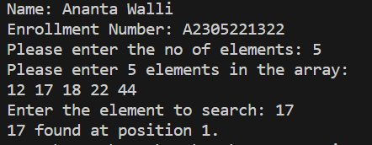

**TIME COMPLEXITY:** The time complexity should be O(n).

**RESULT:** The above code implements the linear search in C programming and returns back the step count and time complexity of the program.