**Practical-6**

**AIM:** To implement Fractional Knapsack Greedy Approach in C programming.

**SOFTWARE REQUIRED:** Vs Code

**PSEUDO CODE:**

FractionalKnapsack(items[], n, capacity):

Sort items[] based on decreasing value-to-weight ratio

totalValue = 0

for i from 0 to n-1:

if capacity == 0:

break

if items[i].weight <= capacity:

totalValue += items[i].value

capacity -= items[i].weight

else:

totalValue += (items[i].value / items[i].weight) * capacity

break

return totalValue

**CODE:**

#include <stdio.h>

#include <stdlib.h>

struct Item {

    int value;

    int weight;

};

int function(const void *a, const void *b) {

    struct Item *itemA = (struct Item *)a;

    struct Item *itemB = (struct Item *)b;

    double ratioA = (double)itemA->value / itemA->weight;

    double ratioB = (double)itemB->value / itemB->weight;

    if (ratioA < ratioB)

        return 1;

    else if (ratioA > ratioB)

        return -1;

    else

        return 0;

}

double fractionalKnapsack(struct Item items[], int n, int capacity) {

    qsort(items, n, sizeof(struct Item), function);

    double totalValue = 0.0;

    for (int i = 0; i < n; ++i) {

        if (capacity == 0)

            break;

        if (items[i].weight <= capacity) {

            totalValue += items[i].value;

            capacity -= items[i].weight;

        } else {

            totalValue += ((double)items[i].value / items[i].weight) * capacity;

            break;

        }

    }

    return totalValue;

}

int main() {

    int n;

    printf("Name: Ananta Walli");

    printf("\nEnrollment No: A2305221322");

    printf("\nPlease enter the number of items required: ");

    scanf("%d", &n);

    struct Item items[n];

    printf("Please enter the value and weight for every item:\n");

    for (int i = 0; i < n; ++i) {

        scanf("%d %d", &items[i].value, &items[i].weight);

    }

    int capacity;

    printf("Please enter the  max capacity: ");

    scanf("%d", &capacity);

    double maxValue = fractionalKnapsack(items, n, capacity);

    printf("The Maximum value= %.2lf\n", maxValue);

    return 0;

}

**OUTPUT:**

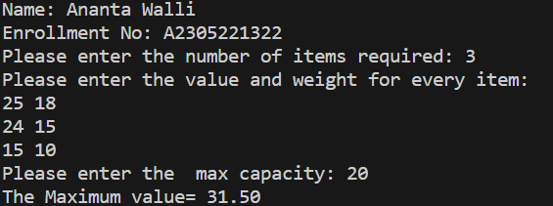

**TIME COMPLEXITY:** The time complexity should be O(nlogn).

**RESULT:** The above code implements the Fractional Knapsack Greedy Approach in C programming.