**PRACTICAL-2**

**AIM:** To implement the Binary Search in C programming in two ways:

1. Without Recursion
2. With Recursion

**SOFTWARE REQUIRED:** Vs Code

**PSEUDO CODE:**

Step 1: Start

Step 2: Input Sorted array in "a[]" and element to be searched in "x" and size of array in "size"

Step 3: Initialize low=0, high=size-1

Step 4: Repeat until low>=high

Step 4.1: mid=(low+high)/2

Step 4.2: If a[mid] is equal to x,

then, print index value of mid and Goto step 6

Else

If a[mid]<x

low=mid+1

else

high=mid-1

Step 5: Print x not found in the list Stop 6: Stop

**CODE:**

**I)Without Recursion**

#include <stdio.h>

int function(int arr[], int size, int k) {

    int leftside = 0;

    int rightside = size - 1;

    while (leftside <= rightside) {

        int midpoint = leftside + (rightside - leftside) / 2;

        if (arr[midpoint] == k) {

            return midpoint;

        } else if (arr[midpoint] < k) {

            leftside = midpoint + 1;

        } else {

            rightside = midpoint - 1;

        }

    }

    return -1;

}

int main() {

    int size, k;

    printf("\nEnter the size of the array(It should be sorted): ");

    scanf("%d", &size);

    int arr[size];

    printf("Please enter the %d elements:\n", size);

    for (int i = 0; i < size; i++) {

        scanf("%d", &arr[i]);

    }

    printf("Please enter the element to be searched: ");

    scanf("%d", &k);

    int index = function(arr, size, k);

    if (index != -1) {

        printf("The element found at position %d.\n", index);

    } else {

        printf("The element is not present.\n");

    }

    return 0;

}

**II)With Recursion**

#include <stdio.h>

int function(int arr[], int leftside, int rightside, int element) {

    if (leftside <= rightside) {

        int mid = leftside + (rightside - leftside) / 2;

        if (arr[mid] == element) {

            return mid;

        } else if (arr[mid] < element) {

            return function(arr, mid + 1, rightside, element);

        } else {

            return function(arr, leftside, mid - 1, element);

        }

    }

    return -1;

}

int main() {

    int size, element;

    printf("\nPlease enter the size of the array(It should be sorted): ");

    scanf("%d", &size);

    int arr[size];

    printf("Please enter the elements:\n");

    for (int i = 0; i < size; i++) {

        scanf("%d", &arr[i]);

    }

    printf("Enter the element to be searched: ");

    scanf("%d", &element);

    int position = function(arr, 0, size - 1, element);

    if (position != -1) {

        printf("Element found at position %d.\n", position);

    } else {

        printf("Element not present.\n");

    }

    return 0;

}

**OUTPUT:**

**I)Without Recursion**

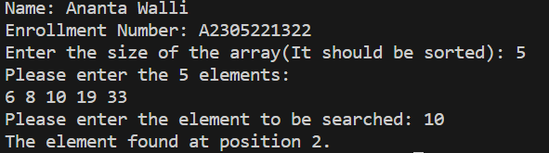

**II)With Recursion**

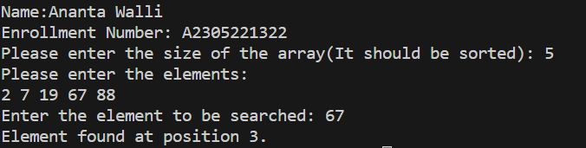

**TIME COMPLEXITY:** The time complexity should be O(logn).

**RESULT:** The above code implements the binary search in C programming in two ways ie without recursion and with recursion.