1. Code to control Built-in LED

void setup() {

pinMode(LED_BUILTIN, OUTPUT); // Set the LED pin as an output

}

void loop() {

digitalWrite(LED_BUILTIN, HIGH); // Turn the LED on

delay(1000); // Wait for 1 second

digitalWrite(LED_BUILTIN, LOW); // Turn the LED off

delay(1000); // Wait for 1 second

}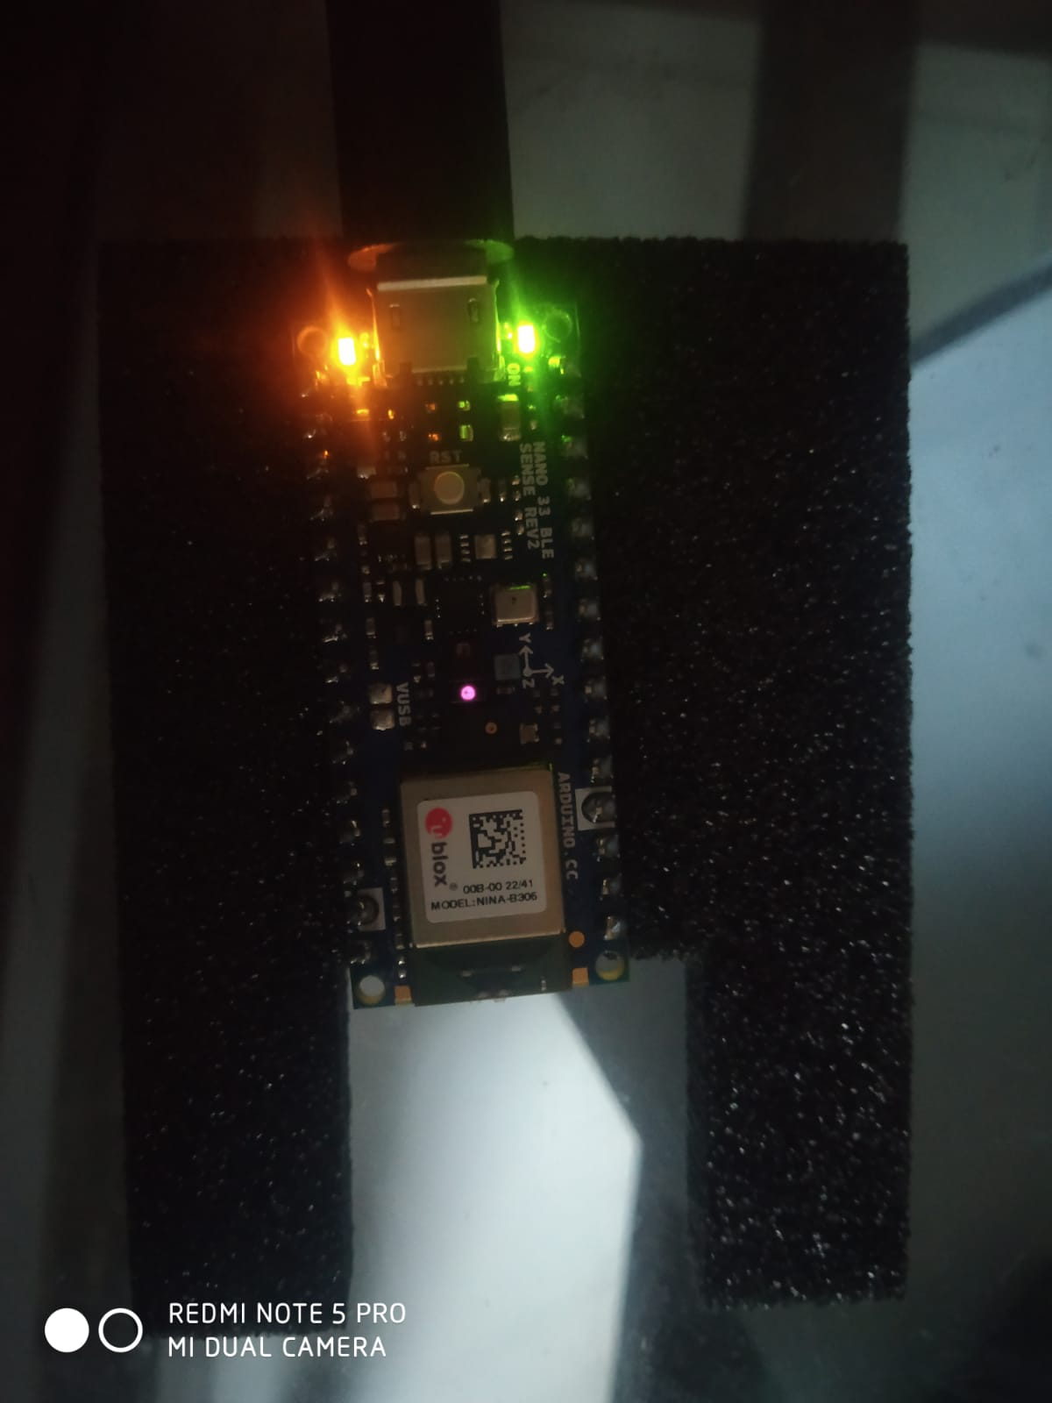



1. Code to Control RGB Light

const int redPin = 22;

const int greenPin = 23;

const int bluePin = 24;

void setup() {

  pinMode(redPin, OUTPUT);

  pinMode(greenPin, OUTPUT);

  pinMode(bluePin, OUTPUT);

}

void loop() {

  digitalWrite(22,HIGH);

  delay(500);

  digitalWrite(22,LOW);

  delay(500);

  digitalWrite(23,HIGH);

  delay(500);

  digitalWrite(23,LOW);

  delay(500);

  digitalWrite(24,HIGH);

  delay(500);

  digitalWrite(24,LOW);

  delay(500);

}

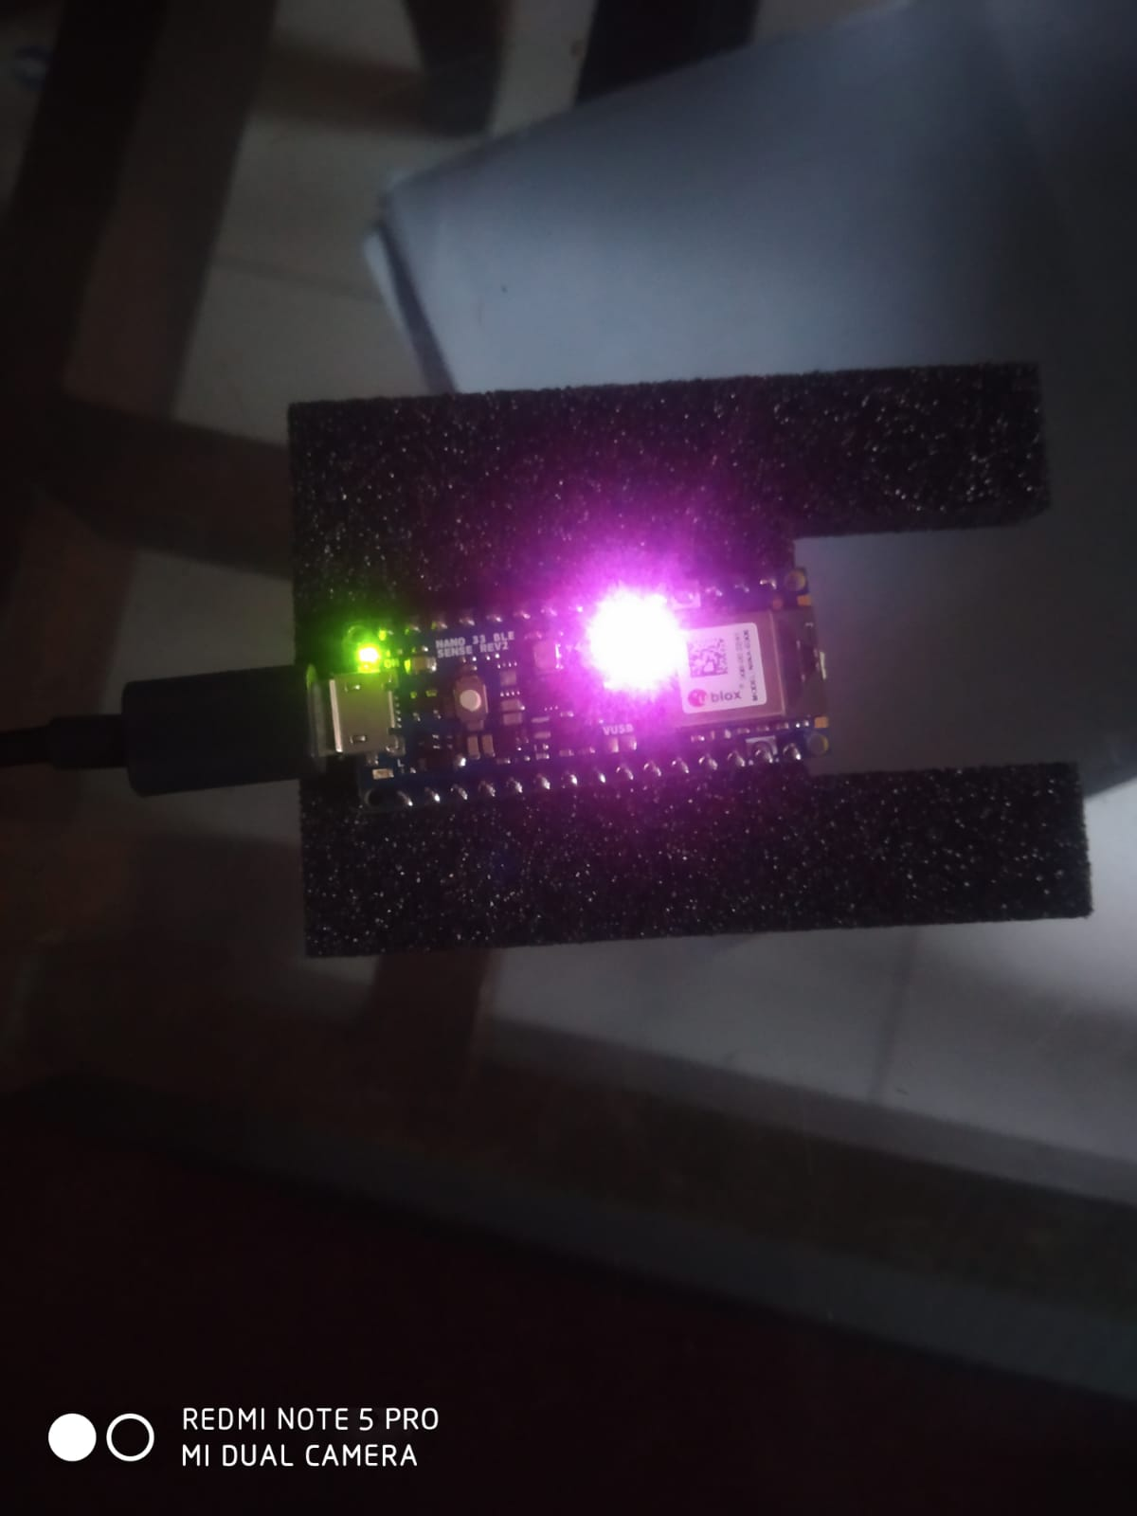

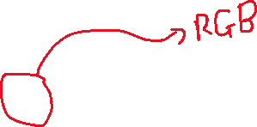

**NANO 33 BLE SENSE HAVE 2 ONBOARD SENSORS FOR IMU (MOTION DETECTION)**

1. **BMI270 (ACCELEROMETER AND GYROSCOPE)**
2. **BMM150 (MAGNETOMETER)**

* **SENSOR TESTING**

1. **COLOR SENSOR**

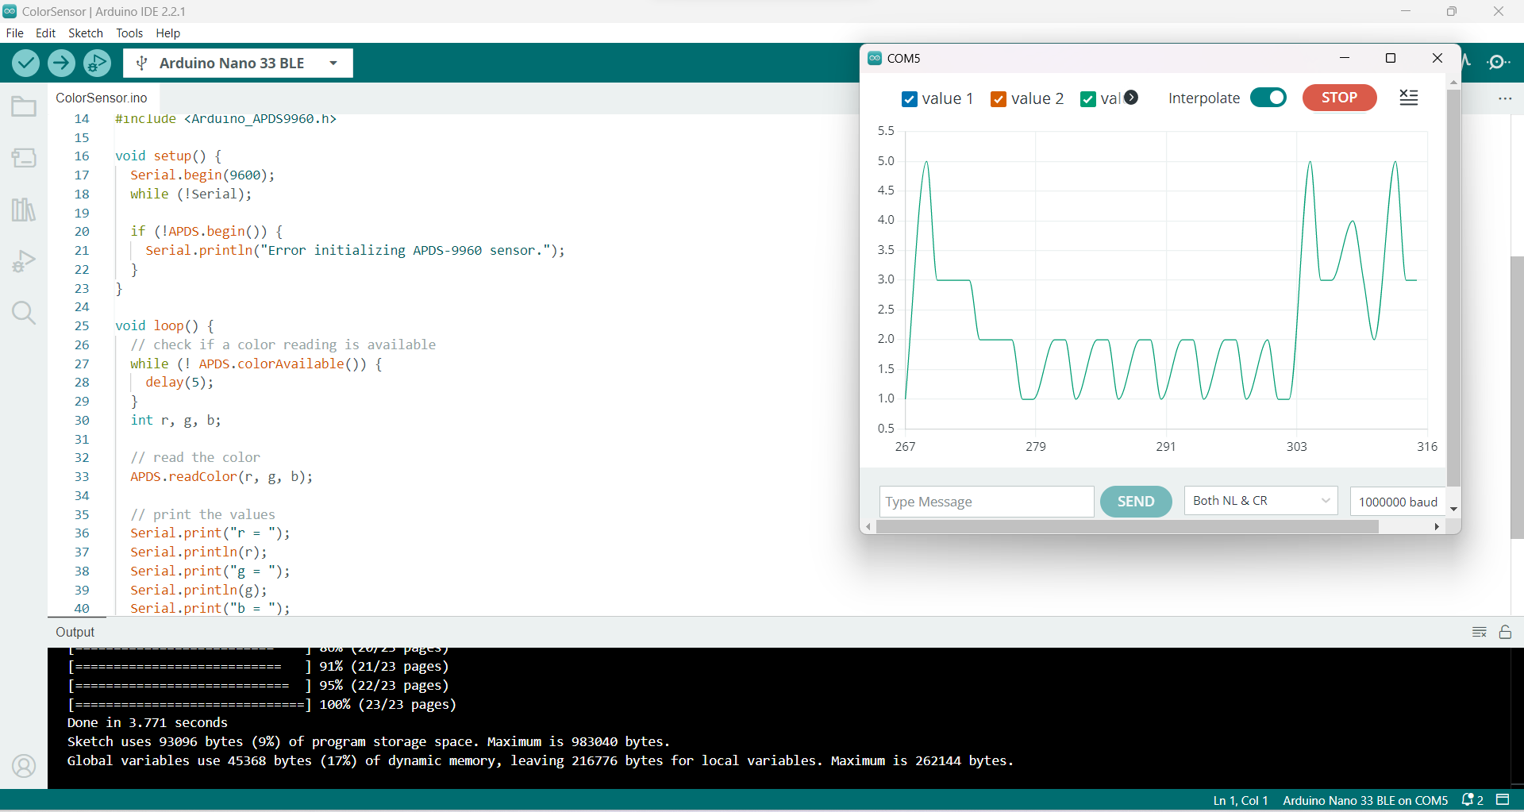

1. PRESSUR SENSOR

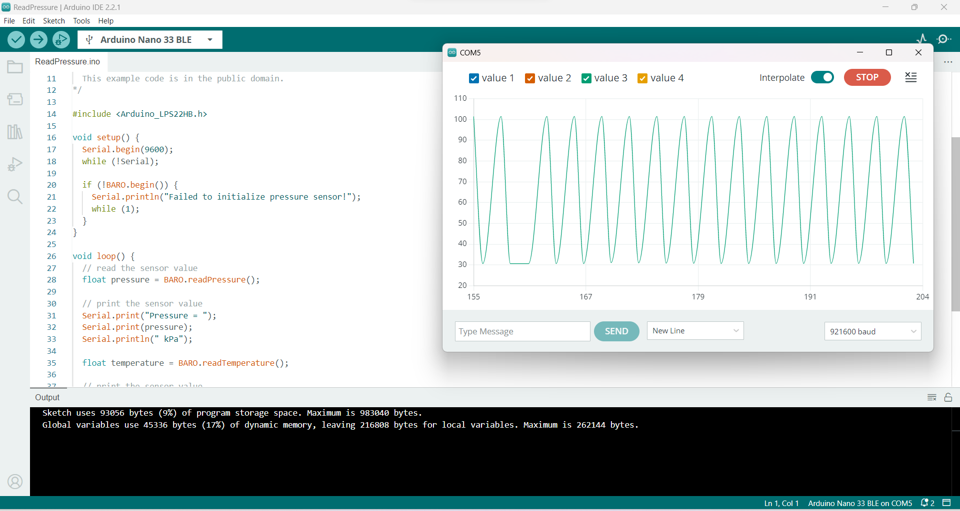

1. GUESTER SENSOR

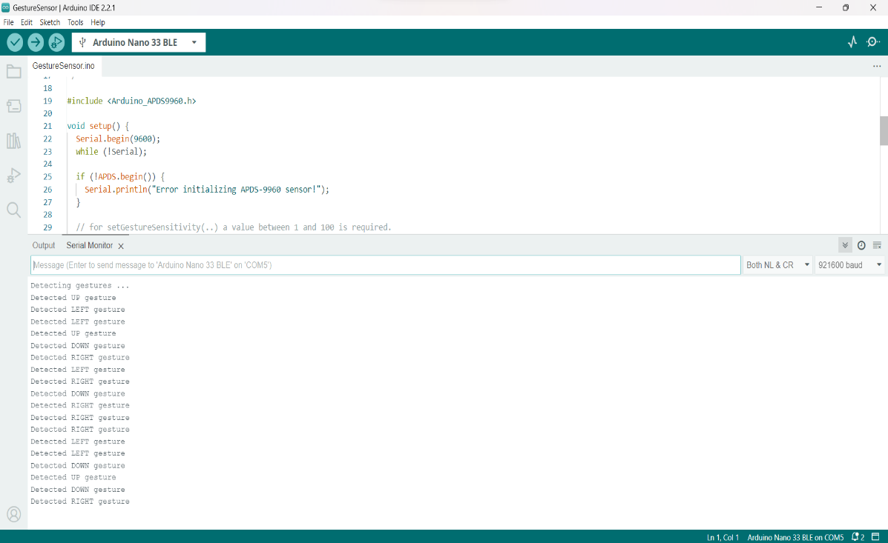

1. PROXIMITY SENSOR

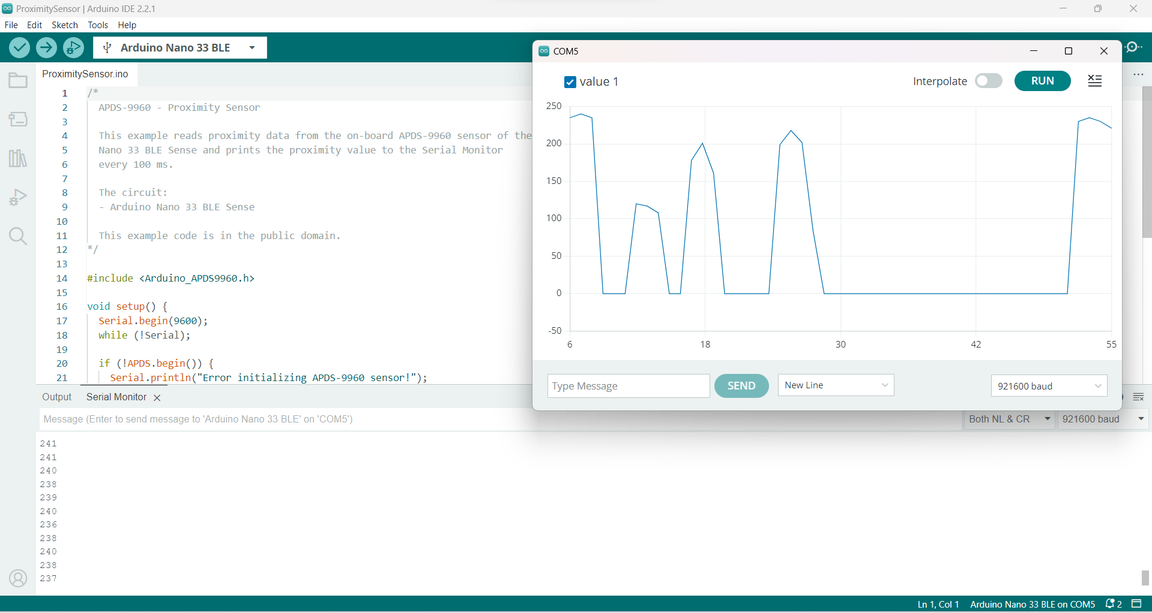

1. ACCELEROMETER SENSOR

